# 

# 

# **Assessment**

# **MongoDB**

Trainee Name : Aditya Upadhyay

Newers ID : 3978

Mentor Name : Tarun Saxena

College : UPES

1. **Install latest version of MongoDB from apt-get repository**

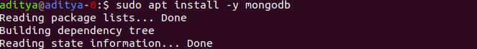

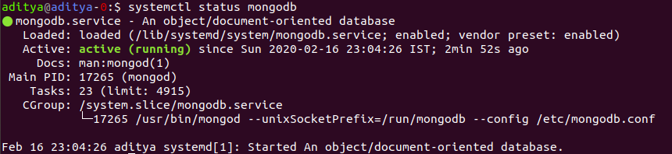

2. **Create a database student**



3.**Insert operation : 5 students data (Name, Contact, City, Roll No, Branch)**

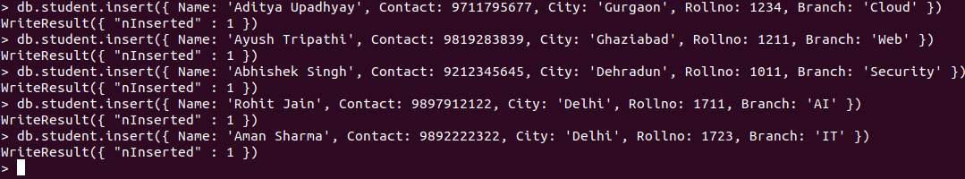

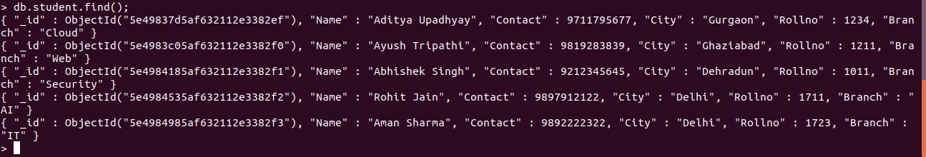

4.**Read operation : All the students belong to a particular city**



5.**Update operation : Update the branch of all the students to CSE** 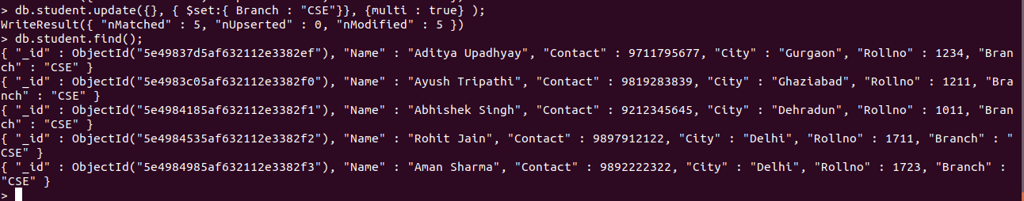

6. **Take dump of the database**

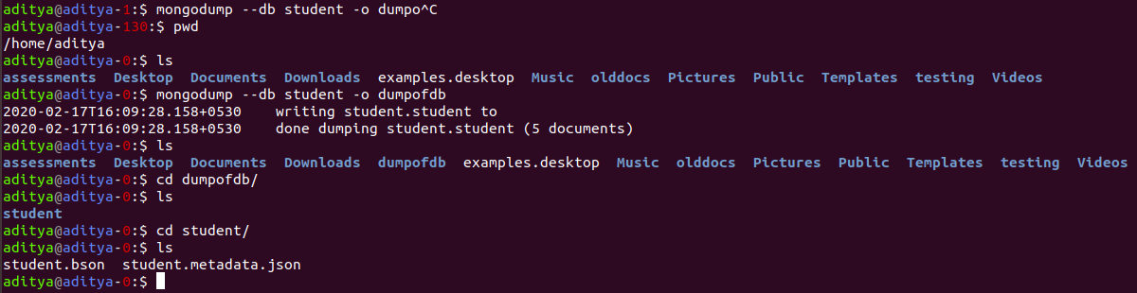

7. **Delete operation : Delete the record of last 2 students according to the roll number** Method 1: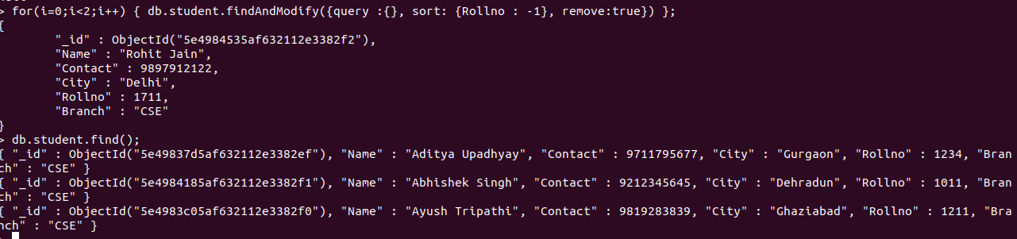

Method 2:

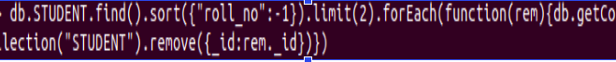

8. **Drop the database**

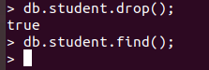

9. **Restore the database again to have the full data** 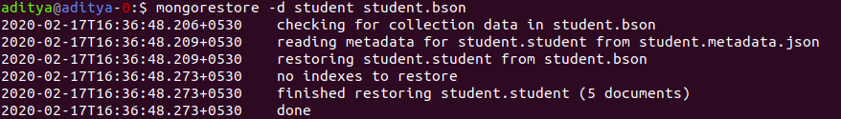

10. **Enable authentication on the Mongo**

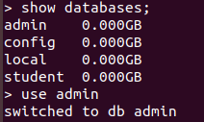

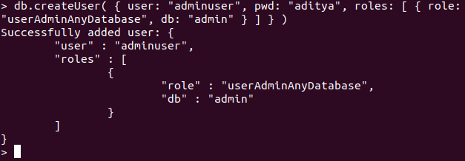

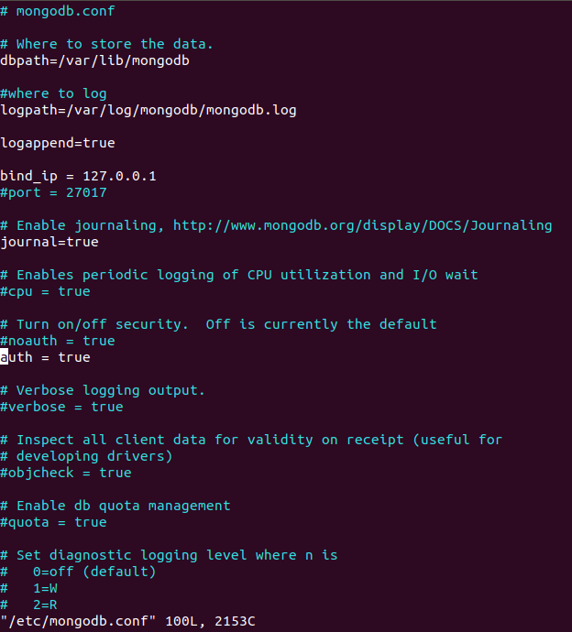

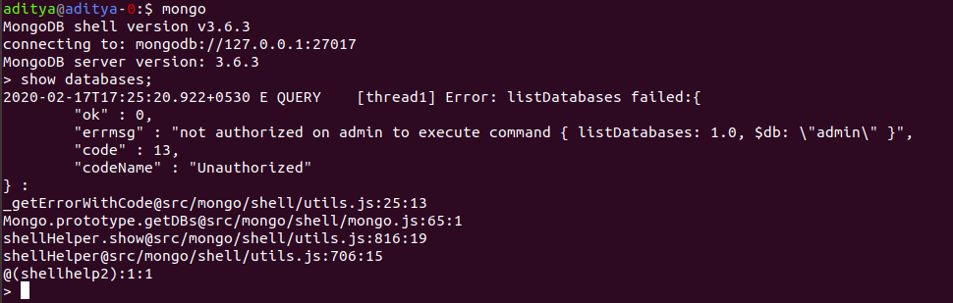 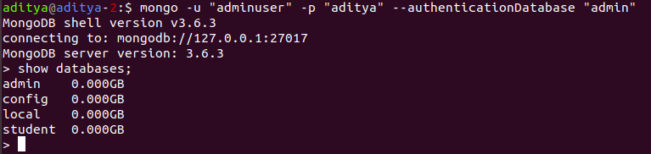

11. **Install another version of MongoDB from source and run it on port 27009**

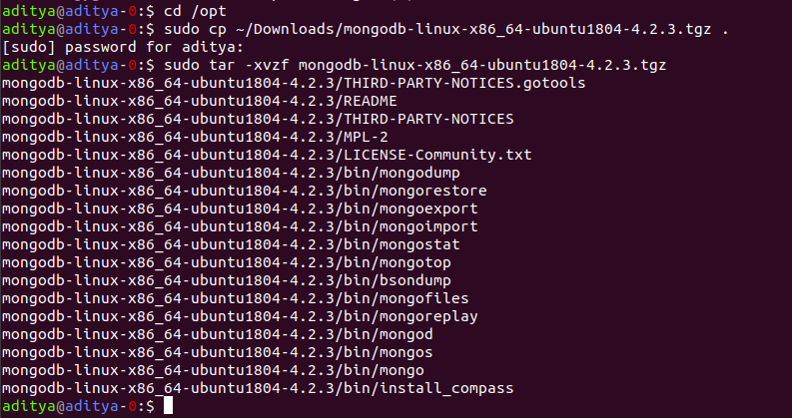

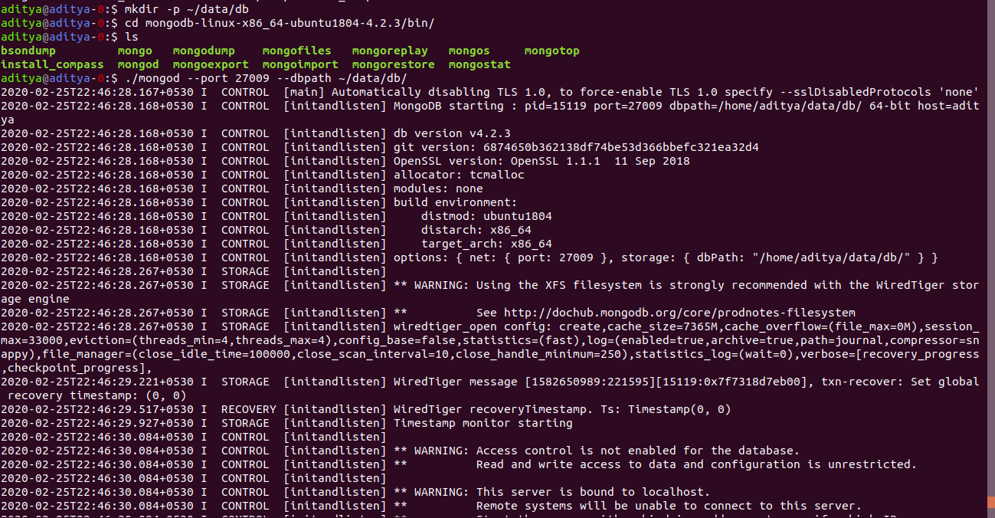

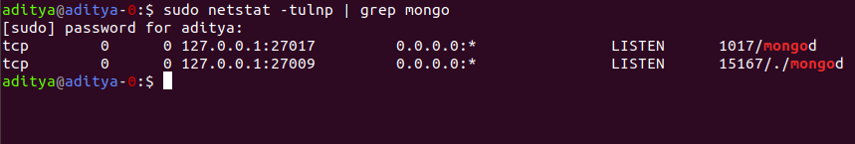

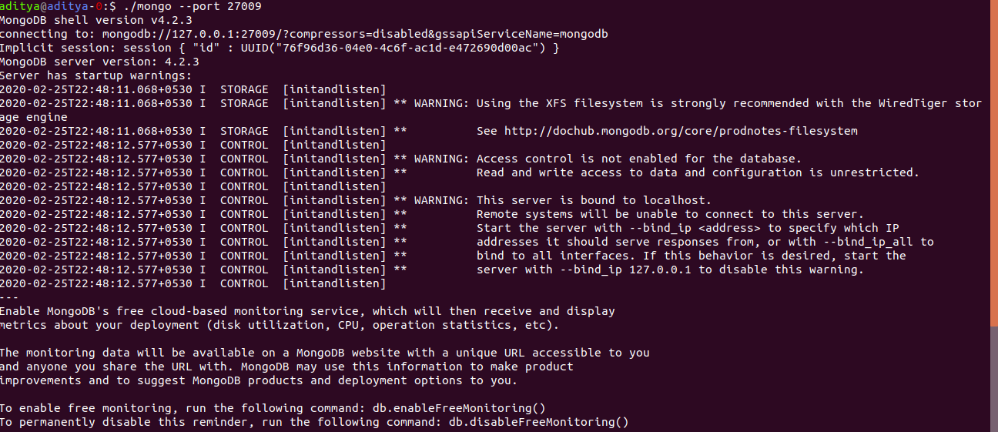

12. **Create init service of Mongo installed later\***



