# 

# 

# **Assessment**

# **Mysql**

Trainee Name : Aditya Upadhyay

Newers ID : 3978

Mentor Name : Tarun Saxena

College : UPES

1.**Install latest version of MySQLDB from apt-get repository**

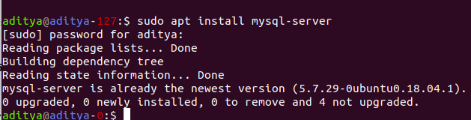

2.**Create a database student** 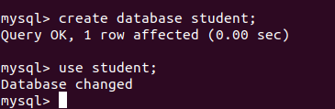

3.**Insert operation : 5 students data (Name, Contact, City, Roll No, Branch)** 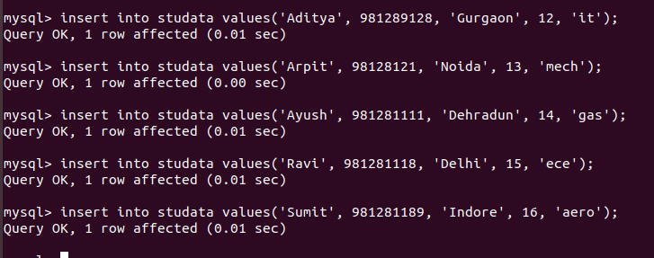

4.**Read operation : All the students belong to a particular city** 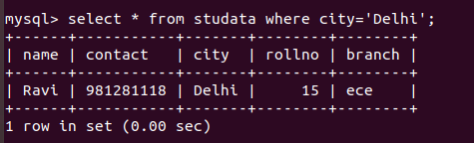

5.**Update operation : Update the branch of all the students to CSE**

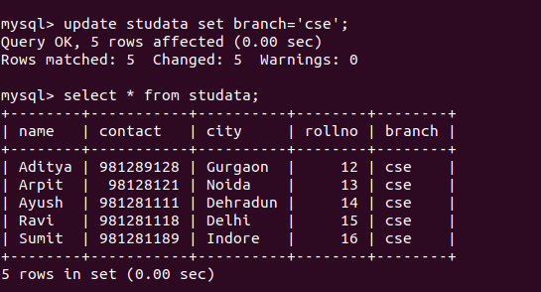

**6.Take dump of the database** 

7.**Delete operation : Delete the record of last 2 students according to the roll number**

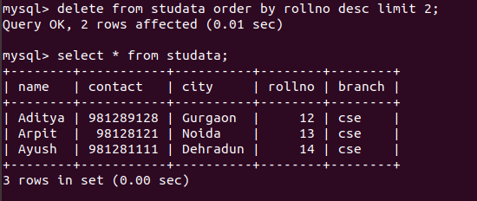

8.**Drop the database**

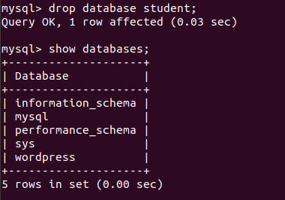

9.**Restore the database again to have the full data**

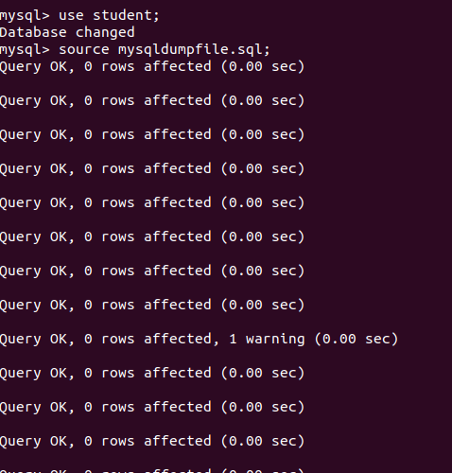

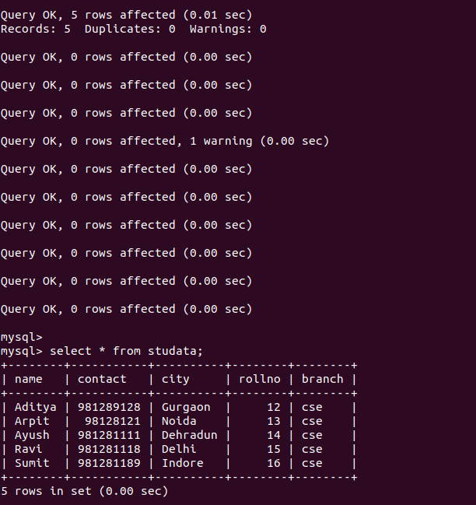

10.**Enable authentication on the MySQL** 