BLOCKCHAIN-BASED SYSTEM CALL
AUDIT FRAMEWORK
Immutable Audit Logs Using Lightweight Blockchain Principles
Final Project Report: Design, Implementation and Evaluation
Operating Systems and Cybersecurity Project

Abstract
Operating-system audit logs underpin incident response and forensics, yet a privileged attacker can edit or delete them on the host that produced them. This project designed, implemented and evaluated B-SCAF, a lightweight permissioned framework that makes Linux system-call evidence tamper-evident without a public blockchain. System calls are captured live through eBPF tracepoints or imported from auditd logs, minimized by a versioned privacy policy, chained with SHA-256, grouped into Merkle batches and committed in Ed25519-signed checkpoint blocks. Blocks are replicated to a quorum of independent witnesses that enforce chain continuity and return signed acknowledgements, so verification can detect even a history rewritten and re-signed with a stolen host key. On 100 real auditd logs from the public Splunk Attack Data repository, the framework ingested every file and committed 673 events, compared with 46 events and 11 aborted files for the earlier prototype. In live capture on a WSL2 6.18 kernel, the eBPF collector recorded about 8,924 host-wide events per run, captured 100% of the operations performed by a repeatable workload, and slowed that workload by 21%, against 28% for eBPF tracing alone; the two are within run-to-run variation, so the cost comes from kernel-side tracing rather than from hashing, signing and replication. All 12 attack scenarios, including tail truncation and re-signing with a stolen key, were detected as designed.
Keywords: system-call auditing; eBPF; tamper-evident logging; permissioned ledger; Merkle tree; witness quorum; digital forensics.

1. Introduction
Every security-relevant action on a Linux host, such as running a program, opening a file, changing permissions, assuming another identity or connecting to the network, crosses the kernel boundary as a system call. A faithful record of these calls lets an investigator reconstruct an intrusion. The difficulty is that the record usually lives on the machine under attack: an intruder with root privileges can alter, delete, reorder or replace the very evidence that would expose them.
B-SCAF (Blockchain-Based System Call Audit Framework) applies blockchain principles without a cryptocurrency network. Raw events remain local and searchable, while compact cryptographic commitments are signed, linked and held by independent witnesses. This report describes the final system, its threat model and implementation, and an evaluation on recorded attack data and on live host activity.

2. Problem Statement and Objectives
How can a Linux host record security-relevant system calls so that later tampering is detectable, the evidence can be verified independently of the host, sensitive arguments are protected, and the overhead stays modest? The project brief set four objectives:
- Objective 1: capture configurable security-relevant system calls with process, user, time, result and selected arguments.
- Objective 2: build a lightweight immutable evidence chain using canonical records, hash links, Merkle batches and signed checkpoints.
- Objective 3: provide independent verification with a clear pass, fail or partial-evidence report.
- Objective 4: measure throughput, capture-to-commit delay, CPU and memory overhead, storage growth and verification time.

3. Research Gap and Contribution
Blockchain logging research has shown the value of immutable audit trails for cloud, healthcare and IoT records, and system-call research has shown that call sequences are strong intrusion signals. Few systems treat host system calls as durable forensic evidence that must survive a privileged compromise. B-SCAF contributes a practical integration of established mechanisms:
- A kernel-to-proof pipeline from eBPF or auditd capture to deterministic, verifiable event records.
- Dual-level integrity: an event hash chain for order and Merkle batch roots for compact commitments and per-event proofs.
- A permissioned witness quorum that holds only signed metadata, enforces chain continuity, records equivocation and signs acknowledgements.
- Privacy by design: an allow-list, key-based and inline secret redaction, and a policy version bound into every block.
- Failure-aware verification that names the first invalid item and distinguishes fail from partial evidence.
The project does not claim to invent hashing, Merkle trees, signatures or distributed ledgers; its contribution is the integration and its evaluation on real data.

4. Threat Model
Protected assets are the integrity, order and origin of committed events, their availability through witness copies, and the confidentiality of argument values. The attacker is assumed to gain root on the source host after collection: they can edit, delete, insert or reorder ledger lines, read the source signing key and re-sign a rewritten history, and take some witnesses offline.
B-SCAF guarantees that any change to committed evidence is reported, provided the verifier trusts the source public key and a quorum of witnesses is honest and reachable. It does not guarantee the honesty of a compromised kernel or collector before capture, it cannot protect events that are not yet in a signed and replicated block, and if the quorum is unreachable the verdict is partial rather than pass.

5. System Design
Figure 1 shows the implemented architecture. Trust is separated: the audited host stores detailed evidence and produces signed commitments; witnesses keep the commitments; any auditor can verify both.
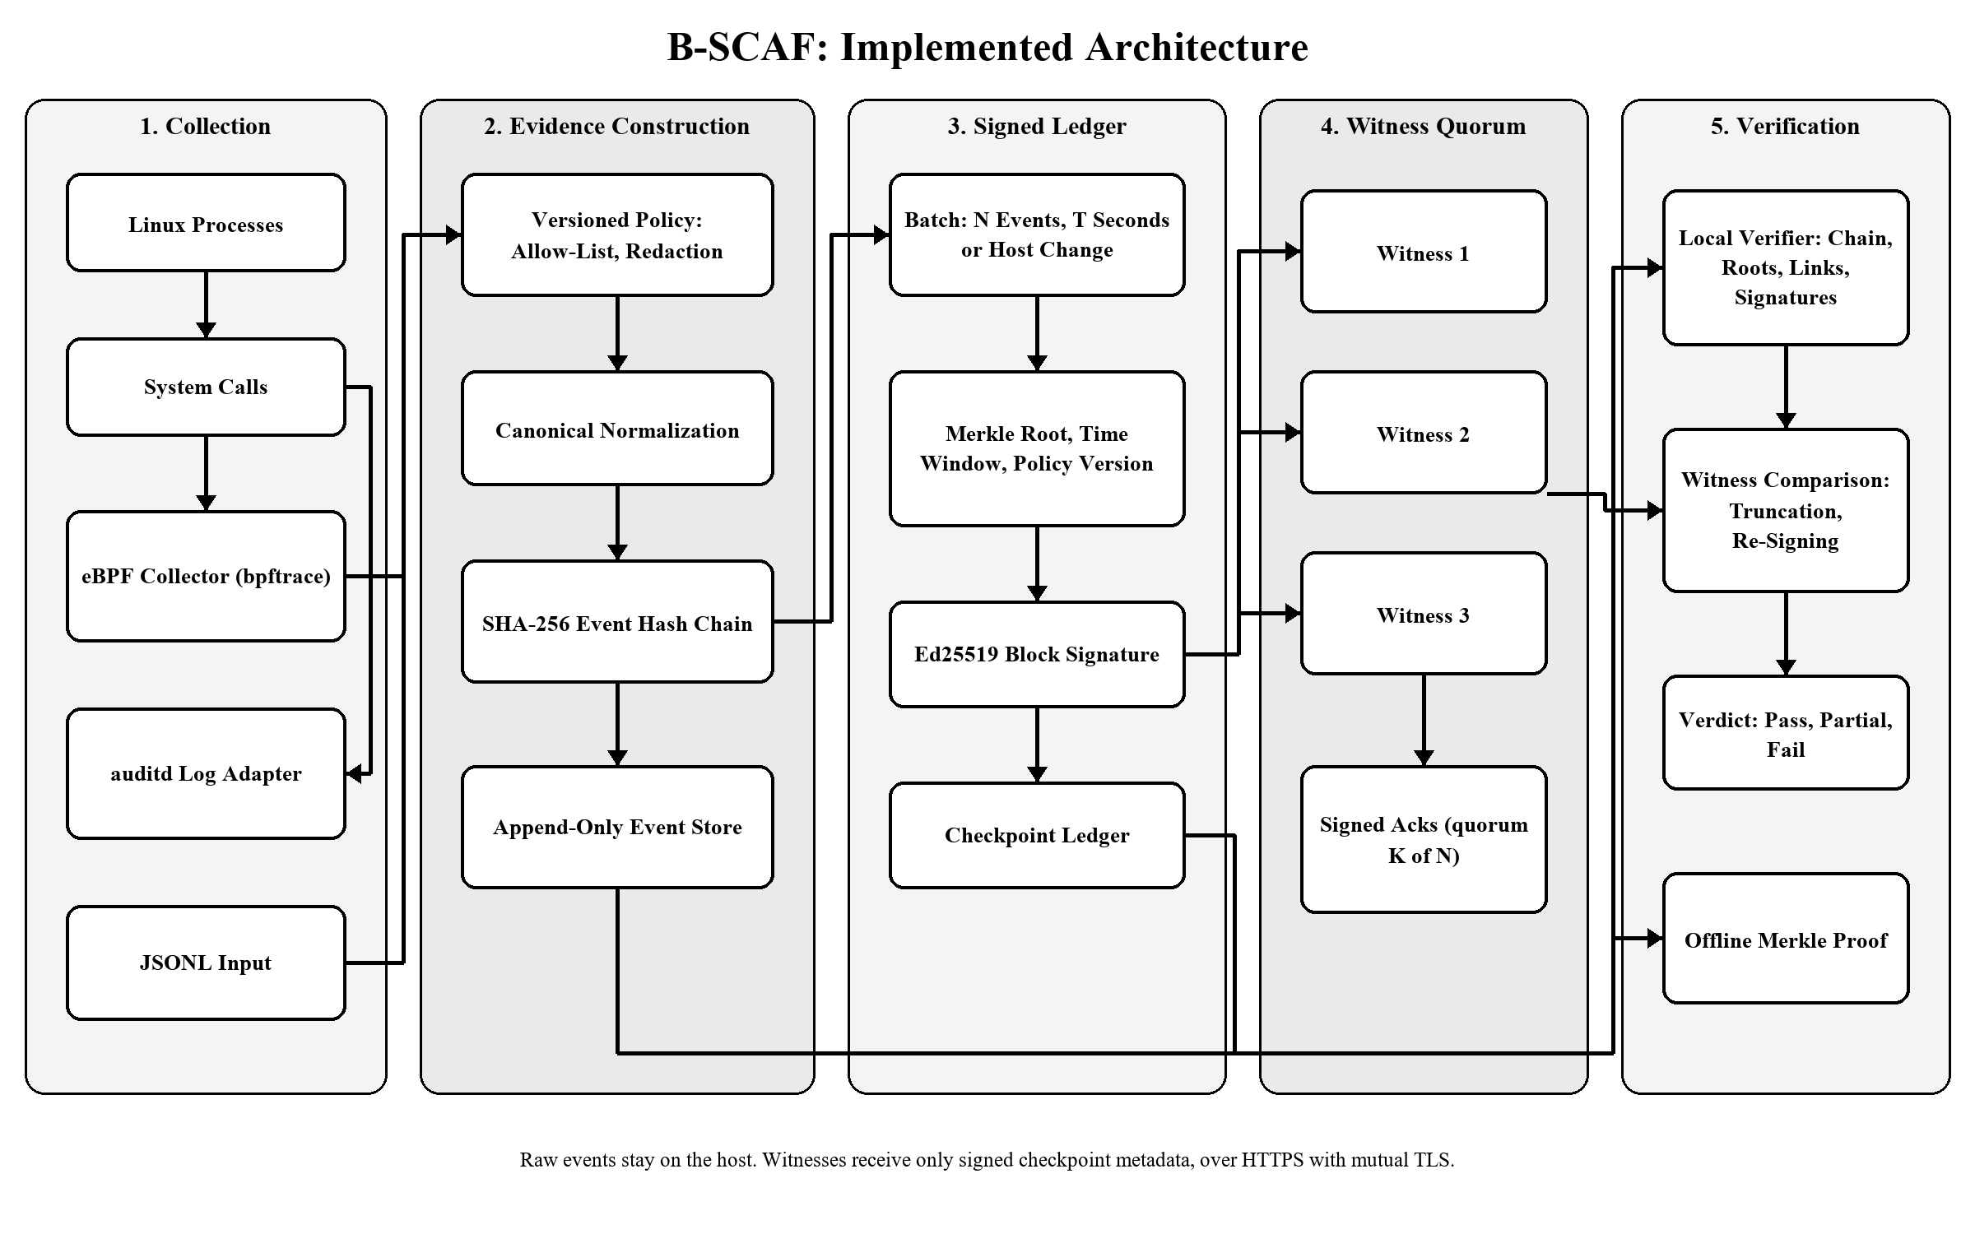
Figure 1. B-SCAF collection, evidence construction, signed ledger, witness quorum and verification.

5.1 Collection
The eBPF collector generates a bpftrace program that attaches to the entry and exit tracepoints of the policy's system calls. Arguments saved at entry are emitted with the return code at exit, keyed by kernel thread ID so the program also works inside a container's PID namespace; execve records carry the command line and connect/bind records carry decoded socket addresses. The collector learns its own kernel PID with a one-shot probe so it never records its own I/O.
The auditd adapter reads raw, ENRICHED, node-prefixed and ausearch -i exports. It merges the SYSCALL, EXECVE, PATH, CWD, SOCKADDR and PROCTITLE records of one kernel event, decodes hex-encoded values, maps syscall numbers per architecture (x86_64, aarch64, i386), streams compressed or standard input, follows rotating logs and skips records already ingested.
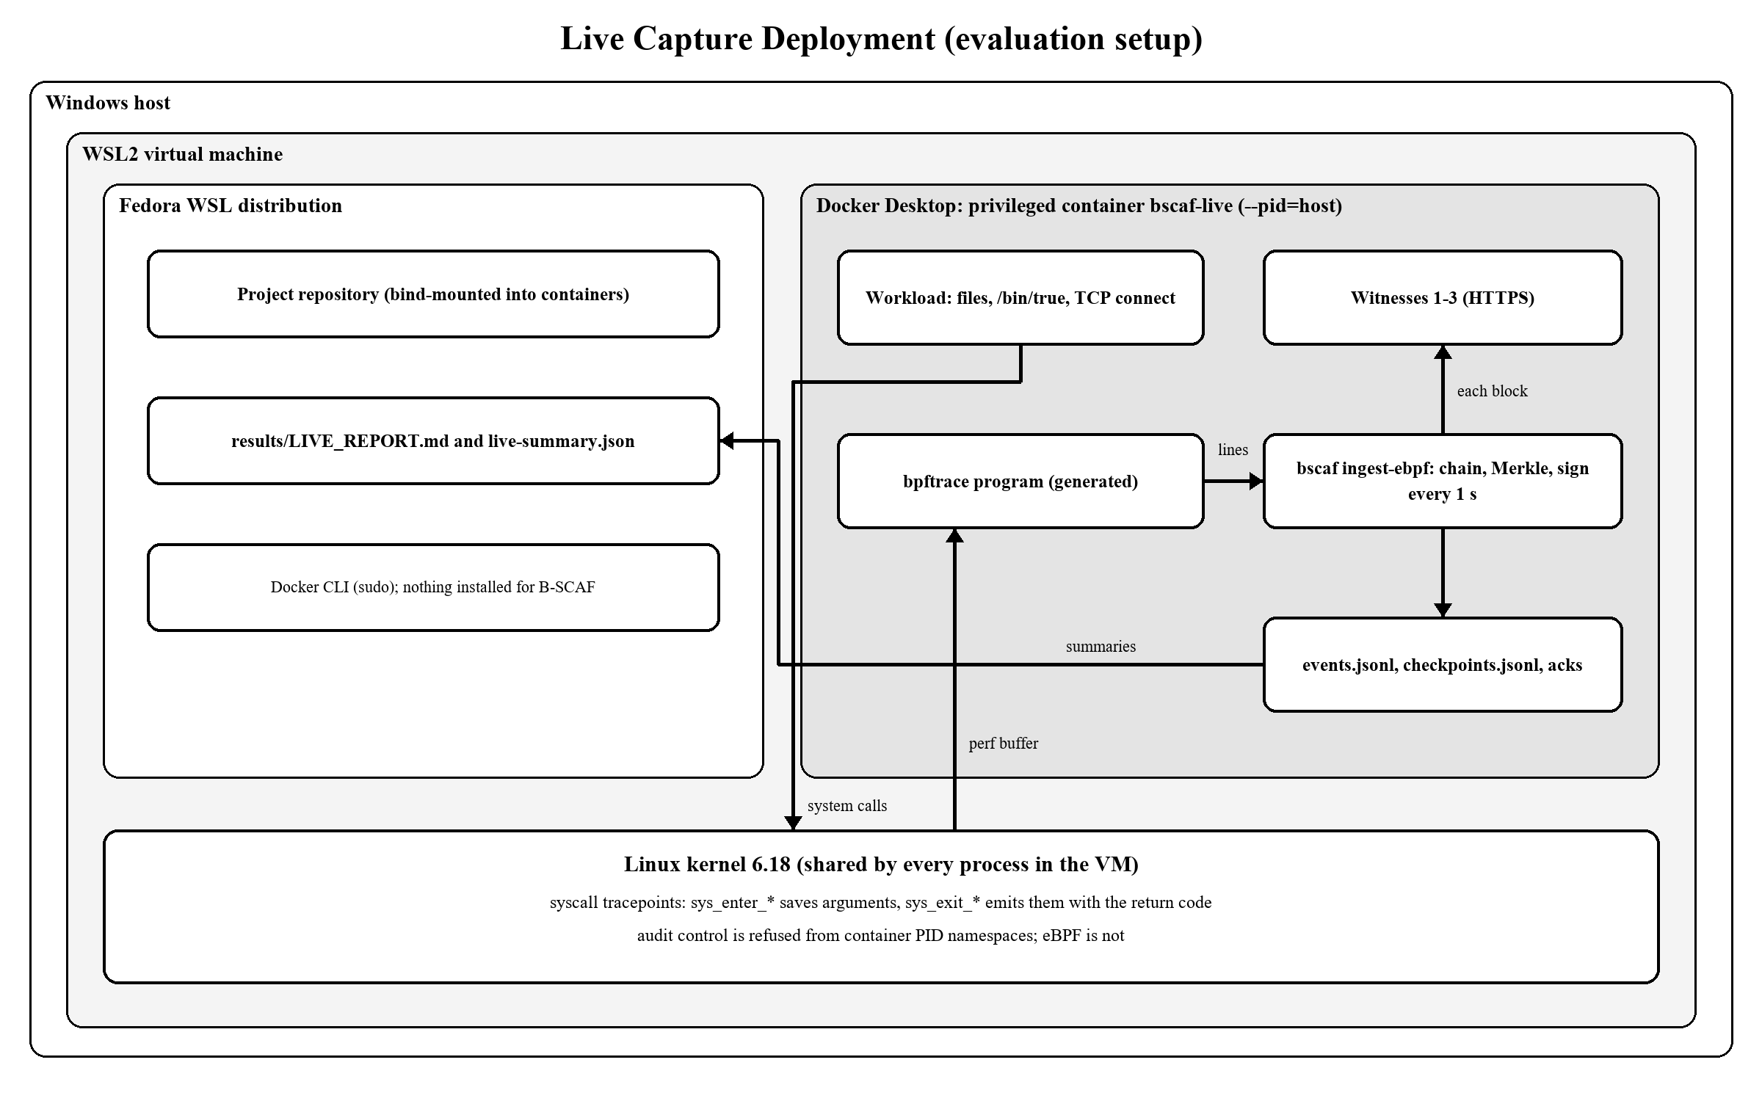
Figure 2. Live-capture deployment used in the evaluation: the eBPF collector runs in a privileged container and traces the shared WSL2 kernel.

5.2 Evidence Construction
Each accepted event is normalized to a fixed schema (sequence, UTC time, host, PID, PPID, UID, system call, process, arguments, return code) and serialized canonically. Its hash covers the previous event's hash. Blocks close after N events, after T seconds of event time, or when the host changes.
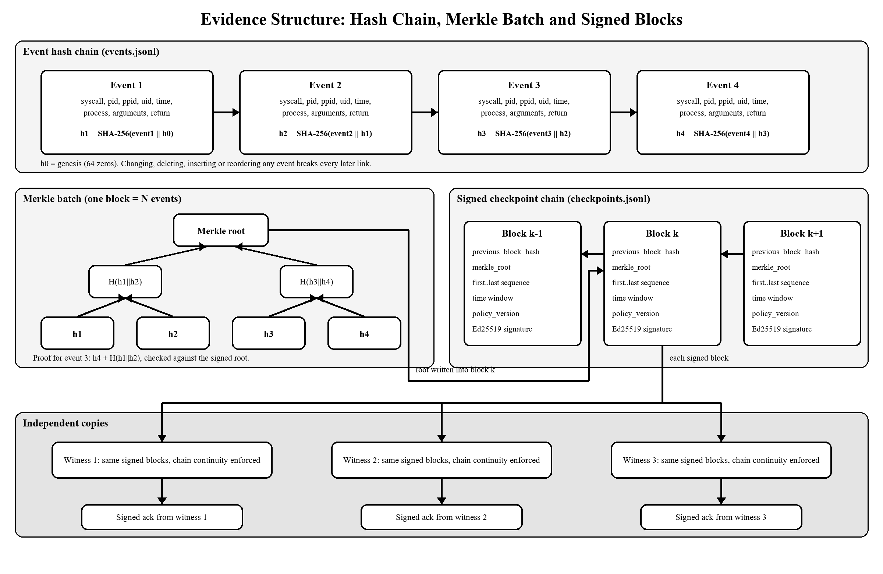
Figure 3. Evidence structure: each event hash covers its predecessor, a Merkle root commits each batch, and signed blocks link to their predecessor and are copied to every witness.

5.3 Checkpoint Blocks
Field | Purpose
block_number, previous_block_hash | Order and linkage of the permissioned chain
batch_id, first/last_sequence, event_count | Exact range of committed events
merkle_root | Commitment to every event hash in the batch
host_id, time_window_start/end | Origin and time span of the evidence
policy_version | Hash of the minimization policy that produced the events
created_at, signer_id, signature, block_hash | Ed25519 authentication of the block
witness acks (stored beside the block) | Witness-signed receipts proving quorum

5.4 Witness Quorum
Witnesses trust a configured set of source keys. A witness accepts a block only if its hash and signature are valid and it extends the chain that witness already holds; a different block for an existing number is refused with HTTP 409 and stored as equivocation evidence. Each acceptance returns an acknowledgement signed with the witness's own key. Transport is HTTPS with optional mutual TLS, and streaming collectors push each block as soon as it is signed.
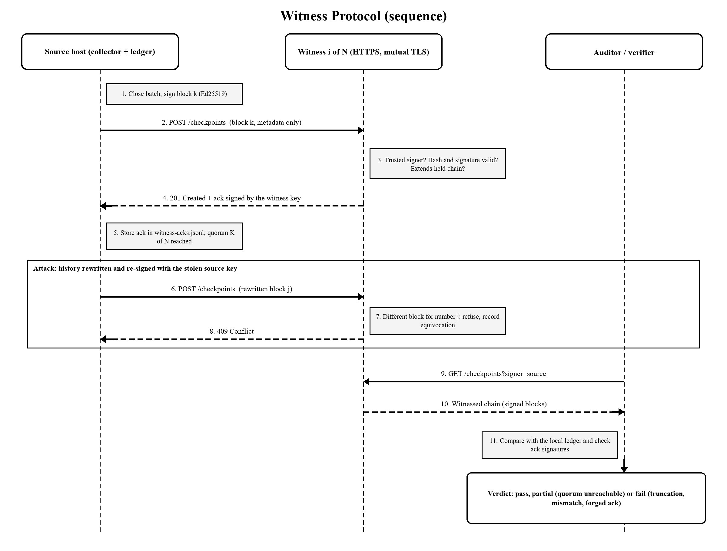
Figure 4. Witness protocol: replication with signed acknowledgements, refusal of a rewritten block, and independent comparison by an auditor.

5.5 Verification
Local verification recomputes every event hash and link, every Merkle root, block hash, link and signature, and checks block numbering, ranges and replayed batches in a single indexed pass. Verification against witnesses compares the local ledger with each witness copy, which exposes tail truncation and re-signed history, and checks acknowledgement signatures. Verdicts are pass, fail (with the first invalid item) or partial (uncommitted events or witness quorum unreachable). A portable proof contains one event, its Merkle path and its signed block, and verifies with only the source public key.
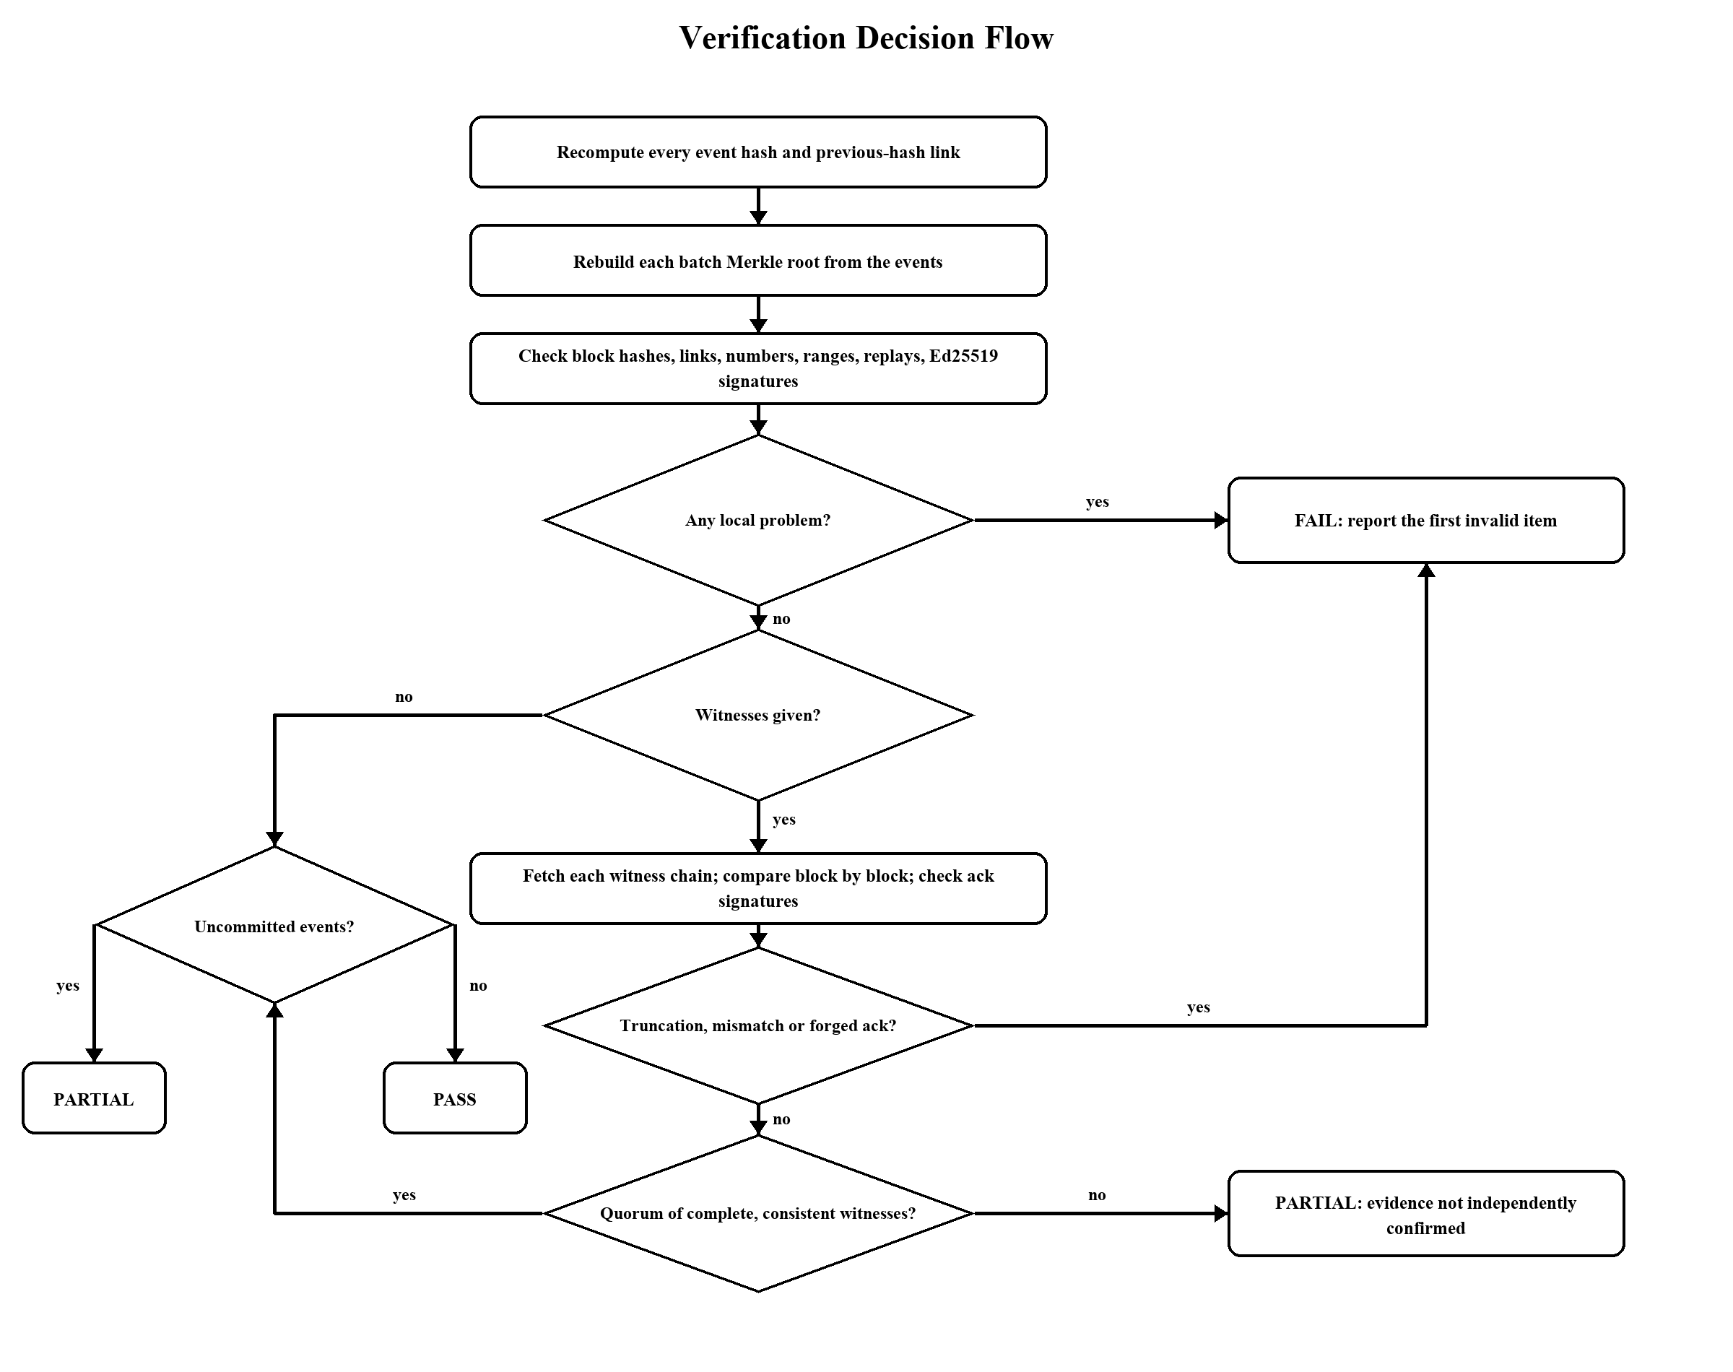
Figure 5. Verification decision flow leading to a pass, partial or fail verdict.

6. Implementation
B-SCAF is a Python 3.11+ package whose only runtime dependency is the cryptography library. Every experiment runs in containers, so nothing is installed on the host: a slim runtime image for tests and replay experiments, and a privileged image with bpftrace for live capture.
Module | Responsibility
ebpf.py | bpftrace program generation, kernel-PID discovery, live capture loop
auditd.py | auditd parsing, record correlation, architecture tables, log following
policy.py | Allow-list, redaction, truncation, policy version
models.py, canonical.py | Event and block schemas, canonical JSON, hashing
service.py, store.py | Ingest with cached tail state, batching, signing, verification, search, locking
merkle.py, crypto.py, proof.py | Merkle roots and proofs, Ed25519 (optionally encrypted keys), offline proofs
witness.py, tlsutil.py | Witness rules, signed acks, quorum replication, comparison, HTTPS/mTLS
attacks.py, bench.py | Reusable tampering scenarios and the Phase 6 benchmark
cli.py, ui.py | Command-line interface and local dashboard

The automated suite has 48 tests: integrity and tampering, real auditd fixtures in every supported format, recorded eBPF output, the CLI including de-duplication and replication on commit, the full attack matrix against HTTP witnesses, witness chain rules, mutual TLS, encrypted keys, search and the benchmark harness.

7. Evaluation

7.1 Data and Environment
Recorded data: 100 raw auditd logs (1,482,016 bytes) from Splunk Attack Data at commit 4389fa7a4e74, captured in Splunk Attack Range while executing MITRE ATT&CK techniques, each verified against a pinned SHA-256. Live data: the eBPF collector in a privileged container on the WSL2 kernel 6.18.54.1-microsoft-standard-WSL2, observing every process on that kernel while a repeatable workload ran. Environment: Linux-6.18.54.1-microsoft-standard-WSL2-x86_64-with-glibc2.41, Python 3.12.15.

7.2 Recorded Attack Data
Measure | Earlier prototype | Final system
Files ingested without aborting | 89 / 100 | 100 / 100
Events committed (all system calls) | 46 | 673
Events committed (default policy) | - | 443
Duplicate records merged | - | 303
Records rejected | 11 whole files | 0

Table 1. Ingestion of the public auditd dataset.
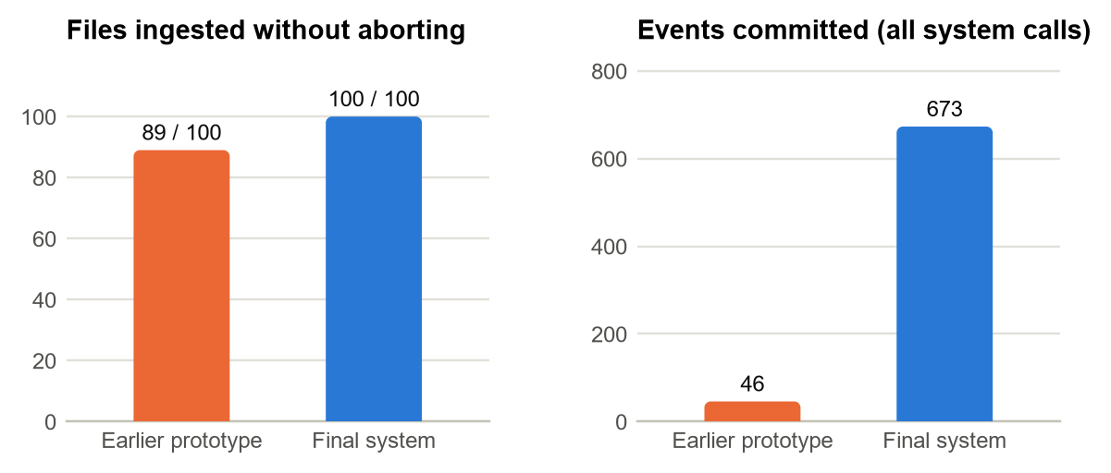
Figure 6. Ingestion of the 100 public auditd logs: earlier prototype compared with the final system.
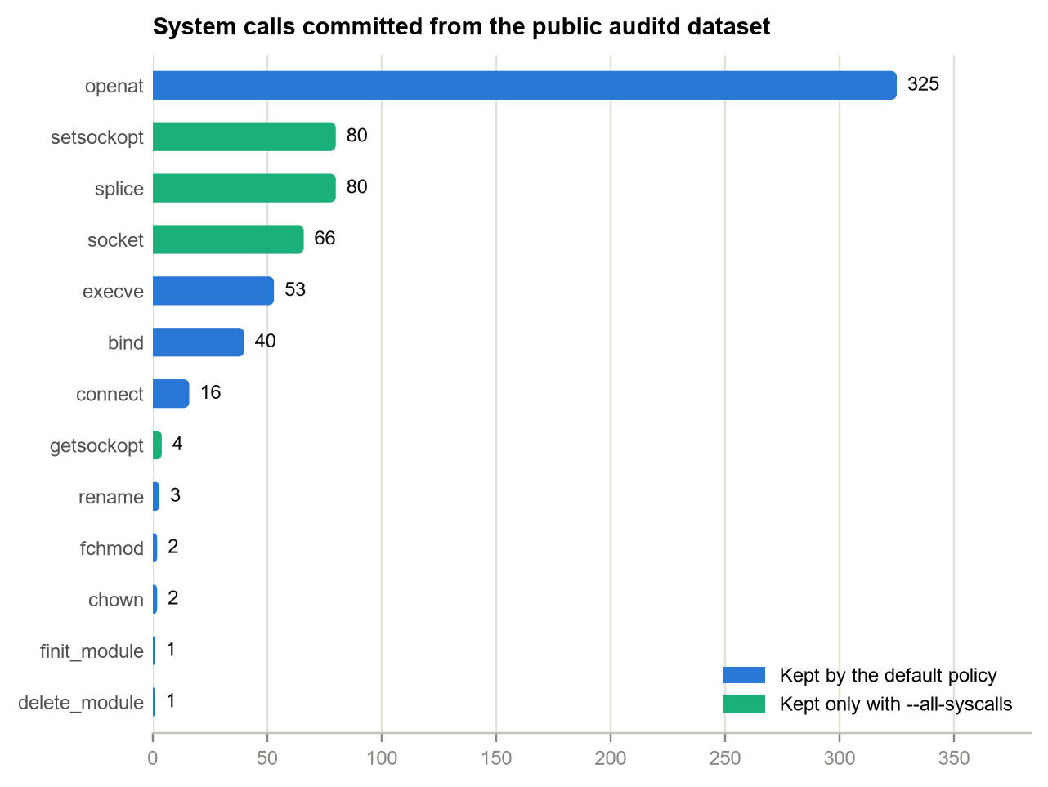
Figure 7. System calls committed from the public dataset, by policy.
Ledger | Verdict | Events | Blocks
Default policy | pass | 443 | 60
All system calls | pass | 673 | 82

Both ledgers verified as pass, and 5 of 5 randomly selected inclusion proofs verified offline with only the public key. With three witnesses and quorum two, all witnesses online gave pass, one offline still gave pass with a notice, and two offline gave partial evidence.

7.3 Live Capture: Completeness and Overhead
Each live run executed 1,000 iterations of a workload that creates and writes a file, renames it, changes its mode, deletes it, starts /bin/true and opens a TCP connection. Each phase ran 3 times; medians are reported.
Phase | Workload time (s) | Slowdown | Collector CPU (s)
baseline | 1.12 | +0.0% | 0.00
tracing only | 1.42 | +27.6% | 0.25
B-SCAF | 1.35 | +20.9% | 1.27

Table 2. Workload slowdown: no tracing, eBPF tracing alone, full B-SCAF capture with witness replication.
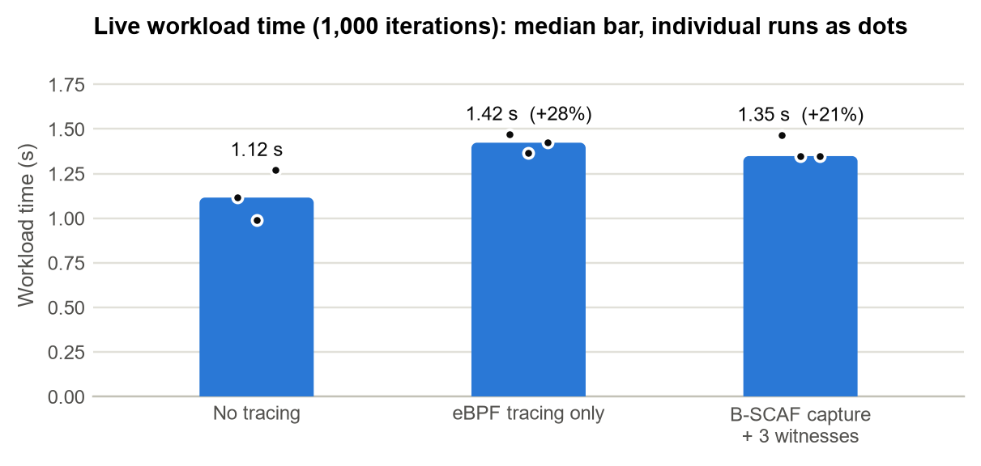
Figure 8. Live workload time per phase (bars: median of three runs; dots: individual runs).
Run | Events | Blocks | Lost | Commit delay p50/p95 (ms) | Verdict (local / witnesses) | Workload calls captured
1 | 8,744 | 6 | 198 | 668 / 1179 | pass / pass | 6,000 / 6,000
2 | 8,947 | 6 | 0 | 417 / 1183 | pass / pass | 6,000 / 6,000
3 | 8,924 | 6 | 0 | 349 / 1052 | pass / pass | 6,000 / 6,000

Table 3. Live B-SCAF runs with 1-second blocks replicated to three witnesses.
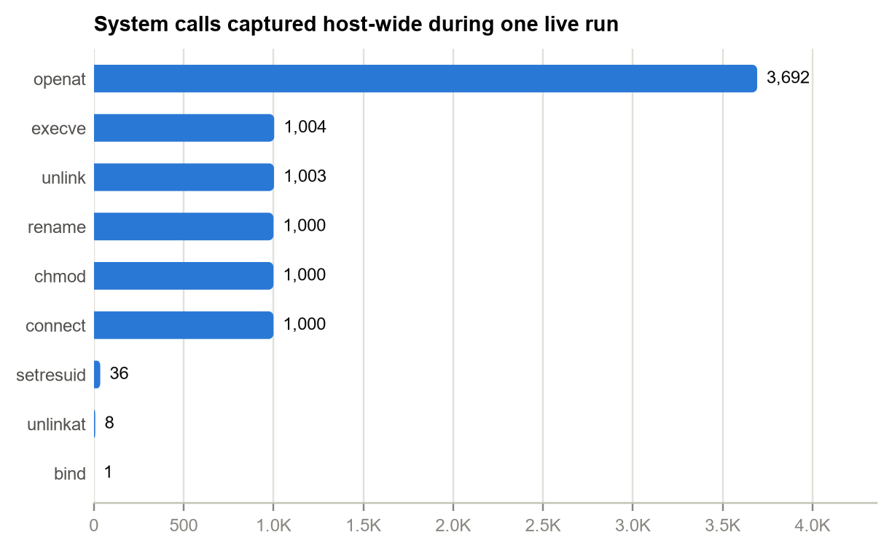
Figure 9. System calls captured host-wide during one live run (the workload plus all other host activity).
Every workload operation reached the signed ledger in every run, and the perf buffer reported a small number of lost host events in some runs, none of them belonging to the workload. The slowdown with full B-SCAF capture is no larger than with tracing alone (the difference is within run-to-run variation on this short workload), so the cost comes from attaching tracepoints to hot system calls such as openat. The user-space work of hashing, signing and replicating runs on another core and used about 1.3 CPU-seconds per run. Commit delay is bounded by the 1-second block interval.

7.4 Attack Tests
Attack | Local | With witnesses | Detected by
untampered copy | pass | pass | -
change one committed event's system call | fail | fail | local
remove one committed event | fail | fail | local
insert a forged, correctly hashed event | fail | fail | local
swap two adjacent committed events | fail | fail | local
replace a stored batch Merkle root | fail | fail | local
append a copy of an old signed checkpoint | fail | fail | local
delete the newest block and its events | pass | fail | witness
edit history and re-sign every block with the stolen source key | pass | fail | witness
alter a stored witness acknowledgement | pass | fail | witness
one witness unreachable; quorum still met | pass | pass | -
witnesses unreachable below quorum | pass | partial | -

Table 4. Attack matrix on the real-data ledger (identical outcomes on the live ledger).
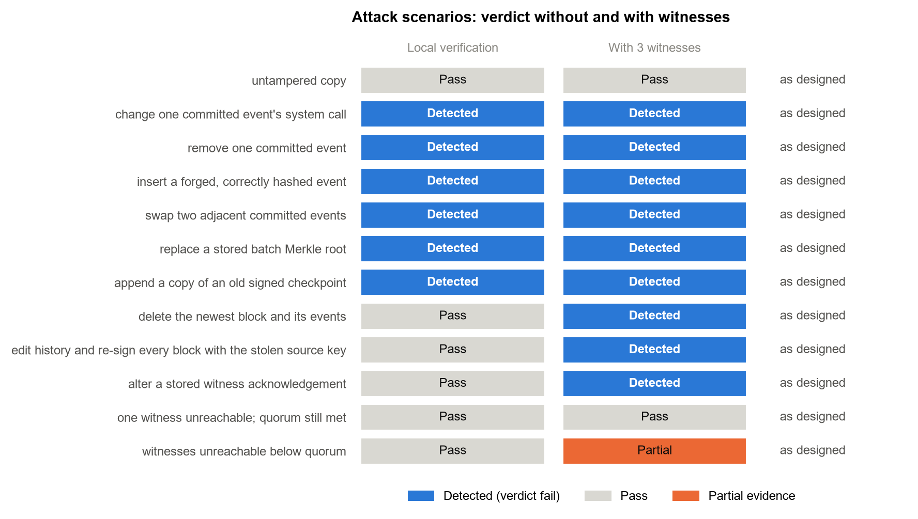
Figure 10. Attack scenarios: verdict with local verification only and with three witnesses.
Edits, deletions, insertions, reordering, Merkle-root changes and replayed blocks are caught by local verification. Deleting the newest block and re-signing a rewritten history with the stolen key leave a locally consistent ledger, and only comparison with the witnesses exposes them; the witnesses also refused the rewritten blocks when they were offered. A forged acknowledgement fails its witness signature, and losing the witness quorum yields partial evidence rather than a false pass.

7.5 Replay Benchmark
100,000 events from the dataset were replayed through plain JSON logging, a hash chain alone and B-SCAF, each configuration in its own process.
Configuration | Events/s | Latency p50/p95 (µs) | Commit delay p50 (ms) | Bytes/event | Full verify (s)
plain log | 54,413 | 15 / 31 | - | 332 | -
hash chain only | 20,200 | 41 / 86 | - | 518 | 2.35
B-SCAF N=10 | 13,054 | 34 / 348 | 0.5 | 586 | 4.62
B-SCAF N=100 | 18,516 | 31 / 66 | 3.3 | 524 | 2.82
B-SCAF N=1000 | 19,684 | 31 / 63 | 31.9 | 518 | 2.56
B-SCAF T=0.05s | 16,865 | 33 / 75 | 1.9 | 531 | 2.93
plain log + fsync/100 | 16,182 | 17 / 49 | - | 332 | -
B-SCAF N=100 + fsync | 7,161 | 34 / 83 | 11.3 | 524 | 2.71

Table 5. Throughput, latency, storage and verification on replayed events.
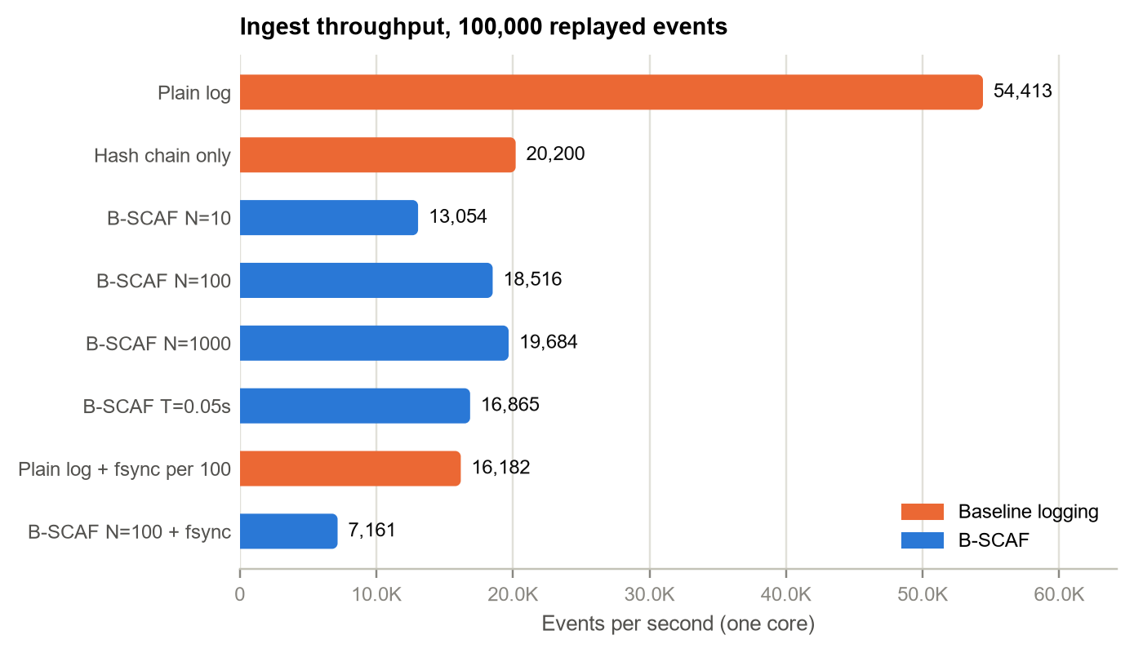
Figure 11. Ingest throughput per configuration on one core.
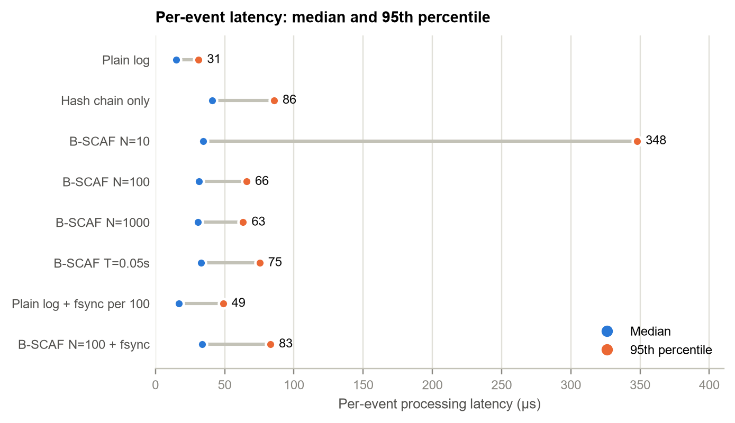
Figure 12. Per-event processing latency: median and 95th percentile.
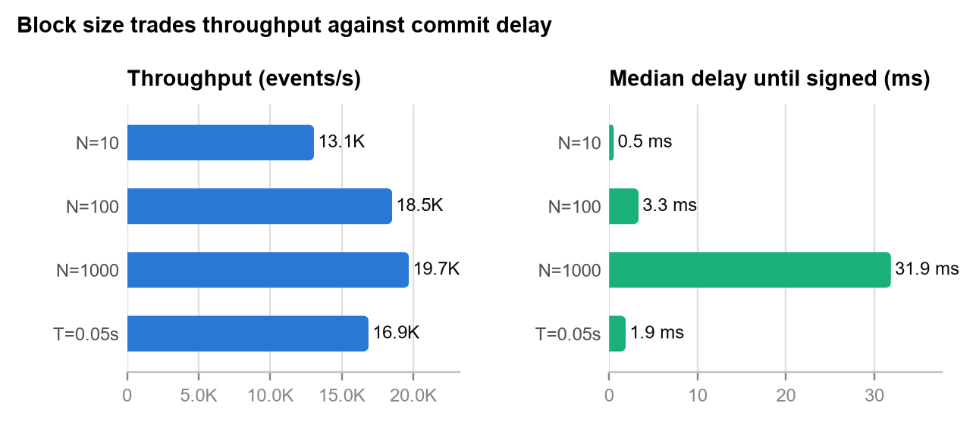
Figure 13. Effect of block size on throughput and on the delay until an event is signed.
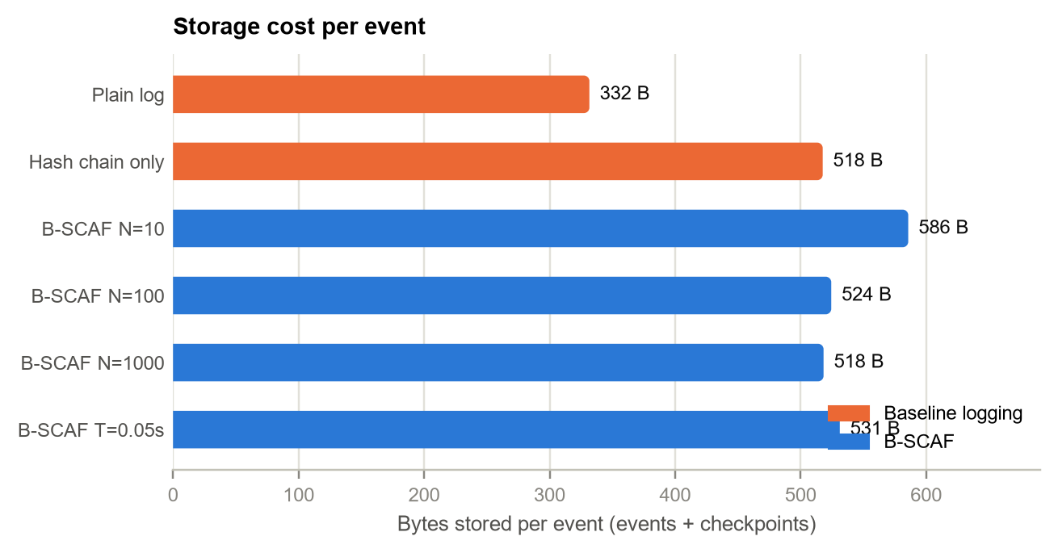
Figure 14. Storage cost per event.
With 100-event blocks B-SCAF sustained 18,516 events/s on one core, verified 100,000 events in 2.8 s, verified a single proof in 0.4 ms and replicated its blocks to three witnesses in 5.1 s. Durable commits (fsync per block) reduce throughput, which matters on filesystems with slow flushes such as the WSL2 virtual disk.

8. Achievement of Objectives
Objective | Status | Evidence
1. Capture system calls with context | Achieved | eBPF live capture with full workload coverage; auditd adapter on 100 real logs
2. Immutable lightweight evidence chain | Achieved | Hash chain, Merkle batches (N, T, host), Ed25519 blocks, policy version
3. Independent verification and report | Achieved | Local and witness verification; pass/fail/partial; offline proofs
4. Practical evaluation | Achieved | Live overhead and completeness; replay throughput, latency, storage, verify time
Phase 4: 3-5 permissioned witnesses | Achieved | Quorum replication, signed acks, equivocation refusal, mTLS
Phase 5: attack tests | Achieved | 12/12 scenarios as designed

9. Limitations and Future Work
- Capture trust: a compromised kernel or collector can fabricate or drop events before capture; remote attestation or TPM-measured boot would reduce this.
- Key custody: signing keys can be passphrase-encrypted but are still files; a TPM or HSM would prevent key theft, which today is detected only through the witnesses.
- Unprotected window: events are protected once their block is signed and replicated, after at most one block interval (1 s in the live runs).
- Scale: verification holds one hash per event in memory and proof export scans the event file; an indexed store and archival are needed for very large ledgers.
- Environment: live results come from WSL2, where Docker Desktop containers cannot control auditd; an auditd-based live run and bare-metal timings remain to be done.
- Datasets: the public auditd sample is small and mostly exports one record type per file; larger multi-host captures would further test record correlation.

10. Conclusion
B-SCAF shows that system-call evidence can be made tamper-evident and independently verifiable with modest overhead and without a public blockchain. Live eBPF capture recorded every operation of a repeatable workload into a signed ledger, recorded attack data from a public dataset was ingested and verified end to end, and every tampering scenario in the brief, plus truncation and re-signing with a stolen key, was detected. The remaining limits concern trust at capture time and key custody, which are hardware and platform questions rather than gaps in the evidence chain.

Appendix A. Reproducing the Results
From the repository root on any machine with Docker:
docker build -t bscaf .
docker run --rm -v "$PWD":/app bscaf pytest -q
docker run --rm -v "$PWD":/app -w /app bscaf python scripts/run_real_data.py
docker build -t bscaf-live -f deploy/live/Dockerfile deploy/live
docker run --rm --privileged --pid=host -v "$PWD":/app -w /app bscaf-live python scripts/live_capture.py
The scripts write results/REAL_DATA_REPORT.md and results/LIVE_REPORT.md with the tables used in this report.

References
1. Ali, A., Khan, A., Ahmed, M., and Jeon, G. (2021/2022). “BCALS: Blockchain-based secure log management system for cloud computing.” Transactions on Emerging Telecommunications Technologies, 33, e4272. https://doi.org/10.1002/ett.4272
2. Ahmad, A., Saad, M., Al Ghamdi, M., Nyang, D. H., and Mohaisen, D. (2022). “BlockTrail: A Service for Secure and Transparent Blockchain-Driven Audit Trails.” IEEE Systems Journal, 16(1), 1367–1378. https://doi.org/10.1109/JSYST.2021.3097744
3. Li, W., Feng, Y., Liu, N., Li, Y., Fu, X., and Yu, Y. (2024). “A secure and efficient log storage and query framework based on blockchain.” Computer Networks, 247, 110683. https://doi.org/10.1016/j.comnet.2024.110683
4. Regueiro, C., Seco, I., Gutiérrez-Agüero, I., and Lanza-Gutiérrez, J. M. (2021). “A Blockchain-Based Audit Trail Mechanism: Design and Implementation.” Algorithms, 14(12), 341. https://doi.org/10.3390/a14120341
5. López-Pimentel, J. C., Morales-Rosales, L. A., Monroy, R., and Ramírez-Quintana, M. J. (2021). “RootLogChain: Registering Log-Events in a Blockchain for Audit Issues from the Creation of the Root.” Sensors, 21(22), 7669. https://doi.org/10.3390/s21227669
6. Aslan, U., and Şen, B. (2021). “GDPR Compliant Audit Log Management System with Blockchain.” 2021 International Conference on Computer Science and Engineering. https://doi.org/10.1109/UYMS54260.2021.9659700
7. Pawar, A., Barthare, D., Rawat, N., and others (2021). “BlockAudit 2.0: PoA blockchain based solution for secure Audit logs.” 2021 5th International Conference on Information Systems and Computer Networks. https://doi.org/10.1109/ISCON52037.2021.9702378
8. Austin, T. H., and Di Troia, F. (2022). “A Blockchain-Based Tamper-Resistant Logging Framework.” In Silicon Valley Cybersecurity Conference 2022, CCIS 1683, 90–104. https://doi.org/10.1007/978-3-031-24049-2_6
9. Guardiola-Múzquiz, G., and Soriano-Salvador, E. (2023). “SealFSv2: combining storage-based and ratcheting for tamper-evident logging.” International Journal of Information Security, 22, 447–466. https://doi.org/10.1007/s10207-022-00643-1
10. Liu, Z., Zhang, X., Li, G., and others (2024). “A Secure and Reliable Blockchain-based Audit Log System.” IEEE ICC 2024. https://doi.org/10.1109/ICC51166.2024.10623012
11. Nagpal, A., Parthi, A. G., Palanigounder, M., and others (2025). “LogProof: Ensuring Integrity and Immutability of Audit Logs Using Blockchain.” IEEE iSES 2025, 350–353. https://doi.org/10.1109/iSES67504.2025.00073
12. Pattengale, N. D., and Hudson, C. (2020). “Decentralized genomics audit logging via permissioned blockchain ledgering.” BMC Medical Genomics, 13(Suppl 7). https://doi.org/10.1186/s12920-020-0720-3
13. Ma, S., Cao, Y., Xiong, L., and others (2020). “Efficient logging and querying for blockchain-based cross-site genomic dataset access audit.” BMC Medical Genomics, 13(Suppl 7). https://doi.org/10.1186/s12920-020-0725-y
14. Adlam, R., and Haskins, B. (2020). “A permissioned blockchain approach to electronic health record audit logs.” Proceedings of the ACM Symposium on Access Control Models and Technologies. https://doi.org/10.1145/3415088.3415118
15. Zhao, W., Aldyaflah, I. M., Gangwani, P., Joshi, S., Upadhyay, H., and Lagos, L. (2023). “A Blockchain-Facilitated Secure Sensing Data Processing and Logging System.” IEEE Access, 11, 21712–21728. https://doi.org/10.1109/ACCESS.2023.3252030
16. Zhao, W., Yang, S., and Luo, X. (2020). “Secure Hierarchical Processing and Logging of Sensing Data and IoT Events with Blockchain.” ACM International Conference on Computing, Networking and Communications. https://doi.org/10.1145/3390566.3391672
17. Byrnes, J. M., Hoang, T. K., Mehta, N. N., and others (2020). “A Modern Implementation of System Call Sequence Based Host-based Intrusion Detection Systems.” IEEE TPS-ISA 2020. https://doi.org/10.1109/TPS-ISA50397.2020.00037
18. Zhang, Y., Luo, S., Pan, L., and others (2021). “Syscall-BSEM: Behavioral semantics enhancement method of system call sequence for high accurate and robust host intrusion detection.” Future Generation Computer Systems, 124, 27–40. https://doi.org/10.1016/j.future.2021.06.030
19. Chaudhari, A. R., Gohil, B. N., Rao, U. P., and others (2023). “A novel hybrid framework for Cloud Intrusion Detection System using system call sequence analysis.” Cluster Computing. https://doi.org/10.1007/s10586-023-04162-z
20. Wan, B., He, Y., Liu, X., and others (2023). “Host Intrusion Detection Method Based on Short Sequence of System Call.” IEEE DSA 2023. https://doi.org/10.1109/DSA59317.2023.00045
21. Vyšniūnas, T., Čeponis, D., Goranin, N., and others (2024). “Risk-Based System-Call Sequence Grouping Method for Malware Intrusion Detection.” Electronics, 13(1), 206. https://doi.org/10.3390/electronics13010206
22. Zipperle, M., Gottwalt, F., Chang, E., and Dillon, T. (2022). “Provenance-based Intrusion Detection Systems: A Survey.” ACM Computing Surveys, 55(1). https://doi.org/10.1145/3539605
23. Alsaedi, A., Moustafa, N., Tari, Z., and others (2020). “TON_IoT Telemetry Dataset: A New Generation Dataset of IoT and IIoT for Data-Driven Intrusion Detection Systems.” IEEE Access, 8, 165130–165150. https://doi.org/10.1109/ACCESS.2020.3022862
24. Lánský, J., Ali, S., Mohammadi, M., and others (2021). “Deep Learning-Based Intrusion Detection Systems: A Systematic Review.” IEEE Access, 9, 100671–100692. https://doi.org/10.1109/ACCESS.2021.3097247
25. Khraisat, A., Alazab, A., and others (2021). “A critical review of intrusion detection systems in the internet of things.” Cybersecurity, 4, 28. https://doi.org/10.1186/s42400-021-00077-7
26. Ahmad, Z., Khan, A. S., Shiang, C. W., Abdullah, J., and Ahmad, F. (2021). “Network intrusion detection system: A systematic study of machine learning and deep learning approaches.” Transactions on Emerging Telecommunications Technologies, 32, e4150. https://doi.org/10.1002/ett.4150
27. Ozkan-Okay, M., Samet, R., Aslan, Ö., and Mat, K. (2021). “A Comprehensive Systematic Literature Review on Intrusion Detection Systems.” IEEE Access, 9, 157727–157760. https://doi.org/10.1109/ACCESS.2021.3129336
28. Bodkhe, U., Tanwar, S., Parekh, K., and others (2020). “Blockchain for Industry 4.0: A Comprehensive Review.” IEEE Access, 8, 79764–79800. https://doi.org/10.1109/ACCESS.2020.2988579
29. Bhutta, M. N. M., Khwaja, A. A., Nadeem, A., and others (2021). “A Survey on Blockchain Technology: Evolution, Architecture and Security.” IEEE Access, 9, 61048–61073. https://doi.org/10.1109/ACCESS.2021.3072849
30. Khan, S., Loukil, F., Ghédira, C., and others (2021). “Blockchain smart contracts: Applications, challenges, and future trends.” Peer-to-Peer Networking and Applications, 14, 2901–2925. https://doi.org/10.1007/s12083-021-01127-0
31. Fernández-Caramés, T. M., and Fraga-Lamas, P. (2020). “Towards Post-Quantum Blockchain: A Review on Blockchain Cryptography Resistant to Quantum Computing Attacks.” IEEE Access, 8, 21091–21116. https://doi.org/10.1109/ACCESS.2020.2968985
32. Hafid, A., Hafid, A. S., and Samih, M. (2020). “Scaling Blockchains: A Comprehensive Survey.” IEEE Access, 8, 125329–125360. https://doi.org/10.1109/ACCESS.2020.3007251
33. Yu, G., Wang, X., Yu, K., and others (2020). “Survey: Sharding in Blockchains.” IEEE Access, 8, 14155–14181. https://doi.org/10.1109/ACCESS.2020.2965147
34. Hewa, T., Ylianttila, M., and Liyanage, M. (2021). “Survey on blockchain based smart contracts: Applications, opportunities and challenges.” Journal of Network and Computer Applications, 177, 102857. https://doi.org/10.1016/j.jnca.2020.102857
35. Lin, S., Zhang, L., Li, J., and others (2022). “A survey of application research based on blockchain smart contract.” Wireless Networks, 28, 635–690. https://doi.org/10.1007/s11276-021-02874-x
36. Belchior, R., Vasconcelos, A., Correia, M., and others (2022). “Hermes: Fault-tolerant middleware for blockchain interoperability.” Future Generation Computer Systems, 127, 331–346. https://doi.org/10.1016/j.future.2021.11.004
37. Kuo, T.-T., Jiang, X., Tang, H., and others (2020). “iDASH secure genome analysis competition 2018: blockchain genomic data access logging, homomorphic encryption on GWAS, and DNA segment searching.” BMC Medical Genomics, 13, 104. https://doi.org/10.1186/s12920-020-0715-0
38. Chukwu, E., and Garg, L. (2020). “A Systematic Review of Blockchain in Healthcare: Frameworks, Prototypes, and Implementations.” IEEE Access, 8, 21196–21214. https://doi.org/10.1109/ACCESS.2020.2969881
39. Zhuang, Y., Sheets, L., Chen, Y.-W., Shae, Z.-Y., Tsai, J. J. P., and Shyu, C.-R. (2020). “A Patient-Centric Health Information Exchange Framework Using Blockchain Technology.” IEEE Journal of Biomedical and Health Informatics, 24(8), 2169–2176. https://doi.org/10.1109/JBHI.2020.2993072
40. Secinaro, S., Dal Mas, F., Brescia, V., and Calandra, D. (2022). “Blockchain in the accounting, auditing and accountability fields: a bibliometric and coding analysis.” Accounting, Auditing & Accountability Journal, 35(9), 2186–2212. https://doi.org/10.1108/AAAJ-10-2020-4987

