CSCE 735
HW 1: Parallel Programming on a Multicore Multiprocessor

Name: Medha Venkata Subrahmanya Aditya Vellampalli
UIN: 237006700

Part 1. Shared-Memory Programming with Threads:
- Execute the code for n=10^8 with p chosen to be 2k, for k = 0, 1, …, 13. Using the experimental data obtained from these experiments, answer the following questions.
  - For plots, use a logarithmic scale for the x-axis. 1.1. (10 points) Plot execution time versus p to demonstrate how time varies with the number of threads.
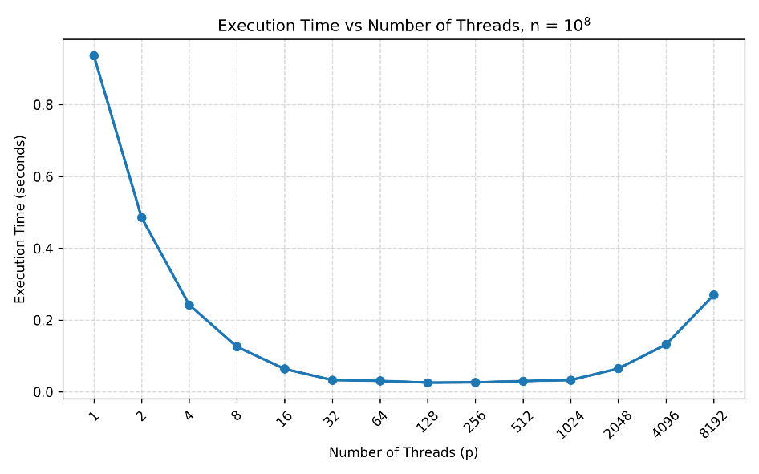
  - (10 points) Plot speedup versus p to demonstrate the change in speedup with p.
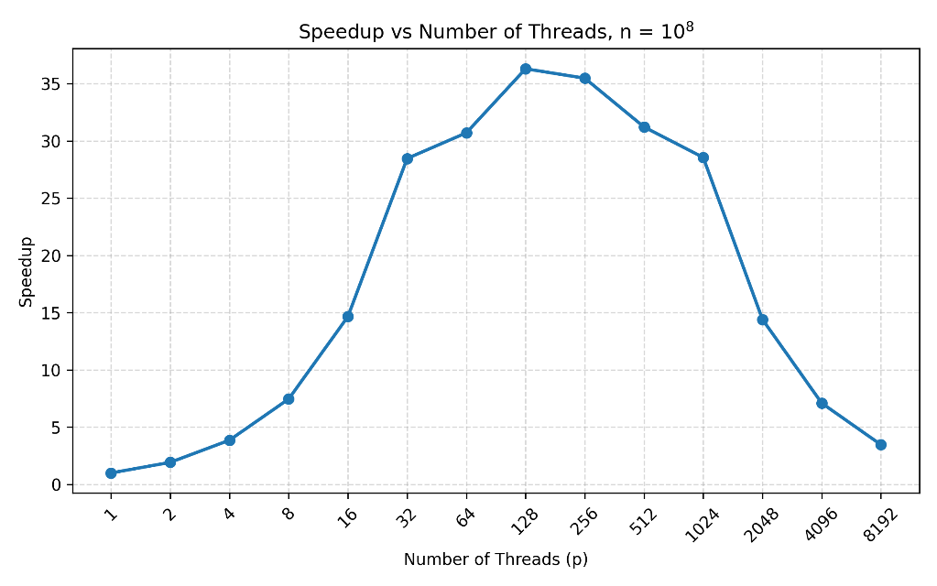

  - (5 points) Using the definition: efficiency = speedup/p, plot efficiency versus p to demonstrate how efficiency changes as the number of threads are increased.
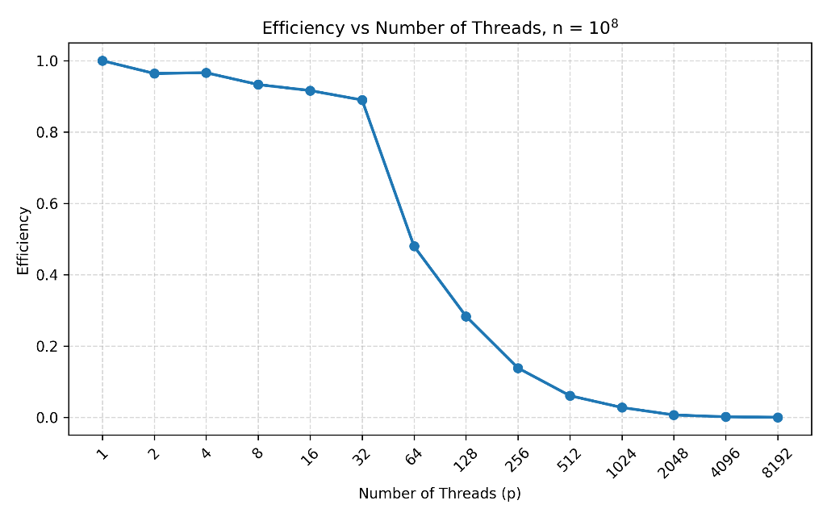
  - (5 points) In your experiments, what value of p minimizes the parallel runtime?
- For n=10^8, the minimum measured parallel runtime was 0.0258 s using p=128 threads.
- Repeat the experiments with n=10^10 to obtain the execution time for p=2k, for k = 0, 1, …, 13.
  - (5 points) In this case, what value of p minimizes the parallel runtime?
- For n=10^10, the minimum measured runtime was 2.2166s at p = 512 threads.
  - (5 points) Do you expect the runtime to increase as p is increased beyond a certain value? If so, why? And is this observed in your experiments.
- Yes. The runtime is expected to increase after the number of threads exceeds a certain value.
- According to Amdahl’s Law, adding more threads gives smaller performance gains because the serial part of the program cannot be parallelized. After a certain point, thread and synchronization overhead can outweigh the benefit.
- For n=10^10, the minimum runtime of 2.2166 s occurs at 512 threads. The runtime then increases to 2.2232 s at 1024 threads, 2.2277 s at 2048 threads, 2.2622 s at 4096 threads, and 2.3616 s at 8192 threads.
- (5 points) Do you expect that there would be a difference in the number of threads needed to obtain the minimum execution time for two values of n? Is this observed in your experiments.
- Yes. A larger problem can benefit from more threads because there is more computation to divide before parallel overhead becomes significant.
- This is observed in the experiments. For n=10^8, the minimum runtime occurred at 128 threads, while for n=10^10, it occurred at 512 threads. So, the larger problem required more threads to achieve the minimum execution time.
- (5 points) Plot error versus n to illustrate accuracy of the algorithm as a function of n. You may have to run experiments with different values of n; for example n could be chosen to be 10k, for k = 3, …, 9. Use p = 48.
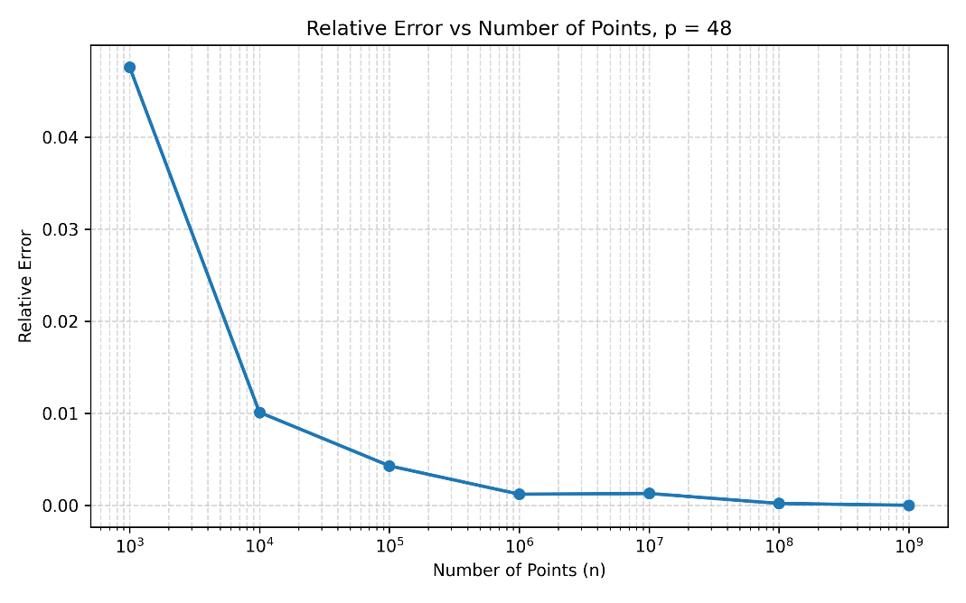
Part 2. Distributed-Memory Programming with MPI:
- Execute the code for n=10^8 with p chosen to be 2k, for k = 0, 1, …, 6. Specify ntasks-per node=4 in the job file. Using the experimental data obtained from these experiments, answer the following questions. For plots, use a logarithmic scale for the x-axis.
  - (10 points) Plot execution time versus p to demonstrate how time varies with the number of processes.
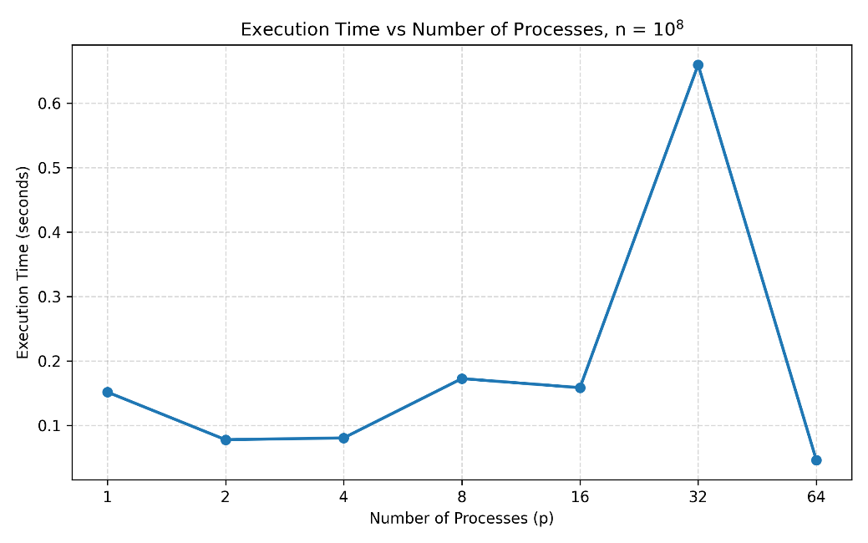

  - (10 points) Plot speedup versus p to demonstrate the change in speedup with p.
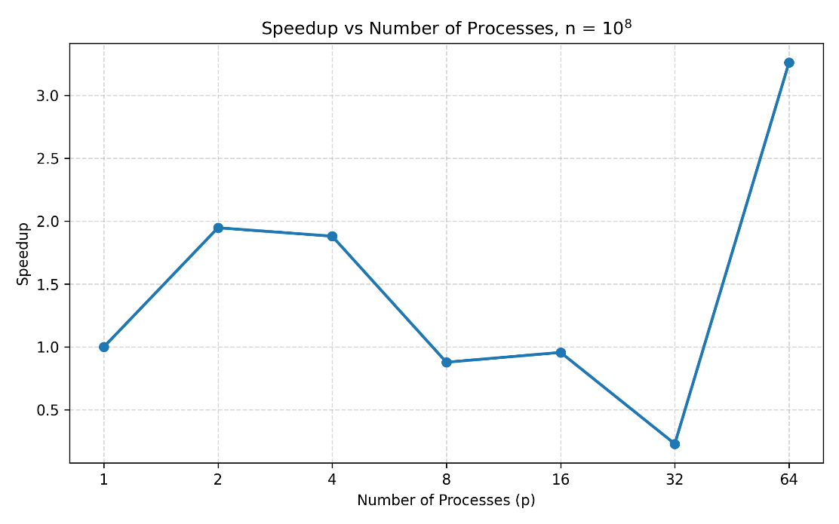

  - (5 points) Using the definition: efficiency = speedup/p, plot efficiency versus p to demonstrate how efficiency changes as the number of processes is increased.
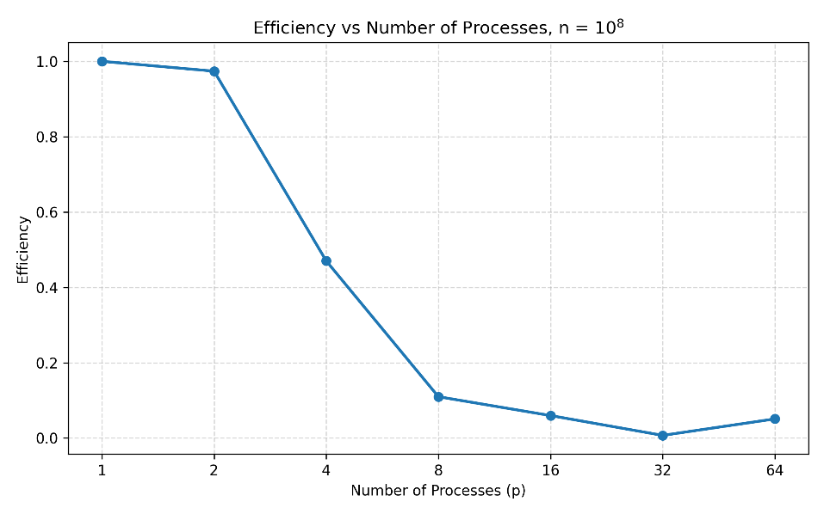

  - (5 points) What value of p minimizes the parallel runtime?
- The minimum measured parallel runtime was 0.04658476 s using p=64 processes.

- (10 points) With n=10^10 and p=64, determine the value of ntasks-per-node that
minimizes the total_time. Plot time versus ntasks-per-node to illustrate your
experimental results for this question.
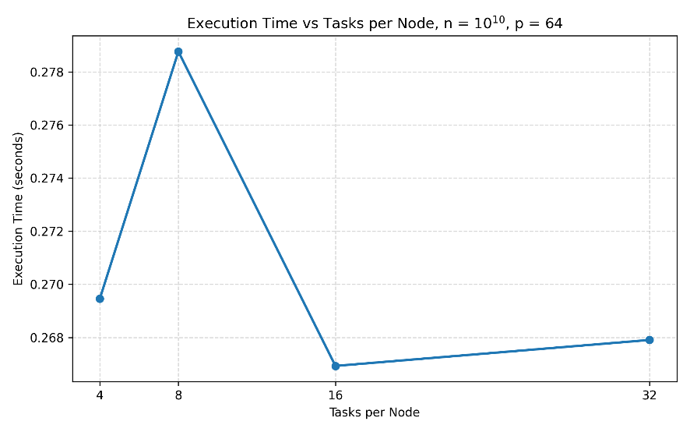
The minimum measured total time was 0.26692614 s with ntasks-per-node = 16. Therefore, among the tested configurations, ntasks-per-node = 16 minimizes the execution time.
- Execute the code with p=64 for n=10^2, 10^4, 10^6 and 10^8, with ntasks-per-node=4.
  - (5 points) Plot the speedup observed as a function of n on p=64 w.r.t. p=1. You will need to obtain execution time on p=1 for n=10^2, 10^4, 10^6 and 10^8.
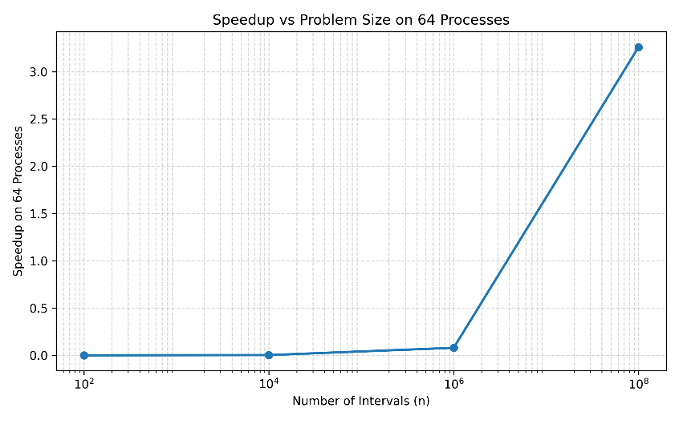

  - (5 points) Plot the relative error versus n to illustrate the accuracy of the algorithm as a function of n.
