Q. 1 Write a program to generate the n unique random numbers by two different algorithms.
Ist Using Fisher Yates Algorithm:

Algorithm: UniqueRandom(n)
Input: Count of number to output.
Output: List of N random unique number.
Assumption: K > N

Initialize MAX = K
Set A = List of Number from 0 to MAX
IF N<=MAX THEN
FOR i=0 to N DO
index = Random(0,MAX-1)
print A_{index}
Swap(A_{index} , A_{(MAX-1)})
MAX = MAX – 1
END LOOP
END IF
END

Note:
Random() : Generates Psudo Random Number in between given Range.
Swap(): Swap given Elements value
Algorithm Analysis:

T(n) = KxC₁ + nxC₂ + C₃
Where,
K = Value of max Random Number (Constant)
n = Output number list count
Simplifying ..
T(n) = O(n) for K>=n

Input/Output:
K=1000000 , input is n = number of element to print
At, CPU: Dual Core 3Ghz, Memory: 4GB
Input | Output | Time (in Sec)
1 | 1 | 0.129
10 | 10 | 0.128
100 | 100 | 0.124
1000 | 1000 | 0.131
5000 | 5000 | 0.156
10000 | 10000 | 0.188
50000 | 50000 | 0.460
100000 | 100000 | 0.784
500000 | 500000 | 3.439
1000000 | 1000000 | 6.656
Complexity Graph:
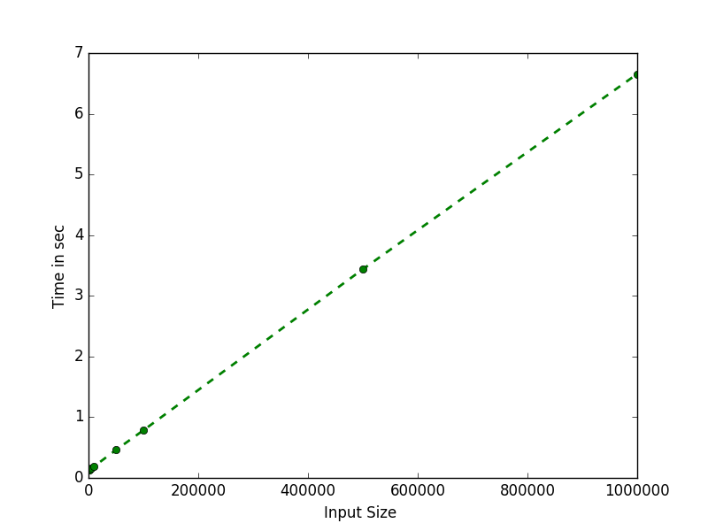
Conclusion:
As it can be seen from graph initially time only depends upon k(MAX) value but as the n increases it linearly depends on n.

2nd Using Linear Congruential:

Algorithm: UniqueRandom(n)
Input: Count of number to output.
Output: List of N random unique number.
Assumption: L >= N , and
1. M ,C are coprime
2. L-1 divisible by all factors of M
3. L-1 is divisible by 4 if M is divisible by 4

Set X = 1, L = K₁ , C = K₂ , M = K₃
// where K₁ , K₂ and K₃ are Constant as per Assumption.
FOR i = 0 to N DO
X = X ((L*X)+C) mod M
print X
END LOOP
END

Algorithm Analysis:
T(n) = nxC₁ + C₃
Where, n = Output number list count

Simplifying ..
T(n) = O(n) for n<=L
Input/Output:
Input is n = number of element to print
At, CPU: Dual Core 3Ghz, Memory: 4GB

Input | Output | Time (in Sec)
1 | 1 | 0.0
10 | 10 | 0.0
100 | 100 | 0.001
1000 | 1000 | 0.007
5000 | 5000 | 0.034
10000 | 10000 | 0.048
50000 | 50000 | 0.258
100000 | 100000 | 0.551
500000 | 500000 | 2.985
1000000 | 1000000 | 6.002

Complexity Graph:
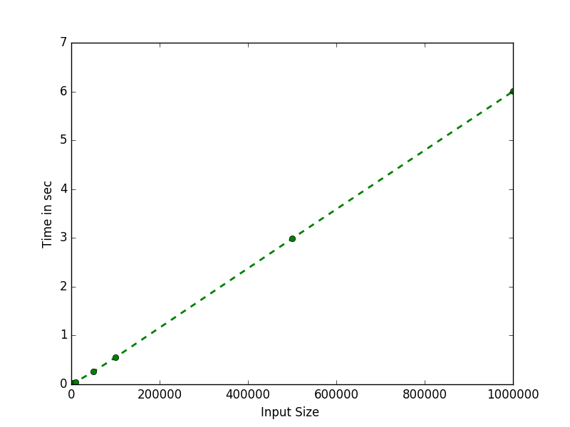
Conclusion:
In comparision to last graph it can be seen initially to end it only depend on value of n, and hence it linearly grow w.r.t n.
Q. 2 There is an array A of integers of size n which cannot directly be accessed. However, you can get true or false response to queries of the form A[i] < A[j]. It is given that A has only one duplicate pair, and rest all the elements are distinct. So it has n-1 distinct elements and 1 element which is same as one of the n-1 elements. Your task is to identify the indices of the two identical elements in A.

Algorithm: DuplicatePair(A)
Input: A as List of N-1 unique number with one duplicate number
Output: Index of Duplicate Pair

SET flag = 0
FOR i=0 to N DO
IF flag != 1 THEN
FOR j=i+1 to N DO
IF !(Compare(A_{i} , A_{j}) || Compare(A_{j} , A_{i})) THEN
Print i and j as index
set flag = 1
BREAK LOOP
ELSE
BREAK LOOP
END IF
END LOOP
END

Note:
Compare(A_{i} , A_{j}) : This Function return Boolean value of A_{i} > A_{j}

Algorithm Analysis:

T(n) = C1 + C2x(n+1) + C3x[ (1x(n-1)) + (2x(n-2)) + (3x(n-3)) + ...
.....+((n-1)x(1))]

reducing constants and writing for all iterations .......for worst case

Where,
n = number of total input

Simplifying ..

T(n) = O(n²) for worst case
= O(1) for best case

Input/Output: (for worst case i.e. no duplicate pair, without printing time)
input is n = Number of element as in Input List
At, CPU: Dual Core 3Ghz, Memory: 4GB

Input | Output (Number) | Time (in Sec)
1 | 1 | 0.0
10 | 1 | 0.0
500 | 1 | 0.033
100 | 1 | 0.002
1000 | 1 | 0.132
2500 | 1 | 0.81
5000 | 1 | 3.295
5500 | 1 | 3.924
7000 | 1 | 6.306
8000 | 1 | 8.281

Complexity Graph:
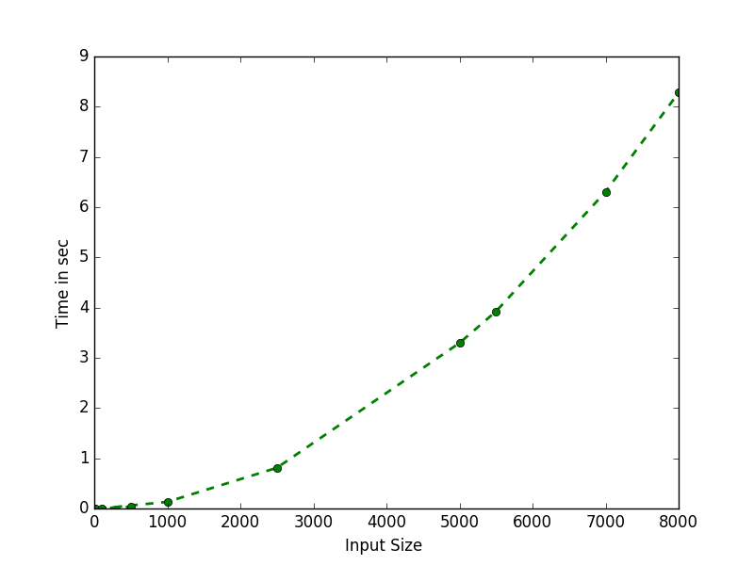
Conclusion:
The curve now grows non-linearly wrt to input value, this is because of polynomial nature of time complexity.
Q. 3 Write a function customSort takes a "num" array of integers as an input along with the array of "weights" which contains the weights of the corresponding integers. We wish to sort this vector "num" from the indices start to end based on the fact that numbers with higher weights appear first and in case the weights are equal, we put the greater number first in the list. We also wish efficient algorithms. We expect an O (n*log(n)) algorithm here instead of a O(n^2) one.

Algorithm: CustomSort(A)
Input: A, B as 2 List of N values of number and their weights.
Output: Sorted array.

Note:
Using merge sort as basic sort technique to sort for nlogn complexity, passing a 2d array as parameter and comparing only first element of there weight and then if equal swap element on basis of bigger element of

Algorithm Analysis:

T(n) = C1 + C2x(n+1) + C3x[ (1x(n-1)) + (2x(n-2)) + (3x(n-3)) + ...
.....+((n-1)x(1))]

reducing constants and writing for all iterations .......for worst case

Where,
n = number of total input

Simplifying ..

T(n) = O(n²) for worst case
= O(1) for best case

Input/Output: (for worst case i.e. no duplicate pair)
input is n = Number of element as in Input List
At, CPU: Dual Core 3Ghz, Memory: 4GB

Input | Output (Number) | Time (in Sec)
1 | 1 | 0.0
10 | 10 | 0.000004
100 | 100 | 0.000027
1000 | 1000 | 0.000223
5000 | 5000 | 0.001283
10000 | 10000 | 0.002801
50000 | 50000 | 0.015544
100000 | 100000 | 0.032946
250000 | 250000 | 0.087610

Complexity Graph:
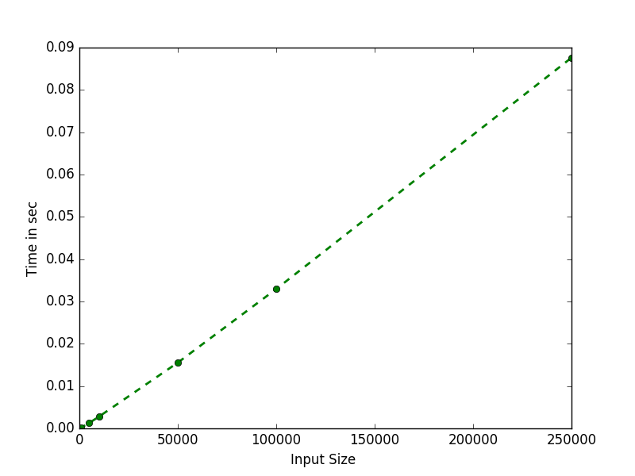
Conclusion:
The curve now grows non-linearly wrt to input value, this is because of polynomial nature of time complexity.

Q. 4 Write a program to find the value of x^{n}, where ‘x’ and ‘n’ are the real numbers using 3 different algorithms.

Algorithm: CustomSort(A)
Input: A, B for A^B
Output: Output Result as A^B

Note:
Using merge sort as basic sort technique to sort for nlogn complexity, passing a 2d array as parameter and comparing only first element of there weight and then if equal swap element on basis of bigger element of

Algorithm Analysis:

T(n) =

reducing constants and writing for all iterations .......for worst case

Where,
n = number of total input

Simplifying ..

T(n) = O(n²) for worst case
= O(1) for best case

Input/Output: (for worst case i.e. no duplicate pair)
input is n = Number of element as in Input List
At, CPU: Dual Core 3Ghz, Memory: 4GB

Input | Output (Number) | Time (in Sec)
1 | 1 | 0.0
10 | 10 | 0.000004
100 | 100 | 0.000027
1000 | 1000 | 0.000223
5000 | 5000 | 0.001283
10000 | 10000 | 0.002801
50000 | 50000 | 0.015544
100000 | 100000 | 0.032946
250000 | 250000 | 0.087610

Complexity Graph:
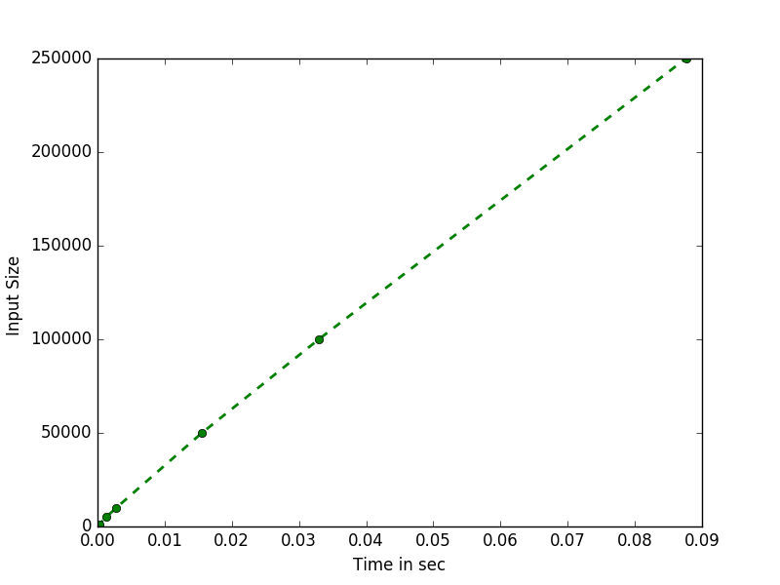
Conclusion:
The curve now grows non-linearly wrt to input value, this is because of polynomial nature of time complexity.

Q. 5 Write a program to find the factorial of the given number
(0 < n < 10,000,000,000).

Algorithm: CustomSort(A)
Input: N
Output: Factorial of N

Note:

Algorithm Analysis:

T(n) =

reducing constants and writing for all iterations .......for worst case

Where,
n = number of total input

Simplifying ..

T(n) = O(n) for worst case
= O(1) for best case

Input/Output: (for worst case i.e. no duplicate pair)
input is n = Number of element as in Input List
At, CPU: Dual Core 3Ghz, Memory: 4GB

Input | Output (Number) | Time (in Sec)
1 | 1 | 0.0
10 | Fact(10) | 0.0
100 | Fact(100) | 0.004
500 | Fact(500) | 0.053
1000 | Fact(1000) | 0.22
2500 | Fact(2500) | 1.543
5000 | Fact(5000) | 6.601
7500 | Fact(7500) | 17.217
10000 | Fact(10000) | 28.401

Complexity Graph:
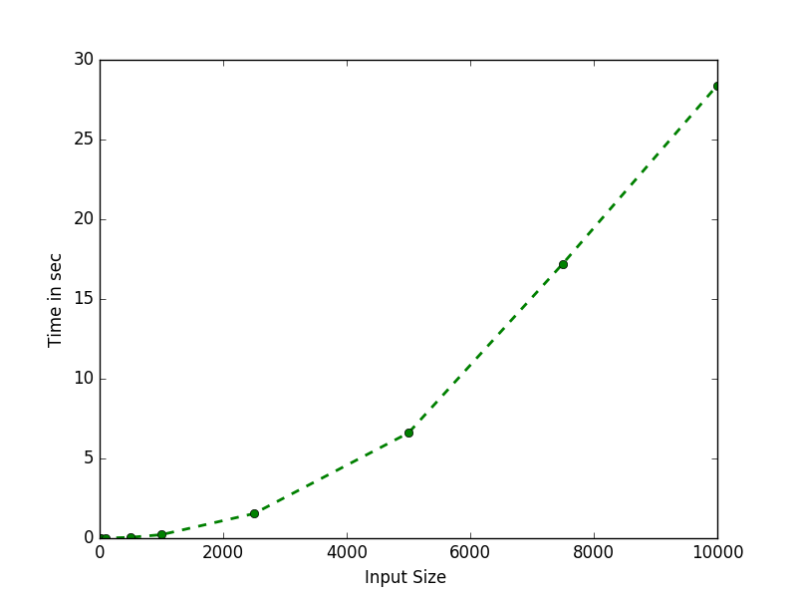
Conclusion:
The curve now grows non-linearly wrt to input value, this is because of polynomial nature of time complexity.

Q. 6 Write a program to find the nth Fibonacci number with two different approach and compare their time complexity.

Algorithm: Fibonacci(A)
Input: N
Output: Nth Fibonacci term
Assumption: Fibonacci(0)=1 and Fibonacci(1)=1

1. Method: Recursive

IF n < 2 THEN
RETURN n
ELSE
RETURN Fibonacci(n-1) + Fibonacci(n-2)
END IF
END

2. Method: Iterative

SET nextVal = 1, old = 0, temp = 0
FOR i =0 to N DO
IF i<2 THEN
SET old=1
SET nextVal=1
ELSE
SET temp = old
SET old = nextVal
SET nextVal = temp + nextVal
END IF
END LOOP
RETURN nextVal
END

Algorithm Analysis:

T(n) = C₁xT(n-1) + C₂xT(n-2) + C₃
..For Recursive
T(n) = C₁ + C₂x(n+1) + nx(C₃)
..For Iterative
Where,
n = nth number to find fibonacci term

Simplifying ..

T(n) = O(2^{n}) for Recursive
T(n) = O(n) for Iterative

Input/Output: (Recursive)
input is n = nth number to find fibonacci term
At, CPU: Dual Core 3Ghz, Memory: 4GB

Input | Output (Number) | Time (in Sec)
1 | 1 | 0.0
5 | 5 | 0.0
10 | 55 | 0.0
15 | 610 | 0.0
20 | 6765 | 0.04
25 | 75025 | 0.028
30 | 832040 | 0.243
35 | 9227465 | 2.638
37 | 24157817 | 6.922
38 | 39088169 | 11.327

Complexity Graph: (Recursive)
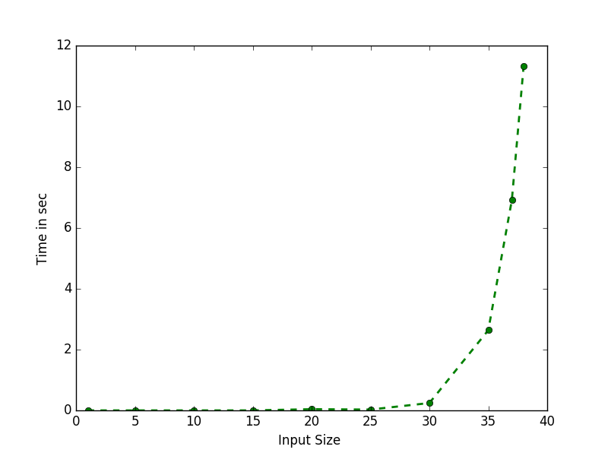
Conclusion:
The curve as expected grows exponetially as the input size increases.

Input/Output: (Iterative)
input is n = nth number to find fibonacci term
At, CPU: Dual Core 3Ghz, Memory: 4GB

Input | Output (Number) | Time (in Sec)
1 | 1 | 0.0
10 | 55 | 0.0
100 | Fibo(100) | 0.0
1000 | Fibo(1000) | 0.0
5000 | Fibo(5000) | 0.002
10000 | Fibo(10000) | 0.006
50000 | Fibo(50000) | 0.046
100000 | Fibo(100000) | 0.168
250000 | Fibo(250000) | 0.938
1000000 | Fibo(1000000) | 14.266

Complexity Graph: (Recursive)
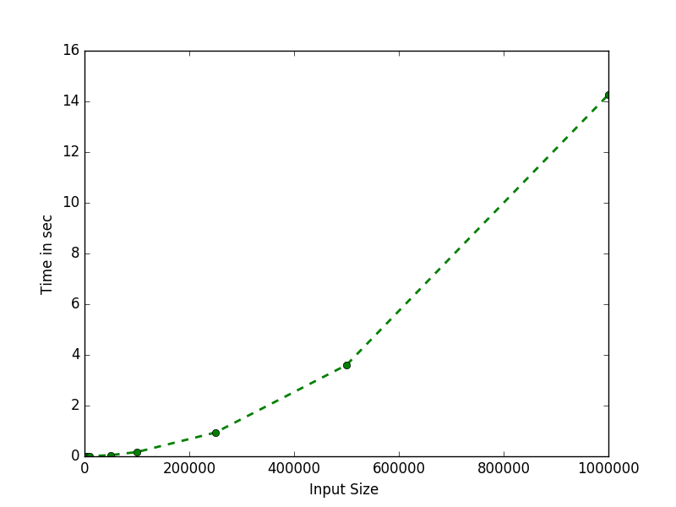
Conclusion:
The curve now grows non-linearly wrt to input value, this is because of polynomial nature of time complexity.
Q. 7 An array of integers is said to be a straight-K, if it contains K elements that are K consecutive numbers. For example, the array {6, 1, 9, 5, 7, 15, 8} is a straight because it contains 5, 6, 7, 8, and 9 for K=5. Write a program to finds the maximum value of K for the given number of integers.

Algorithm: StraightK(A)
Input: A as list of N numbers
Output: K-number for Array as per defination

Algorithm Analysis:

T(n) =

Where,
n = nth number to find fibonacci term

Simplifying ..

T(n) = O(n) for Iterative

Input/Output: (Recursive)
input is n = nth number to find fibonacci term
At, CPU: Dual Core 3Ghz, Memory: 4GB

Input | Output (Number) | Time (in Sec)
1 | 1 | 0.0
10 | 1 | 0.0
100 | 1 | 0.0
1000 | 1 | 0.001
10000 | 1 | 0.007
50000 | 1 | 0.037
100000 | 1 | 0.078
200000 | 1 | 0.175

Complexity Graph: (Recursive)
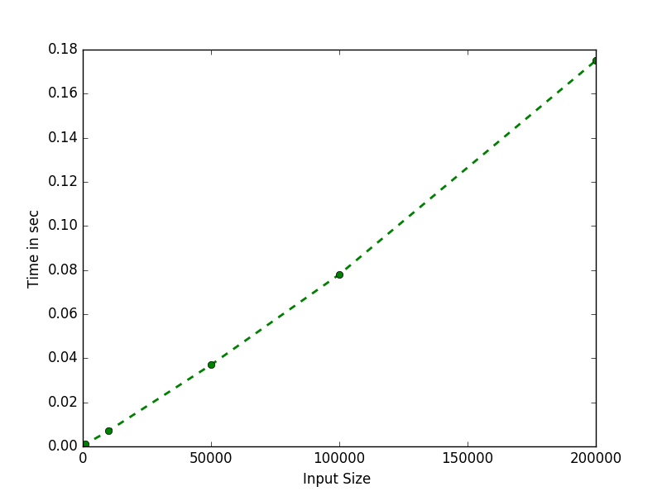
Conclusion:
The curve now grows non-linearly wrt to input value, this is because of polynomial nature of time complexity.

Q. 8 You have an array like :-{ 5,5,5,13,6,13,6,7,8,7,-1) Write and analyze an algorithm to arrange this array in sorted form based upon the number of occurrence e.g.: above should look like this after execution of your also
{5,5,5,13,13,6,6,7,7,8,-1} 13 comes before 6 because it has same number of occurrence as 6 but it come first in the parent array.

Algorithm: FrequencCount(A)
Input: A as list of N numbers
Output: Sorted List as per frequency of occurence

Algorithm Analysis:

T(n) =

Where,
n = nth number to find fibonacci term

Simplifying ..

T(n) = O(n) for Iterative

Input/Output: (Recursive)
input is n = nth number to find fibonacci term
At, CPU: Dual Core 3Ghz, Memory: 4GB

Input | Output (Number) | Time (in Sec)
1 | 1 | 0.0
10 | 1 | 0.0
100 | 1 | 0.001
1000 | 1 | 0.008
5000 | 1 | 0.059
10000 | 1 | 5.892
25000 | 1 | 43.345
50000 | 1 | 134.389

Complexity Graph: (Recursive)
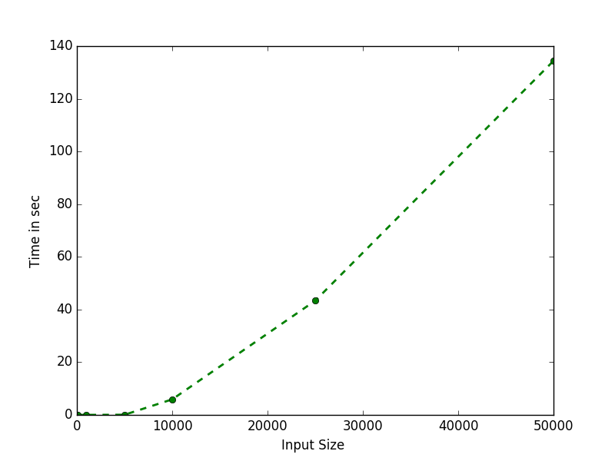
Conclusion:
The curve now grows non-linearly wrt to input value, this is because of polynomial nature of time complexity.

