Q. 1 BubbleSort()

Algorithm analysis:
T(n) = O(n²) for worst case
= O(n²) for average case
= O(n) for best case

Input/Output:
Input is n = Number of element as in Input List
At, CPU: Dual Core 3Ghz, Memory: 4GB

1. For Random list

Input | Time (in Sec)
10 | 0.0
100 | 0.000094
500 | 0.001323
1000 | 0.005551
5000 | 0.100289
10000 | 0.392785
50000 | 9.724364
100000 | 38.8822881

2. For Sorted list

Input | Time (in Sec)
10 | 0.000001
100 | 0.000002
500 | 0.000003
1000 | 0.000010
5000 | 0.000026
10000 | 0.000087
50000 | 0.000424
100000 | 0.000714

3. For Reverse Sorted list

Input | Time (in Sec)
10 | 0.000003
100 | 0.000098
500 | 0.002307
1000 | 0.006709
5000 | 0.103236
10000 | 0.395791
50000 | 9.950184
100000 | 39.867644

Complexity Graph:
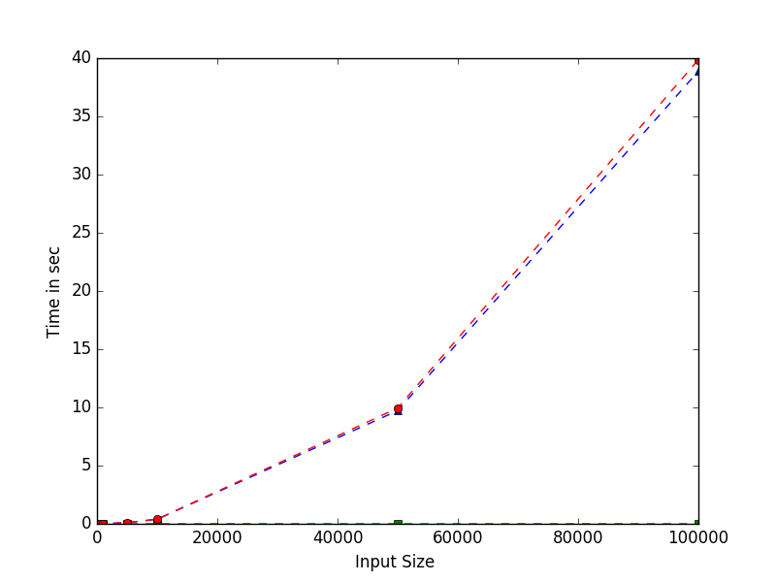

Conclusion :
For Bubble sort it can be seen that Worst case : when list is reverse sorted, Best case : if list is sorted. In average case ( Random list ) it also take order of polynomial time for sorting.

Q. 2 SelectionSort()

Algorithm analysis:
T(n) = O(n²) for worst case
= O(n²) for average case
= O(n²) for best case

Input/Output:
Input is n = Number of element as in Input List
At, CPU: Dual Core 3Ghz, Memory: 4GB

1. For Random list

Input | Time (in Sec)
10 | 0.000002
100 | 0.000028
500 | 0.000667
1000 | 0.001752
5000 | 0.045682
10000 | 0.170458
50000 | 4.169171
100000 | 16.657978

2. For Sorted list

Input | Time (in Sec)
10 | 0.000001
100 | 0.000034
500 | 0.000521
1000 | 0.003108
5000 | 0.045903
10000 | 0.169726
50000 | 4.167574
100000 | 16.662882

3. For Reverse Sorted list

Input | Time (in Sec)
10 | 0.000002
100 | 0.000037
500 | 0.001110
1000 | 0.003384
5000 | 0.048474
10000 | 0.177946
50000 | 4.386236
100000 | 17.514223

Complexity Graph:
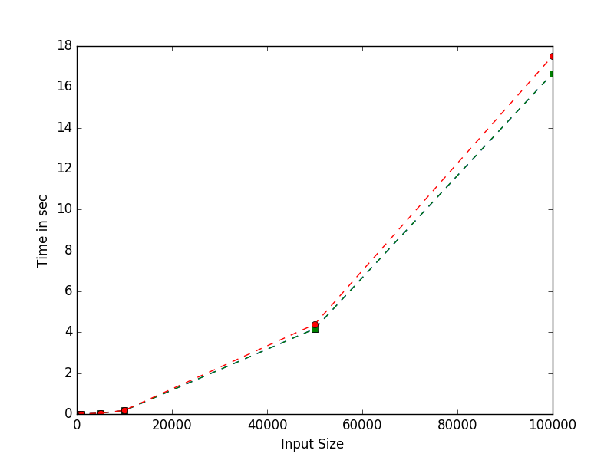

Conclusion :
For Selection sort Worst case, Best case, Average Case List does not matter as it does compare through out the list and hence for all the three cases are order of n² , It can also verified from the graph.

Q. 3 InsertionSort()

Algorithm analysis:
T(n) = O(n²) for worst case
= O(n²) for average case
= O(n) for best case

Input/Output:
Input is n = Number of element as in Input List
At, CPU: Dual Core 3Ghz, Memory: 4GB

1. For Random list

Input | Time (in Sec)
10 | 0.000002
100 | 0.000052
500 | 0.000899
1000 | 0.002850
5000 | 0.032414
10000 | 0.112271
50000 | 2.800497
100000 | 11.202344

2. For Sorted list

Input | Time (in Sec)
10 | 0.000001
100 | 0.000003
500 | 0.000008
1000 | 0.000007
5000 | 0.000051
10000 | 0.000170
50000 | 0.000628
100000 | 0.001261

3. For Reverse Sorted list

Input | Time (in Sec)
10 | 0.000002
100 | 0.000059
500 | 0.000547
1000 | 0.003310
5000 | 0.058911
10000 | 0.224601
50000 | 5.591818
100000 | 22.295033

Complexity Graph:
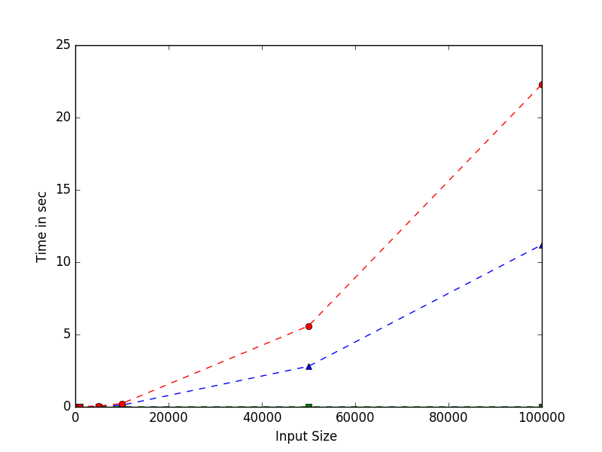

Conclusion :
For Insertion sort Best case list is sorted list as it run in linear time,
Worst case list is reverse sorted list as it took polynomial n² order of time.
Average Case List is random list in which time is less than n² but it is not linear it is some what faster average than other First 2 algorithms.

Q. 4 MergeSort()

Algorithm analysis:
T(n) = O(nLog(n)) for worst, average, best case

Input/Output:
Input is n = Number of element as in Input List
At, CPU: Dual Core 3Ghz, Memory: 4GB

1. For Random list

Input | Time (in Sec)
10 | 0.000004
100 | 0.000032
500 | 0.000176
1000 | 0.000499
5000 | 0.002137
10000 | 0.002991
50000 | 0.014617
100000 | 0.030948

2. For Sorted list

Input | Time (in Sec)
10 | 0.000004
100 | 0.000034
500 | 0.000187
1000 | 0.000394
5000 | 0.002189
10000 | 0.004448
50000 | 0.014344
100000 | 0.024302

3. For Reverse Sorted list

Input | Time (in Sec)
10 | 0.000004
100 | 0.000034
500 | 0.000133
1000 | 0.000282
5000 | 0.002134
10000 | 0.003722
50000 | 0.012336
100000 | 0.025375

Complexity Graph:
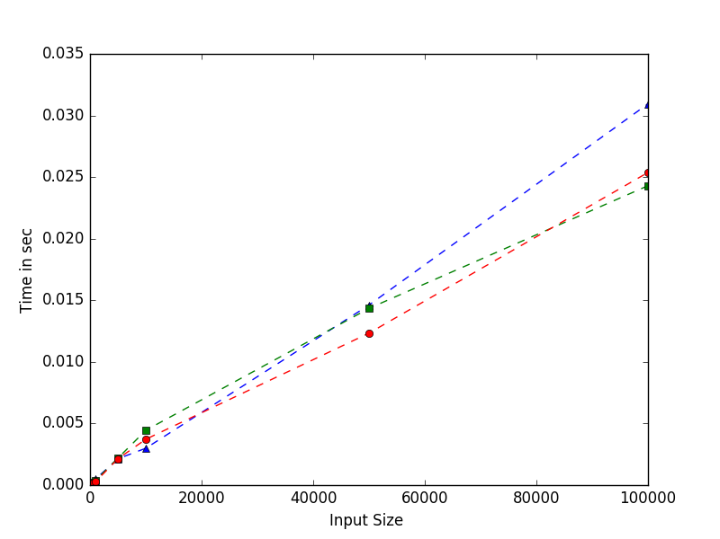

Conclusion :
For Merge sort Best case list, Worst case list, Average Case List It does not matter list is in which order it always run on nlogn time, It can also be verified on graph.

Q. 5 QuickSort()

Algorithm analysis:
T(n) = O(nLog(n)) for average
= O(n²) for worst case
= O(n) for best case

Input/Output:
Input is n = Number of element as in Input List
At, CPU: Dual Core 3Ghz, Memory: 4GB

1. For Random list

Input | Time (in Sec)
10 | 0.000003
100 | 0.000016
500 | 0.000121
1000 | 0.000254
5000 | 0.001135
10000 | 0.003234
50000 | 0.010411
100000 | 0.015513

2. For Sorted list

Input | Time (in Sec)
10 | 0.000002
100 | 0.000011
500 | 0.000037
1000 | 0.000086
5000 | 0.000463
10000 | 0.000728
50000 | 0.003420
100000 | 0.007297

3. For Reverse Sorted list

Input | Time (in Sec)
10 | 0.000003
100 | 0.000010
500 | 0.000025
1000 | 0.000086
5000 | 0.000374
10000 | 0.001033
50000 | 0.003799
100000 | 0.008473

Complexity Graph:
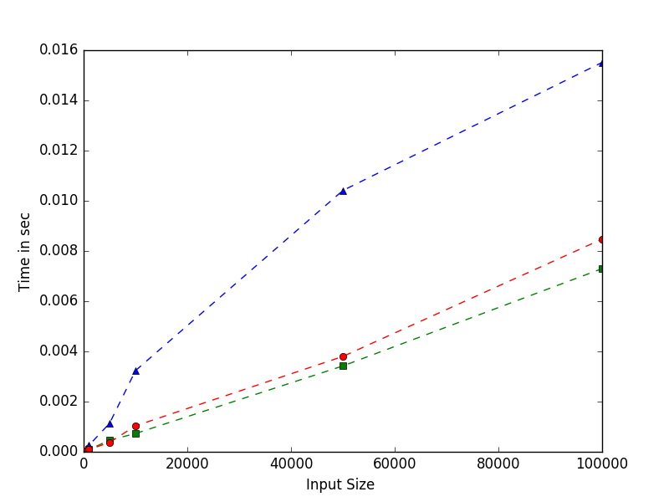

Conclusion :
For Quick sort the best case is that for which after each function call list devided into two equal half. And worst case if it devide in 1 vs n-1 list size.
As in curve for random list graph is nlogn and for both sorted and reverse sorted list it is of linear type this is because in both the case list is devided into two equal part due to sorted list as input.

Q. 6 CountingSort()

Algorithm analysis:
T(n) = O(n + k) where k is max size of elements to be in list

Input/Output:
Input is n = Number of element as in Input List
At, CPU: Dual Core 3Ghz, Memory: 4GB

1. For Random list

Input | Time (in Sec)
10 | 0.000004
100 | 0.000026
500 | 0.000112
1000 | 0.000337
5000 | 0.001455
10000 | 0.001887
50000 | 0.008609
100000 | 0.017021

2. For Sorted list

Input | Time (in Sec)
10 | 0.000005
100 | 0.000025
500 | 0.000149
1000 | 0.000180
5000 | 0.001119
10000 | 0.002208
50000 | 0.007797
100000 | 0.014461

3. For Reverse Sorted list

Input | Time (in Sec)
10 | 0.000003
100 | 0.000026
500 | 0.000113
1000 | 0.000319
5000 | 0.001119
10000 | 0.001689
50000 | 0.007746
100000 | 0.016479

Complexity Graph:
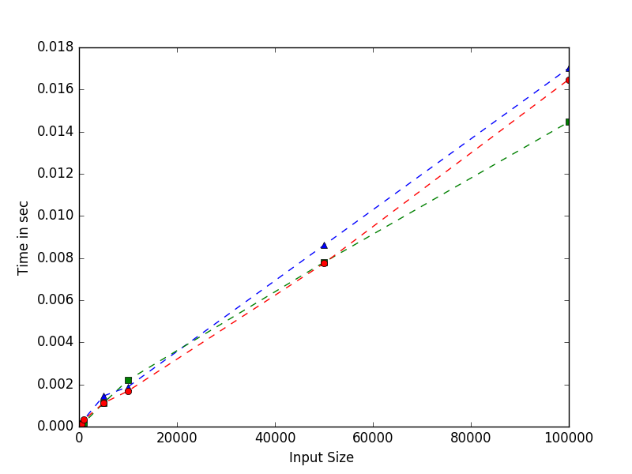

Conclusion :
For counting sort as expected it can also be verified that the graph is linear, since it depends more on the size of count list used to sort the element, and hence for all three list it does not depend upon list order for Best Worst or Average case.

Q. 7 HeapSort()
Algorithm analysis:
T(n) = O(nlogn) for every case

Input/Output: Input is n = Number of element as in Input List
At, CPU: Dual Core 3Ghz, Memory: 4GB

1. For Random list

Input | Time (in Sec)
10 | 0.000002
100 | 0.000026
500 | 0.000215
1000 | 0.000189
5000 | 0.002932
10000 | 0.004771
50000 | 0.017548
100000 | 0.035945

2. For Sorted list

Input | Time (in Sec)
10 | 0.000004
100 | 0.000017
500 | 0.000105
1000 | 0.000460
5000 | 0.002793
10000 | 0.004613
50000 | 0.019744
100000 | 0.036496

3. For Reverse Sorted list

Input | Time (in Sec)
10 | 0.000003
100 | 0.000030
500 | 0.000111
1000 | 0.000307
5000 | 0.002597
10000 | 0.004264
50000 | 0.017881
100000 | 0.029594

Complexity Graph:

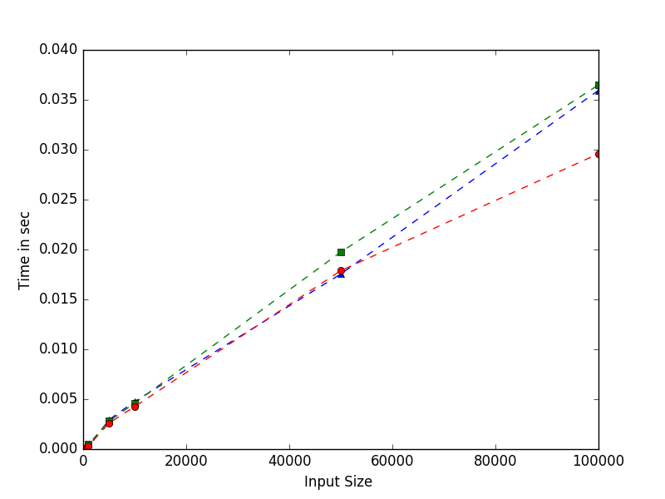
Conclusion :
In Heap sort all three complexity are nlogn, it can also be verified from graph hence there is no perticular best, worst list for it.

Q. 8 RadixSort()

Algorithm analysis:
T(n) = O(nw) where w is word size of size of digits in max num

Input/Output:
Input is n = Number of element as in Input List
At, CPU: Dual Core 3Ghz, Memory: 4GB

1. For Random list

Input | Time (in Sec)
10 | 0.000006
100 | 0.000020
500 | 0.000092
1000 | 0.000311
5000 | 0.000773
10000 | 0.003906
50000 | 0.012594
100000 | 0.019010

2. For Sorted list

Input | Time (in Sec)
10 | 0.000003
100 | 0.000014
500 | 0.000118
1000 | 0.000175
5000 | 0.001570
10000 | 0.002047
50000 | 0.011025
100000 | 0.019851

3. For Reverse Sorted list

Input | Time (in Sec)
10 | 0.000004
100 | 0.000028
500 | 0.000125
1000 | 0.000233
5000 | 0.001167
10000 | 0.002316
50000 | 0.011080
100000 | 0.020677

Complexity Graph:

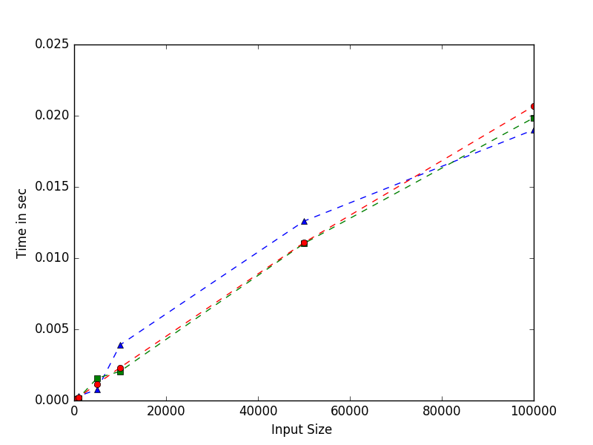
Conclusion :
In Heap sort all three complexity are nlogn, it can also be verified from graph hence there is no perticular best, worst list for it.

