PYTHON

DEEP LEARNING

ICP – 5

Authored By

Nikhitha Kolluri – 12

**Lesson Overview:**

In this lesson, we are going to discuss types of ANNs and Recurrent Neural Network.

**Use Case Description:**

1. Sentiment Analysis on the Twitter data set

**Programming elements:**

1. Basics of LSTM

2. Types of RNN

3. Use case: Sentiment Analysis on the Twitter data set

**In class programming:**

1. Save the model and use the saved model to predict on new text data (ex, “A lot of good things are happening. We are respected again throughout the world, and that's a great [thing.@realDonaldTrump](mailto:thing.@realDonaldTrump)”)

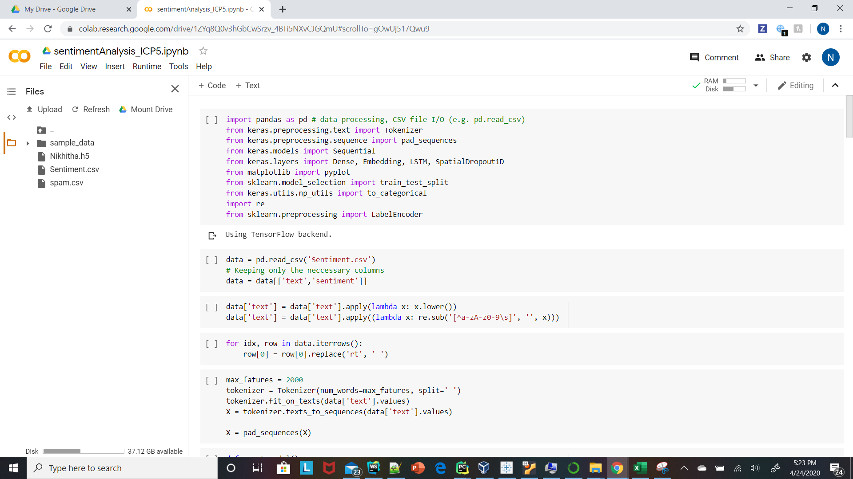

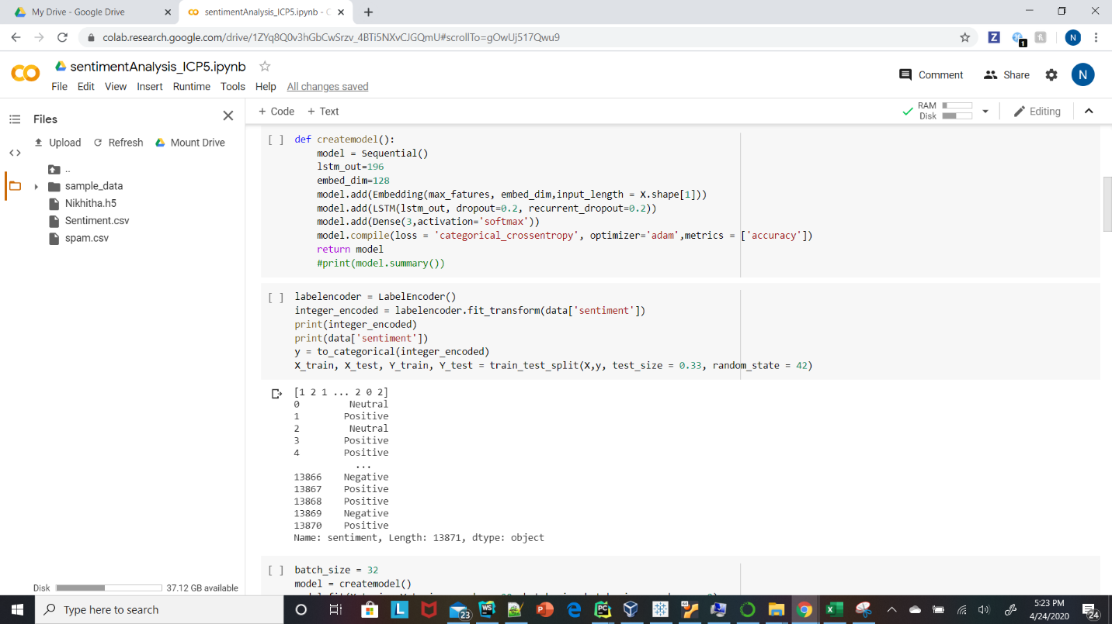

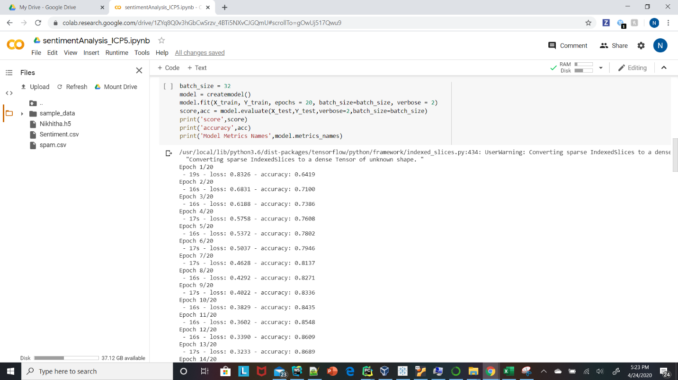

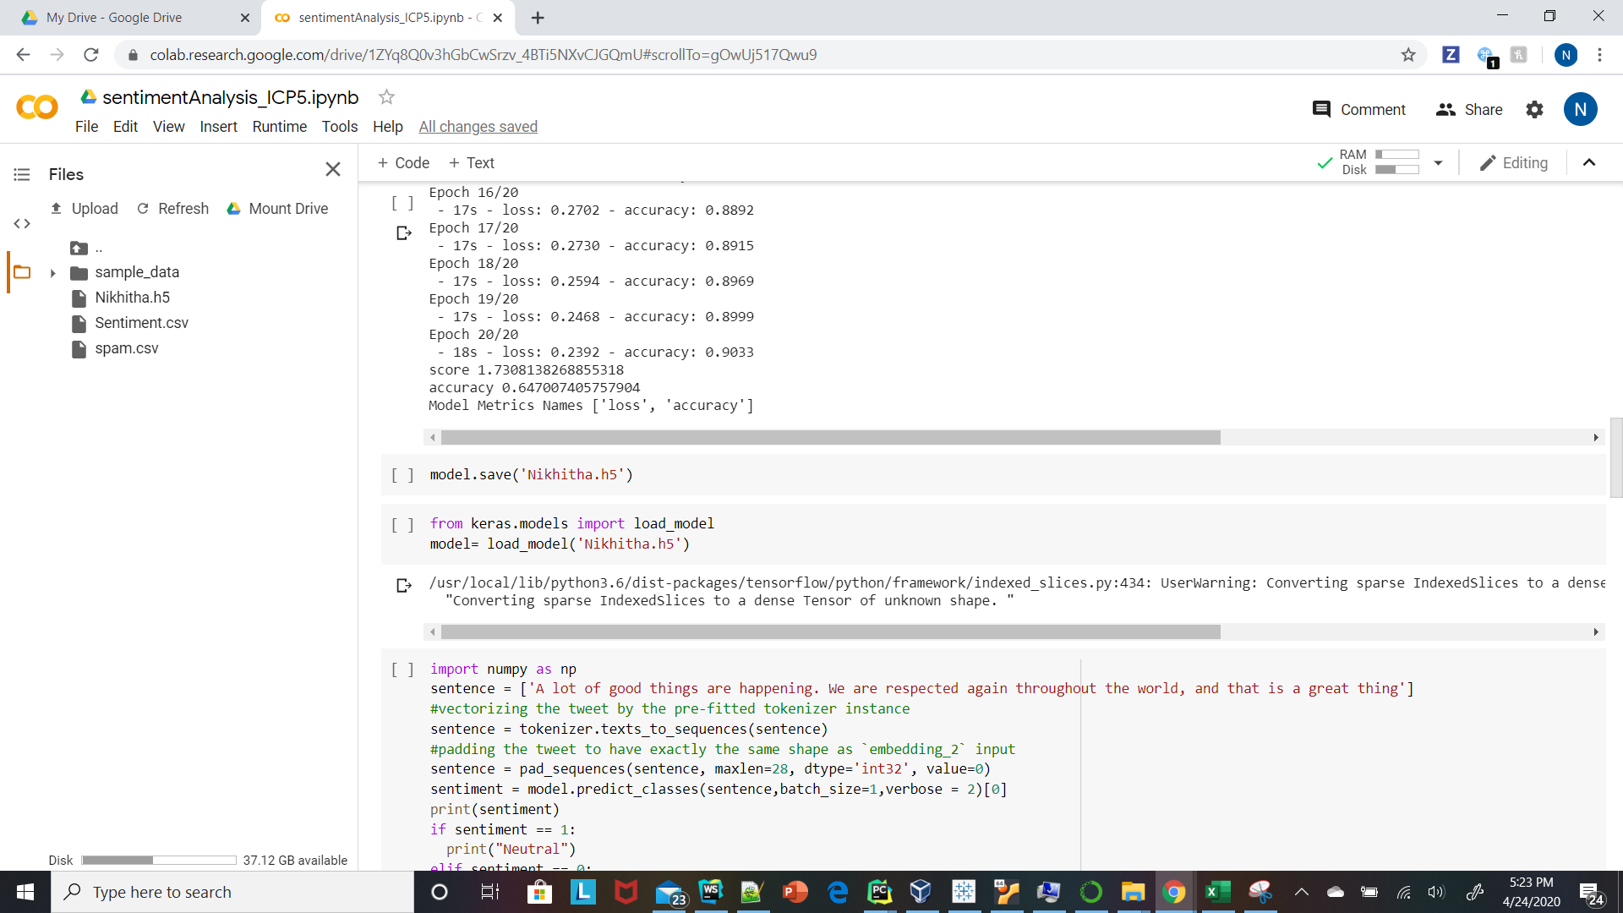

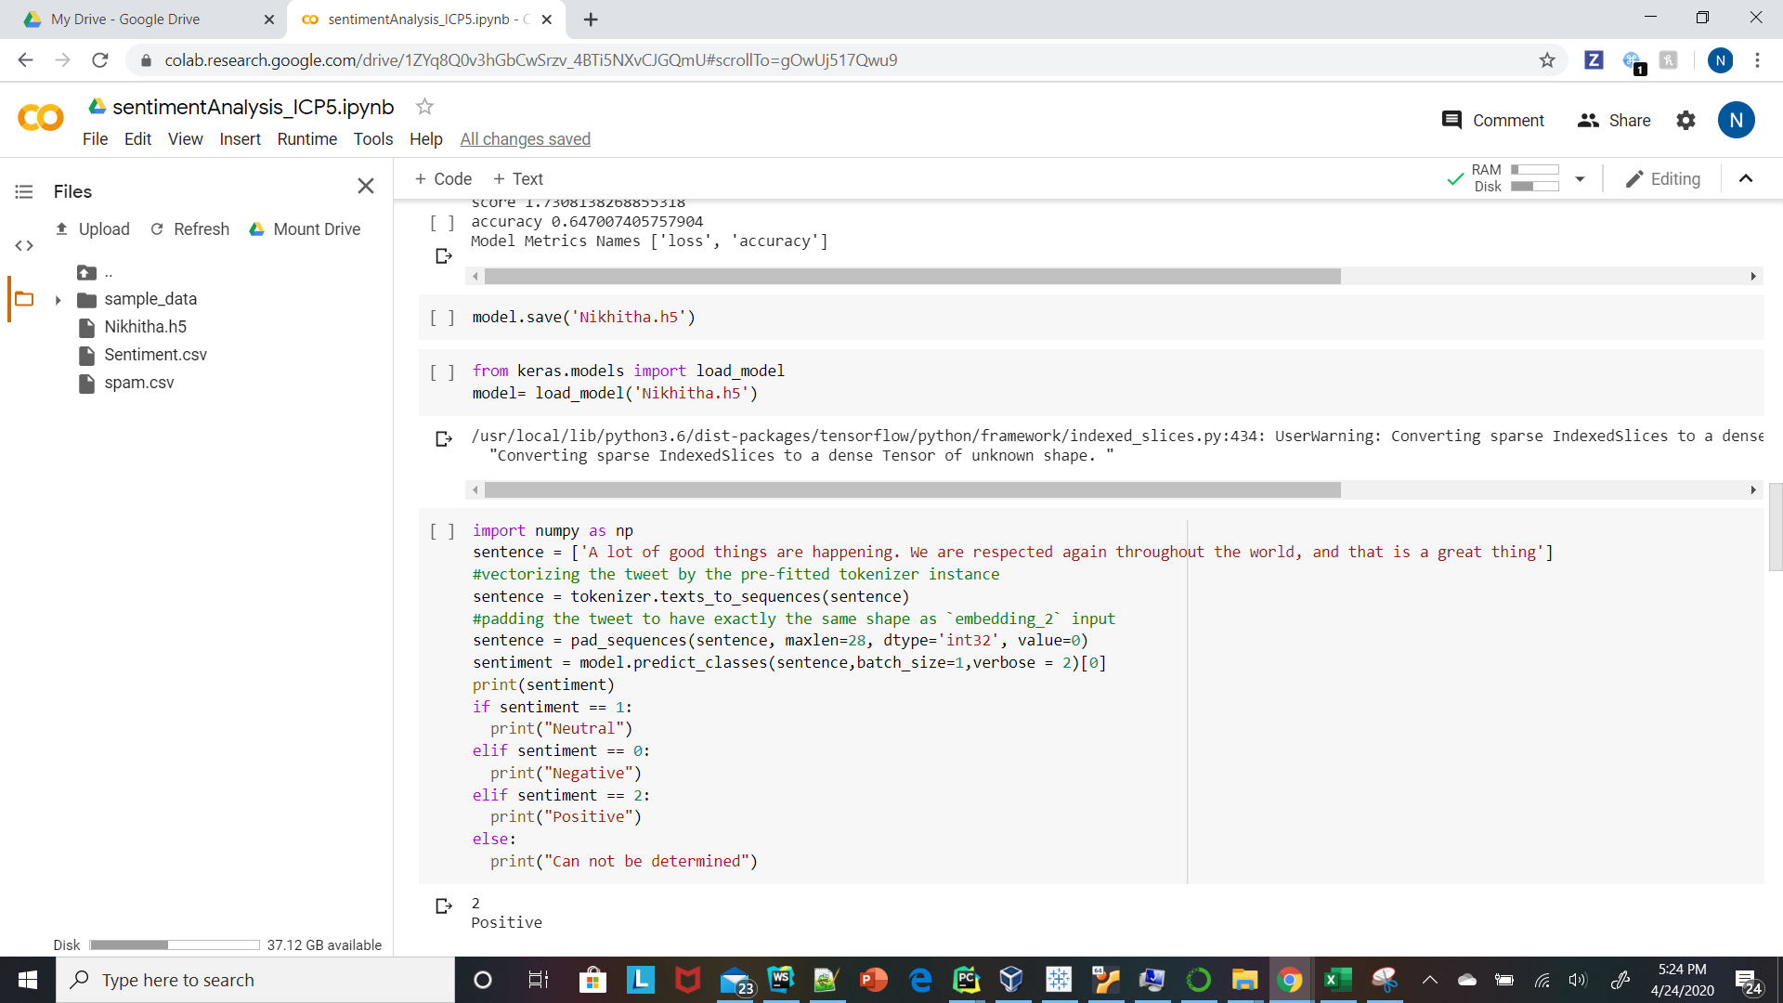

1. Apply GridSearchCV on the source code provided in the class

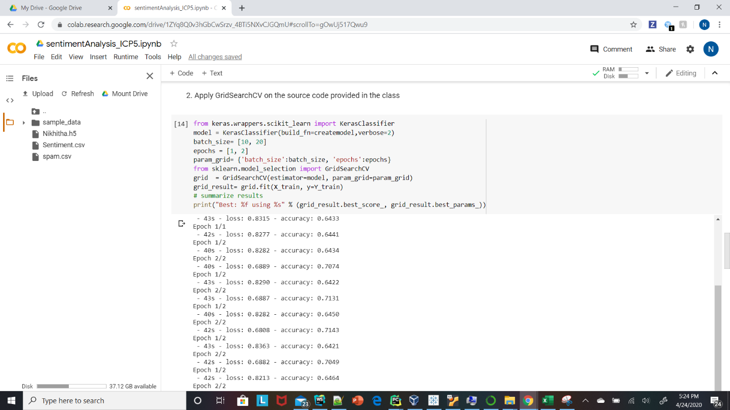

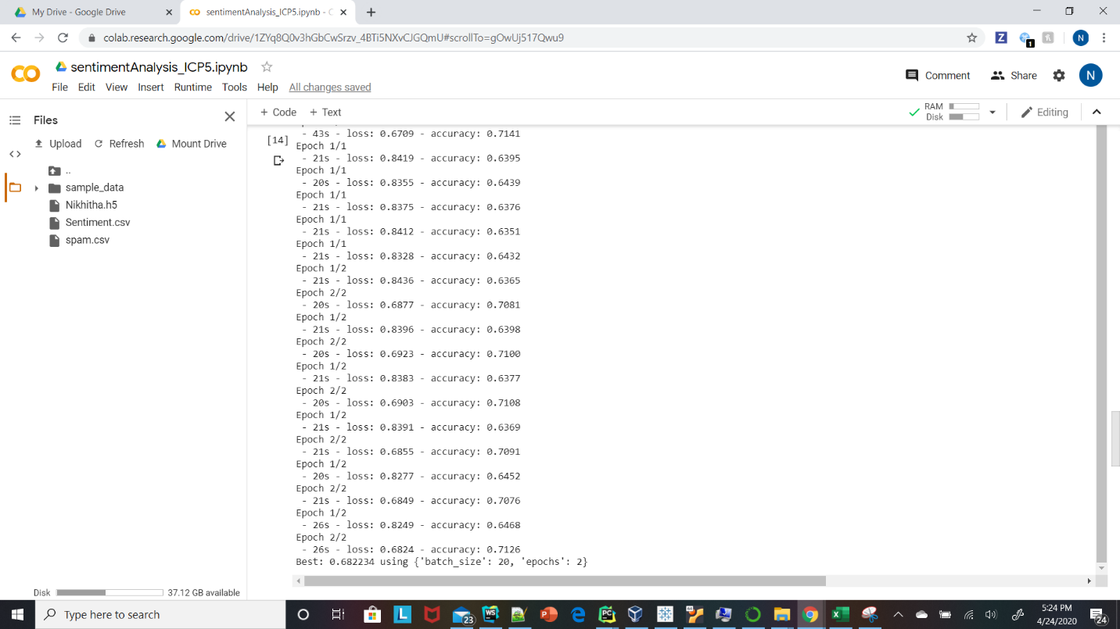

1. Apply the code on spamdata set availablein thesourcecode (text classification on the spam.csvdata set)

