Name – Aditya Wanjale

Roll no – 31282

Assignment No 01

Title : Undirected Search (BSF-DSF)

Code :

class Graph :

def __init__(self):

self.graph = {} # dictionary to store vertices and edges

self.BSFsearch = [] # list to store BSF vertex list

self.DSFsearch = [] # list to store DSF vertex list

def add_vertex(self, vertex):

if vertex not in self.graph :

self.graph[vertex] = [] # vertex : key, array of corresponding vertices : value

else:

print("Vertex " + vertex + " already present in graph.")

def add_edge(self, vertex1, vertex2):

if vertex1 and vertex2 in self.graph :

self.graph[vertex1].append(vertex2)

self.graph[vertex2].append(vertex1)

else:

print("These pair of vertex not present in graph.")

def BSF(self, vertex):

if vertex not in self.BSFsearch :

self.BSFsearch.append(vertex) # append vertex to list

adjacentVertexList = self.graph[vertex]

newAdjacentVertexList = []

for j in adjacentVertexList:

if j not in self.BSFsearch:

newAdjacentVertexList.append(j) # to avoid edge's vertex repeat ambiguity

for i in adjacentVertexList :

if i not in self.BSFsearch :

self.BSFsearch.append(i)

for i in newAdjacentVertexList :

if i in self.BSFsearch :

self.BSF(i) # exlopre a vertex then move to next vertex

def displayBSF(self):

print("BSF order - ")

for i in self.BSFsearch:

print(i, end=", ")

print()

print("Vertices and adges - ", end=" ")

print(self.graph)

def DSF(self, vertex):

if vertex not in self.DSFsearch :

self.DSFsearch.append(vertex) # append vertex to list

adjacentVertexList = self.graph[vertex]

newAdjacentVertexList = []

for j in adjacentVertexList:

if j not in self.DSFsearch:

newAdjacentVertexList.append(j) # to avoid edge's vertex repeat ambiguity

for i in newAdjacentVertexList :

self.DSF(i) # exlopre a vertex till it ends then return to earlier vertex

def displayDSF(self):

print("DSF order - ")

for i in self.DSFsearch:

print(i, end=", ")

print()

print("Vertices and adges - ", end=" ")

print(self.graph)

g=Graph();

while (True) :

print("Menu")

print("1. Add vertices\n2. Add edges\n3. Perform BSF\n4. Perform DSF")

choice = int(input("Enter choice - "))

if(choice==1):

n = int(input("Enter total number of vertices - "))

for i in range(0,n):

a = int(input("Vertex - "))

g.add_vertex(a)

elif (choice==2) :

v1 = int(input("Enter vertex 1 of edge - "))

v2 = int(input("Enter vertex 2 of edge - "))

g.add_edge(v1,v2)

elif (choice==3) :

g.BSF(1)

g.displayBSF()

elif (choice==4) :

g.DSF(1)

g.displayDSF()

else :

break

Breadth First Search Output :

C:\Users\Lenovo\PycharmProjects\SE\venv\Scripts\python.exe C:/Users/Lenovo/PycharmProjects/SE/venv/31282_Aditya_LP2_Assign01.py

Menu

1. Add vertices

2. Add edges

3. Perform BSF

Enter choice - 1

Enter total number of vertices - 7

Vertex - 1

Vertex - 2

Vertex - 3

Vertex - 4

Vertex - 5

Vertex - 6

Vertex - 7

Menu

1. Add vertices

2. Add edges

3. Perform BSF

Enter choice - 2

Enter vertex 1 of edge - 1

Enter vertex 2 of edge - 2

Menu

1. Add vertices

2. Add edges

3. Perform BSF

Enter choice - 2

Enter vertex 1 of edge - 1

Enter vertex 2 of edge - 4

Menu

1. Add vertices

2. Add edges

3. Perform BSF

Enter choice - 2

Enter vertex 1 of edge - 1

Enter vertex 2 of edge - 5

Menu

1. Add vertices

2. Add edges

3. Perform BSF

Enter choice - 2

Enter vertex 1 of edge - 2

Enter vertex 2 of edge - 3

Menu

1. Add vertices

2. Add edges

3. Perform BSF

Enter choice - 2

Enter vertex 1 of edge - 2

Enter vertex 2 of edge - 6

Menu

1. Add vertices

2. Add edges

3. Perform BSF

Enter choice - 2

Enter vertex 1 of edge - 7

Enter vertex 2 of edge - 2

Menu

1. Add vertices

2. Add edges

3. Perform BSF

Enter choice - 3

BSF order -

1, 2, 4, 5, 3, 6, 7,

Vertices and adges - {1: [2, 4, 5], 2: [1, 3, 6, 7], 3: [2], 4: [1], 5: [1], 6: [2], 7: [2]}

Menu

1. Add vertices

2. Add edges

3. Perform BSF

Enter choice - 4

Process finished with exit code 0

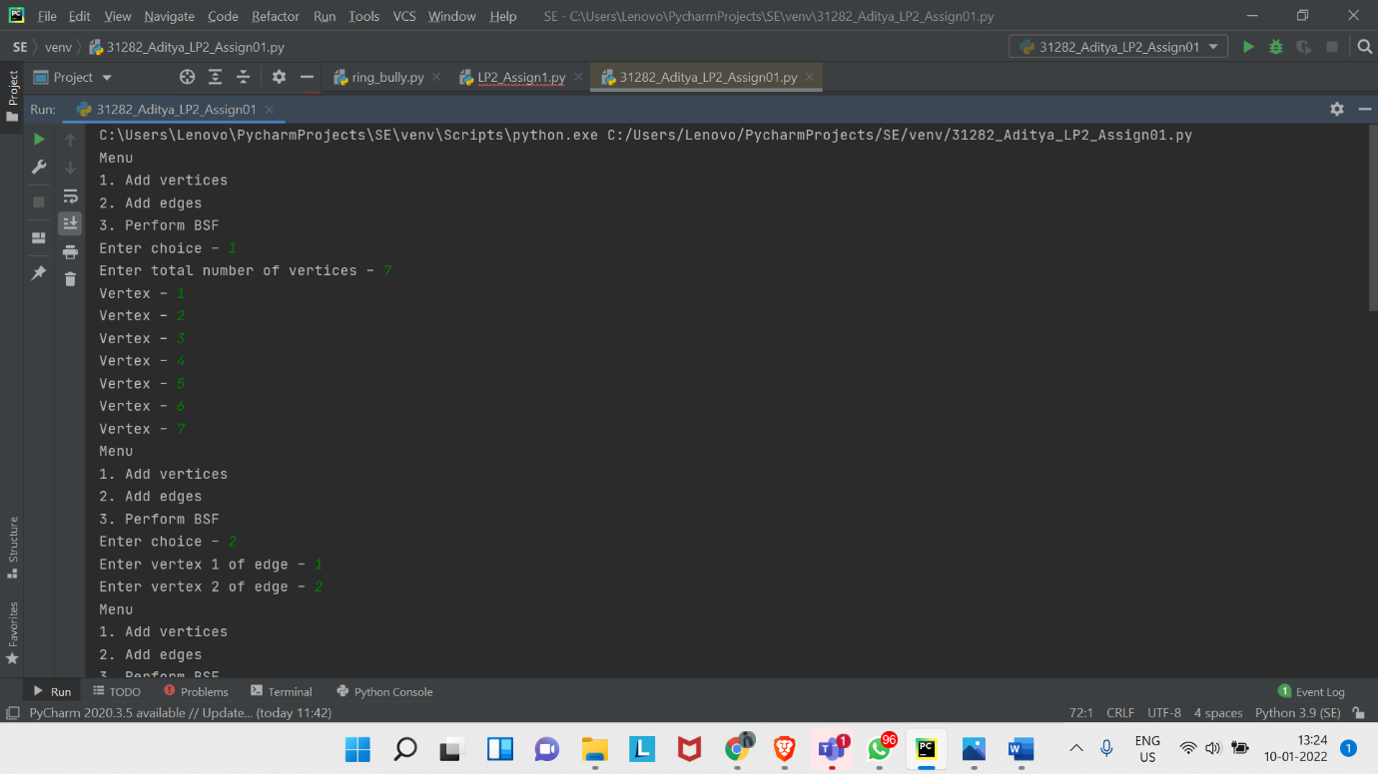

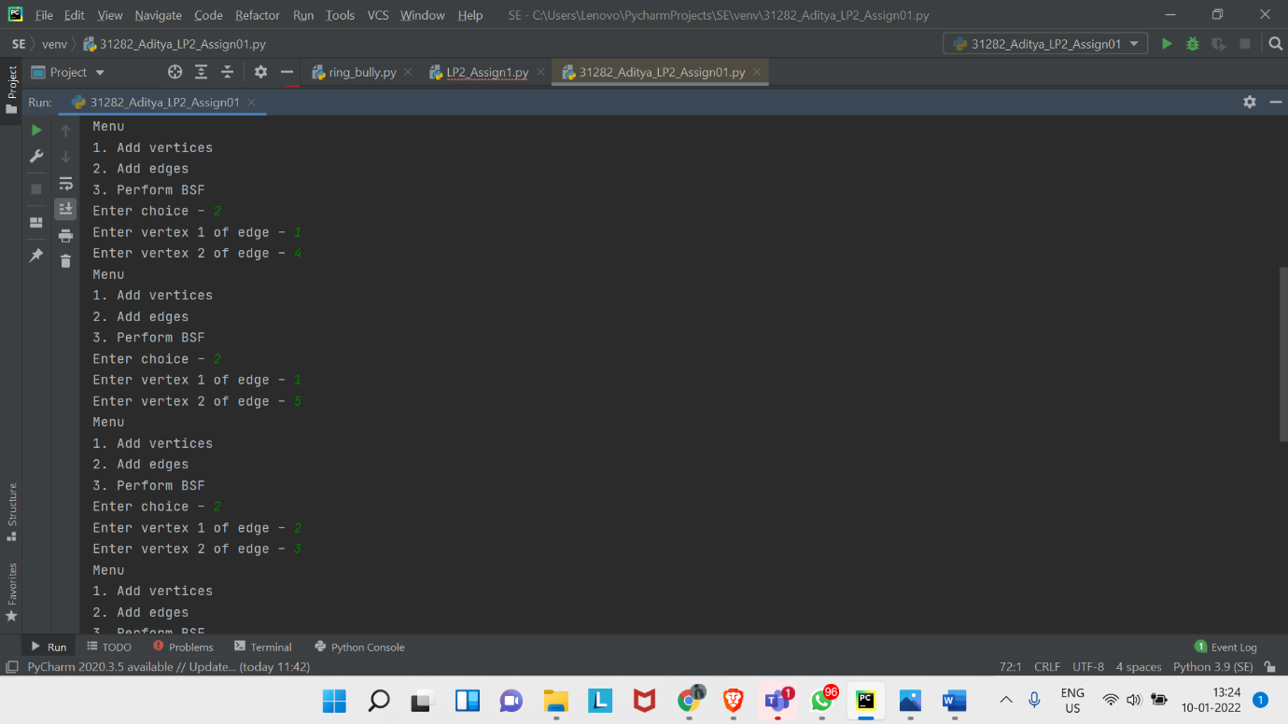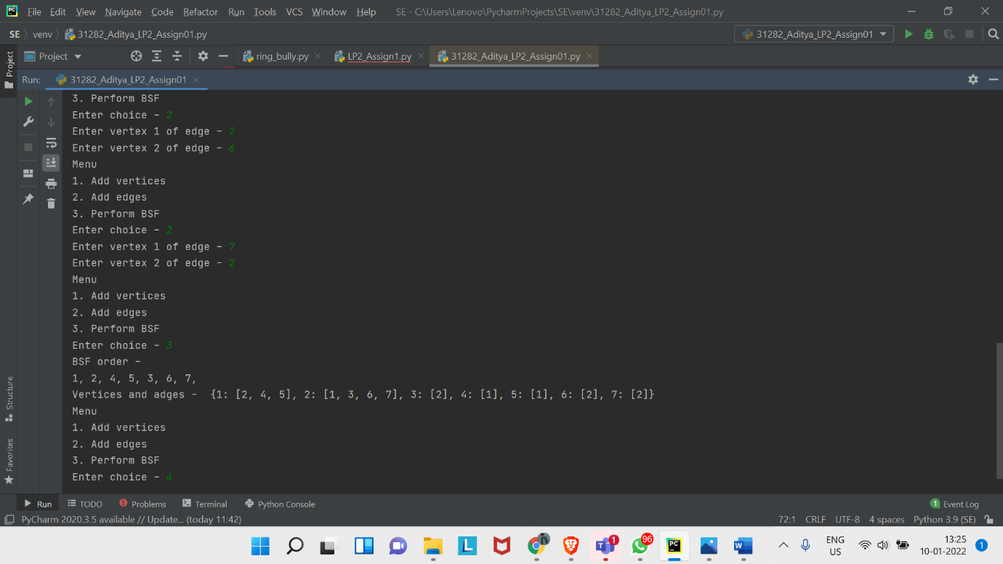

Depth First Search Output :

C:\Users\Lenovo\PycharmProjects\SE\venv\Scripts\python.exe C:/Users/Lenovo/PycharmProjects/SE/venv/31282_Aditya_LP2_Assign01.py

Menu

1. Add vertices

2. Add edges

3. Perform BSF

4. Perform DSF

Enter choice - 1

Enter total number of vertices - 7

Vertex - 1

Vertex - 2

Vertex - 3

Vertex - 4

Vertex - 5

Vertex - 6

Vertex - 7

Menu

1. Add vertices

2. Add edges

3. Perform BSF

4. Perform DSF

Enter choice - 2

Enter vertex 1 of edge - 1

Enter vertex 2 of edge - 2

Menu

1. Add vertices

2. Add edges

3. Perform BSF

4. Perform DSF

Enter choice - 2

Enter vertex 1 of edge - 1

Enter vertex 2 of edge - 4

Menu

1. Add vertices

2. Add edges

3. Perform BSF

4. Perform DSF

Enter choice - 2

Enter vertex 1 of edge - 1

Enter vertex 2 of edge - 5

Menu

1. Add vertices

2. Add edges

3. Perform BSF

4. Perform DSF

Enter choice - 2

Enter vertex 1 of edge - 2

Enter vertex 2 of edge - 3

Menu

1. Add vertices

2. Add edges

3. Perform BSF

4. Perform DSF

Enter choice - 2

Enter vertex 1 of edge - 2

Enter vertex 2 of edge - 6

Menu

1. Add vertices

2. Add edges

3. Perform BSF

4. Perform DSF

Enter choice - 2

Enter vertex 1 of edge - 2

Enter vertex 2 of edge - 7

Menu

1. Add vertices

2. Add edges

3. Perform BSF

4. Perform DSF

Enter choice - 4

DSF order -

1, 2, 3, 6, 7, 4, 5,

Vertices and adges - {1: [2, 4, 5], 2: [1, 3, 6, 7], 3: [2], 4: [1], 5: [1], 6: [2], 7: [2]}

Menu

1. Add vertices

2. Add edges

3. Perform BSF

4. Perform DSF

Enter choice - 4

Process finished with exit code 0

