A Project Report On

# Machine Learning (Mini Project II)

## CLASS: BE-2

GUIDED BY

**Dr. Prajakta Khadkikar**



**DEPARTMENT OF COMPUTER ENGINEERING** PUNE INSTITUTE OF COMPUTER TECHNOLOGY DHANKAWADI, PUNE-43

SAVITRIBAI PHULE PUNE UNIVERSITY 2020-21

Rohit James – 41266

Sufiya Sayyed - 41278

Aditya Wanjale - 41281

# Title:

Logistic Regression

# Problem Definition:

Build a machine learning model that predicts the type of people who survived the Titanic shipwreck using passenger data (i.e. name, age, gender, socio-economic class, etc.).

Dataset Link: https://www.kaggle.com/competitions/titanic/data

# Objective:

To predict the type of people who survived the Titanic shipwreck using the titanic dataset.

**Development Environment:**

Pandas – used to import the training and testing datasets from the .csv files

Numpy – used for mathematical operations and computations

matplotlib.pyplot – used to plot various plots

seaborn - used for data visualization

sklearn – used for machine learning tasks

## Theory:

## Sample Screenshots of application

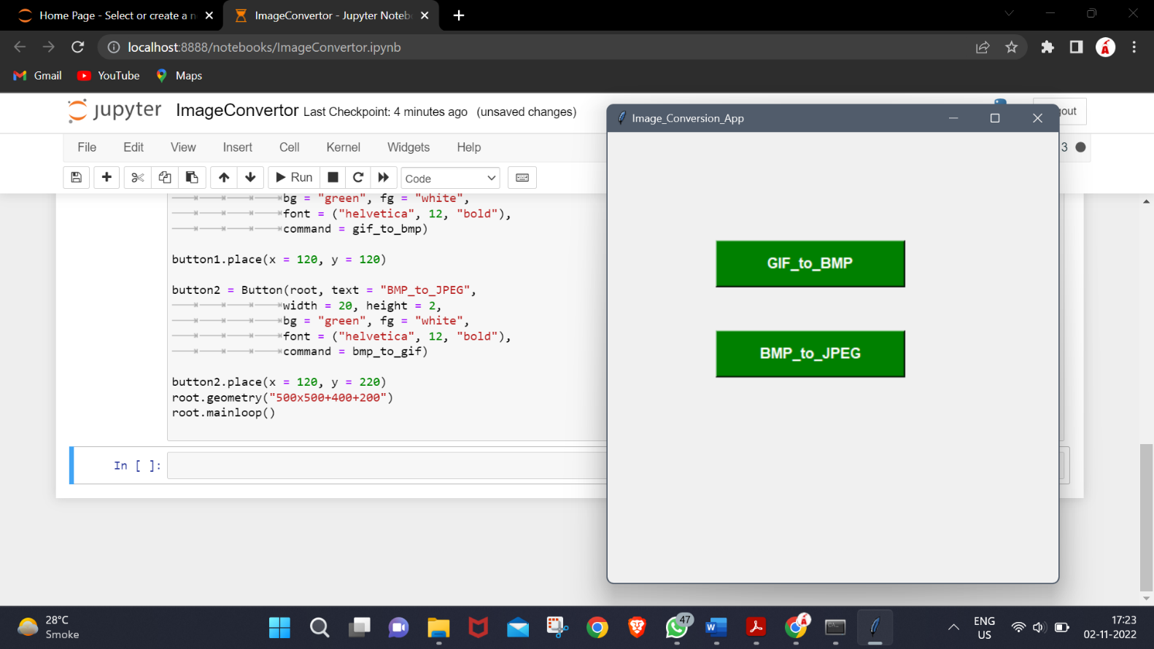

**Output logs of sample tests**

1. Select file

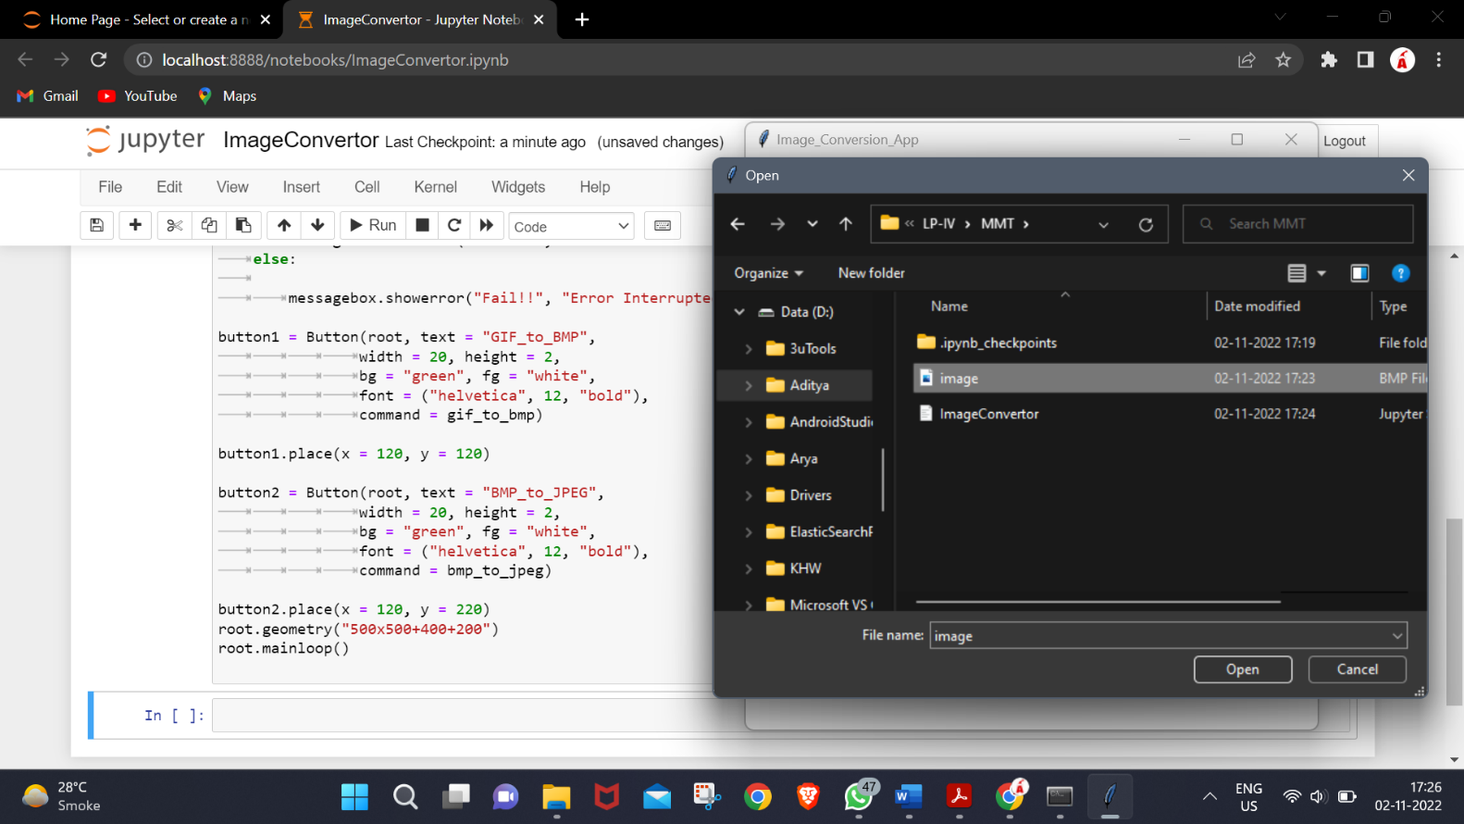

1. Save converted file

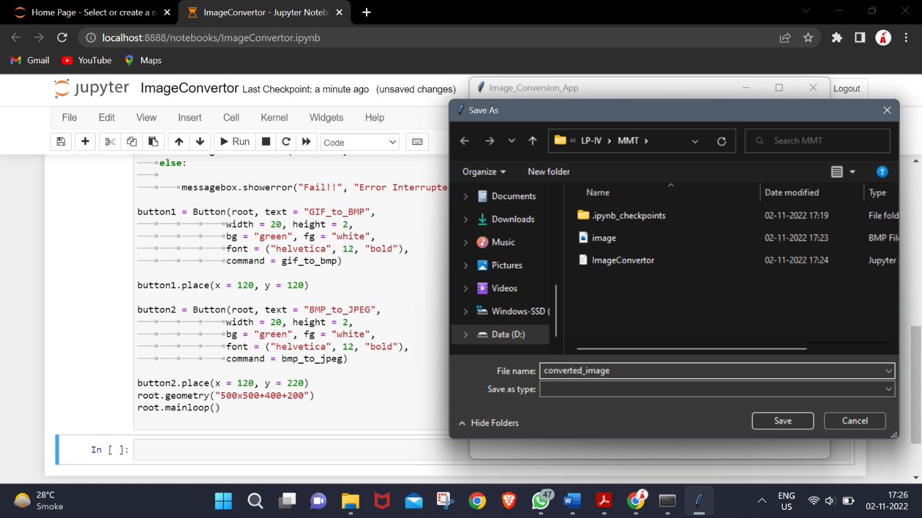

1. Output

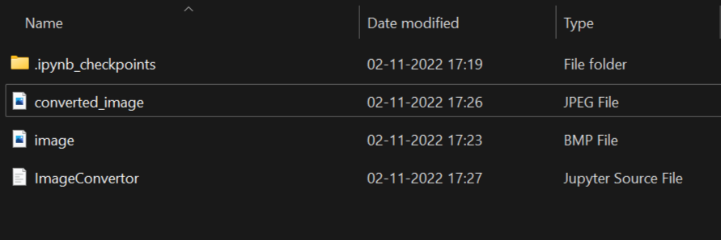

1. Test case – selecting wrong file format

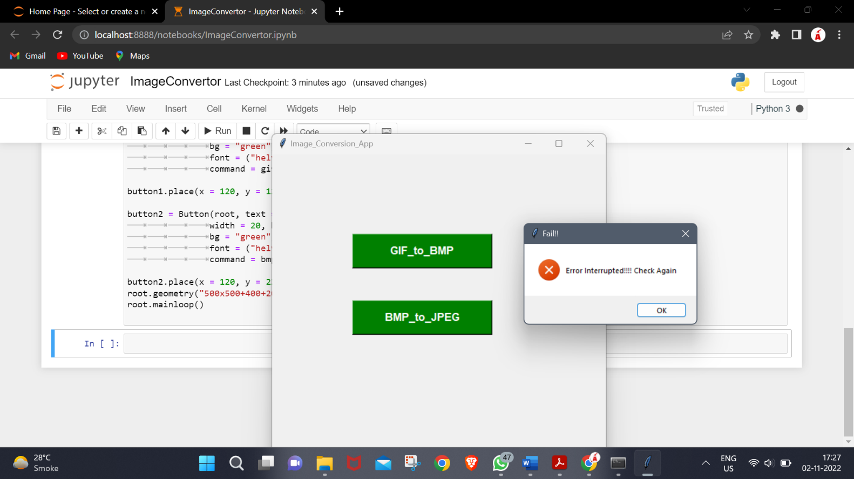

## Functions of the application :

**Source Code :**

## Conclusion :

Hence we developed a tool for converting image from one format into another (eg- bmp to jpeg).