**Assignment No. 7C**

**Name:- Aditya Zade**

**PRN:- 2018BTECS00111**

**Problem 4:-**

**index1.html:-**

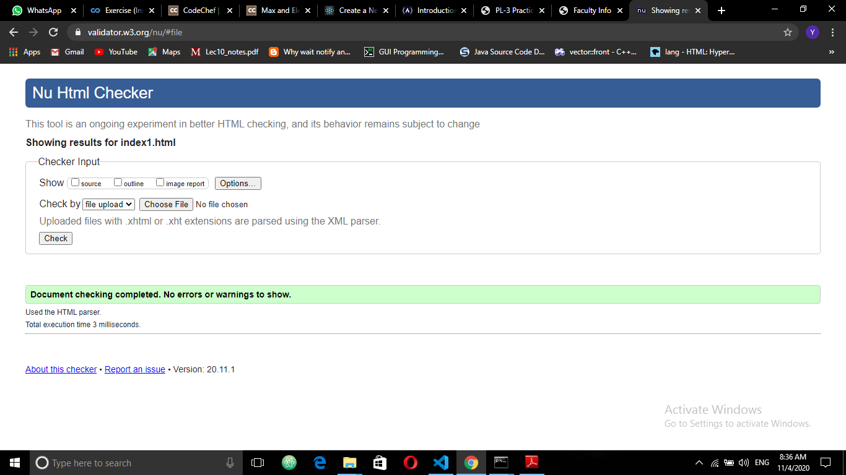

**index2.html**

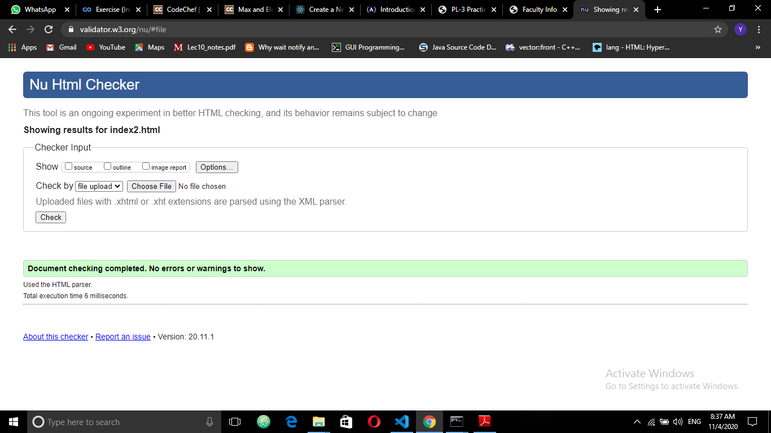

**index3.html**

