**ASSIGNMENT 8**

**NAME : Aditya Zade**

**PRN: 2018BTECS00111**

**PROBLEM STATEMENT NO.1**

**ANS**

**Screenshots of code :**

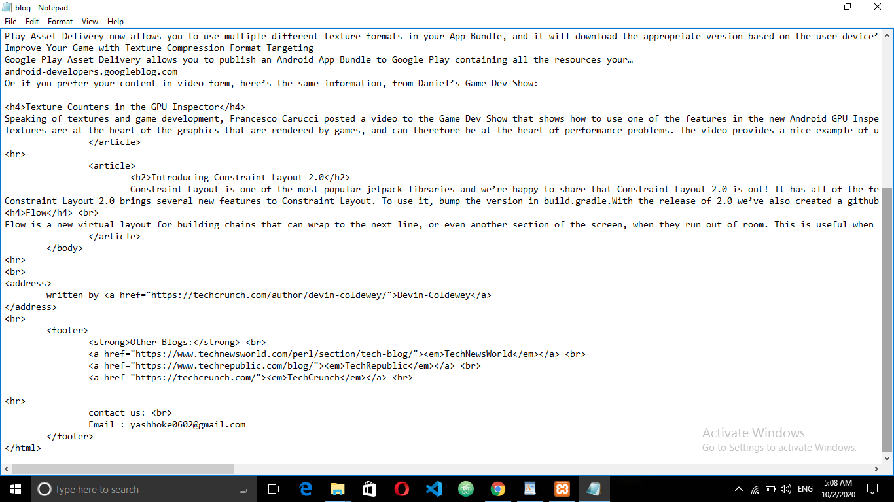

**Screenshots of webpage :**

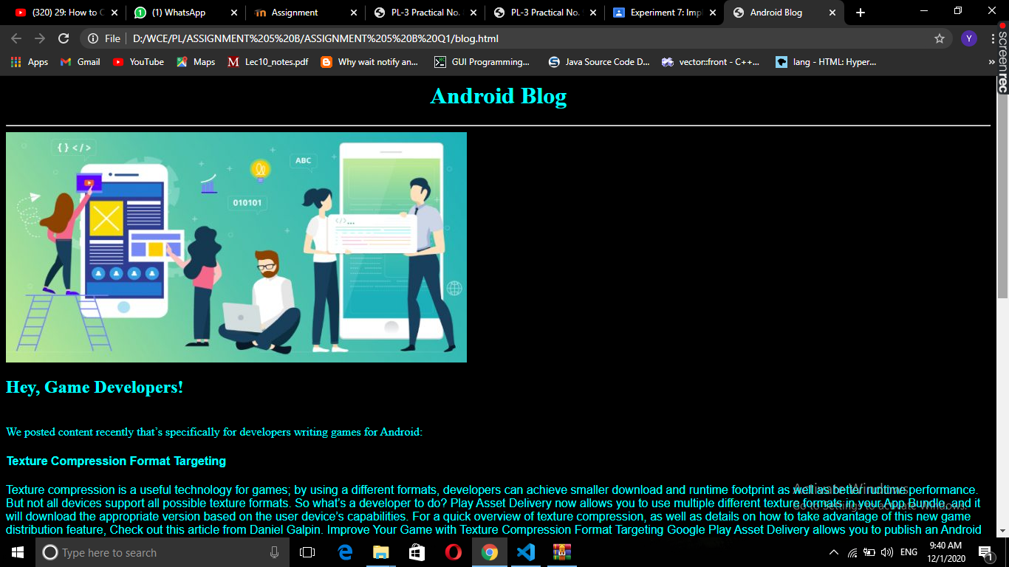

**PROBLEM STATEMENT NO.2**

**ANS:**

**Screenshots of code :**

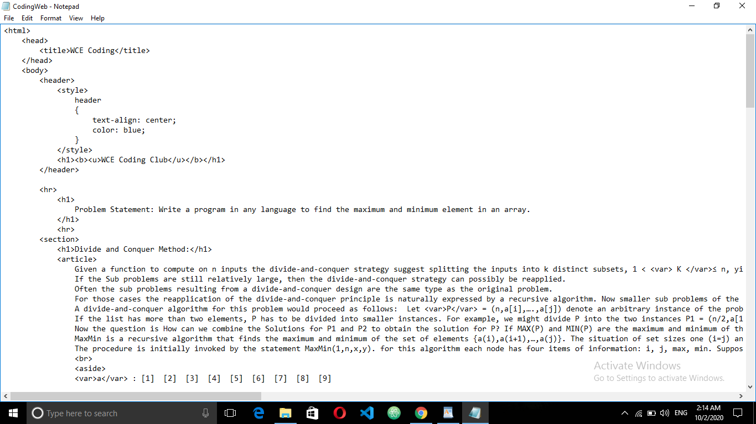

**Screenshots of Webpage :**

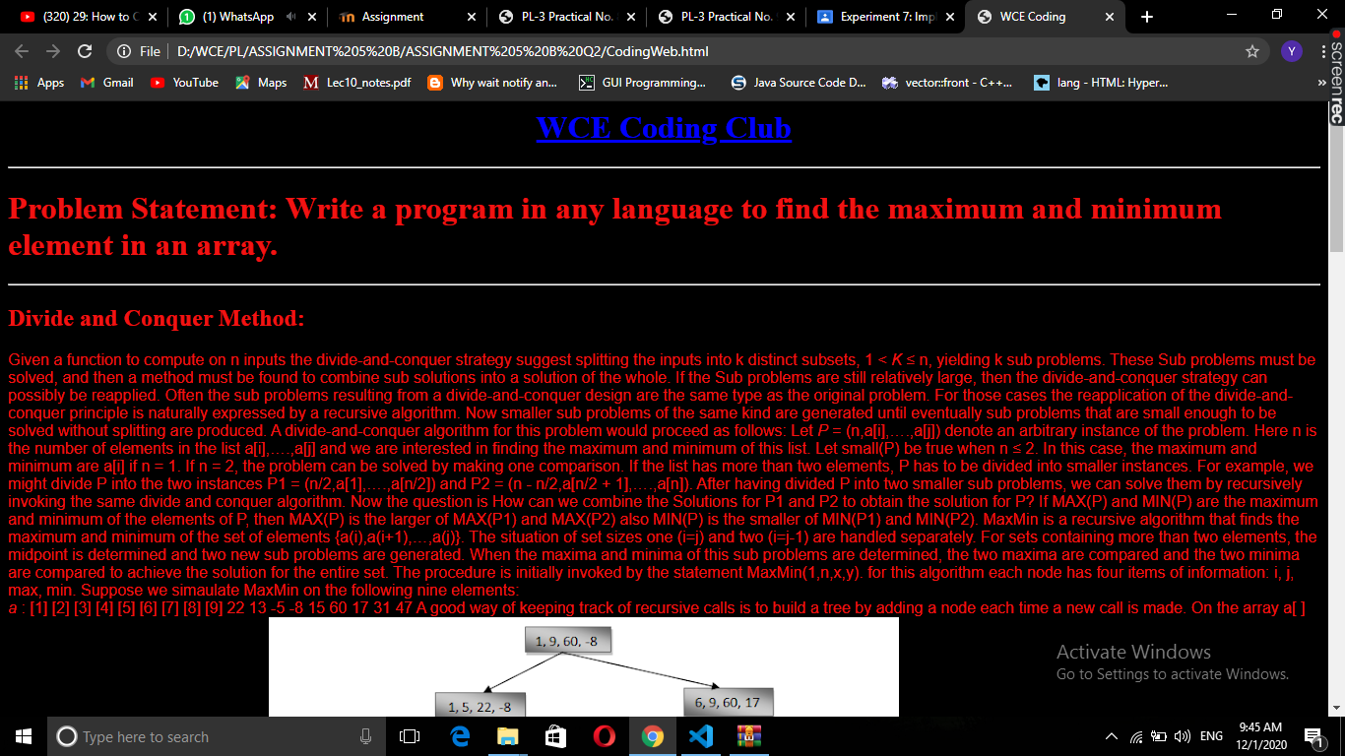

**PROBLEM STATEMENT NO.3**

**ANS:**

**Screen shot of code**

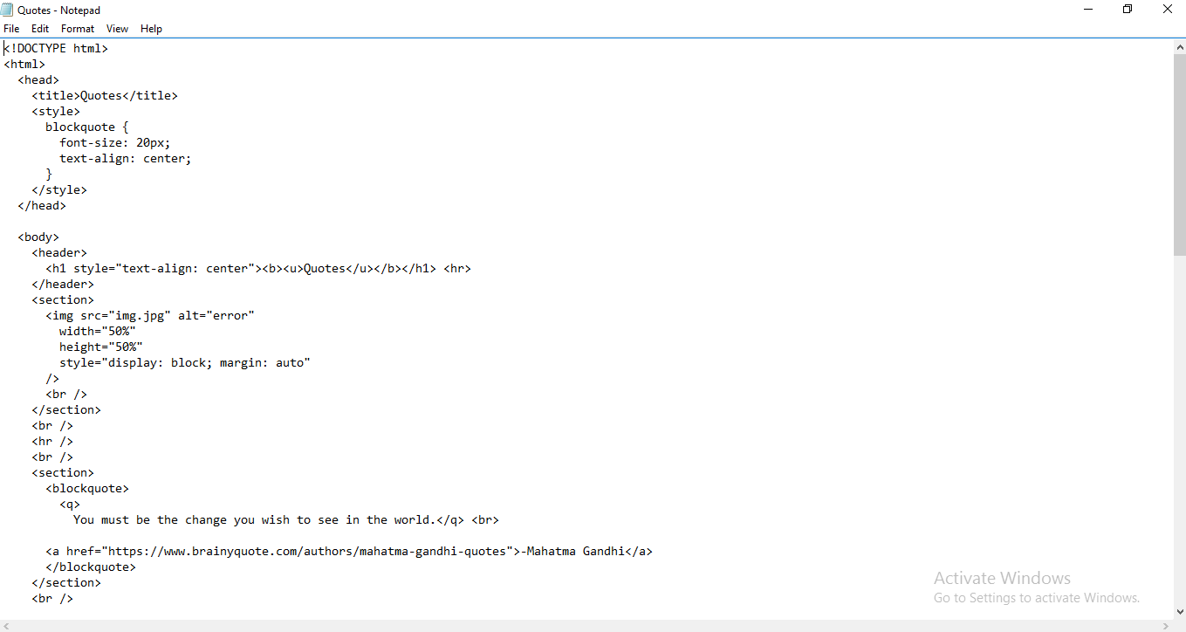

**Screen shot of webpage**

