

Python Assignment-02

Name: Aditya Mishra Class: Section-A G1

Roll No.: 231811009618 Branch: FTD in cse

Academic year: 2023-2026

Functions
Ques1) Which of the calls to print_it( ) in the following program will report errors.
def print_it(i, a, s, *args) :
print( )
print(i, a, s, end = ' ')
for var in args:
print(var, end = ' '):

a) print_it(10, 3.14) b) print_it(20, s = 'Hi', a = 6.28)
c)print_it(a = 6.28, s = 'Hello', i = 30) d)print_it(40, 2.35, 'Nag', 'Mum', 10)
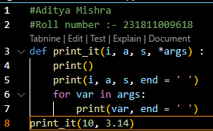

Code:-

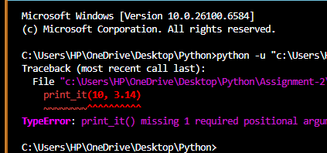
Output:-

Ques2) Which of the calls to fun( ) in the following program will report errors.
def fun(a, *args, s = '!') :
print(a, s)
for i in args :
print(i, s)
a) fun(10) b)fun(10, 20) c)fun(10, 20, 30)
d) fun(10, 20, 30, 40, s = '+')

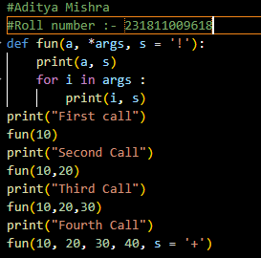
Code:-

Output:- None of the above will give an error

[B] Attempt the following questions:

(a) What is being passed to function fun( ) in the following code?
int a = 20
lst = [10, 20, 30, 40, 50]
fun(a, lst)

ANSWER:- A variable ‘a’ with value 10 and a list of 5 numbers.

(b) Which of the following are valid return statements?
return (a, b, c)
return a + b + c
return a, b, c

ANSWER:- All 3 are valid
NOTE:- 2nd one will only run when the operands are compatible with ‘+’ operator.

(c) What will be the output of the following program?
def fun( ) :
print('First avatar')
fun( )
def fun( ) :
print('New avatar')
fun( )

ANSWER:- First Avatar
New Avatar

(d) How will you define a function containing three return statements, each returning a different type of value?

ANSWER:- Normally we can’t add more than one statements in a function, but we can add multiple return statements through different conditions. For example:-

def multi_returns(x):
if x == 1:
return 42 # returns an integer
elif x == 2:
return "Hello" # returns a string
else:
return [1, 2, 3] # returns a list

(e) Can function definitions be nested? If yes, why would you want to do so?

ANSWER:- Yes, We can definitely define a function inside another function these are actually called the Nested Functions. Reasons to use these functions are as follows:-

1) Encapsulation (hiding helper logic)
- If a function is only useful inside another function, nesting keeps it hidden and avoids polluting the global namespace.
2) Code Organization
- Helps keep related logic grouped together.
- Makes the outer function easier to read.
3) Closures
- An inner function can "remember" variables from the outer function even after the outer function has finished running.

(f) How will you call print_it( ) to print elements of tpl?
def print_it(a, b, c, d, e) :
print(a, b, c, d, e)
tpl = ('A', 'B', 'C', 'D', 'E')
ANSWER:- To pass the whole tuple “tpl” into the function print_it we can’t write print_it(tpl) since it is missing 4 arguments it will give an error. So we will use a special Unpacking Operator to pack the all other 4 arguments, it is denoted by (*). Example:-
print_it(*tpl)
Pseudocode Example:-
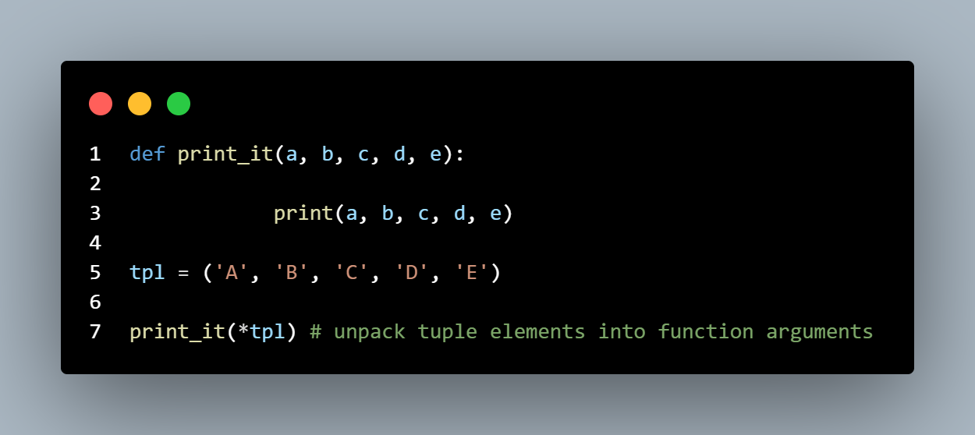
Lists
[A] What will be the output of the following programs:

(a) msg = list('www.kicit.com') (http://www.kicit.com') )
ch = msg[-1]
print(ch)

ANSWER:- It will give TypeError: 'str' object is not callable

(b) msg = list('kanlabs.teachable.com')
s = msg[4:6]
print(s)

ANSWER:- ['a', 'b']

(c) msg = 'Online Courses- KanLabs'
s = list(msg[:3])
print(s)

ANSWER:- ['O', 'n', 'l']

(d) msg = 'Rahate Colony'
s = list(msg[-5:-2])
print(s)

ANSWER:- ['o', 'l', 'o']

(e) s = list('KanLabs')
t = s[::-1]
print(t)

ANSWER:- ['s', 'b', 'a', 'L', 'n', 'a', 'K']

(f) num1 = [10, 20, 30, 40, 50]
num2 = num1 print(id(num1))
print(type(num2))
num[2:4] = [ ]
print(num)

ANSWER:- Since “num” was never defined, this code will throw an exception.

(h) num1 = [10, 20, 30, 40, 50]
num2 = [60, 70, 80]
num1.append(num2)
print(num1)

ANSWER:- [10, 20, 30, 40, 50, [60, 70, 80]]

(i) lst = [10, 25, 4, 12, 3, 8]
sorted(lst)
print(lst)

ANSWER:- [10, 25, 4, 12, 3, 8]

(j) a = [1, 2, 3, 4]
b = [1, 2, 5]
print(a < b)

ANSWER:- True

[B] Attempt the following questions:

(a) Which of the following is a valid List?
a) ['List'] b) {"List"} c)("List") d) "List"

ANSWER:- A

(b) What will happen on execution of the following code snippet?
s = list('Hello')
s[1] = 'M'

ANSWER:-
In the first line :- A list with a STRING element has been created and been named as “s”.
In the second line:- The character at the index 1 is has been assigned a new value “M”.

Final Output:- [‘H’,’M’,’l’,’l’,’o’]

Explanation:- String are immutable, but converting them
into a LIST makes them mutable.

(c) The following code snippet deletes elements 30 and 40 from list:
num = [10, 20, 30, 40, 50]
del(num[2:4])
In which other way can the same effect be obtained?

ANSWER:- Several ways to obtain the same result are as follows:-

1) Remove function:-
num.remove(30)
num.remove(40)
print(num)

2) Pop function (using twice):-
num.pop(2)
num.pop(2)
print(num)
3) Slice Method :-
num[2:4] = []
print(num)

d) Which of the following is an INCORRECT list?
a = [0, 1, 2, 3, [10, 20, 30]]
a = [10, 'Suraj', 34555.50]
a = [[10, 20, 30], [40, 50, 60]]
Answer:- None of the these is INCORRECT

(f) Given a list lst = [10, 25, 4, 12, 3, 8] How will you sort it in descending order?
ANSWER:- Using sort function and assigning reverse = true.
Pseudocode Example:-
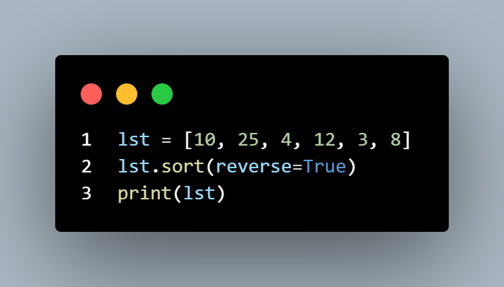

(g) Given a list lst = [10, 25, 4, 12, 3, 8] How will you check whether 30 is present in the list or not?
ANSWER:- Using “in” operator
Pseudocode Example:-
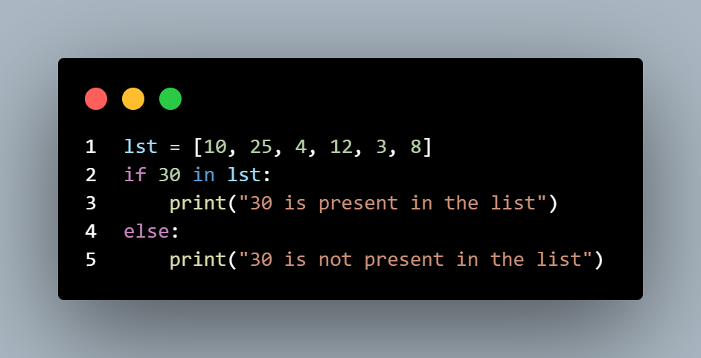
(h) Given a list lst = [10, 25, 4, 12, 3, 8] How will you insert 30 between 25 and 4?
Answer:- Using insert() function which takes value, index as two parameters.
Pseudocode Example:-
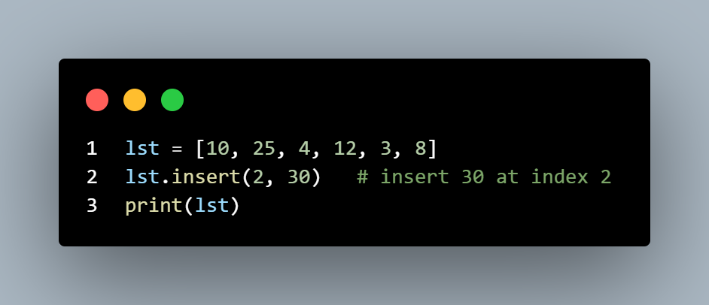
(i) Given a string
s = 'Hello'
How will you obtain a list['H', 'e', 'l', 'l', 'o'] from it?
Answer:- Using List function which converts a data type into list.
lst = list(s) # passing ‘s’ as a parameter

X------END OF LISTS------X

Recursion
[C] What will be the output of the following programs?
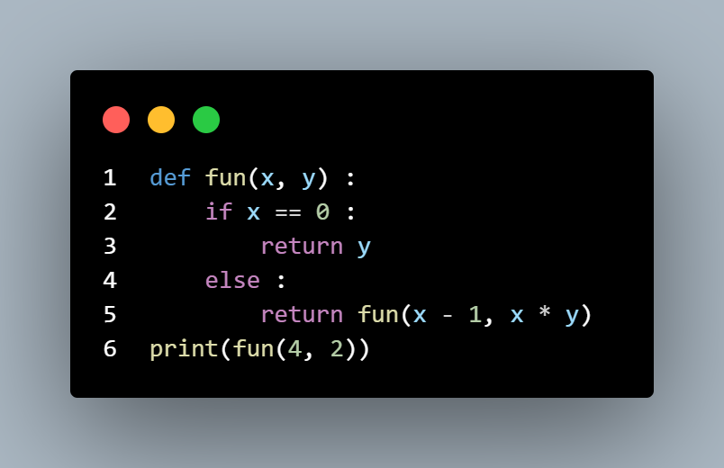
(a)

Answer:- 48
(b)
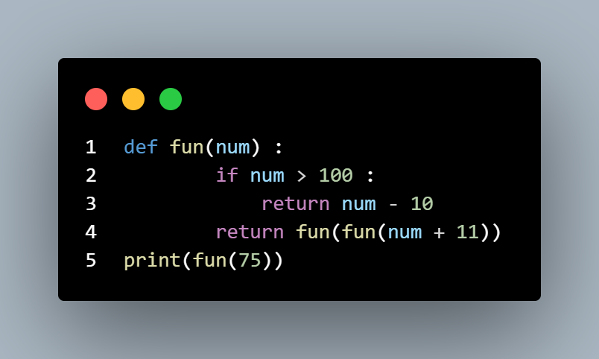
Answer:- 91
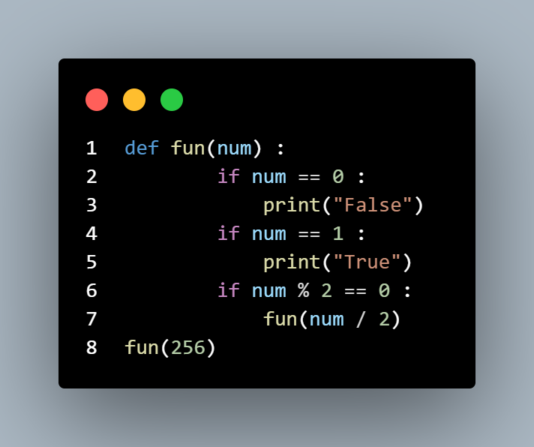
(c)

Answer:- True

X------END OF RECURSION------X
Tuples
[A] Which of the following properties apply to string, list and tuple?
1) Iterable 2) Sliceable 3)Indexable
4) Immutable 5)Sequence 6) Can be empty
7) Sorted collection 8) Ordered collection
9) Unordered collection 10) Elements can be accessed using their position in the collection
Answer:- 1, 2, 3, 5, 6, 8, 10

[B] Which of the following operations can be performed on string, list and tuple?
1) a = b + c - a += b
2) Appending a new element at the end
3) Deletion of an element at the 0th position
4) Modification of last element
5) In place reversal

Answer:- 1,2

[C] Answer the following questions:
(a) Is this a valid tuple?
tpl = ('Square')
Answer = No, since it is a single element tuple it should end with a comma “ , ”.

(b) What will be the output of the following code snippet?
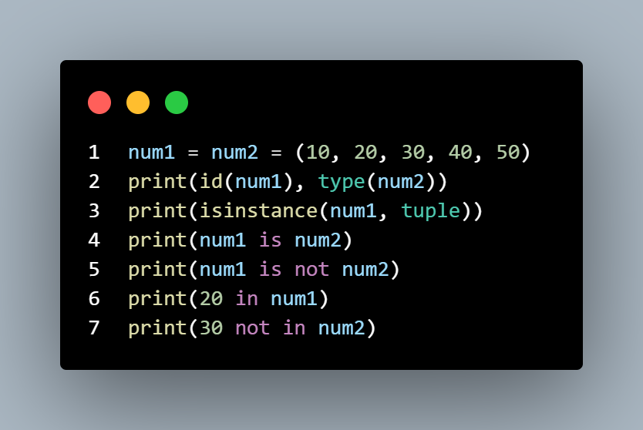

Answer:- True True False True False

(c) Suppose a date is represented as a tuple (d, m, y). Write a program to create two date tuples and find the number of days between the two dates.

Answer:-
Code:-

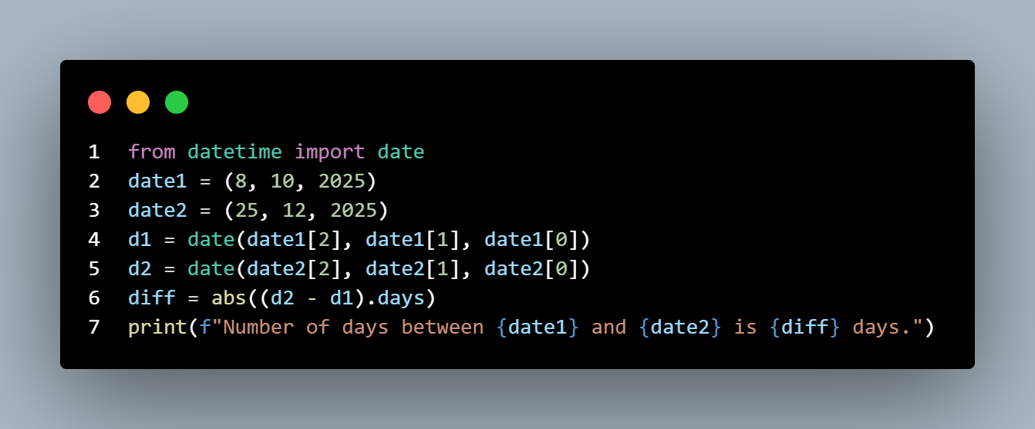
Output:-
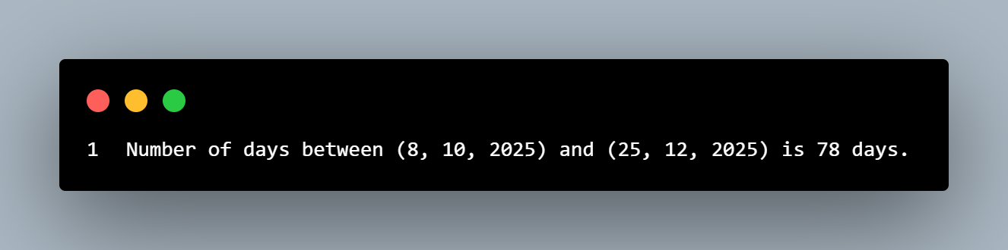
[D] Match the following pairs:

a. tpl1 = ('A',) | 1. tuple of length 6
b. tpl1 = ('A') | 2. tuple of lists
c. t = tpl[::-1] | 3. Tuple
d. ('A', 'B', 'C', 'D') | 4. list of tuples
e. [(1, 2), (2, 3), (4, 5)] | 5. String
f. tpl = tuple(range(2, 5)) | 6. Sorts tuple
g. ([1, 2], [3, 4], [5, 6]) | 7. (2, 3, 4)
h. t = tuple('Ajooba') | 8. tuple of strings
i. [*a, *b, *c] | 9. Unpacking of tuples in a list
j. (*a, *b, *c) | 10. Unpacking of lists in a tuple

Answers:-
a -> 3
b -> 5
c -> 6
d -> 8
e -> 4
f -> 7
g -> 2
h -> 1
i -> 9
j -> 10

X------END OF TUPLES------X
Dictionaries

[C] Answer the following questions:
(a) What will be the output of the following code snippet?
d = { 'Milk' : 1, 'Soap' : 2, 'Towel' : 3, 'Shampoo' : 4, 'Milk' : 7}
print(d[0], d[1], d[2])
Answer:- Since we can’t access dictionaries items using indexes, this code will give an exception that is as follows:-

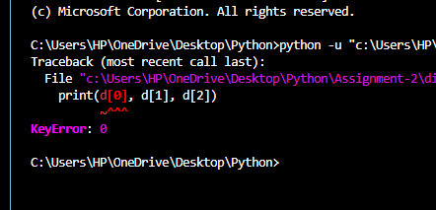

(b) Which of the following statements are CORRECT?
i. A dictionary will always contain unique keys.
ii. Each key in a dictionary may have multiple values.
iii. If same key is assigned a different value, latest value will prevail.
Answer:-
i) All keys in a dictionary are unique, if a key is written twice the last value of the key will prevail.
ii) A key can’t contain more than one value. However, a value can itself be a list or tuple.
iii) If a key has been written twice with two different values the second one will be considered ignoring the 1st one.
So 1st and 3rd ones are correct.

(c) How will you create an empty list, empty tuple, empty set and empty dictionary?

Answer:-Easiest way to create empty list, tuple, set and dictionary are as follows(through constructor):-

🟢 Empty List :-
my_list = list()

🟢 Empty Tuple:-
my_tuple = tuple()

🟢 Empty Set :-
my_set = set()

🟢 Empty Dictionary :-
my_dict = dict()

(d) How will you create a list, tuple, set and dictionary, each containing one element?

Answer:-

🟢 List with one element
my_list = [10]

🟣 Tuple with one element
my_tuple = (10,)

🟠 Set with one element
my_set = {10}

🔵 Dictionary with one key–value pair
my_dict = {'a': 10}

(e) Given the following dictionary:
d = {
'd1': {'Fruitname' : 'Mango', 'Season' : 'Summer'},
'd2': {'Fruitname' : 'Orange', 'Season' : 'Winter'}
}
How will you access and print Mango and Winter?
Code:-
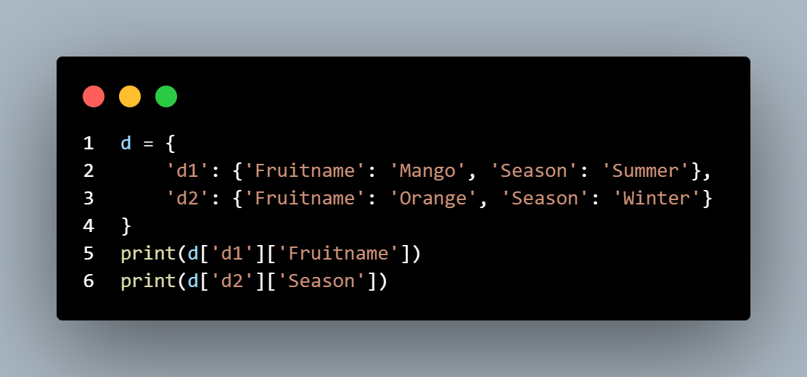
Output:-
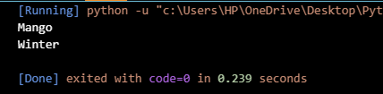

(f) In the following table check the box if a property is enjoyed by the data types mentioned in columns?

Property | str | list | tuple | set | dict
Object
Collection
Mutable
Ordered
Indexed by position
Indexed by key
Iterable
Slicing allowed
Nesting allowed
Homogeneous elements
Heterogeneous elements

Answer:-

Property | str | list | tuple | set | dict
Object | ✅ | ✅ | ✅ | ✅ | ✅
Collection | ✅ | ✅ | ✅ | ✅ | ✅
Mutable | ❌ | ✅ | ❌ | ✅ | ✅
Ordered | ✅ | ✅ | ✅ | ❌ | ✅
Indexed by position | ✅ | ✅ | ✅ | ❌ | ❌
Indexed by key | ❌ | ❌ | ❌ | ❌ | ✅
Iterable | ✅ | ✅ | ✅ | ✅ | ✅
Slicing allowed | ✅ | ✅ | ✅ | ❌ | ❌
Nesting allowed | ✅ | ✅ | ✅ | ✅ | ✅
Homogeneous elements | ✅ | ❌ | ✅ | ✅ | ❌
Heterogeneous | ✅ | ✅ | ✅ | ✅ | ✅

(g) What is the most common usage of the data types mentioned below?
Str
List
Tuple
Set
Dictionary
Answer:-

• str (String):
Primarily used to represent and manipulate textual data, such as names, messages, sentences, and any sequence of characters.

• list:
Used for storing an ordered, mutable collection of items. Lists are ideal when the order of elements is important, and the collection needs to be modified frequently by adding, removing, or changing elements. Examples include storing a list of user inputs, items in a shopping cart, or a sequence of data points for processing.

- tuple:
Used for storing an ordered, immutable collection of items. Tuples are suitable when the sequence of elements should not be changed after creation, offering a degree of data integrity. They are commonly used to represent fixed collections of related items, such as coordinates (x, y), database records, or function arguments that should not be altered.

- set:
Used for storing an unordered collection of unique, hashable items. Sets are efficient for checking membership, removing duplicate elements from a collection, and performing mathematical set operations like union, intersection, and difference.

- dict (Dictionary):
Used for storing data as key-value pairs. Dictionaries are highly efficient for fast lookups and retrieval of values based on their associated unique keys. They are widely used to represent structured data, such as configuration settings, object properties, or mappings between related pieces of information.

X----END OF ASSIGNMENT----X

