FASTAPI TERMINAL WITH ROUTES
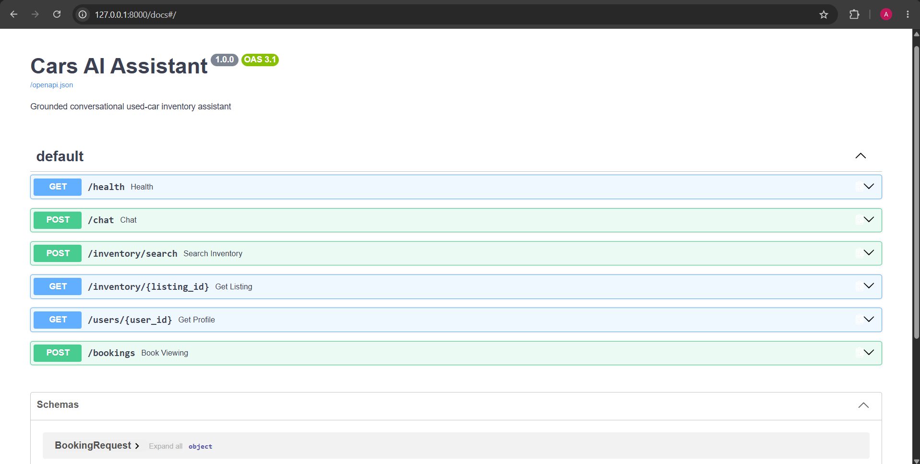

STREAMLIT FRONTEND (USER INTERFACE)
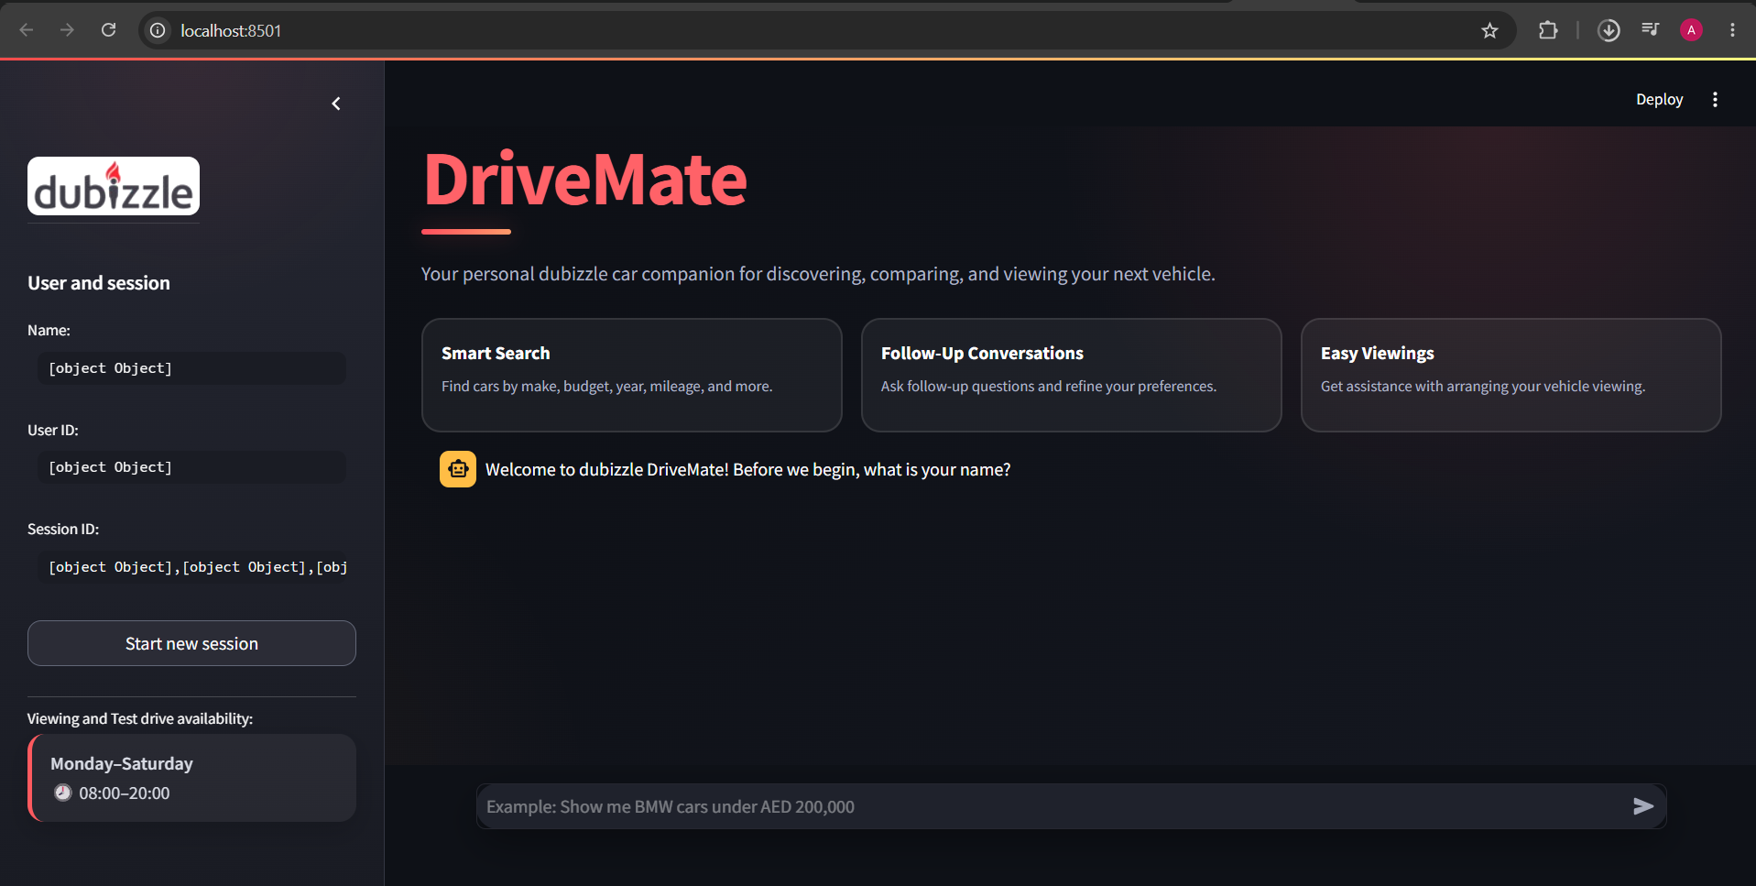

NAME ENTRY
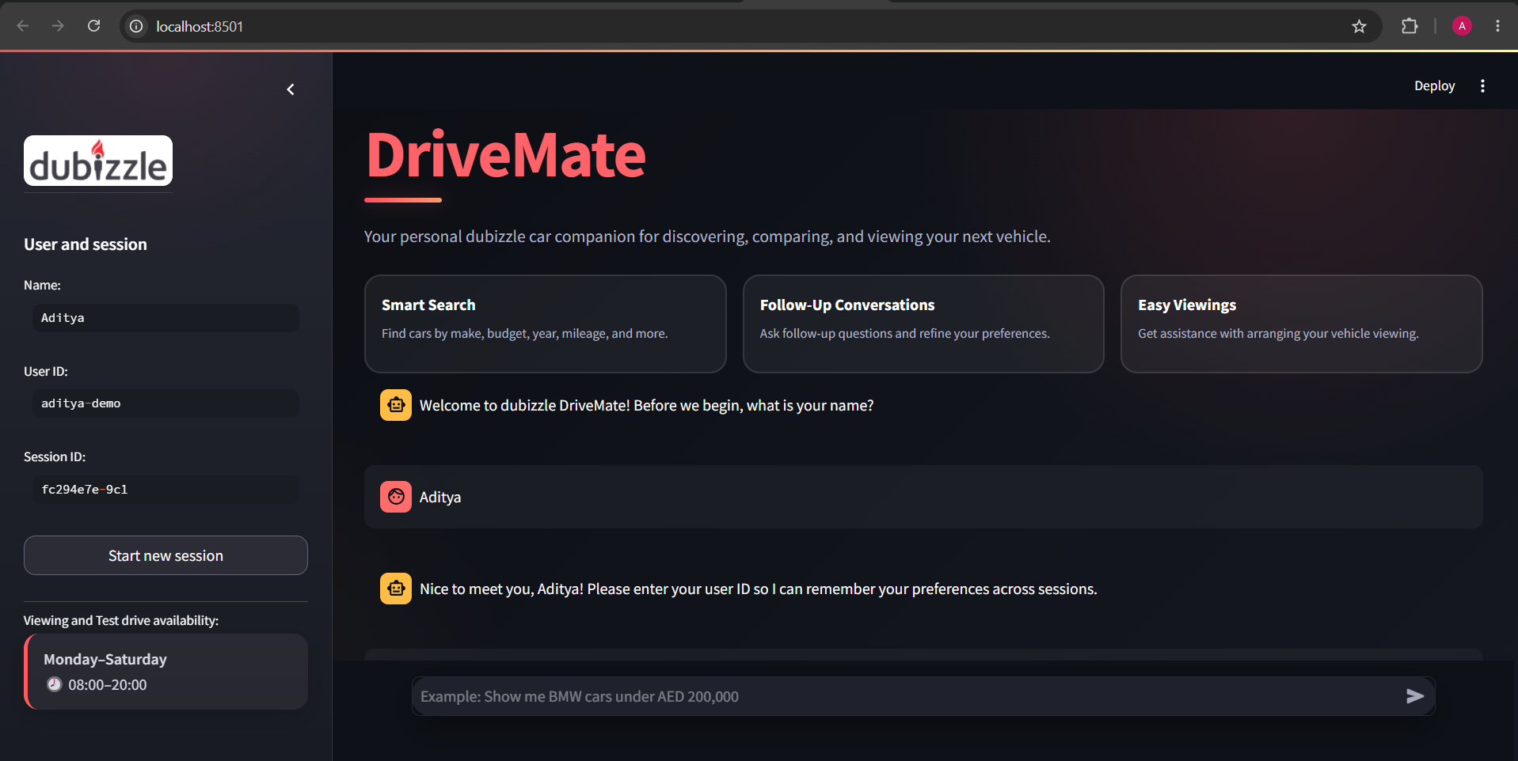

USER ID ENTRY
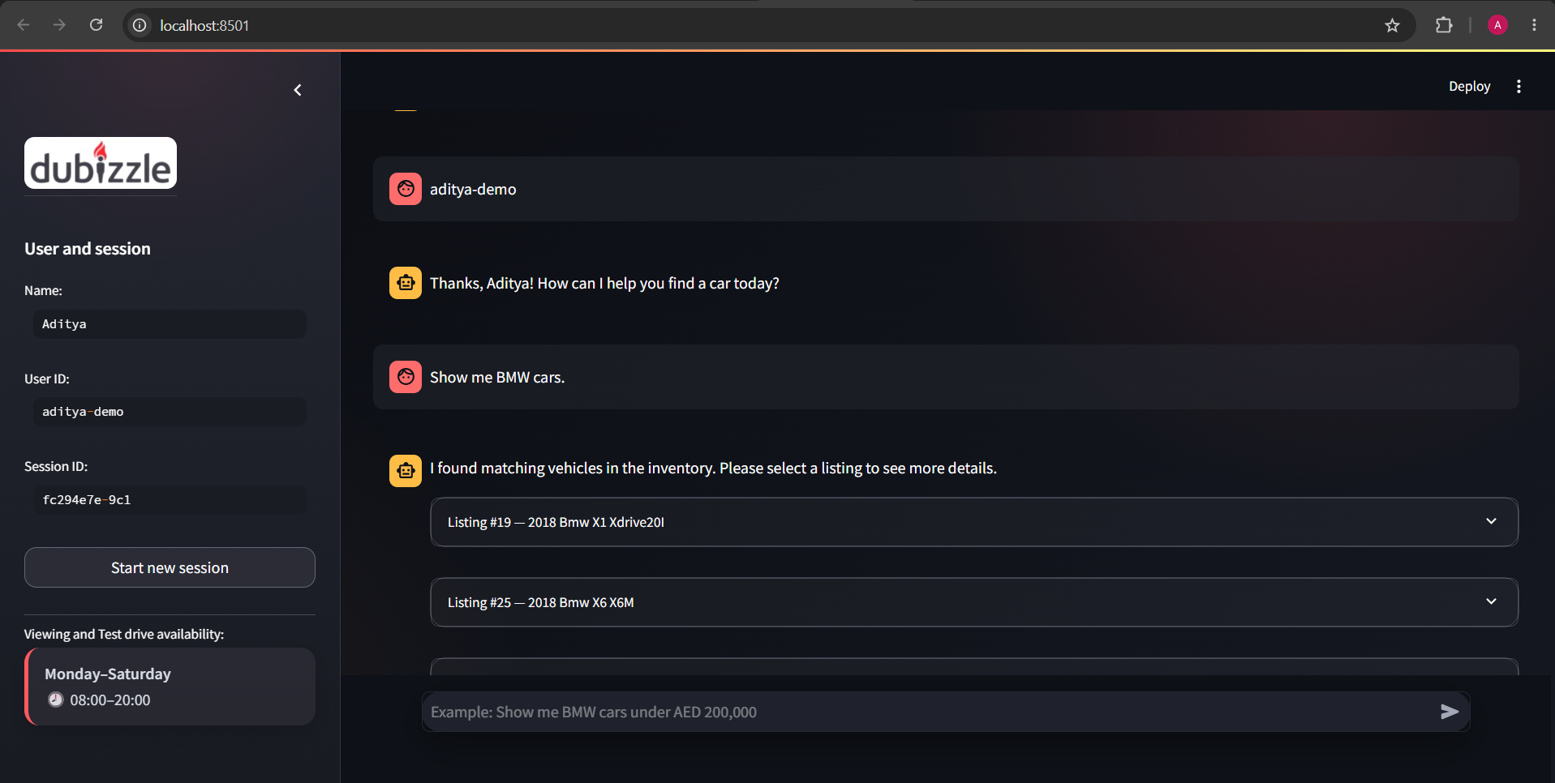

- UNDERSTAND USER REQUEST AND PROVIDE RESULT
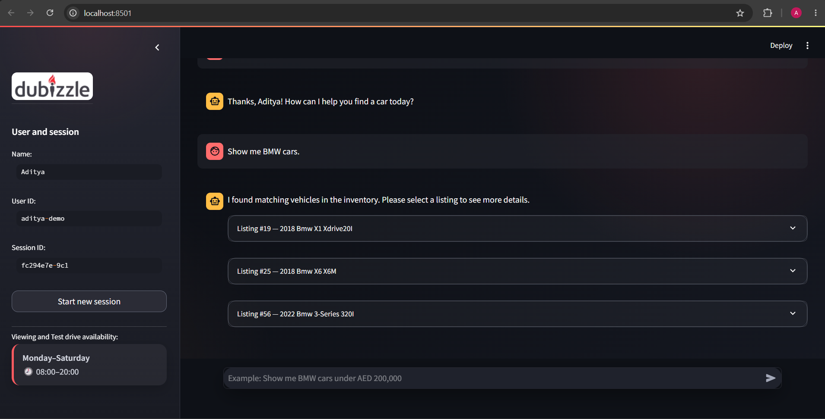

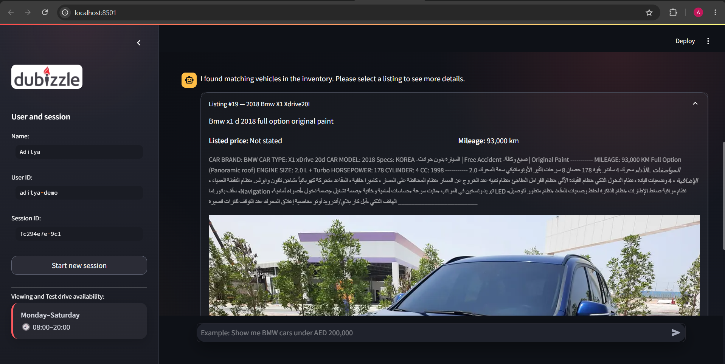

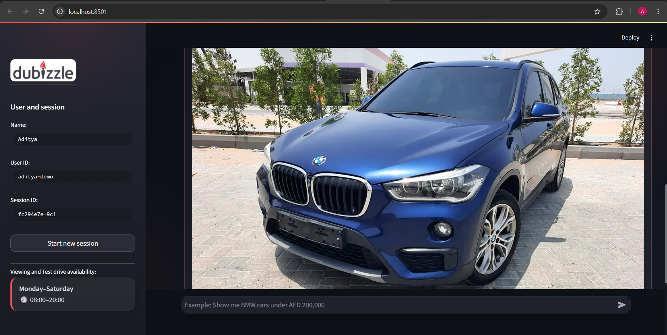

- GENERAL USER QUERY AGAIN
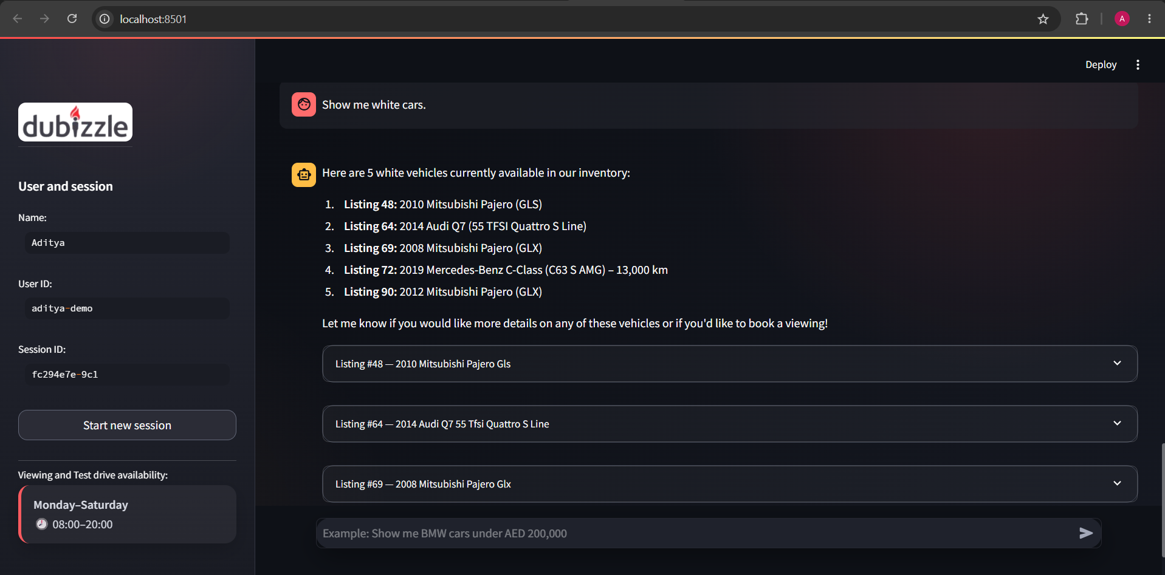

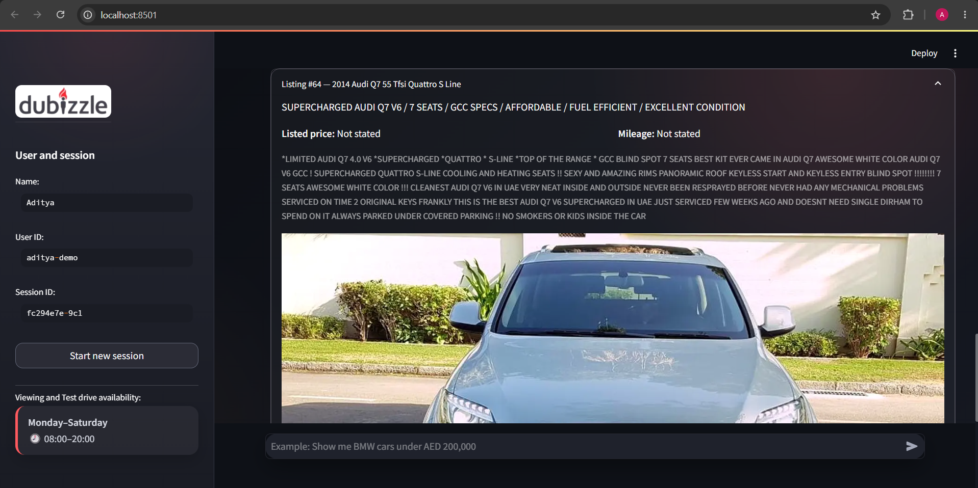

- SHORT MEMORY HAS BEEN PROVEN
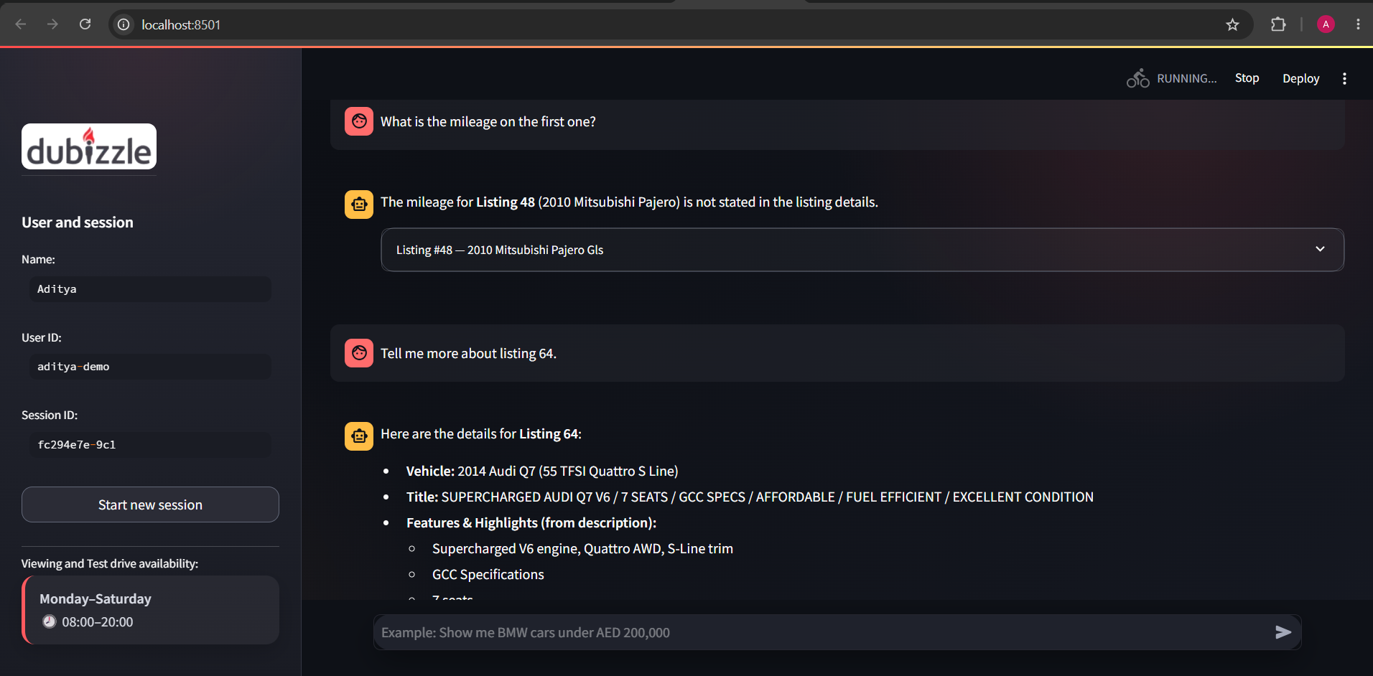

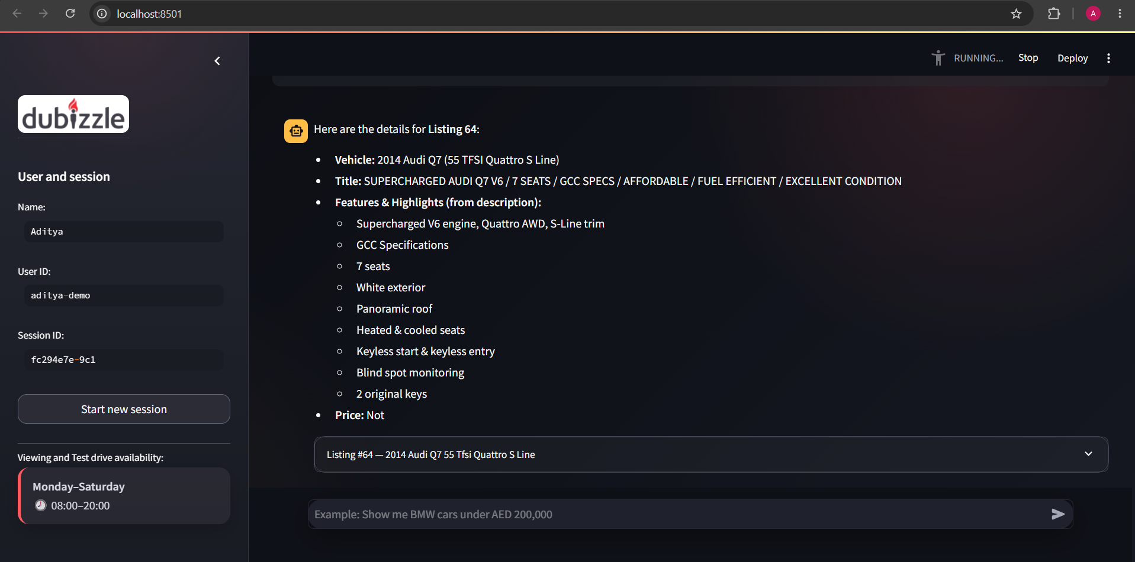

- LONG MEMORY AFTER NEW SESSION ( PLEASE NOTICE SESSION ID CHANGE)

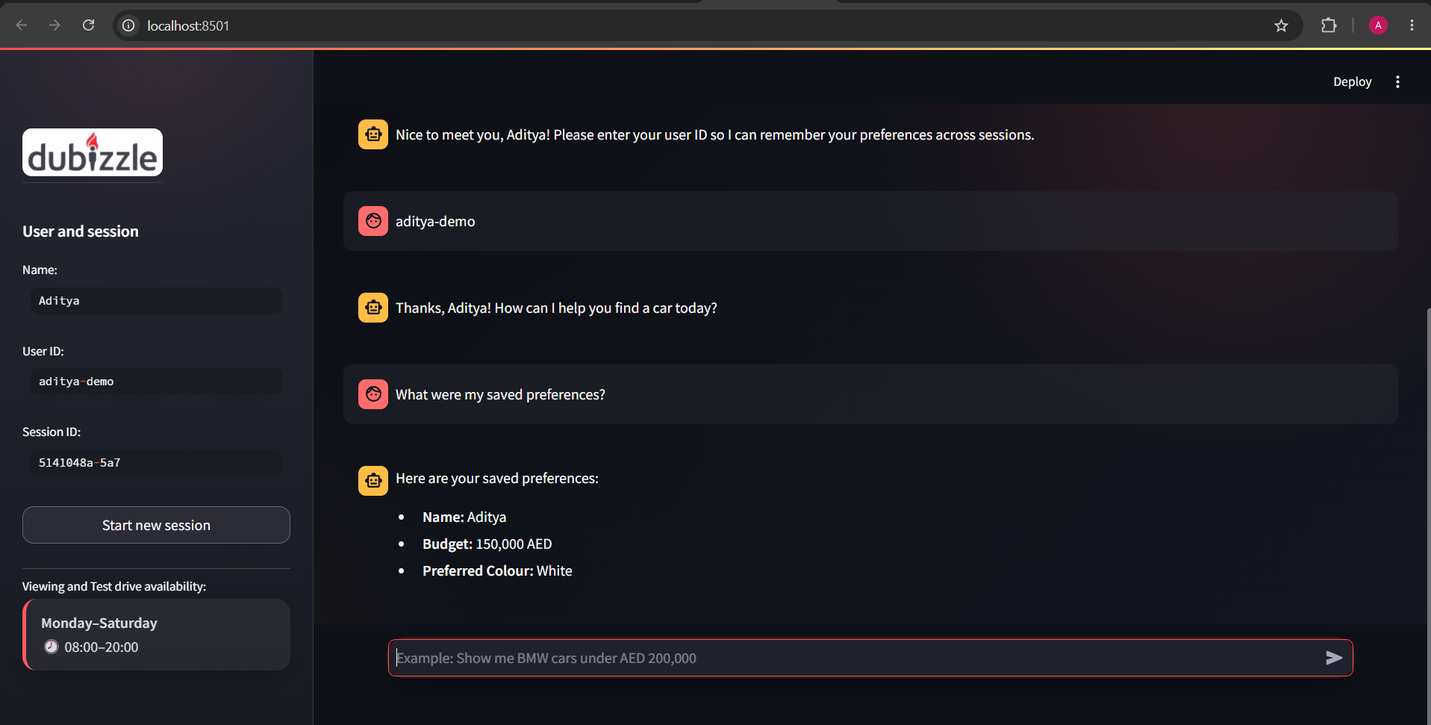

- LONG MEMORY- (AFTER STOPPING AND RUNNING BOTH APPLICATIONS ) (SESSION ID CHANGE AGAIN)
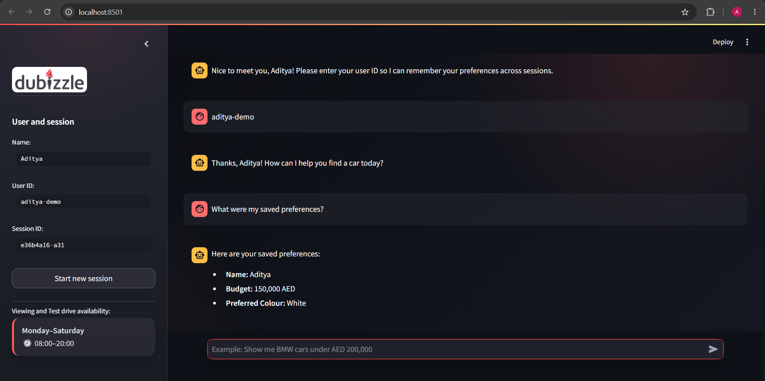

- BOOKING FOR VIEWING THE CAR (STORED IN app.db)
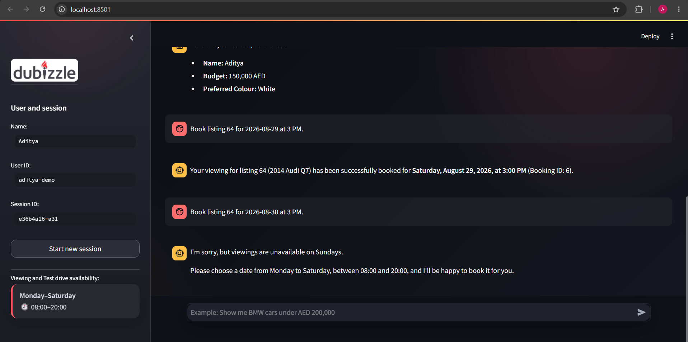

- DENIES OUTSIDE THE ALLOWED TIME
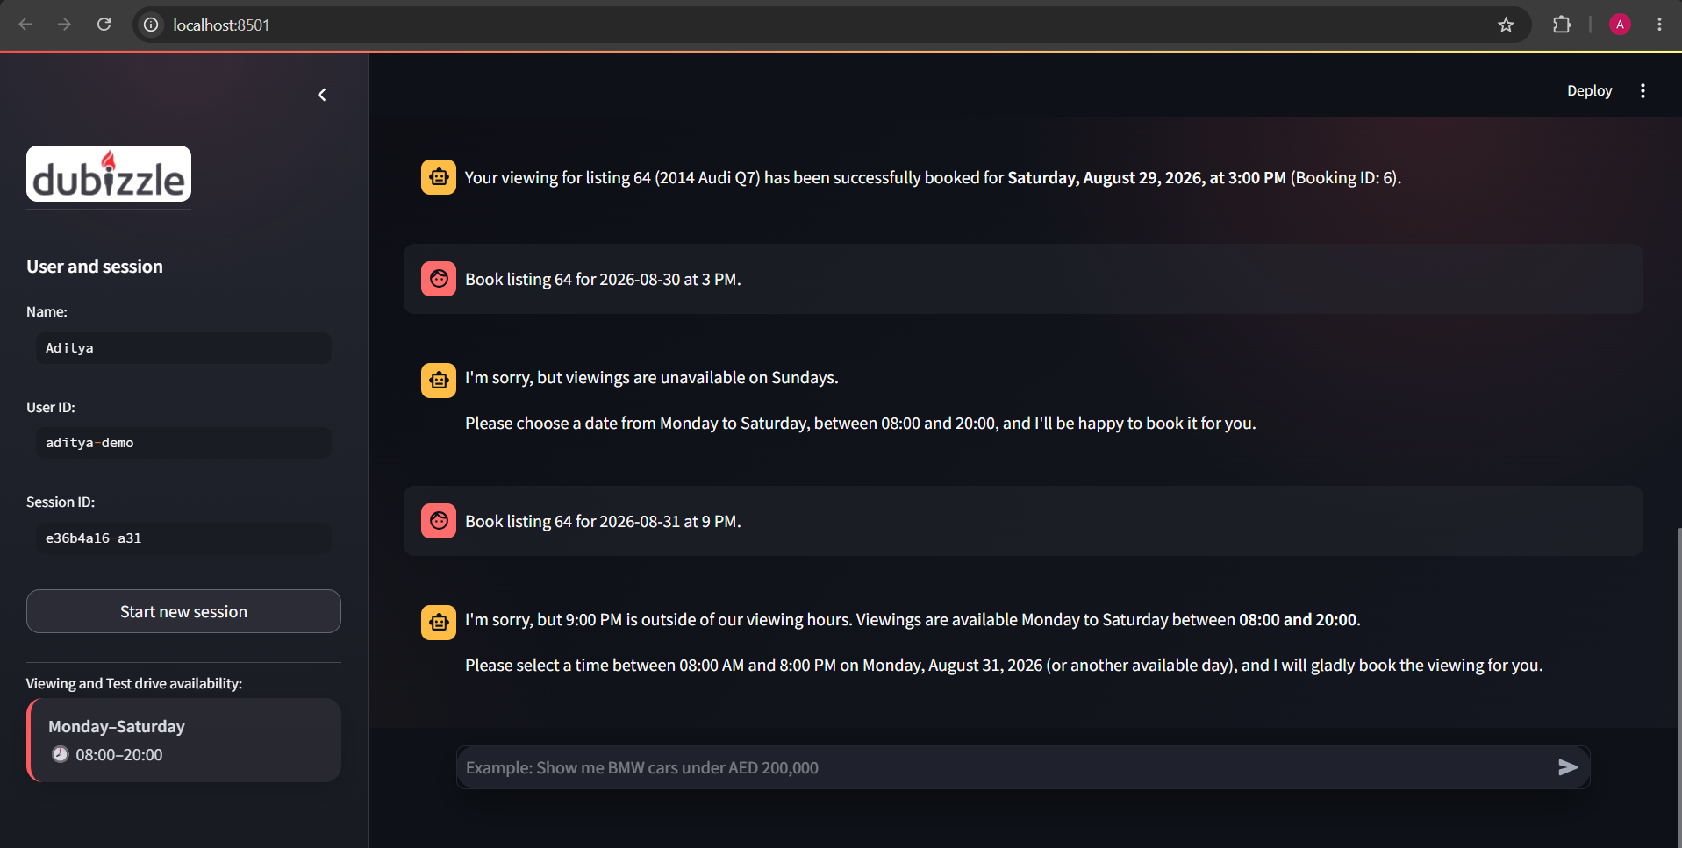

- TO SHOW LEAD GENERATION USING NEW SESSION
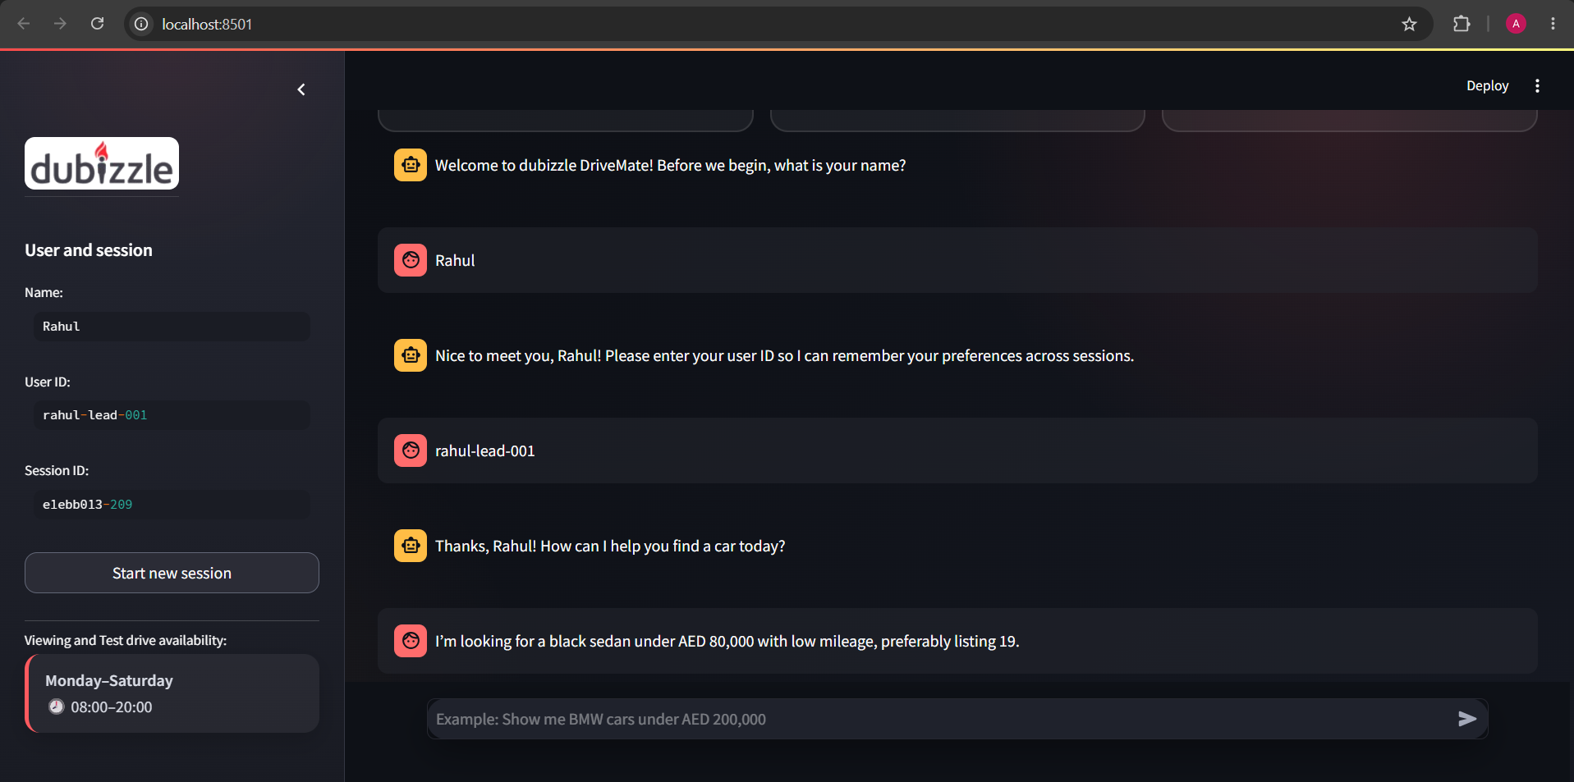
- LEAD.CSV FILE WITH USERS
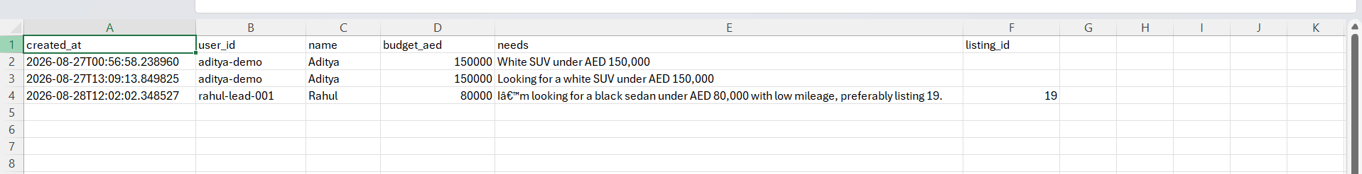
- HANDLING OUTSIDE THE SCOPE OF CAR RELATED QUERIES
