GLA UNIVERSITY


TOPIC: MINI PROJECT SYNOPSIS ON
EventHive — Event Booking Platform
Submitted By  Agrim Sharma-2415000129  Aditya Katiyar-2415000095  Mukti Sharma-2415000997  Abhinav Tiwari-2415000033 | Submitted to:  Faculty Name: Mr. Akash kumar Choudhary  Technical Trainer

DECLARATION
We, the undersigned students, declare that the mini-project proposal for "EventHive — Event Booking Platform" represents our original work. We will complete this project under the guidance and supervision of Mr. Akash Kumar Choudhary.
We confirm that our team will independently design and build the core system architecture, database, user interface, and source code. If we use any third-party open-source libraries, documentation, or existing research, we will properly cite them according to institutional guidelines.
Additionally, this project proposal has not been submitted, in whole or in part, to any other university, institute, or examining body for any degree, diploma, or academic credit.

ACKNOWLEDGEMENT
We would like to express my sincere gratitude to our Technical Trainer, Mr. Akash kumar Choudhary, for his valuable guidance, constant support, and encouragement throughout the initial planning and design of the EventHive project. His insights into full-stack development and industry best practices have been instrumental in helping us shape this project synopsis.
I am also thankful to our university and the Department of Computer Science & Engineering for providing the necessary infrastructure, resources, and technical environment required to undertake this mini-project.
Finally, I extend my heartfelt thanks to my teammates for their active collaboration, as well as our parents and peers for their continuous encouragement during the preparation of this report.

CERTIFICATE
This is to certify that the mini-project synopsis on "EventHive — Event Booking Platform (MERN Stack)" has been successfully submitted by Agrim Sharma-2415000129, Aditya Katiyar-2415000095, Mukti Sharma-2415000997, Abhinav Tiwari-2415000033 in partial fulfillment of the academic requirements.

___________________________
Signature of the Guide
(Mr. Akash kumar Choudhary)

INDEX

S.NO | Topic
1 | Introduction / Abstract / Title
2 | Primary Reason & Main Objective
3 | Scope & Working Methodology
4 | System & Hardware Requirements
5 | Front End and Back End
6 | Module Description
7 | DFD 0 level, 1 level and 2 level
8 | Bibliography & References

INTRODUCTION:

About the Project:
In the modern event management industry, a strong digital presence is crucial for connecting with clients and organizing operations. EventHive is a full-stack web application designed to simplify event package browsing, booking inquiries, and lead management.The platform serves as a centralized digital space to elegantly showcase a diverse array of event packages—ranging from intimate birthday parties to grand weddings and corporate seminars. Beyond merely displaying services, EventHive is built to seamlessly capture client bookings and transform inquiries into valuable business leads.
Key Highlights of the Project:
- Robust Tech Stack: Utilizing the MERN stack (MongoDB, Express.js, React.js, Node.js) provides an integrated JavaScript-based environment for full-stack web development.”
- Engaging User Experience: The front end utilizes React, HTML5, CSS3, and JavaScript to deliver a responsive, interactive, and user-friendly interface across different devices
- Automated Lead Capture: Replaces manual tracking with dynamic forms that securely store client requirements directly into a MongoDB NoSQL database.
- Scalable Architecture: Adheres strictly to clean coding practices, REST API design principles, and Git/GitHub version control to ensure the platform is maintainable and ready for future growth.

Primary Reason to Choose This Project:
The primary reason for selecting this project is to bridge the gap between event organizers and potential clients. Traditional methods of event booking often rely on manual tracking, phone calls, and scattered emails, leading to missed leads. EventHive automates this workflow by offering a digital catalog and an automated lead-capture system, while also providing our team with hands-on experience in full-stack MERN development and modern version control (Git/GitHub).

The Main Objective of the Project:
1. To develop a scalable web application that showcases diverse event packages interactively.
2. To design and implement RESTful APIs for handling booking inquiries and form submissions.
3. To capture and manage client leads effectively in a NoSQL database (MongoDB).
4. To apply industry-standard practices including clean coding, component-based UI design, and Git version control.

Scope Of the Project:
The initial scope of EventHive includes a responsive user frontend to browse packages and submit booking inquiries. The backend will process these requests and store them as leads in the database. An admin view will be provided to track incoming bookings. Future expansions could include a fully integrated payment gateway, real-time chat support for clients, and automated email confirmations.

Working Methodology of the Project:
We are following an Agile development methodology to build EventHive step-by-step:
- Planning & Design: Creating basic layout designs for the event catalog and booking forms.
- Backend Setup: Building the server with Node.js and Express, and setting up MongoDB to store event and booking data.
- Frontend Setup: Building interactive user screens using React and styling them to look clean and modern.
- Integration & Testing: Connecting the React frontend to the Express backend so forms and data work smoothly together.
- Version Control & Deployment: Managing code updates using Git/GitHub and publishing the final app to the web.

Details About the Hardware and the Software

System Requirements: -
To run and develop the EventHive application, the following system setup is required.

Supported Operating system: -
• Windows 10 / 11
• macOS

Software Required:
• Code Editor: Visual Studio Code
• Environment: Node.js
• Database: MongoDB Atlas (Cloud) / MongoDB Community Server (Local)
• Version Control: Git & GitHub
• API Testing: Postman or Thunder Client

Hardware Requirements: -
• Processor: Intel Core i3 / i5 or AMD equivalent
• RAM: Minimum 4 GB
• Storage: Minimum 1GB
• Internet: Stable internet connection

Listing Out testing technology:
• Postman for REST API endpoint testing.
• Manual testing for cross-browser responsiveness.

Frontend and Backend: -

Frontend:
React.js, HTML5, CSS3, JavaScript , BootStrap for styling.

Backend:
Node.js runtime environment, Express.js framework, MongoDB

Module Description:
The system is divided into two primary modules:
1. User Module: Allows visitors to view available event packages, read details, and fill out a booking/lead generation form with their contact details and event requirements.
2. Admin Module: An admin interface where event organizers can log in, view all submitted booking requests (leads), and update or add new event packages

Data Flow Diagrams
DFD: A data flow diagram (DFD) illustrates how data is processed by a system in terms of inputs and outputs. As its name indicates, its focus is on the flow of information, where data comes from, where it goes, and how it gets stored.

0 Level DFD: -
Context Diagram: Shows the external entities (User/Client and Admin) interacting with the EventHive System as a whole. The user provides booking details, and the admin receives lead reports.
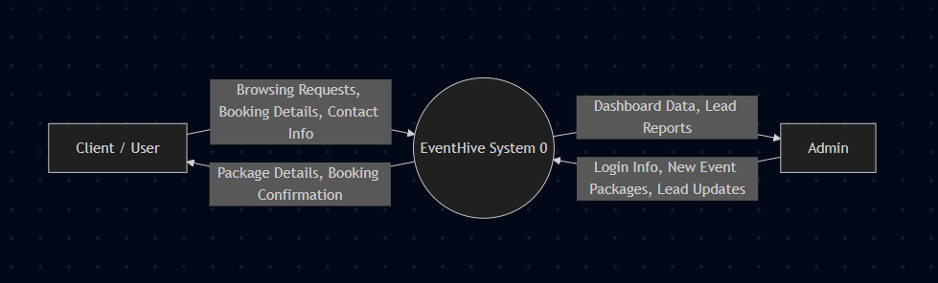

1 level DFD:
Breaks down the main system into primary processes: Package Browsing, Lead Capture/Booking Submission, and Data Storage. It shows the data flowing from the UI to the API server.

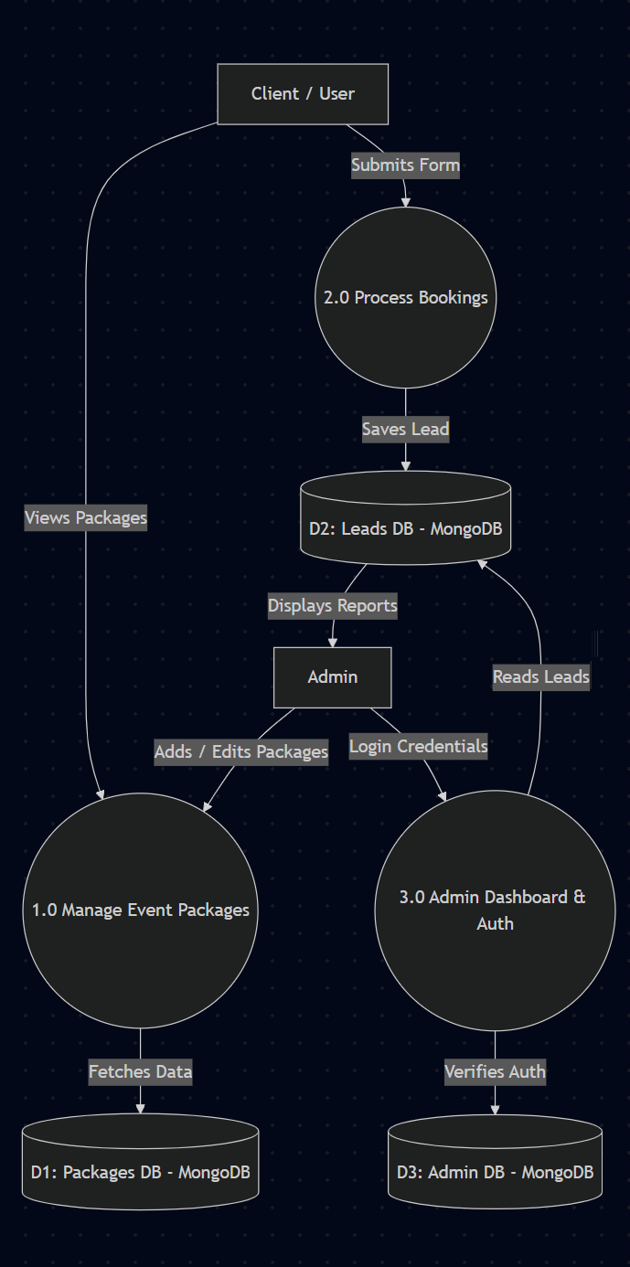

2 level DFD:
Detailed flow showing database interactions. For instance, the Booking Submission process validates user input, sends a POST request to the API, and inserts a new lead document into the MongoDB database.
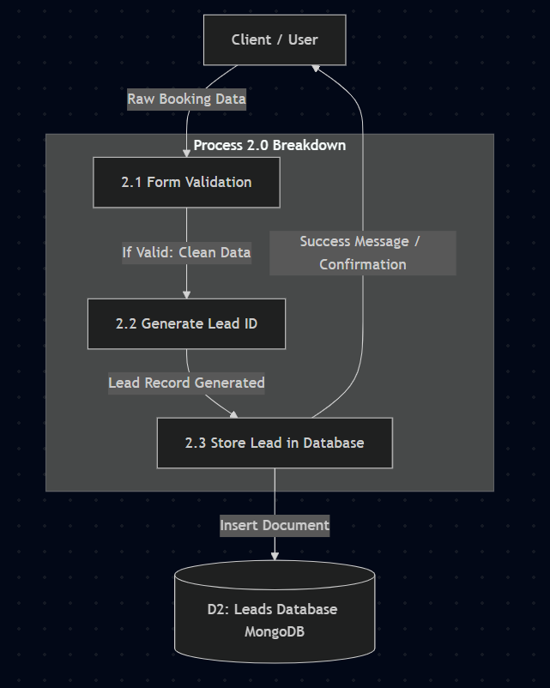

References:
• Node.js Official Documentation - https://nodejs.org/api/
• React.js Official Documentation - https://react.dev/
• Express.js Official Documentation - https://expressjs.com/
• MongoDB Official Documentation - https://www.mongodb.com/docs/manual/
• GitHub Documentation - https://docs.github.com/en

