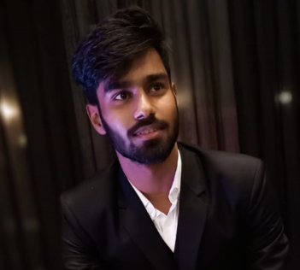

Registration Number: 21BCY10119

Email: aditya94118@gmail.com

Phone: +91 7974310090

<https://www.linkedin.com/in/aditya-kumar-https://github.com/AdityaaSunny>

<https://net-flix-wheat.vercel.app/>

**Aditya Kumar**

**Technical Skills:** C++, Java, HTML/CSS, JavaScript, ReactJS, SQL, Figma, UX, Python(basics)

**Certification:**

* HTML, CSS, and JavaScript for Web Developers, Coursera
* Bits and Bytes of Computer Networking, Coursera

|  |  |  |  |
| --- | --- | --- | --- |
| **EDUCATION** | | | |
| **Board** | **Tenure** | **Educational institution** | **CGPA/Percentage** |
| B. Tech (CSE)  Cybersecurity | Jun 21 –Ongoing | Vellore Institute of Technology,Bhopal | 7.75/10 |
| Class XII | May 21 | Gandhi Nagar Public School, Moradabad | 85.0% |
| Class X | May 19 | Gandhi Nagar Public School, Moradabad | 94.4% |

|  |  |
| --- | --- |
| **ACADEMIC PROJECTS** | |
| Front end | * **Netflix Clone** (Sept 23 – ongoing)   + Description: A try to create a full Netflix webpage   + Technology: HTML/CSS, JavaScript   + Team Project: Individual Project   + Link and Results: https://net-flix-wheat.vercel.app/ |
| Front End | * **Portfolio** (August 23- Sept 23)   + Description: A responsive portfolio website   + Technology: HTML/CSS, JavaScript   + Team Project: Individual Project   + Link and Results: https://portfolio-f34z284pw-adityas-projects-a4fd0286.vercel.app/ |

|  |  |
| --- | --- |
| **INTERNSHIP** | |
| Technook  Oct 22- Dec 22 | * **Technook (Basics Of Cybersecurity):**   + Was trained basics of cybersecurity and completed 2 major projects under guidance of mentors. |
| Bharat Intern  Aug 23 – Sept23 | * **Bharat Intern(Web Development):** * Completed 3 projects |

|  |  |
| --- | --- |
| CO-CURRICULARS | |
| Coding | * Hackerrank 5 Star in Java. * Hackerrank 3 star in Cpp. |

|  |  |
| --- | --- |
| EXTRA-CURRICULARS AND ACHIEVEMENTS | |
| Achievements | * Cranes Varsity certification of Training |
| Responsibilities | * Core Member, Fusion Club |

|  |  |
| --- | --- |
| ADDITIONAL INFORMATION | |
| Hobbies | * Avid Book Reader * Playing Video Games |
| Languages | * English, Hindi |