Kendriya Vidyalaya Upper Camp
Dehradun(Uttarakhand)

A Project Report
on

“unique CD and dvd Library Management System”

For
AISSCE 2012 Examination
[As a part of the Informatics Practices Course (065)]

SUBMITTED BY
NAME ROLL NO.
1. ISHAN PANDEY 5735096
2. RAJESH KUMAR 5735106
3. PRACHI KUKRETI 5735120

Under the Guidance of:
Mr. Rajesh Kumar Mishra
PGT (Comp.Sc)
CERTIFICATE

This is to certify that the Project / Dissertation entitled Unique CD and DVD Library Management System is a bonafide work done by Master Ishan Pandey,Master Rajesh Kumar and Miss Prachi Kukreti of class XII Session 2011-12 in partial fulfillment of CBSE’s AISSCE Examination 2012 and has been carried out under my direct supervision and guidance. This report or a similar report on the topic has not been submitted for any other examination and does not form a part of any other course undergone by the candidate.

NAME ROLL NO. SIGN. ……………..

Signature of Teacher/Guide

ISHAN PANDEY 5735096
RAJESH KUMAR 5735106 Name:Mr.Rajesh Kumar Mishra
PRACHI KUKRETI 5735120 Designation: PGT (Comp.Sc.)

……………

Signature of Principal
Place:Dehradun
Date:……………..

ACKNOWLEDGEMENT

We undertook this Project work, as the part of our XII-Informatics Practices course. We had tried to apply our best of knowledge and experience, gained during the study and class work experience. However, developing software system is generally a quite complex and time-consuming process. It requires a systematic study, insight vision and professional approach during the design and development. Moreover, the developer always feels the need, the help and good wishes of the people near you, who have considerable experience and idea.
We would like to extend our sincere thanks and gratitude to our teacher Mr.Rajesh Kumar Mishra. We are very much thankful to our Principal Mr Yogeshwar Bhardwaj for giving valuable time and moral support to develop this software.
We would like to take the opportunity to extend our sincere thanks and gratitude to our parents for being a source of inspiration and providing time and freedom to develop this software project.
We also feel indebted to our friends for the valuable suggestions during the project work.

Ishan Pandey

Rajesh Kumar

Prachi Kukreti

Class XII

C O N T E N T S

1. Introduction 5
2. Objective & Scope of the Project 6
3. Theoretical Background 7
4. Problem Definition & Analysis 9
5. System Implementation 12
6.1 The Hardware used: 12
6.2 The Softwares used: 12
6. System Design & Development 13
7.2 Database Design: 13
7.3 Menu Design: 14
7.4 I/O Forms Design & Event Coding: 15
7. User Manual 61
8.1 How to install: 61
8.2 Working with Software: 62
8. References

1. Introduction
This software project is developed to automate the functionalities of a CD Store.The purpose of the software project is to develop the Management Information System (MIS) to automate the record keeping of various CDs including those of music ,softwares and movies with a view to enhance the decision making of the functionaries.
A MIS mainly consists of a computerized database, a collection of inter-related tables for a particular subject or purpose, capable to produce different reports relevant to the user. An application program is tied with the database for easy access and interface to the database. Using Application program or front-end, we can store, retrieve and manage all information in proper way.
This software, being simple in design and working, does not require much of training to users, and can be used as a powerful tool for automating aCD Library System.
During coding and design of the software Project, Java NetBeans IDE, a powerful front-end tool is used for getting Graphical User Interface (GUI) based integrated platform and coding simplicity. As a back-end a powerful, open source RDBMS, My SQL is used as per requirement of the CBSE curriculum of Informatics Practices Course.

2. Objective & Scope of the Project
The objective of the software project is to develop a computerized MIS to automate the functions of a CD store This software project is also aimed to enhance the current record keeping system, which will help managers to retrieve the up-to-date information at right time in right shape.
The proposed software system is expected to do the following functionality-
- To provide a user friendly, Graphical User Interface (GUI) based integrated and centralized environment for MIS activities.
- The proposed system should maintain all the records and transactions, and should generate the required reports and information when required.
- To provide graphical and user-friendly interface to interact with a centralized database based on client-server architecture.
- To identify the critical operation procedure and possibilities of simplification using modern IT tools and practices.
In its current scope, the software enables user to retrieve and update the information from centralized database designed with MySQL . This software does not require much training time of the users due to limited functionality and simplicity.
During the development of CD Store Information System project, Java NetBeans IDE, a powerful, open source event-driven form-based development environment is used for modular design and future expandability of the system.
Despite of the best effort of the developer, the following limitations and functional boundaries are visible, which limits the scope of this application software.
- This software can store records and produce reports in pre-designed format in soft copy. There is no facility yet to produce customized reports. Only specified reports are covered.
- There is no provision to calculate fine or penalty etc. for defaulter members; however it can be developed easily with the help of adding modules.
So far as future scope of the project is concerned, firstly it is open to any modular expansion i.e. other modules or functions can be designed and embedded to handle the user need in future. Any part of the software and reports can be modified independently without much effort.

3. Theoretical Background

3.1 What is Database?

Introduction and Concepts:
A database is a collection of information related to a particular subject or purpose, such as tracking customer orders or maintaining a music collection. Using any RDBMS application software like MS SQL Server, MySQL, Oracle, Sybase etc, you can manage all your information from a single database file. Within the file, divide your data into separate storage containers called tables. You may and retrieve the data using queries.
A table is a collection of data about a specific topic, such as products or suppliers. Using a separate table for each topic means you can store that data only once, which makes your database more efficient and reduces data-entry errors. Table organises data into columns (called fields) and rows (called records).
A Primary key is one or more fields whose value or values uniquely identify each record in a table. In a relationship, a primary key is used to refer to specific record in one table from another table. A primary key is called foreign key when it is referred to from another table.

To find and retrieve just the data that meets conditions you specify, including data from multiple tables, create a query. A query can also update or delete multiple records at the same time, and perform built-in or custom calculations on your data.
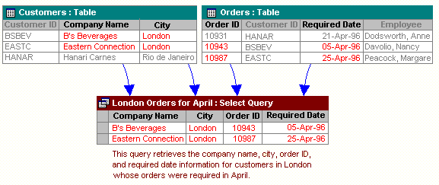

Role of RDBMS Application Program:
A computer database works as a electronic filing system, which has a large number of ways of cross-referencing, and this allows the user many different ways in which to re-organize and retrieve data. A database can handle business inventory, accounting and filing and use the information in its files to prepare summaries, estimates and other reports. The management of data in a database system is done by means of a general-purpose software package called a Database Management System (DBMS). Some commercially available DBMS are MS SQL Server, MS ACCESS, INGRES, ORACLE, and Sybase. A database management system, therefore, is a combination of hardware and software that can be used to set up and monitor a database, and can manage the updating and retrieval of database that has been stored in it. Most of the database management systems have the following capabilities:
- Creating of a table, addition, deletion, modification of records.
- Retrieving data collectively or selectively.
- The data stored can be sorted or indexed at the user's discretion and direction.
- Various reports can be produced from the system. These may be either standardized report or that may be specifically generated according to specific user definition.
- Mathematical functions can be performed and the data stored in the database can be manipulated with these functions to perform the desired calculations.
- To maintain data integrity and database use.
The DBMS interprets and processes users' requests to retrieve information from a database. In most cases, a query request will have to penetrate several layers of software in the DBMS and operating system before the physical database can be accessed. The DBMS responds to a query by invoking the appropriate subprograms, each of which performs its special function to interpret the query, or to locate the desired data in the database and present it in the desired order.

3.2 What is My SQL ? 
The management of data in a database system is done by means of a general-purpose software package called a Database Management System (DBMS). Some commercially available RDBMS are MS SQL Server, MS ACCESS, INGRES, ORACLE, and Sybase.
MySQL, the most popular Open Source SQL database management system, is developed, distributed, and supported by Oracle Corporation. MySQL is named after co-founder Monty Widenius's daughter, My. The name of the MySQL Dolphin (our logo) is “Sakila,”.
- MySQL is a database management system.
A database is a structured collection of data. It may be anything from a simple shopping list to a picture gallery or the vast amounts of information in a corporate network. To add, access, and process data stored in a computer database, you need a database management system such as MySQL Server. Since computers are very good at handling large amounts of data, database management systems play a central role in computing, as standalone utilities, or as parts of other applications.
- MySQL is based on SQL.
A relational database stores data in separate tables rather than putting all the data in one big storeroom. This adds speed and flexibility. The SQL part of “MySQL” stands for “Structured Query Language.” SQL is the most common standardized language used to access databases and is defined by the ANSI/ISO SQL Standard. The SQL standard has been evolving since 1986 and several versions exist. In this manual, “SQL-92” refers to the standard released in 1992, “SQL:1999” refers to the standard released in 1999, and “SQL:2003” refers to the current version of the standard.
- MySQL software is Open Source.
Open Source means that it is possible for anyone to use and modify the software. Anybody can download the MySQL software from the Internet and use it without paying anything. If you wish, you may study the source code and change it to suit your needs. The MySQL software uses the GPL (GNU General Public License),
- The MySQL Database Server is very fast, reliable, and easy to use.
If that is what you are looking for, you should give it a try. MySQL Server also has a practical set of features developed in close cooperation with our users. You can find a performance comparison of MySQL Server with other database managers on our benchmark page. MySQL Server was originally developed to handle large databases much faster than existing solutions and has been successfully used in highly demanding production environments for several years. Although under constant development, MySQL Server today offers a rich and useful set of functions. Its connectivity, speed, and security make MySQL Server highly suited for accessing databases on the Internet.
- MySQL Server works in client/server or embedded systems.
The MySQL Database Software is a client/server system that consists of a multi-threaded SQL server that supports different backends, several different client programs and libraries, administrative tools, and a wide range of application programming interfaces (APIs).

The Main Features of MySQL
- Written in C and C++.
- Works on many different platforms.
- Uses multi-layered server design with independent modules.
- Provides transactional and nontransactional storage engines.
- Designed to make it relatively easy to add other storage engines. This is useful if you want to provide an SQL interface for an in-house database.
- Uses a very fast thread-based memory allocation system.
- Executes very fast joins using an optimized nested-loop join.
- Implements SQL functions using a highly optimized class library that should be as fast as possible. Usually there is no memory allocation at all after query initialization.
- Provides the server as a separate program for use in a client/server networked environment, and as a library that can be embedded (linked) into standalone applications. Such applications can be used in isolation or in environments where no network is available.
- Password security by encryption of all password traffic when you connect to a server.
- Support for large databases. We use MySQL Server with databases that contain 50 million records. We also know of users who use MySQL Server with 200,000 tables and about 5,000,000,000 rows.
- MySQL client programs can be written in many languages. A client library written in C is available for clients written in C or C++, or for any language that provides C bindings.
- APIs for C, C++, Eiffel, Java, Perl, PHP, Python, Ruby, and Tcl are available, enabling MySQL clients to be written in many languages.
- The Connector/ODBC (MyODBC) interface provides MySQL support for client programs that use ODBC (Open Database Connectivity) connections.
- The Connector/J interface provides MySQL support for Java client programs that use JDBC connections. Clients can be run on Windows or Unix. Connector/J source is available.

3.3 What is NetBeans IDE ?
NetBeans started as a student project (originally called Xelfi) in the Czech Republic in 1996. The goal was to write a Delphi-like Java IDE in Java. Xelfi was the first Java IDE (Integrated Development Environment) written in Java, with its first pre-releases in 1997. Xelfi was a fun project to work on, especially since Java IDE space was uncharted territory at that time. The project attracted enough interest that these students, once they graduated, decided that they could market it as a commercial product. Soliciting resources from friends and relatives for a web space, they formed a company around it.
Soon after, they were contacted by Roman Stanek, an entrepreneur who had already been involved in several startups in the Czech Republic. He was looking for a good idea to invest in, and discovered Xelfi. He met with the founders; they hit it off, and a business was born.
In the spring of 1999, NetBeans DeveloperX2 was released, supporting Swing. The performance improvements that came in JDK 1.3, released in the fall of 1999, made NetBeans a viable choice for development tools. By the summer of 1999, the team was hard at work re-architecting DeveloperX2 into the more modular NetBeans that forms the basis of the software today.
Something else was afoot in the summer of 1999: Sun Microsystems wanted better Java development tools, and had become interested in NetBeans. It was a dream come true for the NetBeans team: NetBeans would become the flagship tool set of the maker of Java itself! By the Fall, with the next generation of NetBeans Developer in beta, a deal was struck. Sun Microsystems had also acquired another tools company, During the acqusition, the young developers who had been involved in open-source projects for most of their programming careers, mentioned the idea of open-sourcing NetBeans. Fast forward to less than six months later, the decision was made that NetBeans would be open sourced. While Sun had contributed considerable amounts of code to open source projects over the years, this was Sun's first sponsored open source project, one in which Sun would be paying for the site and handling the infrastructure.

Features of NetBeans
A free, open-source Integrated Development Environment for software developers. You get all the tools you need to create professional desktop, enterprise, web, and mobile applications with the Java platform, as well as C/C++, PHP, JavaScript, Groovy, and Ruby.
NetBeans IDE 6.9 introduces the JavaFX Composer, support for JavaFX SDK 1.3, OSGi interoperability, support for the PHP Zend framework and Ruby on Rails 3.0, and more.

4. Problem Definition & Analysis
The hardest part of building a software system is deciding precisely what to build. No other part of the conceptual work is so difficult as establishing the detailed technical requirement. Defining and applying good, complete requirements are hard to work, and success in this endeavor has eluded many of us. Yet, we continue to make progress.
Problem definition describes the What of a system, not How . The quality of a software product is only as good as the process that creates it. Problem definition is one of the most crucial steps in this creation process. Without defining a problem, developers do not know what to build, customers do not know what to expect, and there is no way to validate that the built system satisfies the requirement.
Problem definition and Analysis is the activity that encompasses learning about the problem to be solved, understanding the needs of customer and users, trying to find out who the user really is, and understanding all the constraints on the solution. It includes all activities related to the following:
- Identification and documentation of customer’s or user’s needs.
- Creation of a document that describes the external behavior and the association constraints that will satisfies those needs.
- Analysis and validation of the requirements documents to ensure consistency, completeness, and feasibility
- Evolution of needs.
After the analysis of the functioning of a Public Library system, the proposed System is expected to do the following: -
- To provide a user friendly, Graphical User Interface (GUI) based integrated and centralized environment for computerized CD Store.
- The proposed system should maintain all the records and transactions, and should generate the required reports and information when required.
- To provide efficient and secured Information storage, flow and retrieval system, ensuring the integrity and validity of records.
- To provide graphical and user-friendly interface to interact with a centralized database based on client-server architecture.
- To identify the critical operation procedure and possibilities of simplification using modern IT tools and practices.

5. System Implementation

5.1 The Hardware used:

While developing the system, the used hardware are:
PC with Pentium IV processor or sometimes, PC with Celeron (1.7 GHz) processor having 256 MB RAM, SVGA and other required devices.

5.2 The Softwares used:
- Microsoft Windows® XP as Operating System.
- Java NetBeans 6.9 as Front-end Development environment.
- MySQL as Back-end Sever with Database for Testing.
- MS-Word 2007 for documentation.

6. System Design & Development

6.1 Database Design:
An important aspect of system design is the design of data storage structure. To begin with a logical model of data structure is developed first. A database is a container object which contains tables, queries, reports and data validation policies enforcement rules or contraints etc. A logical data often represented as a records are kept in different tables after reducing anomalies and redundancies. The goodness of data base design lies in the table structure and its relationship.
This software project maintains a database named board_project which contains the following tables.

Table Design:
The database of Library System contains 9 tables. The tables are normalized to minimize the redundancies of data and enforcing the validation rules of the organization. Most of the tables are designed to store master records. The tables and their structure are given below.

Table: AlbumsList
Column Name Type Size
Item_code Integer 30
name char 50
date_of_release char 30
price float (11,2)

Table: elogin_info
Column Name Type Size
username char 20
password char 20

Table: lib
Column Name Type Size
Acc_no(primary key,not null) int 4
btitle varchar 40
author varchar 30
pub_id int 4
price float
pdate date
edition int 4
status char 1
Table: login_info
Column Name Type Size
userid char 20
passwrd char 20

Table: member
Column Name Type Size
Memb_no Integer 4
Mamb_Name varchar 40
Mem_add varchar 30
mDate date
medate date
mfee double (8,2)
mem_status char 1
mem_issue char 1
mem_phone varchar 12
Table: missue
Column Name Type Size
acc_no Integer 4
Memb_No Integer 4
idate date
rdate date

Table: movieslist
Column Name Type Size
Item_code Integer 30
Name char 50
Date_of_release char 30
price float (11,2)

Table: pcgameslist
Column Name Type Size
Item_code Integer 30
Name char 50
Date_of_release char 30
price float (11,2)

Table: movieslist
Column Name Type Size
Acc_no Integer 4
Memb_no Integer 4
idate date
rdate date

6.2 Menu Design:
JSS Infoware gateway comprises the following options, organized in a user friendly way. The menu system divided in Menu Bars, each having a pull down menus containing options for a specific task.

Sr. | Menu Bar | Pull Down Menu | Purpose | Forms Attached
1. | Report | PC Games | Selection of PC Games | pcgameslist.java
1. | Report | Movies | Selection of Movies | movieslist.java
1. | Report | Albums | Selection of Albums | albumslist.java
1. | Report | Members List | Viewing of members’ records. | mlist.java
2. | CDs and DVDs | Issued CDs and DVDs | Shows the issued CDs and DVDs | illist.java
3. | About | About us | Views the information about software | aboutus.java
3. | About | About Developer | Views the information about developers. | developer.java

6.3 I/O Forms Design & Event Coding:
The software project for Unique CD and DVD Library contains various forms along with programming codes. Forms (JFrames) and their event coding are given below.

Frame: f1.java

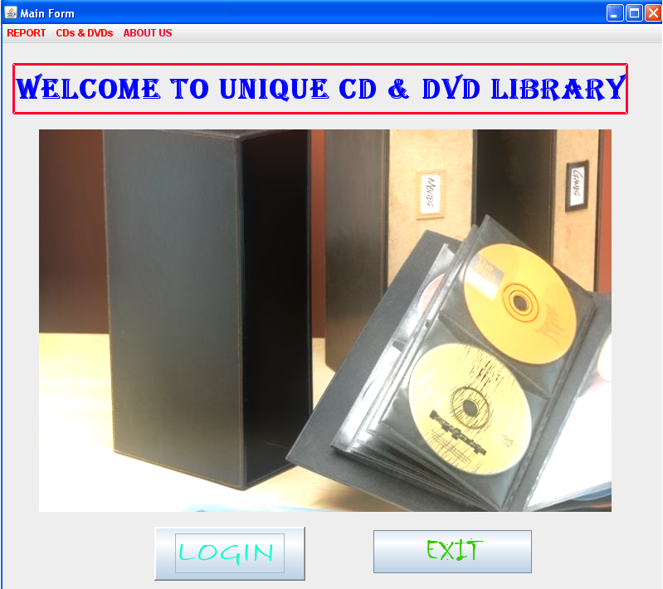
Coding for f1.java
private void login1ActionPerformed(java.awt.event.ActionEvent evt) {
new login().setVisible(true);
new login().getAlignmentX();
// TODO add your handling code here:
}

private void exitActionPerformed(java.awt.event.ActionEvent evt) {
System.exit(0); // TODO add your handling code here:
}

private void moviesFocusGained(java.awt.event.FocusEvent evt) {
// TODO add your handling code here:
}

private void pcgamesActionPerformed(java.awt.event.ActionEvent evt) {
new pcgameslist().setVisible(true); // TODO add your handling code here:
}

private void moviesActionPerformed(java.awt.event.ActionEvent evt) {
new movieslist().setVisible(true); // TODO add your handling code here:
}

private void albumsActionPerformed(java.awt.event.ActionEvent evt) {
new albumslist().setVisible(true); // TODO add your handling code here:
}

private void availablelistFocusGained(java.awt.event.FocusEvent evt) {
// TODO add your handling code here:
}

private void memlistActionPerformed(java.awt.event.ActionEvent evt) {
new mlist().setVisible(true); // TODO add your handling code here:
}

private void jMenu1ActionPerformed(java.awt.event.ActionEvent evt) {
// TODO add your handling code here:
}

private void issuedActionPerformed(java.awt.event.ActionEvent evt) {
new illist().setVisible(true); // TODO add your handling code here:
}

private void mlistActionPerformed(java.awt.event.ActionEvent evt) {
// TODO add your handling code here:
}

private void aboutActionPerformed(java.awt.event.ActionEvent evt) {
// TODO add your handling code here:
}

private void aboutusActionPerformed(java.awt.event.ActionEvent evt) {
new aboutus().setVisible(true); // TODO add your handling code here:
}

private void developerActionPerformed(java.awt.event.ActionEvent evt) {
new developer().setVisible(true); // TODO add your handling code here:
}

Frame: delet.java

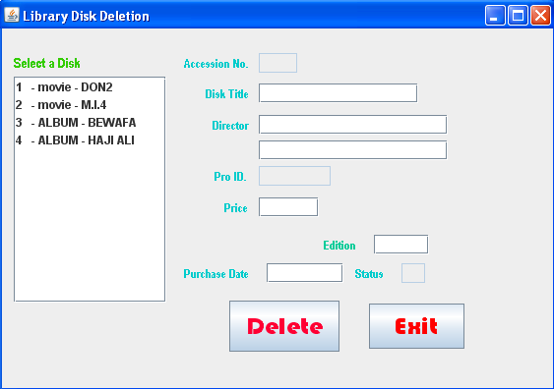
Coding of delet.java
Statement stmt = null;
ResultSet rs = null;
String SQL = "SELECT * FROM Lib";
private void cmdExitActionPerformed(java.awt.event.ActionEvent evt) {
this.setVisible(false);
}

private void cmdDeleteActionPerformed(java.awt.event.ActionEvent evt) {
try {
Class.forName("com.mysql.jdbc.Driver");
Connection con = (Connection)
DriverManager.getConnection("jdbc:mysql://localhost:3306/board_project","root","kvuc");
stmt = con.createStatement();
rs = stmt.executeQuery(SQL);
int Ano = Integer.parseInt(txtAcno.getText().trim());

// Steps to confirm deletion
int opt = JOptionPane.showConfirmDialog(null, "Are you sure to delete this record ?");
if (opt == JOptionPane.YES_OPTION) {
try {
if (txtStatus.getText().contains("Y")) {
String strSQL = "Delete from Lib where acc_no = " + (Ano);
int rowsEffected = stmt.executeUpdate(strSQL);
if (rowsEffected == 0)
JOptionPane.showMessageDialog(this, "Record does not exists");
else {
JOptionPane.showMessageDialog(this,"Record Deleted");
}
} else
JOptionPane.showMessageDialog(this,"Record cannot be deleted, because status is 'N'");
} catch (Exception e) {
JOptionPane.showMessageDialog(null, "Unable to delete");
}
}
con.close();
stmt.close();
rs.close();
} catch (Exception e) {
JOptionPane.showMessageDialog(this, e.getMessage());
}
}

private void jList1MouseClicked(java.awt.event.MouseEvent evt) {
// getSelectedValue() method extracts the current cursor location value into a variable
String MBook = (String) jList1.getSelectedValue();
// Extract the first 4 characters as Accession number into a variable
String Acno =MBook.trim().substring(0, 3);
String query = "SELECT * FROM Lib WHERE acc_no = " + Acno + ";";
try {
Class.forName("com.mysql.jdbc.Driver").newInstance();
Connection con = (Connection) DriverManager.getConnection("jdbc:mysql://localhost:3306/board_project","root","kvuc");
// Create SQL statement and execute query.
stmt = con.createStatement();
rs = stmt.executeQuery(query);
if (rs.next()) {
String bTitle = rs.getString("btitle");
String Auth1 = rs.getString("author1");
String Auth2 = rs.getString("author2");
String PID = rs.getString("pub_id");
String Price = rs.getString("price");
String PDate = rs.getString("pdate");
String edition = rs.getString("edition");
String PStatus = rs.getString("status");
// Displaying the contents in respective text boxes.
txtAcno.setText(Acno);
txtBTitle.setText(bTitle);
txtAuth1.setText(Auth1);
txtAuth2.setText(Auth2);
txtPID.setText(PID);
txtPrice.setText(Price);
txtPDate.setText(PDate);
txtEdition.setText(edition);
txtStatus.setText(PStatus);
// Close the operational object for Student
con.close();
stmt.close();
rs.close();
} else {
JOptionPane.showMessageDialog(null, "Record does not found in library table");
}
} catch (Exception e) {
JOptionPane.showMessageDialog(this, e.getMessage());
}
}

private void formWindowGainedFocus(java.awt.event.WindowEvent evt) {
txtAcno.setEditable(false);
txtPID.setEditable(false);
txtStatus.setEditable(false);
// Creating a ListModel object dModel to perform DefaultListModel
// method operations
DefaultListModel dModel = (DefaultListModel) jList1.getModel();
// Method to add elements into jList1 control
dModel.clear();
try {
Class.forName("com.mysql.jdbc.Driver");
Connection con = (Connection)
DriverManager.getConnection("jdbc:mysql://localhost:3306/Library","root","kvuc");
stmt = con.createStatement();
rs = stmt.executeQuery(SQL);
while (rs.next()) {
String Ano = rs.getString("acc_no");
String BTitle = rs.getString("btitle");
// To make the Accession no. as 4 digit because we will extract 4 digit from list value
// in mouse click event.

if (Ano.length() < 4)
{
int x = Ano.length();
int nl = 4 - x;
while (nl > 0){
Ano = Ano + " ";
nl--;
}
}
dModel.addElement(Ano + "- " + BTitle);
}
jList1.setModel(dModel);
} catch (Exception e) {
JOptionPane.showMessageDialog(this,e.getMessage());
e.printStackTrace();
} // TODO add your handling code here:
}

Frame: Return.java

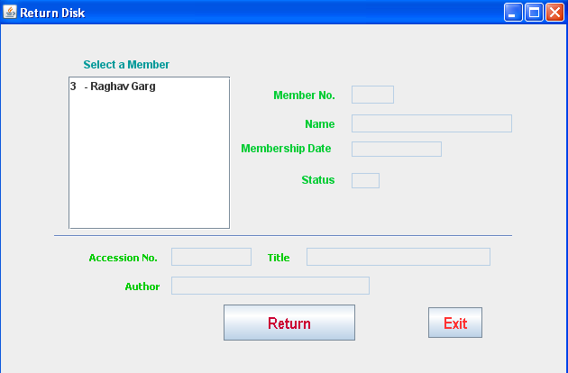

Coding for Return.java
Statement stmt = null;
ResultSet rs = null;
char st1 = 'Y';
String SQL = "SELECT * FROM Member WHERE mem_issue = '" + st1 + "';";

Statement stmt1 = null;
ResultSet rs1 = null;
char st = 'Y'; // Lib table
String SQL1 = "SELECT * FROM Lib WHERE status = '" + st + "';";

Statement stmt2 = null;
ResultSet rs2 = null;
String SQL2 = "SELECT * FROM Missue";

Statement stmt3 = null;
ResultSet rs3 = null;
String SQL3 = "SELECT * FROM Tissue";

private void jList1MouseClicked(java.awt.event.MouseEvent evt) {
// getSelectedValue() method extracts the current cursor location value into a variable
String MembNo = (String) jList1.getSelectedValue();
// Extract the first 4 characters as Member No into a variable
String Mno =MembNo.trim().substring(0, 3);
String query = "SELECT * FROM Member WHERE memb_no = " + (Mno) + ";";
try {
Class.forName("com.mysql.jdbc.Driver").newInstance();
Connection con = (Connection) DriverManager.getConnection("jdbc:mysql://localhost:3306/Library","root","kvuc");
// Create SQL statement and execute query.
stmt = con.createStatement();
rs = stmt.executeQuery(query);
if (rs.next()) {
String MName = rs.getString("memb_name");
String MDate = rs.getString("mdate");
String MStatus = rs.getString("mem_status");
// Displaying the contents in respective text boxes.
txtMNo.setText(Mno);
txtMName.setText(MName);
txtMDate.setText(MDate);
txtMStatus.setText(MStatus);
} else {
JOptionPane.showMessageDialog(null, "Record does not found in Member table");
}

// Extrating the Acc_no from Tissue table to find book details in Lib table
String query1 = "SELECT * FROM Tissue WHERE memb_no = " + (Mno) + ";";
// Create SQL statement and execute query.
stmt3 = con.createStatement();
rs3 = stmt3.executeQuery(query1);
int ACno = 0;
if (rs3.next()) {
ACno = rs3.getInt("acc_no");
txtAcno.setText(String.valueOf(ACno));
}
// Extrating the Library details for Acc_no from Lib table
String query2 = "SELECT * FROM Lib WHERE acc_no = " + (ACno) + ";";
// Create SQL statement and execute query.
stmt1 = con.createStatement();
rs1 = stmt1.executeQuery(query2);
String BTitle, Auth;
if (rs1.next()) {
BTitle = rs1.getString("btitle");
Auth = rs1.getString("author1");
txtBTitle.setText(BTitle);
txtAuth.setText(Auth);

}
} catch (Exception e) {
JOptionPane.showMessageDialog(this, e.getMessage());
}
}

private void txtMNameActionPerformed(java.awt.event.ActionEvent evt) {

}

private void txtMNamePropertyChange(java.beans.PropertyChangeEvent evt) {

}

private void txtMNameKeyPressed(java.awt.event.KeyEvent evt) {

}

private void cmdReturnActionPerformed(java.awt.event.ActionEvent evt) {
try {
Class.forName("com.mysql.jdbc.Driver");
Connection con = (Connection)
DriverManager.getConnection("jdbc:mysql://localhost:3306/Library","root","kvuc");
// Missue table
int Mno = 0, Acno = 0;
Mno = Integer.parseInt(txtMNo.getText().trim());
Acno = Integer.parseInt(txtAcno.getText().trim());
// Steps to confirm return
int opt = JOptionPane.showConfirmDialog(null, "Are you sure to return this book ?");
if (opt == JOptionPane.YES_OPTION) {
String strSQLr = "Delete from Tissue where memb_no = " + (Mno);
stmt3.executeUpdate(strSQLr);
// Change the status as library book issued
char sta = 'Y'; // Lib table
String strSQLa = "Update Lib set status ='"+(sta)+"' where acc_no = " + (Acno);
stmt1.executeUpdate(strSQLa);
// Change the status as Member has a book
char stb = 'N'; // Member table
String strSQLb = "Update Member set mem_issue ='"+(stb)+"' where memb_no = " + (Mno);
stmt.executeUpdate(strSQLb);
JOptionPane.showMessageDialog(this, "Thanks for returning book");
}
} catch (Exception e) {
JOptionPane.showMessageDialog(this, e.getMessage());
}
}

private void cmdExitActionPerformed(java.awt.event.ActionEvent evt) {
this.setVisible(false);
}

private void formWindowGainedFocus(java.awt.event.WindowEvent evt) {
txtMNo.setEditable(false);
txtMName.setEditable(false);
txtMDate.setEditable(false);
txtMStatus.setEditable(false);
txtAcno.setEditable(false);
txtBTitle.setEditable(false);
txtAuth.setEditable(false);
// dModel to perform DefaultListModel for Member
// method operations
DefaultListModel dModel = (DefaultListModel) jList1.getModel();
// Method to add elements into jList1 control for member
dModel.clear();

try {
Class.forName("com.mysql.jdbc.Driver");
Connection con = (Connection)
DriverManager.getConnection("jdbc:mysql://localhost:3306/Library","root","kvuc");

// Listing Members
stmt = con.createStatement();
rs = stmt.executeQuery(SQL);
while (rs.next()) {
String Mno = rs.getString("memb_no");
String MName = rs.getString("memb_name");
// To make the Member no. as 4 digit because we will extract 4 digit from list value
// in mouse click event.

if (Mno.length() < 4)
{
int x = Mno.length();
int nl = 4 - x;
while (nl > 0){
Mno = Mno + " ";
nl--;
}
}
dModel.addElement(Mno + "- " + MName);
}
jList1.setModel(dModel);
} catch (Exception e) {
JOptionPane.showMessageDialog(this,e.getMessage());
e.printStackTrace();
} // TODO add your handling code here:
}

Frame: aboutus.java

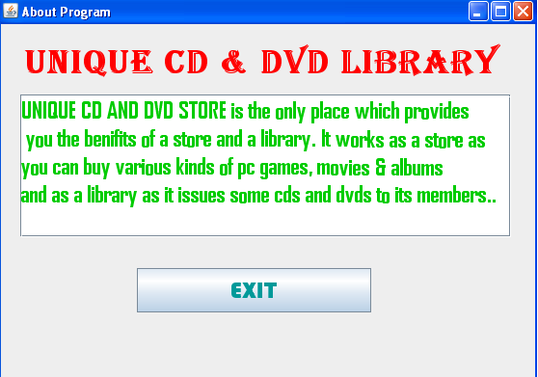
Coding for aboutus.Java
private void exitActionPerformed(java.awt.event.ActionEvent evt) {
this.dispose();
// TODO add your handling code here:
}

Frame: addemployee.java

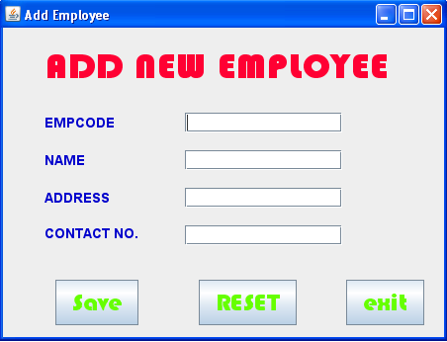
Coding of addemployee.java
public class addemployee extends javax.swing.JFrame {
Connection con=null;
Statement stmt=null;
ResultSet rs=null;
String DB="jdbc:mysql://localhost/board_project";
/** Creates new form addemployee */
public addemployee() {
initComponents();

}

/** This method is called from within the constructor to
* initialize the form.
* WARNING: Do NOT modify this code. The content of this method is
* always regenerated by the Form Editor.
*/
@SuppressWarnings("unchecked")
// <editor-fold defaultstate="collapsed" desc="Generated Code">
private void initComponents() {

jLabel1 = new javax.swing.JLabel();
jLabel2 = new javax.swing.JLabel();
jLabel3 = new javax.swing.JLabel();
jLabel4 = new javax.swing.JLabel();
jLabel5 = new javax.swing.JLabel();
t1 = new javax.swing.JTextField();
t2 = new javax.swing.JTextField();
t3 = new javax.swing.JTextField();
t4 = new javax.swing.JTextField();
save = new javax.swing.JButton();
reset = new javax.swing.JButton();
exit = new javax.swing.JButton();

setDefaultCloseOperation(javax.swing.WindowConstants.EXIT_ON_CLOSE);
setTitle("Add Employee");

jLabel1.setFont(new java.awt.Font("Arial", 1, 14));
jLabel1.setForeground(new java.awt.Color(0, 0, 204));
jLabel1.setText("EMPCODE");

jLabel2.setFont(new java.awt.Font("Arial", 1, 14));
jLabel2.setForeground(new java.awt.Color(0, 0, 204));
jLabel2.setText("NAME");

jLabel3.setFont(new java.awt.Font("Arial", 1, 14));
jLabel3.setForeground(new java.awt.Color(0, 0, 204));
jLabel3.setText("ADDRESS");

jLabel4.setFont(new java.awt.Font("Arial", 1, 14));
jLabel4.setForeground(new java.awt.Color(0, 0, 204));
jLabel4.setText("CONTACT NO.");

jLabel5.setFont(new java.awt.Font("Bauhaus 93", 1, 36));
jLabel5.setForeground(new java.awt.Color(255, 0, 51));
jLabel5.setText("ADD NEW EMPLOYEE ");

t1.setToolTipText("emp code");

t2.setToolTipText("name");

t3.setToolTipText("address");

t4.setToolTipText("contact no.");
t4.addActionListener(new java.awt.event.ActionListener() {
public void actionPerformed(java.awt.event.ActionEvent evt) {
t4ActionPerformed(evt);
}
});

save.setFont(new java.awt.Font("Bauhaus 93", 1, 24));
save.setForeground(new java.awt.Color(102, 255, 0));
save.setText("Save");
save.setToolTipText("cick to add new employee");
save.addActionListener(new java.awt.event.ActionListener() {
public void actionPerformed(java.awt.event.ActionEvent evt) {
saveActionPerformed(evt);
}
});

reset.setFont(new java.awt.Font("Bauhaus 93", 1, 24));
reset.setForeground(new java.awt.Color(102, 255, 0));
reset.setText("RESET");
reset.setToolTipText("click reset");
reset.addActionListener(new java.awt.event.ActionListener() {
public void actionPerformed(java.awt.event.ActionEvent evt) {
resetActionPerformed(evt);
}
});

exit.setFont(new java.awt.Font("Bauhaus 93", 1, 24));
exit.setForeground(new java.awt.Color(102, 255, 0));
exit.setText("exit");
exit.setToolTipText("click to exit");
exit.addActionListener(new java.awt.event.ActionListener() {
public void actionPerformed(java.awt.event.ActionEvent evt) {
exitActionPerformed(evt);
}
});

javax.swing.GroupLayout layout = new javax.swing.GroupLayout(getContentPane());
getContentPane().setLayout(layout);
layout.setHorizontalGroup(
layout.createParallelGroup(javax.swing.GroupLayout.Alignment.LEADING)
.addGroup(layout.createSequentialGroup()
.addGap(42, 42, 42)
.addGroup(layout.createParallelGroup(javax.swing.GroupLayout.Alignment.LEADING, false)
.addComponent(jLabel5, javax.swing.GroupLayout.PREFERRED_SIZE, 380, javax.swing.GroupLayout.PREFERRED_SIZE)
.addGroup(layout.createSequentialGroup()
.addGroup(layout.createParallelGroup(javax.swing.GroupLayout.Alignment.TRAILING)
.addGroup(layout.createParallelGroup(javax.swing.GroupLayout.Alignment.LEADING)
.addComponent(jLabel4)
.addComponent(jLabel3)
.addComponent(jLabel2)
.addComponent(jLabel1))
.addComponent(save))
.addGroup(layout.createParallelGroup(javax.swing.GroupLayout.Alignment.LEADING)
.addGroup(layout.createSequentialGroup()
.addGap(61, 61, 61)
.addComponent(reset)
.addPreferredGap(javax.swing.LayoutStyle.ComponentPlacement.RELATED, 50, Short.MAX_VALUE)
.addComponent(exit))
.addGroup(layout.createSequentialGroup()
.addGap(47, 47, 47)
.addGroup(layout.createParallelGroup(javax.swing.GroupLayout.Alignment.LEADING, false)
.addComponent(t1, javax.swing.GroupLayout.DEFAULT_SIZE, 159, Short.MAX_VALUE)
.addComponent(t2)
.addComponent(t3)
.addComponent(t4))

.addGap(29, 29, 29)))))
.addGap(20, 20, 20))
);
layout.setVerticalGroup(
layout.createParallelGroup(javax.swing.GroupLayout.Alignment.LEADING)
.addGroup(layout.createSequentialGroup()
.addContainerGap()
.addComponent(jLabel5)
.addGap(20, 20, 20)
.addGroup(layout.createParallelGroup(javax.swing.GroupLayout.Alignment.BASELINE)
.addComponent(t1, javax.swing.GroupLayout.PREFERRED_SIZE, javax.swing.GroupLayout.DEFAULT_SIZE, javax.swing.GroupLayout.PREFERRED_SIZE)
.addComponent(jLabel1))
.addGap(18, 18, 18)
.addGroup(layout.createParallelGroup(javax.swing.GroupLayout.Alignment.BASELINE)
.addComponent(jLabel2)
.addComponent(t2, javax.swing.GroupLayout.PREFERRED_SIZE, javax.swing.GroupLayout.DEFAULT_SIZE, javax.swing.GroupLayout.PREFERRED_SIZE))
.addGap(18, 18, 18)
.addGroup(layout.createParallelGroup(javax.swing.GroupLayout.Alignment.BASELINE)
.addComponent(jLabel3)
.addComponent(t3, javax.swing.GroupLayout.PREFERRED_SIZE, javax.swing.GroupLayout.DEFAULT_SIZE, javax.swing.GroupLayout.PREFERRED_SIZE))
.addGap(18, 18, 18)
.addGroup(layout.createParallelGroup(javax.swing.GroupLayout.Alignment.LEADING)
.addComponent(jLabel4)
.addComponent(t4, javax.swing.GroupLayout.PREFERRED_SIZE, javax.swing.GroupLayout.DEFAULT_SIZE, javax.swing.GroupLayout.PREFERRED_SIZE))
.addGap(35, 35, 35)
.addGroup(layout.createParallelGroup(javax.swing.GroupLayout.Alignment.BASELINE)
.addComponent(reset)
.addComponent(save)
.addComponent(exit))
.addContainerGap())
);

pack();
}// </editor-fold>

private void t4ActionPerformed(java.awt.event.ActionEvent evt) {
// TODO add your handling code here:
}

private void saveActionPerformed(java.awt.event.ActionEvent evt) {
try {
Class.forName("com.mysql.jdbc.Driver");
DB="jdbc:mysql://localhost/board_project";
con=DriverManager.getConnection(DB,"root","kvuc");
stmt=con.createStatement();
rs =stmt.executeQuery("select * from emp;" );
String codes = t1.getText();
String name = t2.getText();
String address = t3.getText();
String contact = t4.getText();
int code = JOptionPane.showConfirmDialog(this, "Are you sure to add?", "Confirmation Dialog Box", JOptionPane.YES_NO_CANCEL_OPTION, JOptionPane.INFORMATION_MESSAGE);
if (code == JOptionPane.YES_OPTION) {
stmt.executeUpdate( "INSERT INTO emp VALUEs ('"+codes+ "', '"+name+"', '"+address+"', '"+contact+"');") ;
JOptionPane.showMessageDialog(this, "Record added successfully into Employee table");
}
save.setEnabled(false);
} catch (Exception e) {
JOptionPane.showMessageDialog(this, e.getMessage());
} // TODO add your handling code here:
}

private void resetActionPerformed(java.awt.event.ActionEvent evt) {
t1.setText("");
t2.setText("");
t3.setText("");
t4.setText(""); // TODO add your handling code here:
}

private void exitActionPerformed(java.awt.event.ActionEvent evt) {
this.dispose(); // TODO add your handling code here:
}

/**
* @param args the command line arguments
*/
public static void main(String args[]) {
java.awt.EventQueue.invokeLater(new Runnable() {
public void run() {
new addemployee().setVisible(true);
}
});
}

Frame: albumslist.java

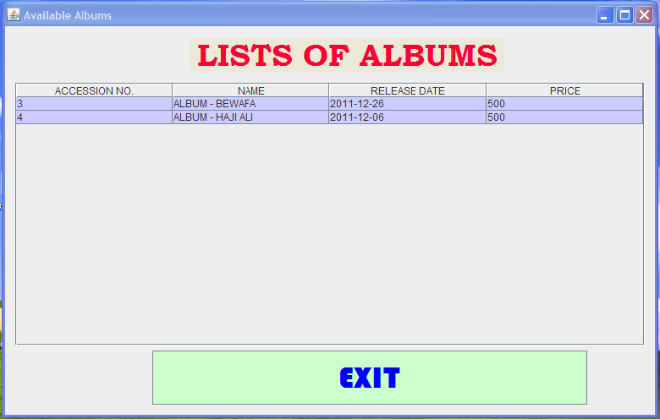

Coding for albumslist.java
public class albumslist extends javax.swing.JFrame {
Connection con=null;
Statement stmt=null;
ResultSet rs=null;
String DB="jdbc:mysql://localhost/board_project";
/** Creates new form albumslist */
public albumslist() {
initComponents();
DefaultTableModel tab = (DefaultTableModel) table.getModel();
try{
Class.forName("com.mysql.jdbc.Driver");
con=DriverManager.getConnection(DB,"root","kvuc");
stmt=con.createStatement();
rs=stmt.executeQuery("select *from lib where btitle like 'album%' ;");
String n,d,c,e;
while (rs.next())
{ n = rs.getString(1);
d = rs.getString(3);
c = rs.getString(8);
e = rs.getString(7);
Object rec[]={n,d,c,e};
tab.addRow(rec);
}
rs.close();
stmt.close();
con.close();
}
catch (Exception e)
{ JOptionPane.showMessageDialog(null,"Error in Connection"); }}

/** This method is called from within the constructor to
* initialize the form.
* WARNING: Do NOT modify this code. The content of this method is
* always regenerated by the Form Editor.
*/
@SuppressWarnings("unchecked")
// <editor-fold defaultstate="collapsed" desc="Generated Code">
private void initComponents() {

exit = new javax.swing.JButton();
jScrollPane1 = new javax.swing.JScrollPane();
table = new javax.swing.JTable();
jLabel1 = new javax.swing.JLabel();

setDefaultCloseOperation(javax.swing.WindowConstants.EXIT_ON_CLOSE);
setTitle("Available Albums");

exit.setBackground(new java.awt.Color(204, 255, 204));
exit.setFont(new java.awt.Font("Bauhaus 93", 1, 36)); // NOI18N
exit.setForeground(new java.awt.Color(0, 0, 255));
exit.setText("EXIT");
exit.addActionListener(new java.awt.event.ActionListener() {
public void actionPerformed(java.awt.event.ActionEvent evt) {
exitActionPerformed(evt);
}
});

table.setBackground(new java.awt.Color(204, 204, 255));
table.setModel(new javax.swing.table.DefaultTableModel(
new Object [][] {

},
new String [] {
"NAME", "ADDRESS", "DATE OF JOINING", "CONTACT NO."
}
) {
Class[] types = new Class [] {
java.lang.String.class, java.lang.String.class, java.lang.String.class, java.lang.Integer.class
};

public Class getColumnClass(int columnIndex) {
return types [columnIndex];
}
});
jScrollPane1.setViewportView(table);

jLabel1.setBackground(new java.awt.Color(0, 0, 0));
jLabel1.setFont(new java.awt.Font("Bookman Old Style", 1, 36)); // NOI18N
jLabel1.setForeground(new java.awt.Color(255, 0, 51));
jLabel1.setText(" LISTS OF ALBUMS");

javax.swing.GroupLayout layout = new javax.swing.GroupLayout(getContentPane());
getContentPane().setLayout(layout);
layout.setHorizontalGroup(
layout.createParallelGroup(javax.swing.GroupLayout.Alignment.LEADING)
.addGroup(layout.createSequentialGroup()
.addContainerGap()
.addGroup(layout.createParallelGroup(javax.swing.GroupLayout.Alignment.LEADING)
.addGroup(layout.createParallelGroup(javax.swing.GroupLayout.Alignment.LEADING)
.addGroup(layout.createSequentialGroup()
.addComponent(jScrollPane1, javax.swing.GroupLayout.DEFAULT_SIZE, 748, Short.MAX_VALUE)
.addContainerGap())
.addGroup(javax.swing.GroupLayout.Alignment.TRAILING, layout.createSequentialGroup()
.addComponent(jLabel1, javax.swing.GroupLayout.PREFERRED_SIZE, 368, javax.swing.GroupLayout.PREFERRED_SIZE)
.addGap(183, 183, 183)))
.addGroup(javax.swing.GroupLayout.Alignment.TRAILING, layout.createSequentialGroup()
.addComponent(exit, javax.swing.GroupLayout.PREFERRED_SIZE, 517, javax.swing.GroupLayout.PREFERRED_SIZE)
.addGap(80, 80, 80))))
);
layout.setVerticalGroup(
layout.createParallelGroup(javax.swing.GroupLayout.Alignment.LEADING)
.addGroup(javax.swing.GroupLayout.Alignment.TRAILING, layout.createSequentialGroup()
.addContainerGap()
.addComponent(jLabel1)
.addPreferredGap(javax.swing.LayoutStyle.ComponentPlacement.UNRELATED)
.addComponent(jScrollPane1, javax.swing.GroupLayout.DEFAULT_SIZE, 311, Short.MAX_VALUE)
.addPreferredGap(javax.swing.LayoutStyle.ComponentPlacement.RELATED)
.addComponent(exit)
.addContainerGap())
);

pack();
}// </editor-fold>

private void exitActionPerformed(java.awt.event.ActionEvent evt) {
this.dispose(); // TODO add your handling code here:
}

Frame: deal.java

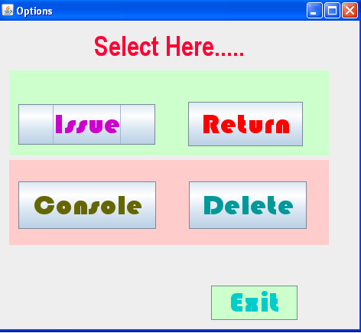
Coding for deal.java
private void issueActionPerformed(java.awt.event.ActionEvent evt) {
new issue().setVisible(true); // TODO add your handling code here:
}

private void ReturnActionPerformed(java.awt.event.ActionEvent evt) {
new Return().setVisible(true); // TODO add your handling code here:
}

private void addActionPerformed(java.awt.event.ActionEvent evt) {
new libui().setVisible(true); // TODO add your handling code here:
}

private void deleteActionPerformed(java.awt.event.ActionEvent evt) {
new Delet().setVisible(true); // TODO add your handling code here:
}

private void jButton1ActionPerformed(java.awt.event.ActionEvent evt) {
this.dispose(); // TODO add your handling code here:
}

Frame: delete.java

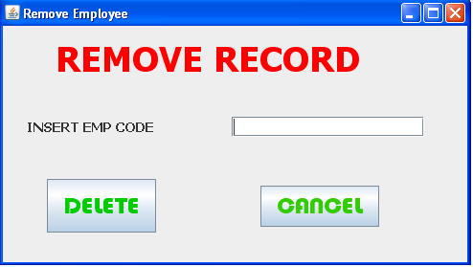
Coding of delete.Java
private void deleteActionPerformed(java.awt.event.ActionEvent evt) {
try {
Class.forName("com.mysql.jdbc.Driver");
String DB="jdbc:mysql://localhost/board_project";
Connection con=DriverManager.getConnection(DB,"root","kvuc");
Statement stmt=con.createStatement();
ResultSet rs =stmt.executeQuery("select * from emp;" );
String empcode = dt1.getText();
int opt = JOptionPane.showConfirmDialog(null, "Are you sure to delete this record ?");
if (opt == JOptionPane.YES_OPTION)
{
try {
String strSQL = "Delete from emp where emp_code = '"+(empcode)+"';";
int rowsEffected = stmt.executeUpdate(strSQL);
if (rowsEffected == 0)
JOptionPane.showMessageDialog(this, "Record does not exists");
else
{
JOptionPane.showMessageDialog(this,"Record Deleted");
dt1.setText("");
}
} catch (Exception e) {
JOptionPane.showMessageDialog(null, "Unable to delete");
}
}
} catch (Exception e) {
JOptionPane.showMessageDialog(this, e.getMessage());
} // TODO add your handling code here:
}

private void cancel2ActionPerformed(java.awt.event.ActionEvent evt) {
this.dispose(); // TODO add your handling code here:
}

/**
* @param args the command line arguments
*/
public static void main(String args[]) {
java.awt.EventQueue.invokeLater(new Runnable() {
public void run() {
new delete().setVisible(true);
}
});
}

Frame: developer.java

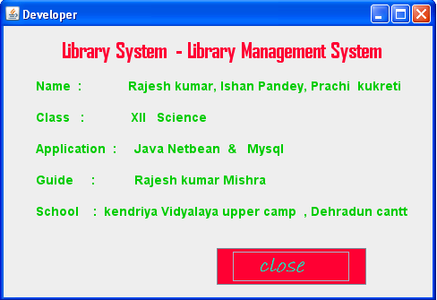
Coding for developer.java
private void jButton1ActionPerformed(java.awt.event.ActionEvent evt) {
this.dispose(); // TODO add your handling code here:
}

Frame: edit.java

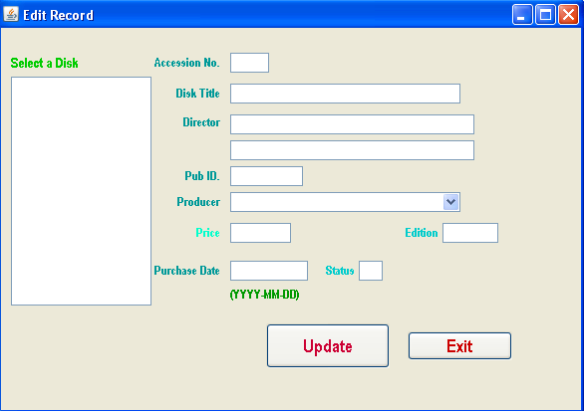
Coding for edit.java
@SuppressWarnings("unchecked")
// <editor-fold defaultstate="collapsed" desc="Generated Code">
private void initComponents() {

jScrollPane1 = new javax.swing.JScrollPane();
jList1 = new javax.swing.JList();
jLabel11 = new javax.swing.JLabel();
jLabel3 = new javax.swing.JLabel();
jLabel2 = new javax.swing.JLabel();
jLabel4 = new javax.swing.JLabel();
jLabel5 = new javax.swing.JLabel();
jLabel6 = new javax.swing.JLabel();
jLabel1 = new javax.swing.JLabel();
jLabel12 = new javax.swing.JLabel();
jLabel10 = new javax.swing.JLabel();
txtPID = new javax.swing.JTextField();
jComboBox1 = new javax.swing.JComboBox();
txtPrice = new javax.swing.JTextField();
jLabel8 = new javax.swing.JLabel();
txtEdition = new javax.swing.JTextField();
txtBTitle = new javax.swing.JTextField();
txtAcno = new javax.swing.JTextField();
txtPDate = new javax.swing.JTextField();
jLabel9 = new javax.swing.JLabel();
txtStatus = new javax.swing.JTextField();
txtAuth2 = new javax.swing.JTextField();
txtAuth1 = new javax.swing.JTextField();
cmdUpdate = new javax.swing.JButton();
cmdExit = new javax.swing.JButton();

setDefaultCloseOperation(javax.swing.WindowConstants.EXIT_ON_CLOSE);
setTitle("Edit Record");
addWindowFocusListener(new java.awt.event.WindowFocusListener() {
public void windowGainedFocus(java.awt.event.WindowEvent evt) {
formWindowGainedFocus(evt);
}
public void windowLostFocus(java.awt.event.WindowEvent evt) {
}
});

jList1.setModel(new DefaultListModel());
jList1.setToolTipText("select disk...");
jList1.addMouseListener(new java.awt.event.MouseAdapter() {
public void mouseClicked(java.awt.event.MouseEvent evt) {
jList1MouseClicked(evt);
}
});
jScrollPane1.setViewportView(jList1);

jLabel11.setFont(new java.awt.Font("Arial Narrow", 1, 14));
jLabel11.setForeground(new java.awt.Color(0, 204, 0));
jLabel11.setText("Select a Disk");

jLabel3.setFont(new java.awt.Font("Arial Narrow", 1, 12));
jLabel3.setForeground(new java.awt.Color(0, 153, 153));
jLabel3.setText("Director");

jLabel2.setFont(new java.awt.Font("Arial Narrow", 1, 12));
jLabel2.setForeground(new java.awt.Color(0, 153, 153));
jLabel2.setText("Disk Title");

jLabel4.setFont(new java.awt.Font("Arial Narrow", 1, 12));
jLabel4.setForeground(new java.awt.Color(0, 153, 153));
jLabel4.setText("Producer");

jLabel5.setFont(new java.awt.Font("Arial Narrow", 1, 12));
jLabel5.setForeground(new java.awt.Color(0, 255, 204));
jLabel5.setText("Price");

jLabel6.setFont(new java.awt.Font("Arial Narrow", 1, 12));
jLabel6.setForeground(new java.awt.Color(0, 153, 153));
jLabel6.setText("Purchase Date");

jLabel1.setFont(new java.awt.Font("Arial Narrow", 1, 12));
jLabel1.setForeground(new java.awt.Color(0, 153, 153));
jLabel1.setText("Accession No.");

jLabel12.setFont(new java.awt.Font("Arial Narrow", 1, 12));
jLabel12.setForeground(new java.awt.Color(0, 153, 153));
jLabel12.setText("Pub ID.");

jLabel10.setFont(new java.awt.Font("Arial Narrow", 1, 12));
jLabel10.setForeground(new java.awt.Color(0, 153, 0));
jLabel10.setHorizontalAlignment(javax.swing.SwingConstants.CENTER);
jLabel10.setText("(YYYY-MM-DD)");

txtPID.setToolTipText("production id...");

jComboBox1.setModel(new DefaultComboBoxModel() );
jComboBox1.setToolTipText("select producer");

txtPrice.setToolTipText("price");

jLabel8.setFont(new java.awt.Font("Arial Narrow", 1, 12));
jLabel8.setForeground(new java.awt.Color(0, 204, 204));
jLabel8.setText("Edition");

txtEdition.setToolTipText("edition");

txtBTitle.setToolTipText("title");

txtAcno.setToolTipText("disk id..");

txtPDate.setToolTipText("date of perchase in yyyy-mm-dd format...");

jLabel9.setFont(new java.awt.Font("Arial Narrow", 1, 12));
jLabel9.setForeground(new java.awt.Color(0, 204, 204));
jLabel9.setText("Status");

txtStatus.setToolTipText("status");

txtAuth2.setToolTipText("co director's name...");

txtAuth1.setToolTipText("director's name");

cmdUpdate.setFont(new java.awt.Font("Arial Narrow", 1, 18)); // NOI18N
cmdUpdate.setForeground(new java.awt.Color(204, 0, 51));
cmdUpdate.setText("Update");
cmdUpdate.setToolTipText("click to update ");
cmdUpdate.addActionListener(new java.awt.event.ActionListener() {
public void actionPerformed(java.awt.event.ActionEvent evt) {
cmdUpdateActionPerformed(evt);
}
});

cmdExit.setFont(new java.awt.Font("Arial Narrow", 1, 18));
cmdExit.setForeground(new java.awt.Color(204, 0, 0));
cmdExit.setText("Exit");
cmdExit.setToolTipText("click to exit...");
cmdExit.addActionListener(new java.awt.event.ActionListener() {
public void actionPerformed(java.awt.event.ActionEvent evt) {
cmdExitActionPerformed(evt);
}
});

javax.swing.GroupLayout layout = new javax.swing.GroupLayout(getContentPane());
getContentPane().setLayout(layout);
layout.setHorizontalGroup(
layout.createParallelGroup(javax.swing.GroupLayout.Alignment.LEADING)
.addGroup(layout.createSequentialGroup()
.addContainerGap()
.addGroup(layout.createParallelGroup(javax.swing.GroupLayout.Alignment.LEADING)
.addGroup(javax.swing.GroupLayout.Alignment.TRAILING, layout.createSequentialGroup()
.addGroup(layout.createParallelGroup(javax.swing.GroupLayout.Alignment.LEADING)
.addComponent(jScrollPane1, javax.swing.GroupLayout.DEFAULT_SIZE, 141, Short.MAX_VALUE)
.addComponent(jLabel11))
.addGap(3, 3, 3)
.addGroup(layout.createParallelGroup(javax.swing.GroupLayout.Alignment.TRAILING)
.addComponent(jLabel3)
.addComponent(jLabel2)
.addComponent(jLabel4)
.addComponent(jLabel5)
.addGroup(layout.createParallelGroup(javax.swing.GroupLayout.Alignment.LEADING)
.addComponent(jLabel6)
.addComponent(jLabel1))
.addComponent(jLabel12))
.addPreferredGap(javax.swing.LayoutStyle.ComponentPlacement.UNRELATED)
.addGroup(layout.createParallelGroup(javax.swing.GroupLayout.Alignment.LEADING)
.addComponent(jLabel10)
.addComponent(txtPID, javax.swing.GroupLayout.PREFERRED_SIZE, 73, javax.swing.GroupLayout.PREFERRED_SIZE)
.addComponent(jComboBox1, javax.swing.GroupLayout.PREFERRED_SIZE, 231, javax.swing.GroupLayout.PREFERRED_SIZE)
.addGroup(layout.createSequentialGroup()
.addComponent(txtPrice, javax.swing.GroupLayout.PREFERRED_SIZE, 61, javax.swing.GroupLayout.PREFERRED_SIZE)
.addGap(115, 115, 115)
.addComponent(jLabel8)
.addPreferredGap(javax.swing.LayoutStyle.ComponentPlacement.RELATED)
.addComponent(txtEdition, javax.swing.GroupLayout.PREFERRED_SIZE, 56, javax.swing.GroupLayout.PREFERRED_SIZE))
.addComponent(txtBTitle, javax.swing.GroupLayout.PREFERRED_SIZE, 231, javax.swing.GroupLayout.PREFERRED_SIZE)
.addComponent(txtAcno, javax.swing.GroupLayout.PREFERRED_SIZE, 39, javax.swing.GroupLayout.PREFERRED_SIZE)
.addGroup(layout.createSequentialGroup()
.addComponent(txtPDate, javax.swing.GroupLayout.PREFERRED_SIZE, 78, javax.swing.GroupLayout.PREFERRED_SIZE)
.addGap(18, 18, 18)
.addComponent(jLabel9)
.addPreferredGap(javax.swing.LayoutStyle.ComponentPlacement.RELATED)
.addComponent(txtStatus, javax.swing.GroupLayout.PREFERRED_SIZE, 24, javax.swing.GroupLayout.PREFERRED_SIZE))
.addGroup(layout.createParallelGroup(javax.swing.GroupLayout.Alignment.TRAILING, false)
.addComponent(txtAuth2, javax.swing.GroupLayout.Alignment.LEADING)
.addComponent(txtAuth1, javax.swing.GroupLayout.Alignment.LEADING, javax.swing.GroupLayout.DEFAULT_SIZE, 245, Short.MAX_VALUE)))
.addContainerGap(83, Short.MAX_VALUE))
.addGroup(javax.swing.GroupLayout.Alignment.TRAILING, layout.createSequentialGroup()
.addComponent(cmdUpdate, javax.swing.GroupLayout.PREFERRED_SIZE, 124, javax.swing.GroupLayout.PREFERRED_SIZE)
.addGap(18, 18, 18)
.addComponent(cmdExit, javax.swing.GroupLayout.PREFERRED_SIZE, 105, javax.swing.GroupLayout.PREFERRED_SIZE)
.addGap(69, 69, 69))))
);
layout.setVerticalGroup(
layout.createParallelGroup(javax.swing.GroupLayout.Alignment.LEADING)
.addGroup(layout.createSequentialGroup()
.addGroup(layout.createParallelGroup(javax.swing.GroupLayout.Alignment.TRAILING)
.addGroup(layout.createSequentialGroup()
.addGap(26, 26, 26)
.addComponent(jLabel11)
.addPreferredGap(javax.swing.LayoutStyle.ComponentPlacement.RELATED)
.addComponent(jScrollPane1, javax.swing.GroupLayout.PREFERRED_SIZE, 230, javax.swing.GroupLayout.PREFERRED_SIZE))
.addGroup(javax.swing.GroupLayout.Alignment.LEADING, layout.createSequentialGroup()
.addGap(25, 25, 25)
.addGroup(layout.createParallelGroup(javax.swing.GroupLayout.Alignment.BASELINE)
.addComponent(jLabel1)
.addComponent(txtAcno, javax.swing.GroupLayout.PREFERRED_SIZE, javax.swing.GroupLayout.DEFAULT_SIZE, javax.swing.GroupLayout.PREFERRED_SIZE))
.addGap(11, 11, 11)
.addGroup(layout.createParallelGroup(javax.swing.GroupLayout.Alignment.BASELINE)
.addComponent(jLabel2)
.addComponent(txtBTitle, javax.swing.GroupLayout.PREFERRED_SIZE, javax.swing.GroupLayout.DEFAULT_SIZE, javax.swing.GroupLayout.PREFERRED_SIZE))
.addPreferredGap(javax.swing.LayoutStyle.ComponentPlacement.UNRELATED)
.addGroup(layout.createParallelGroup(javax.swing.GroupLayout.Alignment.LEADING)
.addComponent(jLabel3)
.addComponent(txtAuth1, javax.swing.GroupLayout.PREFERRED_SIZE, javax.swing.GroupLayout.DEFAULT_SIZE, javax.swing.GroupLayout.PREFERRED_SIZE))
.addPreferredGap(javax.swing.LayoutStyle.ComponentPlacement.RELATED)
.addComponent(txtAuth2, javax.swing.GroupLayout.PREFERRED_SIZE, javax.swing.GroupLayout.DEFAULT_SIZE, javax.swing.GroupLayout.PREFERRED_SIZE)
.addGap(6, 6, 6)
.addGroup(layout.createParallelGroup(javax.swing.GroupLayout.Alignment.BASELINE)
.addComponent(jLabel12)
.addComponent(txtPID, javax.swing.GroupLayout.PREFERRED_SIZE, javax.swing.GroupLayout.DEFAULT_SIZE, javax.swing.GroupLayout.PREFERRED_SIZE))
.addPreferredGap(javax.swing.LayoutStyle.ComponentPlacement.RELATED)
.addGroup(layout.createParallelGroup(javax.swing.GroupLayout.Alignment.BASELINE)
.addComponent(jComboBox1, javax.swing.GroupLayout.PREFERRED_SIZE, javax.swing.GroupLayout.DEFAULT_SIZE, javax.swing.GroupLayout.PREFERRED_SIZE)
.addComponent(jLabel4))
.addPreferredGap(javax.swing.LayoutStyle.ComponentPlacement.UNRELATED)
.addGroup(layout.createParallelGroup(javax.swing.GroupLayout.Alignment.BASELINE)
.addComponent(txtPrice, javax.swing.GroupLayout.PREFERRED_SIZE, javax.swing.GroupLayout.DEFAULT_SIZE, javax.swing.GroupLayout.PREFERRED_SIZE)
.addComponent(jLabel5)
.addComponent(jLabel8)
.addComponent(txtEdition, javax.swing.GroupLayout.PREFERRED_SIZE, javax.swing.GroupLayout.DEFAULT_SIZE, javax.swing.GroupLayout.PREFERRED_SIZE))
.addGap(18, 18, 18)
.addGroup(layout.createParallelGroup(javax.swing.GroupLayout.Alignment.BASELINE)
.addComponent(jLabel6)
.addComponent(txtPDate, javax.swing.GroupLayout.PREFERRED_SIZE, javax.swing.GroupLayout.DEFAULT_SIZE, javax.swing.GroupLayout.PREFERRED_SIZE)
.addComponent(jLabel9)
.addComponent(txtStatus, javax.swing.GroupLayout.PREFERRED_SIZE, javax.swing.GroupLayout.DEFAULT_SIZE, javax.swing.GroupLayout.PREFERRED_SIZE))
.addPreferredGap(javax.swing.LayoutStyle.ComponentPlacement.RELATED)
.addComponent(jLabel10)))
.addGap(18, 18, 18)
.addGroup(layout.createParallelGroup(javax.swing.GroupLayout.Alignment.BASELINE)
.addComponent(cmdExit)
.addComponent(cmdUpdate, javax.swing.GroupLayout.PREFERRED_SIZE, 45, javax.swing.GroupLayout.PREFERRED_SIZE))
.addGap(42, 42, 42))
);

pack();
}// </editor-fold>
Statement stmt1 = null;
ResultSet rs1 = null;
String SQL1 = "SELECT * FROM publisher";
Statement stmt = null;
ResultSet rs = null;
String SQL = "SELECT * FROM Lib";

private void jList1MouseClicked(java.awt.event.MouseEvent evt) {
// getSelectedValue() method extracts the current cursor location value into a variable
String MBook = (String) jList1.getSelectedValue();
// Extract the first 4 characters as Accession number into a variable
String Acno =MBook.trim().substring(0, 3);
String query = "SELECT * FROM Lib WHERE acc_no = " + Acno + ";";
try {
Class.forName("com.mysql.jdbc.Driver").newInstance();
Connection con = (Connection) DriverManager.getConnection("jdbc:mysql://localhost:3306/board_project","root","kvuc");
// Create SQL statement and execute query.
stmt = con.createStatement();
rs = stmt.executeQuery(query);
if (rs.next()) {
String bTitle = rs.getString("btitle");
String Auth1 = rs.getString("author1");
String Auth2 = rs.getString("author2");
String PID = rs.getString("pub_id");
String Price = rs.getString("price");
String PDate = rs.getString("pdate");
String edition = rs.getString("edition");
String PStatus = rs.getString("status");
// Displaying the contents in respective text boxes.
txtAcno.setText(Acno);
txtBTitle.setText(bTitle);
txtAuth1.setText(Auth1);
txtAuth2.setText(Auth2);
txtPID.setText(PID);
txtPrice.setText(Price);
txtPDate.setText(PDate);
txtEdition.setText(edition);
txtStatus.setText(PStatus);
// Close the operational object for Student
con.close();
stmt.close();
rs.close();
} else {
JOptionPane.showMessageDialog(null, "Record does not found in Student table");
}
} catch (Exception e) {
JOptionPane.showMessageDialog(this, e.getMessage());
}
}

private void cmdUpdateActionPerformed(java.awt.event.ActionEvent evt) {
try {
Class.forName("com.mysql.jdbc.Driver");
Connection con = (Connection)
DriverManager.getConnection("jdbc:mysql://localhost:3306/board_project","root","kvuc");
stmt = con.createStatement();
rs = stmt.executeQuery(SQL);

int Acno = Integer.parseInt(txtAcno.getText().trim());

String bTitle = txtBTitle.getText();
String Auth1 = txtAuth1.getText();
String Auth2 = txtAuth2.getText();

// Creating a String object pName
String pName = (String) jComboBox1.getSelectedItem();
// Extract the first 4 characters as publisher number into a variable
String NPubNo = String.valueOf(pName.substring(0, 3).trim());
int Npno = Integer.parseInt(NPubNo);
int PID = Integer.parseInt(txtPID.getText());
if (Npno != PID)
PID = Npno;
float Price = Float.parseFloat(txtPrice.getText());
int edition = Integer.parseInt(txtEdition.getText());
String Pdate = txtPDate.getText();
String BStatus = txtStatus.getText();

String strSQL = "Update Lib set btitle ='"+(bTitle)+"', author1 = '"+(Auth1)+"', author2 = '"+(Auth2)+"', pub_id = "+(PID)+", price = "+(Price)+", pdate = '"+(Pdate)+"', edition = "+(edition)+", status = '"+(BStatus)+"' where acc_no = " + (Acno);
int rowsEffected = stmt.executeUpdate(strSQL);
if (rowsEffected == 0)
JOptionPane.showMessageDialog(this, "Record does not exists");
else
JOptionPane.showMessageDialog(this,"Record modified");
} catch (Exception e) {
JOptionPane.showMessageDialog(this, e.getMessage());
}
}

private void cmdExitActionPerformed(java.awt.event.ActionEvent evt) {
this.setVisible(false);
}

private void formWindowGainedFocus(java.awt.event.WindowEvent evt) {
txtAcno.setEditable(false);
txtPID.setEditable(false);
txtStatus.setEditable(false);

// Creating a ListModel object dModel to perform DefaultListModel
// method operations
DefaultListModel dModel = (DefaultListModel) jList1.getModel();
// Method to add elements into jList1 control
dModel.clear();
try {
Class.forName("com.mysql.jdbc.Driver");
Connection con = (Connection)
DriverManager.getConnection("jdbc:mysql://localhost:3306/board_project","root","kvuc");
stmt = con.createStatement();
rs = stmt.executeQuery(SQL);
while (rs.next()) {
String Ano = rs.getString("acc_no");
String BTitle = rs.getString("btitle");
// To make the Accession no. as 4 digit because we will extract 4 digit from list value
// in mouse click event.

if (Ano.length() < 4)
{
int x = Ano.length();
int nl = 4 - x;
while (nl > 0){
Ano = Ano + " ";
nl--;
}
}
dModel.addElement(Ano + "- " + BTitle);
}
jList1.setModel(dModel);
// To list the publisher id and name into JComboBox1.
DefaultComboBoxModel cModel = (DefaultComboBoxModel) jComboBox1.getModel();
cModel.removeAllElements();
stmt1 = con.createStatement(); // To list publishers in JComboBox1 component
rs1 = stmt1.executeQuery(SQL1);
while (rs1.next()) {
String pubno = rs1.getString("pub_id");
String pubName = rs1.getString("pub_name");
// To make the publisher no. as 4 digit because we will extract 4 digit from list value
// in mouse click event
txtStatus.setText("Y"); // Because it is a new book, when it will be issue,
// it's status will be N.
if (pubno.length() < 4)
{
int x = pubno.length();
int nl = 4 - x;
while (nl > 0){
pubno = pubno + " ";
nl--;
}
}
cModel.addElement(pubno + "- " + pubName);
}
} catch (Exception e) {
JOptionPane.showMessageDialog(this,e.getMessage());
e.printStackTrace();
} // TODO add your handling code here: }

Frame: employee_details.java

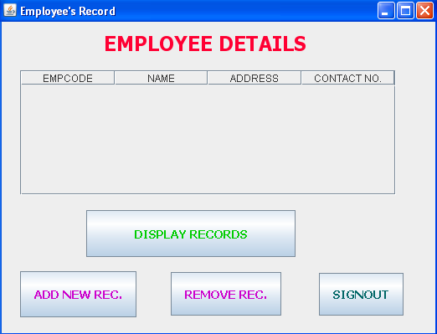
Coding for employee_details.Java
private void displayrecordsActionPerformed(java.awt.event.ActionEvent evt) {
DefaultTableModel tab = (DefaultTableModel) table.getModel();
try{
Class.forName("com.mysql.jdbc.Driver");
String DB="jdbc:mysql://localhost/board_project";
Connection con=DriverManager.getConnection(DB,"root","kvuc");
Statement stmt = con.createStatement();
ResultSet rs = stmt.executeQuery("select * from emp;" );
String n,d,c,e;
while (rs.next())
{
n= rs.getString(1);
d= rs.getString(2);
c= rs.getString(3);
e= rs.getString(4);
Object rec[]={n,d,c,e};
tab.addRow(rec);
}
rs.close();
stmt.close();
con.close();
}
catch (Exception e)
{ JOptionPane.showMessageDialog(null, e.getMessage() ); } // TODO add your handling code here:
}

private void signoutActionPerformed(java.awt.event.ActionEvent evt) {
this.dispose();
new login().setVisible(true);// TODO add your handling code here:
}

private void removerecActionPerformed(java.awt.event.ActionEvent evt) {
new delete().setVisible(true);
new delete().getAlignmentX(); // TODO add your handling code here:
}

private void addrecActionPerformed(java.awt.event.ActionEvent evt) {
new addemployee().setVisible(true);
new addemployee().getAlignmentX();// TODO add your handling code here:
}

Frame: illist.java

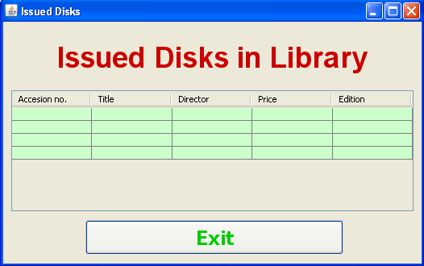

Coding for illist.java
private void cmdExitActionPerformed(java.awt.event.ActionEvent evt) {
this.setVisible(false);
}

private void formWindowGainedFocus(java.awt.event.WindowEvent evt) {
// Before writting the followng line, you should import the line:
// import javax.swing.table.*; at the top of your application
DefaultTableModel model = (DefaultTableModel) jTable1.getModel();
// Clear the existing table
int rows = model.getRowCount();
if (rows > 0) {
for (int i = 0; i < rows; i++) {
model.removeRow(0);
}
}
// SQL Query
char st = 'N'; // Lib table
String query = "SELECT * FROM Lib WHERE status = '" + st + "';";
try {
// Connect to MySQL database
Class.forName("com.mysql.jdbc.Driver").newInstance();
Connection con = (Connection) DriverManager.getConnection("jdbc:mysql://localhost/board_project","root","kvuc");
// Create SQL statement and execute query.
Statement stmt = con.createStatement();
ResultSet rs = stmt.executeQuery(query);

// Iterate through the result and display on screen
while (rs.next()) {
String acc = rs.getString("acc_no");
String bTitle = rs.getString("btitle");
String Auth = rs.getString("author1");
String Price = rs.getString("price");
String edition = rs.getString("edition");
//System.out.println(Acno + "|" + bTitle + "|" + Auth1 + "|" + Price + "|" + edition);
model.addRow(new Object[] {acc, bTitle, Auth, Price, edition});
}
}
catch (Exception e) {
JOptionPane.showMessageDialog(this, e.getMessage());
} // TODO add your handling code here:
}
Frame: issue.java

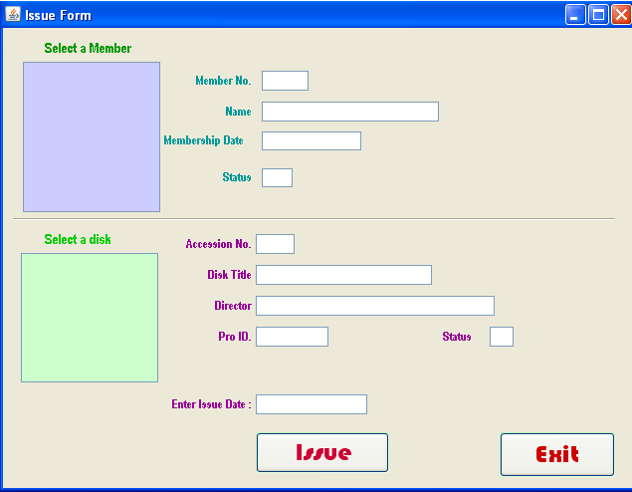
Coding for issue.java
Statement stmt = null;
ResultSet rs = null;
char st1 = 'N';
char ms = 'Y';
String SQL = "SELECT * FROM Member WHERE mem_issue = '" + st1 + "' and mem_status ='" + ms + "'";

Statement stmt1 = null;
ResultSet rs1 = null;
char st = 'Y'; // Lib table
String SQL1 = "SELECT * FROM Lib WHERE status = '" + st + "';";

Statement stmt2 = null;
ResultSet rs2 = null;
String SQL2 = "SELECT * FROM Missue";

Statement stmt3 = null;
ResultSet rs3 = null;
String SQL3 = "SELECT * FROM Tissue";
private void jList1MouseClicked(java.awt.event.MouseEvent evt) {
// getSelectedValue() method extracts the current cursor location value into a variable
String MembNo = (String) jList1.getSelectedValue();
// Extract the first 4 characters as Member No into a variable
String Mno =MembNo.trim().substring(0, 3);
String query = "SELECT * FROM Member WHERE memb_no = " + (Mno) + ";";
try {
Class.forName("com.mysql.jdbc.Driver").newInstance();
Connection con = (Connection) DriverManager.getConnection("jdbc:mysql://localhost:3306/board_project","root","kvuc");
// Create SQL statement and execute query.
stmt = con.createStatement();
rs = stmt.executeQuery(query);

if (rs.next()) {
String MName = rs.getString("memb_name");
String MDate = rs.getString("mdate");
String MStatus = rs.getString("mem_status");
// Displaying the contents in respective text boxes.
txtMNo.setText(Mno);
txtMName.setText(MName);
txtMDate.setText(MDate);
txtMStatus.setText(MStatus);
} else {
JOptionPane.showMessageDialog(null, "Record does not found in Member table");
}
} catch (Exception e) {
JOptionPane.showMessageDialog(this, e.getMessage());
}
}

private void txtMNameActionPerformed(java.awt.event.ActionEvent evt) {

}

private void txtMNamePropertyChange(java.beans.PropertyChangeEvent evt) {

}

private void txtMNameKeyPressed(java.awt.event.KeyEvent evt) {

}

private void jList2MouseClicked(java.awt.event.MouseEvent evt) {
// getSelectedValue() method extracts the current cursor location value into a variable
String MBook = (String) jList2.getSelectedValue();
// Extract the first 4 characters as Accession number into a variable
String Acno =MBook.trim().substring(0, 3);
String query = "SELECT * FROM Lib WHERE acc_no = " + Acno + ";";
try {
Class.forName("com.mysql.jdbc.Driver").newInstance();
Connection con = (Connection) DriverManager.getConnection("jdbc:mysql://localhost:3306/board_project","root","kvuc");
// Create SQL statement and execute query.
stmt1 = con.createStatement();
rs1 = stmt1.executeQuery(query);
if (rs1.next()) {
String bTitle = rs1.getString("btitle");
String Auth1 = rs1.getString("author1");
String PID = rs1.getString("pub_id");
String PStatus = rs1.getString("status");
// Displaying the contents in respective text boxes.
txtAcno.setText(Acno);
txtBTitle.setText(bTitle);
txtAuth1.setText(Auth1);
txtPID.setText(PID);
txtStatus.setText(PStatus);
} else {
JOptionPane.showMessageDialog(null, "Record does not found in Libdent table");
}
} catch (Exception e) {
JOptionPane.showMessageDialog(this, e.getMessage());
}
}

private void cmdIssueActionPerformed(java.awt.event.ActionEvent evt) {
try {
Class.forName("com.mysql.jdbc.Driver");
Connection con = (Connection)
DriverManager.getConnection("jdbc:mysql://localhost:3306/board_project","root","kvuc");
// Missue table
stmt2 = con.createStatement();
rs2 = stmt.executeQuery(SQL);

// Tissue table
stmt3 = con.createStatement();
rs3 = stmt.executeQuery(SQL);
int Acno = Integer.parseInt(txtAcno.getText().trim());
int Mno = Integer.parseInt(txtMNo.getText().trim());
String idt = txtIDate.getText();
String rdt = idt; // Temporarily assigned for testing purpose
int code = JOptionPane.showConfirmDialog(this, "Are you sure to add?", "Confirmation Dialog Box", JOptionPane.YES_NO_CANCEL_OPTION, JOptionPane.INFORMATION_MESSAGE);
if (code == JOptionPane.YES_OPTION) {
// Record updated into Missue and Tissue tables
String strSQL = "INSERT INTO Missue(acc_no, memb_no, idate, rdate) VALUES ("+(Acno)+", "+(Mno)+", '"+(idt)+"', '"+(rdt)+"')";
String strSQL1 = "INSERT INTO Tissue(acc_no, memb_no, idate, rdate) VALUES ("+(Acno)+", "+(Mno)+", '"+(idt)+"', '"+(rdt)+"')";
stmt2.executeUpdate(strSQL);
stmt3.executeUpdate(strSQL1);

// Change the status as library book issued
char sta = 'N'; // Lib table
String strSQLa = "Update Lib set status ='"+(sta)+"' where acc_no = " + (Acno);
stmt1.executeUpdate(strSQLa);

// Change the status as Member has a book
char stb = 'Y'; // Member table
String strSQLb = "Update Member set mem_issue ='"+(stb)+"' where memb_no = " + (Mno);
stmt.executeUpdate(strSQLb);
JOptionPane.showMessageDialog(this, "Record update successfully");
}
} catch (Exception e) {
JOptionPane.showMessageDialog(this, e.getMessage());
}
}

private void cmdExitActionPerformed(java.awt.event.ActionEvent evt) {
this.setVisible(false);
}

private void formWindowGainedFocus(java.awt.event.WindowEvent evt) {
txtMNo.setEditable(false);
txtMName.setEditable(false);
txtMDate.setEditable(false);
txtMStatus.setEditable(false);
txtAcno.setEditable(false);
txtBTitle.setEditable(false);
txtAuth1.setEditable(false);
txtPID.setEditable(false);
txtStatus.setEditable(false);

DefaultListModel dModel = (DefaultListModel) jList1.getModel();
// Method to add elements into jList1 control for member
dModel.clear();

try {
Class.forName("com.mysql.jdbc.Driver");
Connection con = (Connection)
DriverManager.getConnection("jdbc:mysql://localhost:3306/board_project","root","kvuc");

// Listing Members
stmt = con.createStatement();
rs = stmt.executeQuery(SQL);
while (rs.next()) {
String Mno = rs.getString("memb_no");
String MName = rs.getString("memb_name");
// To make the Member no. as 4 digit because we will extract 4 digit from list value
// in mouse click event.

if (Mno.length() < 4)
{
int x = Mno.length();
int nl = 4 - x;
while (nl > 0){
Mno = Mno + " ";
nl--;
}
}
dModel.addElement(Mno + "- " + MName);
}
jList1.setModel(dModel);

// cModel to perform DefaultListModel for Library
// method operations
DefaultListModel cModel = (DefaultListModel) jList2.getModel();
// Method to add elements into jList1 control for Library
cModel.clear();

// Listing books
stmt1 = con.createStatement();
rs1 = stmt1.executeQuery(SQL1);
while (rs1.next()) {
String Ano = rs1.getString("acc_no");
String BTitle = rs1.getString("btitle");
// To make the Accession no. as 4 digit because we will extract 4 digit from list value
// in mouse click event.
if (Ano.length() < 4)
{
int x = Ano.length();
int nl = 4 - x;
while (nl > 0){
Ano = Ano + " ";
nl--;
}
}
cModel.addElement(Ano + "- " + BTitle);
}
jList2.setModel(cModel);

} catch (Exception e) {
JOptionPane.showMessageDialog(this,e.getMessage());
e.printStackTrace();
}// TODO add your handling code here:
}

Frame: libui.java

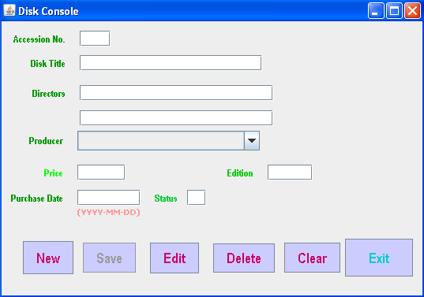
Coding for libui.java
Statement stmt = null;
ResultSet rs = null;
String SQL = "SELECT * FROM Lib";
// for table Publisher
Statement stmt1 = null;
ResultSet rs1 = null;
String SQL1 = "SELECT * FROM publisher";
private void cmdNewActionPerformed(java.awt.event.ActionEvent evt) {
// Activate the Save button when New button pressed
cmdSave.setEnabled(true);
DefaultComboBoxModel cModel = (DefaultComboBoxModel) jComboBox1.getModel();
cModel.removeAllElements();
txtStatus.setEditable(false);
// Activate the Save button when New button clicked
cmdSave.setEnabled(true);
try {
Class.forName("com.mysql.jdbc.Driver");
Connection con = (Connection)
DriverManager.getConnection("jdbc:mysql://localhost:3306/board_project","root","kvuc");

stmt = con.createStatement(); // Connection string for ResultSet - rs.
rs = stmt.executeQuery(SQL);
int acno=0, ACNO = 0;
while (rs.next()) {
ACNO = rs.getInt("acc_no");
}
ACNO++;
acno = ACNO;
txtAcno.setText(Integer.toString(acno));
stmt1 = con.createStatement(); // To list publishers in JComboBox1 component
rs1 = stmt1.executeQuery(SQL1);
while (rs1.next()) {
String pubno = rs1.getString("pub_id");
String pubName = rs1.getString("pub_name");
// To make the publisher no. as 4 digit because we will extract 4 digit from list value
// in mouse click event
txtStatus.setText("Y"); // Because it is a new book, when it will be issue,
// it's status will be N.
if (pubno.length() < 4) {
int x = pubno.length();
int nl = 4 - x;
while (nl > 0){
pubno = pubno + " ";
nl--;
}
}
cModel.addElement(pubno + "- " + pubName);
}
} catch (Exception e) {
JOptionPane.showMessageDialog(this,e.getMessage());
e.printStackTrace();
}
}

private void cmdSaveActionPerformed(java.awt.event.ActionEvent evt) {
try {
Class.forName("com.mysql.jdbc.Driver");
Connection con = (Connection)
DriverManager.getConnection("jdbc:mysql://localhost:3306/board_project","root","kvuc");
stmt = con.createStatement();
rs = stmt.executeQuery(SQL);
int Acno = Integer.parseInt(txtAcno.getText().trim());
String bTitle = txtBTitle.getText();
String Auth1 = txtAuth1.getText();
String Auth2 = txtAuth2.getText();
// Creating a String object pName
String pName = (String) jComboBox1.getSelectedItem();
// Extract the first 4 characters as publisher number into a variable
String PubNo = String.valueOf(pName.substring(0, 3).trim());
int pno = Integer.parseInt(PubNo);
jLabel10.setText(""+pno);
float Price = Float.parseFloat(txtPrice.getText());
int edition = Integer.parseInt(txtEdition.getText());
String Pdate = txtPDate.getText();
char BStatus = 'Y';
int code = JOptionPane.showConfirmDialog(this, "Are you sure to add?", "Confirmation Dialog Box", JOptionPane.YES_NO_CANCEL_OPTION, JOptionPane.INFORMATION_MESSAGE);
if (code == JOptionPane.YES_OPTION) {
String strSQL = "INSERT INTO Lib(acc_no, btitle, author1, author2, pub_id, price, pdate, edition, status) VALUES ("+(Acno)+", '"+(bTitle)+"', '"+(Auth1)+"', '"+(Auth2)+"', "+(pno)+", "+(Price)+", '"+(Pdate)+"', "+(edition)+", '"+(BStatus)+"')";
int rowsEffected = stmt.executeUpdate(strSQL);
JOptionPane.showMessageDialog(this, "Record added successfully into Lib table");
}
cmdSave.setEnabled(false);
} catch (Exception e) {
JOptionPane.showMessageDialog(this, e.getMessage());
}
}

private void cmdEditActionPerformed(java.awt.event.ActionEvent evt) {
new edit().setVisible(true);
}

private void cmdDeleteActionPerformed(java.awt.event.ActionEvent evt) {
new Delet().setVisible(true);
}

private void cmdClearActionPerformed(java.awt.event.ActionEvent evt) {
DefaultComboBoxModel cModel = (DefaultComboBoxModel) jComboBox1.getModel();
txtAcno.setText("");
txtBTitle.setText("");
txtAuth1.setText("");
txtAuth2.setText("");
cModel.removeAllElements();
txtPrice.setText("");
txtEdition.setText("");
txtPDate.setText("");
txtStatus.setText("");
cmdSave.setEnabled(false);
}

private void cmdExitActionPerformed(java.awt.event.ActionEvent evt) {
this.setVisible(false);
}

Frame: login.java

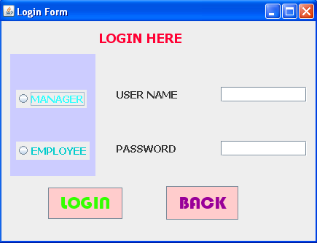
Coding for login.java
private void loginActionPerformed(java.awt.event.ActionEvent evt) {
if(rdmanager.isSelected()){
String usrid1 = lt1.getText();
try{
Class.forName("com.mysql.jdbc.Driver");
con = DriverManager.getConnection("jdbc:mysql://localhost/board_project","root","kvuc");
stmt = con.createStatement();
rs = stmt.executeQuery("select passwrd from login_info where userid ='"+usrid1+"';" );

String pswrd = new String(lp1.getPassword());
rs.next();
String psword= rs.getString(1);
if (pswrd.equals(psword)){
new employee_details().setVisible(true);

}
else
JOptionPane.showMessageDialog(this,"Invalid user name , password");
lt1.setText("");
lp1.setText("");
rs.close();
stmt.close();
con.close();
}
catch (Exception e)
{ JOptionPane.showMessageDialog(null, e.getMessage()+"error in connection" ); }
}
else
if(rdemployee.isSelected()){
String usrid1 = lt1.getText();
try{
Class.forName("com.mysql.jdbc.Driver");
con = DriverManager.getConnection("jdbc:mysql://localhost/board_project","root","kvuc");
stmt = con.createStatement();
rs = stmt.executeQuery("select password from elogin_info where username ='"+usrid1+"';" );

String pswrd = new String(lp1.getPassword());
rs.next();
String psword= rs.getString(1);
if (pswrd.equals(psword)){
new deal().setVisible(true);

}
else
JOptionPane.showMessageDialog(this,"Invalid user name , password");
lt1.setText("");
lp1.setText("");
rs.close();
stmt.close();
con.close();
}
catch (Exception e)
{ JOptionPane.showMessageDialog(null, e.getMessage()+"error in connection" ); }
}// TODO add your handling code here:
}

private void backActionPerformed(java.awt.event.ActionEvent evt) {
this.dispose(); // TODO add your handling code here:
}

Frame: mlist.java

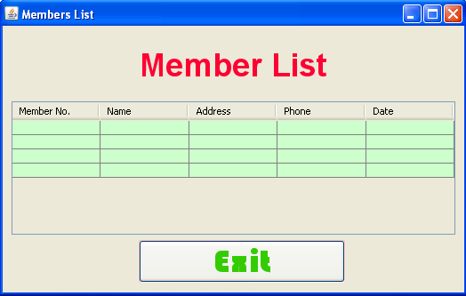
Code for mlist.java
private void cmdExitActionPerformed(java.awt.event.ActionEvent evt) {
this.setVisible(false);
}

private void formWindowGainedFocus(java.awt.event.WindowEvent evt) {
// Before writting the followng line, you should import the line:
// import javax.swing.table.*; at the top of your application
DefaultTableModel model = (DefaultTableModel) jTable1.getModel();
// Clear the existing table
int rows = model.getRowCount();
if (rows > 0) {
for (int i = 0; i < rows; i++) {
model.removeRow(0);
}
}
// SQL Query
String query = "SELECT * FROM Member";
try {
// Connect to MySQL database
Class.forName("com.mysql.jdbc.Driver").newInstance();
Connection con = (Connection) DriverManager.getConnection("jdbc:mysql://localhost/board_project","root","kvuc");
// Create SQL statement and execute query.
Statement stmt = con.createStatement();
ResultSet rs = stmt.executeQuery(query);

// Iterate through the result and display on screen
while (rs.next()) {
String Mno = rs.getString("memb_no");
String MName = rs.getString("memb_name");
String MAdd = rs.getString("memb_add");
String MPh1 = rs.getString("memb_phone");
String MDate = rs.getString("mdate");
//System.out.println(Mno + "|" + MName + "|" + MAdd + "|" + MPh1 + "|" + MDate);
model.addRow(new Object[] {Mno, MName, MAdd, MPh1, MDate});
}
}
catch (Exception e) {
JOptionPane.showMessageDialog(this, e.getMessage());
}
// TODO add your handling code here:
}

Frame: movieslist.java

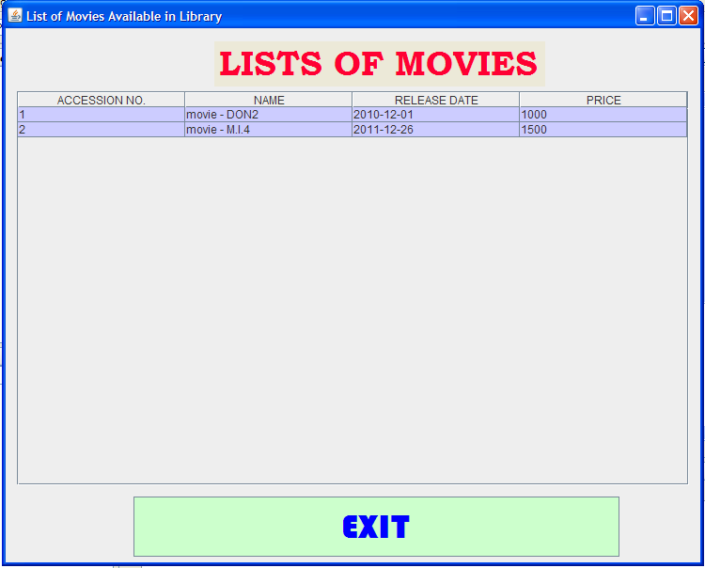
Coding for movieslist.java
public class movieslist extends javax.swing.JFrame {
Connection con=null;
Statement stmt=null;
ResultSet rs=null;
String DB="jdbc:mysql://localhost/board_project";
/** Creates new form movieslist */
public movieslist() {
initComponents();
DefaultTableModel tab = (DefaultTableModel) table.getModel();
try{
Class.forName("com.mysql.jdbc.Driver");
con=DriverManager.getConnection(DB,"root","kvuc");
stmt=con.createStatement();
rs=stmt.executeQuery("select *from lib where btitle like 'movie%' ;");
String n,d,c,e;
while (rs.next())
{ n = rs.getString(1);
d = rs.getString(3);
c = rs.getString(8);
e = rs.getString(7);
Object rec[]={n,d,c,e};
tab.addRow(rec);
}
rs.close();
stmt.close();
con.close();
}
catch (Exception e)
{ JOptionPane.showMessageDialog(null,"Error in Connection"); } }
private void exitActionPerformed(java.awt.event.ActionEvent evt) {
this.dispose(); // TODO add your handling code here:
}

Frame: pcgameslist.java

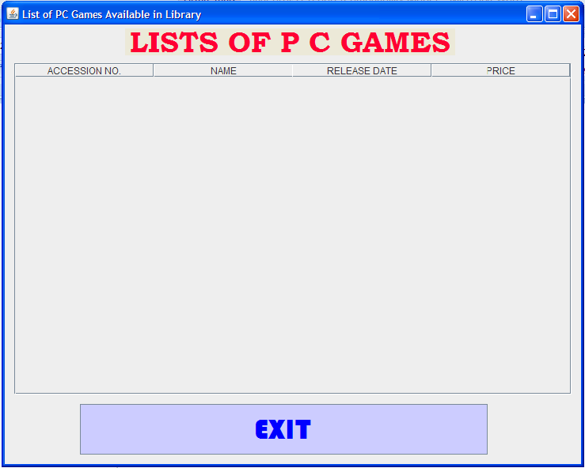
Coding for pcgameslist.java
public class pcgameslist extends javax.swing.JFrame {
Connection con=null;
Statement stmt=null;
ResultSet rs=null;
String DB="jdbc:mysql://localhost/board_project";
/** Creates new form pcgameslist */
public pcgameslist() {
initComponents();
DefaultTableModel tab = (DefaultTableModel) table.getModel();
try{
Class.forName("com.mysql.jdbc.Driver");
con=DriverManager.getConnection(DB,"root","kvuc");
stmt=con.createStatement();
rs=stmt.executeQuery("select *from lib where btitle like 'pcgames%' ;");
String n,d,c,e;
while (rs.next())
{ n = rs.getString(1);
d = rs.getString(3);
c = rs.getString(8);
e = rs.getString(7);
Object rec[]={n,d,c,e};
tab.addRow(rec);
}
rs.close();
stmt.close();
con.close();
}
catch (Exception e)
{ JOptionPane.showMessageDialog(null,"Error in Connection"); } }
private void jButton1ActionPerformed(java.awt.event.ActionEvent evt) {
this.dispose(); // TODO add your handling code here:
}

private void exitActionPerformed(java.awt.event.ActionEvent evt) {
this.dispose(); // TODO add your handling code here:
}

7. User Manual

7.1 How to installSoftware:

Hardware Requirement-
- Intel Pentium/Celeron or similar processor based PC at Client/Server end.
- 128 MB RAM and 4GB HDD space (for Database) is desirable.
- Standard I/O devices like Keyboard and Mouse etc.
- Printer is needed for hard-copy reports.
- Local Area Network(LAN) is required for Client-Server Installation

Software Requirement-
- Windows 2000/XP OS is desirable.
- NetBeans Ver 5.1 or higher should be installed with JDK and JVM.
- MySQL Ver 6.1 with Library Database must be present at machine.

Database Installation
The software project is distributed with a backup copy of a Database named board_project with required tables. Some dummy records are present in the tables for testing purposes, which can be deleted before inserting real data. The project is shipped with board_project.sql file which installs a database and tables in the computer system.
Note: The PC must have MySQL server with user (root) and password (kvuc) . If root password is any other password, it can be changed by running MySQL Server Instance Configure Wizard.
Start Program  MySQL MySQL Server MySQL Server Instance Config Wizard
Provide current password of root and new password as “kvuc” , this will change the root password.
To install a MySQL database from a dump file ( board_project.sql) , simply follow the following steps.
Step 1: Copy the board_project.sql file in C:\Program files\Mysql\MySql server 5.1\Bin folder.
Step 2: Open MySQL and type the following command to create the dabase named Library.
mysql> create database board_project;
Step 3: Open Command Window (Start Run  cmd)
Step 4: Go to the following folder using CD command of DOS.
C:\Program files\Mysql\MySql server 5.1\Bin>
Step 5: type the following command on above prompt -
C:….\bin> mysql -u root -pkvuc board_project < board_project.sql
This will create a board_project databse with required tables.

7.2 Working with SoftwareProject:
The Unique CD and DVD Library consists of the following logically organised Menu-structure for the easy functionality. User may choose the menu options for corresponding works.
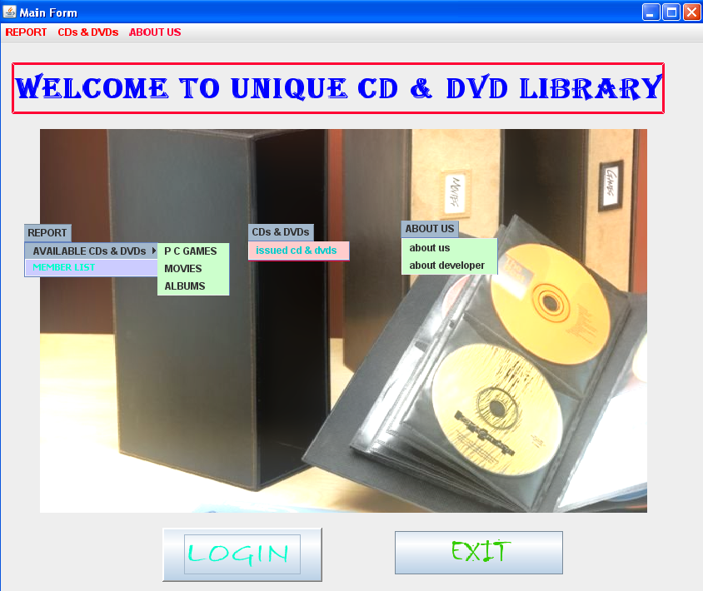
Report:
This menu item gives options to check the available CDs and DVDs and members list.
CDs and DVDs:
This menu gives options to show the issued CDs and DVDs .
About Us:
This menu item gives the information of the software and its developers.

8. References
In order to work on this project titled -LibSys – Public Library Management System, the following books and literature are refered by me during the various phases of development of the project.

(1) The Complete Reference Java 2.0
-by Shildit
- MySQL, Black Book
-by Steven Holzner
(2) Understanding SQL– Gruber

(3) http://www.mysql.org/

(4) http://www.netbeans.org/

(5) On-line Help of NetBeans ®

(6) Informatics Practices for class XII
-by Sumita Arora
(7) Together with Informatics Practices
(8) Various Websites of Discussion Forum and software development activities.

Other than the above-mentioned books, the suggestions and supervision of my teacher and my class experience also helped me to develop this software project.

