Computational Analysis of the Hypothetical Protein
WP_491523178.1 from Helicobacter pylori
A Bioinformatics Project
Sequence analysis, physicochemical characterization, BLAST search,
multiple sequence alignment, domain and motif analysis, and
homology-based structure modelling using Python and public bioinformatics tools
B.Sc. Biotechnology
Project

1. Project Overview
Every genome that gets sequenced ends up with a chunk of its genes labelled "hypothetical protein." That label basically means: we found this gene, we can translate it into a protein sequence, but nobody has figured out what it actually does yet. Helicobacter pylori, the bacterium behind most stomach ulcers and a well-known risk factor for gastric cancer, still has a good number of these in its genome even though it's one of the most studied bacterial pathogens out there.
This project takes one such protein — WP_491523178.1, annotated only as a "hypothetical protein" in NCBI — and runs it through a standard bioinformatics characterization pipeline to see what can be figured out about it using sequence-based methods alone. No wet-lab work, no lab access needed. Just the sequence, some Python scripting, and a set of well-established online tools.

Why this protein
I picked H. pylori because it's a genuinely important organism medically, and I wanted a real, unresolved hypothetical protein rather than something already well-characterized — the point was to practice the actual workflow of figuring out clues about an unknown protein, not to look up an answer that's already known. WP_491523178.1 fit that: it had no functional annotation, a reasonable length (363 amino acids, not too small to analyze and not unreasonably large for a first project), and it turned out to have close relatives across multiple H. pylori strains, which made the BLAST and alignment stages more interesting than a protein with zero hits would have been.

What I wanted to learn
Going into this, I had three goals:
- Get comfortable using BioPython for real sequence analysis instead of just reading about it — parsing FASTA files, computing amino acid composition, calculating physicochemical properties, and parsing BLAST XML output.
- Learn how to combine several different bioinformatics resources (NCBI, BLAST, Clustal Omega, CDD, InterPro, MotifFinder, SWISS-MODEL) into one coherent analysis instead of treating each tool as a separate, disconnected task.
- Practice interpreting biological results honestly — meaning I wanted to get used to saying "this result is inconclusive" or "this doesn't tell us much" when that's actually the case, rather than overstating what the data shows.
This report documents that process: the code I wrote, the results each tool produced, and what I think those results do and don't tell us about this protein.

2. Background and Theory
This section briefly explains the key concepts and tools used in this project, for anyone reading this report who isn't already familiar with them.

2.1 What is Bioinformatics
Bioinformatics is the use of computers and software to study biological data — mostly DNA, RNA, and protein sequences. Instead of only using a microscope or a lab bench, a lot of modern biology also involves comparing sequences, predicting structures, and searching huge databases to understand what a gene or protein might do. This project is entirely computational: no lab work was involved, only sequence data and software tools.

2.2 Helicobacter pylori
Helicobacter pylori is a spiral-shaped bacterium that lives in the human stomach. It's medically important because it's the main cause of stomach ulcers and is a known risk factor for gastric cancer. Because of this, its genome has been sequenced many times across different strains, which is actually useful for this project — it means there are several closely related versions of the same protein available to compare against each other.

2.3 Hypothetical Proteins
When a genome is sequenced, software can usually detect genes and translate them into protein sequences automatically. But not every predicted protein has a known function. If a gene looks like a real gene (correct start/stop, reasonable length) but nothing in the databases tells us what it actually does, it gets labelled a "hypothetical protein." This doesn't mean the protein doesn't exist or doesn't matter — it just means its role hasn't been confirmed yet. Even well-studied organisms like H. pylori still have hypothetical proteins in their genome.

2.4 Protein Sequence Analysis
Protein sequence analysis means calculating properties directly from the amino acid sequence, without needing a solved 3D structure. This includes things like amino acid composition (how often each of the 20 amino acids appears), molecular weight, isoelectric point (the pH at which the protein has no net charge), instability index (a rough statistical estimate of how stable the protein might be), GRAVY score (a measure of overall hydrophobicity), and predicted secondary structure (rough estimates of how much of the protein is likely to form alpha helices, beta sheets, or turns). These numbers don't prove what a protein does, but they help build a general physical profile of it.

2.5 BLAST (Basic Local Alignment Search Tool)
BLAST is one of the most widely used tools in bioinformatics. It takes a query sequence and searches it against a large database of known sequences, returning the closest matches ranked by similarity. Key numbers from a BLAST result include percent identity (how similar two sequences are), query coverage (how much of the original sequence was matched), and E-value (a statistical measure of how likely the match is to have occurred by chance — the lower the E-value, the more significant the match). BLAST is useful for finding related sequences, but a strong match only tells you two sequences are similar, not necessarily what either one does.

2.6 Multiple Sequence Alignment (MSA)
While BLAST compares a query against a database, a multiple sequence alignment lines up several sequences together, column by column, so their similarities and differences can be seen side by side. This is useful for spotting which parts of a protein are conserved (kept the same) across different strains or species, and which parts vary more freely. Regions that stay conserved across many sequences are often more likely to be functionally or structurally important, since evolution tends to preserve important regions and allow less important ones to drift.

2.7 Conserved Domain Database (CDD)
CDD is a database maintained by NCBI that holds a large collection of known conserved domains — regions of a protein that show up repeatedly across many different proteins, often linked to a specific structural or functional role. Searching a sequence against CDD checks whether any part of it resembles one of these known domains. A confident hit can hint at function even if the rest of the protein is unknown; a weak or absent hit simply means no strong match was found in the current database.

2.8 InterPro
InterPro is a resource that combines predictions from several different domain and signature databases (such as Pfam, PROSITE, PANTHER, and others) into a single report. Because different databases are built differently and can pick up different things, InterPro's combined view is often more complete than checking just one database alone. It also flags structural features like transmembrane regions, signal peptides, and coiled-coil regions — patterns that hint at how a protein might be positioned or shaped, even without naming its exact function.

2.9 Motif Analysis
A motif is a short, conserved pattern within a protein sequence that's often associated with a specific structural feature or protein family. Motif-searching tools such as MotifFinder check a sequence against the Pfam database specifically, looking for these short signature patterns. Motif hits are usually reported with an E-value, and — just like with BLAST — a low E-value suggests a meaningful match, while a high E-value suggests the match could easily be a coincidence.

2.10 SWISS-MODEL and Homology Modelling
Determining a protein's 3D structure experimentally (through X-ray crystallography or cryo-EM, for example) is expensive and time-consuming. Homology modelling offers a computational shortcut: if a protein of unknown structure is similar enough in sequence to a protein whose structure has already been solved, that solved structure can be used as a template to build a predicted model. SWISS-MODEL is a widely used tool for this. It reports a GMQE (Global Model Quality Estimation) score, which reflects how reliable the resulting model is likely to be, mainly based on how good the template match was.

3. Objectives
The specific objectives of this project were:
- Retrieve the protein sequence for WP_491523178.1 from NCBI and confirm its basic identity (ID, description, length).
- Write Python scripts (using BioPython) to calculate amino acid composition, molecular weight, isoelectric point, instability index, GRAVY score, aromaticity, and predicted secondary structure fractions.
- Run a sequence quality control check to confirm the sequence is clean (correct length, no unknown residues, no stop codons, valid amino acid alphabet only) before using it in downstream analysis.
- Perform a BLASTP search against the NCBI non-redundant (nr) database to identify similar sequences and estimate how conserved this protein is across related organisms.
- Perform a multiple sequence alignment (Clustal Omega) using the BLAST hits to look at conservation patterns across strains.
- Search for conserved domains using NCBI's CD-Search (CDD) and functional signatures using InterProScan and MotifFinder (Pfam).
- Generate a homology-based 3D structure model using SWISS-MODEL and visually inspect the predicted fold.
- Bring all of these results together into a single, honest interpretation of what can (and cannot) be said about this protein based on sequence analysis alone.

4. Project Workflow
The project follows a linear pipeline. Each stage feeds into the next — the sequence retrieved from NCBI is the input for every Python script, the same sequence goes into BLAST, the BLAST hits are what get aligned in the MSA step, and the same sequence is submitted separately to CDD, InterPro, MotifFinder and SWISS-MODEL. Everything traces back to one 363-residue FASTA sequence.
Protein Sequence (NCBI)
|
v
Python Analysis (BioPython)
|
v
Amino Acid Composition
|
v
Physicochemical Analysis
|
v
Secondary Structure Prediction
|
v
Sequence Quality Control
|
v
BLAST (NCBI BLASTP, nr database)
|
v
Multiple Sequence Alignment (Clustal Omega)
|
v
CDD (Conserved Domain Search)
|
v
InterPro (InterProScan)
|
v
Motif Analysis (MotifFinder / Pfam)
|
v
SWISS-MODEL (Homology Modelling)
|
v
Conclusion
The workflow splits naturally into two halves: a Python-based sequence analysis half (composition, physicochemical properties, secondary structure, quality control) and a web-tool-based homology and structure half (BLAST, MSA, CDD, InterPro, MotifFinder, SWISS-MODEL). The conclusion at the end is where results from both halves get combined.

5. Tools Used
This project combines a Python-based analysis pipeline with several established online bioinformatics tools. Below is what each one does and why it was used.

Python
The core scripting language for this project. All the sequence-level number-crunching — composition counts, molecular weight, isoelectric point, structure fraction predictions, BLAST XML parsing, alignment parsing — was done through small standalone Python scripts, each doing one job.

BioPython
BioPython is a Python library built specifically for biological data. It has ready-made classes for reading FASTA files (SeqIO), handling protein property calculations (ProteinAnalysis from Bio.SeqUtils.ProtParam), parsing BLAST results (Bio.Blast.NCBIXML and NCBIWWW), and reading multiple sequence alignments (Bio.AlignIO). Without BioPython, most of this project would have meant writing low-level string-parsing code from scratch.

NCBI Protein
The NCBI Protein database is where the original sequence and its metadata (accession number, description, organism) came from. WP_491523178.1 was retrieved directly from its NCBI record and saved locally as a FASTA file for use in every downstream script.

BLAST (Basic Local Alignment Search Tool)
BLAST compares a query sequence against a large database of known sequences and reports the best matches, ranked by similarity. Here, BLASTP (protein BLAST) was run against the NCBI nr (non-redundant) protein database to see whether this "hypothetical" protein has any close relatives, and if so, whether any of those relatives have a known function.

Multiple Sequence Alignment (Clustal Omega)
Once BLAST returns a set of related sequences, aligning them together (lining up matching residues column by column) shows which parts of the protein are conserved across strains/species and which parts vary. This project used Clustal Omega to align the query sequence with its top BLAST hits, and the resulting .aln file was parsed in Python using Bio.AlignIO.

CDD (Conserved Domain Database)
CDD, run through NCBI's CD-Search tool, checks a protein sequence against a library of known conserved domains and protein families. A hit here would mean the sequence resembles a domain with a known structural or functional role, even if the whole protein is unannotated.

InterPro (InterProScan)
InterPro combines predictions from multiple different domain and signature databases (Pfam, PROSITE, PANTHER, PHOBIUS, TMHMM, COILS, and others) into one report. It's useful because a domain might be missed by one database but picked up by another. It's also how features like transmembrane regions, coiled-coil regions, and signal peptides get flagged.

Motif Finder (Pfam)
MotifFinder (GenomeNet) searches a sequence against the Pfam database specifically, looking for short conserved motifs associated with known protein families. This was run as a separate, focused check alongside the broader InterPro scan.

SWISS-MODEL
SWISS-MODEL builds a 3D structural model of a protein by homology — meaning it looks for proteins with solved (experimental) structures that are similar enough in sequence to the query, and uses those as templates to build a predicted model. The output includes a confidence score (GMQE) that reflects how reliable the model is likely to be, based on template quality and coverage.

6. Python Implementation
The analysis was carried out using six short Python scripts, each handling one specific step of the pipeline, rather than a single large script. BioPython was used throughout for reading sequences, calculating properties, and parsing results. This section briefly explains what each script does; the full code is available in the project's GitHub repository.

protein_info.py
Purpose: Loads the protein sequence and prints its basic identity (ID, description, length), then calculates amino acid composition and core physicochemical properties (molecular weight, isoelectric point, instability index, GRAVY score, aromaticity) and predicted secondary structure fractions using BioPython's ProteinAnalysis class.
Input: The protein FASTA file (sequence.fasta).
Output: A console report showing protein identity, amino acid composition table, physicochemical properties, and secondary structure percentages.

amino_acid.py
Purpose: Generates a simple bar chart of amino acid frequency so the composition data is easier to read visually than a table of numbers.
Input: The same FASTA file.
Output: A bar chart of amino acid frequency (Figure 2).

quality_control.py
Purpose: Runs basic checks on the sequence before it is used in further analysis: confirms the sequence is long enough, contains no unknown residues, has no internal stop codons, and uses only valid amino acid letters.
Input: The FASTA sequence.
Output: A PASS/FAIL report for each check and an overall result.

blast_search.py
Purpose: Submits the protein sequence to NCBI's BLASTP service and saves the raw result locally, so the search only needs to be run once.
Input: The FASTA sequence.
Output: A saved BLAST result file (blast_results.xml).

blast_result.py
Purpose: Reads the saved BLAST XML file and prints a clean, readable summary of the top hits, including percent identity, query coverage, bit score, and E-value.
Input: blast_results.xml.
Output: A formatted summary of the top 5 BLAST hits.

msa_analysis.py
Purpose: Reads a Clustal Omega alignment file and prints the number of aligned sequences, the alignment length, and each sequence with its gaps.
Input: A Clustal-format alignment file (clustal_result.aln).
Output: A console printout of the alignment details and aligned sequences.

7. Results and Discussion
This section goes through each analysis in turn, but the goal isn't to just list what each tool printed. Each result is looked at on its own (observation, interpretation, biological meaning, limitations) and then tied back to the other results, because on its own, no single tool here gives a confident answer about what this protein does.

7.1 Sequence Identity and Basic Properties
Observation: WP_491523178.1 is a 363-amino-acid protein annotated in NCBI simply as a "hypothetical protein" from Helicobacter pylori, with no functional description attached.
Interpretation: A "hypothetical protein" label doesn't mean the protein is unusual — it just means nobody has assigned it a confirmed function yet. This is common in bacterial genomes, especially for genes that don't closely resemble anything in well-studied model organisms.
Biological meaning: Not much can be concluded from the label itself. It's really just the starting point that justifies doing this kind of analysis in the first place.
Limitations: The NCBI accession record doesn't include any additional annotation (no GO terms, no linked publications, no domain hits shown on the page itself), so everything past this point has to come from independent analysis.
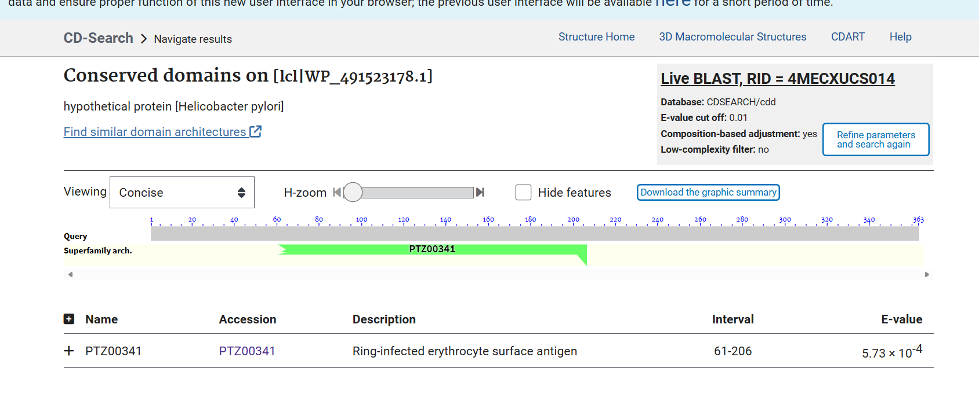
Figure 1. NCBI Protein database entry for WP_491523178.1, showing the sequence and "hypothetical protein" annotation.

7.2 Amino Acid Composition
Observation: The most frequent residues in the sequence are lysine (K, 42 residues, 11.57%), glutamic acid (E, 41 residues, 11.29%), leucine (L, 35 residues, 9.64%) and isoleucine (I, 33 residues, 9.09%). On the low end, tryptophan (W, 3 residues, 0.83%), proline (P, 4 residues, 1.10%) and histidine (H, 6 residues, 1.65%) are rare.
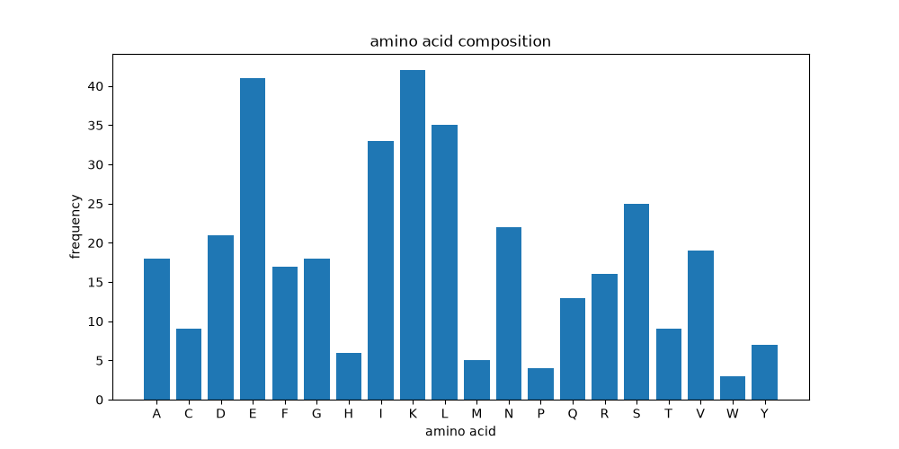
Figure 2. Amino acid composition of WP_491523178.1 (frequency per residue type).
Interpretation: A composition this heavily weighted toward lysine and glutamic acid — both charged residues — combined with a strong showing from leucine and isoleucine (both hydrophobic) suggests a sequence built mostly from charged and hydrophobic residues, without much aromatic or ring-containing content (low F, W, Y, H, P).
Biological meaning: Charged-residue-rich, low-proline sequences are frequently associated with proteins that form extended alpha-helical structures — proline in particular is known as a "helix breaker" because its rigid ring structure disrupts the regular hydrogen bonding pattern of an alpha helix, so a sequence with very few prolines (only 4 out of 363 residues here) is at least structurally permissive of long uninterrupted helices.
Limitations: Composition alone cannot prove a fold. Plenty of proteins with similar amino acid profiles fold into completely different shapes. This observation only becomes meaningful once it's checked against the secondary structure prediction and the 3D model — which, as shown further below, it lines up with reasonably well.

7.3 Physicochemical Properties
Property | Value | Quick read
Molecular weight | 41,756.43 Da (~41.8 kDa) | Mid-sized bacterial protein
Isoelectric point (pI) | 6.028 | Slightly acidic; net negative charge at physiological pH (~7.4)
Instability index | 46.589 | Above the 40 cutoff — classified as unstable in the ProtParam sense
GRAVY score | -0.476 | Negative value — on average, hydrophilic
Aromaticity | 0.074 | Low aromatic residue content (F+W+Y ≈ 7.4%)
Interpretation: A pI of 6.03 means the protein is very slightly acidic and would carry a small net negative charge at normal physiological pH. The instability index of 46.59 is above the conventional 40.0 threshold that ProtParam uses to flag a sequence as "unstable" — but it's worth being careful here, because that instability index is a statistical rule of thumb based on dipeptide composition, not a measurement of actual protein half-life or folding stability in the cell. The negative GRAVY score confirms the protein is, overall, more hydrophilic than hydrophobic, which fits with a soluble or partially soluble cytoplasmic protein rather than something deeply buried in a membrane.
Biological meaning: None of these numbers point to a specific function, but together they sketch a rough physical profile: a moderately sized, mildly acidic, largely hydrophilic protein that ProtParam's instability heuristic flags as unstable. That combination doesn't rule out anything, but it also doesn't confirm a role — it's descriptive, not diagnostic.
Limitations: The instability index specifically is known to have a high false-positive/false-negative rate and shouldn't be treated as a reliable predictor on its own. All of these values were computed from sequence alone; nothing here has been experimentally validated.

7.4 Secondary Structure Prediction
Observation: BioPython's secondary_structure_fraction() function predicted 38.84% alpha helix, 24.79% beta turn, and 33.88% beta sheet.
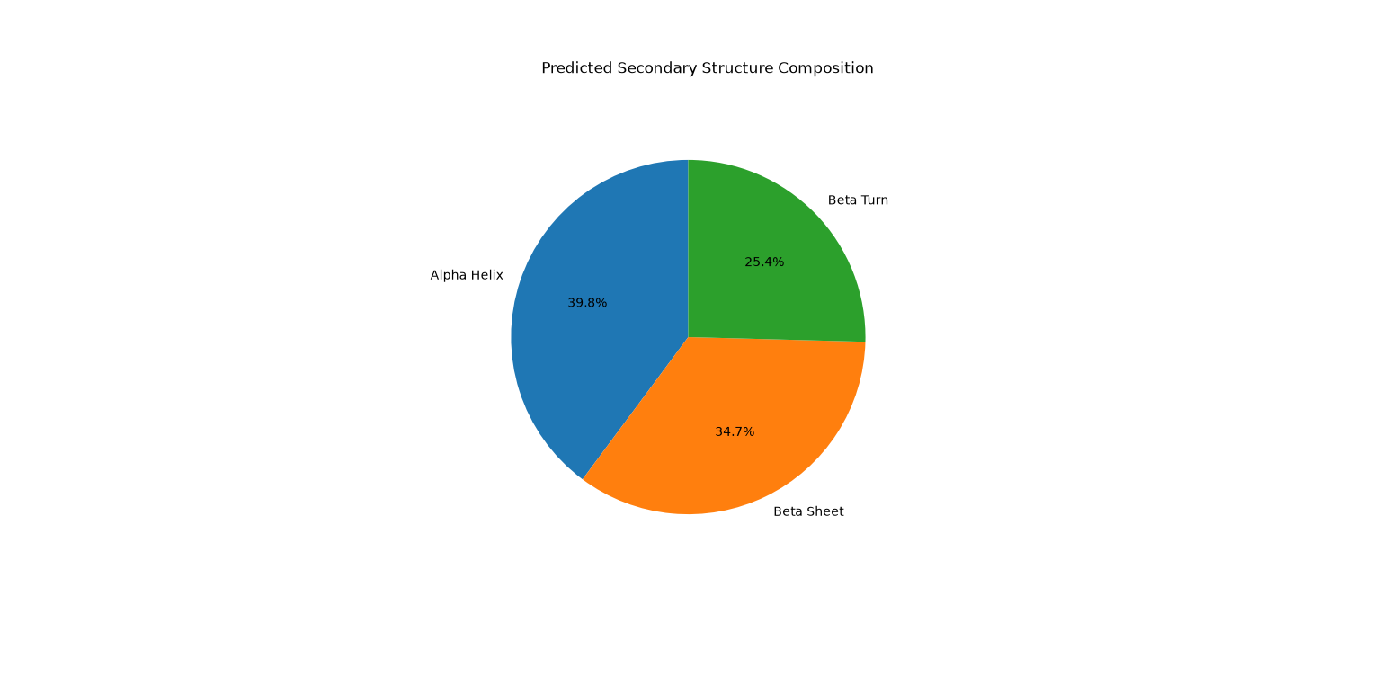
Figure 3. Predicted secondary structure composition of WP_491523178.1.
Interpretation: Alpha helix is the single largest predicted component, which is consistent with the amino acid composition observation above (low proline, high charged-residue content). However, this particular BioPython method is a simple fractional estimate based on known propensities of each amino acid to appear in helix/turn/sheet regions in a general reference dataset — it is not a per-residue structural prediction like tools such as PSIPRED provide, and it doesn't say where along the sequence these regions are.
Biological meaning: A helix-leaning secondary structure prediction is broadly consistent with the long, tightly-wound multi-helix bundle later seen in the SWISS-MODEL structure (Section 6.7) — the two independent analyses agree with each other, which adds a bit of confidence to both, even though neither one is definitive on its own.
Limitations: This is a coarse, whole-sequence estimate, not a positional map, and it comes from statistical propensity tables rather than physics-based or machine-learning structure prediction. It should be read as a rough hint, not a structural fact.

7.5 Sequence Quality Control
Observation: The sequence passed all four quality checks — length above 100 amino acids, no unknown residue placeholder ("x"), no internal stop codons ("*"), and every character restricted to the standard 20-letter amino acid alphabet.
Interpretation: This just confirms the FASTA sequence pulled from NCBI is a complete, clean, single open reading frame translation with no obvious parsing errors or truncation.
Biological meaning: There isn't a biological finding here — this step exists purely to make sure everything downstream (BLAST, MSA, structure modelling) is working from a trustworthy sequence rather than something corrupted.
Limitations: Passing these checks says nothing about whether the sequence is biologically "correct" in the sense of matching the real expressed protein — it only confirms the file itself is well-formed.

7.6 BLAST Search and Sequence Conservation
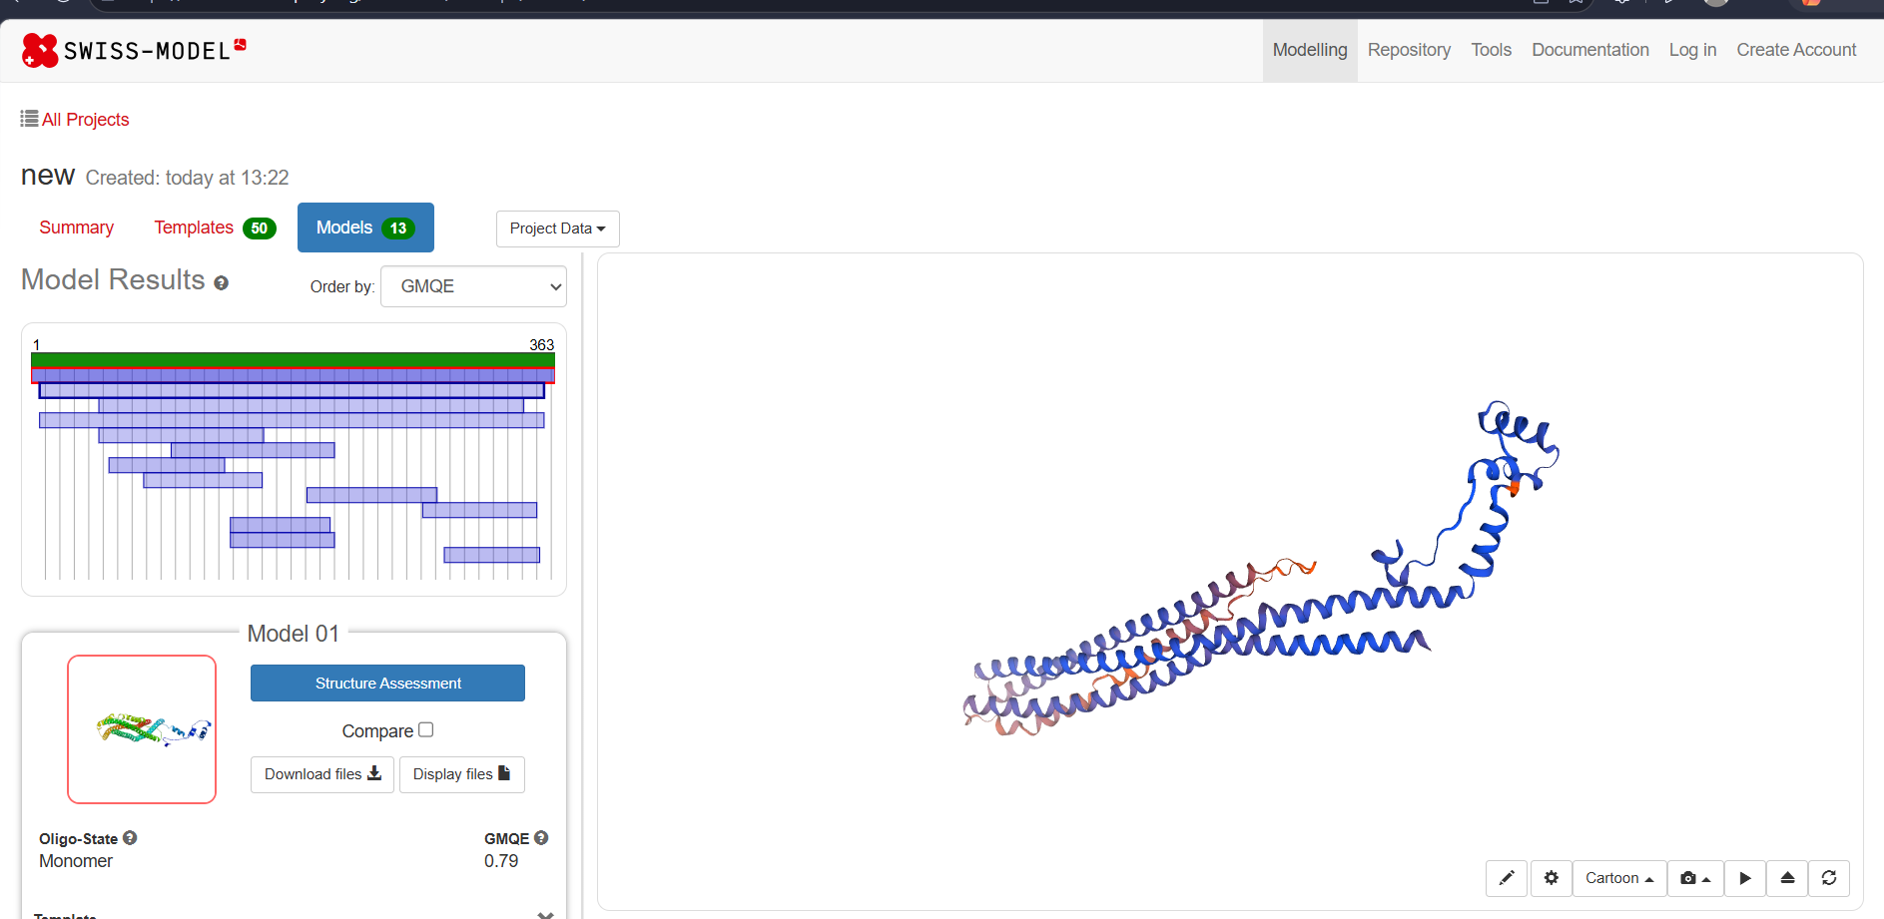
Figure 4. BLASTP search setup and results page (NCBI, nr database, blastp).
Observation: The top BLAST hit was EPZ97267.1, a hypothetical protein from Helicobacter pylori strain UM077, with 100% identity and 100% query coverage across all 363 residues. The next four hits were also all H. pylori proteins (WP_373367023.1 at 93.39% identity, MHU2104007.1 at 99.37% identity but only 87.6% query coverage, WP_245057011.1 at 87.09% identity, and MHU2029575.1 — annotated as a "GTPase" — at 86.23% identity).
Interpretation: A 100% identical hit against another H. pylori strain isn't surprising — it likely reflects the same gene (or a near-identical allele of it) present across different sequenced isolates of the same species, which is common for core or strain-conserved bacterial genes. What is more interesting is that identity stays high (86–99%) even against hits with slightly different lengths and one different annotation ("GTPase" for MHU2029575.1). All five top hits are exclusively from H. pylori — there were no hits from other genera in the top 5, which suggests this protein, or at least this specific sequence, may not be broadly conserved outside Helicobacter, at least not closely enough to appear in the top 5 by bit score.
Biological meaning: The fact that this protein is consistently present and highly conserved across multiple independently sequenced H. pylori strains suggests it's not a fluke ORF or sequencing artifact — it's a real, stably maintained gene in this species. The GTPase-annotated hit is worth flagging but not over-interpreting: sharing 86% identity with a protein annotated as a GTPase doesn't confirm WP_491523178.1 is itself a GTPase, especially since no GTP-binding motif (like a P-loop / Walker A motif) showed up in the CDD, InterPro, or MotifFinder results discussed below. It may simply mean that annotation was assigned loosely, or that the shared region isn't the part responsible for GTPase activity, or that the two proteins are just closely related without sharing that specific function.
Limitations: BLAST measures sequence similarity, not function. High identity to another "hypothetical protein" doesn't teach us anything about function — it just means both proteins are unannotated. The presence of one differently-annotated hit is interesting but is not, by itself, evidence of a specific molecular function for this protein.

7.7 Multiple Sequence Alignment
Observation: The Clustal Omega alignment of the query and its top 4 BLAST hits produced an alignment length of 614 amino acids across 5 sequences (the increase from 363 to 614 is due to gap insertions needed to line up sequences of different lengths, including the 613-residue GTPase-annotated hit). Large gap blocks appear at the start of several sequences (WP_245057011.1, WP_373367023.1, EPZ97267.1, MHU2104007.1), meaning those sequences are shorter at the N-terminus compared to MHU2029575.1, which carries a long additional N-terminal region before the point where the other four sequences begin.
Interpretation: The core aligned region (roughly corresponding to the 363 residues of the original query) shows high conservation across all five sequences, with mostly single-residue substitutions rather than large insertions or deletions in that shared region. The N-terminal extension unique to MHU2029575.1 lines up with its distinct "GTPase" annotation — it's plausible that MHU2029575.1 is a longer, multi-domain protein where the region matching WP_491523178.1 is only part of the full protein, and the additional N-terminal region (not present in the other four) may be what actually carries the GTPase-associated function.
Biological meaning: This supports treating WP_491523178.1 as a conserved "core" region that appears both as a standalone shorter protein (in most strains) and as part of a longer, differently annotated protein in at least one case. That pattern — a conserved domain appearing both alone and fused to other domains — is a fairly common phenomenon in bacterial genomes.
Limitations: With only 5 sequences in the alignment (all from the same species), this MSA can't identify deeply conserved functional residues the way an alignment across many diverse species could. It also can't distinguish whether the shared region is functionally important or just happens to be conserved for other reasons (e.g., structural stability, recent common ancestry).

7.8 Conserved Domain Search (CDD)
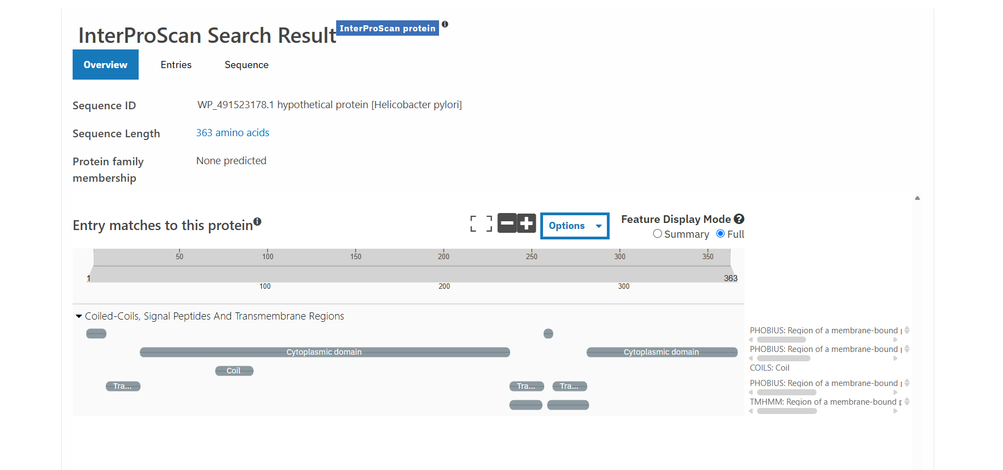
Figure 5. NCBI CD-Search (CDD) result for WP_491523178.1.
Observation: CD-Search returned one hit at the superfamily level: PTZ00341, described as "Ring-infected erythrocyte surface antigen," spanning residues 61–206, with an E-value of 5.73 × 10⁻⁴.
Interpretation: An E-value of 5.73 × 10⁻⁴ is a weak-to-borderline hit — well above the very strict E-value thresholds (like 1 × 10⁻¹⁰ or lower) that would indicate strong domain-level confidence, but still below the general 0.01 cutoff CD-Search used for this search. PTZ00341 is normally associated with Plasmodium (the malaria parasite), which has no obvious biological connection to H. pylori. This is very likely a coincidental sequence similarity rather than a meaningful evolutionary or functional relationship.
Biological meaning: This result should not be read as evidence that WP_491523178.1 has anything to do with erythrocyte surface antigens or malaria biology. It's best interpreted as: no confident conserved domain was identified by CDD for this protein.
Limitations: A single weak superfamily-level hit with no matching functional context is exactly the kind of result that's easy to over-interpret if taken at face value. Reporting it honestly (as a weak, likely spurious hit) is more useful than pretending it points to a real function.

7.9 InterPro (InterProScan)
Observation: InterProScan reported no predicted protein family membership ("None predicted") for WP_491523178.1. Under the "Coiled-Coils, Signal Peptides and Transmembrane Regions" category, it flagged several features: two cytoplasmic domain regions (one large region roughly in the first third to half of the sequence, one smaller region later on), a coiled-coil segment (COILS), and multiple predicted transmembrane regions detected independently by PHOBIUS and TMHMM.
Interpretation: The absence of a predicted protein family is consistent with the CDD result — no database in this analysis found a confident, well-characterized domain match. What InterPro did detect, though, is structurally informative even without a family assignment: coiled-coil regions and long cytoplasmic domains flanked by predicted transmembrane segments are patterns typically seen in membrane-associated or membrane-anchored proteins, rather than freely soluble cytoplasmic enzymes.
Biological meaning: Taken together with the strongly helical secondary structure prediction and the elongated, multi-helix shape of the SWISS-MODEL structure, this points toward WP_491523178.1 being some kind of structural or membrane-associated protein built from long helical/coiled-coil segments, rather than a globular enzyme with a defined active site. This is a modest but genuinely multi-source-supported observation — it comes independently from the secondary structure prediction, the amino acid composition, InterPro's transmembrane/coiled-coil calls, and the 3D model shape.
Limitations: PHOBIUS and TMHMM transmembrane predictions are sequence-based heuristics and can produce false positives, especially for proteins that are simply hydrophobic-and-helical without actually being membrane proteins. "No protein family predicted" is also just an absence of evidence — it doesn't rule out a function that InterPro's current databases simply don't have a matching entry for.

7.10 Motif Analysis (MotifFinder / Pfam)
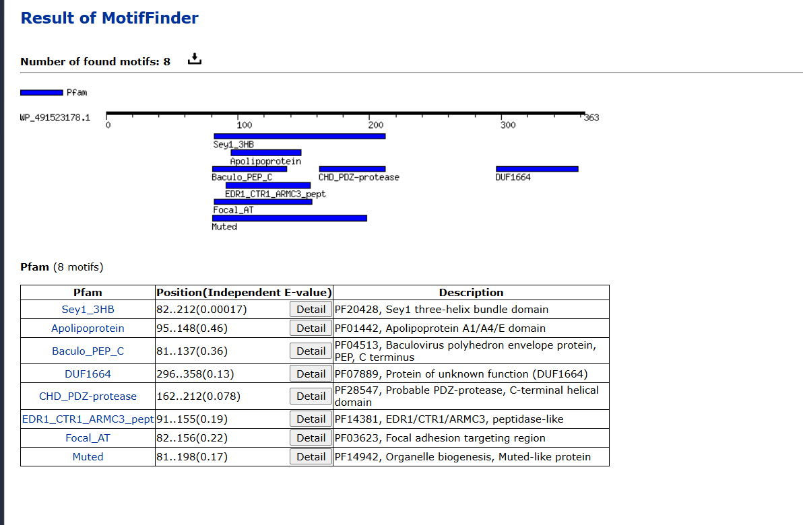
Figure 6. MotifFinder (Pfam) result for WP_491523178.1, showing 8 low-confidence motif matches.
Observation: MotifFinder reported 8 Pfam motif matches, all overlapping in the same general region of the protein (roughly residues 80–360), with fairly high (weak) E-values: Sey1_3HB (E = 0.00017), Apolipoprotein A1/A4/E domain (E = 0.46), Baculo_PEP_C (E = 0.36), DUF1664 (E = 0.13), CHD_PDZ-protease (E = 0.078), EDR1/CTR1/ARMC3 peptidase-like (E = 0.19), Focal adhesion targeting region (E = 0.22), and Muted-like protein (E = 0.17).
Interpretation: Only one of these eight (Sey1_3HB) has an E-value in a range that's arguably worth taking seriously; the rest are well above typical significance cutoffs and shouldn't be treated as real matches. What's notable, though, is the pattern across all eight hits: nearly every one of them — Sey1_3HB (three-helix bundle), Apolipoprotein A1/A4/E domain, DUF1664, Focal adhesion targeting region — describes a domain that is itself helical, coiled-coil, or membrane/cytoskeleton-associated in nature, even though none of them are individually confident hits.
Biological meaning: This is the same signal showing up a third time: composition, secondary structure, InterPro, and now MotifFinder are all independently pointing toward a helical, structural/membrane-associated character for this protein, even though no single tool has confidently assigned it a specific family or function. That consistency across independent methods is worth noting, but it stops short of being proof — it's an accumulation of weak, mutually consistent hints rather than one strong result.
Limitations: With E-values this high, any one of these eight motifs could easily be a statistical coincidence rather than a real evolutionary relationship. The fact that they cluster thematically (helical/structural domains) is suggestive but should be treated as a hypothesis to investigate further, not a conclusion.

7.11 SWISS-MODEL Structure Prediction
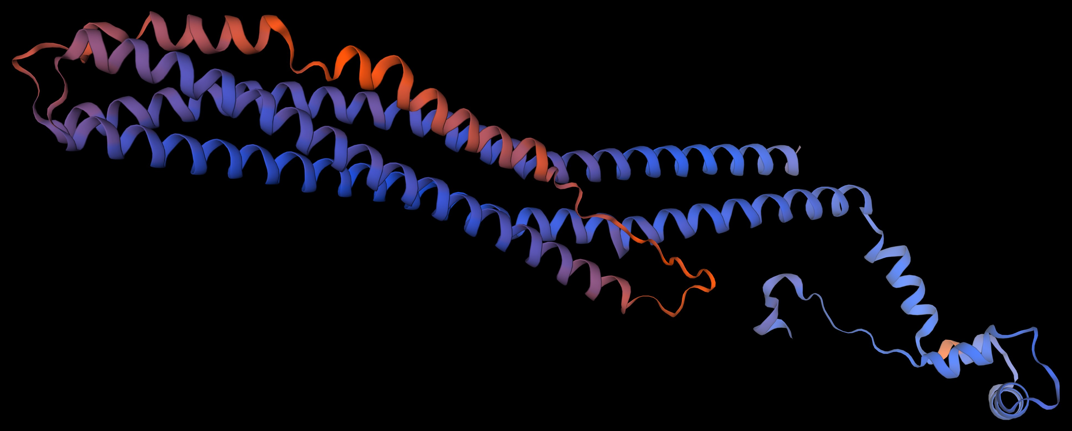
Figure 7. SWISS-MODEL predicted structure (Model 01) for WP_491523178.1 — cartoon representation.
Observation: SWISS-MODEL identified 50 possible templates and built 13 candidate models. The top-ranked model (Model 01) is a monomer with a GMQE (Global Model Quality Estimation) score of 0.79. Visually, the model is a long, narrow structure made up of several extended alpha helices packed closely together in a bundle, with a shorter, more irregular loop region at one end.
Interpretation: A GMQE of 0.79 is a reasonably good score (GMQE ranges from 0 to 1, with values closer to 1 indicating higher expected model reliability, usually driven by good template coverage and sequence similarity to the template). This gives some confidence that the general shape SWISS-MODEL produced — an elongated multi-helix bundle — is a reasonable representation of the protein's real fold, even without experimental structure data to confirm it directly.
Biological meaning: This is the most visually direct confirmation of the pattern that's been building through the whole analysis: the protein is predicted, by composition, by BioPython's secondary structure fraction estimate, by InterPro's coiled-coil call, and now by an actual 3D homology model, to be a long helical bundle rather than a compact globular enzyme fold. Long helical bundles like this are structurally associated with roles such as structural scaffolding, membrane anchoring, or protein-protein interaction surfaces — though which of those (if any) applies here can't be determined from structure prediction alone.
Limitations: SWISS-MODEL's confidence score reflects how good the template match is, not whether the biological function has been identified — a well-modelled structure can still belong to a protein of completely unknown function, which is exactly the situation here. No QMEAN score or specific template PDB ID was recorded for this run, so the structural confidence assessment here relies on GMQE alone.

7.12 Bringing It All Together
Individually, none of the tools used in this project gave a confident, specific functional annotation for WP_491523178.1 — no strong domain hit, no clear enzyme family, no confidently predicted active site. But looking across all of them together, a consistent (if modest) picture does emerge:
- The amino acid composition is low in proline and rich in charged/hydrophobic residues, both of which are compatible with long alpha-helical regions.
- BioPython's secondary structure prediction independently estimated the highest fraction of the sequence as alpha helix (38.84%).
- InterProScan detected coiled-coil regions and possible transmembrane segments, even without assigning a protein family.
- MotifFinder's weak but thematically consistent hits (three-helix bundle, apolipoprotein-like, focal adhesion targeting) all describe helical or membrane/cytoskeleton-associated domains.
- The SWISS-MODEL structure (GMQE 0.79) visually confirms an elongated, multi-helix bundle shape.
- BLAST shows the protein is highly conserved across multiple H. pylori strains, and appears as an embedded region within a longer, differently annotated "GTPase" protein in one strain — hinting that this region may function as a conserved structural module that appears both independently and fused into larger proteins.
What this adds up to is a reasonable, evidence-based hypothesis — this looks like it could be a structural or membrane-associated helical protein — rather than a confirmed function. That distinction matters. Five independent methods agreeing on "probably helical / probably membrane-associated" is a much stronger signal than any one of them alone, but it's still a very different thing from knowing what the protein actually binds, catalyzes, or interacts with in the cell.

Key Findings

• Successfully analyzed a hypothetical protein using Python and public bioinformatics tools.

• The protein consists of 363 amino acids.

• Sequence quality passed all validation checks.

• BLAST showed strong conservation among H. pylori strains.

• Multiple sequence alignment confirmed conserved regions.

• CDD did not identify a confident functional domain.

• InterPro predicted structural features including coiled-coil and transmembrane regions.

• SWISS-MODEL predicted a reliable alpha-helical 3D structure.

• Computational evidence suggests—but does not prove—that the protein may have a structural or membrane-associated role.

8. Conclusion

What I learned
This project was my first time running a full sequence-to-structure analysis pipeline on a real, unannotated protein rather than a textbook example with a known answer. Technically, I got comfortable with BioPython's core modules — SeqIO for reading sequences, ProteinAnalysis for physicochemical calculations, NCBIWWW/NCBIXML for running and parsing BLAST, and AlignIO for reading multiple sequence alignments. I also got practice writing small, single-purpose scripts rather than one large script, which made debugging and re-running individual steps much easier.
Just as importantly, I learned how to read results critically instead of taking every number or hit at face value — for example, recognizing that a CDD hit with an E-value of 5.73 × 10⁻⁴ to a malaria-associated domain is almost certainly not biologically meaningful, or that a high instability index from ProtParam is a statistical heuristic and not a measured fact about the protein's real-world stability.

What the analyses suggest
No single tool in this project gave a confident, specific functional annotation for WP_491523178.1. But five independent lines of evidence — amino acid composition, BioPython's secondary structure prediction, InterProScan's coiled-coil/transmembrane calls, the thematically consistent (if individually weak) MotifFinder hits, and the SWISS-MODEL 3D structure — all point in the same general direction: this protein is likely built mostly from long alpha-helical regions, possibly arranged as a coiled-coil or membrane-associated bundle, rather than folding into a compact globular enzyme with a defined active site.
The BLAST and MSA results add another layer: this protein is highly conserved across multiple H. pylori strains, and in at least one strain, a nearly identical stretch appears embedded within a longer protein annotated as a GTPase — suggesting this region might function as a conserved structural module that can occur either on its own or fused into a larger multi-domain protein.

What cannot yet be concluded
It would be overstating the evidence to claim this protein has been "identified" or that its function is now known. None of the following can be concluded from this analysis:
- What specific molecular function this protein carries out (no confident enzyme family, active site, or binding motif was identified by any tool used).
- Whether it is actually membrane-associated, or simply hydrophobic/helical without being a true membrane protein — InterPro's transmembrane calls are predictions, not confirmed topology.
- Whether the shared region with the GTPase-annotated hit (MHU2029575.1) has any real functional relationship to GTPase activity, or is just a conserved structural module that happens to co-occur with a GTPase domain in that one strain.
- Where in H. pylori biology this protein actually acts — nothing in this analysis touches on expression conditions, localization, interaction partners, or phenotype.

Why lab work is still needed
Sequence-based bioinformatics is genuinely useful for narrowing down hypotheses and prioritizing what to test next, but it cannot substitute for direct experimental evidence. Confirming what WP_491523178.1 actually does in Helicobacter pylori would require laboratory work — for example, expressing the protein and testing its solubility/membrane association directly, using techniques like circular dichroism or actual crystallography/cryo-EM to confirm the predicted helical structure, gene knockout or knockdown studies to see what phenotype is lost, or pull-down/co-immunoprecipitation experiments to identify real binding partners. This project only gets as far as a computational hypothesis — a reasonable, evidence-supported guess about the kind of protein this might be, not a confirmed answer about what it does.

9. Appendix — Script Reference
The full Python source code for all six scripts used in this project (protein_info.py, amino_acid.py, quality_control.py, blast_search.py, blast_result.py, msa_analysis.py) is available in the project's GitHub repository under /scripts. Section 6 of this report summarizes the purpose, input, and output of each script.

10. Skills Demonstrated

• Python programming
• BioPython
• Protein sequence analysis
• FASTA parsing
• Physicochemical property analysis
• BLAST (NCBI BLASTP)
• Multiple Sequence Alignment (Clustal Omega)
• Conserved Domain Database (CDD)
• InterPro analysis
• Protein motif analysis
• Homology modelling (SWISS-MODEL)
• Scientific data interpretation
• Data visualization
• Technical documentation
• Git & GitHub

11. Future Work

Future work could include protein localization prediction, phylogenetic analysis, comparison with AlphaFold models, protein-protein interaction analysis, and laboratory validation. These analyses were not performed in this project and are suggested only as future extensions.

12. Project Repository

GitHub Repository:
Adityabhartiya8/bioinformatics-project

Project Highlights

• Analyzed a hypothetical Helicobacter pylori protein.
• Developed Python scripts using BioPython.
• Performed BLAST and multiple sequence alignment.
• Investigated conserved domains and motifs.
• Predicted a 3D structure with SWISS-MODEL.
• Integrated computational results into a biological interpretation.

