CLOUD SECURITY

UNIT 4 ASSIGNMENT
Launch a Windows VM and Connect Using RDP
Step-by-step practical report with remote access configuration, PowerShell commands, representative output, and security checks
Student Name | Aditya Borhade
Roll Number | 2124UCSM1016
College / University | Sanjivani University
Programme | CSE · Cyber Security Engineering
Semester | VI (5th Semester)
Subject | Cloud Security
Submission date | 27 October 2026

Execution and output note
This report contains commands and representative expected outputs for documentation. The output examples are illustrative and may differ by operating-system image, package version, region, or account settings. They are not represented as captured execution evidence.

Aim
To launch a Windows Server virtual machine on Amazon EC2, restrict Remote Desktop Protocol access to the user's IP address, connect using RDP, inspect system information, create a local user, verify Windows Firewall status, and create a test text file.

Requirements
- An AWS account with permission to create and manage EC2 instances and security groups.
- A Windows Server EC2 AMI and a key pair selected at launch.
- A Windows client with Remote Desktop Connection (mstsc.exe), or a compatible RDP client.
- The EC2 administrator password retrieved through the AWS console using the selected key pair; do notinclude passwords in the report.

Security Group Configuration
Inbound rule | Protocol / port
RDP | TCP 3389 — source: My IP (your current public IPv4 address /32)
HTTP/SSH | Not required for this RDP-only task unless separately needed
Outbound | Default outbound rules are acceptable for a basic lab unless the instructor specifies otherwise
Critical security note: Do not expose RDP (3389) to 0.0.0.0/0. Limit access to your own public IP and remove or tighten the rule when the practical is finished.

Procedure

Step 1 — Launch a Windows Server EC2 instance
- Open AWS Management Console → EC2 → Instances → Launch instances.
- Choose a Windows Server AMI, select an instance type appropriate for the lab, and choose or create a keypair.
- Create or select a security group with TCP 3389 allowed only from My IP.
- Launch the instance and wait for Running status and successful status checks.

Step 2 — Retrieve the administrator password and connect
Select the instance in the EC2 console and use Connect → RDP client → Get password. Use the private key associated with the instance to decrypt the password. Keep the password private; do not paste it into this report. Download the Remote Desktop file if provided, or open Remote Desktop Connection and enter the instance's public IPv4 address or public DNS name.
Remote Desktop Connection (mstsc.exe)
Computer: <EC2-PUBLIC-IP-OR-DNS>
User name: Administrator
Password: <enter privately; do not record in report>
Representative connection result:
Remote Desktop session opens to the Windows Server desktop.
The Windows desktop and Server Manager are visible.

Step 3 — Check system information in PowerShell
Open PowerShell as Administrator on the remote Windows Server and run:
Get-ComputerInfo |
Select-Object CsName, WindowsProductName, WindowsVersion,
OsArchitecture, CsTotalPhysicalMemory
Representative output format (values vary by AMI and instance type):
CsName : EC2AMAZ-EXAMPLE
WindowsProductName : Windows Server
WindowsVersion : <version varies>
OsArchitecture : 64-bit
CsTotalPhysicalMemory : <memory varies by instance type>

Step 4 — Create a local user account
Run PowerShell as Administrator. The command prompts for a password without printing it. Use a strong password that meets the server's password policy. This example creates a standard local account and does not add it to the Administrators group.
$Password = Read-Host "Enter a strong password for LabUser" -AsSecureString
New-LocalUser -Name "LabUser" -Password $Password -FullName "Cloud Security Lab User" -Description "Created for U
Get-LocalUser -Name "LabUser" | Select-Object Name, Enabled, Description
Representative output:
Name Enabled Description
---- ------- -----------
LabUser True Created for Unit 4 practical

Step 5 — Enable and verify Windows Firewall
Set-NetFirewallProfile -Profile Domain,Private,Public -Enabled True
Get-NetFirewallProfile |
Select-Object Name, Enabled, DefaultInboundAction, DefaultOutboundAction
Representative output:
Name Enabled DefaultInboundAction DefaultOutboundAction
---- ------- -------------------- ---------------------
Domain True NotConfigured NotConfigured
Private True NotConfigured NotConfigured
Public True NotConfigured NotConfigured
The Enabled field should be True for each profile. Default action values can differ depending on the image and local policy.

Step 6 — Create and verify a text file
New-Item -Path C:\CloudSecurityUnit4.txt -ItemType File -Force
Set-Content -Path C:\CloudSecurityUnit4.txt -Value "Unit 4 - Windows EC2 RDP practical"
Get-Content C:\CloudSecurityUnit4.txt
Get-Item C:\CloudSecurityUnit4.txt | Select-Object FullName, Length, LastWriteTime
Representative output:
Unit 4 - Windows EC2 RDP practical
FullName Length LastWriteTime
-------- ------ -------------
C:\CloudSecurityUnit4.txt 35 <date/time varies>

Security and Validation Checklist
- The Windows EC2 instance is running and status checks pass.
- RDP inbound access is limited to the current public IP (/32).
- RDP login succeeds using the correct instance administrator credentials.
- PowerShell returns Windows system information.
- The LabUser account is present and enabled; its password is not documented.
- Windows Firewall is enabled for Domain, Private, and Public profiles.
- The test text file is created and its content can be read.

Troubleshooting
RDP connection times out | Check instance state, public IP, subnet routing, Windows RDP availability, and inbound TCP 3389 rule.
Unable to decrypt password | Confirm that the private key matches the key pair selected when the instance was launched.
Incorrect credentials | Use the correct administrator username and decrypted password; check keyboard layout.
PowerShell command not found | Run on the Windows Server instance in an elevated PowerShell session; some commands require appropriate privileges.

Clean-up
When the faculty no longer needs the instance, stop or terminate it according to the lab instructions. Review attached EBS volumes, snapshots, and other billable resources. Keep RDP restricted throughout and do not leave a broad inbound rule in place.

Conclusion
This practical covers deployment and remote administration of a Windows Server EC2 instance through RDP. It demonstrates restricted network access, retrieval and private handling of connection credentials, system-information inspection, local user creation, firewall verification, and basic file creation.

References
- Amazon EC2 Windows instances:https://docs.aws.amazon.com/AWSEC2/latest/WindowsGuide/EC2_GetStarted.html
- Connect to a Windows instance:https://docs.aws.amazon.com/AWSEC2/latest/WindowsGuide/connecting_to_windows_instance.html
- Amazon EC2 security groups:https://docs.aws.amazon.com/AWSEC2/latest/UserGuide/ec2-security-groups.html
- Microsoft Learn — Get-ComputerInfo:https://learn.microsoft.com/powershell/module/microsoft.powershell.management/get-computerinfo
- Microsoft Learn — Windows Firewall with Advanced Security:
https://learn.microsoft.com/windows/security/operating-system-security/network-security/windows-firewall/

01 Adobe security txt
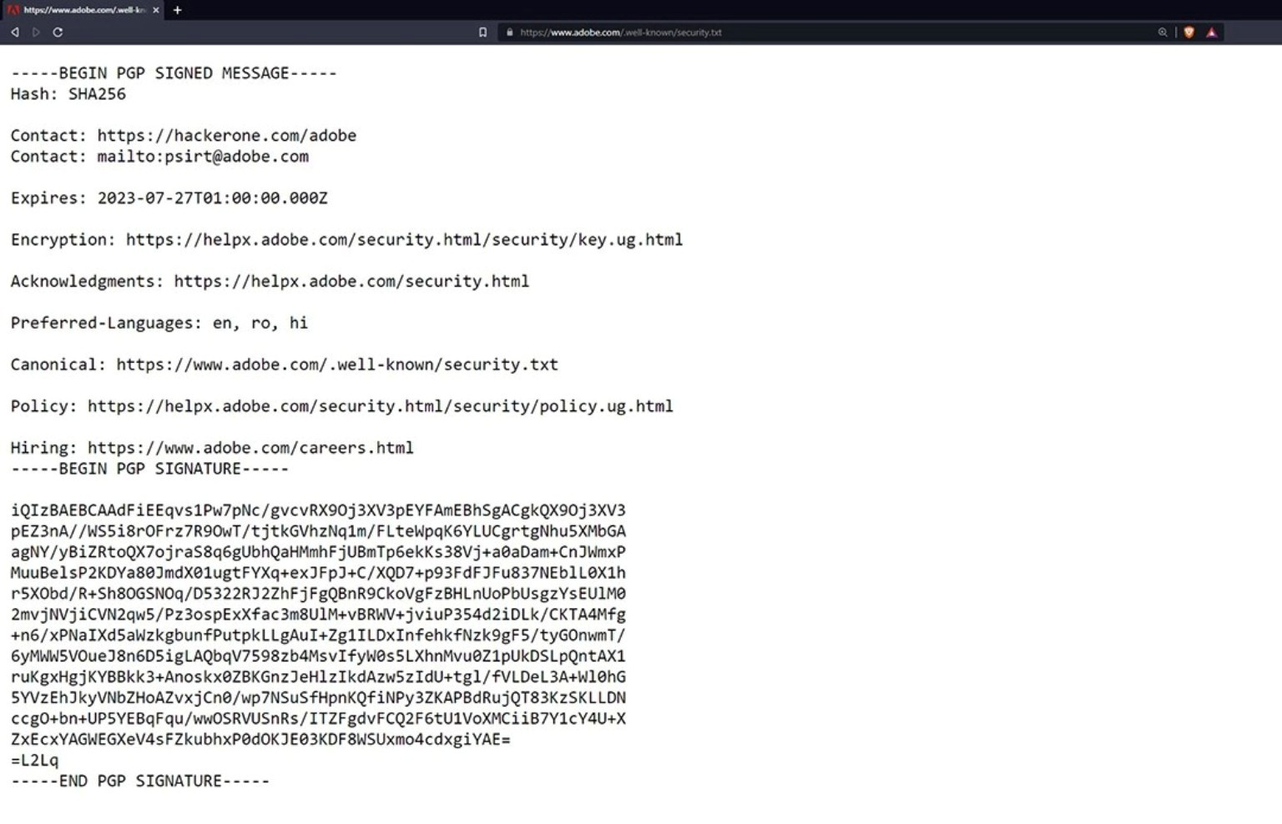
Browser displaying Adobe security.txt. Supplementary security reference; not evidence of Windows RDP.

02 Firewall port filter
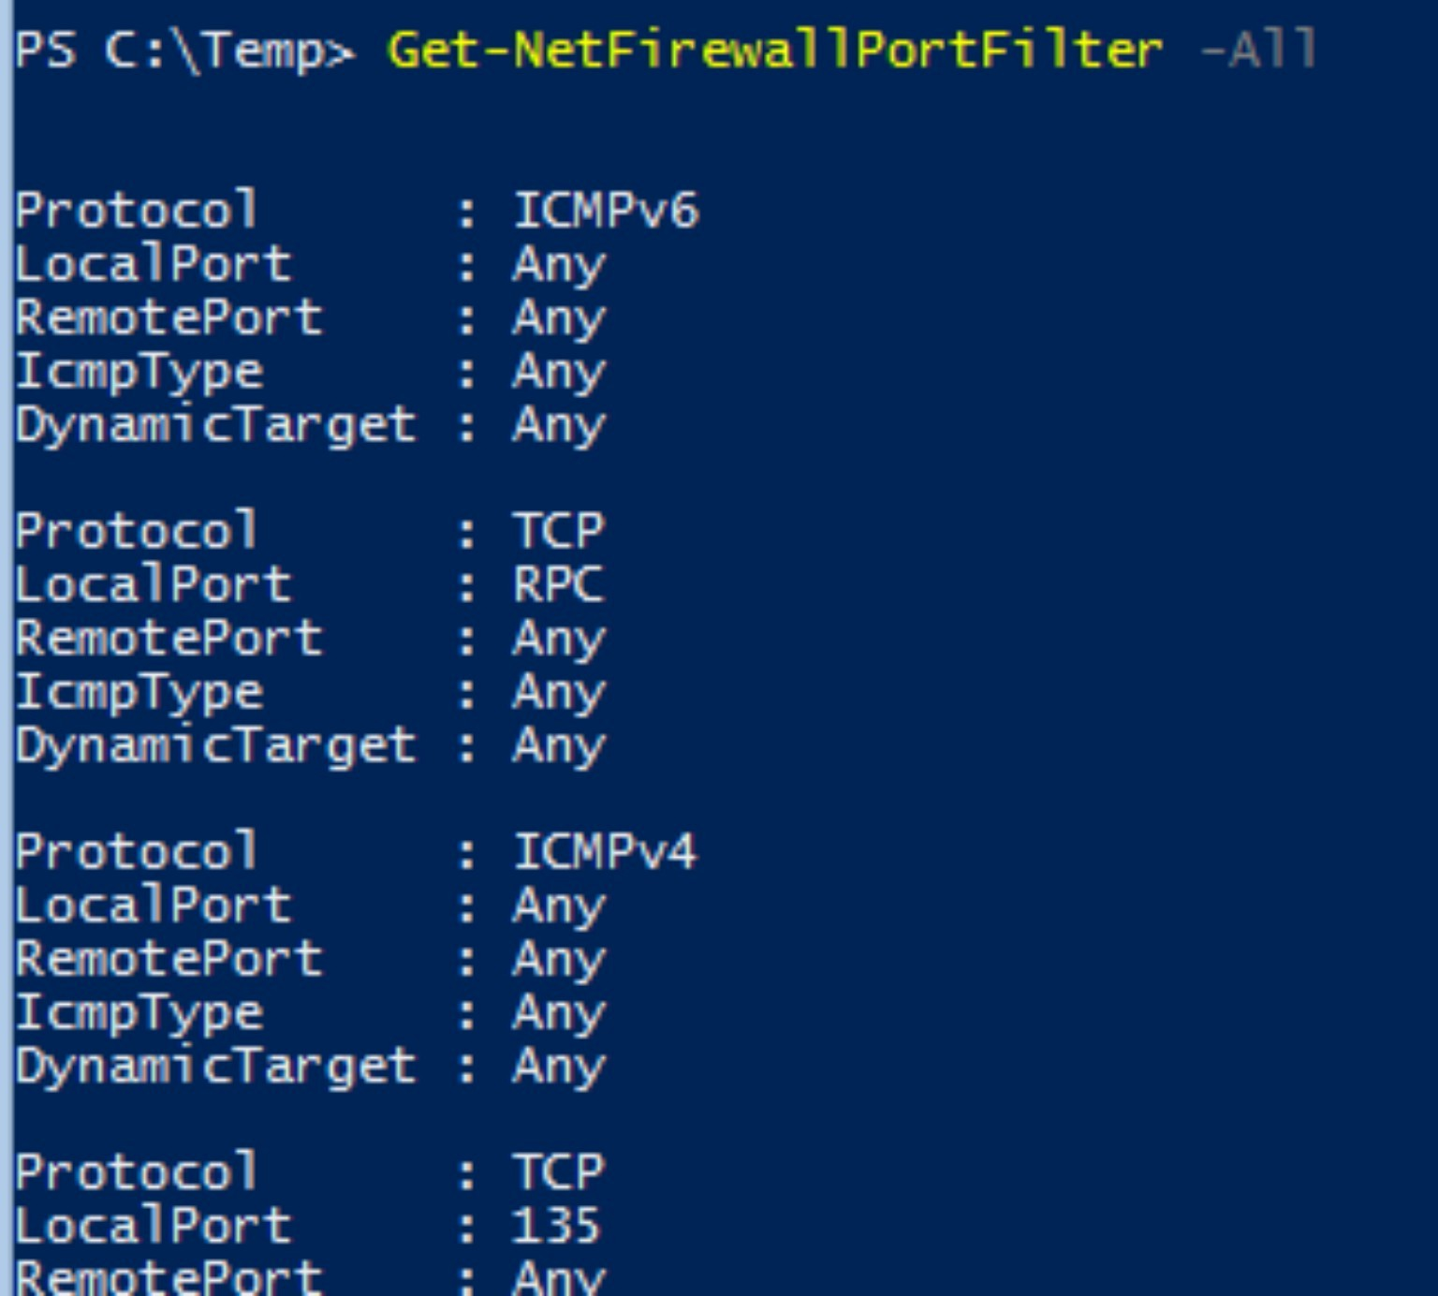
PowerShell output of Get-NetFirewallPortFilter -All. Shows firewall port-filter information.

03 Local user creation
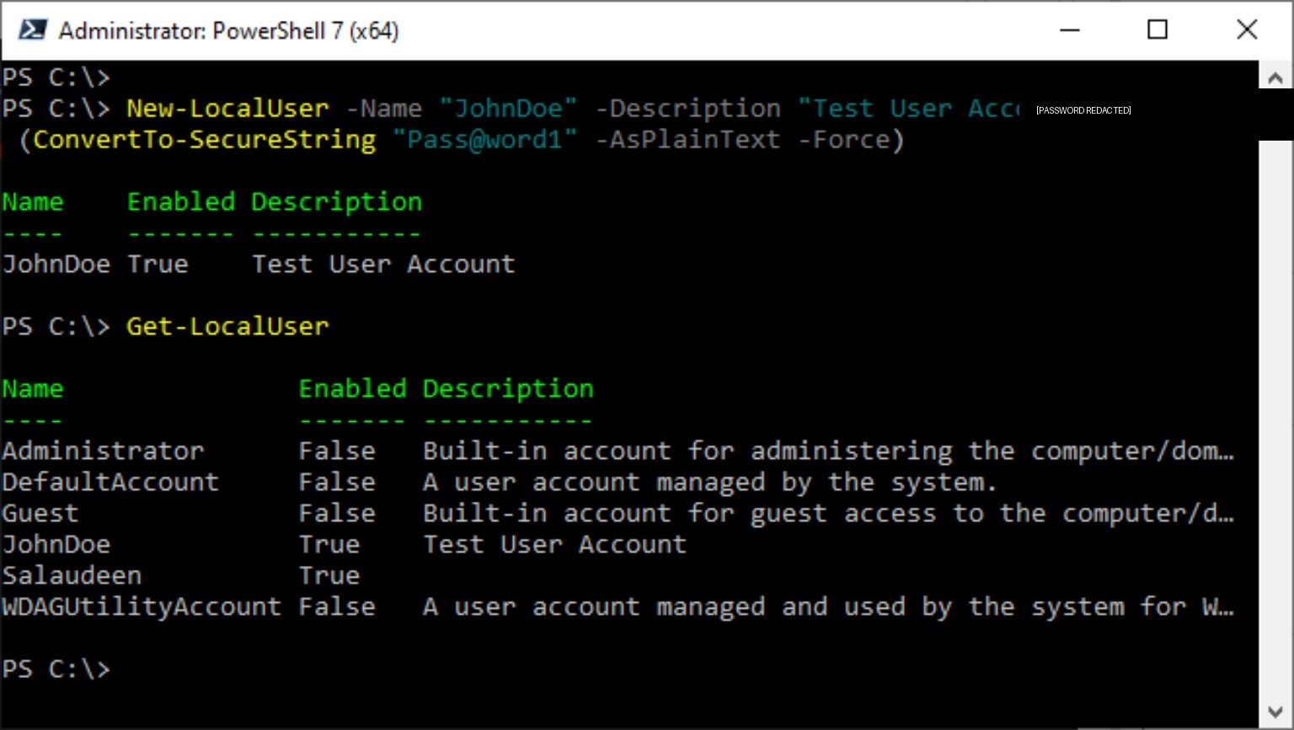
PowerShell output showing creation and listing of a local user. Example password visible in original image has been redacted in this report.

04 Computer model inventory
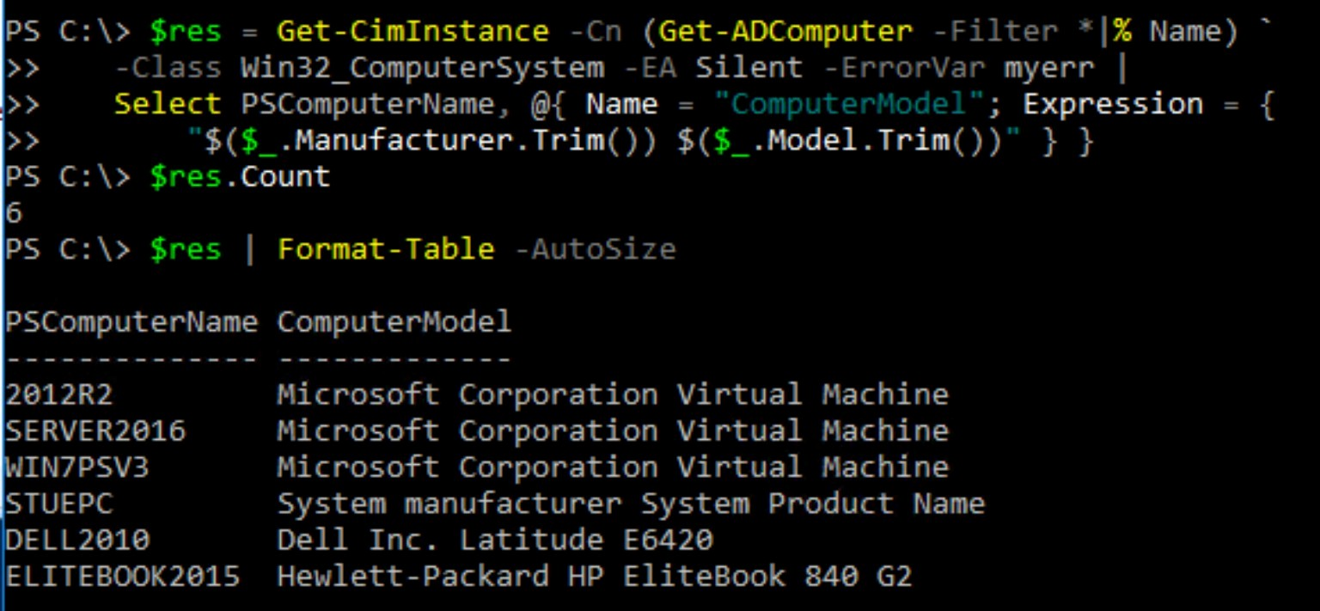
PowerShell inventory output listing computer names and models. This is not the requested Get-ComputerInfo output from the target EC2 instance.

05 Get ComputerInfo
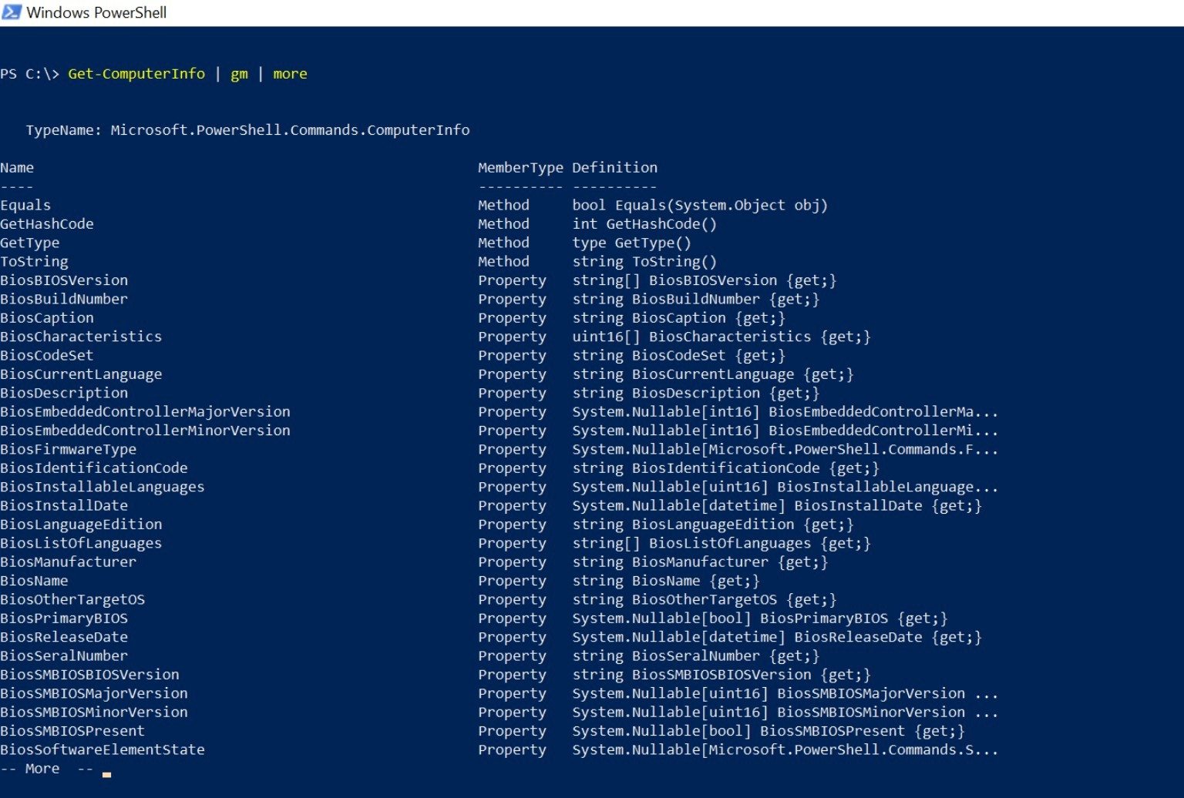
PowerShell Get-ComputerInfo command. The displayed output is the property list, not a concise Windows Server identity summary.

06 AWS EC2 search
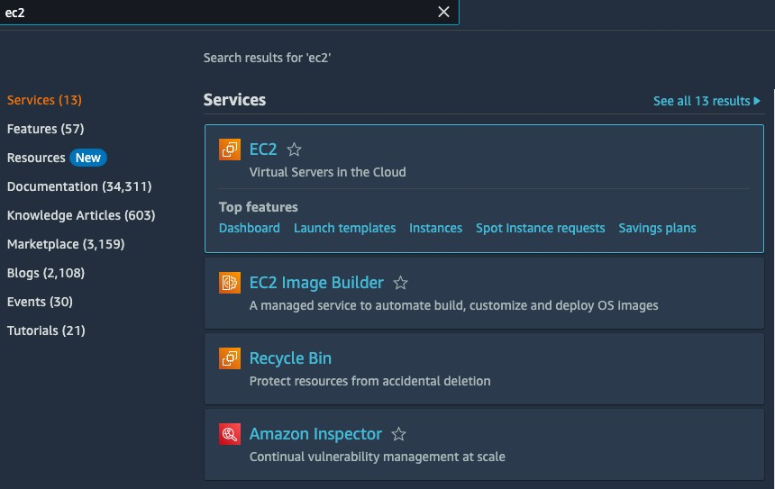
AWS console search for EC2 service. It does not show a running Windows instance.

07 Inbound rule port 8080
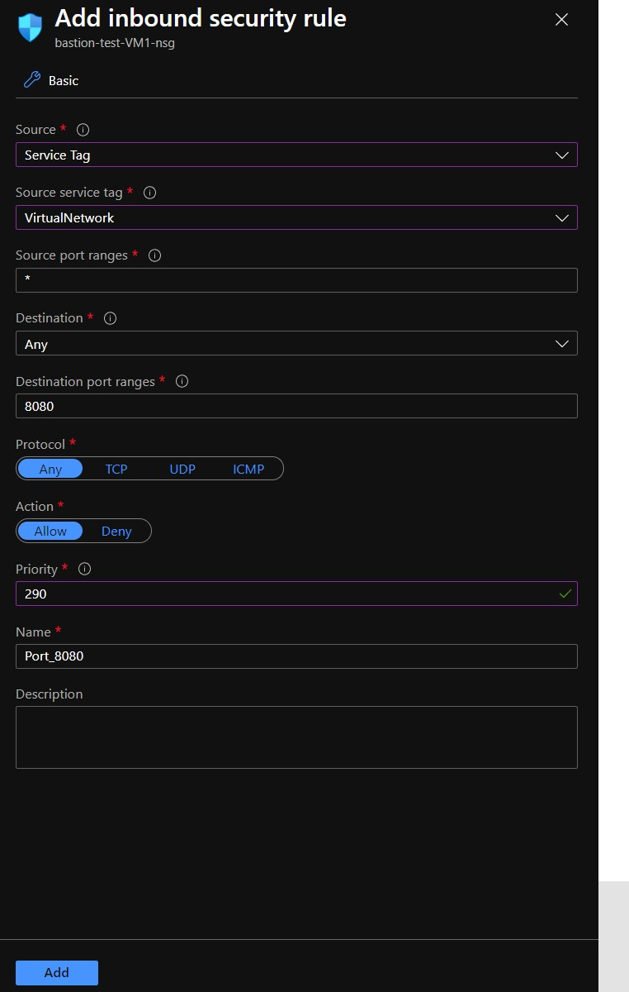
Azure network security rule configuration for port 8080, not AWS RDP port 3389.

