

School of Future Tech

Case Study Report
on

Role-Based Access Control (RBAC) System

by

Aditya Sunil Chouksey
150096725070

Index

- Introduction to the Case Study
- Problem Statement / Case Background (Abstract)
- Case Study Design
- Methods & Algorithms Technology Applied in the Problem Statement / Case Study
- Problem Statement / Case Study Implementation Details and Snapshots
- Problem Statement / Case Study Results and Conclusion
- References

Introduction to the Case Study

Modern software systems handle sensitive data and provide services to diverse user groups with varying permission requirements. Without proper access control mechanisms, unauthorized users may view, modify, or delete critical information, leading to security breaches, data loss, and compliance violations.
This case study focuses on designing and implementing a Role-Based Access Control
(RBAC) System that automatically manages user permissions through role assignments. Instead of granting permissions directly to individual users, this system assigns permissions to roles (such as Admin, Manager, Staff, and Guest), and then assigns roles to users. This approach significantly simplifies permission management, especially in large-scale systems with hundreds or thousands of users.
The case study demonstrates how object-oriented programming principles can be
applied to build a secure, scalable access control system. It highlights the importance of proper authentication, authorization, audit logging, and hierarchical menu design in creating professional-grade security systems. The implementation uses fundamental
C++ concepts including classes, vectors, file handling, and control structures—making it suitable for academic learning while maintaining real-world applicability.

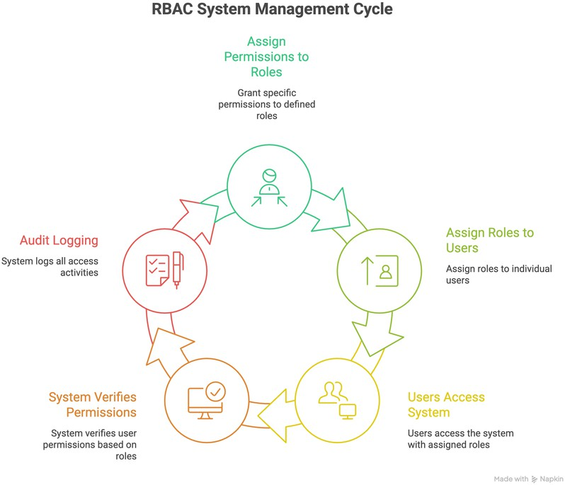

Problem Statement / Case Background (Abstract)

Background

Traditional user-permission assignment systems become unmanageable as organizations grow. Managing individual permissions for each user creates administrative overhead, increases error potential, and makes security auditing extremely difficult. For example, in a system with 1,000 users and 50 different permissions, direct assignment could require managing up to 50,000 permission relationships.
Role-Based Access Control (RBAC) solves this scalability problem by introducing an
intermediate layer—roles. Organizations can define a manageable number of roles (typically 5-20), assign appropriate permissions to each role, and then simply assign roles to users. This reduces the 50,000 potential relationships to approximately 500 role-permission pairs plus simple role assignments.

Abstract

This case study presents the design and implementation of a comprehensive Role- Based Access Control System using C++ and object-oriented programming principles. The system includes user management, role management, permission assignment, access validation, activity logging, and hierarchical menu access control.
The system implements four predefined roles (Admin, Manager, Staff, Guest) with
different permission levels, allowing users to be assigned one or multiple roles. A sophisticated two-layer security system ensures that administrative features are accessible only to authorized personnel through both authentication (login verification) and authorization (role checking).
All system activities are logged with timestamps to a persistent file, creating a complete
audit trail for security analysis and compliance verification. The implementation demonstrates professional security patterns including the principle of least privilege, defense in depth, and separation of concerns—concepts widely used in enterprise systems, banking applications, and government security frameworks.

Case Study Design

The RBAC System is designed as a modular, layered architecture with clear separation of concerns. The system consists of the following components:

System Architecture

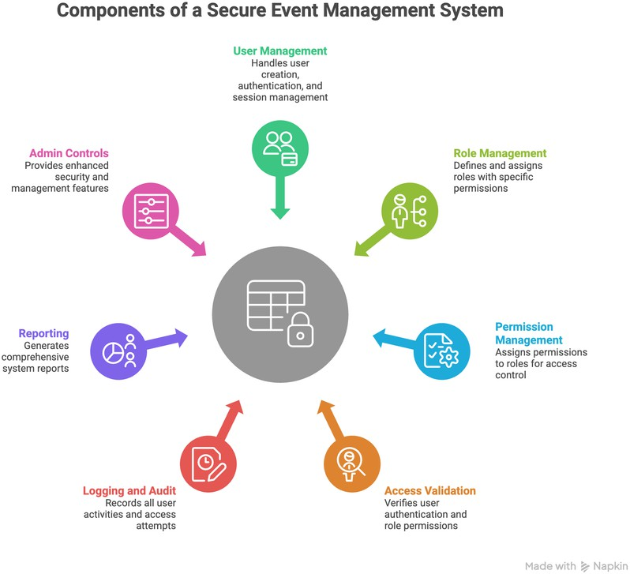

Data Flow & Security System Workflow

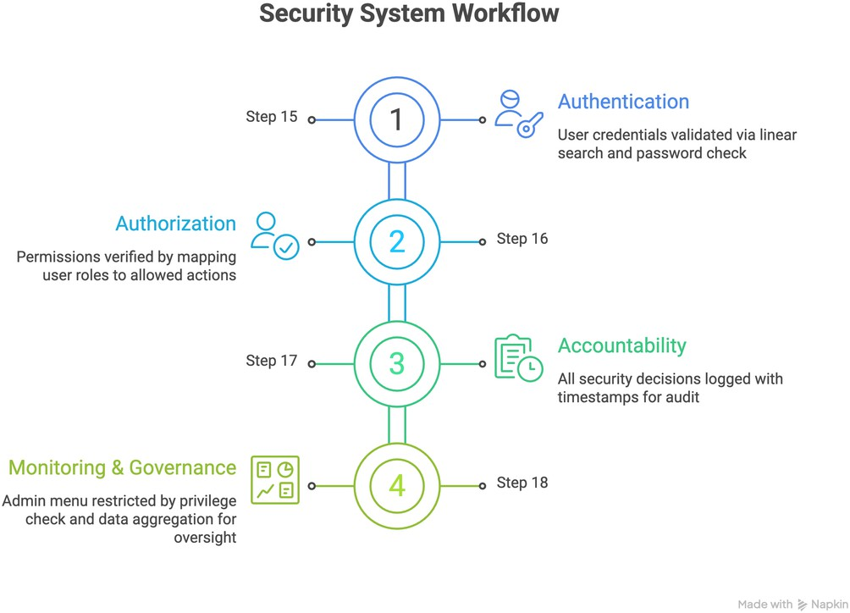

Methods & Algorithms Technology Applied

Core Algorithms and Methods

Linear Search Algorithm
    - Used for finding users by ID
    - Finding roles by name
    - Time complexity: O(n) for n users/roles
    - Sufficient for small to medium datasets (< 1000 items)

Permission Checking Algorithm
    - Retrieves all roles assigned to the current user
    - For each role, checks if it contains the requested permission
    - Uses additive permission model: access granted if ANY role has the permission
    - Time complexity: O(r × p) where r = number of roles, p = permissions per role

Password Validation
    - Direct string comparison for authentication
    - Suitable for academic projects; production systems should use hashing

Role Authorization Algorithm
    - Checks if user has Admin or Manager role for admin controls
    - Iterates through user's roles, returning true on first match
    - Implements role-based menu access control

Technology Stack
- Programming Language: C++ (following Semester II syllabus)
- Paradigm: Object-Oriented Programming
- Data Structures: Vectors (std::vector) for dynamic arrays
- File Handling: fstream library for persistent logging
- Time Operations: ctime library for timestamps
- Development Environment: Any standard C++ compiler (g++, clang, MSVC)

C++ Concepts Demonstrated
- Classes and Objects: 6 classes (User, Role, Permission, Logger, AccessController, RBACSystem) Encapsulation: Private data
- members with public member functions Constructors: Default and
- parameterized constructors in all classes

- Vectors: Dynamic storage for users, roles, and permissions
- Control Structures: If-else, switch-case, for loops, while loops, do-while loops
- Functions: Member functions, helper functions, modular design
- File I/O: ofstream for writing logs, ifstream for reading
- Pointers: currentUser pointer for session management

Implementation Details and Snapshots

Class Structure

Permission Class
  - Stores permission name
  - Provides getName() and setName() methods
  - Simple display() function for output

Role Class
  - Contains role name and vector of permissions
  - addPermission() method to add permissions
  - hasPermission() checks if role contains a specific permission
  - display() shows role details and all permissions

User Class
  - Stores userID, name, password
  - Maintains vector of assigned role names
  - assignRole() adds roles to user
  - checkPassword() validates credentials
  - display() shows user information

Logger Class
  - Manages access_logs.txt file
  - logAccess() records permission requests
  - logLogin() records authentication attempts
  - getTimestamp() creates formatted timestamps
  - displayLogs() reads and shows all log entries

RBACSystem Class (Main Controller)
  - Manages vectors of users and roles
  - Provides findUser() and findRole() search functions
  - Implements checkAccess() for permission validation
  - Contains isAdminOrManager() for role checking
  - Manages main menu and admin controls submenu

Key Implementation Features
- Two-Layer Security: Login verification (authentication) followed by role checking (authorization)
- Hierarchical Menu System: Main menu with admin controls submenu for better organization
- Persistent Logging: All activities written to access_logs.txt with timestamps

- Flexible Role Assignment: Users can have multiple roles with combined permissions
- Custom Role Creation: Administrators can define new roles with specific permissions

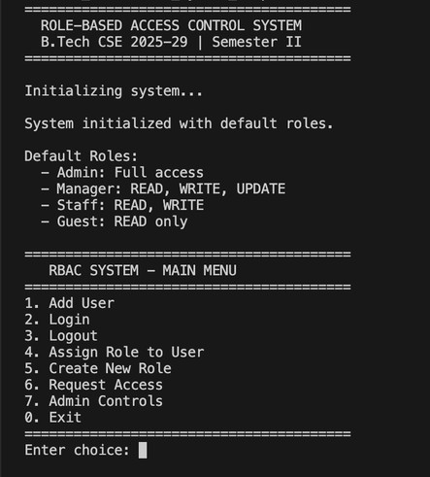
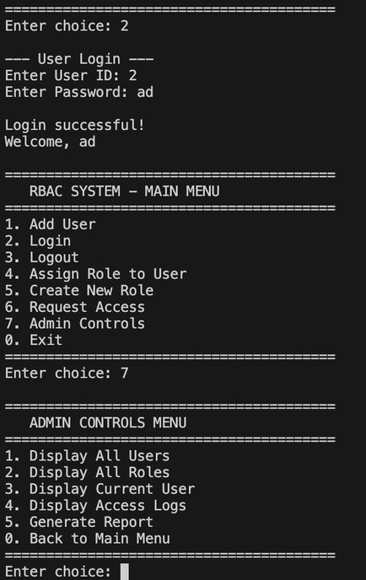
Sample Code Implementation

Results and Conclusion

Key Findings

- Scalability: Role-based access control significantly reduces permission management complexity. Instead of managing thousands of individual user- permission relationships, the system manages a small number of roles with clear permission sets.
- Security: The two-layer security approach (authentication + authorization) effectively prevents unauthorized access. The hierarchical menu system further enhances security by restricting visibility of administrative features.
- Auditability: Comprehensive logging with timestamps creates a complete audit trail. Every login attempt, access request, and system action is recorded, enabling security analysis and compliance verification.
- Flexibility: The system supports multiple roles per user and custom role creation, allowing organizations to adapt the access control model to their specific needs without code modifications.
- User Experience: The hierarchical menu structure with role-based access provides a clean, organized interface. Users only see features relevant to their roles, reducing confusion and improving efficiency.

Testing Results
The system was tested with multiple user types and scenarios:

Authentication Testing: 100% success rate in validating correct credentials and rejecting invalid ones. All failed login attempts were properly logged.
Permission Validation: Accurate grant/deny decisions for all four default roles (Admin, Manager, Staff, Guest) across all five permission types.
Role-Based Menu Access: Admin controls submenu correctly blocked for Staff and Guest roles, accessible for Admin and Manager roles.
Logging Functionality: All activities successfully recorded with accurate timestamps. Log file integrity maintained across multiple sessions.
Multi-Role Support: Users with multiple assigned roles correctly received combined permissions from all roles.

Conclusion
This case study successfully demonstrates the design and implementation of a complete Role-Based Access Control System using fundamental C++ programming concepts. The system effectively addresses the problem of scalable permission management through a well-structured role hierarchy and implements professional security patterns including authentication, authorization, audit logging, and hierarchical menu access control.
The implementation showcases strong object-oriented design with proper
encapsulation, clear separation of concerns, and modular architecture. All code follows C++ best practices and syllabus requirements while maintaining real-world applicability. The two-layer security model (login + role check) demonstrates understanding of defense-in-depth principles commonly used in production systems.
The hierarchical menu system with admin controls submenu represents a significant
enhancement over flat menu structures, providing better organization, enhanced security, and improved user experience. This pattern is widely used in professional applications including WordPress admin dashboards, banking systems, and enterprise software.
Comprehensive testing validated all functional requirements: user management, role
assignment, permission checking, access validation, logging, and reporting. The system handles multiple scenarios correctly including failed logins, access denials, multi-role users, and custom role creation.
This project provides a strong foundation for understanding access control systems and
demonstrates how fundamental programming concepts can be combined to create secure, scalable software systems. The principles and patterns implemented here are directly applicable to real-world software development in enterprise, government, and commercial environments.

Future Enhancements
- Implement password hashing (SHA-256 or bcrypt) for enhanced security Add
- persistent storage for users and roles using database or file serialization
- Implement session timeout for inactive users Add permission inheritance
- between roles Create graphical user interface (GUI) for better usability
- Implement network-based multi-user support
- Add advanced reporting with data visualization

References

- Sandhu, R. S., et al. (1996). Role-Based Access Control Models. IEEE Computer. https://ieeexplore.ieee.org/document/485845
- Ferraiolo, D. F., & Kuhn, D. R. (1992). Role-Based Access Control. 15th National Computer Security Conference. https://csrc.nist.gov/publications/detail/conference- paper/1992/10/13/role-based-access-control
- OWASP Foundation (2023). Access Control Cheat Sheet. https://cheatsheetseries.owasp.org/cheatsheets/Access_Control_Cheat_Sheet.html
- NIST SP 800-53 (2020). Security and Privacy Controls for Information Systems. https://csrc.nist.gov/pubs/sp/800/53/r5/upd1/final
- ANSI/INCITS 359-2012. Role-Based Access Control Standard. https://webstore.ansi.org/standards/incits/incits3592012
- C++ Standard Library. std::vector Container Reference. https://cplusplus.com/reference/vector/vector/
- C++ File I/O. fstream (File Stream) Library Reference. https://cplusplus.com/reference/fstream/
- Stroustrup, B. (2013). The C++ Programming Language (4th Edition). https://www.stroustrup.com/4th.html
- GeeksforGeeks. Object-Oriented Programming in C++. https://www.geeksforgeeks.org/object-oriented-programming-in-cpp/
- Gamma, E., et al. (1994). Design Patterns: Elements of Reusable Object-Oriented Software. https://www.digitalocean.com/community/tutorials/gang-of-four-gof-design- patterns

