
School of Future Tech
Case Study Report
on
Restaurant Table Reservation & Waitlist System
by
Aditya Sunil Chouksey
150096725070

Index
1. Introduction to the Case Study.
1.1 Objectives
1.2 How this report covers the brief
2. Problem Statement / Case Background (Abstract).
2.1 Background
2.2 Problem Statement
2.3 Abstract
3. Problem Statement / Case Study Design.
3.1 System architecture
3.2 Packages and classes
3.3 UML class diagram
3.4 Data structures
3.5 Process flowcharts
3.6 Business rules
4. Methods & Algorithms Technology Applied in the Problem Statement / Case Study.
4.1 Key methods and algorithms
4.2 Java concepts applied
4.3 Technology stack
5. Problem Statement / Case Study Implementation Details and Snapshots.
5.1 Source files by module
5.2 Key code
5.3 Snapshots
6. Problem Statement / Case Study Results and Conclusion.
6.1 Test cases and results
6.2 Findings
6.3 Limitations and future scope
6.4 Conclusion
7. References
A. Appendix - Complete Source Code

1. Introduction to the Case Study
A busy restaurant has to keep three things in step at the same time: guests who booked a table in advance, guests who simply walk in, and tables that keep changing between free, held and occupied. When this is managed on paper or from memory, tables get double-booked, large tables are wasted on small groups, and walk-in guests are forgotten or seated out of turn. This case study designs and implements a Restaurant Table Reservation & Waitlist System - a Java desktop application used by the host at the front desk that manages reservations, the walk-in waitlist and seating, and tells the host exactly which guests should get a table the moment it becomes free.
The case study demonstrates how core Java - classes and objects, enums, the Collections Framework (ArrayList, LinkedList, HashMap, TreeMap), threads, exception handling, validation and a Swing GUI - can be combined into a realistic, working front-of-house system. A LinkedList is used as the natural structure for the sequential waitlist queue, as the brief suggests.

1.1 Objectives
- Maintain table and reservation information.
- Manage the walk-in customer waitlist.
- Assign tables based on party size.
- Notify availability for reserved and waitlisted guests.
- Search and sort reservations.
- Provide a reservation management GUI.

1.2 How this report covers the brief
Table 1 maps every item asked for in the problem statement to the part of this report that covers it.
Table 1: Problem-statement deliverables and where they are covered
Requirement in the brief | Delivered as | Section
Objective: maintain table and reservation information | Table Setup and Reservation Booking modules | 3.2, 5.1, 5.3
Objective: manage walk-in customer waitlist | Waitlist Management module, LinkedList queue | 3.5, 4.1, 5.3
Objective: assign tables based on party size | Best-fit table assignment | 4.1 (method 1)
Objective: notify availability for reserved / waitlisted guests | WaitlistNotifier thread, holds, alerts | 3.5, 4.1 (methods 4-5)
Objective: search and sort reservations | Live search and five sort orders | 4.1 (method 6), 5.3
Objective: reservation management GUI | Swing window with four tabs | 5.3 (Figures 5-11)
14 required Java concepts (Classes to Validation) | One row per concept | 4.2 (Table 4)
7 expected modules (Table Setup to Seating Reports) | One tab or service per module | 3.2, 5.1
Deliverable: realistic front-of-house workflow using a LinkedList waitlist | Complete working application | 3, 5, 6

2. Problem Statement / Case Background (Abstract)

2.1 Background
Restaurants take bookings by phone and in person, while walk-in guests arrive without notice. Each party has a different size, tables come in different sizes, and the dining room is split into sections such as the main hall, the patio and the bar. The host must decide, many times an hour, which party sits where - without seating a walk-in at a table that is booked twenty minutes later, without giving a six-seat table to a couple when a two-seat table is free, and without skipping guests who have been waiting longer. These decisions follow clear rules, which makes them a good fit for software.

2.2 Problem Statement
A restaurant needs a system to manage table reservations, walk-in waitlists, and seating assignments across different table sizes and sections. The system should notify hosts when a reserved or waitlisted table becomes available.

2.3 Abstract
This case study presents the design and implementation of a Restaurant Table Reservation & Waitlist System in Java. Tables, reservations, customers and waitlisted parties are modelled as classes; table status is an enum (AVAILABLE, RESERVED, OCCUPIED). Reservations are stored in an ArrayList, indexed by ID in a HashMap and kept in time order in a TreeMap, while walk-in parties wait in a LinkedList queue. New bookings are given the smallest table that fits (best fit) and every party blocks its table for a 90-minute dining window, so double bookings are impossible. When guests leave, a background thread waits 2 seconds while the table is reset and then offers it to the booking due next or to the first waitlisted party that fits, alerting the host. A second thread checks every 15 seconds to hold tables 30 minutes before booked guests arrive and to flag late parties. All input is validated, every rule violation is reported through custom checked exceptions, and the data is saved automatically to a file. The system is operated through a Swing GUI with four tabs, and all 16 planned test cases passed.

3. Problem Statement / Case Study Design
The system is designed in layers so that the business rules do not depend on the user interface. The Swing GUI only collects input and displays results; every decision is made by one service class, RestaurantManager, which is shared by the GUI and the two background threads.

3.1 System architecture
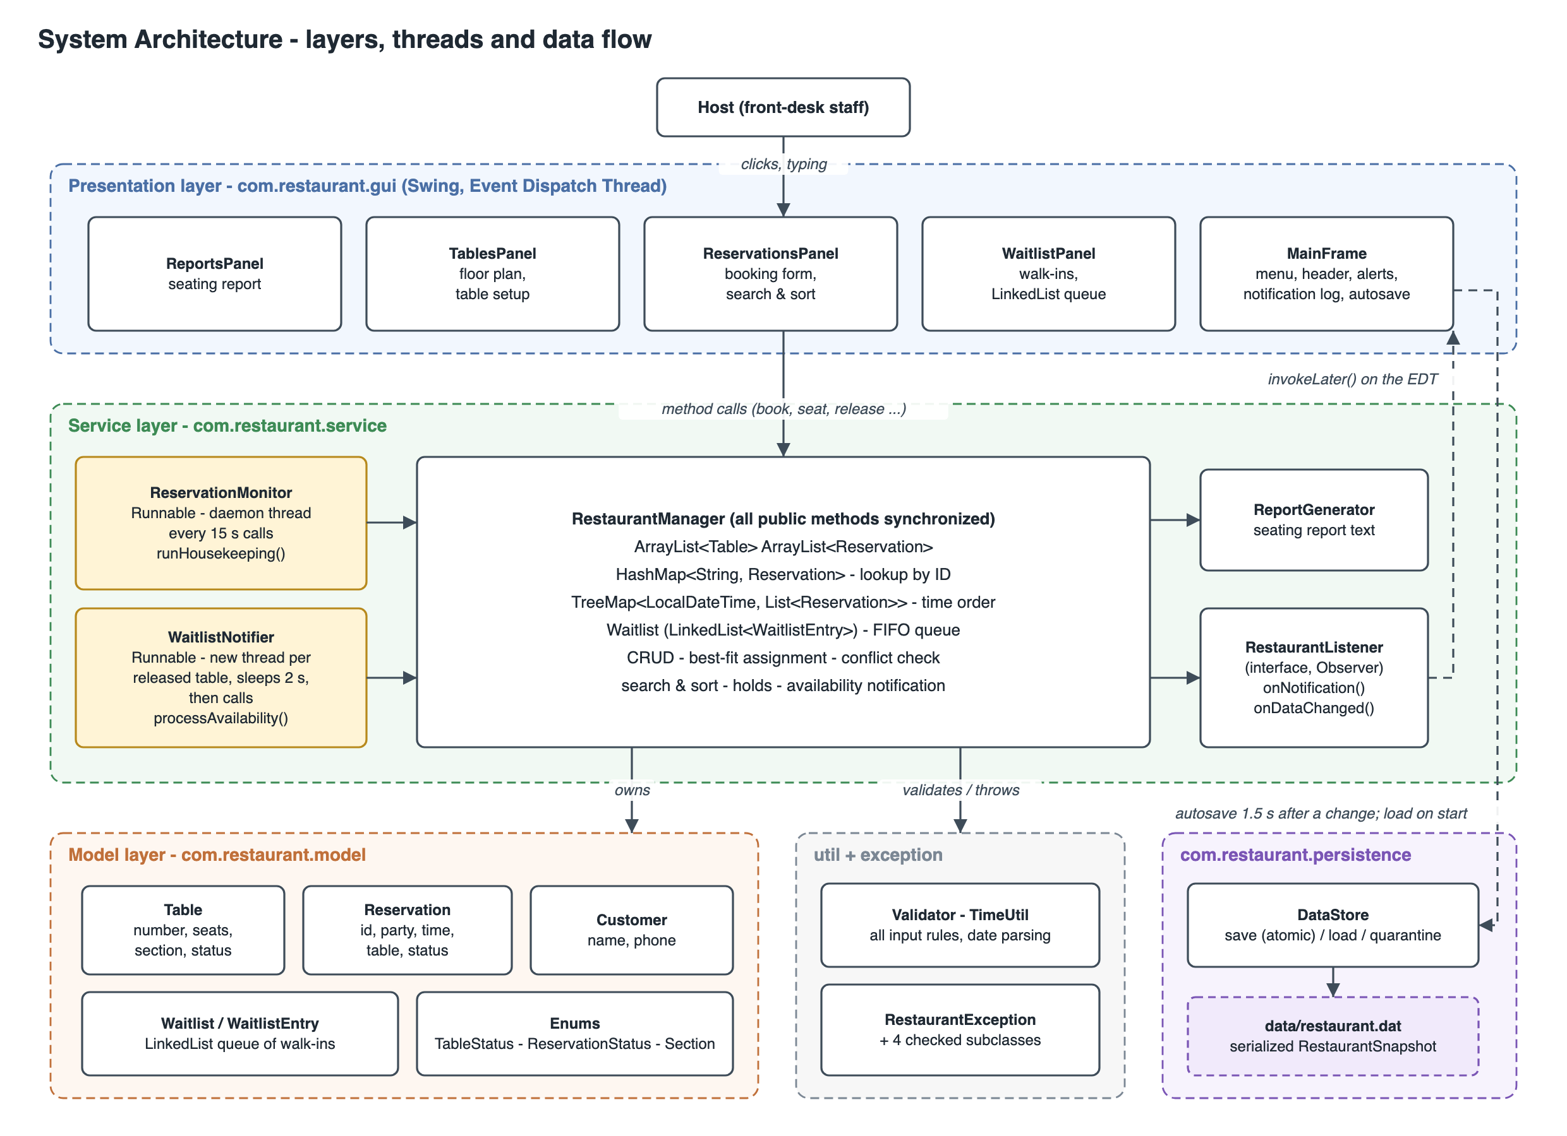
Figure 1: System architecture: presentation, service, model, utility and persistence layers, the two background threads and how data flows between them

3.2 Packages and classes
Table 2: Packages, their responsibilities and the expected modules they implement
Package | Responsibility | Main classes | Modules
model | Plain data classes and enums | Table, Reservation, Customer, Waitlist, WaitlistEntry, TableStatus, ReservationStatus, Section | 1, 2, 3
service | All business rules, threads and reports | RestaurantManager, WaitlistNotifier, ReservationMonitor, ReportGenerator, RestaurantListener, WalkInResult, SampleData | 2-7
persistence | Saving and loading | DataStore, RestaurantSnapshot | -
exception | Checked exception hierarchy | RestaurantException + InvalidReservation-, InvalidTable-, TableNotAvailable-, NotFoundException | all
util | Validation and date/time handling | Validator, TimeUtil | all
gui | Swing user interface | MainFrame, TablesPanel, ReservationsPanel, WaitlistPanel, ReportsPanel, StatusCellRenderer, GuiUtil | 1-7
Module numbers: 1 Table Setup, 2 Reservation Booking, 3 Waitlist Management, 4 Table Assignment, 5 Availability Notification, 6 Reservation Search, 7 Seating Reports. All packages sit under com.restaurant.
The UML class diagram (Figure 2) follows on a landscape page.

3.3 UML class diagram
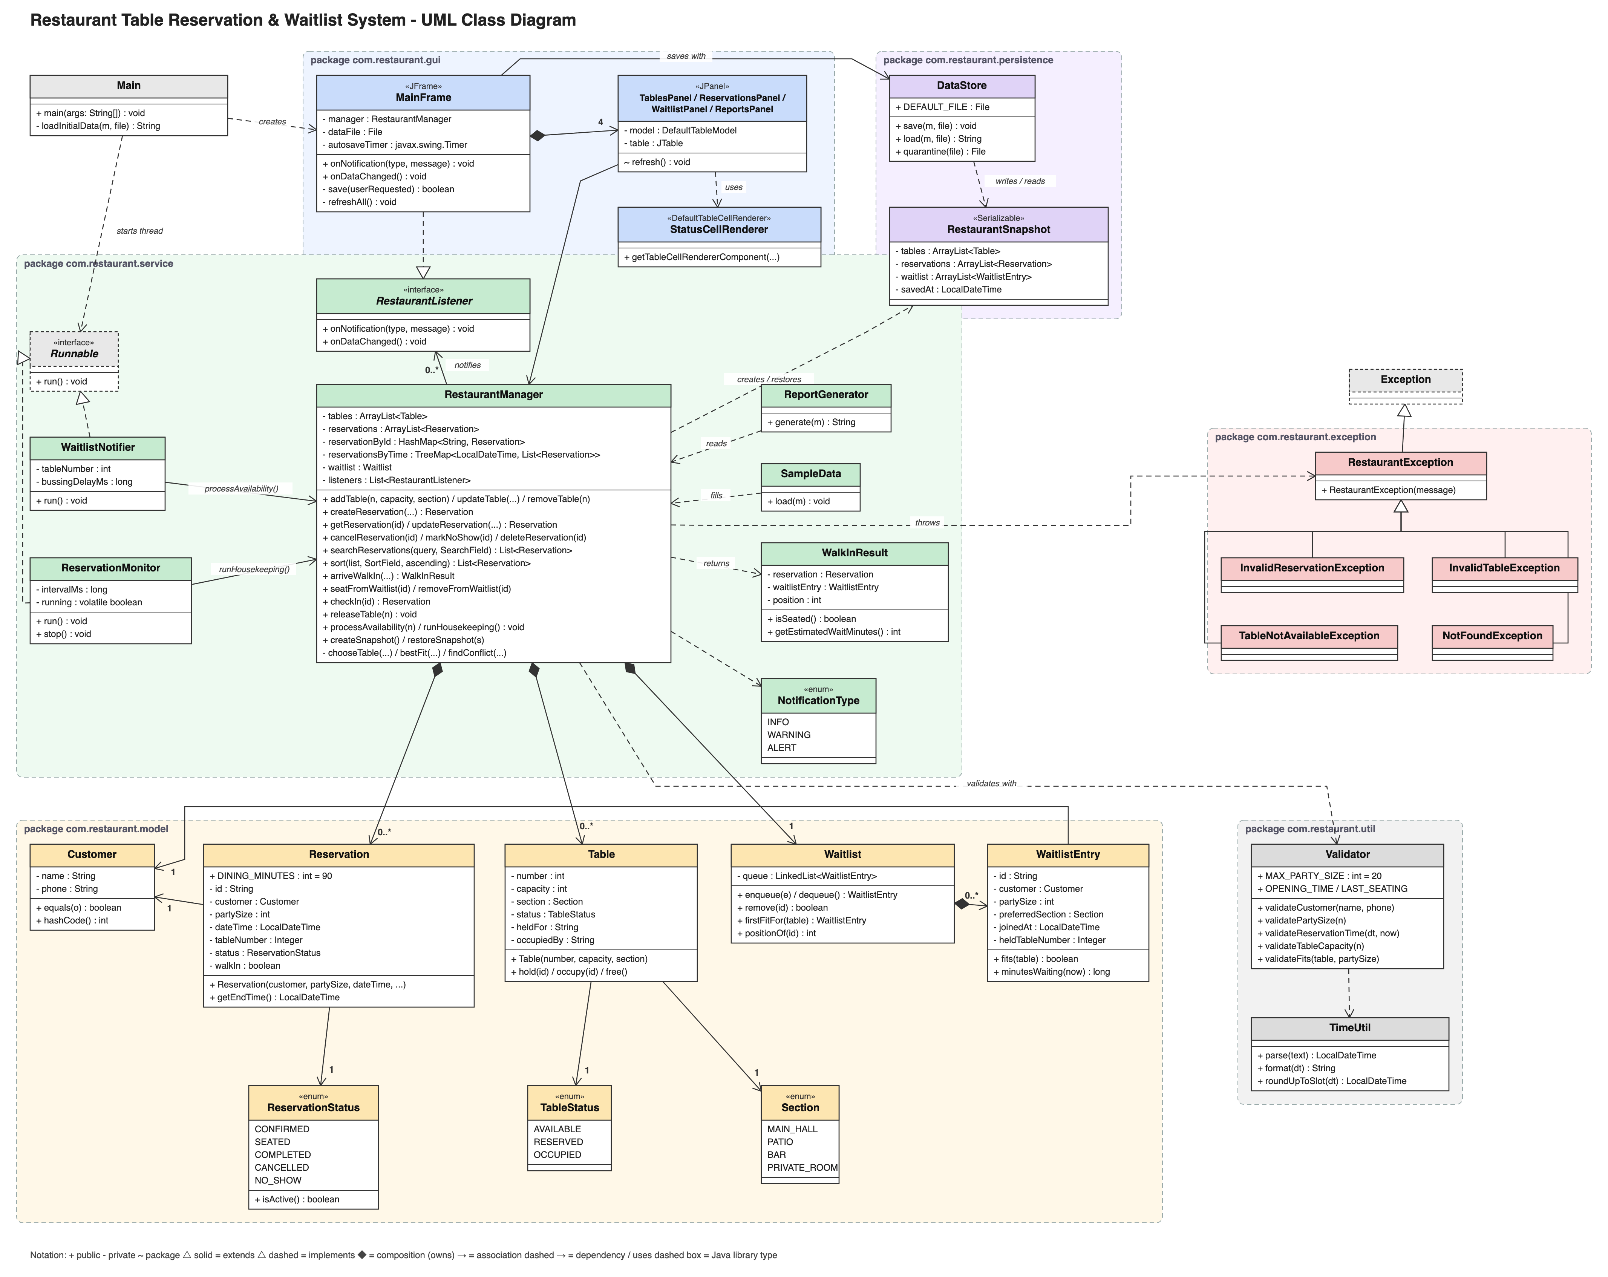
Figure 2: UML class diagram - every class with its key fields and methods, grouped by package (+ public, - private, ~ package)

3.4 Data structures
Table 3: Collections used by RestaurantManager and why each was chosen
Structure | Holds | Why this structure
ArrayList<Table> | All tables, sorted by table number | A small list that is scanned for the best-fit table; its order gives a stable tie-break (lowest table number wins).
ArrayList<Reservation> | Every reservation and seated walk-in | The master record in creation order; scanned for conflicts and for customer searches.
HashMap<String, Reservation> | Reservation ID -> reservation | O(1) lookup when the host checks in, edits, cancels or searches by ID.
TreeMap<LocalDateTime, List<Reservation>> | Reservations grouped by start time | Always sorted by time. subMap() answers "who is due in the next 30 minutes?" and "today's bookings" without scanning everything; tailMap() finds the next booking for a table.
LinkedList<WaitlistEntry> | The walk-in queue (inside Waitlist) | A natural first-come-first-served queue: addLast() to join, removal from the front or the middle when a party is seated or leaves, iteration in arrival order to find the first party that fits.

3.5 Process flowcharts
Flowchart 1 shows how a booking is validated and given a table. Flowchart 2 shows the two halves of the waitlist: a walk-in arriving (left) and a table being released, which starts the notification thread (right).
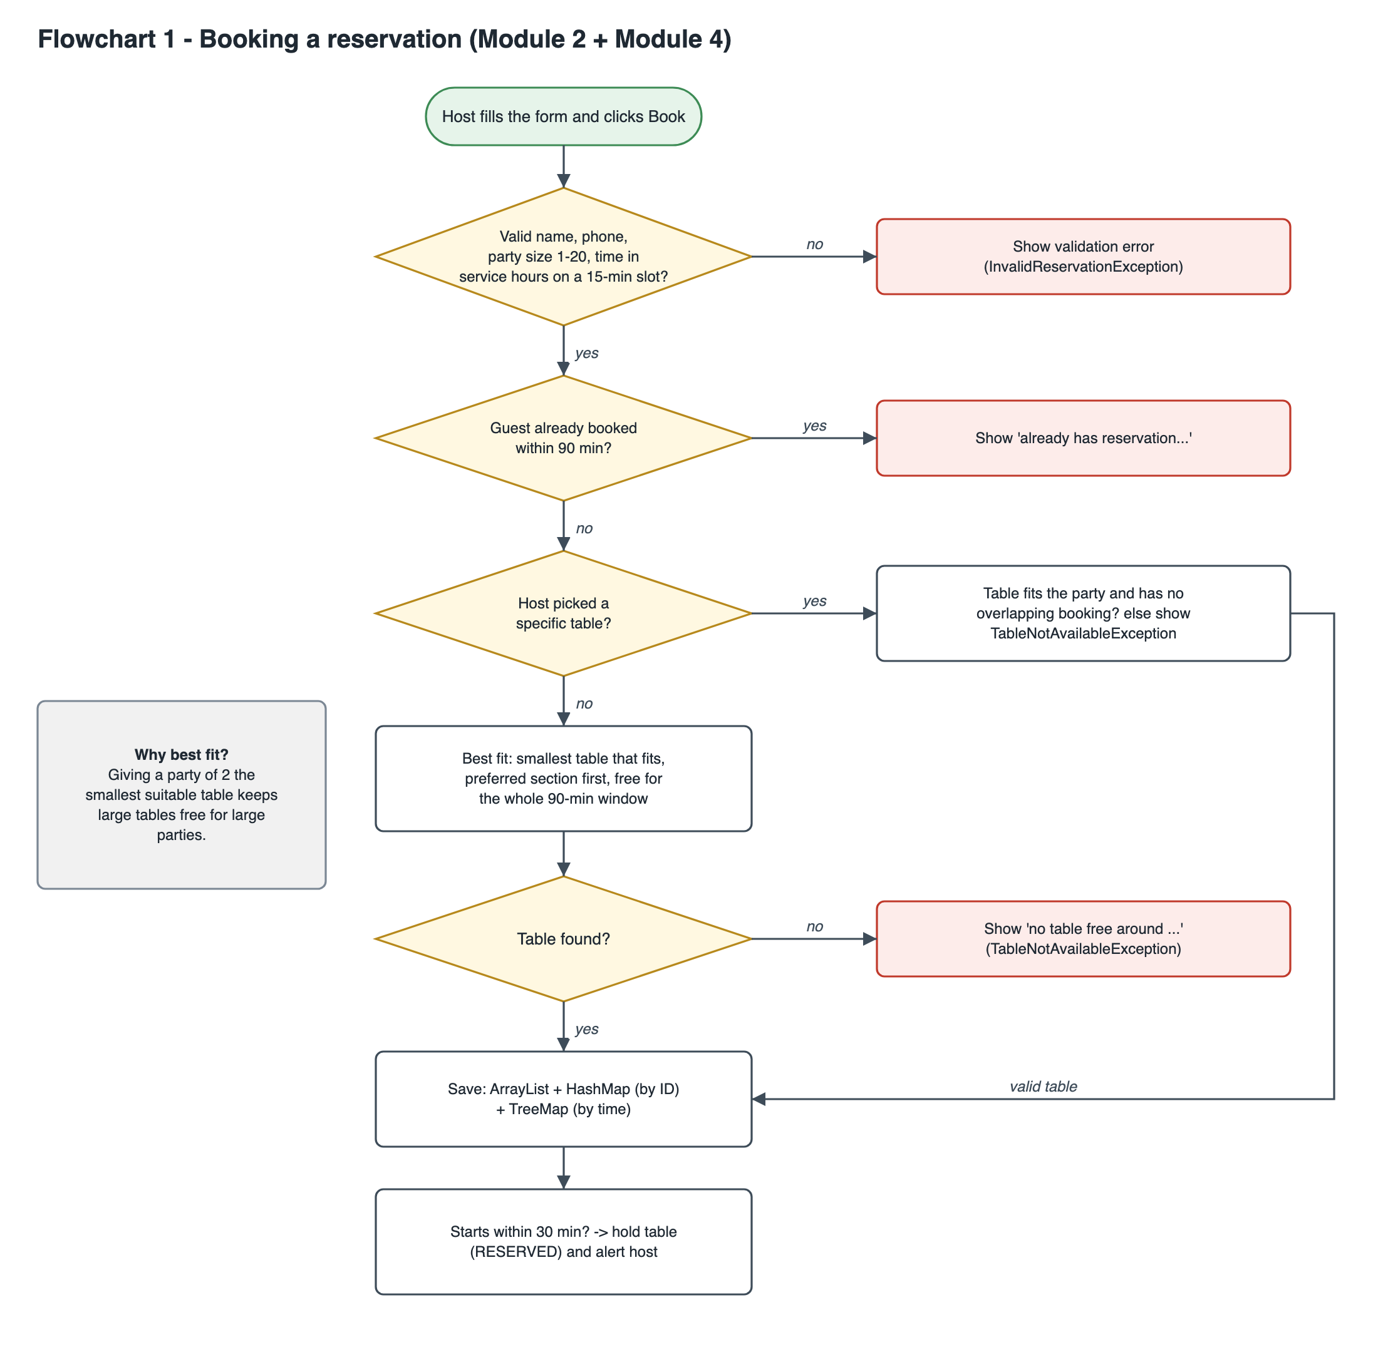
Figure 3: Flowchart 1 - booking a reservation (validation, duplicate check, best-fit assignment, indexing, holding)
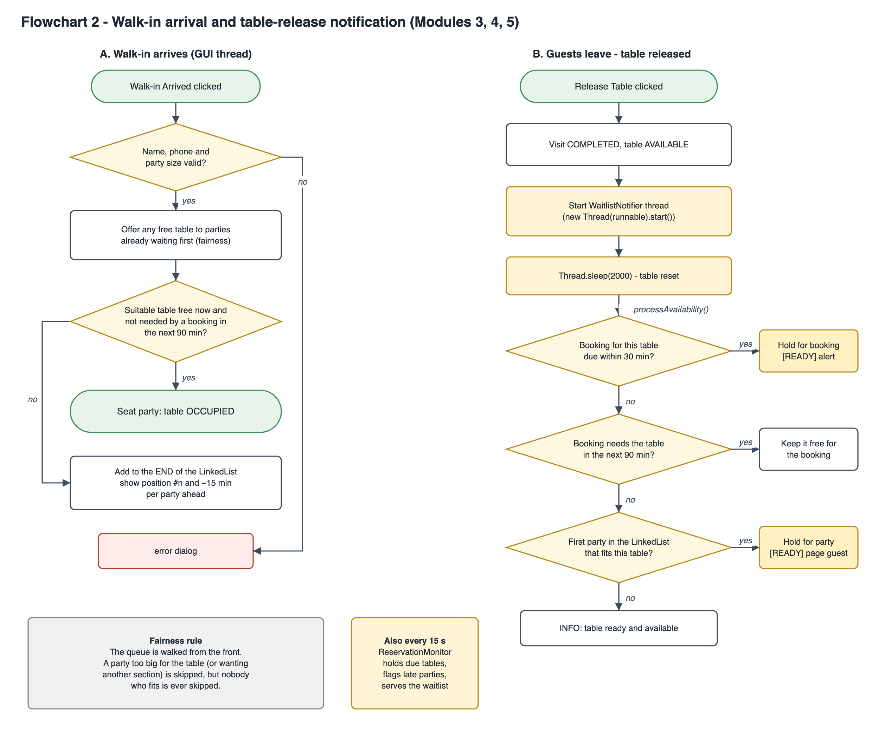
Figure 4: Flowchart 2 - walk-in arrival and the table-release notification thread

3.6 Business rules
- Service hours: guests are seated between 11:00 and 22:30, in 15-minute slots, up to 60 days ahead.
- Party size: 1 to 20 guests; the party must fit the table.
- Dining window: each party is expected to use its table for 90 minutes; two parties on one table may not overlap.
- Holding tables: a table turns RESERVED for a booked party from 30 minutes before its time.
- Waitlist fairness: the earliest party in the queue that fits a free table gets it; a newcomer cannot take a table while an earlier waiting party fits it.
- Bookings come first: a walk-in is not given a table that a reservation needs within the next 90 minutes.
- Late guests: a booked party 15 minutes late triggers a warning so the host can call them or mark a no-show.
- One booking per guest per slot: the same phone number cannot hold two overlapping bookings or queue twice.

4. Methods & Algorithms Technology Applied in the Problem Statement / Case Study

4.1 Key methods and algorithms
- Best-fit table assignment
  - Consider every table that is big enough and free for the whole dining window, and pick the one with the fewest seats.
  - Search the guest's preferred section first; if it is full, fall back to any section and tell the host.
  - Ties go to the lowest table number, so the result is predictable.
- Interval conflict detection
  - Every active party occupies the interval [start, start + 90 min) on its table.
  - Two parties conflict when their intervals overlap: newStart < busyEnd and newEnd > busyStart.
  - A seated party keeps its table at least until "now", even if it stays longer than planned.
- FIFO first-fit waitlist (LinkedList)
  - Walk-ins are appended to the end of the queue.
  - When a table frees up, the queue is walked from the front and the first party that fits is chosen; parties that are too large or want another section are skipped, nobody who fits is.
- Holding tables for arriving guests
  - A TreeMap range query (subMap) finds bookings starting within 30 minutes; their tables are switched to RESERVED.
  - Late bookings (15+ minutes) raise a single warning.
- Background availability notification (threads)
  - Releasing a table starts a WaitlistNotifier thread, which sleeps 2 s (table being reset) and then offers the table.
  - A ReservationMonitor daemon thread sweeps every 15 s. All shared state is protected with synchronized methods.
- Searching and sorting
  - HashMap lookup for IDs; linear, case-insensitive matching for names and phone fragments; filtering by table number.
  - Sorting with Comparator chains (time, party size, customer, table, status), ascending or descending.
- Validation
  - Regular expressions for names and phone numbers; range checks for party size and capacity.
  - Strict date parsing that rejects impossible dates such as 30 February.
- Persistence with atomic save
  - Java serialization of one snapshot object, written to a temporary file and moved over the real file; automatic save 1.5 s after each change.

4.2 Java concepts applied
The brief lists fourteen Java concepts. Table 4 shows where each one is used; all fourteen are implemented for the purpose the brief describes.
Table 4: Required Java concepts and where they are implemented
Java concept | Application (brief) | Implementation in this project
Classes & Objects | Table, Reservation, Customer, Waitlist | model package: Table, Reservation, Customer, Waitlist, WaitlistEntry
Constructors | Initialise reservation/table objects | Table(number, capacity, section) starts AVAILABLE; Reservation(...) generates its ID and starts CONFIRMED
Enum | TableStatus (AVAILABLE, RESERVED, OCCUPIED) | TableStatus, plus ReservationStatus, Section and NotificationType
Runnable / Thread | Simulate waitlist notification | WaitlistNotifier and ReservationMonitor implement Runnable and run on their own threads
ArrayList | Store tables and reservations | RestaurantManager.tables and .reservations
LinkedList | Maintain waitlist queue | Waitlist.queue - FIFO queue with removal from the middle
HashMap | Reservation ID -> details | RestaurantManager.reservationById
TreeMap | Reservations sorted by time | RestaurantManager.reservationsByTime with subMap() / tailMap() range queries
CRUD | Reservation management | createReservation, getReservation, updateReservation, cancelReservation / markNoShow, deleteReservation
Searching | Search by customer/table | searchReservations(query, SearchField): name, phone, table or ID
Sorting | Sort by time, party size | RestaurantManager.sort(list, SortField, ascending) - time, party size, customer, table, status
Swing | Reservation management GUI | gui package: tabs, tables, forms, dialogs, menu, timers, colour-coded cells
Exception Handling | Invalid reservation/table data | Checked RestaurantException hierarchy; try/catch around every GUI action; try-with-resources for files
Validation | Party size, reservation time, table capacity | Validator: name, phone, party size, service hours, 15-minute slots, date range, capacity, strict dates
Additional concepts used: interfaces and the Observer pattern (RestaurantListener), inheritance (exceptions, Swing panels), encapsulation, lambdas and method references, the java.time API, serialization and file I/O, synchronized / volatile / AtomicInteger.

4.3 Technology stack
- Programming language: Java (Java 8 or newer).
- Libraries and tools:
  - Java Collections Framework - ArrayList, LinkedList, HashMap, TreeMap.
  - Java Swing - JFrame, JTabbedPane, JTable, dialogs, javax.swing.Timer.
  - java.lang.Thread / Runnable - background notification and monitoring.
  - java.time - LocalDateTime, Duration, DateTimeFormatter.
  - java.io / java.nio.file - object serialization and atomic file moves.
- Environment:
  - JDK (javac and java), any IDE such as IntelliJ IDEA, Eclipse or VS Code; run scripts run.sh / run.bat.
- Data storage:
  - data/restaurant.dat - a serialized snapshot of tables, reservations and the waitlist. No external database or library is needed.

5. Problem Statement / Case Study Implementation Details and Snapshots
The implementation consists of 33 Java source files (about 3400 lines) in six packages, with no external libraries. The complete code is in Appendix A.

5.1 Source files by module
- model/ - Table.java, Reservation.java, Customer.java, Waitlist.java, WaitlistEntry.java and the enums
  - Data for tables, bookings, guests and the walk-in queue (Modules 1-3).
- service/RestaurantManager.java
  - All business logic: table setup, reservation CRUD, best-fit assignment, waitlist, check-in, release, holds, search and sort (Modules 1-6).
- service/WaitlistNotifier.java, service/ReservationMonitor.java
  - The two Runnable classes that run on background threads (Module 5).
- service/ReportGenerator.java
  - Builds the seating report: floor status, sections, today's parties, upcoming bookings, waitlist (Module 7).
- persistence/DataStore.java, persistence/RestaurantSnapshot.java
  - Saving and loading with serialization.
- util/Validator.java, util/TimeUtil.java, exception/*.java
  - Validation rules, date handling and the custom exceptions.
- gui/*.java and Main.java
  - The Swing window, one tab per area, and the entry point that loads data and starts the monitor thread.

5.2 Key code
Best-fit assignment - the smallest suitable table that is free for the whole dining window:
private Table bestFit(int partySize, LocalDateTime start, Section section, String ignoreId, boolean mustBeFreeNow) {
Table best = null;
for (Table t : tables) {
if (t.getCapacity() < partySize) continue;
if (section != null && t.getSection() != section) continue;
if (mustBeFreeNow && t.getStatus() != TableStatus.AVAILABLE) continue;
if (findConflict(t, start, ignoreId) != null) continue;
if (isBlockedByWaitlistHold(t, start)) continue;
// tables are sorted by number, so ties keep the lowest-numbered table
if (best == null || t.getCapacity() < best.getCapacity()) best = t;
}
return best;
}
The waitlist is a LinkedList; this method walks it from the front to find the first party that fits a free table:
/** Earliest party in line that fits the table and is not already holding another table. */
public WaitlistEntry firstFitFor(Table table) {
for (WaitlistEntry e : queue) {
if (e.getHeldTableNumber() == null && e.fits(table)) return e;
}
return null;
}
The Runnable that runs on its own thread when a table is released:
@Override
public void run() {
try {
if (bussingDelayMs > 0) {
Thread.sleep(bussingDelayMs);
}
manager.processAvailability(tableNumber);
} catch (InterruptedException e) {
Thread.currentThread().interrupt();
}
}
TreeMap range query used to find bookings that are due soon:
/** Reservations starting in [from, to), using the TreeMap's range view. */
public synchronized List<Reservation> getReservationsBetween(LocalDateTime from, LocalDateTime to) {
List<Reservation> out = new ArrayList<>();
for (List<Reservation> slot : reservationsByTime.subMap(from, true, to, false).values()) {
out.addAll(slot);
}
return out;
}
Validation of the reservation time - each rule throws a checked exception with a message the host can act on:
public static void validateReservationTime(LocalDateTime dateTime, LocalDateTime now) throws InvalidReservationException {
if (dateTime == null) {
throw new InvalidReservationException("Reservation date and time are required.");
}
if (dateTime.isBefore(now)) {
throw new InvalidReservationException("Reservation time " + TimeUtil.format(dateTime) + " is in the past.");
}
if (dateTime.isAfter(now.plusDays(MAX_DAYS_AHEAD))) {
throw new InvalidReservationException("Reservations can only be made up to " + MAX_DAYS_AHEAD + " days in advance.");
}
LocalTime time = dateTime.toLocalTime();
if (time.isBefore(OPENING_TIME) || time.isAfter(LAST_SEATING)) {
throw new InvalidReservationException("Guests are seated between " + OPENING_TIME + " and " + LAST_SEATING
+ "; " + time + " is outside service hours.");
}
if (dateTime.getMinute() % SLOT_MINUTES != 0) {
throw new InvalidReservationException("Reservations are taken in " + SLOT_MINUTES
+ "-minute slots (e.g. 19:00, 19:15, 19:30).");
}
}

5.3 Snapshots
All snapshots were captured from the running application with its sample data. Status cells are colour-coded: green = available, amber = reserved/held, red = occupied, blue = confirmed booking, grey = closed.
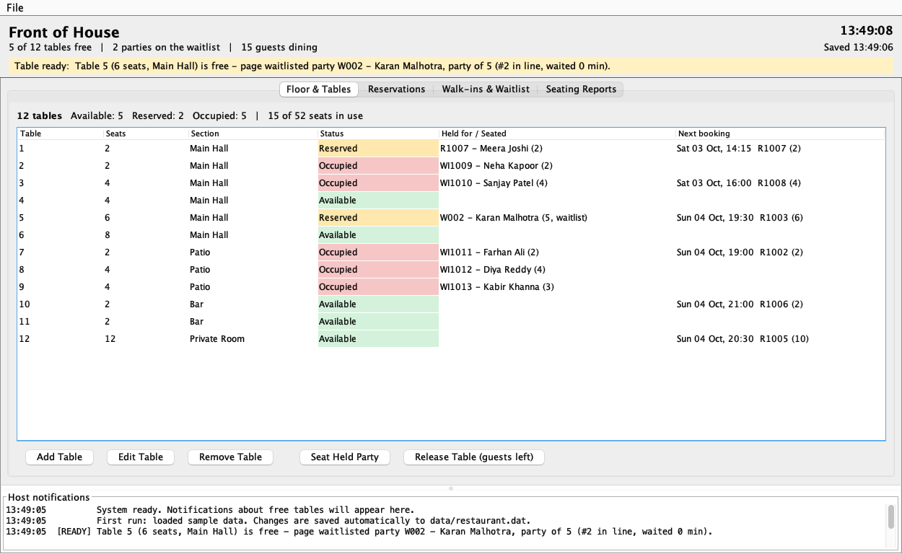
Figure 5: Floor & Tables tab (Modules 1 and 4): every table with its status, who is seated or expected, and its next booking. Table 1 is already held for a booking due within 30 minutes
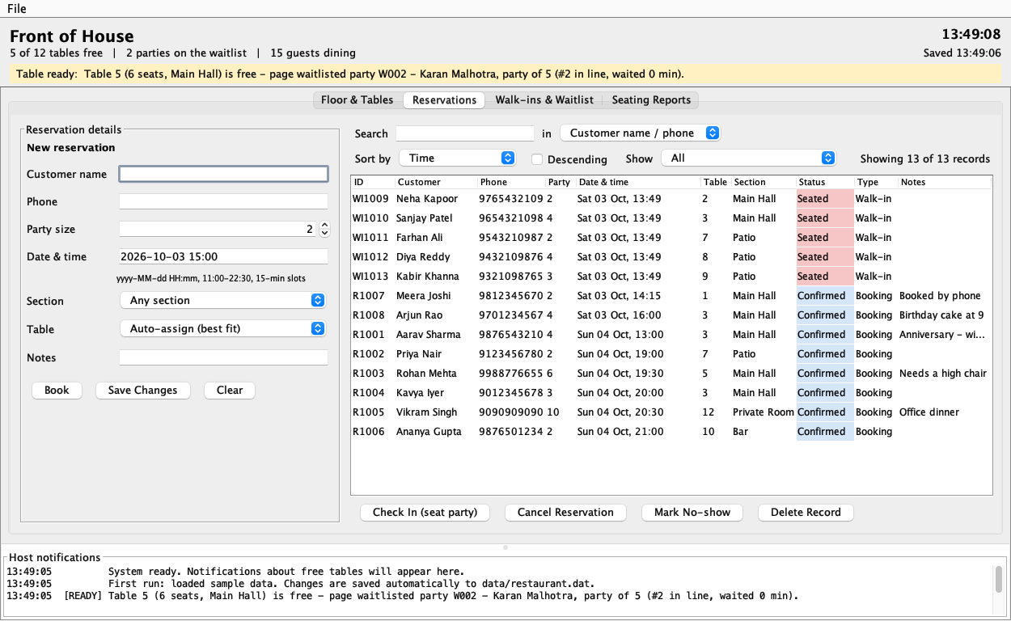
Figure 6: Reservations tab (Modules 2 and 6): booking form, live search, sort order and view filter, and actions for the selected booking
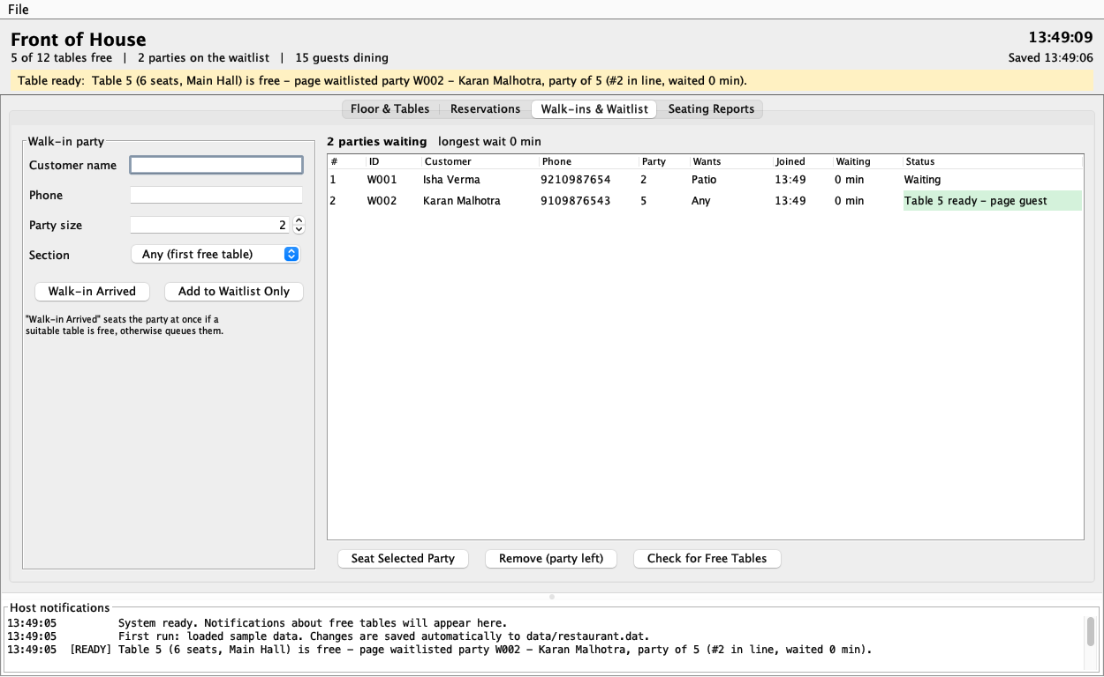
Figure 7: Walk-ins & Waitlist tab (Module 3): the LinkedList queue in arrival order; W002 already has table 5 held
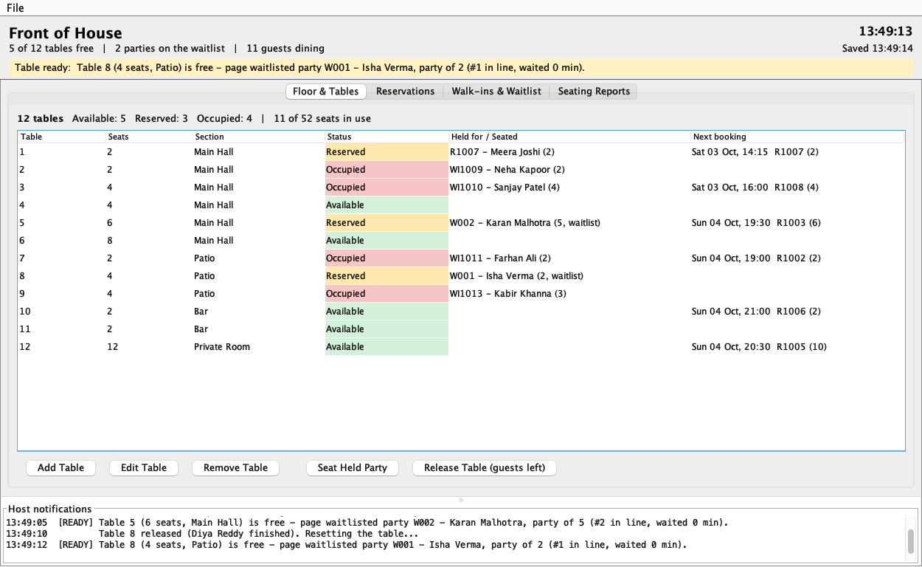
Figure 8: Availability notification (Module 5): table 8 was released; 2 s later the notifier thread held it for Isha Verma, the first waiting party that wants the Patio, and alerted the host
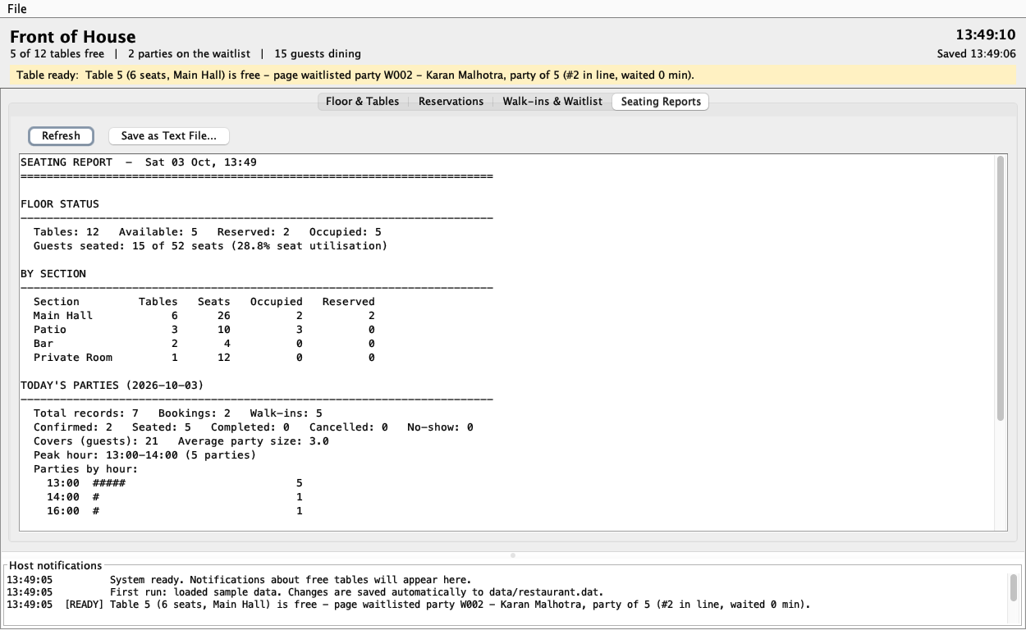
Figure 9: Seating Reports tab (Module 7): floor status, seat utilisation, section breakdown, today's parties and waitlist statistics
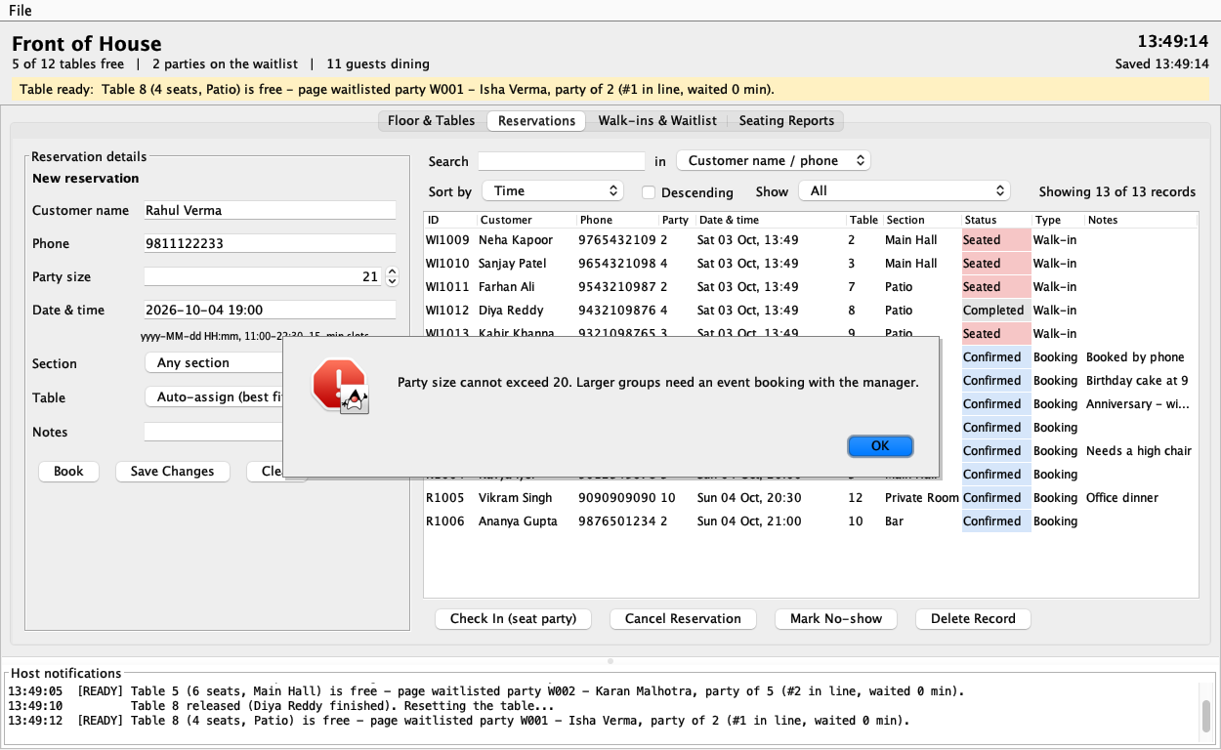
Figure 10: Validation: a party of 21 typed into the booking form is rejected with a clear message
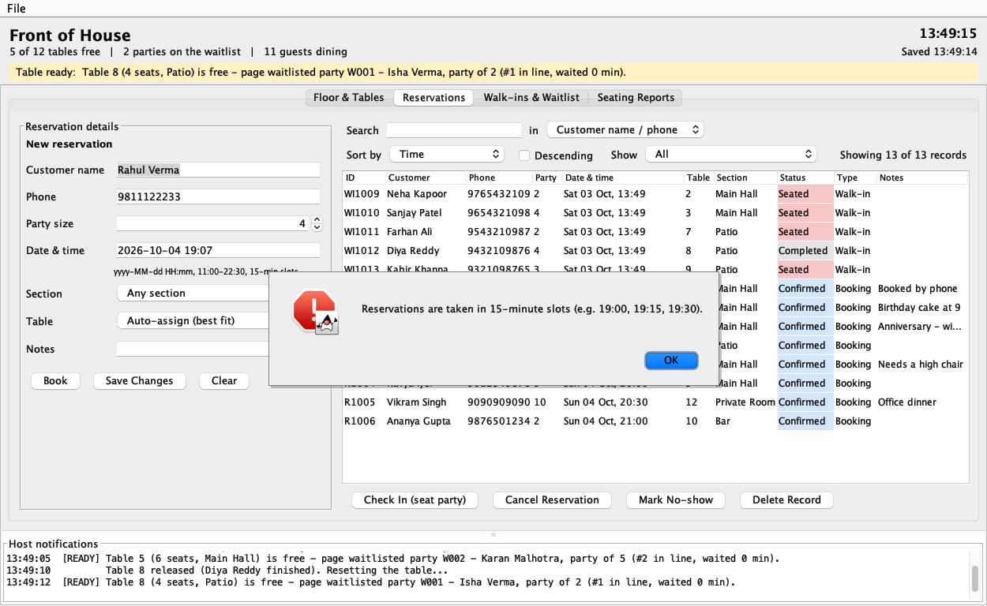
Figure 11: Validation: a booking at 19:07 is rejected because reservations are taken in 15-minute slots

6. Problem Statement / Case Study Results and Conclusion

6.1 Test cases and results
The finished application was tested against the following cases, covering every module and every validation rule. All 16 test cases passed.
Table 5: Test cases and results
ID | Test case | Expected result | Result
TC01 | Add a table whose number already exists | Error "Table 3 already exists." | Pass
TC02 | Reduce a table to fewer seats than a booked party | Error naming the reservation that needs the seats | Pass
TC03 | Book a party of 21 | Error "Party size cannot exceed 20..." | Pass
TC04 | Book a time in the past, or 23:00 | Error explaining the rule that was broken | Pass
TC05 | Book at 19:07 | Error: reservations are taken in 15-minute slots | Pass
TC06 | Enter an impossible date (2026-02-30) | Error: not a valid date/time, with the expected format | Pass
TC07 | Party of 3 when 2-, 4- and 6-seat tables are free | The 4-seat table is assigned (best fit) | Pass
TC08 | Request a table already booked at an overlapping time | Error: table is already booked by another reservation | Pass
TC09 | Walk-in arrives when every suitable table is taken | Added to the waitlist with position and estimated wait | Pass
TC10 | Release a 2-seat table; queue holds a party of 4, then a party of 2 | About 2 s later the table is held for the party of 2; [READY] alert | Pass
TC11 | New walk-in while a free table is held for a waiting party | Newcomer is queued; the waiting party keeps the table | Pass
TC12 | A reservation becomes due within 30 minutes | Its table turns RESERVED and the host is alerted | Pass
TC13 | Search part of a name in capitals ("YA"), then sort by party size | Only matching rows, case-insensitive, in party-size order | Pass
TC14 | Cancel a reservation whose table is being held | Status Cancelled; the table is offered to the next party | Pass
TC15 | Close the application and open it again | All tables, reservations and the waitlist are restored | Pass
TC16 | Start the application with a damaged data file | Starts with sample data; the damaged file is kept | Pass

6.2 Findings
- Keeping one sorted index per question (HashMap by ID, TreeMap by time) made each operation simple and fast instead of scanning every reservation every time.
- A LinkedList is the right fit for the waitlist: parties join at the end, leave from anywhere, and are examined in arrival order.
- Best-fit assignment with a 90-minute window prevented every double booking in testing while keeping large tables free for large parties.
- Moving the waiting and checking onto background threads kept the GUI responsive; synchronized methods and invokeLater() kept the shared data consistent.
- Specific error messages ("Reservations are taken in 15-minute slots...") make validation useful to the host instead of merely blocking input.

6.3 Limitations and future scope
- Data lives in one local file; a database (for example MySQL through JDBC) would let several front-desk computers share one reservation book.
- The 90-minute dining window is fixed; it could depend on party size or the time of day.
- The host pages waitlisted guests in person; SMS or WhatsApp messages could notify them automatically.
- Tables cannot be joined for very large parties, and the floor plan is a list rather than a visual map.

6.4 Conclusion
This case study delivers a complete Restaurant Table Reservation & Waitlist System that meets all six objectives, all seven expected modules and all fourteen required Java concepts of the brief. ArrayList, HashMap and TreeMap organise the reservation book, a LinkedList models the waitlist queue, Runnable threads deliver availability notifications, and a Swing GUI puts everything in front of the host. Beyond the brief, the system enforces realistic front-of-house rules - best-fit assignment, no double bookings, a fair waitlist and tables held for arriving guests - and saves its data automatically. Separating the business logic from the user interface kept the code easy to test and would make it straightforward to add a database or a web front end in future.

7. References
- Oracle. Java Platform, Standard Edition 8 API Specification - java.util, java.time, java.io, javax.swing. docs.oracle.com/javase/8/docs/api
- Oracle. The Java Tutorials - Collections, Concurrency, Creating a GUI With Swing, Date-Time, Basic I/O. docs.oracle.com/javase/tutorial
- Bloch, J. Effective Java, 3rd edition. Addison-Wesley, 2018.
- Goetz, B. et al. Java Concurrency in Practice. Addison-Wesley, 2006.
- Gamma, E., Helm, R., Johnson, R. and Vlissides, J. Design Patterns - the Observer pattern. Addison-Wesley, 1994.
- ITM Skills University, School of Future Tech. Java Programming - Case Study 70 problem statement, B.Tech CSE 2025-29, Semester III.

Appendix A - Complete Source Code
All 33 source files, exactly as submitted, grouped by package. Package com.restaurant is abbreviated to the folder name.

A.1 Main.java
package com.restaurant;

import com.restaurant.gui.MainFrame;
import com.restaurant.persistence.DataStore;
import com.restaurant.service.ReservationMonitor;
import com.restaurant.service.RestaurantManager;
import com.restaurant.service.SampleData;

import javax.swing.SwingUtilities;
import javax.swing.UIManager;
import java.awt.GraphicsEnvironment;
import java.io.File;
import java.io.IOException;

/**
* Entry point: loads saved data (or sample data on first run), opens the GUI and starts the
* background reservation monitor. Optional argument: path of the data file to use.
*/
public class Main {
private static final long MONITOR_INTERVAL_MS = 15_000;

public static void main(String[] args) {
if (GraphicsEnvironment.isHeadless()) {
System.err.println("This application needs a graphical display (Swing GUI).");
System.exit(1);
}
File dataFile = args.length > 0 ? new File(args[0]) : DataStore.DEFAULT_FILE;
RestaurantManager manager = new RestaurantManager();
String startupMessage = loadInitialData(manager, dataFile);

SwingUtilities.invokeLater(() -> {
try {
UIManager.setLookAndFeel(UIManager.getSystemLookAndFeelClassName());
} catch (Exception ignored) {
// fall back to the default look and feel
}
new MainFrame(manager, dataFile, startupMessage).setVisible(true);

Thread monitor = new Thread(new ReservationMonitor(manager, MONITOR_INTERVAL_MS), "reservation-monitor");
monitor.setDaemon(true);
monitor.start();
});
}

private static String loadInitialData(RestaurantManager manager, File dataFile) {
if (!dataFile.exists()) {
SampleData.load(manager);
return "First run: loaded sample data. Changes are saved automatically to "
+ dataFile.getAbsolutePath() + ".";
}
try {
return DataStore.load(manager, dataFile);
} catch (IOException e) {
File backup = DataStore.quarantine(dataFile);
manager.reset();
SampleData.load(manager);
return "Could not read saved data (" + e.getMessage() + "). "
+ (backup != null ? "The unreadable file was kept as " + backup.getName() + ". " : "")
+ "Started with sample data instead.";
}
}
}

A.2 model/Customer.java
package com.restaurant.model;

import java.io.Serializable;
import java.util.Objects;

/** A guest. Two customers are the same person when their phone numbers match. */
public class Customer implements Serializable {
private static final long serialVersionUID = 1L;

private final String name;
private final String phone;

public Customer(String name, String phone) {
this.name = name;
this.phone = phone;
}

public String getName() {
return name;
}

public String getPhone() {
return phone;
}

@Override
public boolean equals(Object o) {
if (this == o) return true;
if (!(o instanceof Customer)) return false;
return Objects.equals(phone, ((Customer) o).phone);
}

@Override
public int hashCode() {
return Objects.hashCode(phone);
}

@Override
public String toString() {
return name + " (" + phone + ")";
}
}

A.3 model/Reservation.java
package com.restaurant.model;

import java.io.Serializable;
import java.time.LocalDateTime;
import java.util.concurrent.atomic.AtomicInteger;

/** A table booking. Walk-ins who get seated are recorded as reservations too, so reports see every party. */
public class Reservation implements Serializable {
private static final long serialVersionUID = 1L;

/** How long a party is expected to hold a table. Used for double-booking checks. */
public static final int DINING_MINUTES = 90;

private static final AtomicInteger SEQUENCE = new AtomicInteger(1000);

private final String id;
private final boolean walkIn;
private final LocalDateTime createdAt;
private Customer customer;
private int partySize;
private LocalDateTime dateTime;
private Section preferredSection; // null means "any section"
private Integer tableNumber;
private ReservationStatus status;
private String notes;
private LocalDateTime seatedAt;
private LocalDateTime completedAt;

public Reservation(Customer customer, int partySize, LocalDateTime dateTime,
Section preferredSection, String notes, boolean walkIn) {
this.id = (walkIn ? "WI" : "R") + SEQUENCE.incrementAndGet();
this.customer = customer;
this.partySize = partySize;
this.dateTime = dateTime;
this.preferredSection = preferredSection;
this.notes = notes == null ? "" : notes.trim();
this.walkIn = walkIn;
this.status = ReservationStatus.CONFIRMED;
this.createdAt = LocalDateTime.now();
}

/** After loading saved data, make sure new ids continue after the highest saved one. */
public static void ensureSequenceAtLeast(int value) {
SEQUENCE.accumulateAndGet(value, Math::max);
}

/** Numeric part of an id such as "R1007" or "WI1008". */
public static int numberOf(String id) {
String digits = id == null ? "" : id.replaceAll("\\D", "");
return digits.isEmpty() ? 0 : Integer.parseInt(digits);
}

public String getId() {
return id;
}

public boolean isWalkIn() {
return walkIn;
}

public LocalDateTime getCreatedAt() {
return createdAt;
}

public Customer getCustomer() {
return customer;
}

public void setCustomer(Customer customer) {
this.customer = customer;
}

public int getPartySize() {
return partySize;
}

public void setPartySize(int partySize) {
this.partySize = partySize;
}

public LocalDateTime getDateTime() {
return dateTime;
}

public void setDateTime(LocalDateTime dateTime) {
this.dateTime = dateTime;
}

public LocalDateTime getEndTime() {
return dateTime.plusMinutes(DINING_MINUTES);
}

public Section getPreferredSection() {
return preferredSection;
}

public void setPreferredSection(Section preferredSection) {
this.preferredSection = preferredSection;
}

public Integer getTableNumber() {
return tableNumber;
}

public void setTableNumber(Integer tableNumber) {
this.tableNumber = tableNumber;
}

public ReservationStatus getStatus() {
return status;
}

public void setStatus(ReservationStatus status) {
this.status = status;
}

public String getNotes() {
return notes;
}

public void setNotes(String notes) {
this.notes = notes == null ? "" : notes.trim();
}

public LocalDateTime getSeatedAt() {
return seatedAt;
}

public void setSeatedAt(LocalDateTime seatedAt) {
this.seatedAt = seatedAt;
}

public LocalDateTime getCompletedAt() {
return completedAt;
}

public void setCompletedAt(LocalDateTime completedAt) {
this.completedAt = completedAt;
}

@Override
public String toString() {
return id + " - " + customer.getName() + ", party of " + partySize
+ (tableNumber != null ? ", table " + tableNumber : "");
}
}

A.4 model/ReservationStatus.java
package com.restaurant.model;

/** Life cycle of a reservation (or a seated walk-in). */
public enum ReservationStatus {
CONFIRMED("Confirmed"),
SEATED("Seated"),
COMPLETED("Completed"),
CANCELLED("Cancelled"),
NO_SHOW("No-show");

private final String label;

ReservationStatus(String label) {
this.label = label;
}

public String getLabel() {
return label;
}

/** Active reservations still block a table; closed ones do not. */
public boolean isActive() {
return this == CONFIRMED || this == SEATED;
}

@Override
public String toString() {
return label;
}
}

A.5 model/Section.java
package com.restaurant.model;

/** Dining-room sections a table can belong to. */
public enum Section {
MAIN_HALL("Main Hall"),
PATIO("Patio"),
BAR("Bar"),
PRIVATE_ROOM("Private Room");

private final String label;

Section(String label) {
this.label = label;
}

public String getLabel() {
return label;
}

@Override
public String toString() {
return label;
}
}

A.6 model/Table.java
package com.restaurant.model;

import java.io.Serializable;

/** A physical table on the floor plan. */
public class Table implements Serializable {
private static final long serialVersionUID = 1L;

private final int number;
private int capacity;
private Section section;
private TableStatus status;
private String heldFor; // reservation or waitlist id the table is being held for
private String occupiedBy; // reservation id of the party currently seated

public Table(int number, int capacity, Section section) {
this.number = number;
this.capacity = capacity;
this.section = section;
this.status = TableStatus.AVAILABLE;
}

public int getNumber() {
return number;
}

public int getCapacity() {
return capacity;
}

public void setCapacity(int capacity) {
this.capacity = capacity;
}

public Section getSection() {
return section;
}

public void setSection(Section section) {
this.section = section;
}

public TableStatus getStatus() {
return status;
}

public String getHeldFor() {
return heldFor;
}

public String getOccupiedBy() {
return occupiedBy;
}

public void hold(String id) {
status = TableStatus.RESERVED;
heldFor = id;
occupiedBy = null;
}

public void occupy(String reservationId) {
status = TableStatus.OCCUPIED;
occupiedBy = reservationId;
heldFor = null;
}

public void free() {
status = TableStatus.AVAILABLE;
heldFor = null;
occupiedBy = null;
}

@Override
public String toString() {
return "Table " + number + " (" + capacity + " seats, " + section + ")";
}
}

A.7 model/TableStatus.java
package com.restaurant.model;

/** Live front-of-house state of a physical table. */
public enum TableStatus {
AVAILABLE("Available"),
RESERVED("Reserved"),
OCCUPIED("Occupied");

private final String label;

TableStatus(String label) {
this.label = label;
}

public String getLabel() {
return label;
}

@Override
public String toString() {
return label;
}
}

A.8 model/Waitlist.java
package com.restaurant.model;

import java.util.ArrayList;
import java.util.Iterator;
import java.util.LinkedList;
import java.util.List;

/**
* First-come-first-served queue of walk-in parties. A LinkedList gives O(1) enqueue at the tail and
* O(1) removal of whoever is being seated, while still letting the host remove a party from the middle
* when they leave or when a free table only suits someone further back.
*/
public class Waitlist {
/** Rough table-turn estimate used to quote guests a wait time. */
public static final int MINUTES_PER_PARTY_AHEAD = 15;

private final LinkedList<WaitlistEntry> queue = new LinkedList<>();

public void enqueue(WaitlistEntry entry) {
queue.addLast(entry);
}

public WaitlistEntry peek() {
return queue.peekFirst();
}

public WaitlistEntry dequeue() {
return queue.pollFirst();
}

public WaitlistEntry find(String id) {
for (WaitlistEntry e : queue) {
if (e.getId().equalsIgnoreCase(id)) return e;
}
return null;
}

public WaitlistEntry findByPhone(String phone) {
for (WaitlistEntry e : queue) {
if (e.getCustomer().getPhone().equals(phone)) return e;
}
return null;
}

public boolean remove(String id) {
Iterator<WaitlistEntry> it = queue.iterator();
while (it.hasNext()) {
if (it.next().getId().equalsIgnoreCase(id)) {
it.remove();
return true;
}
}
return false;
}

/** 1-based queue position, or -1 when the id is not waiting. */
public int positionOf(String id) {
int pos = 1;
for (WaitlistEntry e : queue) {
if (e.getId().equalsIgnoreCase(id)) return pos;
pos++;
}
return -1;
}

/** Earliest party in line that fits the table and is not already holding another table. */
public WaitlistEntry firstFitFor(Table table) {
for (WaitlistEntry e : queue) {
if (e.getHeldTableNumber() == null && e.fits(table)) return e;
}
return null;
}

public int estimatedWaitMinutes(int position) {
return Math.max(0, position) * MINUTES_PER_PARTY_AHEAD;
}

public void clear() {
queue.clear();
}

public List<WaitlistEntry> snapshot() {
return new ArrayList<>(queue);
}

public int size() {
return queue.size();
}

public boolean isEmpty() {
return queue.isEmpty();
}
}

A.9 model/WaitlistEntry.java
package com.restaurant.model;

import java.io.Serializable;
import java.time.Duration;
import java.time.LocalDateTime;
import java.util.concurrent.atomic.AtomicInteger;

/** A walk-in party waiting for a table. */
public class WaitlistEntry implements Serializable {
private static final long serialVersionUID = 1L;

private static final AtomicInteger SEQUENCE = new AtomicInteger(0);

private final String id;
private final Customer customer;
private final int partySize;
private final Section preferredSection; // null means "first suitable table anywhere"
private final LocalDateTime joinedAt;
private Integer heldTableNumber; // set once a table has been held for this party
private LocalDateTime notifiedAt;

public WaitlistEntry(Customer customer, int partySize, Section preferredSection, LocalDateTime joinedAt) {
this.id = String.format("W%03d", SEQUENCE.incrementAndGet());
this.customer = customer;
this.partySize = partySize;
this.preferredSection = preferredSection;
this.joinedAt = joinedAt;
}

/** After loading saved data, make sure new ids continue after the highest saved one. */
public static void ensureSequenceAtLeast(int value) {
SEQUENCE.accumulateAndGet(value, Math::max);
}

/** Numeric part of an id such as "W003". */
public static int numberOf(String id) {
String digits = id == null ? "" : id.replaceAll("\\D", "");
return digits.isEmpty() ? 0 : Integer.parseInt(digits);
}

public String getId() {
return id;
}

public Customer getCustomer() {
return customer;
}

public int getPartySize() {
return partySize;
}

public Section getPreferredSection() {
return preferredSection;
}

public LocalDateTime getJoinedAt() {
return joinedAt;
}

public Integer getHeldTableNumber() {
return heldTableNumber;
}

public LocalDateTime getNotifiedAt() {
return notifiedAt;
}

public void holdTable(int tableNumber, LocalDateTime when) {
this.heldTableNumber = tableNumber;
this.notifiedAt = when;
}

public void clearHold() {
this.heldTableNumber = null;
this.notifiedAt = null;
}

public boolean fits(Table table) {
return table.getCapacity() >= partySize
&& (preferredSection == null || preferredSection == table.getSection());
}

public long minutesWaiting(LocalDateTime now) {
return Math.max(0, Duration.between(joinedAt, now).toMinutes());
}

@Override
public String toString() {
return id + " - " + customer.getName() + ", party of " + partySize;
}
}

A.10 exception/InvalidReservationException.java
package com.restaurant.exception;

/** Bad reservation input: customer details, party size, time or an illegal state change. */
public class InvalidReservationException extends RestaurantException {
public InvalidReservationException(String message) {
super(message);
}
}

A.11 exception/InvalidTableException.java
package com.restaurant.exception;

/** Bad table setup data or an illegal change to a table. */
public class InvalidTableException extends RestaurantException {
public InvalidTableException(String message) {
super(message);
}
}

A.12 exception/NotFoundException.java
package com.restaurant.exception;

/** Lookup by id or table number found nothing. */
public class NotFoundException extends RestaurantException {
public NotFoundException(String message) {
super(message);
}
}

A.13 exception/RestaurantException.java
package com.restaurant.exception;

/** Base checked exception for every business-rule failure; the message is safe to show to the host. */
public class RestaurantException extends Exception {
public RestaurantException(String message) {
super(message);
}
}

A.14 exception/TableNotAvailableException.java
package com.restaurant.exception;

/** No suitable table is free for the requested party or time. */
public class TableNotAvailableException extends RestaurantException {
public TableNotAvailableException(String message) {
super(message);
}
}

A.15 util/TimeUtil.java
package com.restaurant.util;

import com.restaurant.exception.InvalidReservationException;

import java.time.Duration;
import java.time.LocalDateTime;
import java.time.format.DateTimeFormatter;
import java.time.format.DateTimeParseException;
import java.time.format.ResolverStyle;

/** Parsing and formatting of the date/time strings used in the GUI and reports. */
public final class TimeUtil {
public static final String INPUT_PATTERN = "yyyy-MM-dd HH:mm";

// STRICT + 'uuuu' rejects impossible dates such as 2026-02-30 instead of silently adjusting them.
private static final DateTimeFormatter INPUT =
DateTimeFormatter.ofPattern("uuuu-MM-dd HH:mm").withResolverStyle(ResolverStyle.STRICT);
private static final DateTimeFormatter DAY_TIME = DateTimeFormatter.ofPattern("EEE dd MMM, HH:mm");
private static final DateTimeFormatter TIME = DateTimeFormatter.ofPattern("HH:mm");

private TimeUtil() {
}

public static LocalDateTime parse(String text) throws InvalidReservationException {
if (text == null || text.trim().isEmpty()) {
throw new InvalidReservationException("Reservation date and time are required (" + INPUT_PATTERN + ").");
}
try {
return LocalDateTime.parse(text.trim(), INPUT);
} catch (DateTimeParseException e) {
throw new InvalidReservationException("\"" + text.trim() + "\" is not a valid date/time. Use "
+ INPUT_PATTERN + ", e.g. 2026-10-02 19:30.");
}
}

public static String format(LocalDateTime dt) {
return dt == null ? "" : INPUT.format(dt);
}

public static String formatDayTime(LocalDateTime dt) {
return dt == null ? "" : DAY_TIME.format(dt);
}

public static String formatTime(LocalDateTime dt) {
return dt == null ? "" : TIME.format(dt);
}

public static long minutesBetween(LocalDateTime from, LocalDateTime to) {
return Duration.between(from, to).toMinutes();
}

/** Rounds up to the next 15-minute reservation slot. */
public static LocalDateTime roundUpToSlot(LocalDateTime dt) {
LocalDateTime t = dt.withSecond(0).withNano(0);
int remainder = t.getMinute() % 15;
return remainder == 0 ? t : t.plusMinutes(15 - remainder);
}
}

A.16 util/Validator.java
package com.restaurant.util;

import com.restaurant.exception.InvalidReservationException;
import com.restaurant.exception.InvalidTableException;
import com.restaurant.model.Table;

import java.time.LocalDateTime;
import java.time.LocalTime;
import java.util.regex.Pattern;

/** All input rules in one place, so the GUI, sample data and tests enforce exactly the same checks. */
public final class Validator {
public static final int MIN_PARTY_SIZE = 1;
public static final int MAX_PARTY_SIZE = 20;
public static final int MIN_TABLE_CAPACITY = 1;
public static final int MAX_TABLE_CAPACITY = 20;
public static final int MAX_TABLE_NUMBER = 999;
public static final LocalTime OPENING_TIME = LocalTime.of(11, 0);
public static final LocalTime LAST_SEATING = LocalTime.of(22, 30);
public static final int MAX_DAYS_AHEAD = 60;
public static final int SLOT_MINUTES = 15;

private static final Pattern NAME = Pattern.compile("^[A-Za-z][A-Za-z .'-]{1,49}$");
private static final Pattern PHONE = Pattern.compile("^\\+?\\d{10,13}$");

private Validator() {
}

public static String normalizePhone(String phone) {
return phone == null ? "" : phone.replaceAll("[\\s()-]", "");
}

public static void validateCustomer(String name, String phone) throws InvalidReservationException {
if (name == null || name.trim().isEmpty()) {
throw new InvalidReservationException("Customer name is required.");
}
if (!NAME.matcher(name.trim()).matches()) {
throw new InvalidReservationException("Customer name must be 2-50 characters and may contain only "
+ "letters, spaces, apostrophes, dots and hyphens.");
}
if (phone == null || phone.trim().isEmpty()) {
throw new InvalidReservationException("Phone number is required so the host can reach the guest.");
}
if (!PHONE.matcher(normalizePhone(phone)).matches()) {
throw new InvalidReservationException("Phone number must contain 10-13 digits (an optional leading + is allowed).");
}
}

public static void validatePartySize(int partySize) throws InvalidReservationException {
if (partySize < MIN_PARTY_SIZE) {
throw new InvalidReservationException("Party size must be at least " + MIN_PARTY_SIZE + ".");
}
if (partySize > MAX_PARTY_SIZE) {
throw new InvalidReservationException("Party size cannot exceed " + MAX_PARTY_SIZE
+ ". Larger groups need an event booking with the manager.");
}
}

public static void validateReservationTime(LocalDateTime dateTime, LocalDateTime now) throws InvalidReservationException {
if (dateTime == null) {
throw new InvalidReservationException("Reservation date and time are required.");
}
if (dateTime.isBefore(now)) {
throw new InvalidReservationException("Reservation time " + TimeUtil.format(dateTime) + " is in the past.");
}
if (dateTime.isAfter(now.plusDays(MAX_DAYS_AHEAD))) {
throw new InvalidReservationException("Reservations can only be made up to " + MAX_DAYS_AHEAD + " days in advance.");
}
LocalTime time = dateTime.toLocalTime();
if (time.isBefore(OPENING_TIME) || time.isAfter(LAST_SEATING)) {
throw new InvalidReservationException("Guests are seated between " + OPENING_TIME + " and " + LAST_SEATING
+ "; " + time + " is outside service hours.");
}
if (dateTime.getMinute() % SLOT_MINUTES != 0) {
throw new InvalidReservationException("Reservations are taken in " + SLOT_MINUTES
+ "-minute slots (e.g. 19:00, 19:15, 19:30).");
}
}

public static void validateTableNumber(int number) throws InvalidTableException {
if (number < 1 || number > MAX_TABLE_NUMBER) {
throw new InvalidTableException("Table number must be between 1 and " + MAX_TABLE_NUMBER + ".");
}
}

public static void validateTableCapacity(int capacity) throws InvalidTableException {
if (capacity < MIN_TABLE_CAPACITY || capacity > MAX_TABLE_CAPACITY) {
throw new InvalidTableException("Table capacity must be between " + MIN_TABLE_CAPACITY
+ " and " + MAX_TABLE_CAPACITY + " seats.");
}
}

public static void validateFits(Table table, int partySize) throws InvalidReservationException {
if (partySize > table.getCapacity()) {
throw new InvalidReservationException("A party of " + partySize + " does not fit table "
+ table.getNumber() + " (" + table.getCapacity() + " seats).");
}
}
}

A.17 service/NotificationType.java
package com.restaurant.service;

/** Severity of a host notification. ALERT means "act now" (a table is ready for someone). */
public enum NotificationType {
INFO,
WARNING,
ALERT
}

A.18 service/ReportGenerator.java
package com.restaurant.service;

import com.restaurant.model.Reservation;
import com.restaurant.model.ReservationStatus;
import com.restaurant.model.Section;
import com.restaurant.model.Table;
import com.restaurant.model.TableStatus;
import com.restaurant.model.WaitlistEntry;
import com.restaurant.util.TimeUtil;

import java.time.LocalDate;
import java.time.LocalDateTime;
import java.util.EnumMap;
import java.util.List;
import java.util.Map;
import java.util.TreeMap;

/** Builds the plain-text seating report shown on the Reports tab. */
public final class ReportGenerator {
private static final int WIDTH = 72;

private ReportGenerator() {
}

public static String generate(RestaurantManager manager) {
LocalDateTime now = manager.now();
LocalDate today = now.toLocalDate();
List<Table> tables = manager.getTables();
List<Reservation> todays = manager.getReservationsOn(today);
List<WaitlistEntry> waiting = manager.getWaitlist();
StringBuilder sb = new StringBuilder();

sb.append("SEATING REPORT - ").append(TimeUtil.formatDayTime(now)).append('\n');
sb.append(line('=')).append('\n');

// ---- floor status
Map<TableStatus, Integer> byStatus = new EnumMap<>(TableStatus.class);
for (TableStatus s : TableStatus.values()) byStatus.put(s, 0);
int totalSeats = 0;
for (Table t : tables) {
byStatus.put(t.getStatus(), byStatus.get(t.getStatus()) + 1);
totalSeats += t.getCapacity();
}
int seatedGuests = manager.countSeatedGuests();
sb.append("\nFLOOR STATUS\n").append(line('-')).append('\n');
sb.append(String.format(" Tables: %d Available: %d Reserved: %d Occupied: %d%n", tables.size(),
byStatus.get(TableStatus.AVAILABLE), byStatus.get(TableStatus.RESERVED), byStatus.get(TableStatus.OCCUPIED)));
sb.append(String.format(" Guests seated: %d of %d seats (%.1f%% seat utilisation)%n",
seatedGuests, totalSeats, percent(seatedGuests, totalSeats)));

// ---- by section
sb.append("\nBY SECTION\n").append(line('-')).append('\n');
sb.append(String.format(" %-14s %7s %7s %10s %10s%n", "Section", "Tables", "Seats", "Occupied", "Reserved"));
for (Section section : Section.values()) {
int count = 0, seats = 0, occupied = 0, reserved = 0;
for (Table t : tables) {
if (t.getSection() != section) continue;
count++;
seats += t.getCapacity();
if (t.getStatus() == TableStatus.OCCUPIED) occupied++;
if (t.getStatus() == TableStatus.RESERVED) reserved++;
}
if (count > 0) {
sb.append(String.format(" %-14s %7d %7d %10d %10d%n", section, count, seats, occupied, reserved));
}
}

// ---- today's reservations
Map<ReservationStatus, Integer> resByStatus = new EnumMap<>(ReservationStatus.class);
for (ReservationStatus s : ReservationStatus.values()) resByStatus.put(s, 0);
TreeMap<Integer, Integer> byHour = new TreeMap<>();
int covers = 0, walkIns = 0, booked = 0;
for (Reservation r : todays) {
resByStatus.put(r.getStatus(), resByStatus.get(r.getStatus()) + 1);
if (r.getStatus() == ReservationStatus.CANCELLED || r.getStatus() == ReservationStatus.NO_SHOW) continue;
covers += r.getPartySize();
if (r.isWalkIn()) walkIns++; else booked++;
int hour = r.getDateTime().getHour();
byHour.put(hour, byHour.containsKey(hour) ? byHour.get(hour) + 1 : 1);
}
sb.append("\nTODAY'S PARTIES (").append(today).append(")\n").append(line('-')).append('\n');
sb.append(String.format(" Total records: %d Bookings: %d Walk-ins: %d%n", todays.size(), booked, walkIns));
sb.append(String.format(" Confirmed: %d Seated: %d Completed: %d Cancelled: %d No-show: %d%n",
resByStatus.get(ReservationStatus.CONFIRMED), resByStatus.get(ReservationStatus.SEATED),
resByStatus.get(ReservationStatus.COMPLETED), resByStatus.get(ReservationStatus.CANCELLED),
resByStatus.get(ReservationStatus.NO_SHOW)));
int parties = booked + walkIns;
sb.append(String.format(" Covers (guests): %d Average party size: %.1f%n", covers,
parties == 0 ? 0.0 : (double) covers / parties));
if (!byHour.isEmpty()) {
int peakHour = byHour.firstKey();
for (Map.Entry<Integer, Integer> e : byHour.entrySet()) {
if (e.getValue() > byHour.get(peakHour)) peakHour = e.getKey();
}
sb.append(String.format(" Peak hour: %02d:00-%02d:00 (%d parties)%n", peakHour, peakHour + 1, byHour.get(peakHour)));
sb.append(" Parties by hour:\n");
for (Map.Entry<Integer, Integer> e : byHour.entrySet()) {
sb.append(String.format(" %02d:00 %-30s %d%n", e.getKey(), bar(e.getValue()), e.getValue()));
}
}

// ---- upcoming
List<Reservation> upcoming = manager.getReservationsBetween(now, now.plusHours(3));
sb.append("\nUPCOMING - NEXT 3 HOURS\n").append(line('-')).append('\n');
int shown = 0;
for (Reservation r : upcoming) {
if (r.getStatus() != ReservationStatus.CONFIRMED) continue;
sb.append(String.format(" %s %-7s %-22s party %-3d table %s%n", TimeUtil.formatTime(r.getDateTime()),
r.getId(), truncate(r.getCustomer().getName(), 22), r.getPartySize(), r.getTableNumber()));
shown++;
}
if (shown == 0) sb.append(" No confirmed reservations in the next 3 hours.\n");

// ---- waitlist
sb.append("\nWAITLIST\n").append(line('-')).append('\n');
if (waiting.isEmpty()) {
sb.append(" Nobody is waiting.\n");
} else {
long longest = 0, total = 0;
for (WaitlistEntry e : waiting) {
long m = e.minutesWaiting(now);
longest = Math.max(longest, m);
total += m;
}
sb.append(String.format(" Parties waiting: %d Longest wait: %d min Average wait: %d min%n",
waiting.size(), longest, total / waiting.size()));
int pos = 1;
for (WaitlistEntry e : waiting) {
sb.append(String.format(" %2d. %-5s %-22s party %-3d %-13s %3d min %s%n", pos++, e.getId(),
truncate(e.getCustomer().getName(), 22), e.getPartySize(),
e.getPreferredSection() == null ? "Any" : e.getPreferredSection().toString(),
e.minutesWaiting(now),
e.getHeldTableNumber() != null ? "[table " + e.getHeldTableNumber() + " ready]" : ""));
}
}
return sb.toString();
}

private static double percent(int part, int whole) {
return whole == 0 ? 0 : part * 100.0 / whole;
}

private static String line(char c) {
StringBuilder sb = new StringBuilder(WIDTH);
for (int i = 0; i < WIDTH; i++) sb.append(c);
return sb.toString();
}

private static String bar(int n) {
StringBuilder sb = new StringBuilder();
for (int i = 0; i < Math.min(n, 30); i++) sb.append('#');
return sb.toString();
}

private static String truncate(String s, int max) {
return s.length() <= max ? s : s.substring(0, max - 1) + ".";
}
}

A.19 service/ReservationMonitor.java
package com.restaurant.service;

/**
* Background daemon that periodically sweeps the reservation book: holds tables for guests arriving soon,
* warns about late parties and offers idle tables to the waitlist.
*/
public class ReservationMonitor implements Runnable {
private final RestaurantManager manager;
private final long intervalMs;
private volatile boolean running = true;

public ReservationMonitor(RestaurantManager manager, long intervalMs) {
this.manager = manager;
this.intervalMs = intervalMs;
}

public void stop() {
running = false;
}

@Override
public void run() {
while (running) {
try {
manager.runHousekeeping();
Thread.sleep(intervalMs);
} catch (InterruptedException e) {
Thread.currentThread().interrupt();
return;
} catch (RuntimeException e) {
// Never let one bad sweep kill the monitor thread.
System.err.println("Reservation monitor error: " + e);
}
}
}
}

A.20 service/RestaurantListener.java
package com.restaurant.service;

/**
* Observer for {@link RestaurantManager} events. Callbacks may arrive on background threads,
* so GUI implementations must hand work over to the Swing event thread.
*/
public interface RestaurantListener {
void onNotification(NotificationType type, String message);

void onDataChanged();
}

A.21 service/RestaurantManager.java
package com.restaurant.service;

import com.restaurant.exception.InvalidReservationException;
import com.restaurant.exception.InvalidTableException;
import com.restaurant.exception.NotFoundException;
import com.restaurant.exception.RestaurantException;
import com.restaurant.exception.TableNotAvailableException;
import com.restaurant.model.Customer;
import com.restaurant.model.Reservation;
import com.restaurant.model.ReservationStatus;
import com.restaurant.model.Section;
import com.restaurant.model.Table;
import com.restaurant.model.TableStatus;
import com.restaurant.model.Waitlist;
import com.restaurant.model.WaitlistEntry;
import com.restaurant.persistence.RestaurantSnapshot;
import com.restaurant.util.TimeUtil;
import com.restaurant.util.Validator;

import java.time.Clock;
import java.time.LocalDate;
import java.time.LocalDateTime;
import java.util.ArrayList;
import java.util.Collection;
import java.util.Collections;
import java.util.Comparator;
import java.util.HashMap;
import java.util.HashSet;
import java.util.List;
import java.util.Map;
import java.util.Set;
import java.util.TreeMap;
import java.util.concurrent.CopyOnWriteArrayList;

/**
* Front-of-house service: owns the floor plan, the reservation book and the walk-in waitlist.
*
* <p>Data structures:
* <ul>
* <li>{@code ArrayList<Table>} / {@code ArrayList<Reservation>} - master lists of tables and reservations</li>
* <li>{@code HashMap<String, Reservation>} - O(1) lookup of a reservation by its id</li>
* <li>{@code TreeMap<LocalDateTime, List<Reservation>>} - reservations kept in time order, used for
* "what is due next" queries via {@code subMap}</li>
* <li>{@link Waitlist} - a {@code LinkedList} queue of walk-ins</li>
* </ul>
*
* <p>Every public method is {@code synchronized}: the Swing GUI, the {@link ReservationMonitor} thread and
* {@link WaitlistNotifier} threads all touch the same state.
*/
public class RestaurantManager {

/** A table is held for a reservation this many minutes before (and after) its start time. */
public static final int HOLD_WINDOW_MINUTES = 30;
/** A confirmed party this late triggers a "consider no-show" warning. */
public static final int LATE_GRACE_MINUTES = 15;

public enum SearchField {
CUSTOMER("Customer name / phone"),
TABLE("Table number"),
ID("Reservation ID");

private final String label;

SearchField(String label) {
this.label = label;
}

@Override
public String toString() {
return label;
}
}

public enum SortField {
TIME("Time", Comparator.comparing(Reservation::getDateTime).thenComparing(Reservation::getId)),
PARTY_SIZE("Party size", Comparator.comparingInt(Reservation::getPartySize)
.thenComparing(Reservation::getDateTime)),
CUSTOMER("Customer name", Comparator.comparing((Reservation r) -> r.getCustomer().getName(),
String.CASE_INSENSITIVE_ORDER).thenComparing(Reservation::getDateTime)),
TABLE("Table", Comparator.comparingInt((Reservation r) ->
r.getTableNumber() == null ? Integer.MAX_VALUE : r.getTableNumber())
.thenComparing(Reservation::getDateTime)),
STATUS("Status", Comparator.comparing(Reservation::getStatus).thenComparing(Reservation::getDateTime));

private final String label;
private final Comparator<Reservation> comparator;

SortField(String label, Comparator<Reservation> comparator) {
this.label = label;
this.comparator = comparator;
}

public Comparator<Reservation> comparator() {
return comparator;
}

@Override
public String toString() {
return label;
}
}

private final List<Table> tables = new ArrayList<>();
private final List<Reservation> reservations = new ArrayList<>();
private final Map<String, Reservation> reservationById = new HashMap<>();
private final TreeMap<LocalDateTime, List<Reservation>> reservationsByTime = new TreeMap<>();
private final Waitlist waitlist = new Waitlist();
private final Set<String> lateAlertsSent = new HashSet<>();
private final List<RestaurantListener> listeners = new CopyOnWriteArrayList<>();
private final Clock clock;

private boolean asyncNotifications = true;
private long bussingDelayMs = 2000;

public RestaurantManager() {
this(Clock.systemDefaultZone());
}

/** A custom clock lets tests run against a fixed "now". */
public RestaurantManager(Clock clock) {
this.clock = clock;
}

public LocalDateTime now() {
return LocalDateTime.now(clock).withSecond(0).withNano(0);
}

// ------------------------------------------------------------------ configuration & listeners

public void addListener(RestaurantListener listener) {
listeners.add(listener);
}

public void removeListener(RestaurantListener listener) {
listeners.remove(listener);
}

/** When false, availability checks run inline instead of on a {@link WaitlistNotifier} thread (used by tests). */
public synchronized void setAsyncNotifications(boolean async) {
this.asyncNotifications = async;
}

/** Simulated time to clear and reset a table after guests leave. */
public synchronized void setBussingDelayMs(long delayMs) {
this.bussingDelayMs = Math.max(0, delayMs);
}

private void fire(NotificationType type, String message) {
for (RestaurantListener l : listeners) {
l.onNotification(type, message);
}
}

private void fireDataChanged() {
for (RestaurantListener l : listeners) {
l.onDataChanged();
}
}

// ------------------------------------------------------------------ module 1: table setup

public synchronized Table addTable(int number, int capacity, Section section) throws InvalidTableException {
Validator.validateTableNumber(number);
Validator.validateTableCapacity(capacity);
if (section == null) {
throw new InvalidTableException("Choose a section for the table.");
}
if (findTable(number) != null) {
throw new InvalidTableException("Table " + number + " already exists.");
}
Table table = new Table(number, capacity, section);
tables.add(table);
Collections.sort(tables, Comparator.comparingInt(Table::getNumber));
fire(NotificationType.INFO, "Added " + table + ".");
fireDataChanged();
return table;
}

public synchronized Table updateTable(int number, int capacity, Section section) throws RestaurantException {
Table table = getTable(number);
Validator.validateTableCapacity(capacity);
if (section == null) {
throw new InvalidTableException("Choose a section for the table.");
}
for (Reservation r : reservations) {
if (r.getStatus().isActive() && isOnTable(r, number) && r.getPartySize() > capacity) {
throw new InvalidTableException("Cannot reduce table " + number + " to " + capacity + " seats: "
+ r.getId() + " has a party of " + r.getPartySize() + ".");
}
}
WaitlistEntry holder = heldWaitlistEntry(table);
table.setCapacity(capacity);
table.setSection(section);
if (holder != null && !holder.fits(table)) {
holder.clearHold();
table.free();
scheduleAvailabilityCheck(table, 0);
}
fire(NotificationType.INFO, "Updated " + table + ".");
fireDataChanged();
return table;
}

public synchronized void removeTable(int number) throws RestaurantException {
Table table = getTable(number);
if (table.getStatus() == TableStatus.OCCUPIED) {
throw new TableNotAvailableException("Table " + number + " has guests seated. Release it before removing.");
}
for (Reservation r : reservations) {
if (r.getStatus() == ReservationStatus.CONFIRMED && isOnTable(r, number)) {
throw new InvalidTableException("Table " + number + " still has reservation " + r.getId() + " ("
+ TimeUtil.formatDayTime(r.getDateTime()) + "). Move or cancel it first.");
}
}
WaitlistEntry holder = heldWaitlistEntry(table);
if (holder != null) {
holder.clearHold();
}
tables.remove(table);
fire(NotificationType.INFO, "Removed table " + number + ".");
fireDataChanged();
}

public synchronized Table getTable(int number) throws NotFoundException {
Table table = findTable(number);
if (table == null) {
throw new NotFoundException("Table " + number + " does not exist.");
}
return table;
}

public synchronized List<Table> getTables() {
return new ArrayList<>(tables);
}

// ------------------------------------------------------------------ module 2: reservation booking (CRUD)

public synchronized Reservation createReservation(String name, String phone, int partySize, LocalDateTime dateTime,
Section preferredSection, Integer requestedTable, String notes)
throws RestaurantException {
Validator.validateCustomer(name, phone);
Validator.validatePartySize(partySize);
Validator.validateReservationTime(dateTime, now());
Customer customer = new Customer(name.trim(), Validator.normalizePhone(phone));
ensureNoOverlappingBooking(customer, dateTime, null);

Table table = chooseTable(partySize, dateTime, preferredSection, requestedTable, null);
Reservation r = new Reservation(customer, partySize, dateTime, preferredSection, notes, false);
r.setTableNumber(table.getNumber());
index(r);

fire(NotificationType.INFO, "Booked " + describe(r) + sectionNote(preferredSection, table));
holdIfDue(r);
fireDataChanged();
return r;
}

public synchronized Reservation getReservation(String id) throws NotFoundException {
Reservation r = id == null ? null : reservationById.get(id.trim().toUpperCase());
if (r == null) {
throw new NotFoundException("No reservation with id \"" + id + "\".");
}
return r;
}

public synchronized Reservation updateReservation(String id, String name, String phone, int partySize,
LocalDateTime dateTime, Section preferredSection,
Integer requestedTable, String notes) throws RestaurantException {
Reservation r = getReservation(id);
if (r.getStatus() != ReservationStatus.CONFIRMED) {
throw new InvalidReservationException("Only confirmed reservations can be edited; " + r.getId()
+ " is " + r.getStatus().getLabel().toLowerCase() + ".");
}
Validator.validateCustomer(name, phone);
Validator.validatePartySize(partySize);
Validator.validateReservationTime(dateTime, now());
Customer customer = new Customer(name.trim(), Validator.normalizePhone(phone));
ensureNoOverlappingBooking(customer, dateTime, r.getId());

Table current = findTable(r.getTableNumber());
Table target;
boolean keepCurrent = requestedTable == null && current != null
&& current.getCapacity() >= partySize
&& (preferredSection == null || current.getSection() == preferredSection)
&& findConflict(current, dateTime, r.getId()) == null
&& !isBlockedByWaitlistHold(current, dateTime);
if (keepCurrent) {
target = current;
} else {
target = chooseTable(partySize, dateTime, preferredSection, requestedTable, r.getId());
}

boolean timeChanged = !r.getDateTime().equals(dateTime);
if (timeChanged) {
unindexTime(r);
}
r.setCustomer(customer);
r.setPartySize(partySize);
r.setDateTime(dateTime);
r.setPreferredSection(preferredSection);
r.setNotes(notes);
r.setTableNumber(target.getNumber());
if (timeChanged) {
indexTime(r);
lateAlertsSent.remove(r.getId());
}

// A hold on the old table no longer applies if the party moved tables or is no longer due soon.
if (current != null && r.getId().equals(current.getHeldFor()) && (current != target || !isDueSoon(r))) {
current.free();
scheduleAvailabilityCheck(current, 0);
}
fire(NotificationType.INFO, "Updated " + describe(r) + sectionNote(preferredSection, target));
holdIfDue(r);
fireDataChanged();
return r;
}

public synchronized void cancelReservation(String id) throws RestaurantException {
closeUnseated(getReservation(id), ReservationStatus.CANCELLED, "Cancelled");
}

public synchronized void markNoShow(String id) throws RestaurantException {
Reservation r = getReservation(id);
if (r.getStatus() == ReservationStatus.CONFIRMED && now().isBefore(r.getDateTime())) {
throw new InvalidReservationException(r.getId() + " is not due until "
+ TimeUtil.formatDayTime(r.getDateTime()) + "; it cannot be a no-show yet.");
}
closeUnseated(r, ReservationStatus.NO_SHOW, "Marked no-show:");
}

/** Permanently removes a reservation record (the "D" in CRUD). Seated parties must be released first. */
public synchronized void deleteReservation(String id) throws RestaurantException {
Reservation r = getReservation(id);
if (r.getStatus() == ReservationStatus.SEATED) {
throw new InvalidReservationException(r.getId() + " is seated at table " + r.getTableNumber()
+ ". Release the table before deleting the record.");
}
reservations.remove(r);
reservationById.remove(r.getId());
unindexTime(r);
lateAlertsSent.remove(r.getId());
releaseHoldFor(r);
fire(NotificationType.INFO, "Deleted reservation " + r.getId() + ".");
fireDataChanged();
}

/** All reservations in the order they were created. */
public synchronized List<Reservation> getReservations() {
return new ArrayList<>(reservations);
}

/** All reservations in time order, read straight from the TreeMap. */
public synchronized List<Reservation> getReservationsSortedByTime() {
List<Reservation> out = new ArrayList<>();
for (List<Reservation> slot : reservationsByTime.values()) {
out.addAll(slot);
}
return out;
}

/** Reservations starting in [from, to), using the TreeMap's range view. */
public synchronized List<Reservation> getReservationsBetween(LocalDateTime from, LocalDateTime to) {
List<Reservation> out = new ArrayList<>();
for (List<Reservation> slot : reservationsByTime.subMap(from, true, to, false).values()) {
out.addAll(slot);
}
return out;
}

public synchronized List<Reservation> getReservationsOn(LocalDate date) {
return getReservationsBetween(date.atStartOfDay(), date.plusDays(1).atStartOfDay());
}

// ------------------------------------------------------------------ module 6: search & sort

public synchronized List<Reservation> searchReservations(String query, SearchField field) {
String q = query == null ? "" : query.trim();
if (q.isEmpty()) {
return getReservations();
}
List<Reservation> out = new ArrayList<>();
switch (field) {
case ID: {
Reservation r = reservationById.get(q.toUpperCase());
if (r != null) out.add(r);
break;
}
case TABLE: {
int number;
try {
number = Integer.parseInt(q);
} catch (NumberFormatException e) {
return out;
}
for (Reservation r : reservations) {
if (isOnTable(r, number)) out.add(r);
}
break;
}
case CUSTOMER:
default: {
String lower = q.toLowerCase();
String digits = Validator.normalizePhone(q);
for (Reservation r : reservations) {
Customer c = r.getCustomer();
if (c.getName().toLowerCase().contains(lower)
|| (!digits.isEmpty() && c.getPhone().contains(digits))) {
out.add(r);
}
}
break;
}
}
return out;
}

public static List<Reservation> sort(Collection<Reservation> input, SortField field, boolean ascending) {
List<Reservation> list = new ArrayList<>(input);
Comparator<Reservation> comparator = field.comparator();
Collections.sort(list, ascending ? comparator : comparator.reversed());
return list;
}

// ------------------------------------------------------------------ module 3: waitlist management

/** A walk-in arrives: seat them now if a suitable table is free, otherwise add them to the waitlist. */
public synchronized WalkInResult arriveWalkIn(String name, String phone, int partySize, Section preferredSection)
throws RestaurantException {
Validator.validateCustomer(name, phone);
Validator.validatePartySize(partySize);
Customer customer = new Customer(name.trim(), Validator.normalizePhone(phone));
ensureNotWaiting(customer);

// Parties already in line get first claim on any free table.
offerFreeTablesToWaitlist();

Table table = bestFit(partySize, now(), preferredSection, null, true);
if (table != null) {
Reservation r = seatWalkIn(customer, partySize, preferredSection, table);
fire(NotificationType.INFO, "Walk-in seated immediately: " + describe(r) + ".");
fireDataChanged();
return WalkInResult.seated(r, table);
}
WaitlistEntry entry = enqueue(customer, partySize, preferredSection);
int position = waitlist.positionOf(entry.getId());
fireDataChanged();
return WalkInResult.waitlisted(entry, position, waitlist.estimatedWaitMinutes(position));
}

/** Adds a party straight to the waitlist (e.g. they would rather wait for the patio). */
public synchronized WaitlistEntry addToWaitlist(String name, String phone, int partySize, Section preferredSection)
throws RestaurantException {
Validator.validateCustomer(name, phone);
Validator.validatePartySize(partySize);
Customer customer = new Customer(name.trim(), Validator.normalizePhone(phone));
ensureNotWaiting(customer);
WaitlistEntry entry = enqueue(customer, partySize, preferredSection);
fireDataChanged();
return entry;
}

/** Seats a waitlisted party at the table held for them, or at the best table free right now. */
public synchronized Reservation seatFromWaitlist(String entryId) throws RestaurantException {
WaitlistEntry entry = getWaitlistEntry(entryId);
Table table = null;
if (entry.getHeldTableNumber() != null) {
table = findTable(entry.getHeldTableNumber());
}
if (table == null) {
table = bestFit(entry.getPartySize(), now(), entry.getPreferredSection(), null, true);
if (table == null) {
throw new TableNotAvailableException("No suitable table is free yet for " + entry
+ ". They remain #" + waitlist.positionOf(entry.getId()) + " on the waitlist.");
}
}
waitlist.remove(entry.getId());
Reservation r = seatWalkIn(entry.getCustomer(), entry.getPartySize(), entry.getPreferredSection(), table);
fire(NotificationType.INFO, "Seated waitlisted party " + entry.getId() + " after "
+ entry.minutesWaiting(now()) + " min: " + describe(r) + ".");
fireDataChanged();
return r;
}

/** The party left or no longer wants a table. Any table held for them is offered to the next party. */
public synchronized void removeFromWaitlist(String entryId) throws RestaurantException {
WaitlistEntry entry = getWaitlistEntry(entryId);
waitlist.remove(entry.getId());
Table held = entry.getHeldTableNumber() == null ? null : findTable(entry.getHeldTableNumber());
if (held != null && entry.getId().equals(held.getHeldFor())) {
held.free();
scheduleAvailabilityCheck(held, 0);
}
fire(NotificationType.INFO, "Removed " + entry + " from the waitlist.");
fireDataChanged();
}

public synchronized WaitlistEntry getWaitlistEntry(String entryId) throws NotFoundException {
WaitlistEntry entry = entryId == null ? null : waitlist.find(entryId.trim());
if (entry == null) {
throw new NotFoundException("No waitlist entry with id \"" + entryId + "\".");
}
return entry;
}

public synchronized List<WaitlistEntry> getWaitlist() {
return waitlist.snapshot();
}

public synchronized int getWaitlistPosition(String entryId) {
return waitlist.positionOf(entryId);
}

// ------------------------------------------------------------------ module 4: table assignment & seating

/** Guests with a reservation arrive and are seated at their assigned table. */
public synchronized Reservation checkIn(String id) throws RestaurantException {
Reservation r = getReservation(id);
if (r.getStatus() != ReservationStatus.CONFIRMED) {
throw new InvalidReservationException("Only confirmed reservations can be checked in; " + r.getId()
+ " is " + r.getStatus().getLabel().toLowerCase() + ".");
}
Table table = getTable(r.getTableNumber());
if (table.getStatus() == TableStatus.OCCUPIED) {
throw new TableNotAvailableException("Table " + table.getNumber() + " is still occupied. Edit "
+ r.getId() + " to move the party to another table.");
}
if (table.getStatus() == TableStatus.RESERVED && !r.getId().equals(table.getHeldFor())) {
throw new TableNotAvailableException("Table " + table.getNumber() + " is being held for "
+ table.getHeldFor() + ". Edit " + r.getId() + " to move the party to another table.");
}
table.occupy(r.getId());
r.setStatus(ReservationStatus.SEATED);
r.setSeatedAt(now());
lateAlertsSent.remove(r.getId());
fire(NotificationType.INFO, "Checked in " + describe(r) + ".");
fireDataChanged();
return r;
}

/** Guests have left: close their visit and start the bussing -> waitlist notification cycle. */
public synchronized void releaseTable(int number) throws RestaurantException {
Table table = getTable(number);
if (table.getStatus() != TableStatus.OCCUPIED) {
throw new InvalidTableException("Table " + number + " is not occupied.");
}
Reservation r = reservationById.get(table.getOccupiedBy());
if (r != null) {
r.setStatus(ReservationStatus.COMPLETED);
r.setCompletedAt(now());
}
table.free();
fire(NotificationType.INFO, "Table " + number + " released"
+ (r != null ? " (" + r.getCustomer().getName() + " finished)" : "") + ". Resetting the table...");
fireDataChanged();
scheduleAvailabilityCheck(table, bussingDelayMs);
}

// ------------------------------------------------------------------ module 5: availability notification

/**
* Offers a free table to whoever should get it next: first a reservation due within the hold window,
* otherwise the earliest waitlisted party that fits. Called by {@link WaitlistNotifier} threads.
*/
public synchronized void processAvailability(int tableNumber) {
Table table = findTable(tableNumber);
if (table == null || table.getStatus() != TableStatus.AVAILABLE) {
return;
}
if (!offerTable(table)) {
fire(NotificationType.INFO, "Table " + tableNumber + " is ready and available.");
}
fireDataChanged();
}

/** Periodic sweep run by {@link ReservationMonitor}: hold tables, flag late parties, serve the waitlist. */
public synchronized void runHousekeeping() {
LocalDateTime now = now();
for (Reservation r : getReservationsBetween(now.minusMinutes(HOLD_WINDOW_MINUTES),
now.plusMinutes(HOLD_WINDOW_MINUTES).plusSeconds(1))) {
holdIfDue(r);
}
for (Reservation r : getReservationsOn(now.toLocalDate())) {
if (r.getStatus() == ReservationStatus.CONFIRMED
&& !now.isBefore(r.getDateTime().plusMinutes(LATE_GRACE_MINUTES))
&& lateAlertsSent.add(r.getId())) {
fire(NotificationType.WARNING, describe(r) + " is " + TimeUtil.minutesBetween(r.getDateTime(), now)
+ " min late. Call the guest or mark as no-show.");
}
}
offerFreeTablesToWaitlist();
fireDataChanged();
}

// ------------------------------------------------------------------ persistence

public synchronized RestaurantSnapshot createSnapshot() {
return new RestaurantSnapshot(tables, reservations, waitlist.snapshot(), now());
}

/**
* Replaces all state with a saved snapshot and rebuilds the HashMap / TreeMap indexes.
* Visits left open on an earlier day are closed, so the floor starts clean after an overnight restart.
*/
public synchronized String restoreSnapshot(RestaurantSnapshot snapshot) {
clearState();
tables.addAll(snapshot.getTables());
Collections.sort(tables, Comparator.comparingInt(Table::getNumber));
for (Reservation r : snapshot.getReservations()) {
index(r);
Reservation.ensureSequenceAtLeast(Reservation.numberOf(r.getId()));
}
for (WaitlistEntry e : snapshot.getWaitlist()) {
waitlist.enqueue(e);
WaitlistEntry.ensureSequenceAtLeast(WaitlistEntry.numberOf(e.getId()));
}

LocalDate today = now().toLocalDate();
int closedVisits = 0, missedBookings = 0;
for (Reservation r : reservations) {
if (r.getStatus() == ReservationStatus.SEATED && r.getSeatedAt().toLocalDate().isBefore(today)) {
r.setStatus(ReservationStatus.COMPLETED);
r.setCompletedAt(r.getSeatedAt().plusMinutes(Reservation.DINING_MINUTES));
Table t = findTable(r.getTableNumber());
if (t != null && r.getId().equals(t.getOccupiedBy())) t.free();
closedVisits++;
} else if (r.getStatus() == ReservationStatus.CONFIRMED && r.getDateTime().toLocalDate().isBefore(today)) {
r.setStatus(ReservationStatus.NO_SHOW);
missedBookings++;
}
}
if (!snapshot.getSavedAt().toLocalDate().equals(today)) {
// yesterday's walk-in queue has long gone home
waitlist.clear();
}
// Drop holds that no longer make sense (booking closed, or no longer due soon).
for (Table t : tables) {
if (t.getStatus() != TableStatus.RESERVED) continue;
Reservation r = reservationById.get(t.getHeldFor());
WaitlistEntry e = waitlist.find(t.getHeldFor());
boolean validReservationHold = r != null && r.getStatus() == ReservationStatus.CONFIRMED && isDueSoon(r);
if (!validReservationHold && e == null) t.free();
}

String summary = "Loaded " + tables.size() + " tables, " + reservations.size() + " reservations and "
+ waitlist.size() + " waiting parties (saved " + TimeUtil.formatDayTime(snapshot.getSavedAt()) + ")."
+ (closedVisits > 0 ? " Closed " + closedVisits + " visit(s) left open from an earlier day." : "")
+ (missedBookings > 0 ? " Marked " + missedBookings + " past booking(s) as no-show." : "");
fire(NotificationType.INFO, summary);
fireDataChanged();
return summary;
}

/** Wipes every table, reservation and waitlist entry. */
public synchronized void reset() {
clearState();
fire(NotificationType.INFO, "All data cleared.");
fireDataChanged();
}

private void clearState() {
tables.clear();
reservations.clear();
reservationById.clear();
reservationsByTime.clear();
waitlist.clear();
lateAlertsSent.clear();
}

// ------------------------------------------------------------------ helpers used by the GUI & reports

/** Earliest confirmed reservation on this table from (now - hold window) onward, or null. */
public synchronized Reservation nextReservationForTable(int number) {
for (List<Reservation> slot : reservationsByTime.tailMap(now().minusMinutes(HOLD_WINDOW_MINUTES), true).values()) {
for (Reservation r : slot) {
if (r.getStatus() == ReservationStatus.CONFIRMED && isOnTable(r, number)) return r;
}
}
return null;
}

/** Human-readable "who is at / waiting for this table". */
public synchronized String describeTableAssignment(Table table) {
String id = table.getStatus() == TableStatus.OCCUPIED ? table.getOccupiedBy() : table.getHeldFor();
if (id == null) return "";
Reservation r = reservationById.get(id);
if (r != null) {
return r.getId() + " - " + r.getCustomer().getName() + " (" + r.getPartySize() + ")";
}
WaitlistEntry e = waitlist.find(id);
return e != null ? e.getId() + " - " + e.getCustomer().getName() + " (" + e.getPartySize() + ", waitlist)" : id;
}

public synchronized int countSeatedGuests() {
int guests = 0;
for (Reservation r : reservations) {
if (r.getStatus() == ReservationStatus.SEATED) guests += r.getPartySize();
}
return guests;
}

public static String describe(Reservation r) {
return r.getId() + " (" + r.getCustomer().getName() + ", party of " + r.getPartySize() + ", "
+ TimeUtil.formatDayTime(r.getDateTime())
+ (r.getTableNumber() != null ? ", table " + r.getTableNumber() : "") + ")";
}

// ------------------------------------------------------------------ internals

private Table findTable(Integer number) {
if (number == null) return null;
for (Table t : tables) {
if (t.getNumber() == number) return t;
}
return null;
}

private static boolean isOnTable(Reservation r, int number) {
return r.getTableNumber() != null && r.getTableNumber() == number;
}

private void index(Reservation r) {
reservations.add(r);
reservationById.put(r.getId(), r);
indexTime(r);
}

private void indexTime(Reservation r) {
reservationsByTime.computeIfAbsent(r.getDateTime(), k -> new ArrayList<>()).add(r);
}

private void unindexTime(Reservation r) {
List<Reservation> slot = reservationsByTime.get(r.getDateTime());
if (slot != null) {
slot.remove(r);
if (slot.isEmpty()) reservationsByTime.remove(r.getDateTime());
}
}

/** Picks the requested table if it is valid, otherwise the smallest free table that fits (best fit). */
private Table chooseTable(int partySize, LocalDateTime start, Section preferred, Integer requestedTable,
String ignoreId) throws RestaurantException {
if (requestedTable != null) {
Table table = getTable(requestedTable);
Validator.validateFits(table, partySize);
Reservation clash = findConflict(table, start, ignoreId);
if (clash != null) {
throw new TableNotAvailableException("Table " + table.getNumber() + " is already booked by "
+ clash.getId() + " around " + TimeUtil.formatDayTime(start) + ". Choose another table or time.");
}
if (isBlockedByWaitlistHold(table, start)) {
throw new TableNotAvailableException("Table " + table.getNumber()
+ " is being held for a waitlisted party right now.");
}
return table;
}
Table best = bestFit(partySize, start, preferred, ignoreId, false);
if (best == null && preferred != null) {
best = bestFit(partySize, start, null, ignoreId, false);
}
if (best == null) {
throw new TableNotAvailableException("No table for a party of " + partySize + " is free around "
+ TimeUtil.formatDayTime(start) + ". Try another time, or add the guests to the waitlist.");
}
return best;
}

private Table bestFit(int partySize, LocalDateTime start, Section section, String ignoreId, boolean mustBeFreeNow) {
Table best = null;
for (Table t : tables) {
if (t.getCapacity() < partySize) continue;
if (section != null && t.getSection() != section) continue;
if (mustBeFreeNow && t.getStatus() != TableStatus.AVAILABLE) continue;
if (findConflict(t, start, ignoreId) != null) continue;
if (isBlockedByWaitlistHold(t, start)) continue;
// tables are sorted by number, so ties keep the lowest-numbered table
if (best == null || t.getCapacity() < best.getCapacity()) best = t;
}
return best;
}

/** An active reservation on this table whose dining window overlaps a new party starting at {@code start}. */
private Reservation findConflict(Table table, LocalDateTime start, String ignoreId) {
LocalDateTime end = start.plusMinutes(Reservation.DINING_MINUTES);
for (Reservation r : reservations) {
if (!r.getStatus().isActive() || !isOnTable(r, table.getNumber()) || r.getId().equals(ignoreId)) continue;
LocalDateTime busyFrom;
LocalDateTime busyTo;
if (r.getStatus() == ReservationStatus.SEATED) {
// A seated party keeps the table at least until now, even if they are staying longer than planned.
busyFrom = r.getSeatedAt();
LocalDateTime planned = r.getSeatedAt().plusMinutes(Reservation.DINING_MINUTES);
busyTo = planned.isAfter(now()) ? planned : now().plusMinutes(1);
} else {
busyFrom = r.getDateTime();
busyTo = r.getEndTime();
}
if (start.isBefore(busyTo) && end.isAfter(busyFrom)) return r;
}
return null;
}

private boolean isBlockedByWaitlistHold(Table table, LocalDateTime start) {
return heldWaitlistEntry(table) != null && start.isBefore(now().plusMinutes(Reservation.DINING_MINUTES));
}

private WaitlistEntry heldWaitlistEntry(Table table) {
return table.getStatus() == TableStatus.RESERVED && table.getHeldFor() != null
? waitlist.find(table.getHeldFor()) : null;
}

private void ensureNoOverlappingBooking(Customer customer, LocalDateTime start, String ignoreId)
throws InvalidReservationException {
for (Reservation r : reservations) {
if (r.getStatus() == ReservationStatus.CONFIRMED && r.getCustomer().equals(customer)
&& !r.getId().equals(ignoreId)
&& Math.abs(TimeUtil.minutesBetween(r.getDateTime(), start)) < Reservation.DINING_MINUTES) {
throw new InvalidReservationException(customer.getName() + " already has reservation " + r.getId()
+ " at " + TimeUtil.formatDayTime(r.getDateTime()) + ".");
}
}
}

private void ensureNotWaiting(Customer customer) throws InvalidReservationException {
WaitlistEntry existing = waitlist.findByPhone(customer.getPhone());
if (existing != null) {
throw new InvalidReservationException(existing.getCustomer().getName() + " is already on the waitlist as "
+ existing.getId() + " (#" + waitlist.positionOf(existing.getId()) + ").");
}
}

private WaitlistEntry enqueue(Customer customer, int partySize, Section preferred) {
WaitlistEntry entry = new WaitlistEntry(customer, partySize, preferred, now());
waitlist.enqueue(entry);
int position = waitlist.positionOf(entry.getId());
fire(NotificationType.INFO, "Added " + entry + " to the waitlist at #" + position + " (about "
+ waitlist.estimatedWaitMinutes(position) + " min"
+ (preferred != null ? ", wants " + preferred : "") + ").");
return entry;
}

private Reservation seatWalkIn(Customer customer, int partySize, Section preferred, Table table) {
Reservation r = new Reservation(customer, partySize, now(), preferred, "", true);
r.setTableNumber(table.getNumber());
r.setStatus(ReservationStatus.SEATED);
r.setSeatedAt(now());
index(r);
table.occupy(r.getId());
return r;
}

private void closeUnseated(Reservation r, ReservationStatus newStatus, String verb) throws InvalidReservationException {
if (r.getStatus() != ReservationStatus.CONFIRMED) {
throw new InvalidReservationException("Only confirmed reservations can be changed this way; " + r.getId()
+ " is " + r.getStatus().getLabel().toLowerCase() + ".");
}
r.setStatus(newStatus);
releaseHoldFor(r);
fire(NotificationType.INFO, verb + " " + describe(r) + ".");
fireDataChanged();
}

private void releaseHoldFor(Reservation r) {
Table table = findTable(r.getTableNumber());
if (table != null && r.getId().equals(table.getHeldFor())) {
table.free();
scheduleAvailabilityCheck(table, 0);
}
}

private boolean isDueSoon(Reservation r) {
LocalDateTime now = now();
return !r.getDateTime().isBefore(now.minusMinutes(HOLD_WINDOW_MINUTES))
&& !r.getDateTime().isAfter(now.plusMinutes(HOLD_WINDOW_MINUTES));
}

/** Holds the assigned table for a reservation that is about to arrive. */
private boolean holdIfDue(Reservation r) {
if (r.getStatus() != ReservationStatus.CONFIRMED || !isDueSoon(r)) return false;
Table table = findTable(r.getTableNumber());
if (table == null || table.getStatus() != TableStatus.AVAILABLE) return false;
table.hold(r.getId());
fire(NotificationType.ALERT, "Table " + table.getNumber() + " is now held for " + describe(r) + ".");
return true;
}

private void offerFreeTablesToWaitlist() {
for (Table t : tables) {
if (t.getStatus() == TableStatus.AVAILABLE) offerTable(t);
}
}

private boolean offerTable(Table table) {
for (Reservation r : getReservationsBetween(now().minusMinutes(HOLD_WINDOW_MINUTES),
now().plusMinutes(HOLD_WINDOW_MINUTES).plusSeconds(1))) {
if (isOnTable(r, table.getNumber()) && holdIfDue(r)) return true;
}
// Don't hand the table to a walk-in if a booked party needs it within the next dining window.
if (findConflict(table, now(), null) != null) return false;
WaitlistEntry entry = waitlist.firstFitFor(table);
if (entry == null) return false;
entry.holdTable(table.getNumber(), now());
table.hold(entry.getId());
fire(NotificationType.ALERT, table + " is free - page waitlisted party " + entry
+ " (#" + waitlist.positionOf(entry.getId()) + " in line, waited " + entry.minutesWaiting(now()) + " min).");
return true;
}

private void scheduleAvailabilityCheck(Table table, long delayMs) {
if (asyncNotifications) {
Thread t = new Thread(new WaitlistNotifier(this, table.getNumber(), delayMs),
"waitlist-notifier-table-" + table.getNumber());
t.setDaemon(true);
t.start();
} else {
offerTable(table);
}
}

private static String sectionNote(Section preferred, Table table) {
if (preferred != null && table.getSection() != preferred) {
return " - " + preferred + " was full, assigned " + table.getSection() + ".";
}
return ".";
}
}

A.22 service/SampleData.java
package com.restaurant.service;

import com.restaurant.exception.RestaurantException;
import com.restaurant.model.Section;
import com.restaurant.util.TimeUtil;
import com.restaurant.util.Validator;

import java.time.LocalDate;
import java.time.LocalDateTime;
import java.time.LocalTime;

/** Seeds a realistic floor plan, bookings and a busy floor so the GUI has something to show. */
public final class SampleData {
private SampleData() {
}

public static void load(RestaurantManager m) {
try {
m.addTable(1, 2, Section.MAIN_HALL);
m.addTable(2, 2, Section.MAIN_HALL);
m.addTable(3, 4, Section.MAIN_HALL);
m.addTable(4, 4, Section.MAIN_HALL);
m.addTable(5, 6, Section.MAIN_HALL);
m.addTable(6, 8, Section.MAIN_HALL);
m.addTable(7, 2, Section.PATIO);
m.addTable(8, 4, Section.PATIO);
m.addTable(9, 4, Section.PATIO);
m.addTable(10, 2, Section.BAR);
m.addTable(11, 2, Section.BAR);
m.addTable(12, 12, Section.PRIVATE_ROOM);

LocalDate tomorrow = m.now().toLocalDate().plusDays(1);
m.createReservation("Aarav Sharma", "9876543210", 4, tomorrow.atTime(13, 0), null, null, "Anniversary - window seat");
m.createReservation("Priya Nair", "9123456780", 2, tomorrow.atTime(19, 0), Section.PATIO, null, "");
m.createReservation("Rohan Mehta", "9988776655", 6, tomorrow.atTime(19, 30), null, null, "Needs a high chair");
m.createReservation("Kavya Iyer", "9012345678", 3, tomorrow.atTime(20, 0), Section.MAIN_HALL, null, "");
m.createReservation("Vikram Singh", "9090909090", 10, tomorrow.atTime(20, 30), Section.PRIVATE_ROOM, null, "Office dinner");
m.createReservation("Ananya Gupta", "9876501234", 2, tomorrow.atTime(21, 0), Section.BAR, null, "");

// Bookings for later today, only if the kitchen is still taking them.
LocalDateTime soon = TimeUtil.roundUpToSlot(m.now().plusMinutes(20));
if (withinServiceHours(soon)) {
m.createReservation("Meera Joshi", "9812345670", 2, soon, Section.MAIN_HALL, null, "Booked by phone");
}
LocalDateTime later = TimeUtil.roundUpToSlot(m.now().plusHours(2));
if (withinServiceHours(later) && later.toLocalDate().equals(m.now().toLocalDate())) {
m.createReservation("Arjun Rao", "9701234567", 4, later, null, null, "Birthday cake at 9");
}

// A busy floor: walk-ins already dining, the patio full, and people waiting.
m.arriveWalkIn("Neha Kapoor", "9765432109", 2, null);
m.arriveWalkIn("Sanjay Patel", "9654321098", 4, null);
m.arriveWalkIn("Farhan Ali", "9543210987", 2, Section.PATIO);
m.arriveWalkIn("Diya Reddy", "9432109876", 4, Section.PATIO);
m.arriveWalkIn("Kabir Khanna", "9321098765", 3, Section.PATIO);
m.addToWaitlist("Isha Verma", "9210987654", 2, Section.PATIO);
m.addToWaitlist("Karan Malhotra", "9109876543", 5, null);
} catch (RestaurantException e) {
throw new IllegalStateException("Sample data is invalid: " + e.getMessage(), e);
}
}

private static boolean withinServiceHours(LocalDateTime dt) {
LocalTime t = dt.toLocalTime();
return !t.isBefore(Validator.OPENING_TIME) && !t.isAfter(Validator.LAST_SEATING);
}
}

A.23 service/WaitlistNotifier.java
package com.restaurant.service;

/**
* Runs on its own thread after a table frees up. It simulates the time staff need to clear and reset the
* table, then asks the manager to offer the table to the next reservation or waitlisted party - which in
* turn notifies the host.
*/
public class WaitlistNotifier implements Runnable {
private final RestaurantManager manager;
private final int tableNumber;
private final long bussingDelayMs;

public WaitlistNotifier(RestaurantManager manager, int tableNumber, long bussingDelayMs) {
this.manager = manager;
this.tableNumber = tableNumber;
this.bussingDelayMs = bussingDelayMs;
}

@Override
public void run() {
try {
if (bussingDelayMs > 0) {
Thread.sleep(bussingDelayMs);
}
manager.processAvailability(tableNumber);
} catch (InterruptedException e) {
Thread.currentThread().interrupt();
}
}
}

A.24 service/WalkInResult.java
package com.restaurant.service;

import com.restaurant.model.Reservation;
import com.restaurant.model.Table;
import com.restaurant.model.WaitlistEntry;

/** Outcome of a walk-in arriving: either seated straight away or placed on the waitlist. */
public final class WalkInResult {
private final Reservation reservation;
private final Table table;
private final WaitlistEntry waitlistEntry;
private final int position;
private final int estimatedWaitMinutes;

private WalkInResult(Reservation reservation, Table table, WaitlistEntry entry, int position, int estimatedWait) {
this.reservation = reservation;
this.table = table;
this.waitlistEntry = entry;
this.position = position;
this.estimatedWaitMinutes = estimatedWait;
}

static WalkInResult seated(Reservation reservation, Table table) {
return new WalkInResult(reservation, table, null, 0, 0);
}

static WalkInResult waitlisted(WaitlistEntry entry, int position, int estimatedWaitMinutes) {
return new WalkInResult(null, null, entry, position, estimatedWaitMinutes);
}

public boolean isSeated() {
return reservation != null;
}

public Reservation getReservation() {
return reservation;
}

public Table getTable() {
return table;
}

public WaitlistEntry getWaitlistEntry() {
return waitlistEntry;
}

public int getPosition() {
return position;
}

public int getEstimatedWaitMinutes() {
return estimatedWaitMinutes;
}
}

A.25 persistence/DataStore.java
package com.restaurant.persistence;

import com.restaurant.service.RestaurantManager;

import java.io.BufferedInputStream;
import java.io.BufferedOutputStream;
import java.io.File;
import java.io.IOException;
import java.io.InvalidClassException;
import java.io.ObjectInputStream;
import java.io.ObjectOutputStream;
import java.nio.file.AtomicMoveNotSupportedException;
import java.nio.file.Files;
import java.nio.file.Path;
import java.nio.file.StandardCopyOption;

/**
* Saves and loads the restaurant state with Java object serialization.
*
* <p>Saves are atomic: data is written to a temporary file first and then moved over the real file,
* so a crash in the middle of a save can never leave a half-written data file behind.
*/
public final class DataStore {
/** Default location, relative to the folder the app is started from. */
public static final File DEFAULT_FILE = new File("data", "restaurant.dat");

private DataStore() {
}

public static void save(RestaurantManager manager, File file) throws IOException {
File dir = file.getAbsoluteFile().getParentFile();
if (dir != null && !dir.exists() && !dir.mkdirs()) {
throw new IOException("Could not create folder " + dir);
}
Path target = file.toPath();
Path temp = new File(dir, file.getName() + ".tmp").toPath();
// Lock the manager so background threads cannot change objects while they are being written.
synchronized (manager) {
try (ObjectOutputStream out = new ObjectOutputStream(
new BufferedOutputStream(Files.newOutputStream(temp)))) {
out.writeObject(manager.createSnapshot());
}
}
try {
Files.move(temp, target, StandardCopyOption.REPLACE_EXISTING, StandardCopyOption.ATOMIC_MOVE);
} catch (AtomicMoveNotSupportedException e) {
Files.move(temp, target, StandardCopyOption.REPLACE_EXISTING);
}
}

/** Replaces the manager's state with the saved file. Returns a short summary for the host. */
public static String load(RestaurantManager manager, File file) throws IOException {
RestaurantSnapshot snapshot;
try (ObjectInputStream in = new ObjectInputStream(
new BufferedInputStream(Files.newInputStream(file.toPath())))) {
Object obj = in.readObject();
if (!(obj instanceof RestaurantSnapshot)) {
throw new IOException(file + " is not a restaurant data file.");
}
snapshot = (RestaurantSnapshot) obj;
} catch (ClassNotFoundException | InvalidClassException | ClassCastException e) {
throw new IOException(file + " was saved by an incompatible version of the app (" + e.getMessage() + ").", e);
}
return manager.restoreSnapshot(snapshot);
}

/** Keeps an unreadable data file for inspection instead of silently overwriting it. */
public static File quarantine(File file) {
File backup = new File(file.getPath() + ".corrupt-" + System.currentTimeMillis());
return file.renameTo(backup) ? backup : null;
}
}

A.26 persistence/RestaurantSnapshot.java
package com.restaurant.persistence;

import com.restaurant.model.Reservation;
import com.restaurant.model.Table;
import com.restaurant.model.WaitlistEntry;

import java.io.Serializable;
import java.time.LocalDateTime;
import java.util.ArrayList;
import java.util.Collections;
import java.util.List;

/**
* Everything that needs to survive a restart, written as one serialized object graph.
* The HashMap and TreeMap indexes are not saved - they are rebuilt from the reservation list on load.
*/
public class RestaurantSnapshot implements Serializable {
private static final long serialVersionUID = 1L;

private final ArrayList<Table> tables;
private final ArrayList<Reservation> reservations;
private final ArrayList<WaitlistEntry> waitlist; // kept in queue order
private final LocalDateTime savedAt;

public RestaurantSnapshot(List<Table> tables, List<Reservation> reservations,
List<WaitlistEntry> waitlist, LocalDateTime savedAt) {
this.tables = new ArrayList<>(tables);
this.reservations = new ArrayList<>(reservations);
this.waitlist = new ArrayList<>(waitlist);
this.savedAt = savedAt;
}

public List<Table> getTables() {
return Collections.unmodifiableList(tables);
}

public List<Reservation> getReservations() {
return Collections.unmodifiableList(reservations);
}

public List<WaitlistEntry> getWaitlist() {
return Collections.unmodifiableList(waitlist);
}

public LocalDateTime getSavedAt() {
return savedAt;
}
}

A.27 gui/GuiUtil.java
package com.restaurant.gui;

import javax.swing.JButton;
import javax.swing.JComponent;
import javax.swing.JLabel;
import javax.swing.JOptionPane;
import javax.swing.JPanel;
import javax.swing.JTable;
import javax.swing.ListSelectionModel;
import javax.swing.table.DefaultTableModel;
import java.awt.Color;
import java.awt.Component;
import java.awt.GridBagConstraints;
import java.awt.Insets;
import java.awt.event.ActionListener;

/** Small helpers shared by the Swing panels. */
final class GuiUtil {
static final Color AVAILABLE = new Color(0xD4F2DB);
static final Color RESERVED = new Color(0xFFE8AD);
static final Color OCCUPIED = new Color(0xF6C6C6);
static final Color CONFIRMED = new Color(0xD6E6FA);
static final Color CLOSED = new Color(0xE4E4E4);
static final Color ALERT_BANNER = new Color(0xFFF1C2);

/**
* Upper bound for party-size and seat spinners. Deliberately wider than the business limits so that
* Validator - not the spinner silently snapping back - rejects bad input with a clear message.
*/
static final int SPINNER_MAX = 99;

private GuiUtil() {
}

static DefaultTableModel readOnlyModel(String... columns) {
return new DefaultTableModel(columns, 0) {
@Override
public boolean isCellEditable(int row, int column) {
return false;
}
};
}

static JTable table(DefaultTableModel model) {
JTable table = new JTable(model);
table.setRowHeight(24);
table.setSelectionMode(ListSelectionModel.SINGLE_SELECTION);
table.setFillsViewportHeight(true);
table.getTableHeader().setReorderingAllowed(false);
return table;
}

/** Preferred column widths; spare space is still shared out when the window grows. */
static void setColumnWidths(JTable table, int... widths) {
for (int i = 0; i < widths.length && i < table.getColumnCount(); i++) {
table.getColumnModel().getColumn(i).setPreferredWidth(widths[i]);
}
}

static JButton button(String text, ActionListener action) {
JButton b = new JButton(text);
b.addActionListener(action);
return b;
}

static void addFormRow(JPanel form, int row, String label, JComponent field) {
GridBagConstraints gc = new GridBagConstraints();
gc.gridx = 0;
gc.gridy = row;
gc.anchor = GridBagConstraints.WEST;
gc.insets = new Insets(4, 4, 4, 8);
form.add(new JLabel(label), gc);
gc.gridx = 1;
gc.fill = GridBagConstraints.HORIZONTAL;
gc.weightx = 1;
form.add(field, gc);
}

/** Value of the given column in the selected row, or null when nothing is selected. */
static Object selectedValue(JTable table, int column) {
int row = table.getSelectedRow();
return row < 0 ? null : table.getModel().getValueAt(table.convertRowIndexToModel(row), column);
}

static void selectRowWhere(JTable table, int column, Object value) {
if (value == null) return;
for (int i = 0; i < table.getRowCount(); i++) {
if (value.equals(table.getModel().getValueAt(table.convertRowIndexToModel(i), column))) {
table.setRowSelectionInterval(i, i);
table.scrollRectToVisible(table.getCellRect(i, 0, true));
return;
}
}
}

static void error(Component parent, String message) {
JOptionPane.showMessageDialog(parent, message, "Cannot complete action", JOptionPane.ERROR_MESSAGE);
}

static void info(Component parent, String message) {
JOptionPane.showMessageDialog(parent, message, "Done", JOptionPane.INFORMATION_MESSAGE);
}

static boolean confirm(Component parent, String message) {
return JOptionPane.showConfirmDialog(parent, message, "Please confirm",
JOptionPane.YES_NO_OPTION, JOptionPane.QUESTION_MESSAGE) == JOptionPane.YES_OPTION;
}
}

A.28 gui/MainFrame.java
package com.restaurant.gui;

import com.restaurant.model.Table;
import com.restaurant.model.TableStatus;
import com.restaurant.persistence.DataStore;
import com.restaurant.service.NotificationType;
import com.restaurant.service.RestaurantListener;
import com.restaurant.service.RestaurantManager;
import com.restaurant.service.SampleData;

import javax.swing.BorderFactory;
import javax.swing.JFrame;
import javax.swing.JLabel;
import javax.swing.JMenu;
import javax.swing.JMenuBar;
import javax.swing.JMenuItem;
import javax.swing.JPanel;
import javax.swing.JScrollPane;
import javax.swing.JSplitPane;
import javax.swing.JTabbedPane;
import javax.swing.JTextArea;
import javax.swing.KeyStroke;
import javax.swing.SwingUtilities;
import javax.swing.Timer;
import java.awt.BorderLayout;
import java.awt.Dimension;
import java.awt.Font;
import java.awt.Toolkit;
import java.awt.event.ActionListener;
import java.awt.event.InputEvent;
import java.awt.event.KeyEvent;
import java.awt.event.WindowAdapter;
import java.awt.event.WindowEvent;
import java.io.File;
import java.io.IOException;
import java.time.LocalTime;
import java.time.format.DateTimeFormatter;

/** Main window: tabs for each module, a live host-notification log, and automatic saving. */
public class MainFrame extends JFrame implements RestaurantListener {
private static final DateTimeFormatter LOG_TIME = DateTimeFormatter.ofPattern("HH:mm:ss");
private static final int AUTOSAVE_DELAY_MS = 1500;

private final RestaurantManager manager;
private final File dataFile;
private final TablesPanel tablesPanel;
private final ReservationsPanel reservationsPanel;
private final WaitlistPanel waitlistPanel;
private final ReportsPanel reportsPanel;
private final JTextArea log = new JTextArea(7, 80);
private final JLabel clock = new JLabel();
private final JLabel saveStatus = new JLabel(" ");
private final JLabel headline = new JLabel();
private final JLabel alertBanner = new JLabel(" ");
private final Timer autosaveTimer;
private boolean refreshQueued;
private boolean lastSaveFailed;

public MainFrame(RestaurantManager manager, File dataFile, String startupMessage) {
super("Restaurant Table Reservation & Waitlist System");
this.manager = manager;
this.dataFile = dataFile;
setDefaultCloseOperation(DO_NOTHING_ON_CLOSE);
setMinimumSize(new Dimension(1100, 700));

tablesPanel = new TablesPanel(manager);
reservationsPanel = new ReservationsPanel(manager);
waitlistPanel = new WaitlistPanel(manager);
reportsPanel = new ReportsPanel(manager);

JTabbedPane tabs = new JTabbedPane();
tabs.addTab("Floor & Tables", tablesPanel);
tabs.addTab("Reservations", reservationsPanel);
tabs.addTab("Walk-ins & Waitlist", waitlistPanel);
tabs.addTab("Seating Reports", reportsPanel);

log.setEditable(false);
log.setLineWrap(true);
log.setWrapStyleWord(true);
log.setFont(new Font(Font.MONOSPACED, Font.PLAIN, 12));
JScrollPane logScroll = new JScrollPane(log);
logScroll.setBorder(BorderFactory.createTitledBorder("Host notifications"));

JSplitPane split = new JSplitPane(JSplitPane.VERTICAL_SPLIT, tabs, logScroll);
split.setResizeWeight(0.78);

setJMenuBar(buildMenu());
add(buildHeader(), BorderLayout.NORTH);
add(split, BorderLayout.CENTER);

// Every change schedules a save; a burst of changes produces a single write.
autosaveTimer = new Timer(AUTOSAVE_DELAY_MS, e -> save(false));
autosaveTimer.setRepeats(false);

addWindowListener(new WindowAdapter() {
@Override
public void windowClosing(WindowEvent e) {
exit();
}
});

manager.addListener(this);
refreshAll();
new Timer(1000, e -> clock.setText(LocalTime.now().format(LOG_TIME))).start();
// keep "minutes waiting" and "next booking" columns current even when nothing else changes
new Timer(30_000, e -> refreshAll()).start();

pack();
setSize(1250, 800);
setLocationRelativeTo(null);
appendLog(NotificationType.INFO, "System ready. Notifications about free tables will appear here.");
if (startupMessage != null) appendLog(NotificationType.INFO, startupMessage);
}

private JMenuBar buildMenu() {
int shortcut = System.getProperty("os.name", "").toLowerCase().contains("mac")
? InputEvent.META_DOWN_MASK : InputEvent.CTRL_DOWN_MASK;
JMenu file = new JMenu("File");
file.add(menuItem("Save Now", KeyStroke.getKeyStroke(KeyEvent.VK_S, shortcut), e -> save(true)));
file.add(menuItem("Reload Saved Data", null, e -> reload()));
file.addSeparator();
file.add(menuItem("Load Sample Data", null, e -> loadSampleData()));
file.add(menuItem("Clear All Data", null, e -> clearAll()));
file.addSeparator();
file.add(menuItem("Exit", KeyStroke.getKeyStroke(KeyEvent.VK_Q, shortcut), e -> exit()));
JMenuBar bar = new JMenuBar();
bar.add(file);
return bar;
}

private static JMenuItem menuItem(String text, KeyStroke key, ActionListener action) {
JMenuItem item = new JMenuItem(text);
if (key != null) item.setAccelerator(key);
item.addActionListener(action);
return item;
}

private JPanel buildHeader() {
JLabel title = new JLabel("Front of House");
title.setFont(title.getFont().deriveFont(Font.BOLD, 20f));
clock.setFont(clock.getFont().deriveFont(Font.BOLD, 16f));
clock.setHorizontalAlignment(JLabel.RIGHT);
saveStatus.setHorizontalAlignment(JLabel.RIGHT);
alertBanner.setOpaque(true);
alertBanner.setBorder(BorderFactory.createEmptyBorder(4, 8, 4, 8));

JPanel left = new JPanel(new BorderLayout());
left.add(title, BorderLayout.NORTH);
left.add(headline, BorderLayout.SOUTH);

JPanel right = new JPanel(new BorderLayout());
right.add(clock, BorderLayout.NORTH);
right.add(saveStatus, BorderLayout.SOUTH);

JPanel header = new JPanel(new BorderLayout(10, 6));
header.setBorder(BorderFactory.createEmptyBorder(10, 12, 4, 12));
header.add(left, BorderLayout.WEST);
header.add(right, BorderLayout.EAST);
header.add(alertBanner, BorderLayout.SOUTH);
return header;
}

// ------------------------------------------------------------------ saving & loading

private boolean save(boolean userRequested) {
autosaveTimer.stop();
try {
DataStore.save(manager, dataFile);
saveStatus.setText("Saved " + LocalTime.now().format(LOG_TIME));
if (userRequested || lastSaveFailed) {
appendLog(NotificationType.INFO, "Data saved to " + dataFile.getAbsolutePath());
}
lastSaveFailed = false;
return true;
} catch (IOException ex) {
saveStatus.setText("NOT SAVED");
if (!lastSaveFailed || userRequested) {
appendLog(NotificationType.WARNING, "Could not save data: " + ex.getMessage());
}
if (userRequested) GuiUtil.error(this, "Could not save data to " + dataFile + ":\n" + ex.getMessage());
lastSaveFailed = true;
return false;
}
}

private void reload() {
if (!dataFile.exists()) {
GuiUtil.error(this, "There is no saved data file yet (" + dataFile.getAbsolutePath() + ").");
return;
}
if (!GuiUtil.confirm(this, "Replace what is on screen with the last saved data?")) return;
autosaveTimer.stop();
try {
DataStore.load(manager, dataFile);
} catch (IOException ex) {
GuiUtil.error(this, "Could not load " + dataFile + ":\n" + ex.getMessage());
}
}

private void loadSampleData() {
if (!GuiUtil.confirm(this, "Replace ALL current tables, reservations and the waitlist with sample data?")) return;
manager.reset();
SampleData.load(manager);
}

private void clearAll() {
if (!GuiUtil.confirm(this, "Delete ALL tables, reservations and waitlist entries?\n"
+ "The empty state will be saved automatically.")) return;
manager.reset();
}

private void exit() {
if (!save(false) && !GuiUtil.confirm(this, "Your latest changes could not be saved.\nExit anyway?")) {
return;
}
dispose();
System.exit(0);
}

// ------------------------------------------------------------------ listener callbacks
// They can arrive on background threads, so always hop onto the Swing event thread.

@Override
public void onNotification(NotificationType type, String message) {
SwingUtilities.invokeLater(() -> appendLog(type, message));
}

@Override
public void onDataChanged() {
SwingUtilities.invokeLater(() -> {
autosaveTimer.restart();
// Coalesce bursts of change events into one refresh.
if (refreshQueued) return;
refreshQueued = true;
SwingUtilities.invokeLater(() -> {
refreshQueued = false;
refreshAll();
});
});
}

private void appendLog(NotificationType type, String message) {
String prefix = type == NotificationType.ALERT ? "[READY] " : type == NotificationType.WARNING ? "[WARN] " : " ";
log.append(LocalTime.now().format(LOG_TIME) + " " + prefix + message + "\n");
log.setCaretPosition(log.getDocument().getLength());
if (type != NotificationType.INFO) {
alertBanner.setBackground(GuiUtil.ALERT_BANNER);
alertBanner.setText((type == NotificationType.ALERT ? "Table ready: " : "Attention: ") + message);
Toolkit.getDefaultToolkit().beep();
}
}

private void refreshAll() {
tablesPanel.refresh();
reservationsPanel.refresh();
waitlistPanel.refresh();
reportsPanel.refresh();
int free = 0, total = 0;
for (Table t : manager.getTables()) {
total++;
if (t.getStatus() == TableStatus.AVAILABLE) free++;
}
headline.setText(free + " of " + total + " tables free | " + manager.getWaitlist().size()
+ " parties on the waitlist | " + manager.countSeatedGuests() + " guests dining");
}
}

A.29 gui/ReportsPanel.java
package com.restaurant.gui;

import com.restaurant.service.ReportGenerator;
import com.restaurant.service.RestaurantManager;

import javax.swing.BorderFactory;
import javax.swing.JFileChooser;
import javax.swing.JPanel;
import javax.swing.JScrollPane;
import javax.swing.JTextArea;
import java.awt.BorderLayout;
import java.awt.FlowLayout;
import java.awt.Font;
import java.io.File;
import java.io.IOException;
import java.io.PrintWriter;

/** Module 7 - seating reports. */
class ReportsPanel extends JPanel {
private final RestaurantManager manager;
private final JTextArea area = new JTextArea();

ReportsPanel(RestaurantManager manager) {
super(new BorderLayout(6, 6));
this.manager = manager;
setBorder(BorderFactory.createEmptyBorder(10, 10, 10, 10));
area.setEditable(false);
area.setFont(new Font(Font.MONOSPACED, Font.PLAIN, 13));

JPanel buttons = new JPanel(new FlowLayout(FlowLayout.LEFT, 6, 0));
buttons.add(GuiUtil.button("Refresh", e -> refresh()));
buttons.add(GuiUtil.button("Save as Text File...", e -> save()));
add(buttons, BorderLayout.NORTH);
add(new JScrollPane(area), BorderLayout.CENTER);
}

void refresh() {
int caret = area.getCaretPosition();
area.setText(ReportGenerator.generate(manager));
area.setCaretPosition(Math.min(caret, area.getDocument().getLength()));
}

private void save() {
JFileChooser chooser = new JFileChooser();
chooser.setSelectedFile(new File("seating-report.txt"));
if (chooser.showSaveDialog(this) != JFileChooser.APPROVE_OPTION) return;
try (PrintWriter out = new PrintWriter(chooser.getSelectedFile(), "UTF-8")) {
out.print(area.getText());
GuiUtil.info(this, "Report saved to " + chooser.getSelectedFile().getAbsolutePath());
} catch (IOException ex) {
GuiUtil.error(this, "Could not save the report: " + ex.getMessage());
}
}
}

A.30 gui/ReservationsPanel.java
package com.restaurant.gui;

import com.restaurant.exception.RestaurantException;
import com.restaurant.model.Reservation;
import com.restaurant.model.ReservationStatus;
import com.restaurant.model.Section;
import com.restaurant.model.Table;
import com.restaurant.service.RestaurantManager;
import com.restaurant.service.RestaurantManager.SearchField;
import com.restaurant.service.RestaurantManager.SortField;
import com.restaurant.util.TimeUtil;
import com.restaurant.util.Validator;

import javax.swing.BorderFactory;
import javax.swing.JCheckBox;
import javax.swing.JComboBox;
import javax.swing.JLabel;
import javax.swing.JPanel;
import javax.swing.JScrollPane;
import javax.swing.JSpinner;
import javax.swing.JTable;
import javax.swing.JTextField;
import javax.swing.SpinnerNumberModel;
import javax.swing.event.DocumentEvent;
import javax.swing.event.DocumentListener;
import javax.swing.table.DefaultTableModel;
import java.awt.BorderLayout;
import java.awt.FlowLayout;
import java.awt.GridBagConstraints;
import java.awt.GridBagLayout;
import java.awt.GridLayout;
import java.awt.Insets;
import java.time.LocalDate;
import java.time.LocalDateTime;
import java.time.LocalTime;
import java.util.ArrayList;
import java.util.HashMap;
import java.util.List;
import java.util.Map;

/** Module 2 (booking CRUD) and module 6 (search & sort). */
class ReservationsPanel extends JPanel {
private static final String ANY_SECTION = "Any section";
private static final String AUTO_TABLE = "Auto-assign (best fit)";
private static final String VIEW_ALL = "All";
private static final String VIEW_TODAY = "Today";
private static final String VIEW_ACTIVE = "Active (confirmed / seated)";

private final RestaurantManager manager;

private final JTextField nameField = new JTextField(16);
private final JTextField phoneField = new JTextField(16);
private final JSpinner partySpinner = new JSpinner(
new SpinnerNumberModel(2, Validator.MIN_PARTY_SIZE, GuiUtil.SPINNER_MAX, 1));
private final JTextField dateTimeField = new JTextField(16);
private final JComboBox<Object> sectionCombo = new JComboBox<>();
private final JComboBox<Object> tableCombo = new JComboBox<>();
private final JTextField notesField = new JTextField(16);
private final JLabel formTitle = new JLabel();

private final JTextField searchField = new JTextField(14);
private final JComboBox<SearchField> searchCombo = new JComboBox<>(SearchField.values());
private final JComboBox<SortField> sortCombo = new JComboBox<>(SortField.values());
private final JCheckBox descending = new JCheckBox("Descending");
private final JComboBox<String> viewCombo = new JComboBox<>(new String[]{VIEW_ALL, VIEW_TODAY, VIEW_ACTIVE});
private final JLabel countLabel = new JLabel();

private final DefaultTableModel model = GuiUtil.readOnlyModel(
"ID", "Customer", "Phone", "Party", "Date & time", "Table", "Section", "Status", "Type", "Notes");
private final JTable table = GuiUtil.table(model);

private String editingId; // reservation loaded into the form, null for a new booking
private boolean refreshing; // suppresses selection events caused by refresh()

ReservationsPanel(RestaurantManager manager) {
super(new BorderLayout(10, 10));
this.manager = manager;
setBorder(BorderFactory.createEmptyBorder(10, 10, 10, 10));

sectionCombo.addItem(ANY_SECTION);
for (Section s : Section.values()) sectionCombo.addItem(s);

add(buildForm(), BorderLayout.WEST);
add(buildListArea(), BorderLayout.CENTER);
clearForm();
}

private JPanel buildForm() {
JPanel form = new JPanel(new GridBagLayout());
form.setBorder(BorderFactory.createTitledBorder("Reservation details"));
int row = 0;
GridBagConstraints title = new GridBagConstraints();
title.gridx = 0;
title.gridy = row++;
title.gridwidth = 2;
title.anchor = GridBagConstraints.WEST;
title.insets = new Insets(4, 4, 8, 4);
form.add(formTitle, title);

GuiUtil.addFormRow(form, row++, "Customer name", nameField);
GuiUtil.addFormRow(form, row++, "Phone", phoneField);
GuiUtil.addFormRow(form, row++, "Party size", partySpinner);
GuiUtil.addFormRow(form, row++, "Date & time", dateTimeField);
JLabel hint = new JLabel("<html><small>" + TimeUtil.INPUT_PATTERN + ", " + Validator.OPENING_TIME + "-"
+ Validator.LAST_SEATING + ", 15-min slots</small></html>");
GuiUtil.addFormRow(form, row++, "", hint);
GuiUtil.addFormRow(form, row++, "Section", sectionCombo);
GuiUtil.addFormRow(form, row++, "Table", tableCombo);
GuiUtil.addFormRow(form, row++, "Notes", notesField);

JPanel buttons = new JPanel(new FlowLayout(FlowLayout.LEFT, 4, 0));
buttons.add(GuiUtil.button("Book", e -> book()));
buttons.add(GuiUtil.button("Save Changes", e -> saveChanges()));
buttons.add(GuiUtil.button("Clear", e -> clearForm()));
GridBagConstraints gc = new GridBagConstraints();
gc.gridx = 0;
gc.gridy = row++;
gc.gridwidth = 2;
gc.anchor = GridBagConstraints.WEST;
gc.insets = new Insets(10, 0, 0, 0);
form.add(buttons, gc);

// push everything to the top
GridBagConstraints filler = new GridBagConstraints();
filler.gridy = row;
filler.weighty = 1;
form.add(new JLabel(), filler);
return form;
}

private JPanel buildListArea() {
JPanel searchRow = new JPanel(new FlowLayout(FlowLayout.LEFT, 6, 0));
searchRow.add(new JLabel("Search"));
searchRow.add(searchField);
searchRow.add(new JLabel("in"));
searchRow.add(searchCombo);
JPanel sortRow = new JPanel(new FlowLayout(FlowLayout.LEFT, 6, 0));
sortRow.add(new JLabel("Sort by"));
sortRow.add(sortCombo);
sortRow.add(descending);
sortRow.add(new JLabel(" Show"));
sortRow.add(viewCombo);
sortRow.add(new JLabel(" "));
sortRow.add(countLabel);
JPanel toolbar = new JPanel(new GridLayout(2, 1, 0, 4));
toolbar.add(searchRow);
toolbar.add(sortRow);

searchField.getDocument().addDocumentListener(new DocumentListener() {
public void insertUpdate(DocumentEvent e) { refresh(); }
public void removeUpdate(DocumentEvent e) { refresh(); }
public void changedUpdate(DocumentEvent e) { refresh(); }
});
searchCombo.addActionListener(e -> refresh());
sortCombo.addActionListener(e -> refresh());
descending.addActionListener(e -> refresh());
viewCombo.addActionListener(e -> refresh());

table.getColumnModel().getColumn(7).setCellRenderer(new StatusCellRenderer());
GuiUtil.setColumnWidths(table, 60, 115, 95, 42, 175, 42, 90, 80, 60, 130);
table.getSelectionModel().addListSelectionListener(e -> {
if (!e.getValueIsAdjusting() && !refreshing) loadSelectedIntoForm();
});

JPanel actions = new JPanel(new FlowLayout(FlowLayout.LEFT, 6, 0));
actions.add(GuiUtil.button("Check In (seat party)", e -> checkIn()));
actions.add(GuiUtil.button("Cancel Reservation", e -> cancel()));
actions.add(GuiUtil.button("Mark No-show", e -> noShow()));
actions.add(GuiUtil.button("Delete Record", e -> delete()));

JPanel area = new JPanel(new BorderLayout(6, 6));
area.add(toolbar, BorderLayout.NORTH);
area.add(new JScrollPane(table), BorderLayout.CENTER);
area.add(actions, BorderLayout.SOUTH);
return area;
}

// ------------------------------------------------------------------ refresh

void refresh() {
refreshing = true;
try {
Object selected = GuiUtil.selectedValue(table, 0);
Map<Integer, Table> tablesByNumber = new HashMap<>();
for (Table t : manager.getTables()) tablesByNumber.put(t.getNumber(), t);

List<Reservation> rows = manager.searchReservations(searchField.getText(),
(SearchField) searchCombo.getSelectedItem());
rows = applyView(rows);
rows = RestaurantManager.sort(rows, (SortField) sortCombo.getSelectedItem(), !descending.isSelected());

model.setRowCount(0);
for (Reservation r : rows) {
Table t = r.getTableNumber() == null ? null : tablesByNumber.get(r.getTableNumber());
model.addRow(new Object[]{r.getId(), r.getCustomer().getName(), r.getCustomer().getPhone(),
r.getPartySize(), TimeUtil.formatDayTime(r.getDateTime()), r.getTableNumber(),
t == null ? "" : t.getSection(), r.getStatus(), r.isWalkIn() ? "Walk-in" : "Booking",
r.getNotes()});
}
countLabel.setText("Showing " + rows.size() + " of " + manager.getReservations().size() + " records");
refreshTableChoices(tablesByNumber.values());
GuiUtil.selectRowWhere(table, 0, selected);
} finally {
refreshing = false;
}
}

private List<Reservation> applyView(List<Reservation> rows) {
String view = (String) viewCombo.getSelectedItem();
if (VIEW_ALL.equals(view)) return rows;
LocalDate today = manager.now().toLocalDate();
List<Reservation> out = new ArrayList<>();
for (Reservation r : rows) {
if (VIEW_TODAY.equals(view) && r.getDateTime().toLocalDate().equals(today)) out.add(r);
if (VIEW_ACTIVE.equals(view) && r.getStatus().isActive()) out.add(r);
}
return out;
}

private void refreshTableChoices(Iterable<Table> tables) {
Object current = tableCombo.getSelectedItem();
Integer currentNumber = current instanceof Table ? ((Table) current).getNumber() : null;
tableCombo.removeAllItems();
tableCombo.addItem(AUTO_TABLE);
List<Table> sorted = new ArrayList<>();
for (Table t : tables) sorted.add(t);
sorted.sort((a, b) -> Integer.compare(a.getNumber(), b.getNumber()));
for (Table t : sorted) {
tableCombo.addItem(t);
if (currentNumber != null && t.getNumber() == currentNumber) tableCombo.setSelectedItem(t);
}
}

// ------------------------------------------------------------------ form

private void clearForm() {
editingId = null;
formTitle.setText("<html><b>New reservation</b></html>");
nameField.setText("");
phoneField.setText("");
partySpinner.setValue(2);
dateTimeField.setText(TimeUtil.format(suggestedTime()));
sectionCombo.setSelectedItem(ANY_SECTION);
if (tableCombo.getItemCount() > 0) tableCombo.setSelectedIndex(0);
notesField.setText("");
refreshing = true;
table.clearSelection();
refreshing = false;
}

/** Next bookable slot about an hour from now, or dinner tomorrow if the kitchen is closing. */
private LocalDateTime suggestedTime() {
LocalDateTime t = TimeUtil.roundUpToSlot(manager.now().plusHours(1));
LocalTime time = t.toLocalTime();
if (time.isBefore(Validator.OPENING_TIME)) return t.toLocalDate().atTime(12, 0);
if (time.isAfter(Validator.LAST_SEATING) || !t.toLocalDate().equals(manager.now().toLocalDate())) {
return manager.now().toLocalDate().plusDays(1).atTime(19, 0);
}
return t;
}

private void loadSelectedIntoForm() {
Object id = GuiUtil.selectedValue(table, 0);
if (id == null) return;
try {
Reservation r = manager.getReservation((String) id);
editingId = r.getId();
formTitle.setText("<html><b>Editing " + r.getId() + "</b> (" + r.getStatus() + ")</html>");
nameField.setText(r.getCustomer().getName());
phoneField.setText(r.getCustomer().getPhone());
partySpinner.setValue(r.getPartySize());
dateTimeField.setText(TimeUtil.format(r.getDateTime()));
sectionCombo.setSelectedItem(r.getPreferredSection() == null ? ANY_SECTION : r.getPreferredSection());
tableCombo.setSelectedIndex(0);
for (int i = 1; i < tableCombo.getItemCount(); i++) {
Table t = (Table) tableCombo.getItemAt(i);
if (r.getTableNumber() != null && t.getNumber() == r.getTableNumber()) tableCombo.setSelectedIndex(i);
}
notesField.setText(r.getNotes());
} catch (RestaurantException ex) {
GuiUtil.error(this, ex.getMessage());
}
}

private Section chosenSection() {
Object o = sectionCombo.getSelectedItem();
return o instanceof Section ? (Section) o : null;
}

private Integer chosenTable() {
Object o = tableCombo.getSelectedItem();
return o instanceof Table ? ((Table) o).getNumber() : null;
}

private void book() {
try {
LocalDateTime when = TimeUtil.parse(dateTimeField.getText());
Reservation r = manager.createReservation(nameField.getText(), phoneField.getText(),
(Integer) partySpinner.getValue(), when, chosenSection(), chosenTable(), notesField.getText());
GuiUtil.info(this, "Reservation " + r.getId() + " confirmed for " + r.getCustomer().getName() + "\n"
+ TimeUtil.formatDayTime(r.getDateTime()) + ", party of " + r.getPartySize()
+ ", table " + r.getTableNumber() + ".");
clearForm();
} catch (RestaurantException ex) {
GuiUtil.error(this, ex.getMessage());
}
}

private void saveChanges() {
if (editingId == null) {
GuiUtil.error(this, "Select a reservation in the list to edit it, or use Book for a new one.");
return;
}
try {
LocalDateTime when = TimeUtil.parse(dateTimeField.getText());
Reservation r = manager.updateReservation(editingId, nameField.getText(), phoneField.getText(),
(Integer) partySpinner.getValue(), when, chosenSection(), chosenTable(), notesField.getText());
GuiUtil.info(this, "Reservation " + r.getId() + " updated: " + TimeUtil.formatDayTime(r.getDateTime())
+ ", party of " + r.getPartySize() + ", table " + r.getTableNumber() + ".");
} catch (RestaurantException ex) {
GuiUtil.error(this, ex.getMessage());
}
}

// ------------------------------------------------------------------ row actions

private String selectedId() {
Object id = GuiUtil.selectedValue(table, 0);
if (id == null) GuiUtil.error(this, "Select a reservation in the list first.");
return (String) id;
}

private void checkIn() {
String id = selectedId();
if (id == null) return;
try {
Reservation r = manager.checkIn(id);
GuiUtil.info(this, r.getCustomer().getName() + " seated at table " + r.getTableNumber() + ".");
} catch (RestaurantException ex) {
GuiUtil.error(this, ex.getMessage());
}
}

private void cancel() {
String id = selectedId();
if (id == null || !GuiUtil.confirm(this, "Cancel reservation " + id + "?")) return;
try {
manager.cancelReservation(id);
clearForm();
} catch (RestaurantException ex) {
GuiUtil.error(this, ex.getMessage());
}
}

private void noShow() {
String id = selectedId();
if (id == null || !GuiUtil.confirm(this, "Mark " + id + " as a no-show and free its table?")) return;
try {
manager.markNoShow(id);
clearForm();
} catch (RestaurantException ex) {
GuiUtil.error(this, ex.getMessage());
}
}

private void delete() {
String id = selectedId();
if (id == null) return;
try {
Reservation r = manager.getReservation(id);
String warning = r.getStatus() == ReservationStatus.CONFIRMED
? "\nThis is an upcoming booking - consider Cancel instead so it stays in the reports." : "";
if (!GuiUtil.confirm(this, "Permanently delete " + id + "?" + warning)) return;
manager.deleteReservation(id);
clearForm();
} catch (RestaurantException ex) {
GuiUtil.error(this, ex.getMessage());
}
}
}

A.31 gui/StatusCellRenderer.java
package com.restaurant.gui;

import com.restaurant.model.ReservationStatus;
import com.restaurant.model.TableStatus;

import javax.swing.JTable;
import javax.swing.table.DefaultTableCellRenderer;
import java.awt.Color;
import java.awt.Component;

/** Colour-codes status cells so the host can read the floor at a glance. */
class StatusCellRenderer extends DefaultTableCellRenderer {
@Override
public Component getTableCellRendererComponent(JTable table, Object value, boolean isSelected,
boolean hasFocus, int row, int column) {
Component c = super.getTableCellRendererComponent(table, value, isSelected, hasFocus, row, column);
if (!isSelected) {
c.setBackground(colorFor(value));
c.setForeground(Color.BLACK);
}
return c;
}

private static Color colorFor(Object value) {
if (value instanceof TableStatus) {
switch ((TableStatus) value) {
case AVAILABLE: return GuiUtil.AVAILABLE;
case RESERVED: return GuiUtil.RESERVED;
default: return GuiUtil.OCCUPIED;
}
}
if (value instanceof ReservationStatus) {
switch ((ReservationStatus) value) {
case CONFIRMED: return GuiUtil.CONFIRMED;
case SEATED: return GuiUtil.OCCUPIED;
default: return GuiUtil.CLOSED;
}
}
if (value instanceof String && ((String) value).startsWith("Table")) {
return GuiUtil.AVAILABLE; // waitlist "Table N ready"
}
return Color.WHITE;
}
}

A.32 gui/TablesPanel.java
package com.restaurant.gui;

import com.restaurant.exception.RestaurantException;
import com.restaurant.model.Reservation;
import com.restaurant.model.Section;
import com.restaurant.model.Table;
import com.restaurant.model.TableStatus;
import com.restaurant.service.RestaurantManager;
import com.restaurant.util.TimeUtil;
import com.restaurant.util.Validator;

import javax.swing.BorderFactory;
import javax.swing.JComboBox;
import javax.swing.JLabel;
import javax.swing.JOptionPane;
import javax.swing.JPanel;
import javax.swing.JScrollPane;
import javax.swing.JSpinner;
import javax.swing.JTable;
import javax.swing.SpinnerNumberModel;
import javax.swing.table.DefaultTableModel;
import java.awt.BorderLayout;
import java.awt.FlowLayout;
import java.awt.GridBagLayout;

/** Module 1 (table setup) and module 4 (seating): the live floor plan. */
class TablesPanel extends JPanel {
private final RestaurantManager manager;
private final DefaultTableModel model =
GuiUtil.readOnlyModel("Table", "Seats", "Section", "Status", "Held for / Seated", "Next booking");
private final JTable table = GuiUtil.table(model);
private final JLabel summary = new JLabel();

TablesPanel(RestaurantManager manager) {
super(new BorderLayout(8, 8));
this.manager = manager;
setBorder(BorderFactory.createEmptyBorder(10, 10, 10, 10));
table.getColumnModel().getColumn(3).setCellRenderer(new StatusCellRenderer());
GuiUtil.setColumnWidths(table, 50, 50, 110, 100, 260, 220);

JPanel buttons = new JPanel(new FlowLayout(FlowLayout.LEFT, 6, 0));
buttons.add(GuiUtil.button("Add Table", e -> showTableDialog(null)));
buttons.add(GuiUtil.button("Edit Table", e -> editSelected()));
buttons.add(GuiUtil.button("Remove Table", e -> removeSelected()));
buttons.add(new JLabel(" "));
buttons.add(GuiUtil.button("Seat Held Party", e -> seatHeldParty()));
buttons.add(GuiUtil.button("Release Table (guests left)", e -> releaseSelected()));

add(summary, BorderLayout.NORTH);
add(new JScrollPane(table), BorderLayout.CENTER);
add(buttons, BorderLayout.SOUTH);
}

void refresh() {
Object selected = GuiUtil.selectedValue(table, 0);
model.setRowCount(0);
int available = 0, reserved = 0, occupied = 0, seats = 0;
for (Table t : manager.getTables()) {
Reservation next = manager.nextReservationForTable(t.getNumber());
String nextText = next == null ? "" : TimeUtil.formatDayTime(next.getDateTime()) + " " + next.getId()
+ " (" + next.getPartySize() + ")";
model.addRow(new Object[]{t.getNumber(), t.getCapacity(), t.getSection(), t.getStatus(),
manager.describeTableAssignment(t), nextText});
seats += t.getCapacity();
if (t.getStatus() == TableStatus.AVAILABLE) available++;
else if (t.getStatus() == TableStatus.RESERVED) reserved++;
else occupied++;
}
summary.setText(String.format("<html><b>%d tables</b> &nbsp; Available: %d &nbsp; Reserved: %d &nbsp; "
+ "Occupied: %d &nbsp; | &nbsp; %d of %d seats in use</html>",
model.getRowCount(), available, reserved, occupied, manager.countSeatedGuests(), seats));
GuiUtil.selectRowWhere(table, 0, selected);
}

private Integer selectedNumber() {
Object v = GuiUtil.selectedValue(table, 0);
if (v == null) {
GuiUtil.error(this, "Select a table first.");
return null;
}
return (Integer) v;
}

private void showTableDialog(Table existing) {
int suggested = 1;
for (Table t : manager.getTables()) suggested = Math.max(suggested, t.getNumber() + 1);
JSpinner number = new JSpinner(new SpinnerNumberModel(
existing != null ? existing.getNumber() : Math.min(suggested, Validator.MAX_TABLE_NUMBER),
1, Validator.MAX_TABLE_NUMBER, 1));
number.setEnabled(existing == null);
JSpinner capacity = new JSpinner(new SpinnerNumberModel(existing != null ? existing.getCapacity() : 4,
Validator.MIN_TABLE_CAPACITY, GuiUtil.SPINNER_MAX, 1));
JComboBox<Section> section = new JComboBox<>(Section.values());
if (existing != null) section.setSelectedItem(existing.getSection());

JPanel form = new JPanel(new GridBagLayout());
GuiUtil.addFormRow(form, 0, "Table number", number);
GuiUtil.addFormRow(form, 1, "Seats", capacity);
GuiUtil.addFormRow(form, 2, "Section", section);
String title = existing == null ? "Add Table" : "Edit Table " + existing.getNumber();
if (JOptionPane.showConfirmDialog(this, form, title, JOptionPane.OK_CANCEL_OPTION,
JOptionPane.PLAIN_MESSAGE) != JOptionPane.OK_OPTION) {
return;
}
try {
if (existing == null) {
manager.addTable((Integer) number.getValue(), (Integer) capacity.getValue(), (Section) section.getSelectedItem());
} else {
manager.updateTable(existing.getNumber(), (Integer) capacity.getValue(), (Section) section.getSelectedItem());
}
} catch (RestaurantException ex) {
GuiUtil.error(this, ex.getMessage());
}
}

private void editSelected() {
Integer n = selectedNumber();
if (n == null) return;
try {
showTableDialog(manager.getTable(n));
} catch (RestaurantException ex) {
GuiUtil.error(this, ex.getMessage());
}
}

private void removeSelected() {
Integer n = selectedNumber();
if (n == null || !GuiUtil.confirm(this, "Remove table " + n + " from the floor plan?")) return;
try {
manager.removeTable(n);
} catch (RestaurantException ex) {
GuiUtil.error(this, ex.getMessage());
}
}

private void seatHeldParty() {
Integer n = selectedNumber();
if (n == null) return;
try {
Table t = manager.getTable(n);
if (t.getStatus() != TableStatus.RESERVED || t.getHeldFor() == null) {
GuiUtil.error(this, "Table " + n + " is not being held for anyone.");
return;
}
String id = t.getHeldFor();
if (id.startsWith("R")) {
manager.checkIn(id); // held for a booked reservation
} else {
manager.seatFromWaitlist(id); // held for a waitlisted walk-in
}
} catch (RestaurantException ex) {
GuiUtil.error(this, ex.getMessage());
}
}

private void releaseSelected() {
Integer n = selectedNumber();
if (n == null) return;
try {
manager.releaseTable(n);
} catch (RestaurantException ex) {
GuiUtil.error(this, ex.getMessage());
}
}
}

A.33 gui/WaitlistPanel.java
package com.restaurant.gui;

import com.restaurant.exception.RestaurantException;
import com.restaurant.model.Reservation;
import com.restaurant.model.Section;
import com.restaurant.model.WaitlistEntry;
import com.restaurant.service.RestaurantManager;
import com.restaurant.service.WalkInResult;
import com.restaurant.util.TimeUtil;
import com.restaurant.util.Validator;

import javax.swing.BorderFactory;
import javax.swing.JComboBox;
import javax.swing.JLabel;
import javax.swing.JPanel;
import javax.swing.JScrollPane;
import javax.swing.JSpinner;
import javax.swing.JTable;
import javax.swing.JTextField;
import javax.swing.SpinnerNumberModel;
import javax.swing.table.DefaultTableModel;
import java.awt.BorderLayout;
import java.awt.FlowLayout;
import java.awt.GridBagConstraints;
import java.awt.GridBagLayout;
import java.awt.Insets;
import java.time.LocalDateTime;
import java.util.List;

/** Module 3 (waitlist) - walk-ins arrive here and are seated in LinkedList order. */
class WaitlistPanel extends JPanel {
private static final String ANY_SECTION = "Any (first free table)";

private final RestaurantManager manager;
private final JTextField nameField = new JTextField(16);
private final JTextField phoneField = new JTextField(16);
private final JSpinner partySpinner = new JSpinner(
new SpinnerNumberModel(2, Validator.MIN_PARTY_SIZE, GuiUtil.SPINNER_MAX, 1));
private final JComboBox<Object> sectionCombo = new JComboBox<>();
private final JLabel summary = new JLabel();

private final DefaultTableModel model = GuiUtil.readOnlyModel(
"#", "ID", "Customer", "Phone", "Party", "Wants", "Joined", "Waiting", "Status");
private final JTable table = GuiUtil.table(model);

WaitlistPanel(RestaurantManager manager) {
super(new BorderLayout(10, 10));
this.manager = manager;
setBorder(BorderFactory.createEmptyBorder(10, 10, 10, 10));
sectionCombo.addItem(ANY_SECTION);
for (Section s : Section.values()) sectionCombo.addItem(s);

JPanel form = new JPanel(new GridBagLayout());
form.setBorder(BorderFactory.createTitledBorder("Walk-in party"));
GuiUtil.addFormRow(form, 0, "Customer name", nameField);
GuiUtil.addFormRow(form, 1, "Phone", phoneField);
GuiUtil.addFormRow(form, 2, "Party size", partySpinner);
GuiUtil.addFormRow(form, 3, "Section", sectionCombo);
JPanel formButtons = new JPanel(new FlowLayout(FlowLayout.LEFT, 4, 0));
formButtons.add(GuiUtil.button("Walk-in Arrived", e -> walkInArrived()));
formButtons.add(GuiUtil.button("Add to Waitlist Only", e -> addToWaitlist()));
GridBagConstraints gc = new GridBagConstraints();
gc.gridy = 4;
gc.gridwidth = 2;
gc.anchor = GridBagConstraints.WEST;
gc.insets = new Insets(10, 0, 0, 0);
form.add(formButtons, gc);
JLabel help = new JLabel("<html><small>\"Walk-in Arrived\" seats the party at once if a<br>"
+ "suitable table is free, otherwise queues them.</small></html>");
gc.gridy = 5;
form.add(help, gc);
GridBagConstraints filler = new GridBagConstraints();
filler.gridy = 6;
filler.weighty = 1;
form.add(new JLabel(), filler);

table.getColumnModel().getColumn(8).setCellRenderer(new StatusCellRenderer());
GuiUtil.setColumnWidths(table, 30, 50, 120, 100, 45, 80, 55, 65, 190);

JPanel actions = new JPanel(new FlowLayout(FlowLayout.LEFT, 6, 0));
actions.add(GuiUtil.button("Seat Selected Party", e -> seatSelected()));
actions.add(GuiUtil.button("Remove (party left)", e -> removeSelected()));
actions.add(GuiUtil.button("Check for Free Tables", e -> manager.runHousekeeping()));

JPanel list = new JPanel(new BorderLayout(6, 6));
list.add(summary, BorderLayout.NORTH);
list.add(new JScrollPane(table), BorderLayout.CENTER);
list.add(actions, BorderLayout.SOUTH);

add(form, BorderLayout.WEST);
add(list, BorderLayout.CENTER);
}

void refresh() {
Object selected = GuiUtil.selectedValue(table, 1);
LocalDateTime now = manager.now();
List<WaitlistEntry> entries = manager.getWaitlist();
model.setRowCount(0);
int pos = 1;
long longest = 0;
for (WaitlistEntry e : entries) {
long waited = e.minutesWaiting(now);
longest = Math.max(longest, waited);
String status = e.getHeldTableNumber() != null
? "Table " + e.getHeldTableNumber() + " ready - page guest" : "Waiting";
model.addRow(new Object[]{pos++, e.getId(), e.getCustomer().getName(), e.getCustomer().getPhone(),
e.getPartySize(), e.getPreferredSection() == null ? "Any" : e.getPreferredSection(),
TimeUtil.formatTime(e.getJoinedAt()), waited + " min", status});
}
summary.setText(entries.isEmpty() ? "Nobody is waiting."
: "<html><b>" + entries.size() + " parties waiting</b> &nbsp; longest wait " + longest + " min</html>");
GuiUtil.selectRowWhere(table, 1, selected);
}

private Section chosenSection() {
Object o = sectionCombo.getSelectedItem();
return o instanceof Section ? (Section) o : null;
}

private void walkInArrived() {
try {
WalkInResult result = manager.arriveWalkIn(nameField.getText(), phoneField.getText(),
(Integer) partySpinner.getValue(), chosenSection());
if (result.isSeated()) {
Reservation r = result.getReservation();
GuiUtil.info(this, "Table free - seat " + r.getCustomer().getName() + " at "
+ result.getTable() + ".\nRecorded as " + r.getId() + ".");
} else {
WaitlistEntry e = result.getWaitlistEntry();
GuiUtil.info(this, "No suitable table is free right now.\n" + e.getCustomer().getName()
+ " added to the waitlist as " + e.getId() + " - position #" + result.getPosition()
+ ", estimated wait about " + result.getEstimatedWaitMinutes() + " min.");
}
clearForm();
} catch (RestaurantException ex) {
GuiUtil.error(this, ex.getMessage());
}
}

private void addToWaitlist() {
try {
WaitlistEntry e = manager.addToWaitlist(nameField.getText(), phoneField.getText(),
(Integer) partySpinner.getValue(), chosenSection());
GuiUtil.info(this, e.getCustomer().getName() + " added to the waitlist as " + e.getId()
+ " (#" + manager.getWaitlistPosition(e.getId()) + ").");
clearForm();
} catch (RestaurantException ex) {
GuiUtil.error(this, ex.getMessage());
}
}

private void clearForm() {
nameField.setText("");
phoneField.setText("");
partySpinner.setValue(2);
sectionCombo.setSelectedIndex(0);
}

private String selectedId() {
Object id = GuiUtil.selectedValue(table, 1);
if (id == null) GuiUtil.error(this, "Select a party on the waitlist first.");
return (String) id;
}

private void seatSelected() {
String id = selectedId();
if (id == null) return;
try {
Reservation r = manager.seatFromWaitlist(id);
GuiUtil.info(this, "Seat " + r.getCustomer().getName() + " at table " + r.getTableNumber() + ".");
} catch (RestaurantException ex) {
GuiUtil.error(this, ex.getMessage());
}
}

private void removeSelected() {
String id = selectedId();
if (id == null || !GuiUtil.confirm(this, "Remove " + id + " from the waitlist?")) return;
try {
manager.removeFromWaitlist(id);
} catch (RestaurantException ex) {
GuiUtil.error(this, ex.getMessage());
}
}
}

