***Implementation of android application in React-Native***

***“Daily Dairy”***

**A Project Report Submitted to**

**Rajiv Gandhi Proudyogiki Vishwavidyalaya**



**Towards Partial Fulfillment for the Award of**

**Bachelor of Engineering in *Computer Science Engineering***

***Submitted by:***

***Guided by:***

**Aditya Purohit (0827CS181018)**

**Aditya Deshmukh(0827CS181016)**

**Aman Singh (0827CS181028)**

**Anirudha Singh (0827CS181033)**



**Asst. Prof Krupi Saraf**

**Dr. Kamal Kumar Sethi**

**Professor & Head, CSE**

**AITR, Indore**

***Acropolis Institute of Technology & Research, Indore***

**July - Dec 2021**

EXAMINER APPROVAL

The Project entitled ***“An android application for “Daily Dairy”***

submitted by**Aditya Purohit (0827CS181018) Aditya Deshmukh (0827CS181016)Aman Singh (0827CS181028) Anirudha Singh (0827CS181033)** has been examined and is hereby approvedtowards partial fulfillment for the award of ***Bachelor of Engineering*** ***degree in Computer Science Engineering*** discipline, for which it has beensubmitted. It is understood that by this approval the undersigned do not necessarily endorse or approve any statement made, opinion expressed or conclusion drawn therein, but approve the project only for the purpose for which it has been submitted.

**(Internal Examiner)** **(External Examiner)**

**Date:** **Date:**

GUIDE RECOMMENDATION

This is to certify that the work embodied in this project entitled **“*An android application for “Daily Dairy”*** submitted by**Aditya Purohit (0827CS181018) Aditya Deshmukh (0827CS181016)Aman Singh (0827CS181028) Anirudha Singh (0827CS181033)** is asatisfactory account of the bonafide work done under the supervision of ***Dr. Kamal Kumar Sethi***, is recommended towards partial fulfillment forthe award of the Bachelor of Engineering (Computer Science Engineering) degree by Rajiv Gandhi Proudyogiki Vishwavidhyalaya, Bhopal.

**(Project Guide)** **(Project Coordinator)**

STUDENTS UNDERTAKING

This is to certify that a project entitled ***“An android application for “Daily Dairy”*** has been developed by us under the supervision of ***Dr. Kamal Kumar Sethi***. The whole responsibility of work done in this project is ours.The sole intention of this work is only for practical learning and research.

We further declare that to the best of our knowledge, this report does not contain any part of any work which has been submitted for the award of any degree either in this University or in any other University / Deemed University without proper citation and if the same work is found then we are liable for explanation to this.

**Aditya Purohit (0827CS181018)**

**Aditya Deshmukh (0827CS181016)**

**Aman Singh (0827CS181028)**

**Anirudha Singh (0827CS181033)**

Acknowledgement



We thank the almighty Lord for giving me the strength and courage to sail out through the tough and reach on shore safely.

There are a number of people without whom this project's work would not have been feasible. Their high academic standards and personal integrity provided me with continuous guidance and support.

We owe a debt of sincere gratitude, deep sense of reverence and respect to our guide and mentor **Dr. Kamal Kumar Sethi,** Professor, AITR, Indore for his motivation, sagacious guidance, constant encouragement, vigilant supervision, and valuable critical appreciation throughout this project work, which helped us to successfully complete the project on time.

We express profound gratitude and heartfelt thanks to **Dr. Kamal** **Kumar Sethi**, HOD CS, AITR Indore for his support, suggestion, andinspiration for carrying out this project. I am very much thankful to other faculty and staff members of the CS Dept, AITR Indore for providing me with all support, help, and advice during the project. We would be failing in our duty if we do not acknowledge the support and guidance received from **Dr. S C** **Sharma**, Director, AITR, Indore whenever needed. We take the opportunity toconvey my regards to the management of Acropolis Institute, Indore for extending academic and administrative support and providing me with all necessary facilities for the project to achieve our objectives.

We are grateful to **our parents** and **family members** who have always loved and supported us unconditionally. To all of them, we want to say “Thank you”, for being the best family that one could ever have and without whom none of this would have been possible.

**Aditya Purohit (0827CS181018)**

**Aditya Deshmukh (0827CS181016)**

**Aman Singh (0827CS181028)**

**Anirudha Singh (0827CS181033)**

Executive Summary



***An android application for “Daily Dairy***

This project is submitted to Rajiv Gandhi Proudyogiki Vishwavidhyalaya, Bhopal(MP), India for partial fulfillment of Bachelor of Engineering in Computer Science Engineering branch under the sagacious guidance and vigilant supervision of ***Dr. Kamal Kumar Sethi***.

The project is based on React native , which is a sub field of Application development which is concerned with developing android apps. In the project, many libraries are used , which is an open-source Node Modules And dependencies created by react native developer support. We also used the firebase database management system for realtime database and account management. The purpose of this project is to implement 'Daily Dairy' for real-time use.

**Key words** : Android Application , Dairy Management , React Native , Statistics , Real Time.

*“Where the vision is one year, cultivate flowers;*

*Where the vision is ten years, cultivate trees;*

*Where the vision is eternity,*

*cultivate people.” - Oriental Saying*

List of Figures



Figure 3-1 : Block Diagram 20

Figure 3-2: Data Flow Diagram 21

Figure 3-3 : Entity Relationship Diagram 22

Figure 3-4 : Activity Diagram for Consumer 23

Figure 3-5 : Use Case Diagram 24

Figure 3-6 : Database 25

Figure 3-7 : Database 25

Figure 4-1 : Agile Methodology 27

Figure 4.4 : Screenshots 33

**Table of Content**

| **Chapters** | **Topic** | **Page Number** |
| --- | --- | --- |
| **Chapter 1** | **Introduction** | 12 |
| 1.1 | Overview | 12 |
| 1.2 | Background and Motivation | 12 |
| 1.3 | Problem Statement and Objectives | 13 |
| 1.4 | Scope of The Project | 13 |
| 1.5 | Team Organization | 14 |
| 1.6 | Report Structure | 15 |
| **Chapter 2** | **Review of Literature** | 16 |
| 2.1 | Preliminary Investigation | 16 |
| 2.1.1 | Current system | 16 |
| 2.2 | Limitation of Current System | 16 |
| 2.3 | Requrement Identification and Analysis for Project | 16 |
| 2.4 | Conclusion | 18 |
| **Chapter 3** | **Proposed System** | 19 |
| 3.1 | The Proposal | 19 |
| 3.2 | Benifits of Proposed System | 19 |
| 3.3 | Block Diagram 3.3 | 20 |
| 3.4 | Feasibility Study | 20 |
| 3.4.1 | Technical | 20 |
| 3.4.2 | Economical | 20 |
| 3.4.3 | Operational | 21 |
| 3.5 | Design Representaion | 21 |
| 3.5.1 | Data Flow Diagrams | 21 |
| 3.5.2 | Entity Relation Diagram | 22 |
| 3.6 | Deployment Requirements | 25 |
| 3.6.1 | Hardware | 25 |
| 3.6.2 | Software | 26 |
| **Chapter 4** | **Implementaion** | 27 |
| 4.1 | Technique used | 27 |
| 4.1.1 | Agile life Cycle | 27 |
| 4.1.2 | Cloud Firebase Firestore | 28 |
| 4.2 | Tools used | 28 |
| 4.2.1 | VS Code | 28 |
| 4.2.2 | React Native | 28 |
| 4.2.3 | Android Studio | 29 |
| 4.2.4 | Google Cloud Firebase | 29 |
| 4.2.5 | Google Cloud Firebase Authentication | 30 |
| 4.2.6 | Google Cloud Firebase Storage | 30 |
| 4.3 | Language Used | 30 |
| 4.3.1 | Java Script | 30 |
| 4.3.2 | React | 30 |
| 4.3.3 | Object Oriented Programming | 31 |
| 43.4 | Node Modules | 31 |
| 4.4 | Screeshots | 33 |
| **Chapter 5** | **Conclusion** | 36 |
| 5.1 | Conclusion | 36 |
| 5.2 | Limtitation of the Work | 36 |
| 5.3 | Suggestion and Recommendation for Future Work | 36 |
| 5.4 | Biblography | 36 |
| **Chapter 6** | **Project Plan** | 37 |
| 6.1 | Gantt Chart | 37 |
| 6.2 | Guide Intraction Sheet | 38 |

**Chapter 1 . Introduction**

Android/IOS based applications are flourishing worldwide day by day. Here in our project, we have developed an Android application software that provides the service to handle all the information for consumers and daily vendors which will be used to maintain records, access to history and payments, and add daily needs on this app.. Also, it manages resources which were managed and handled by manpower previously. The main purpose of the project is to integrate the facilities of daily vendors which were offline like milkman , newspaper, and other similar workgroups into a digital platform so that complex functions can be handled smoothly by any user who wants to use their services without any hassle. Its main objectives are to provide a digital platform to such vendors and , Consistently update the information of all the users, Keep a record of every sale and delivery, Real Time display of times of deliveries and charges according to it, Digital payment for the best seamless experience.

**1.1 Overview**

This project idea includes the complete solution of a problem that is faced by daily distributors/vendors and consumers. With this solution, we are solving the problem on a large scale and solving the major differences between users and consumers.

Our solution will solve the issues like purchasing, daily management, accounting and billing of daily essential products and grocery items. It helps in budget control by tracking the expenses

**1.2 Background and Motivation**

The project is about to handle all the information of a place that will be used to provide services.. Also, it manages resources that were managed and handled by manpower previously. The main purpose of the project is to integrate the facilities of hotels and locker rooms into one and modify it for the one-day travel scenario in a consistent manner so that complex functions can be handled smoothly by any user who wants to use our services..The project aims at the following matters:

* Automation of entering and leaving a hotel.
* To provide a place to stay with flexible charges.
* Consistently update the information of all the users.
* Keep a record of every visit.
* Real-Time display of time and charges according to it.
* Digital payment for the best seamless experience.

**1.3 Problem Statement and Objectives**

In our lives we have people like vendors like newspapers, milkmen, and other offline subscription-based retailers who need to be brought into the digital platform so we build it.

**Objective 1:** The very first module will be frontend designing which is further divided into two sub-modules First is UI designing for customers Second is UI design for vendors both UI’s will have their separate login, signup, homepage, etc.

**Objective 2:** The second module will be the backend to maintain and manage the data

**1.4 Scope of the Project**

The scope of the project includes the following:-

* Any user can use this app for both visiting and hosting.
* Hoverstay centers on GoogleMap.
* Application Support & Maintenance after deployment to production.
* Charges overview projections and real-time tracking.
* Provides a network between the host and user.
* Users can easily analyze his/her expenses and time left

The scope of the project is to design and deploy a “Daily Essentials Delivery system”. The vision of this project is to develop and deploy an open-source project to help out the service providers like distributors/vendors of daily supplies like milk, newspaper, etc. in organizing their daily management and their delivery network. This application is built in such a way that it

should suit distributors like Milk distributors, News Paper distributors, etc in the future. We can integrate marketing tools, such as call, email, text, coupons, etc., to send special offers to the customers and motivate them to use the “Ease On Essentials” application. Also, we can apply some machine learning algorithms to the data that we gather and can use it to gain some useful

information regarding price change(increase/decrease), or rate of the number of customers increasing or decreasing and show these results to the service providers, distributors so that they can work on these matters.

* **1.5 Team** **Organization**
* **Aditya Deshmukh :**

Along with doing a preliminary investigation and understanding the limitations of the current system, I studied about the topic and its scope and surveyed various research papers related to Dairy Delivery systems and the technology that is to be used.

Worked on creating a database for storing results in the database. Documentation is also a part of the work done by me in this project.

* **Aditya purohit :**

I investigated and found the right technology and studied it. For the implementation of the project , I developed the front end of the project. Also, worked on Back end design for storing results in the database for maintaining logs. And designed UML diagrams

* **Aman Pratap Singh :**
* I worked on the front-end and back-end of the project. Implementation logic for the project objective and coding of internal functionalities is also done by me. I studied about the topic and its scope and surveyed various research papers related to Dairy Delivery systems and the technology that is to be used.
* **Anirudha Singh :**

I investigated and found the right technology and studied it. For the implementation of the project , I Implemented logic for the project objective, and coding of internal functionalities is also done by me.

Also, worked on Back end design for storing results in a database for maintaining logs.

**1.6 Report Structure**

The project ***“Daily Dairy'' is primarily*** concerned with the **Android application for real-time record maintenance and statistical analysis** and the whole project report is categorized into five chapters.

Chapter 1: Introduction- introduces the background of the problem followed rationally for the project undertaken. The chapter describes the objectives, scope and applications of the project. Further, the gives the details of team members and their contribution in development of the project which is then subsequently ended with a report outlin

Chapter 2: Review of Literature- explores the work done in the area of Project undertaken and discusses the limitations of the existing system and highlights the issues and challenges of the project area. The chapter finally ends up with the requirement identification for present project work based on findings drawn from reviewed literature and end user interactions.

Chapter 3: Proposed System - starts with the project proposal based on requirement identified, followed by benefits of the project. The chapter also illustrates the software engineering paradigm used along with different design representations. The chapter also includes a block diagram and details of major modules of the project. Chapter also gives insights of different types of feasibility study carried out for the project undertaken. Later it gives details of the different deployment requirements for the developed project.

Chapter 4: Implementation - includes the details of different Technology/ Techniques/ Tools/ Programming Languages used in developing the Project. The chapter also includes the different user interfaces designed in the project along with their functionality. Further it discusses the experiment results along with testing of the project. The chapter ends with evaluation of the project on different parameters like accuracy and efficiency.

Chapter 5: Conclusion - Concludes with objective wise analysis of results and limitation of present work which is then followed by suggestions and recommendations for further improvement.

**Chapter 2 . Review of Literature**



**2.1 Preliminary Investigation**

**2.1.1 Current System**

* The Current System for Problems addressed-delivery service of grocery. All grocery of all types in addition to all subscription services which is Not available for local vendors and small scale businesses and eventually turn into running and owning everything instead of being the helper they tend to build for a big and capable ecommerce platform with big fundings and only for products they produce.

**2.2 Limitations of Current System**

The limitations of these are as follows :

There are numerous current systems on the market, but none are like ours, and the shortcomings of their platform, which we can counter, are clearly known.some of them are-

There are apps which try to counter problems by making their own personal brands and control the whole chain from manufacturing , supply, and sales.

Every app is some sort of ecommerce platform unlike ours.

Not available for small vendors and small scale businesses.

Not centered for the convenience to maintain record for customers in a way to verify customised orders daily.

**2.3 Requirement Identification and Analysis for Project**

India produces more than 90 million tons of milk annually from a herd (cows and buffalo) numbering more than 70 million under the control of an estimated 70 million farmers. The U.S., by comparison, produces 80 million tons of milk annually from 9 million cows in about 65,000 herds. Crop residues represent the major feed source for Indiaʼs dairy herd. Green fodder and concentrate feeds are in limited supply because of the Indian govern-mentʼs emphasis on self-sufficiently in rice and wheat. The composition of the dairy ration constrains milk yields, but small improvements in the quality or quan-tity of the ration applied to the large number of dairy animals in India would generate large gains in total milk production.Because of inexpensive feeds and low opportunity costs for labor, the average cost of producing milk in India is very low by world standards despite low yields per animal. However, the marginal cost of

production could be considerably higher if demand increases rap-idly and India retains its policy of promoting domestic production to meet internal consumption. Meeting the educational and service needs of Indian dairy farmers is a challenge due to sheer numbers and relatively low literacy rates in rural areas. Both coop-eratives and private dairy ﬁrms play a major role in dairy education and in providing feeds and services.

Our country has a rich tradition in dairying since the time of Lord Krishna. Dairying has been inherent and non separable in Indian culture for centuries. Milk and milk products have always been an integral part of our consumption habits. In the vast field of animalHusbandry, the contribution of dairying has been most significant, in terms of employment, as well as income generation. In post-independence India, co-operative dairying has been one of our great successes, having a profound impact on socio-economic development of rural areas.India stands first in world milk production with a share of about 14 per cent in world milk production. Milk has achieved a unique status in terms of its output value exceeding Rs. 1,00,000 crore and has made a rapid stride both in terms of number of milk producers and quantity of milk produced. In India, dairying is the important subsidiary occupation in rural areas, next to the main occupation of agriculture. Livestock sub-sector alone contributed to 4.22 per cent of the total value of GDP (Gross Domestic Product). The development of the dairy industry in India is well known all over the world as one of the most successful development programmes in the globe known as white revolution. Dairy farming is visualized by the farmers in the country as part of an integrated agricultural system where dairy and agriculture complement one another.

In India, rural households consume almost 50 percent of India’s total milk production. The remaining 50 percent of milk production is sold in the domestic market. Of the share of milk sold in the domestic market, almost 50 percent is used as fluid milk, 35 percent is consumed as traditional products (paneer cheese, yoghurt and milk based sweets), and 15 percent is consumed for the production of butter, ghee, milk powder and other processed dairy

products (including baby foods, ice cream, whey powder, casein, and milk albumin). The organized dairy sector consumes 15% of India’s total milk production, which it uses primarily for the production of liquid milk, butter, cheese, and milk powder. Although some traditional products are manufactured by the organized sector, this market is dominated by the unorganized sector. As a result, organized sector Indian style paneer cheese production is only estimated to be 22,000 metric tons. This diverse consumption pattern is attached to a fairly complex supply chain model in the Indian Dairy. If we try to look at it separately for the unorganized and organized section of the dairy industry then it would be rather easier to understand the intricacies of the entire trade.

**2.4 Conclusion**

This chapter reviews the literature surveys that have been done during the research work. The related work that has been proposed by many researchers has been discussed. With the above knowledge we can safely say that there is a big percentage of the unorganised milk industry which delivers and works without any integration to companies and industries which has an untapped potential which can be accessed using our application.



**Chapter 3 .Proposed System**



**3.1 The Proposal**

The proposal is to deploy an android application which provides a solution to the problem of daily subscription management for local goods like Dairy Products , Vegetables , Newspapers , etc . And solving the disputes of vendors and his customers . Creating an application for vendors and Customers to track whether they paid their monthly bills or not and the vendor can check his statistics , profits and sales . The system is designed in such a way that everything is accomplished using Firebase realtime database to maintain accuracy and reduce redundancy.

It can also help in managing statistics and reduce paperwork to keep track record of every user and their monthly payments , our application provides graphical analysis of sales and profits for vendors and customers can see vendors available in their area or locality.

**3.2 Benefits of the Proposed System**

The current system had a lot of challenges that are overcome by this system :

This project will be an escalating step towards Digital India Campaign.

● Paperwork reduction will be the most prominent outcome for nature.

● Instant & quick access will allow users to experience good quality of service.

● Product distributors can view their stats about their customers.

● Consumers can view reports anywhere anytime.

● Less human efforts on marking product delivery dates on calendars, calculating bills, etc. So this application will reduce the discordance between consumer and vendor regarding payments and dates.

● No stress on management of old data.



**3.3 Block Diagram**

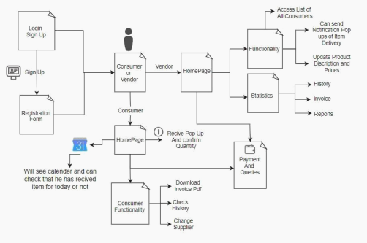

**Figure 3-1 : Block Diagram**

**3.4 Feasibility Study**

A feasibility study is an analysis of how successfully a system can be implemented, accounting for factors that affect it such as economic, technical and operational factors to determine its potential positive and negative outcomes before investing a considerable amount of time and money into it.

**3.4.1 Technical**

Managing large amount of data of consumers is haptic task for daily and local vendors our application provides real time database from Firebase Google which is database as a service which helps in real time updation of records and reduce redundancies form the database which will help both customer as well as vendor to keep track of their daily needs purchase And with the help of analytics feature in our application vendore can observe and analyse statistics and analytics of sales and purchase of any product consumed by his user/Customer.

**3.4.2 Economical**

In Today's generation it is very normal to have a smart android phone which is why android application are in demand and our application needs less storage space because whole database is based on cloud and can be accessed with nominal internet connection to use our services , as vendors are not very well educated there will be no problem in using our application.

**3.4.3 Operational**

As most of the vendors are not from a educated background so this application is our initiative to make vendors and local distributors to digitize there work for reducing there manual work to maintain bill books and old records it will encourage their customers also that their vendor is moving towards digitalization in this era and help them get better marketing and work experience

**3.5 Design Representation**

## 3.5.1 Data Flow Diagram

A data-flow diagram is a way of representing a flow of data through a process or a system. The DFD also provides information about the outputs and inputs of each entity and the process itself. A data-flow diagram has no control flow — there are no decision rules and no loops.

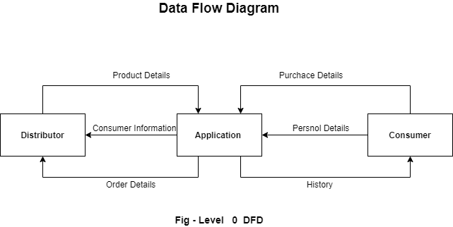

**Figure : 3-2 Data Flow Diagram**

## 

## 3.5.2 Entity-Relationship Diagram

ER Diagram stands for Entity Relationship Diagram, also known as ERD is a diagram that displays the relationship of entity sets stored in a database. In other words, ER diagrams help to explain the logical structure of databases. ER diagrams are created based on three basic concepts: entities, attributes and relationships.

ER Diagrams contain different symbols that use rectangles to represent entities, ovals to define attributes and diamond shapes to represent relationships.At first look, an ER diagram looks very similar to the flowchart. However, ER Diagram includes many specialized symbols, and its meanings make this model unique. The purpose of ER Diagram is to represent the entity framework infrastructure.

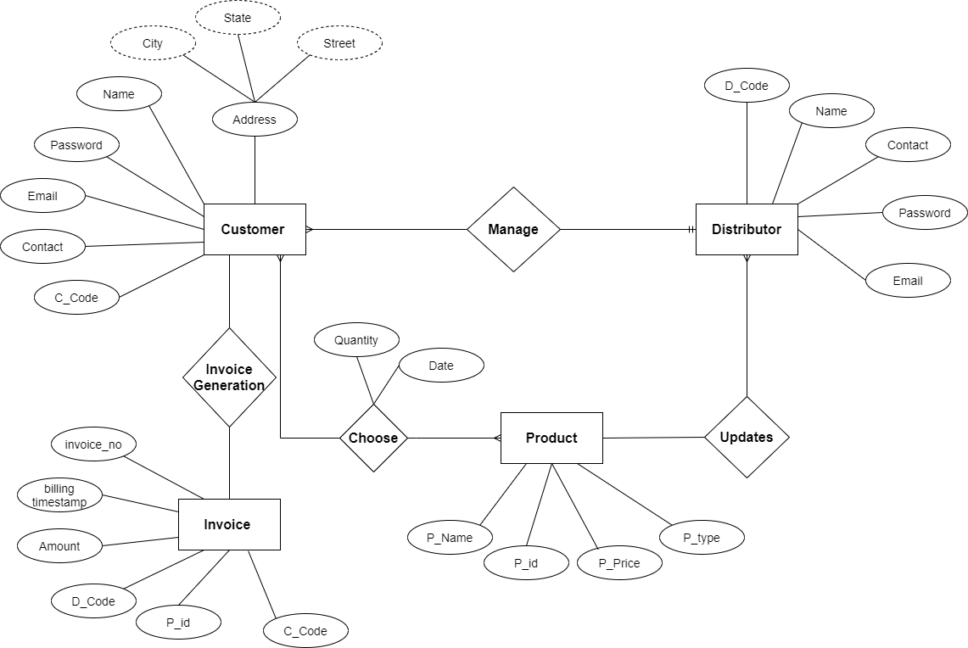

**Figure : 3-3 Entity Relationship Diagram**

## 3.5.3 Activity Diagram

Activity diagram is another important diagram in UML to describe the dynamic aspects of the system. Activity diagram is basically a flowchart to represent the flow from one activity to another activity. The activity can be described as an operation of the system. The control flow is drawn from one operation to another. This flow can be sequential, branched, or concurrent. Activity diagrams deal with all types of flow control by using different elements such as fork, join, etc. The basic purpose of activity diagrams is similar to the other four diagrams. It captures the dynamic behavior of the system. Other four diagrams are used to show the message flow from one object to another but the activity diagram is used to show the message flow from one activity to another. Activity is a particular operation of the system. Activity diagrams are not only used for visualizing the dynamic nature of a system, but they are also used to construct the executable system by using forward and reverse engineering techniques.

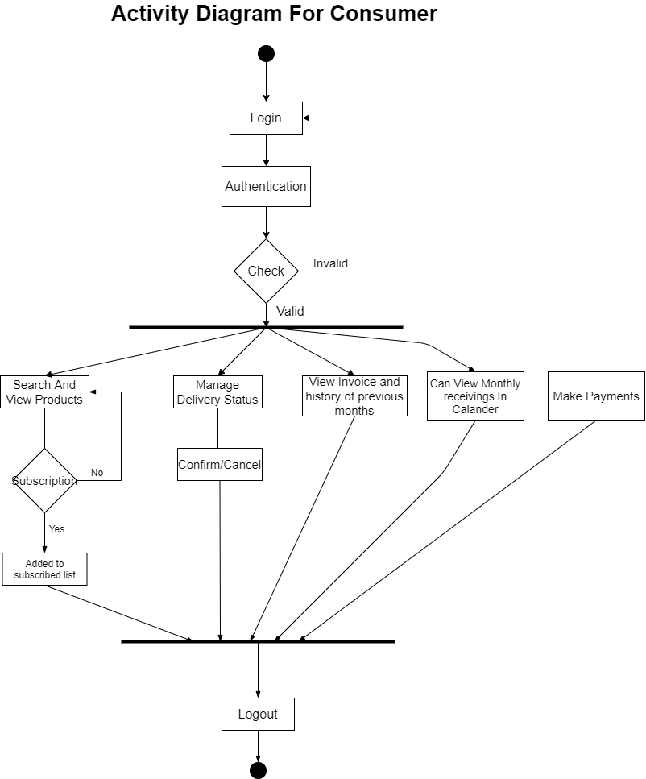

**Fig : 3-4 Activity Diagram for Consumer**

## 3.5.4 Use Case Diagram

There are many different UML diagrams that serve different purposes (as you can see from the UML diagram tree above). You can describe those details in other UML diagram types and documents, and have them be linked from use cases. Use cases represent only the functional requirements of a system. Other requirements such as business rules, quality of service requirements, and implementation constraints must be represented separately, again, with other UML diagrams

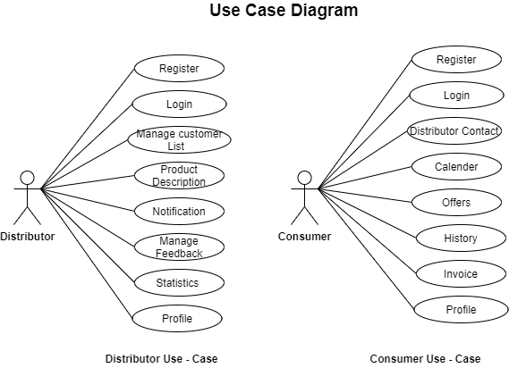

**Fig : 3-5 Use Case Diagram**

**3.5.5 Database Structure**

Database Architecture is a representation of DBMS design. It helps to design, develop, implement, and maintain the database management system. A DBMS architecture allows dividing the database system into individual components that can be independently modified, changed, replaced, and altered. It also helps to understand the components of a database.A Database stores critical information and helps access data quickly and securely. Therefore, selecting the correct Architecture of DBMS helps in easy and efficient data management.

Cloud Firestore is a NoSQL, document-oriented database. Unlike a SQL database, there are no tables or rows. ... Documents can contain subcollections and nested objects, both of which can include primitive fields like strings or complex objects like lists. Collections and documents are created implicitly in Cloud Firestore.

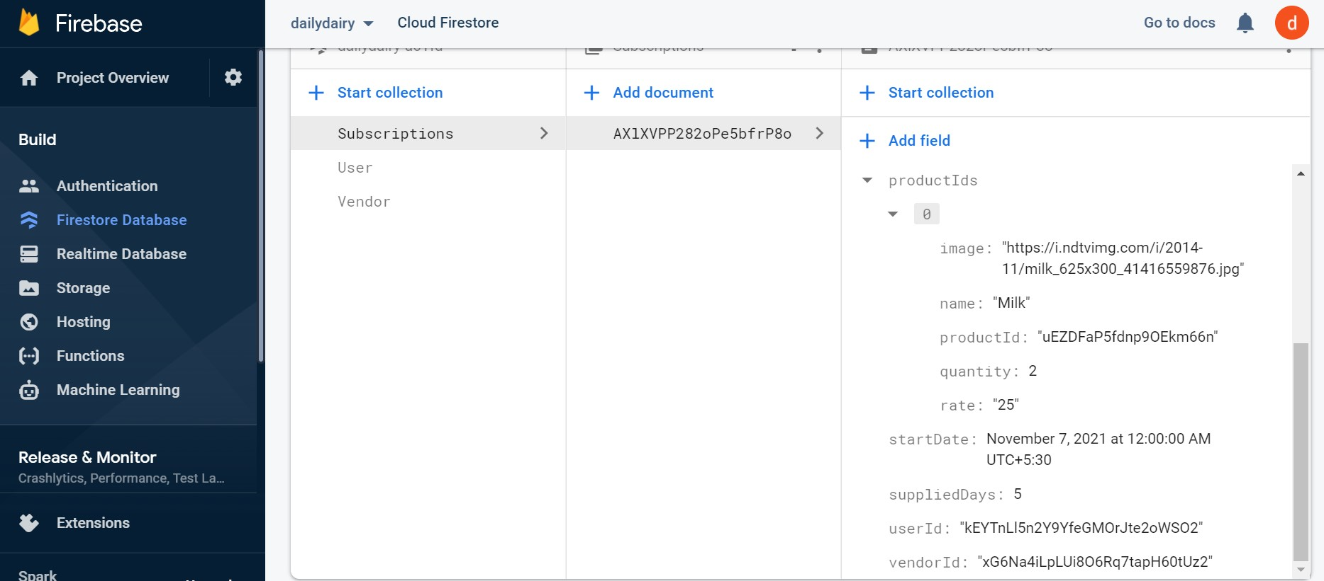

**Fig : 3-6 Database**

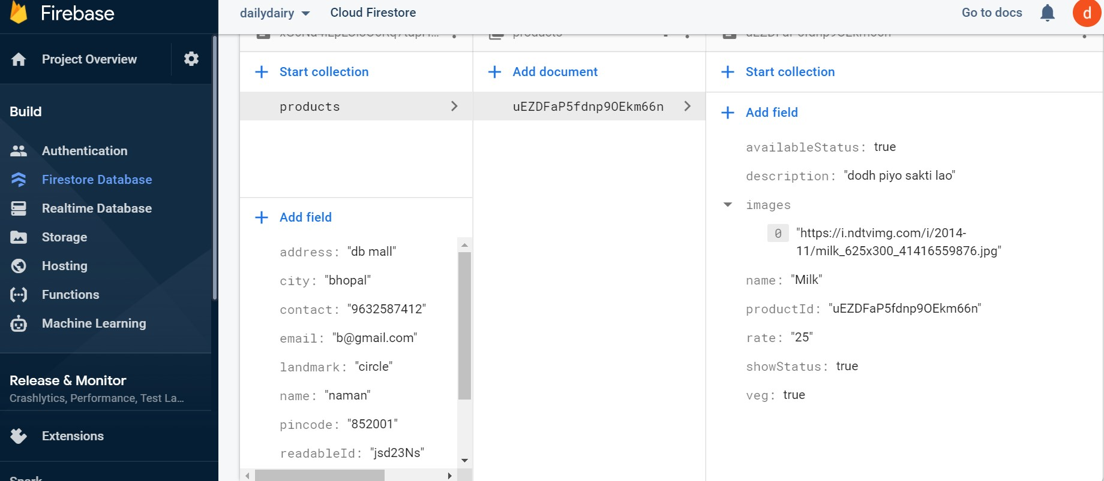

**Fig : 3-7 Database**

**3.6 Deployment Requirements**

There are various requirements (hardware, software and services) to successfully deploy the system. These are mentioned below :

**3.6.1 Hardware for using application**

* Android Mobile device of installing application

Active internet Connection

**3.6.2 Hardware & Software for developing Application**

* Minimum System Requirements for Android Studio
* Microsoft Windows 7/8/10 (32 or 64 bit).
* Mac OS X 10.8.5.
* GNOME or KDE or Unity desktop on Ubuntu or Fedora or GNU/Linux
* Debian.
* 2GB RAM.
* 4GB RAM recommended.
* 500 MB disk space
* 1 GB for Android SDK.
* Java Development Kit (JDK) 7.
* 1280x800 screen resolution.
* A faster processor (according to your budget).

**Chapter 4-Implementation**



For the problem of daily subscription management for local goods like Dairy Products , Vegetables , Newspapers , etc . And solving the disputes of vendors and his customers . Creating an application for vendors and Customers to track whether they paid their monthly bills or not and the vendor can check his statistics , profits, and sales . The system is designed in such a way that everything is accomplished using Firebase realtime database to maintain accuracy and reduce redundancy.

**4.1 Technique Used**

**4.1.1 Agile Software Development Life cycle.**

Agile is based on the adaptive software development methods, whereas the traditional SDLC models like the waterfall model are based on a predictive approach. Predictive teams in the traditional SDLC models usually work with detailed planning and have a complete forecast of the exact tasks and features to be delivered in the next few months or during the product life cycle.

Following are the Agile Manifesto principles −

* Individuals and interactions − In Agile development, self-organization and motivation are important, as are interactions like co-location and pair programming.
* Working software − Demo working software is considered the best means of communication with the customers to understand their requirements, instead of just depending on documentation.
* Customer collaboration − As the requirements cannot be gathered completely in the beginning of the project due to various factors, continuous customer interaction is very important to get proper product requirements.
* Responding to change − Agile Development is focused on quick responses to change and continuous development.

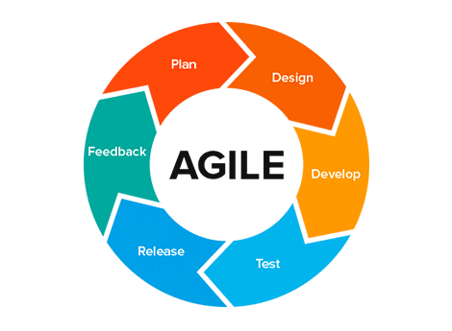

**Figure 4-1 : Agile Methodology**

Agile is a software development methodology to build a software incrementally using short iterations of 1 to 4 weeks so that the development is aligned with the changing business needs. This simple tutorial uses appropriate examples to help you understand agile development in a general and quick way.

**4.1.2 Cloud Firebase Firestore.**

Firestore is a NoSQL, document-oriented database. Unlike a SQL database, there are no tables or rows. Instead, you store data in documents, which are organized into collections.

Each document contains a set of key-value pairs. Firestore is optimized for storing large collections of small documents.

All documents must be stored in collections. Documents can contain subcollections and nested objects, both of which can include primitive fields like strings or complex objects like lists.

**4.2 Tools Used**

**4.2.1 Visual Studio code**

It is an IDE with less features than the actual Visual Studio and it could be used on Linux and Mac Platforms. With the release of this version Microsoft is trying to address the concerns of the Developer community who actually work on Linux platforms.Well actually Microsoft has realized from it's quarterly results that the Windows is sinking and it could not stay healthy by completely creating an ecosystem around Windows. So slowly it is unbuckling applications for other platforms so it has released applications for iOS, Android and the latest one is VS Code.



**4.2.2 React-Native**

React Native is a JavaScript framework for writing real, natively rendering mobile applications for iOS and Android. It’s based on React, Facebook’s JavaScript library for building user interfaces, but instead of targeting the browser, it targets mobile platforms.

In other words: web developers can now write mobile applications that look and feel truly “native,” all from the comfort of a JavaScript library that we already know and love. Plus, because most of the code you write can be shared between platforms, React Native makes it easy to simultaneously develop for both Android and iOS.Similar to React for the Web, React Native applications

are written using a mixture of JavaScript and XML-esque markup, known as JSX.

**4.2.3 Android Studio**

Android Studio is the official Integrated Development Environment (IDE) for Android app development, based on IntelliJ IDEA . On top of IntelliJ's powerful code editor and developer tools, Android Studio offers even more features that enhance your productivity when building Android apps, such as: A flexible Gradle-based build system , A fast and feature-rich emulator



A unified environment where you can develop for all Android devices Apply Changes to push code and resource changes to your running app without restarting your app , Code templates and GitHub integration to help you build common app features and import sample code , Extensive testing tools and frameworks , Lint tools to catch performance, usability, version compatibility, and other problems , C++ and NDK support , Built-in support for Google Cloud Platform, making it easy to integrate Google Cloud Messaging and App Engine

**4.2.4 Google Cloud Firebase**

Firebase is a product of Google which helps developers to build, manage, and grow their apps easily. It helps developers to build their apps faster and in a more secure way. No programming is required on the firebase side which makes it easy to use its features more efficiently. It provides services to android, ios, web, and unity. It provides cloud storage. It uses NoSQL for the database for the storage of data.



**4.2.5 Google Cloud Firebase Authentications**

provides backend services, easy-to-use SDKs, and ready-made UI libraries to authenticate users to your app. It supports authentication using passwords, phone numbers, popular federated identity providers like Google, Facebook and Twitter, and more. It’s supported for Android, iOS and Web Platform.

**4.2.6 Google Cloud Firebase Storage**

is for object storage service built for Google scale. The Firebase SDKs for Cloud Storage add Google security to file uploads and downloads for your Firebase apps, regardless of network quality. You can use our SDKs to store images, audio, video, or other user-generated content. On the server, you can use Google Cloud Storage, to access the same files. It’s supported for Android, iOS, C++, Unity and Web Platform.

**4.3 Language Used**

**4.3.1 JavaScript**

JavaScript is a dynamic computer programming language. It is lightweight and most commonly used as a part of web pages, whose implementations allow client-side scripts to interact with the user and make dynamic pages. It is an interpreted programming language with object-oriented capabilities.

**4.3.2 React**

The ReactJS tutorial provides basic and advanced concepts of ReactJS. Currently, ReactJS is one of the most popular JavaScript front-end libraries which has a strong foundation and a large community. ReactJS is a declarative, efficient, and flexible JavaScript library for building reusable UI components. It is an open-source, component-based front end library which is responsible only for the view layer of the application.



It was initially developed and maintained by Facebook and later used in its products like WhatsApp & Instagram. Our ReactJS tutorial includes all the topics which help to learn ReactJS. These are ReactJS Introduction, ReactJS Features, ReactJS Installation, Pros and Cons of ReactJS, ReactJS JSX, ReactJS Components, ReactJS State, ReactJS Props, ReactJS Forms, ReactJS Events, ReactJS Animation and many more.

**4.3.3 Object Oriented Programing**

As the name suggests, Object-Oriented Programming or OOPs refers to languages that use objects in programming. Object-oriented programming aims to implement real-world entities like inheritance, hiding, polymorphism etc in programming. The main aim of OOP is to bind together the data and the functions that operate on them so that no other part of the code can access this data except that function.

**4.3.4 Node Modules**

In Node.js, Modules are the blocks of encapsulated code that communicate with an external application on the basis of their related functionality. Modules can be a single file or a collection of multiple

files/folders. The reason programmers are heavily reliant on modules is because of their re-usability as well as the ability to break down a complex piece of code into manageable chunks.

Modules are of three types:

Core Modules,local Modules,Third-party Modules

Dependencies Used In Our Project :-

"dependencies": {

"@react-native-firebase/app": "^12.9.3",

"@react-native-firebase/auth": "^12.9.3",

"@react-native-firebase/firestore": "^12.9.3",

"@react-navigation/bottom-tabs": "^6.0.9",

"@react-navigation/drawer": "^6.1.8",

"@react-navigation/native": "^6.0.6",

"@react-navigation/stack": "^6.0.11",

"react": "17.0.2",

"react-native": "0.66.1",

"react-native-animatable": "^1.3.3",

"react-native-chart-kit": "^6.11.0",

"react-native-elements": "^3.4.2",

"react-native-gesture-handler": "^1.10.3",

"react-native-linear-gradient": "^2.5.6",

"react-native-reanimated": "^2.2.3",

"react-native-safe-area-context": "^3.3.2",

"react-native-safe-area-view": "^1.1.1",

"react-native-screens": "^3.9.0",

"react-native-svg": "^12.1.1",

"react-native-vector-icons": "^9.0.0"

},

**4.4 Screenshots**

The Following are the screenshots of the result of the project :

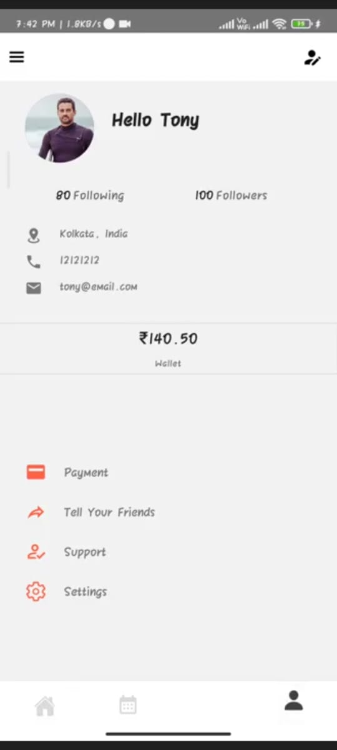 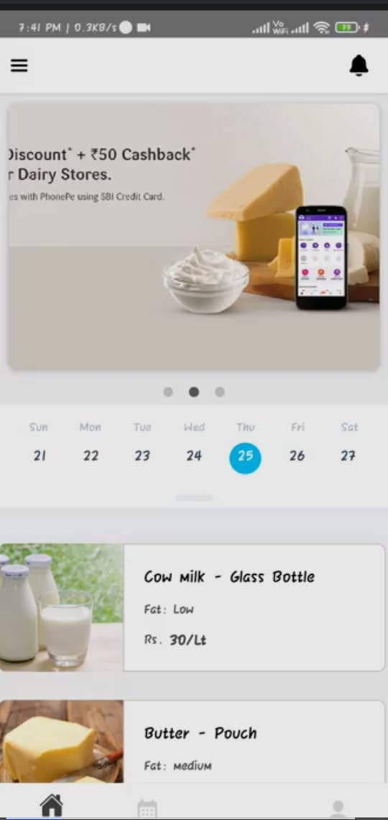

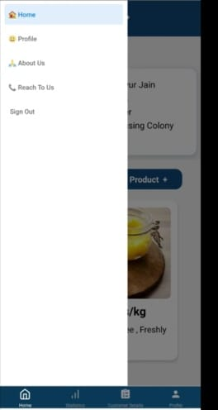 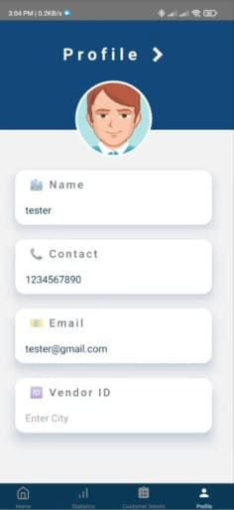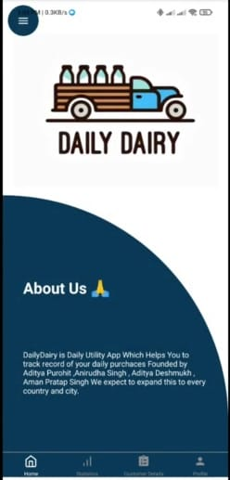 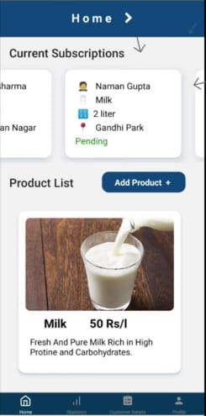

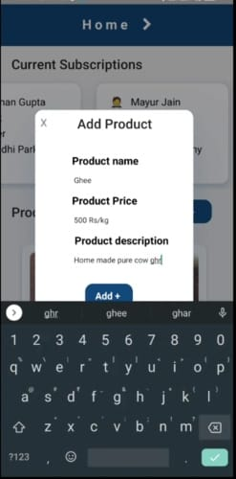 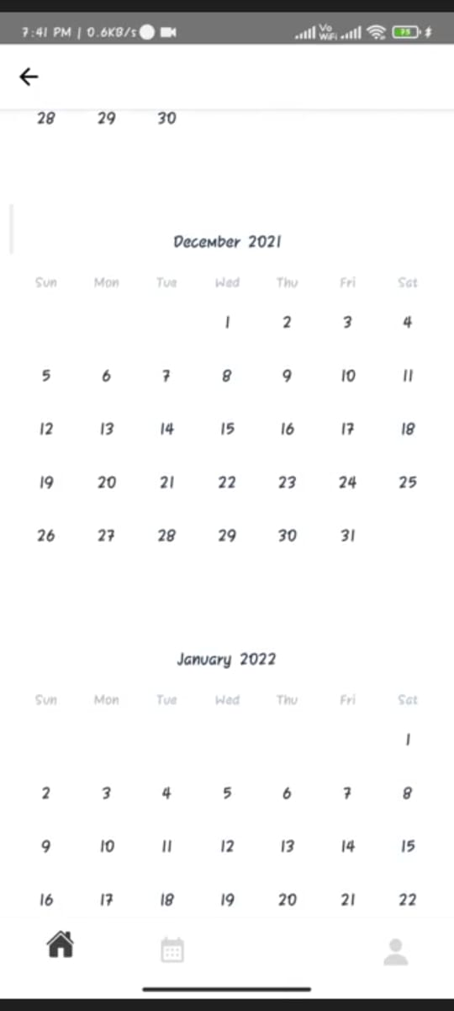 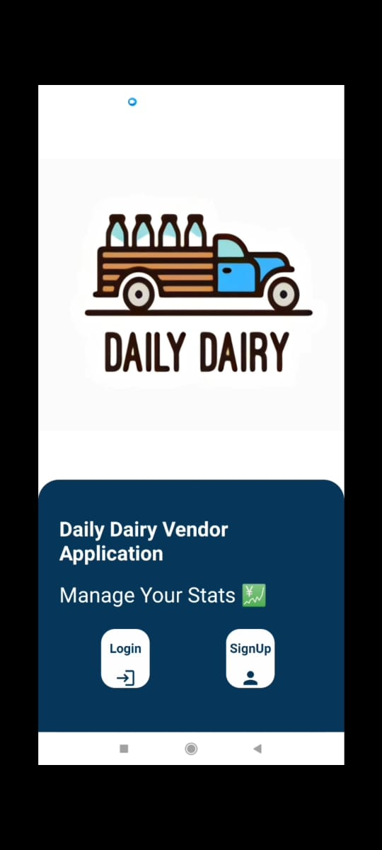

**Figure 4.4 :- Screen Shots**



**Chapter 5.Conclusion**



**5.1 Conclusion**

The aim of the project was to reduce the problems occurring in the offline methods of dealing with daily vendors with the help of maintaining records,payments and easy validation of receiving and delivering products done by this project with the use of concepts like React Native, Android Studio and various libraries..

The work done manually can now be completely replaced by this automated system and it can reduce all the extra efforts of maintaining the records.

**5.2 Limitations of the Work**

The working of this project would be buggy as the support for different devices is not yet integrated and working of different modules from which some of them are made using third party modules are not reliable as their support is highly questionable for long term use .One the main setback is it It can only work with the access of the internet .

**5.3 Suggestion and Recommendations for Future Work**

This project can be further changed to incorporate maps which suggest the vendors which areas they deliver or limit or increase their range to increase business.payments can be integrated for wider types of subscription models,data analytics and statistics for both vendor and retailer for the sell and purchase history .

ML models can be integrated for analysis of seasonal changes in buying patterns to prepare in advance for surge and crash of demands due to various reasons

**5.4 Bibliography**

**[1]**[**https://www.researchgate.net/publication/307568825_Issues_and_Challenges_of_Supply_Chain_Management_with_perspective_to_Indian_Dairy_Industry**](https://www.researchgate.net/publication/307568825_Issues_and_Challenges_of_Supply_Chain_Management_with_perspective_to_Indian_Dairy_Industry)

**[2]**[**https://pdf.sciencedirectassets.com/277811/**](https://pdf.sciencedirectassets.com/277811/)

**[3]Year: 2020, Volume: 7, Issue: Supplementary 5, Pages: 1–2,Original Article**

**A Study on the Dairy Industries in India,**[**https://dx.doi.org/10.17485/ijst/2014/v7sp5.1**](https://dx.doi.org/10.17485/ijst/2014/v7sp5.1)

**[4]ISSN: 2249-7196 IJMRR/June 2015/ Volume 5/Issue 6/Article No-2/341-350**

**Bhagyashree S. Kunte et. al. / International Journal of Management Research & Review**

**[5]ISSN 2277-9809 mithilesh kumar pandey,feasibility of tradition milk delivery channel ;study of milkmans in punjab**

**Chapter 6 - Project Plan**



**6.1 Gantt Chart**

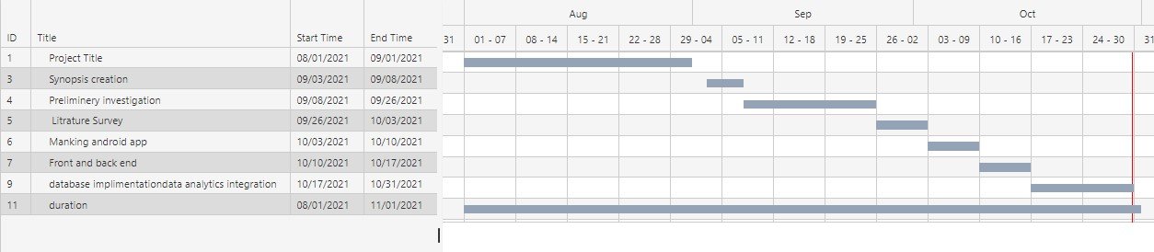



**6.2 Guide Interaction Sheet**



| **Date** | **Discussion** | **Action Plan** |
| --- | --- | --- |
|  |  |  |
|  | Discussed about the title of the |  |
| 4/09/2021 | An android application for Daily Dairy was decided as the project title. |
| Project |
|  |  |
|  |  |
|  |  |  |
| 10/09/2021 | Discussion on the technology to be | React native , VS code and |
|  | used for object detection in real-time | other tools were finalized |
| 14/09/2021 | Discussion of the creation of | Gathering of information for |
|  | synopsis of the project | synopsis creation |
|  |  |  |
|  | Suggestions on how to do a literature | Many research papers were |
| 17/09/2021 | survey and preliminary investigation | read , understood and their |
|  | on the topic | abstract were to be written. |
|  |  |  |
|  | Discussion on the implementation of | Using React native and other |
| 22/09/2021 | tools, we decided to |
|  | the project. | implement detection. |
|  |  |
|  |  |  |
|  | Discussion on the objective of the | Decided to Include the logic |
| 15/10/2021 | project(counting of students at the | of data analysis of records of deliveries. |
|  | entrance gate of college in real-time) |  |
|  |  |  |
|  | Suggestion for counting the number | Took steps for adding and |
| 26/10/2021 | of vehicles like cars, bikes, buses also | modifying the program for |
|  | at the college entrance | integration with firebase. |
|  |  |  |
|  | For generation of log files and | Action taken that for each |
|  | user an entry must be made |
| 26/10/2021 | storing the result, database was |
| in the database so that count |
|  | advised to be added |
|  | can be made easy |
|  |  |
|  |  |  |
|  |  | Decided to write the content |
| 01/11/2021 | Discussion on project documentation | and integrate it in the proper |
|  |  | format of the report |
|  |  |  |