***Implementation of android application in React-Native***

***“Daily Dairy”***

**ADITYA PUROHIT,ADITYA DESHMUKH, AMAN PRATAP SINGH ,ANIRUDHA SINGH**

ACROPOLIS INSTITUTE OF TECHNOLOGY AND RESEARCH INDORE

adityapurohitcs18@acropolis.in,anirudhasinghcs18@acropolis.in,adityadeshmukhcs18@acropolis.in,amansingh@acropolis.in

***Abstract*** :- This paper describes the whole process of android application development using react-native framework and firebase of google and developed the application “DailyDairy”. The Application is developed for medium-sized and digital illiterate dairy farmers . The software is divided into milk distribution management and payment transactions , statistics and analysis can be a variety of technical data to analyze, synthesize, organize, and User Interface is practical, economic, and user-friendly , This application also solves the differences between Vendor and his Customers . This paper also describes the integration of firebase firestore (database provided by google) with android application development with javascript framework react-native and code editor used in is visual studio code by microsoft.

***Key-Words*** :- Dairy Management ,Android application,Vendor,Customer,Milk,Dairy Farmer,Digital Literacy.

**I Introduction**

The main purpose of the project is to bring the non digitised and unorganised sector of dairy industry which has huge potential and is a promising industry as covid times has taught us how big and necessary is this industry is and big companies like amul and sanchi milk brands used the potential of digital platforms ,statistics and data analytics tools provided by their partnerships with IBM and HCL did record breaking businesses and sold more products in a year than they did in couple of years combined the same way people of unorganised sector like milkman could be brought into digital sector and connect them to their product consumers using our application which will help them to get the advantages like delivery management on daily basis ,daily and monthly records ,sales statistics,digital payments ,get new customers on milkmans preferences of area and capabilities.Our application will be resolving the basic situations like disagreement between vendors and consumers about totaling ,monthly estimation of total sales and wastage of resources which otherwise would have caused losses to the small peoples who cannot afford such losses at their financial situation.

## **II. Problem Formulation**

Like any other industry the dairy industry provides socioeconomic opportunities for both the vendor and the consumers . Its purpose is to provide people with dairy products as quickly and as cheap as possible.whenever we as a consumer think about getting dairy products mainly milk we either have a milkman which provide us milk on a monthly basis or we go to the nearest grocery store and ask for a milk packet.but as now the times have changed due to a pandemic we all have changed the way we purchase things and the convenience of tetrapacks and packaged products have overtaken the need of fresh product or local produces from a milkman or vegetable vendors in rear view.But doing so we all have opened us up to a whole new problem that is high chemical or processed products which are of both low quality and low price within cute packaging .and they vendor side the people who does not own factories who were mainly the people who brought us food and dairy products starlight from farm unable to compete to big companies duwe to digital illiteracy and business analytical mindset.which in the ed pushing both the vendors and consumers taking wrong choices you might ask how?The answer is quite simple: vendors have to succumb to big companies in becoming their source or increase prices to increase profit margins and consumers to get bad products in packets or expensive but good quality products direct from farms.but both the problems can be countered with our solution..

## 

## **III. Literature Review**

### **3.1 Tools and Technology**

**3.1.1 HARDWARE REQUIREMENTS**

Since the App does not have any designated hardware, it does not have any direct hardware interfaces over Client Side. The hardware connection to the database server is managed by the underlying operating system on the web server over server side.

**Server Side**

The Android Application will be Uploaded to Android Studio to use and the firebase database is directly hosted to google’s firebase Servers.

**Client Side**

The system is an Android platform based application; clients are required using a modern Android device and enable access to files and location. the Internet connection in order to be able to access application.

**3.1.2 SOFTWARE REQUIREMENTS**

Minimum system requirements:

Operating System : Android version 7.0 Plus

User Interface : Android app based on react native

Database : Firebase

integrated development environment (IDE) : Visual Studio Code

**React Native** :- React Native is a JavaScript framework for writing real, natively rendering mobile applications for Android And iOS. React Native combines the best parts of native development with React, a best-in-class JavaScript library for building user interfaces. Plus, because most of the code you write can be shared between platforms, React Native makes it easy to simultaneously develop for both Android and iOS.Similar to React for the Web, React Native applications are written using a mixture of JavaScript and XML-esque markup, known as JSX.

**Firebase Server** :- Google Firebase is a Google-backed application development software that enables developers to develop iOS, Android and Web apps. Firebase provides tools for tracking analytics, reporting and fixing app crashes, creating marketing and product experiments. This includes things like analytics, authentication, databases, configuration, file storage, push messaging, and the list goes on. The services are hosted in the cloud, and scale with little to no effort on the part of the developer.

**Visual studio code**  :-It is a source-code editor made by Microsoft for Windows, Linux and macOS. Features include support for debugging, syntax highlighting, intelligent code completion, snippets, code refactoring, and embedded Git. Users can change the theme, keyboard shortcuts, preferences, and install extensions that add additional functionality.Well actually Microsoft has realized from it's quarterly results that the Windows is sinking and it could not stay healthy by completely creating an ecosystem around Windows. So slowly it is unbuckling applications for other platforms so it has released applications for iOS, Android and the latest one is VS Code.

### 

### **3.2 “DailyDairy” Proposed Solution**

DailyDairy is an application which brings convenience to both vendor and consumers its elaborate and easy to understand interface on both the ends of application brings the convenience of its users to manage products and its availability and the history of when and where the product was delivered Digital confirmation of delivering product , digital payment , digital invoice , and information produced by these combination of data can be used to predict and formulate educational , statistical information with the ease by just clicking a button which will help both the vendor and customers who are not that much technologically sound have the convenience of digital platform in these era .

### **3.3 The Existing System**

There are many existing systems that exist in this sector which ranges from many different intents of solutions but most of them are centered towards owning and controlling the whole chain from the start of owning barns and sheds to maintenance and manufacturing of the main product milk and subproducts of milk like curd cheese and butter and then the sites and shops that these companies own or have and business partnerships for the shelf spaces in big conglomerates like big bazaar,D'Mart and reliance fresh ,bigbasket and others .these companies even go the extra mile to do direct partnerships with hotel and food chain companies .some of the existing system which work on these business models are Amul,country delight ,big basket ,grofers and reliance fresh .each of them controls or owns most of the part of business model.But the problem arises for the unorganized sector of milkman selling their produce daily on a bike or even cycles being helpless and clueless how to control their losses and stand back against such models without a digital platform.

## **IV. Methodology**

### **4.1 Development Model**

Agile is based on the adaptive software development methods, whereas the traditional SDLC models like the waterfall model are based on a predictive approach. Predictive teams in the traditional SDLC models usually work with detailed planning and have a complete forecast of the exact tasks and features to be delivered in the next few months or during the product life cycle.

Agile is a software development methodology to build a software incrementally using short iterations of 1 to 4 weeks so that the development is aligned with the changing business needs. This simple tutorial uses appropriate examples to help you understand agile development in a general and quick way.

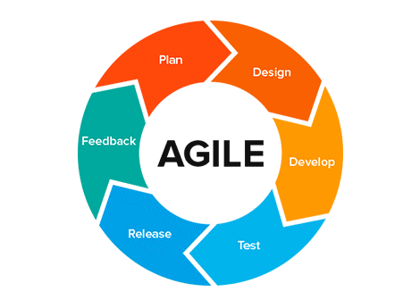

**Figure 1 : - Agile Development Model**

**4.2 Working Model**

Need to have 2 Account Holders

1.Vendor 2.Customer

Vendors and Customers will both have their different registration page where they can register with necessary details. And enable Customers to search Vendors Providing facilities in their locality and use services. Vendors can add / change /update/ delete products that they sell . and can track monthly and daily records of every customer for which they have completed delivery or not . calculate and share monthly bills and save past data for analytics purposes.

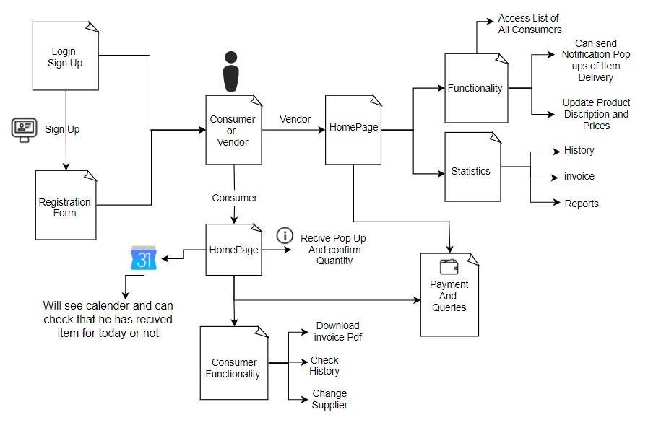

## 

**Figure 2 : - Working Model**

Display the Details Of User To Vendors that which user has started a subscription with them . Both Vendor And Customer Can Check Whether Monthly bill Is correct And has been Paid or not .Both can check History And download invoice . If any User Faces any Issue Then Have Real time FAQs And they can share their contact details and we will contact them as soon as possible to resolve their query .Users can contact us and review us on the Basis of services They love. Every process happening in the application is real time completely controlled with google firebase as backend and react native as frontend.

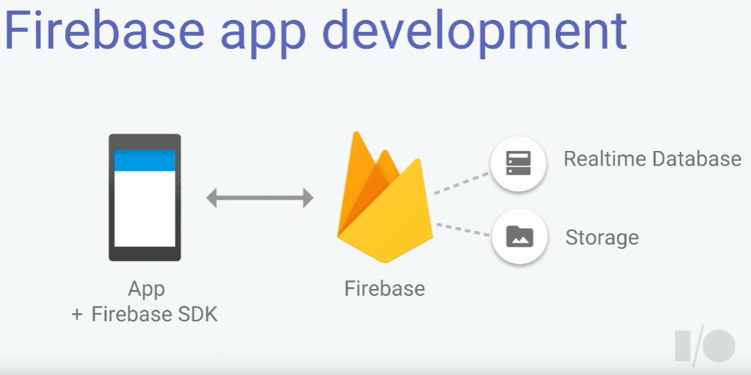

**Figure 3 : - Firebase app Development**

## **V. Conclusion**

The Daily Dairy was created to take the place of the manual process of maintaining records of milk distribution. The traditional system does not provide better service to customers; rather, it puts the risk of losing data. Daily Dairy was introduced to reduce paper usage and hectic work. The new system keeps proper records of milk distribution and provides online payment service.

## **VI.Acknowledgment**

We take this opportunity to express our deepest and sincere gratitude to our Guide Dr. Kamal Sethi, HOD CSE Department and Ms.Krupi Saraf, Assistant Professor for their insightful advice, motivating suggestions, invaluable guidance, help and support in successful completion of this research paper and also for their constant encouragement and advice.

## **VII. References**

[1]Vancouver

[1]Li HQ, Lu HB, Qu J, Li XL. Dairy Digital Management Information System Development Based on SOA. AMM 2012;182–183:1141–4.

[2] https://www.cabdirect.org/cabdirect/abstract/19530401529

[3] https://reactnative.dev/docs/getting-started#developer-notes

[4] https://firebase.google.com/docs/build

## **VIII.Authors**

First Author – Aditya Purohit, B.tech-4rd year, Acropolis institute of Technology and Research

Second Author – Anirudha Singh, B.tech-4rd year, Acropolis institute of Technology and Research

Third Author – Aman Pratap Singh, B.tech-4rd year, Acropolis institute of Technology and Research

Fourth Author – Aditya Deshmukh , B.tech-4rd year, Acropolis institute of Technology and Research