Experiment-1
Aim: Create a Web Page for Course Curriculum: Use of Headings, Paragraphs, Bold, Italic, Underline, and Special Characters, Ordered List, Unordered List, Description List, Nested List, and Mixed Lists.
Objective:-
1. To design a simple course curriculum webpage using HTML.
2. To practice the use of basic text formatting tags (bold, italic, underline, special characters).
3. To learn the implementation of ordered, unordered, description, nested, and mixed lists.
4. To understand webpage content structuring using headings and paragraphs.
Tools Required:-
• Computer / Laptop with any OS
• Text Editor (VS Code, Sublime Text, Notepad++)
• Web Browser (Chrome, Edge, Firefox)
Theory:-
1. Headings (<H1>…. <H6>: Used to display titles and subheadings in different sizes.

2. Paragraphs (<p>): Defines blocks of text content.

3. Formatting Tags:

O <b> for bold text
- <i> for italic text
- <u> for underlined text </t>
- Special characters are displayed using HTML entities (e.g., ©, <, >).

4. Lists:

Ordered List (<ol>): Numbered items.

Unordered List (<ul>): Buleted items.

Descripteion List: A list inside another list.

Mixed List: Combination of ordered, unordered and nested lists.

Code implementation:-
<!DOCTYPE html>
<html>
<head>
<title>Course Curriculum</title>
</head>
<body>

<h2>Introduction</h2>
<p>
Welcome to the <b><i>Course Curriculum</i></b>.
This page demonstrates the use of <i>HTML formatting</i>,
<b>lists</b>, and special characters such as &copy;, &lt;, &gt;.
</p>

<h3>1.Semester 1 Subjects (Ordered List)</h3>
<ol>
<li>Mathematics I</li>
<li>Computer Fundamentals</li>
<li>Programming in C</li>
<li>Electronics Basics</li>
</ol>

<h3>2.Programming Languages (Unordered List)</h3>
<ul>
<li>C</li>
<li>Java</li>
<li>Python</li>
<li>JavaScript</li>
</ul>

<h3>3.Course Description (Description List)</h3>
<dl>
<dt><b>C Programming</b></dt>
<dd>Learn basics of C language including loops, arrays, and functions.</dd>

<dt><b>Java</b></dt>
<dd>Introduction to Object-Oriented Programming concepts.</dd>
</dl>

<h3>4.Course Modules (Nested List)</h3>
<ol>
<li>Module 1: Basics
<ul>
<li>Introduction</li>
<li>History of Computers</li>
</ul>
</li>
<li>Module 2: Programming
<ul>
<li>Variables & Data Types</li>
<li>Control Statements</li>
</ul>
</li>
</ol>

<h3>5.Project Work (Mixed List)</h3>
<ul>
<li>Web Development
<ol>
<li>HTML</li>
<li>CSS</li>
<li>JavaScript</li>
</ol>
</li>
<li>Database
<ol>
<li>MySQL</li>
<li>MongoDB</li>
</ol>
</li>
</ul>

</body>
</html>

Output:- 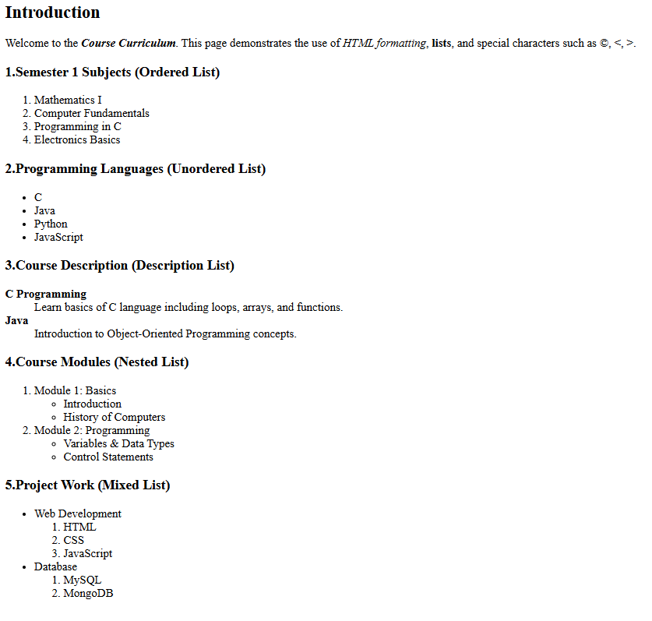

Outcome:-

• Successfully designed a basic course curriculum webpage and Identify and implement all major HTML list types.

•Structure educational content effectively using lists and headings.

•Format text and symbols using HTML tags and entities.

