Experiment:- 2
Aim:- Create a Web Page for a News Website with Embedded YouTube Video, Hyperlinks, and Navigation Structure, and Insert Multimedia in a Webpage.

Objectives:-
1. To design a simple news website homepage using HTML and CSS.
2. To learn how to embed YouTube videos into a webpage.
3. To implement hyperlinks and navigation menus for easy browsing.
4. To insert multimedia (images, videos, audio) in a webpage.

Theory
1. Hyperlinks (<a> tag):
Hyperlinks allow navigation between pages or websites. Example: Visit BBC News

2. Navigation Structure:
A <nav> element groups navigation links for better structure.

3. Embedding YouTube Video:
YouTube provides an <iframe> code for embedding videos into a webpage.

4. Multimedia in Webpages:
o Image (<img>): Display news images.
o Audio (<audio>): Add podcasts or news audio clips.
o Video (<video>): Insert local or hosted video files.

Code Implementation:-
Output:-
<!DOCTYPE html>
<html lang="en">
<head>
<meta charset="UTF-8">
<meta name="viewport" content="width=device-width, initial-scale=1.0">
<title>News Homepage</title>
<style>
body {
font-family: Arial, sans-serif;
margin: 20px;
background-color: #f9f9f9;
}
nav {
background: #eee;
padding: 10px;
margin-bottom: 20px;
}
nav a {
margin-right: 10px;
text-decoration: none;
color: #333;
font-weight: bold;
}
h1, h2, h5 {
color: #232696;
}
footer {
margin-top: 30px;
padding: 10px;
background: #eee;
text-align: center;
}
</style>
</head>
<body>
<!--Header-->
<h1>Experiment 2</h1>
<h5>CSE-12:Aditya gola</h5>
<!-- Description -->
<p> Create a web page for a news </p>
<!-- Navigation bar -->
<nav>
<a href="#Home">home</a>
<br>
<a href="#Latest">Latest news</a>
<br>
<a href="#Trending">Trending</a>
<br>
<a href="#Media">Media</a>
<br>
<a href="#Contact">Contact for business</a>
<br>
<a href="#About">More about us </a>
</nav>
<!-- Main content -->
<h2 id="Home">Home</h2>
<p>Welcome to our news homepage! Stay updated with the latest headlines and stories from around the world.</p>

<h2 id="Latest">Latest News</h2>
<ul>
<li>Global markets rally as economic outlook improves.</li>
<li>New technological advancements in renewable energy.</li>
<li>Health officials announce new guidelines for public safety.</li>
</ul>

<h2 id="Trending">Trending</h2>
<ol>
<li>Celebrity couple announces engagement.</li>
<li>Breakthrough in cancer research offers new hope.</li>
<li>Major sports event draws record crowds.</li>
</ol>

<h2 id="Media">Media</h2>
<p>Check out our latest videos and photo galleries covering recent events and stories.</p>
<h2 id=Contact">Contact for Business</h2>
<address>
For business inquiries, please reach out to us at:<br>
Email: abc@ac.in<br>
Phone: +91-1234567890<br>
Address: 123 News St, Media City, Country:india
</address>
<h2 id="about">More About Us</h2>
<p>We are committed to delivering accurate and timely news to our readers. Our team of experienced journalists works around the clock to bring you the stories that matter.</p>
<p>Follow us on social media for real-time updates and exclusive content.</p>
<footer>
<p>&copy; 2024 News Homepage. All rights reserved.</p>
</footer>
<!-- Embedded YouTube Video -->
<p>Watch our featured news video below:</p>

<iframe width="560" height="315" src="https://www.youtube.com/embed/2e-eXJ6HgkQ?si=nqqcxYlyxRQmzre9" title="YouTube video player" frameborder="0"
allow="accelerometer; autoplay; clipboard-write; encrypted-media; gyroscope; picture-in-picture; web-share"
referrerpolicy="strict-origin-when-cross-origin" allowfullscreen></iframe>
<footer>
<p>For more videos, visit our :
<br>
<a href="https://www.youtube.com/"target="_blank">YouTube</a>
</p>
</footer>
<!-- Image with alt text -->
<p>Stay informed with our latest news image:</p>
<img src="download.png" alt="News Image" width="500" height="500">
</body>
</html>

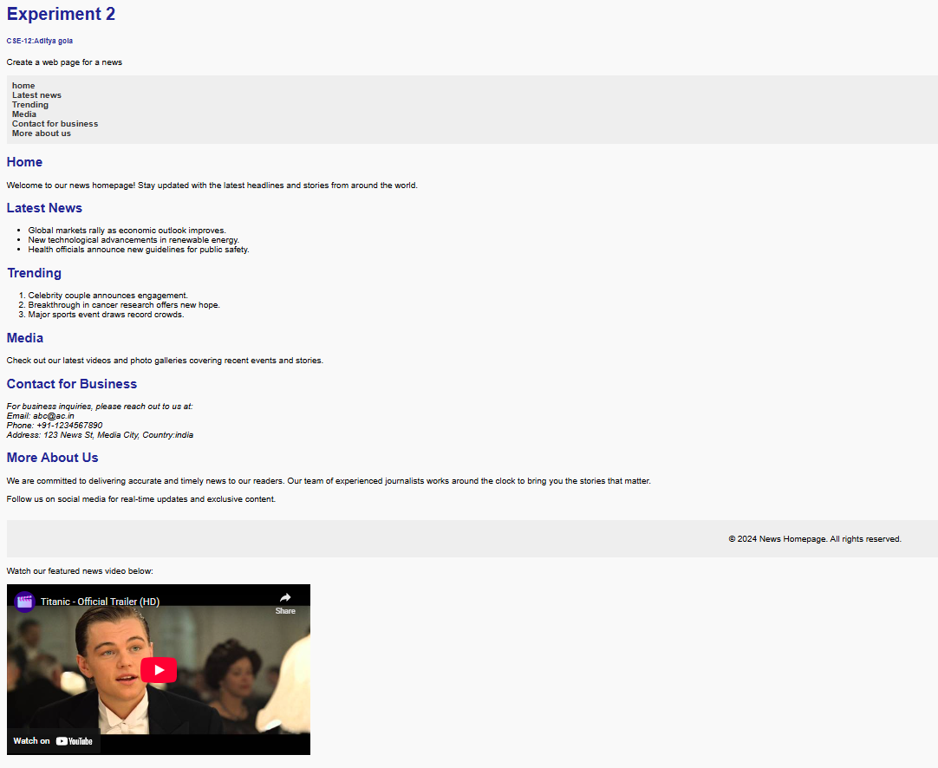

Outcome:-
• Design a complete, structured webpage for a news platform.
• Use HTML elements effectively for layout, navigation, and content organization.
• Embed media and contact details in a professional format.
• Understand how to present information clearly on a web interface.

