Experiment:- 3
Aim:- Create a Web Page for College Timetable: Use of Tables with Rowspan, Colspan, Headers, Captions, and Nested Tables.

Objectives:-
1. To design a college timetable webpage using HTML tables.
2. To apply rowspan and colspan attributes for merging cells.
3. To use table headers (), captions (), and formatting for readability.
4. To implement nested tables within a timetable cell.

Theory
- Table (<table>: Arranges data in rows and columns,
- Rowspan: Merges a cell vertically across rows.
- <td colspan= “2”> Break</td>
- Colspan: Merges a cell horizontally across columns.
- <td colspan= “3”> Break</td>
- Header (<th>): Displays header cells in bold and centered.
- Caption (<caption>): Defines the title of the table.
- Nested Table: A table placed inside another table cell.

Code Implementation:-

<!DOCTYPE html>
<html lang="en">
<head>
<meta charset="UTF-8">
<meta name="viewport" content="width=device-width, initial-scale=1.0">
<title>College Timetable</title>
<style>
/* Basic styling for readability */
body {
font-family: Arial, sans-serif;
padding: 20px;
}

/* Main table styling */
table {
width: 100%;
border-collapse: collapse; /* Merges cell borders */
text-align: center;
font-size: 0.9em;
}

/* Caption styling */
caption {
font-size: 1.2em;
font-weight: bold;
margin: 10px;
}

/* Cell padding and border */
th, td {
border: 1px solid black;
padding: 8px;
height: 50px; /* Gives cells a uniform height */
}

/* Header row styling */
thead th {
background-color: #f2f2f2;
}

/* Day header column styling */
tbody th {
background-color: #f2f2f2;
width: 8%; /* Give the day column a bit of space */
}

/* Nested table styling */
td table {
width: 100%;
font-size: 1em; /* Reset font size inside nested table */
}

td table caption {
font-size: 1em; /* Reset caption size */
font-weight: bold;
margin: 2px;
}

td table td {
height: auto; /* Allow nested table rows to size automatically */
padding: 4px;
}
</style>
</head>
<body>

<h1>Experiment-3: College Timetable</h1>
<hr>

<table>
<caption>College Timetable - CSE Department</caption>

<thead>
<tr>
<th>Day / Time</th>
<th>9:00 - 10:00</th>
<th>10:00 - 11:00</th>
<th>11:00 - 12:00</th>
<th>12:00 - 1:00</th>
<th>1:00 - 2:00</th>
<th>2:00 - 3:00</th>
<th>3:00 - 4:00</th>
</tr>
</thead>

<tbody>
<tr>
<th>Monday</th>
<td>Mathematics</td>
<td>Economics</td>
<td>Break</td>
<td>Computer Networks</td>
<td colspan="2">Library</td>
</tr>

<tr>
<th>Tuesday</th>
<td>Mathematics</td>
<td>C Programming</td>
<td rowspan="2">Physics</td> <td>Break</td>
<td>Electronics Lab</td>
<td colspan="2"> <table>
<caption>Lab Details</caption>
<tr>
<td>Batch A: OS Lab</td>
</tr>
<tr>
<td>Batch B: OS Lab</td>
</tr>
</table>
</td>
</tr>

<tr>
<th>Wednesday</th>
<td>Mathematics</td>
<td>English</td>
<td>Break</td>
<td>Computer Networks</td>
<td>Library</td>
<td>Library</td>
</tr>

<tr>
<th>Thursday</th>
<td>Workshop</td>
<td>English</td>
<td rowspan="2">Physics</td> <td>Break</td>
<td>Mathematics</td>
<td>English</td>
<td>Seminar</td>
</tr>

<tr>
<th>Friday</th>
<td>Computer Networks</td>
<td>English</td>
<td>Break</td>
<td colspan="3">Project Work</td> </tr>
</tbody>
</table>

</body>
</html>

Output:-

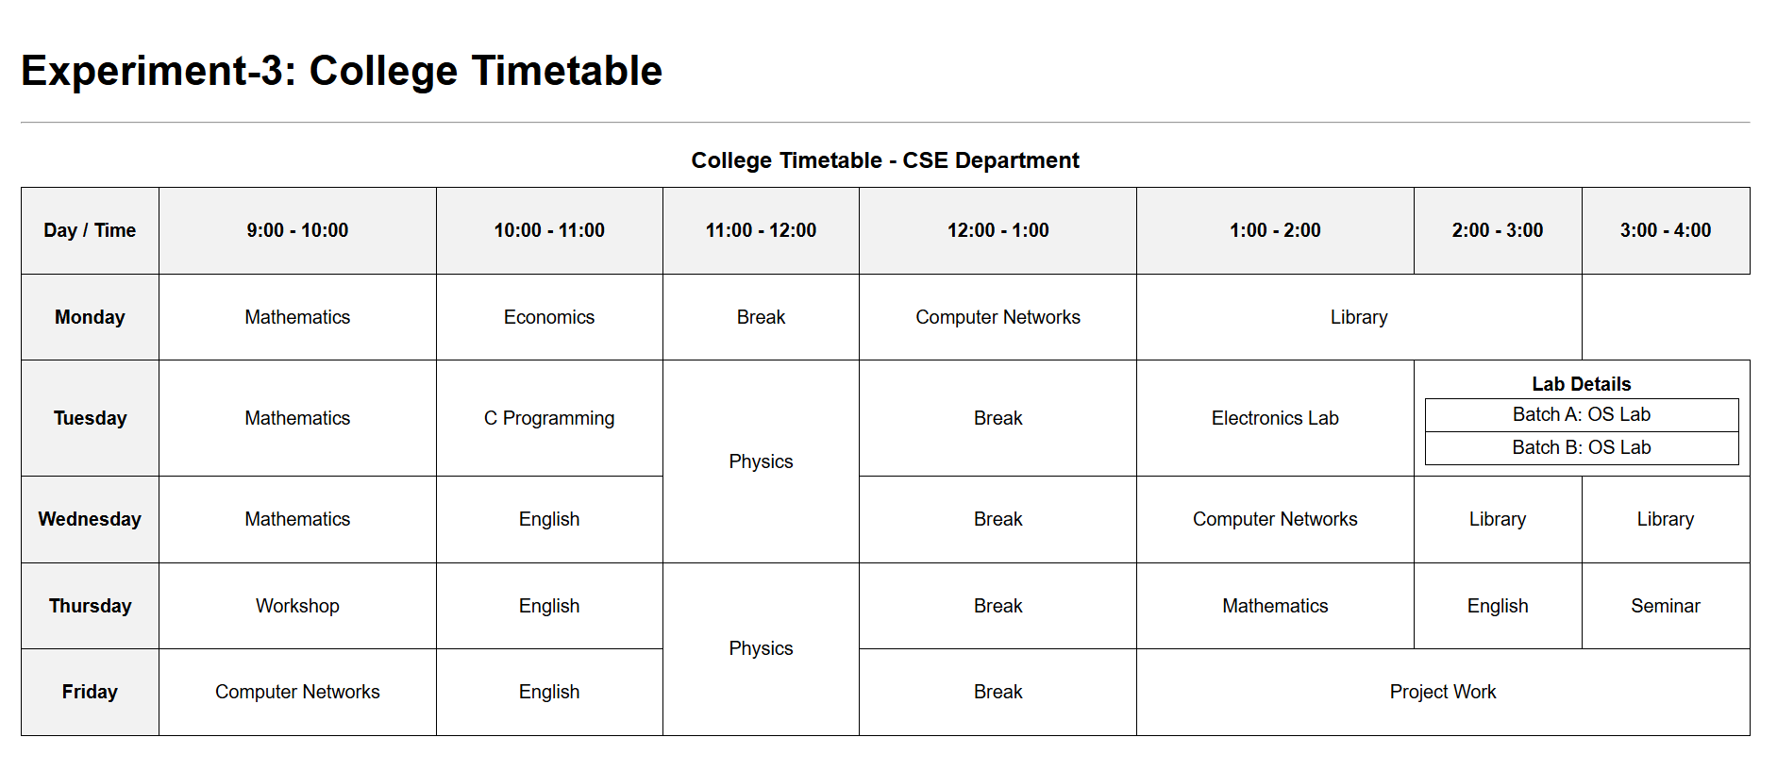

Outcome:-
• Apply rowspan and colspan attributes to merge cells for timetable formatting
• Use headings, captions, and proper table alignment to improve readability
• Understand the role of semantic formatting for representing schedules
• Format a timetable with different time slots and days of the week
• Organize webpage content effectively for academic or real-world use
• Develop confidence in creating visually clear, real-life structured tables

