Experiment:- 4
Aim:- Create Web page for Hotel room booking form: Use of input fields, labels, select, textarea, and buttons.

Objectives:-

1. To design a hotel room booking form using HTML.
2. To understand the use of input fields for collecting user details.
3. To apply labels for form accessibility.
4. To implement dropdown menus (select) and text areas.
5. To create functional buttons for form submission and reset.

Theory
- Form (<form>): Defines a section for user input.
- Input Fields (<input>): Used for text, numbers, emails, dates, etc.
- <input type="text" name="username">
- Labels (<label>): Connects text with form elements for better usability.
- Select (<select>): Provides a dropdown menu.
- <select><option>Single</option><option>Double</option></select>
- Textarea (<textarea>): Allows multi-line text input.
- Buttons (<button > or <input type=”submit”

>).

Code Implementation:-
<!DOCTYPE html>
<html lang="en">
<head>
<meta charset="UTF-8">
<meta name="viewport" content="width=device-width, initial-scale=1.0">
<title>Student Registration Form</title>
<style>
body {
font-family: Arial, sans-serif;
background-color: #efefef;
display: grid;
place-items: center;
min-height: 90vh;
margin: 0;

}

/* Styles the main form container */
form {
width: 500px;
}

/* Styles the box around the form */
fieldset {
background-color: #ffffff;
border: 1px solid #ddd;
border-radius: 8px;
padding: 20px 30px;
box-shadow: 0 2px 5px rgba(0, 0, 0, 0.1);
}

/* Styles the "Student Registration Form" title */
legend {
font-size: 1.8em;
font-weight: bold;
text-align: center;
padding: 0 10px;
color: #333;
}

/* Styles each form row */
div {
margin-bottom: 15px;
}

/* Styles the text labels */
label {
display: block;
margin-bottom: 5px;
font-weight: bold;
color: #555;
}

/* Styles all text inputs, email, and textarea */
input[type="text"],
input[type="email"],
input[type="tel"],
textarea {
width: 100%;
padding: 8px;
box-sizing: border-box; /* Ensures padding doesn't affect width */
border: 1px solid #ccc;
border-radius: 4px;
}

/* Styles the gender radio button section */
.gender-group {
display: flex;
align-items: center;
gap: 15px; /* Space between radio buttons */
}

/* Ensures radio button labels are aligned */
.gender-group label {
font-weight: normal;
margin-bottom: 0;
display: inline-block; /* Keep label next to radio */
margin-left: 3px;
}

.gender-group input[type="radio"] {
margin: 0;
}

/* Container for the buttons */
.button-container {
text-align: left;
margin-top: 20px;
border-top: 1px solid #eee;
padding-top: 20px;
}

/* Styles for the buttons */
input[type="submit"],
input[type="reset"] {
background-color: #007bff;
color: white;
border: none;
padding: 10px 20px;
border-radius: 4px;
cursor: pointer;
font-size: 1em;
margin-right: 10px;
}

input[type="reset"] {
background-color: #6c757d;
}

input[type="submit"]:hover {
background-color: #0056b3;
}

input[type="reset"]:hover {
background-color: #5a6268;
}

/* Footer text styling */
footer p {
text-align: center;
font-size: 0.8em;
color: #888;
margin-top: 20px;
}
</style>
</head>
<body>

<form action="submit.html" method="post">
<fieldset>
<legend>Student Registration Form</legend>

<div>
<label for="fullName">Full Name:</label>
<input type="text" id="fullName" name="user_name"
placeholder="Enter your full name" required>
</div>

<div>
<label for="email">Email:</label>
<input type="email" id="email" name="user_email"
placeholder="Enter your email address" required>
</div>

<div>
<label>Gender:</label>
<div class="gender-group">
<input type="radio" id="male" name="gender" value="male">
<label for="male">Male</label>

<input type="radio" id="female" name="gender" value="female">
<label for="female">Female</label>

<input type="radio" id="other" name="gender" value="other">
<label for="other">Other</label>
</div>
</div>

<div>
<label for="contact">Contact No:</label>
<input type="tel" id="contact" name="user_contact"
placeholder="Enter phone number">
</div>

<div>
<label for="address">Address:</label>
<textarea id="address" name="user_address" rows="4"></textarea>
</div>

<div class="button-container">
<input type="submit" value="Register">
<input type="reset" value="Clear">
</div>

</fieldset>
</form>

<footer>
<p>&copy; 2025 Student Registration Portal</p>
</footer>

</body>
</html>

Output:- 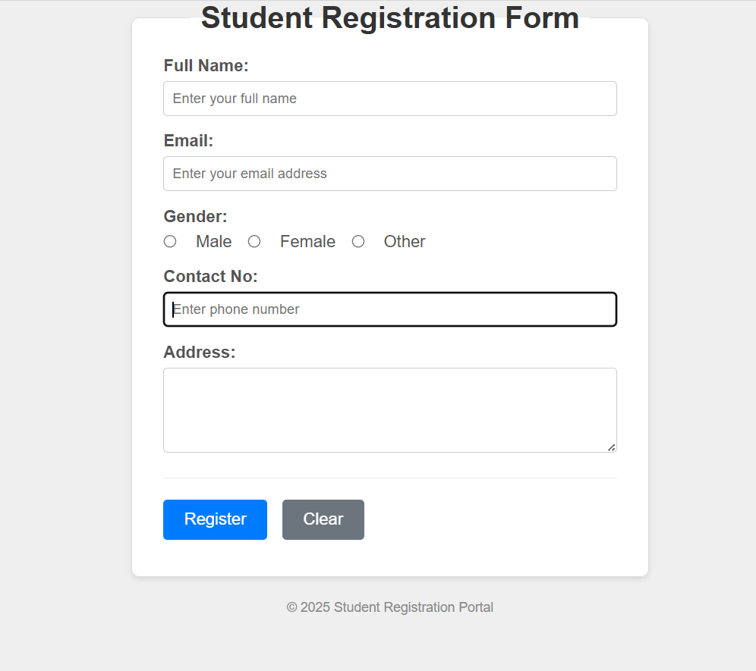

Outcomes:-

- Use semantic tags to improve clarity and user experience.
- Understand navigation after form submission using action and method attributes.
- Develop confidence in building real-world web forms such as login, feedback, or registration forms.
- Organize content visually using layout structures such as <div> and basic alignment.

