**Overview**

**Arduino/Genuino Uno**

Arduino/Genuino Uno is a microcontroller board based on the ATmega328P. It has 14 digital input/output pins. 6 analog inputs, a 16 MHz quartz crystal, a USB connection, a power jack, an ICSP header and a reset button.

"Uno" means “one” in Italian and was chosen to mark the release of Arduino Software (IDE) 1.0. The Uno board and version 1.0 of Arduino Software (IDE) were the reference versions of Arduino, now evolved to newer releases. The Uno board is the first in a series of USB Arduino boards, and the reference model for the Arduino platform.

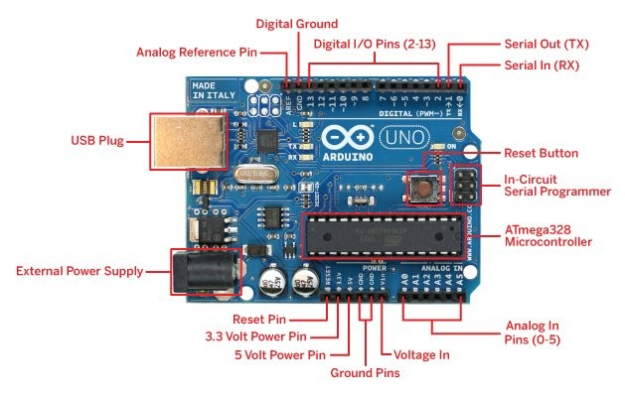

**Technical specs**

Microcontroller [ATmega328P](http://www.atmel.com/Images/doc8161.pdf)

Operating Voltage 5V

Bit 8 bit

Input Voltage (recommended) 7-12V

Input Voltage (limit) 6-20V

Digital I/O Pins 14

PWM Digital I/O Pins 6

Analog Input Pins 6

DC Current per I/O Pin 20 mA

DC Current for 3.3V Pin 50 mA

Flash Memory 32 KB (0.5 KB by bootloader)

SRAM 2 KB

EEPROM 1 KB Clock Speed 16 MHz

LED_BUILTIN 13

**Power**

The Arduino/Genuino Uno board can be powered via the USB connection or with an external power supply. The power source is selected automatically.

External (non-USB) power can come either from an AC-to-DC adapter (wall-wart) or battery. The board can operate on an external supply from 6 to 20 volts. If supplied with less than 7V, however, the 5V pin may supply less than five volts and the board may become unstable. If using more than 12V, the voltage regulator may overheat and damage the board. The recommended range is 7 to 12 volts.

**The power pins are as follows:**

* Vin. The input voltage to the Arduino/Genuino board when it's using an external power source (as opposed to 5 volts from the USB connection or other regulated power source). You can supply voltage through this pin, or, if supplying voltage via the power jack, access it through this pin.
* 5V.This pin outputs a regulated 5V from the regulator on the board. Supplying voltage via the 5V or 3.3V pins bypasses the regulator, and can damage your board.
* 3V3. A 3.3 volt supply generated by the on-board regulator. Maximum current draw is 50 mA.
* GND. Ground pins.
* IOREF. This pin on the Arduino/Genuino board provides the voltage reference with which the microcontroller operates. A properly configured shield can read the IOREF pin voltage and select the appropriate power source or enable voltage translators on the outputs to work with the 5V or 3.3V.

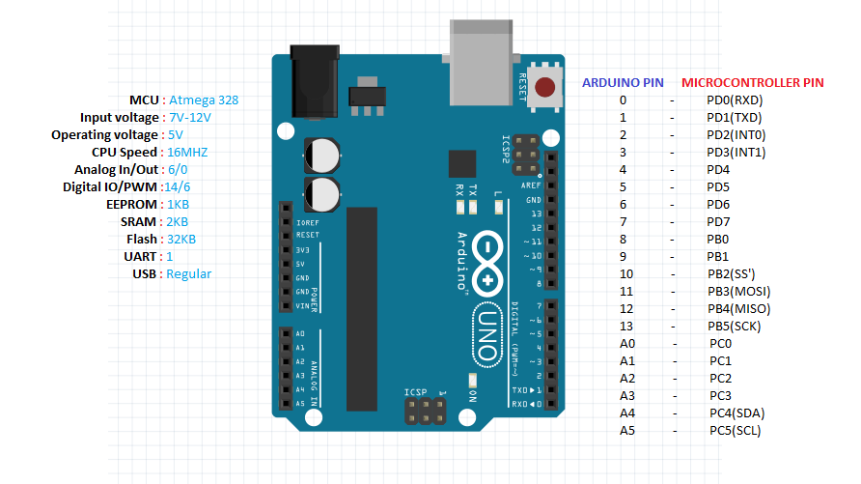

**Input and Output**

See the mapping between Arduino pins and ATmega328P ports. The mapping for the Atmega8, 168, and 328 is identical.

Each of the 14 digital pins on the Uno can be used as an input or output, using [pinMode()](https://www.arduino.cc/en/Reference/PinMode),[digitalWrite()](https://www.arduino.cc/en/Reference/DigitalWrite), and [digitalRead()](https://www.arduino.cc/en/Reference/DigitalRead) functions. They operate at 5 volts. Each pin can provide or receive 20 mA as recommended operating condition and has an internal pull-up resistor (disconnected by default) of 20-50k ohm. A maximum of 40mA is the value that must not be exceeded on any I/O pin to avoid permanent damage to the microcontroller.

**In addition, some pins have specialized functions:**

* Serial: 0 (RX) and 1 (TX). Used to receive (RX) and transmit (TX) TTL serial data. These pins are connected to the corresponding pins of the ATmega8U2 USB-to-TTL Serial chip.
* External Interrupts: 2 and 3. These pins can be configured to trigger an interrupt on a low value, a rising or falling edge, or a change in value. See the attachInterrupt() function for details.
* PWM: 3, 5, 6, 9, 10, and 11. Provide 8-bit PWM output with the analogWrite() function.
* SPI: 10 (SS), 11 (MOSI), 12 (MISO), 13 (SCK). These pins support SPI communication using the SPI library.
* LED: 13. There is a built-in LED driven by digital pin 13. When the pin is HIGH value, the LED is on, when the pin is LOW, it's off.
* TWI: A4 or SDA pin and A5 or SCL pin. Support TWI communication using the Wire library.

The Uno has 6 analog inputs, labeled A0 through A5, each of which provide 10 bits of resolution (i.e. 1024 different values). By default they measure from ground to 5 volts, though is it possible to change the upper end of their range using the AREF pin and the analogReference()function.

**Other pins on the board:**

* AREF. Reference voltage for the analog inputs. Used with analogReference().
* Reset. Bring this line LOW to reset the microcontroller. Typically used to add a reset button to shields which block the one on the board.

**Communication**

Arduino/Genuino Uno has a number of facilities for communicating with a computer, another Arduino/Genuino board, or other microcontrollers. The ATmega328 provides UART TTL (5V) serial communication, which is available on digital pins 0 (RX) and 1 (TX). An ATmega16U2 on the board channels this serial communication over USB and appears as a virtual com port to software on the computer. The 16U2 firmware uses the standard USB COM drivers, and no external driver is needed. However, [on Windows, a .inf file is required](https://www.arduino.cc/en/Guide/Windows#toc4). The Arduino Software (IDE) includes a serial monitor which allows simple textual data to be sent to and from the board. The RX and TX LEDs on the board will flash when data is being transmitted via the USB-to-serial chip and USB connection to the computer (but not for serial communication on pins 0 and 1).

A [SoftwareSerial library](https://www.arduino.cc/en/Reference/SoftwareSerial) allows serial communication on any of the Uno's digital pins. The ATmega328 also supports I2C (TWI) and SPI communication. The Arduino Software (IDE) includes a Wire library to simplify use of the I2C bus; see the [documentation](https://www.arduino.cc/en/Reference/Wire) for details. For SPI communication, use the [SPI library](https://www.arduino.cc/en/Reference/SPI).

**Automatic (Software) Reset**

Rather than requiring a physical press of the reset button before an upload, the Arduino/Genuino Uno board is designed in a way that allows it to be reset by software running on a connected computer.