Part -2: To start with simple array operation using Python
Till the end of this part you will be able to perform python operation mathematical operation on arrays
- Go to the folder where python program were saved in our case address would be
Sudo cd Downloads/opencv-3.0.0/samples/python2

Now you can run the previous sample program store for example python.py to run that write in command prompt
Downloads/opencv-3.0.0/samples/python2->$ sudo python ‘name of python file’
For example to open squares.py
Downloads/opencv-3.0.0/samples/python2->$ sudo python squares.py
The program will get run and you will found the output. It must be noted that GUI need to be installed proper during the installation if not there is any error regarding GUI or openCL. It that case program will get run but output cannot be displayed.
- Program to create 2 X 3 matrix name a and b, and perform mathematical operation like addition ,substraction and finding out mean
import numpy as np
import cv2 #this two are compulsary line for every program.
from numpy import *
import cv
A=array([[55,2,3],[5,25,4],]) #2 X3 matrix containing single channel
B=array([[55,1,3],[5,2,6],]) #2 X3 matrix containing single channel
# to create array of 5 X 5 having all ones
#size=5,5
#a=np.ones(size, dtype=uint8)
print 'matrix-A is\n', A # this will print value of matrix ‘A’
print 'matrix-B is\n', B
Addn=cv2.add(A,B) #PERFORMS ADDITION and store it in matrix Addn
print 'Addn of matrix is\n',Addn
Subtn=cv2.subtract(A,B) #PERFORMS Substraction and store it in matrix subtn
print 'Subtractnn of matrix is\n',Subtn
#To find out mean of matrix a
Mean_a=mean(A) #this will calculate the mean value of ‘A’
print 'mean of Matrix-A is',Mean_a

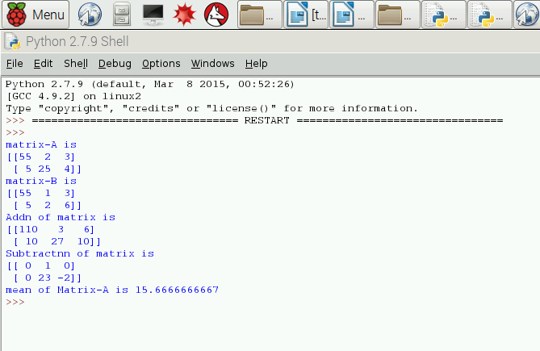

- To perform matrix operation like accessing single element and to change its values
import numpy as np
import cv2 #this two are compulsary line for every program.
from numpy import *
import cv
#!/usr/bin/python
A=array([[55,2,3],[5,25,4],]) #2 X3 matrix containing single channel
print 'Matrix-a is \n',A
#to store vale of a(1,2) in variable c
C=A[1,2]
print 'A[1,2] is',C
# it is to be note that here [1,2] represent 2nd row and 3rd column like ‘C’
# and unlike MATLAB
# to change the value of A[1,1] to ‘50’ instead of ‘25’
A[1,1]=50
# to create a matrix ‘b’ whose is of float type
B=np.float32(A)
print 'value of B is',B
#you can’t perform matrix operation of addition subtraction etc between A and B as both are #having different data types to perform transposes operation
D=cv2.transpose(A) ;
print 'transpose of A is',D
#to find out maximum value in the matrix
Y, X= [55,2,3], ['gyh', 'abc', 'xyz']
Max_valueY = max(Y)
Max_valueX=max(X)
print Max_valueX, Max_valueY
#It is to be noted that using single max() function will tell the maximum value present in each columns that’s why two max function is usedimport numpy as np
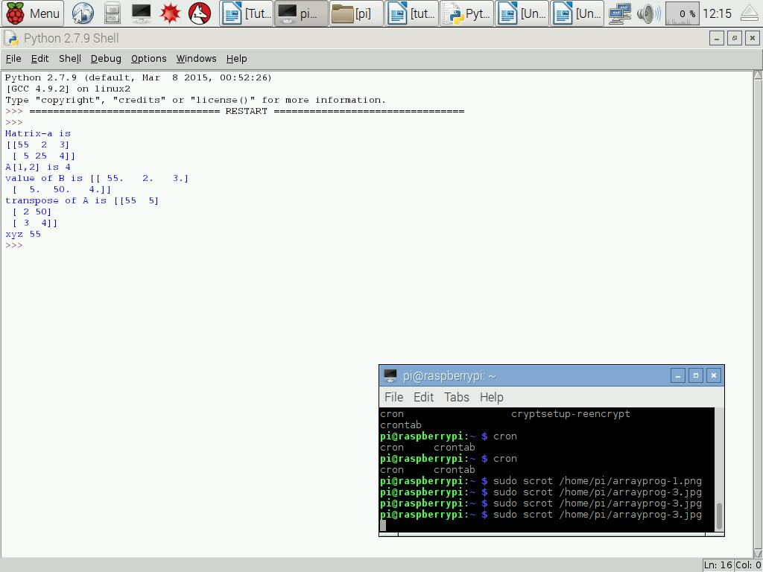

- Program to perform logical operation and looping operation
import numpy as np
import cv2 #this two are compulsary line for every program.
from numpy import *
import cv
# to create array of 5 X 5 having all ones
size=5,5
A=np.ones(size, dtype=uint8)
print 'Matrix-a \n',A
B= np.zeros(size, dtype=uint8)
print 'Matrix-b \n',B
B[2,3]=1;
C=A | B #OR operation
print 'Matrix-C OR operation \n',C
D= A & B #AND operation
print 'Matrix-D AND operation\n',D
E=np.ones(size, dtype=uint8)
print 'Matrix-e \n',E
# for loop have been use to check weather matrix A element must be equal to B or not
for i in range(0,5): # content inside the for loop must be write after tab down below
for j in range(0,5): # this for loop will be inside ‘i-for’ loop don’t forgot to write ‘:’
if(A[i,j]!=B[i,j]): #it checks for inequality
E[i,j]=255
else:
E[i,j]=0
#elif A[i,j]!=B[i,j]:
# print'inside second else but wont run'
print 'the matrix after comparison is\n',E
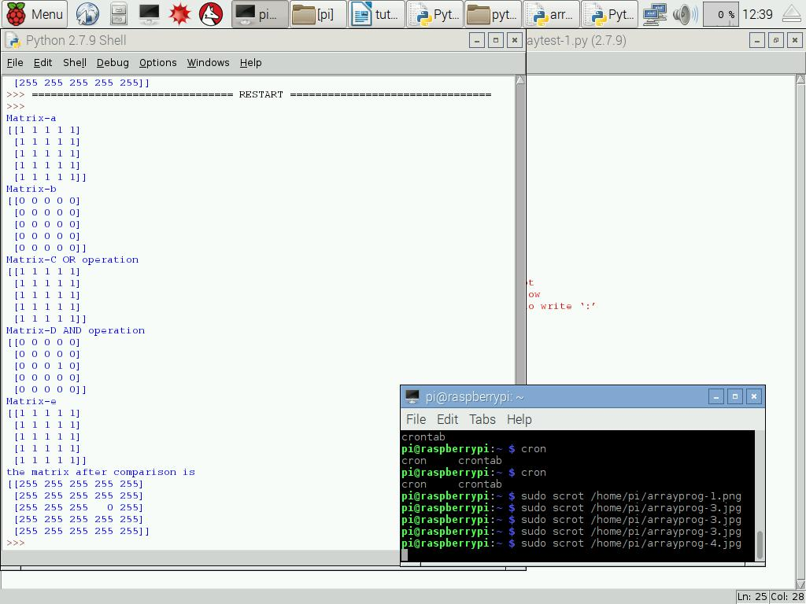

- Program to perform basic array operation
import numpy as np
import cv2 #this two are compulsary line for every program.
from numpy import *
import cv
a = floor(10*random.random((2,12)))#this will generate an random matrix of size 2 X 12 #To split the matrix #horizontally into 3 parts
print 'matrix-A\n',a
B=hsplit(a,3) #hence column break into 3X4 instead of 1 X 12
print 'matrix-B\n',B
#similarly vsplit can be perform to do vertical split
# hstack and vstack are two functions to combine the two matrix of same #size horizontally or vertically
print 'type-a',a.dtype #this will tell the data type integer, float etc.
#a.shape #it tells the dimention of matrix (2X12)
print 'shape-a',a.shape
c = array( [ [1,2], [3,4] ], dtype=complex )
print 'matrix-C\n',c
# this will generate an array who is having complex no as matrix elements
C= linspace(0, 2, 9 ) # array of 9 numbers from 0 to 2 will get generate
print 'matrix-C\n',C
b = arange(12).reshape(4,3) # this will generate a matrix containg 12 element 1-12 whose dimensions are 4 X 3
print 'matrix-b\n',b
print 'sum-b',b.sum(axis=0) # this will tell the sum of each column
b.min (axis=1)#this will tell the min value of each row
# It is to be noted that axis-0 for column and axis-1 for row operation
# exp(b) and sqrt(b) to find out exponential and square root of array ‘b’
BB= b.ravel()
print 'matrix-BB\n',BB
# this function will convert the 2-D matrix which is b (4 X 3) in our case into 1-D matrix #which will be 1 X 12
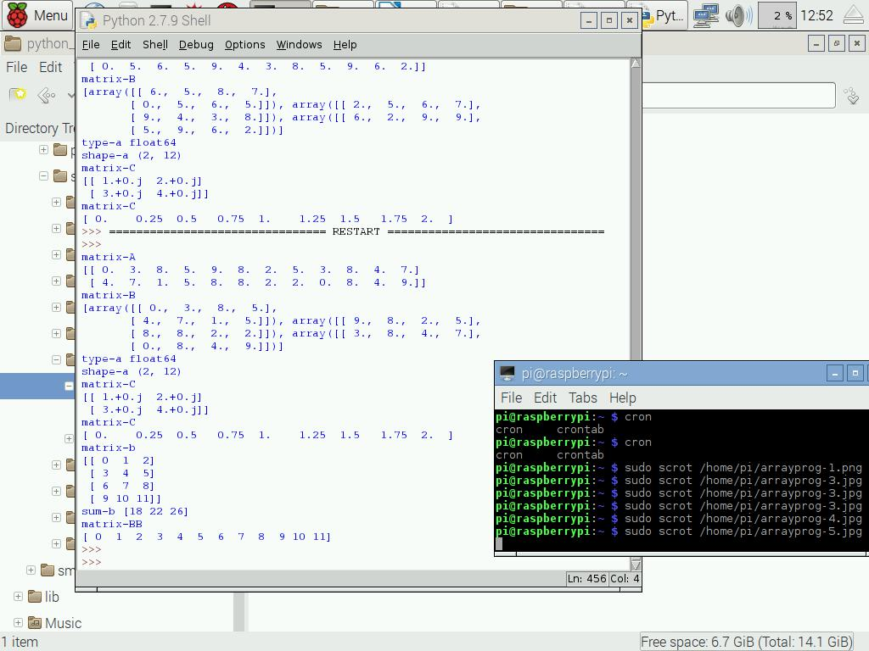

- Program to perform inverse, dot product , Eigen vale operation on matrix
import numpy as np
import cv2 #this two are compulsary line for every program.
from numpy import *
import cv

A=array([[2., 3.],[4.,5.]])
Inv_A=np.linalg.inv(A)
print 'inverse-A\n',Inv_A
B=eye(2) # this will create array [[1,0],[0,1]]
print 'matrix B\n',B
C=dot(A,B) #calculate dot product of matrix
print 'Dot_Product is\n',C
Trace_C=trace(C) #THIS WILL CALCULATE TRACE OF MATRIX C
print 'Trace of matrix c is\n',Trace_C
Eg_valur=np.linalg.eig(B) #calculate eigen values of matrix B
print 'eigen values and vectors are',Eg_valur

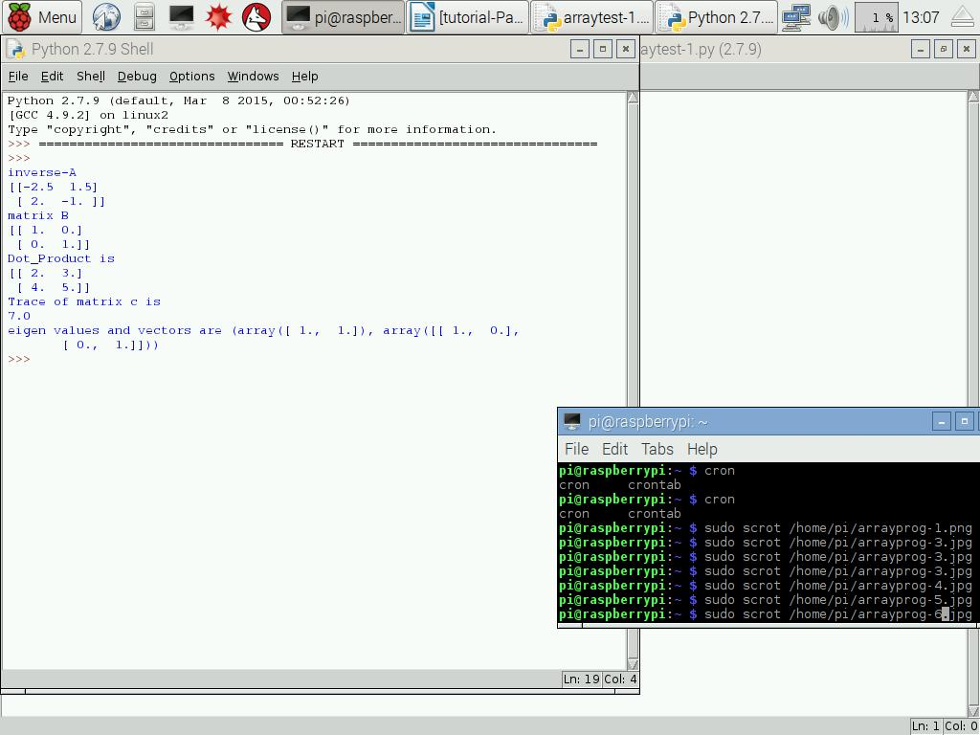

- Program to perform histogram analysis
import numpy as np
import cv2 #this two are compulsary line for every program.
from numpy import *
import cv

import numpy
import pylab
# Build a vector of 10000 normal deviates with variance 0.5^2 and mean 2
mu, sigma = 2, 0.5
v = numpy.random.normal(mu,sigma,10000)
# Plot a normalized histogram with 50 bins
pylab.hist(v, bins=50, normed=1) # matplotlib version (plot)
pylab.show()
# Compute the histogram with numpy and then plot it
(n, bins) = numpy.histogram(v, bins=50, normed=True)#NumPy version(no plot)
pylab.plot(.5*(bins[1:]+bins[:-1]), n)

pylab.show()
import numpy as np
import cv2 #this two are compulsary line for every program.
from numpy import *
import cv

import numpy
import pylab
# Build a vector of 10000 normal deviates with variance 0.5^2 and mean 2
mu, sigma = 2, 0.5
v = numpy.random.normal(mu,sigma,10000)
# Plot a normalized histogram with 50 bins
pylab.hist(v, bins=50, normed=1) # matplotlib version (plot)
pylab.show()
# Compute the histogram with numpy and then plot it
(n, bins) = numpy.histogram(v, bins=50, normed=True)#NumPy version(no plot)
pylab.plot(.5*(bins[1:]+bins[:-1]), n)
pylab.show()
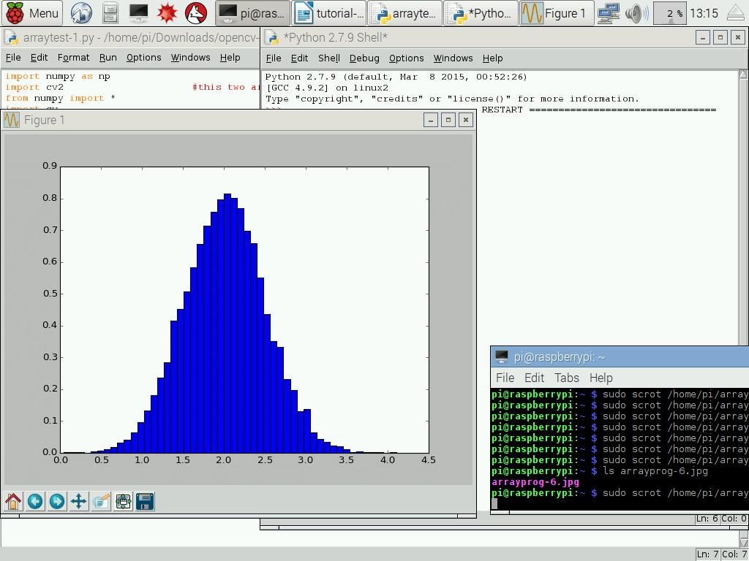
- Program to open an image and convert it into grayscale using function
import numpy as np
import cv2
# here we are writing function known as gray_conv which will convert image into grayscale
def gray_conv(img):
gray = cv2.cvtColor(img, cv2.COLOR_BGR2GRAY) #to convert into gray
print 'inside function'
return gray #returning the gray scale image

img = cv2.imread('baboon.jpg',1)
gray= gray_conv(img)
cv2.imwrite('gray_fu.jpg',gray)
print 'outside function'

