create database practice2;

use practice2;

create table orders(ord_no int primary key,purch_amt double,ord_date date,custid int,salesid int);

select * from orders;

insert into orders values(70001,105.5,'2012-10-05',3005,5002);

insert into orders values(70009,270.65,'2012-09-10',3001,5005);

insert into orders values(70002,65.26,'2012-10-05',3002,5001);

insert into orders values(70004,110.5,'2012-08-17',3009,5003);

insert into orders values(70007,948.5,'2012-09-10',3005,5002);

insert into orders values(70005,2400.6,'2012-07-27',3007,5001);

insert into orders values(70008,5760,'2012-09-10',3002,5001);

insert into orders values(70010,1983.43,'2012-10-10',3004,5006);

insert into orders values(70003,2480.4,'2012-10-10',3009,5003);

insert into orders values(700012,250.45,'2012-06-27',3008,5002);

insert into orders values(70011,75.29,'2012-08-17',3003,5007);

insert into orders values(70013,3045.6,'2012-04-25',3002,5001);

select sum(purch_amt) from orders;

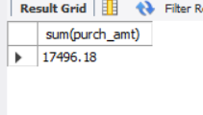

select avg(purch_amt) from orders;

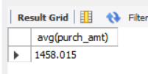

select count(distinct salesid) from orders;

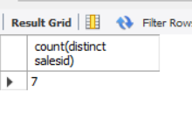

select max(purch_amt) from orders;

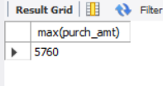

select min(purch_amt) from orders;

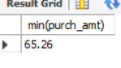

select custid from orders where purch_amt=(select max(purch_amt) from orders);

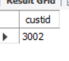

select max(purch_amt),ord_date from orders group by ord_date;

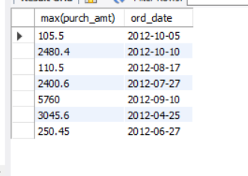

select custid,purch_amt,ord_date from orders where purch_amt=(select max(purch_amt) from orders where ord_date='2012-08-17' and purch_amt>2000);

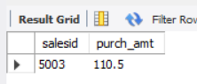

select salesid,purch_amt from orders where purch_amt=(select max(purch_amt) from orders where ord_date='2012-07-27');

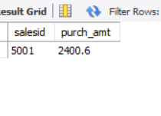

select custid,ord_date,max(purch_amt) as max_amount from orders where purch_amt between 2000 and 6000 group by custid,ord_date;

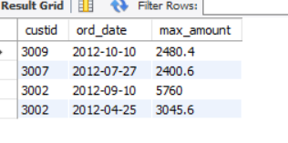

select custid,ord_date,purch_amt from orders where purch_amt=(select max(purch_amt) from orders where purch_amt in(2000,3000,5760,6000) group by ord_date);

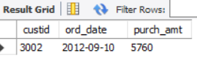

select max(purch_amt) as max_amt,custid from orders where custid between 3002 and 3007 group by custid;

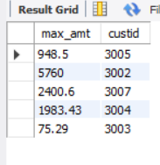

select max(purch_amt) as max_amt,custid from orders where custid between 3002 and 3007 and purch_amt >1000 group by custid;

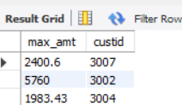

select max(purch_amt) as max_amt,salesid from orders where salesid between 5003 and 5008 group by salesid;

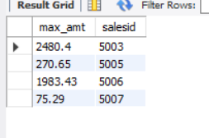

select count(ord_no) from orders where ord_date='2012-08-17';



(select count(ord_no) from orders group by ord_date,salesid);

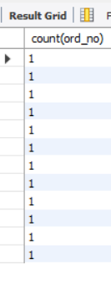

select ord_date,salesid,ord_no,purch_amt from orders order by ord_no asc;

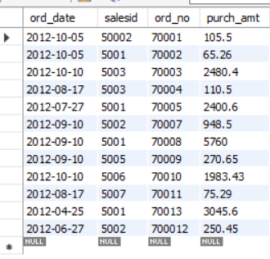

select distinct salesid from orders;

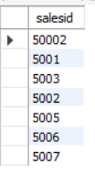

select * from orders where salesid=5001;

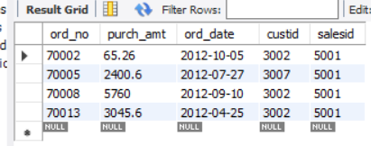

select ord_date,salesid,ord_no,purch_amt from orders order by ord_no asc;

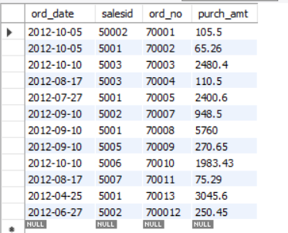

select * from orders order by ord_date desc;

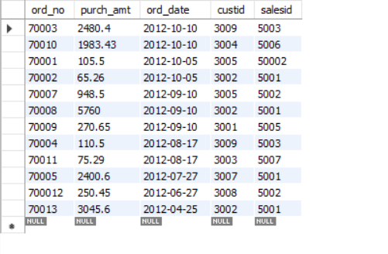

select * from orders order by ord_date,purch_amt desc;

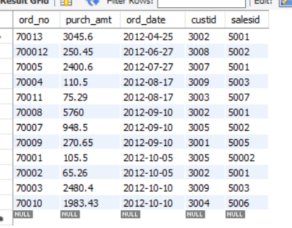

SELECT

salesid,

ord_date,

MAX(purch_amt) AS max_purch_amt

FROM

orders

GROUP BY

salesid, ord_date

ORDER BY

salesid ASC, ord_date ASC;

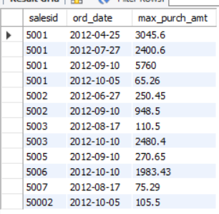

select count(*) as cnt,purch_amt,custid

from orders

GROUP BY custid,purch_amt

having purch_amt=(select max(purch_amt) from orders)

order by purch_amt desc;

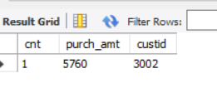

select count(*) as cnt,sum(purch_amt),custid,ord_date

from orders

GROUP BY custid,ord_date

having purch_amt=(select max(purch_amt) from orders)

order by purch_amt desc;