AI ASSISTED CODING
Assignment-13.2
Name : Aditya
Roll Number : 2303A52113
Batch : 40
Lab 13: Code Refactoring – Improving Legacy Code with AI Suggestions
Lab Objectives:
• Identify code smells and inefficiencies in legacy Python scripts.
• Use AI-assisted coding tools to refactor for readability, maintainability, and performance.
• Apply modern Python best practices while ensuring output correctness.
Task Description -1 (Refactoring – Eliminating Repetitive Logic)
• Task: Use AI-assisted coding techniques to restructure a Python
program that performs repeated calculations, transforming it into
a reusable and maintainable design.
Instructions:
• Ask AI to locate repeated computations within the program.
• Encapsulate repeated logic into reusable functions.
• Verify that program output remains unchanged after refactoring.
• Add proper docstrings to all defined functions.

Sample Code:
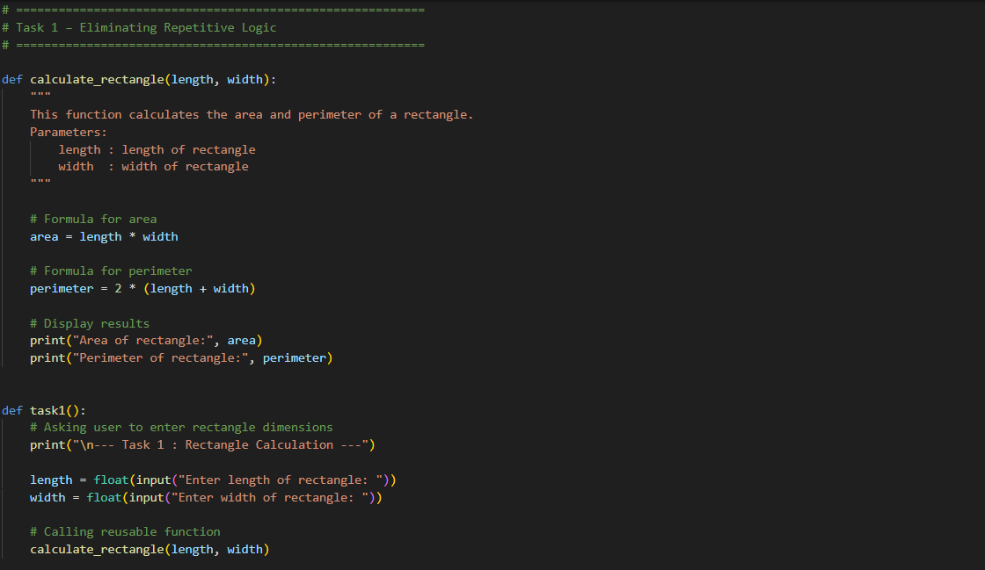Expected Output: 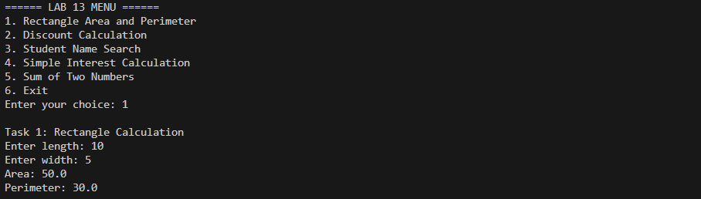

Task Description -2 (Refactoring – Modularizing Inline Calculations)
• Task: Use AI to refactor a Python script by extracting repeated
inline calculations into reusable and well-documented functions.
Instructions:
• Identify repeated calculation patterns in the code.
• Convert them into reusable functions.
• Ensure readability and proper documentation.
Sample Code:
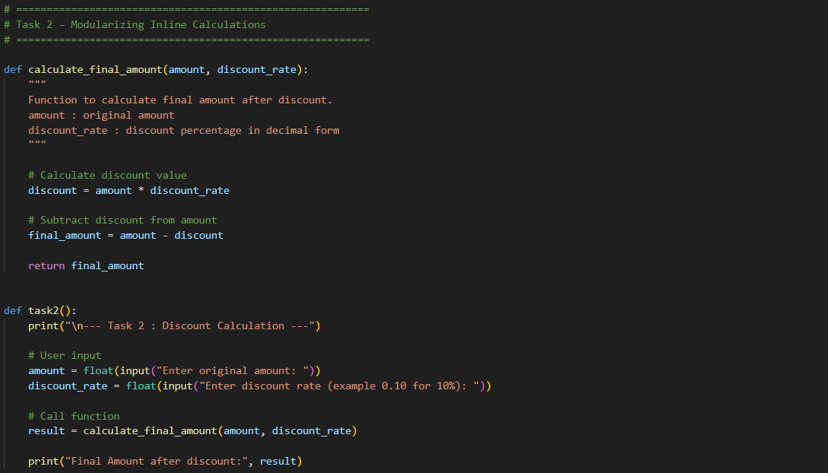Expected Output: 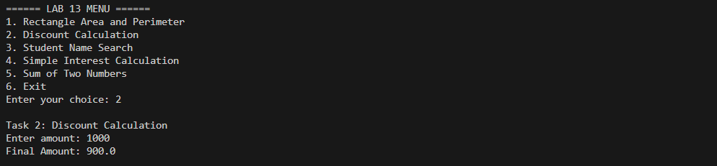

Task Description -3 (Refactoring – Improving Loop and Conditional Performance)
• Task: Apply AI-based suggestions to enhance the performance of
Python code that relies on nested loops and repeated conditional
checks.
Instructions:
• Use AI to recommend more efficient data structures or logic
simplifications.
• Replace inefficient constructs while preserving program behavior.
• Compare execution efficiency before and after refactoring.
Sample Code: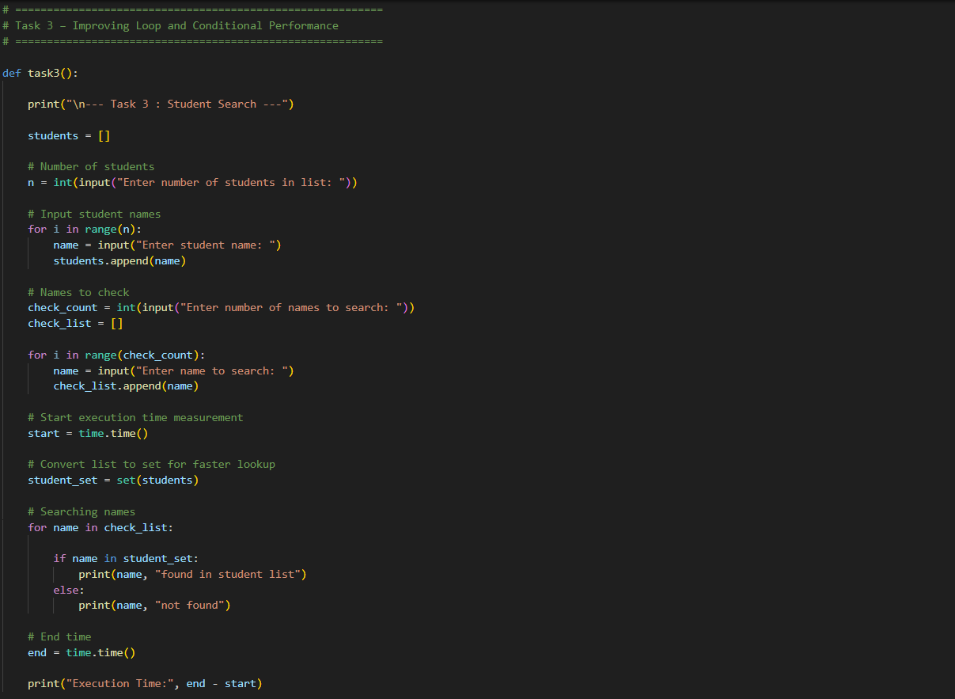
Expected Output: 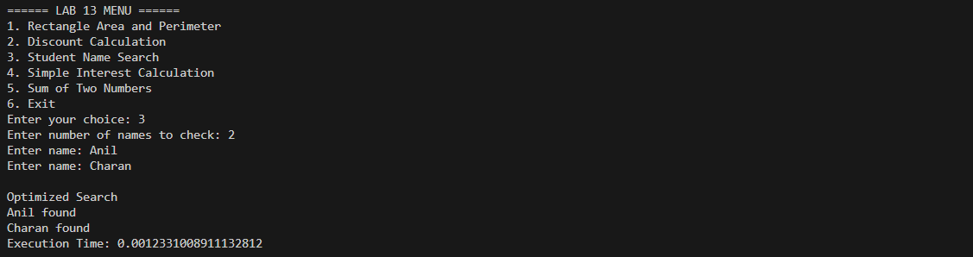

Task Description -4 (Refactoring – Replacing Hardcoded Values with Constants)
• Task: Utilize AI assistance to improve maintainability by
replacing hardcoded numerical values with named constants.
Instructions:
• Detect hardcoded numeric values used directly in expressions.
• Define descriptive constants at the beginning of the program.
• Update calculations to use these constants without changing
results.
Sample Code: 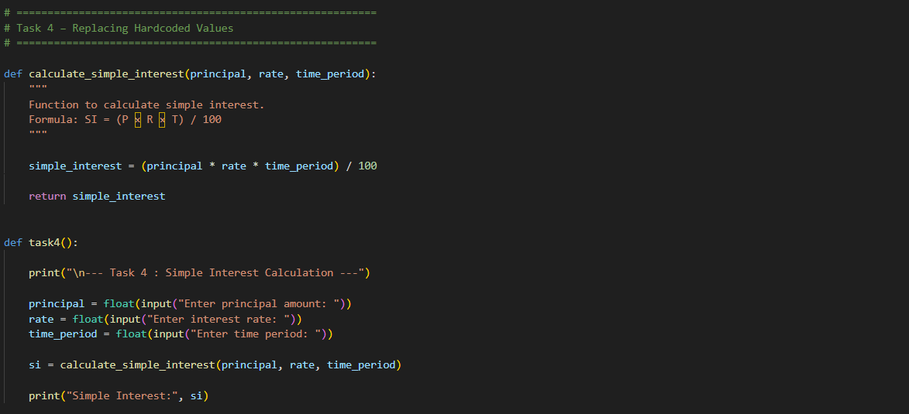
Expected Output: 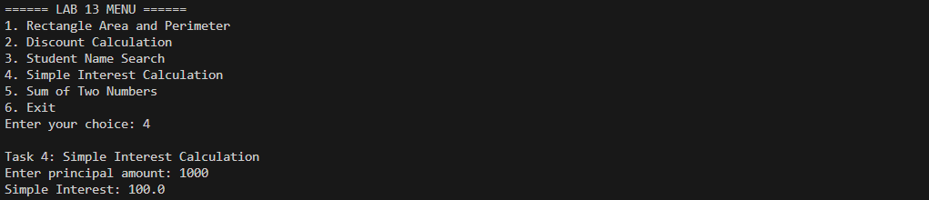

Task Description -5 (Re factoring – Enhancing Variable Naming and Code Clarity)
• Task: Apply AI tools to improve code readability by renaming
unclear variables and adding meaningful comments..
Instructions:
• Replace non-descriptive variable names with meaningful
identifiers.
• Add inline comments where the logic may be unclear.
• Ensure program output remains the same.
Sample Code:
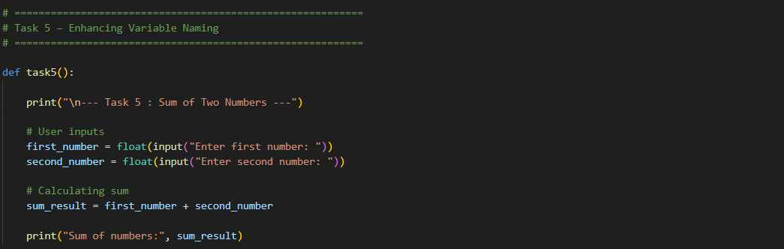Expected Output: 