AI ASSISTED CODING
Assignment-10.1
Name: Aditya
Roll Number: 2303A52113
Batch: 40
Lab 10 – Code Review and Quality: Using AI to Improve Code Quality and Readability
Lab Objectives
• Use AI for automated code review and quality enhancement.
• Identify and fix syntax, logical, performance, and security
issues in Python code.
• Improve readability and maintainability through structured
refactoring and comments.
• Apply prompt engineering for targeted improvements.
• Evaluate AI-generated suggestions against PEP 8 standards
and software engineering best practices
Lab Outcomes
1. Students will be able to use AI tools to review code.
2. Students will be able to improve code quality and readability.
3. Students will be able to identify and fix common coding
issues.
Task Description #1 – Syntax and Logic Errors
Task: Use AI to identify and fix syntax and logic errors in a faulty
Python script.
Sample Input Code:
# Calculate average score of a student
def calc_average(marks):
total = 0
for m in marks:
total += m
average = total / len(marks)
return avrage # Typo here
marks = [85, 90, 78, 92]
print("Average Score is ", calc_average(marks)
Code:
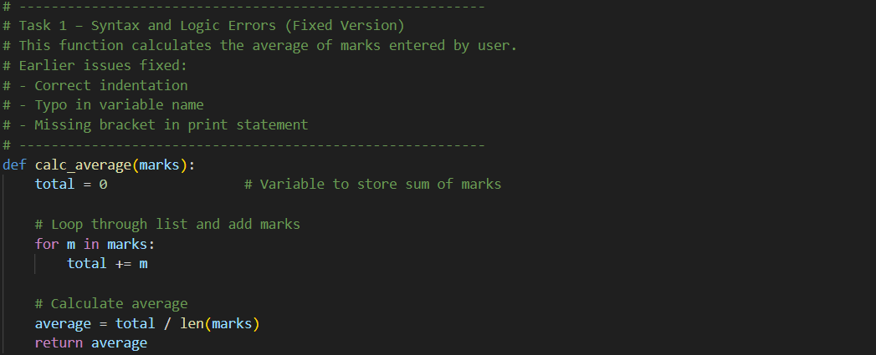
Expected Output:
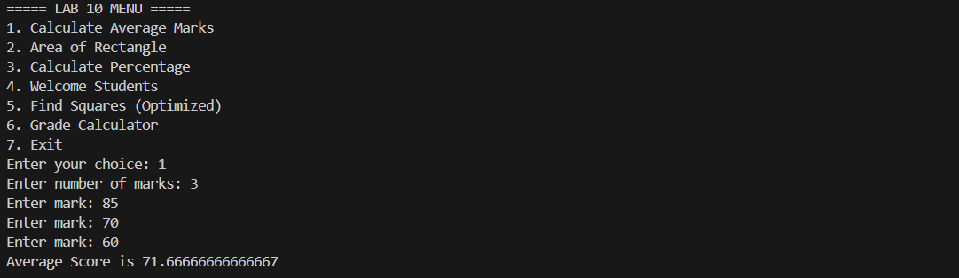

Task Description #2 – PEP 8 Compliance
Task: Use AI to refactor Python code to follow PEP 8 style
guidelines.
Sample Input Code:
def area_of_rect(L,B) : return L*B
print(area_of_rect(10,20))
Code:
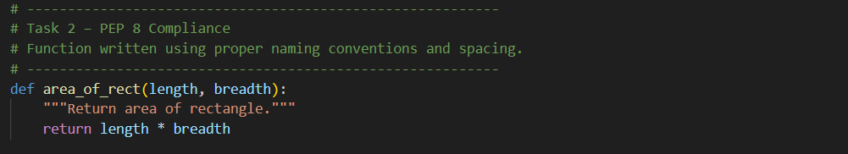
Expected Output:
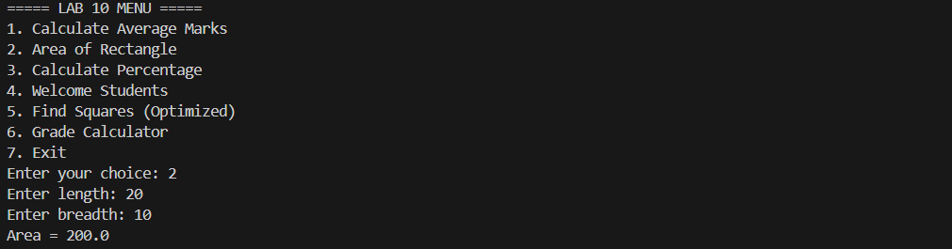

Task Description #3 – Readability Enhancement
Task: Use AI to make code more readable without changing its
logic.
Sample Input Code:
def c(x,y):
return x*y/100
a=200
b=15
print(c(a,b))
Code:
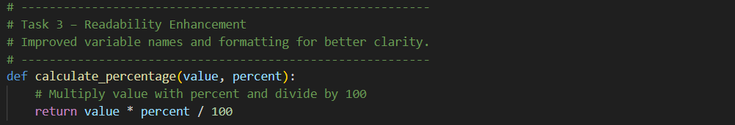
Expected Output: 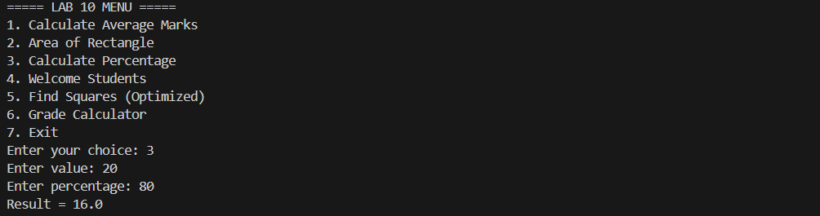

Task Description #4 – Refactoring for Maintainability
Task: Use AI to break repetitive or long code into reusable
functions.
Sample Input Code:
students = ["Alice", "Bob", "Charlie"]
print("Welcome", students[0])
print("Welcome", students[1])
print("Welcome", students[2])
Code:
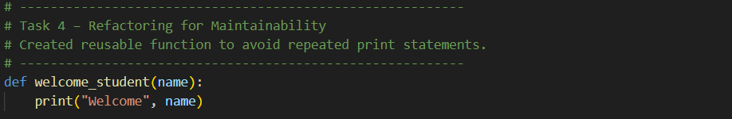
Expected Output: 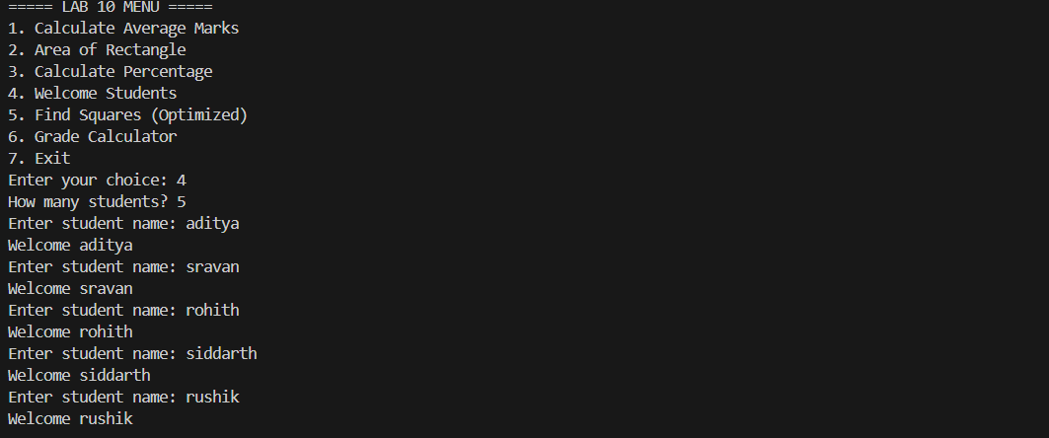

Task Description #5 – Performance Optimization
Task: Use AI to make the code run faster.
Sample Input Code:
# Find squares of numbers
nums = [i for i in range(1,1000000)]
squares = []
for n in nums:
squares.append(n**2)
print(len(squares))
Code:
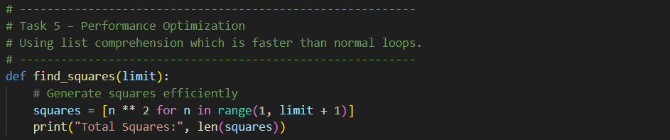
Expected Output: 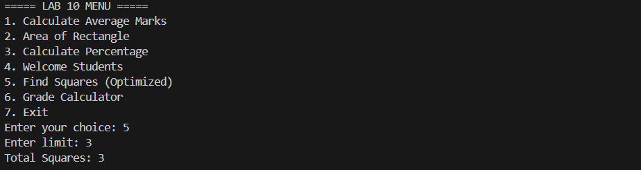

Task Description #6 – Complexity Reduction
Task: Use AI to simplify overly complex logic.
Sample Input Code:
def grade(score):
if score >= 90:
return "A"
else:
if score >= 80:
return "B"
else:
if score >= 70:
return "C"
else:
if score >= 60:
return "D"
else:
return "F"
Code:
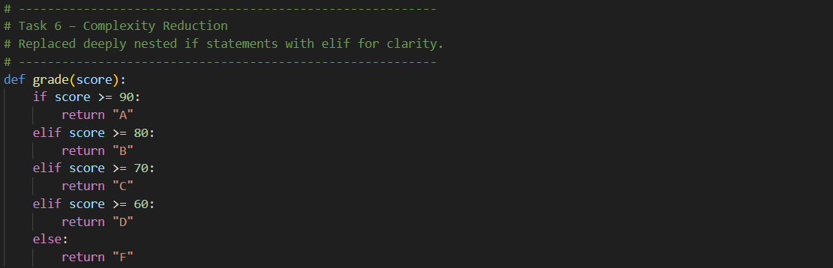
Expected Output: 