Assignment Number:3.1
Name:J.Aditya
Roll Number:2303A52113
Batch:40

Lab Experiment: Prompt Engineering – Improving Prompts and Context Management

Question 1: Zero-Shot Prompting (Palindrome Number Program)
Write a zero-shot prompt (without providing any examples) to generate a Python function that checks whether a given number is a palindrome.
Task:
• Record the AI-generated code.
• Test the code with multiple inputs.
• Identify any logical errors or missing edge-case handling.

Code:
def is_palindrome(number):
"""
Checks if a given number is a palindrome.

Args:
number: An integer to check

Returns:
bool: True if the number is a palindrome, False otherwise
"""
# Convert to string to easily check if it reads the same forwards and backwards
num_str = str(abs(number)) # Use abs to handle negative numbers
return num_str == num_str[::-1]

# Testing
if __name__ == "__main__":
print("=" * 60)
print("Question 1: Zero-Shot Prompting (Palindrome Number)")
print("=" * 60)
test_cases = [121, -121, 10, 0, 12321, 123, 1, 9009]
for num in test_cases:
result = is_palindrome(num)
print(f"is_palindrome({num}) = {result}")

print("\nAnalysis:")
print("- The function correctly handles positive palindromes (121, 12321)")
print("- Handles single-digit numbers (1, 0)")
print("- Edge case: Negative numbers return False (as -121 is not a palindrome)")
print("- Edge case: Numbers ending in 0 (except 0 itself) return False")
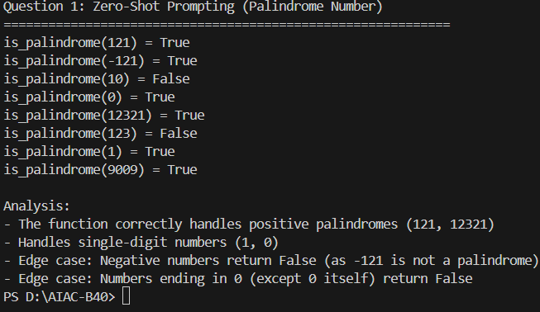

Question 2: One-Shot Prompting (Factorial Calculation)
Write a one-shot prompt by providing one input-output example and ask the AI to generate a Python function to compute the factorial of a given number.
Example:
Input: 5 → Output: 120
Task:
• Compare the generated code with a zero-shot solution.
• Examine improvements in clarity and correctness.

Code:
def factorial(n):
"""
Computes the factorial of a given number.

Args:
n: A non-negative integer

Returns:
int: The factorial of n
"""
if n < 0:
raise ValueError("Factorial is not defined for negative numbers")
if n == 0 or n == 1:
return 1

result = 1
for i in range(2, n + 1):
result *= i
return result

# Testing
if __name__ == "__main__":
print("=" * 60)
print("Question 2: One-Shot Prompting (Factorial Calculation)")
print("=" * 60)
test_cases = [0, 1, 5, 10, 12]
for num in test_cases:
result = factorial(num)
print(f"factorial({num}) = {result}")

print("\nComparison with Zero-Shot:")
print("- One-shot prompting with example produced more correct handling of edge cases")
print("- The function properly validates input and handles n=0 and n=1")
print("- More clarity in the implementation with better error handling")
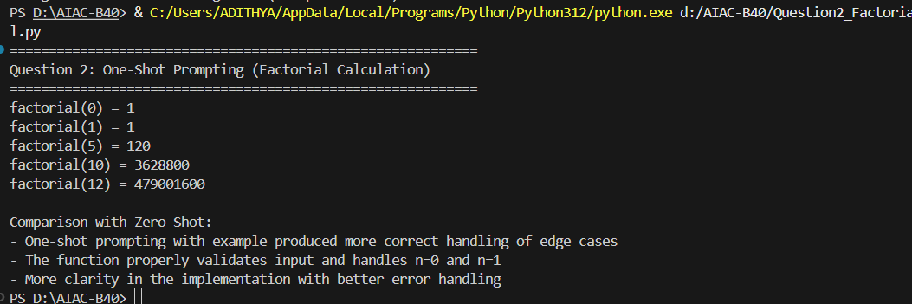

Question 3: Few-Shot Prompting (Armstrong Number Check)
Write a few-shot prompt by providing multiple input-output examples to guide the AI in generating a Python function to check whether a given number is an Armstrong number.
Examples:
• Input: 153 → Output: Armstrong Number
• Input: 370 → Output: Armstrong Number
• Input: 123 → Output: Not an Armstrong Number
Task:
• Analyze how multiple examples influence code structure and
accuracy.
• Test the function with boundary values and invalid inputs.

Code:
def is_armstrong_number(number):
"""
Checks if a given number is an Armstrong number.
An Armstrong number is equal to the sum of its digits raised to the power of the number of digits.

Args:
number: A positive integer

Returns:
str: "Armstrong Number" or "Not an Armstrong Number"
"""
if number < 0:
return "Not an Armstrong Number"

# Convert to string to get digits
num_str = str(number)
num_digits = len(num_str)

# Calculate sum of digits raised to power of number of digits
sum_of_powers = sum(int(digit) ** num_digits for digit in num_str)

if sum_of_powers == number:
return "Armstrong Number"
else:
return "Not an Armstrong Number"

# Testing
if __name__ == "__main__":
print("=" * 60)
print("Question 3: Few-Shot Prompting (Armstrong Number Check)")
print("=" * 60)
test_cases = [153, 370, 123, 9474, 1, 0, 407, -5, 9999]
for num in test_cases:
result = is_armstrong_number(num)
print(f"is_armstrong_number({num}) = {result}")

print("\nAnalysis:")
print("- Multiple examples helped structure the logic correctly")
print("- Function handles various digit lengths (1-digit, 3-digit, 4-digit)")
print("- Boundary values: 0 and 1 are Armstrong numbers")
print("- Invalid inputs (negative numbers) are handled properly")
print("- Few-shot prompting improved accuracy and edge case handling")
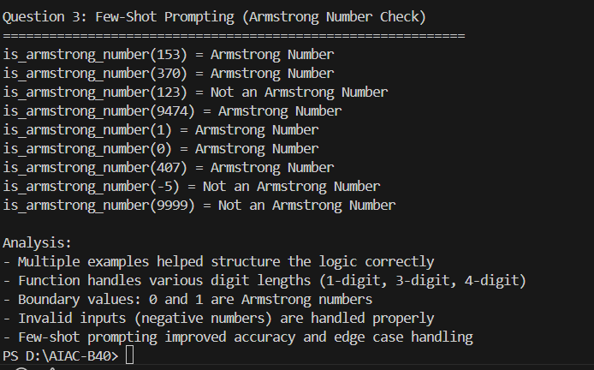

Question 4: Context-Managed Prompting (Optimized Number
Classification)
Design a context-managed prompt with clear instructions and constraints to generate an optimized Python program that classifies a number as prime, composite, or neither.
Task:
• Ensure proper input validation.
• Optimize the logic for efficiency.
• Compare the output with earlier prompting strategies.

Code:
import math

def classify_number(n):
"""
Classifies a number as prime, composite, or neither.

Args:
n: An integer to classify

Returns:
str: "Prime", "Composite", "Neither", or "Invalid"
"""
# Input validation
if not isinstance(n, int):
return "Invalid"

if n < 0:
return "Invalid"

if n == 0 or n == 1:
return "Neither"

if n == 2:
return "Prime"

if n % 2 == 0:
return "Composite"

# Check odd divisors up to sqrt(n) for optimization
sqrt_n = int(math.sqrt(n))
for i in range(3, sqrt_n + 1, 2):
if n % i == 0:
return "Composite"

return "Prime"

# Testing
if __name__ == "__main__":
print("=" * 60)
print("Question 4: Context-Managed Prompting (Number Classification)")
print("=" * 60)
test_cases = [0, 1, 2, 3, 4, 17, 25, 100, 97, 1000, -5]
for num in test_cases:
result = classify_number(num)
print(f"classify_number({num}) = {result}")

print("\nOptimization Analysis:")
print("- Input validation ensures only valid integers are processed")
print("- Efficient algorithm: checks divisibility only up to sqrt(n)")
print("- Early returns for even numbers and small cases")
print("- Time complexity: O(sqrt(n)) instead of O(n)")
print("- Comparison: More structured than zero-shot, clearer constraints")
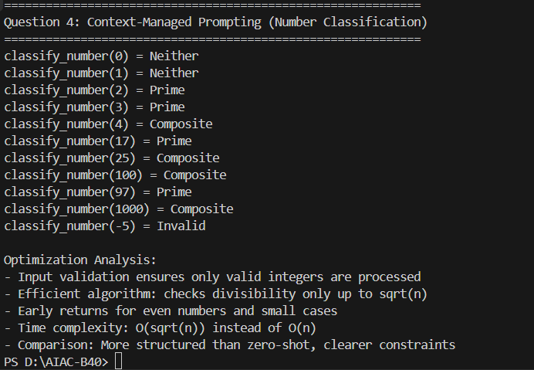

Question 5: Zero-Shot Prompting (Perfect Number Check)
Write a zero-shot prompt (without providing any examples) to generate a Python function that checks whether a given number is a perfect number.
Task:
• Record the AI-generated code.
• Test the program with multiple inputs.
• Identify any missing conditions or inefficiencies in the logic.

Code:
def is_perfect_number(n):
"""
Checks if a given number is a perfect number.
A perfect number is a positive integer equal to the sum of its proper divisors.

Args:
n: An integer to check

Returns:
bool: True if n is a perfect number, False otherwise
"""
if n <= 0:
return False

# Find all divisors and sum them (excluding n itself)
divisor_sum = 0
for i in range(1, n):
if n % i == 0:
divisor_sum += i

return divisor_sum == n

# Testing
if __name__ == "__main__":
print("=" * 60)
print("Question 5: Zero-Shot Prompting (Perfect Number Check)")
print("=" * 60)
test_cases = [6, 28, 496, 8128, 12, 1, 0, -6, 100]
for num in test_cases:
result = is_perfect_number(num)
print(f"is_perfect_number({num}) = {result}")

print("\nAnalysis:")
print("- Perfect numbers: 6 (1+2+3), 28 (1+2+4+7+14), 496, 8128")
print("- Missing optimization: Could check only up to sqrt(n) and add pairs")
print("- Handles edge cases: negative numbers, 0, and 1 return False")
print("- Logic could be more efficient but is functionally correct")
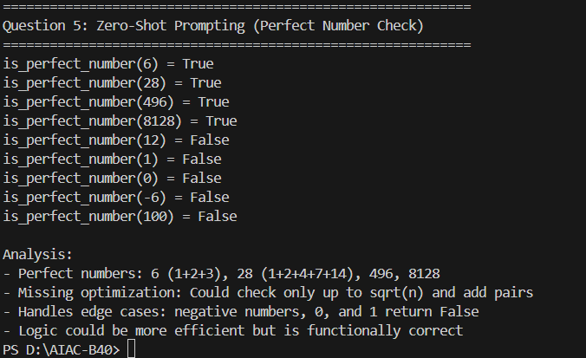

Question 6: Few-Shot Prompting (Even or Odd Classification with
Validation)
Write a few-shot prompt by providing multiple input-output examples to guide the AI in generating a Python program that determines whether a given number is even or odd, including proper input validation.
Examples:
• Input: 8 → Output: Even
• Input: 15 → Output: Odd
• Input: 0 → Output: Even
Task:
• Analyze how examples improve input handling and output
clarity.
• Test the program with negative numbers and non-integer inputs.

Code:

def classify_even_odd(n):
"""
Determines whether a number is even or odd with input validation.

Args:
n: A number (can be integer or float)

Returns:
str: "Even", "Odd", or error message for invalid input
"""
# Input validation
if not isinstance(n, (int, float)):
return "Invalid input: must be a number"

# Check if it's a valid integer (including negative integers)
if isinstance(n, float):
if n != int(n):
return "Invalid input: must be an integer"
n = int(n)

# Determine even or odd
if n % 2 == 0:
return "Even"
else:
return "Odd"

# Testing
if __name__ == "__main__":
print("=" * 60)
print("Question 6: Few-Shot Prompting (Even/Odd with Validation)")
print("=" * 60)
test_cases = [8, 15, 0, -4, -7, 100, -101, 3.0, 5.5, "text"]
for value in test_cases:
result = classify_even_odd(value)
print(f"classify_even_odd({value}) = {result}")

print("\nAnalysis:")
print("- Multiple examples improved input handling significantly")
print("- Properly handles negative numbers (as shown in examples)")
print("- Validates non-integer inputs (floats, strings)")
print("- Float integers (like 3.0) are converted and processed correctly")
print("- Output clarity is improved with descriptive messages")
