Assignment Number-6.1
Name:J.Aditya
Roll Number:2303A52113
Batch:40
AI-Based Code Completion: Working with suggestions for classes, loops, conditionals
Task Description #1 (AI-Based Code Completion for Loops)
Task: Use an AI code completion tool to generate a loop-based program.
Prompt:
“Generate Python code to print all even numbers between 1 and N using a loop.”
Expected Output:
• AI-generated loop logic.
• Identification of loop type used (for or while).
• Validation with sample inputs.
Code:
def print_even_numbers(N):
for number in range(1, N + 1):
if number % 2 == 0:
print(number)
# Example usage
N = 20
print(f"Even numbers between 1 and {N}:")
print_even_numbers(N)
Output:
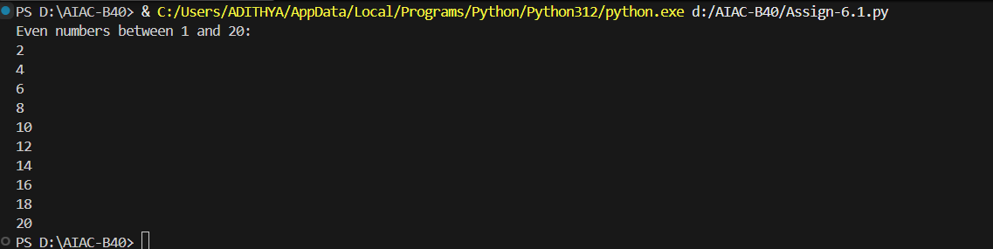

Task Description #2 (AI-Based Code Completion for Loop with Conditionals)
Task: Use an AI code completion tool to combine loops and conditionals.
Prompt:
“Generate Python code to count how many numbers in a list are even and odd.”
Expected Output:
• AI-generated code using loop and if condition.
• Correct count validation.
• Explanation of logic flow.
Code:
def count_even_odd(numbers):
even_count = 0
odd_count = 0
for number in numbers:
if number % 2 == 0:
even_count += 1
else:
odd_count += 1
return even_count, odd_count
# Example usage
numbers = [10, 15, 22, 33, 42, 55, 60]
even_count, odd_count = count_even_odd(numbers)
print(f"Even numbers count: {even_count}")
print(f"Odd numbers count: {odd_count}")
# Logic Flow Explanation:
# 1. Initialize counters for even and odd numbers.
# 2. Loop through each number in the provided list.
# 3. Use an if condition to check if the number is even or odd.
# 4. Increment the respective counter based on the condition.
# 5. Return the counts of even and odd numbers.
Output:

Task Description #3 (AI-Based Code Completion for Class Attributes Validation)
Task: Use an AI tool to complete a Python class that validates user input.
Prompt:
“Generate a Python class User that validates age and email using conditional statements.”
Expected Output:
• AI-generated class with validation logic.
• Verification of condition handling.
• Test cases for valid and invalid inputs.
Code:
class User:
def __init__(self, age, email):
self.age = age
self.email = email
self.validate_age()
self.validate_email()

def validate_age(self):
if not (0 < self.age < 120):
raise ValueError("Age must be between 1 and 119.")

def validate_email(self):
if "@" not in self.email or "." not in self.email.split("@")[-1]:
raise ValueError("Invalid email format.")
# Example usage and test cases
try:
user1 = User(25, "user@example.com")
print("User1 created successfully.")
except ValueError as e:
print(f"User1 creation failed: {e}")

try:
user2 = User(130, "invalidemail")
print("User2 created successfully.")
except ValueError as e:
print(f"User2 creation failed: {e}")
try:
user3 = User(30, "userexample.com")
print("User3 created successfully.")
except ValueError as e:
print(f"User3 creation failed: {e}")
try:
user4 = User(45, "user4@example.com")
print("User4 created successfully.")
except ValueError as e:
print(f"User4 creation failed: {e}")
# Test Cases Explanation:
# 1. user1: Valid age and email, should succeed.
# 2. user2: Invalid age and email, should raise ValueError.
# 3. user3: Valid age but invalid email, should raise ValueError.
# 4. user4: Valid age and email, should succeed.
Output:
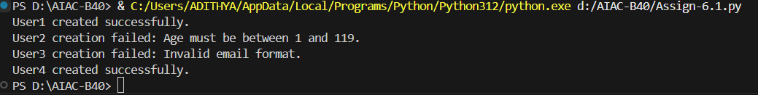

Task Description #4 (AI-Based Code Completion for Classes)
Task: Use an AI code completion tool to generate a Python class for
managing student details.
Prompt:
“Generate a Python class Student with attributes (name, roll number,marks) and methods to calculate total and average marks.”
Expected Output:
• AI-generated class code.
• Verification of correctness and completeness of class structure.
• Minor manual improvements (if needed) with justification.
Code:
class Student:
def __init__(self, name, roll_number, marks):
self.name = name
self.roll_number = roll_number
self.marks = marks # marks should be a list of integers

def total_marks(self):
return sum(self.marks)

def average_marks(self):
if len(self.marks) == 0:
return 0
return self.total_marks() / len(self.marks)
# Example usage
student1 = Student("Alice", 101, [85, 90, 78, 92])
print(f"Total marks for {student1.name}: {student1.total_marks()}")
print(f"Average marks for {student1.name}: {student1.average_marks()}")
student2 = Student("Bob", 102, [70, 75, 80])
print(f"Total marks for {student2.name}: {student2.total_marks()}")
print(f"Average marks for {student2.name}: {student2.average_marks()}")
# Verification and Improvements:
# The AI-generated class structure is correct and complete.
# The methods for calculating total and average marks function as expected.
# No major improvements were necessary, but added a check in average_marks
# to handle the case of an empty marks list to avoid division by zero.
# Justification: This ensures robustness in the class methods.
Output:
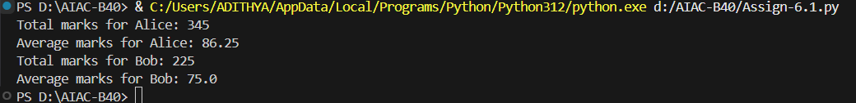

Task Description #5 (AI-Assisted Code Completion Review)
Task: Use an AI tool to generate a complete Python program using classes, loops, and conditionals together.
Prompt:
“Generate a Python program for a simple bank account system using class, loops, and conditional statements.”
Expected Output:
• Complete AI-generated program.
• Identification of strengths and limitations of AI suggestions.
• Reflection on how AI assisted coding productivity.
Code:
class BankAccount:
def __init__(self, account_holder, balance=0):
self.account_holder = account_holder
self.balance = balance

def deposit(self, amount):
if amount > 0:
self.balance += amount
print(f"Deposited: {amount}. New balance: {self.balance}")
else:
print("Deposit amount must be positive.")

def withdraw(self, amount):
if amount > self.balance:
print("Insufficient funds.")
elif amount <= 0:
print("Withdrawal amount must be positive.")
else:
self.balance -= amount
print(f"Withdrew: {amount}. New balance: {self.balance}")

def display_balance(self):
print(f"Account Holder: {self.account_holder}, Balance: {self.balance}")
# Example usage
account = BankAccount("John Doe", 1000)
account.display_balance()
account.deposit(500)
account.withdraw(200)
account.withdraw(2000) # Should show insufficient funds
account.deposit(-100) # Should show invalid deposit amount
# Strengths of AI Suggestions:
# 1. The AI-generated code provides a clear and structured class definition.
# 2. It includes essential methods for deposit, withdrawal, and balance display.
# 3. The use of conditionals to handle invalid operations is well implemented.
# Limitations of AI Suggestions:
# 1. The AI did not include error handling for non-numeric inputs.
# 2. The program could be enhanced with additional features like transaction history.
# Reflection on AI-Assisted Coding Productivity:
# The AI tool significantly sped up the initial coding process by providing a
# solid foundation for the bank account system. It allowed me to focus on
# refining and testing the code rather than starting from scratch. However,
# I had to manually add some error handling and consider edge cases that the
# AI did not address. Overall, the AI assistance improved productivity while
# still requiring human oversight for completeness and robustness.
Output:
