Assignment 3.2
Name:J.Aditya
Roll Number:2303A52113
Batch:40
Lab 3: Prompt Engineering - Improving Prompts and Context Management

Lab Objectives:
- To understand how prompt structure and wording influence AI-generated code
- To explore how context (like comments and function names) helps AI generate relevant output
- To evaluate the quality and accuracy of code based on prompt clarity
- To develop effective prompting strategies for AI-assisted programming

Task Description-1: Progressive Prompting for Calculator Design
# Ask the AI to design a simple calculator program by initially providing
# only the function name. Gradually enhance the prompt by adding comments and usage examples.

print("=" * 80)
print("TASK 1: Progressive Prompting for Calculator Design")
print("=" * 80)

Version 1: Basic prompt with just function name
def calculator_v1():
"""Basic calculator with minimal context"""
while True:
print("\n--- Simple Calculator ---")
print("1. Add")
print("2. Subtract")
print("3. Multiply")
print("4. Divide")
print("5. Exit")

choice = input("Enter choice (1-5): ")

if choice == '5':
print("Exiting calculator...")
break

if choice in ['1', '2', '3', '4']:
try:
num1 = float(input("Enter first number: "))
num2 = float(input("Enter second number: "))

if choice == '1':
result = num1 + num2
print(f"Result: {num1} + {num2} = {result}")
elif choice == '2':
result = num1 - num2
print(f"Result: {num1} - {num2} = {result}")
elif choice == '3':
result = num1 * num2
print(f"Result: {num1} × {num2} = {result}")
elif choice == '4':
if num2 != 0:
result = num1 / num2
print(f"Result: {num1} ÷ {num2} = {result}")
else:
print("Error: Division by zero!")
except ValueError:
print("Error: Invalid input. Please enter numbers only.")
else:
print("Invalid choice. Please select 1-5.")

Version 2: Enhanced with better structure, comments, and error handling
def calculator_v2():
"""
Enhanced calculator with improved structure and error handling

Features:
- Clear menu-driven interface
- Comprehensive error handling
- Input validation
- Support for basic arithmetic operations

Usage:
calculator_v2()
"""

def add(x, y):
"""Return the sum of two numbers"""
return x + y

def subtract(x, y):
"""Return the difference of two numbers"""
return x - y

def multiply(x, y):
"""Return the product of two numbers"""
return x * y

def divide(x, y):
"""Return the quotient of two numbers"""
if y == 0:
raise ValueError("Cannot divide by zero")
return x / y

operations = {
'1': ('Addition', add, '+'),
'2': ('Subtraction', subtract, '-'),
'3': ('Multiplication', multiply, '×'),
'4': ('Division', divide, '÷')
}

print("\n--- Enhanced Calculator (Version 2) ---")

while True:
print("\nAvailable Operations:")
for key, (name, _, _) in operations.items():
print(f"{key}. {name}")
print("5. Exit")

choice = input("\nSelect operation (1-5): ").strip()

if choice == '5':
print("Thank you for using the calculator!")
break

if choice not in operations:
print("❌ Invalid choice. Please select 1-5.")
continue

try:
num1 = float(input("Enter first number: "))
num2 = float(input("Enter second number: "))

name, operation, symbol = operations[choice]
result = operation(num1, num2)

print(f"✓ Result: {num1} {symbol} {num2} = {result:.2f}")

except ValueError as e:
print(f"❌ Error: {e}")
except Exception as e:
print(f"❌ Unexpected error: {e}")

print("\n--- Comparison of Calculator Versions ---")
print("Version 1: Basic implementation with inline logic")
print("Version 2: Modular design with separate functions, better error handling")
print("Version 2 demonstrates improved code structure, reusability, and maintainability")

# Uncomment to run:
# calculator_v1()
# calculator_v2()
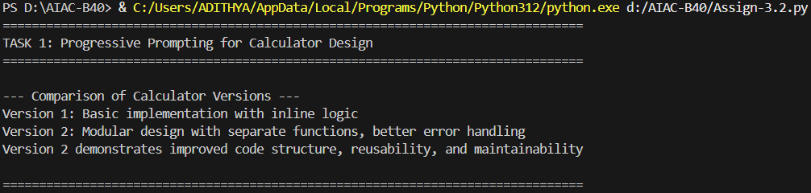

Task Description-2: Refining Prompts for Sorting Logic
# Start with a vague prompt for sorting student marks, then refine it to
# clearly specify sorting order and constraints.

print("\n" + "=" * 80)
print("TASK 2: Refining Prompts for Sorting Logic")
print("=" * 80)

Version 1: Ambiguous implementation (vague prompt result)
def sort_marks_v1(marks):
"""Sort marks with ambiguous logic"""
return sorted(marks)

Version 2: Clear and accurate implementation (refined prompt result)
def sort_marks_v2(marks, order='descending'):
"""
Sort student marks with clear specification

Args:
marks (list): List of student marks (0-100)
order (str): 'ascending' or 'descending' (default: 'descending')

Returns:
list: Sorted list of marks

Constraints:
- Marks must be between 0 and 100
- Invalid marks are filtered out
- Default sorting is descending (highest to lowest)

Examples:
>>> sort_marks_v2([85, 92, 78, 95, 88])
[95, 92, 88, 85, 78]
>>> sort_marks_v2([85, 92, 78], order='ascending')
[78, 85, 92]
"""
# Validate and filter marks
valid_marks = [mark for mark in marks if isinstance(mark, (int, float)) and 0 <= mark <= 100]

if len(valid_marks) != len(marks):
print(f"⚠ Warning: {len(marks) - len(valid_marks)} invalid mark(s) filtered out")

# Sort based on specified order
reverse = (order.lower() == 'descending')
return sorted(valid_marks, reverse=reverse)

# Demonstration
print("\n--- Testing Sorting Function ---")
test_marks = [85, 92, 78, 95, 88, 101, -5, 76, 90]

print(f"Original marks: {test_marks}")
print(f"\nVersion 1 (ambiguous): {sort_marks_v1(test_marks)}")
print(f"Version 2 (descending): {sort_marks_v2(test_marks, 'descending')}")
print(f"Version 2 (ascending): {sort_marks_v2(test_marks, 'ascending')}")

print("\n--- Evolution from Ambiguous to Accurate ---")
print("V1: Simple sorted() - unclear order, no validation")
print("V2: Clear parameters, input validation, error handling, documentation")
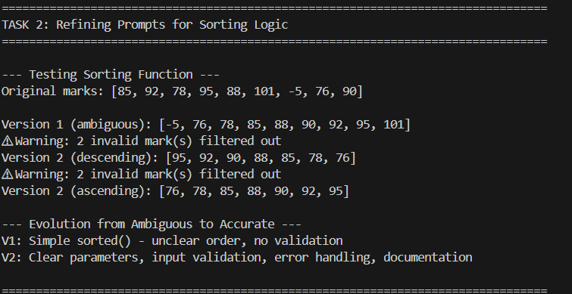

Task Description-3: Few-Shot Prompting for Prime Number Validation
# Provide multiple input-output examples to improve prime number checking function

print("\n" + "=" * 80)
print("TASK 3: Few-Shot Prompting for Prime Number Validation")
print("=" * 80)

Version 1: Basic prime checking (without examples)
def is_prime_v1(n):
"""Basic prime number check"""
if n < 2:
return False
for i in range(2, n):
if n % i == 0:
return False
return True

Version 2: Enhanced with edge case handling (with few-shot examples)
def is_prime_v2(n):
"""
Check if a number is prime with comprehensive edge case handling

Args:
n: Number to check

Returns:
bool: True if prime, False otherwise

Examples (Few-Shot Learning):
>>> is_prime_v2(2) # Smallest prime
True
>>> is_prime_v2(1) # Not prime by definition
False
>>> is_prime_v2(0) # Edge case: zero
False
>>> is_prime_v2(-5) # Edge case: negative
False
>>> is_prime_v2(17) # Prime number
True
>>> is_prime_v2(18) # Composite number
False
>>> is_prime_v2(2.5) # Non-integer
False
"""
# Handle non-integer inputs
if not isinstance(n, int):
return False

# Handle edge cases
if n <= 1:
return False
if n == 2:
return True
if n % 2 == 0:
return False

# Check odd divisors up to sqrt(n)
import math
for i in range(3, int(math.sqrt(n)) + 1, 2):
if n % i == 0:
return False

return True

# Demonstration with comprehensive test cases
print("\n--- Testing Prime Number Validation ---")
test_cases = [
(2, "Smallest prime"),
(1, "Not prime by definition"),
(0, "Edge case: zero"),
(-5, "Edge case: negative"),
(17, "Prime number"),
(18, "Composite number"),
(97, "Large prime"),
(100, "Large composite"),
(2.5, "Non-integer")
]

print("\nComparison of V1 vs V2:")
print(f"{'Number':<10} {'Description':<30} {'V1':<10} {'V2':<10} {'Status'}")
print("-" * 70)

for num, desc in test_cases:
try:
v1_result = is_prime_v1(num) if isinstance(num, int) else "Error"
except:
v1_result = "Error"

v2_result = is_prime_v2(num)
status = "✓" if v2_result == is_prime_v2(num) else "✗"

print(f"{str(num):<10} {desc:<30} {str(v1_result):<10} {str(v2_result):<10} {status}")

print("\n--- Improvement from Few-Shot Prompting ---")
print("V1: Basic logic, missing edge cases, inefficient")
print("V2: Handles negatives, zero, one, non-integers, optimized with sqrt")
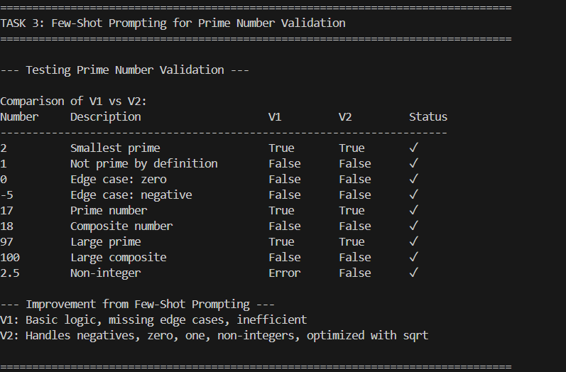

Task Description-4: Prompt UI Design for Student Grading System
# Create a user interface for a student grading system that calculates
# total marks, percentage, and grade based on user input

print("\n" + "=" * 80)
print("TASK 4: Student Grading System UI Design")
print("=" * 80)

def student_grading_system():
"""
Interactive student grading system with UI

Features:
- Input validation for student details
- Multiple subject marks input
- Automatic calculation of total, percentage, and grade
- Clear output display
- Grade classification based on percentage

Grading Scale:
- A+: 90-100%
- A: 80-89%
- B+: 70-79%
- B: 60-69%
- C: 50-59%
- D: 40-49%
- F: Below 40%
"""

def calculate_grade(percentage):
"""Calculate letter grade based on percentage"""
if percentage >= 90:
return "A+"
elif percentage >= 80:
return "A"
elif percentage >= 70:
return "B+"
elif percentage >= 60:
return "B"
elif percentage >= 50:
return "C"
elif percentage >= 40:
return "D"
else:
return "F"

def get_remark(grade):
"""Get remark based on grade"""
remarks = {
"A+": "Outstanding! 🌟",
"A": "Excellent! 🎯",
"B+": "Very Good! 👍",
"B": "Good! ✓",
"C": "Average",
"D": "Below Average",
"F": "Fail - Need Improvement"
}
return remarks.get(grade, "")

print("\n" + "╔" + "═" * 58 + "╗")
print("║" + " " * 15 + "STUDENT GRADING SYSTEM" + " " * 21 + "║")
print("╚" + "═" * 58 + "╝")

# Get student details
print("\n📋 Enter Student Details:")
student_name = input("Student Name: ").strip()

while not student_name:
print("❌ Name cannot be empty!")
student_name = input("Student Name: ").strip()

student_id = input("Student ID: ").strip()

# Get number of subjects
while True:
try:
num_subjects = int(input("Number of subjects: "))
if num_subjects > 0:
break
else:
print("❌ Number of subjects must be positive!")
except ValueError:
print("❌ Please enter a valid number!")

# Get marks for each subject
print(f"\n📚 Enter marks for {num_subjects} subjects (0-100):")
marks = []
subjects = []

for i in range(num_subjects):
while True:
subject_name = input(f"Subject {i+1} name: ").strip()
if subject_name:
subjects.append(subject_name)
break
print("❌ Subject name cannot be empty!")

while True:
try:
mark = float(input(f"Marks for {subject_name}: "))
if 0 <= mark <= 100:
marks.append(mark)
break
else:
print("❌ Marks must be between 0 and 100!")
except ValueError:
print("❌ Please enter a valid number!")

# Calculate results
total_marks = sum(marks)
max_marks = num_subjects * 100
percentage = (total_marks / max_marks) * 100
grade = calculate_grade(percentage)
remark = get_remark(grade)

# Display results
print("\n" + "╔" + "═" * 58 + "╗")
print("║" + " " * 20 + "GRADE REPORT" + " " * 26 + "║")
print("╚" + "═" * 58 + "╝")

print(f"\n👤 Student Name: {student_name}")
print(f"🆔 Student ID: {student_id}")
print(f"\n{'Subject':<30} {'Marks':<10}")
print("-" * 40)

for subject, mark in zip(subjects, marks):
print(f"{subject:<30} {mark:<10.2f}")

print("-" * 40)
print(f"{'Total Marks':<30} {total_marks:.2f}/{max_marks}")
print(f"{'Percentage':<30} {percentage:.2f}%")
print(f"{'Grade':<30} {grade}")
print(f"{'Remark':<30} {remark}")
print("═" * 40)

# Display performance analysis
print("\n📊 Performance Analysis:")
avg_mark = total_marks / num_subjects
print(f"Average per subject: {avg_mark:.2f}")

highest = max(marks)
lowest = min(marks)
print(f"Highest score: {highest:.2f} ({subjects[marks.index(highest)]})")
print(f"Lowest score: {lowest:.2f} ({subjects[marks.index(lowest)]})")

return {
'name': student_name,
'id': student_id,
'total': total_marks,
'percentage': percentage,
'grade': grade
}

print("\n--- Well-Structured UI Code Features ---")
print("✓ Input validation for all user inputs")
print("✓ Clear prompts and instructions")
print("✓ Formatted output with visual separators")
print("✓ Accurate calculations with percentage and grade")
print("✓ Performance analysis and feedback")

# Uncomment to run:
# result = student_grading_system()
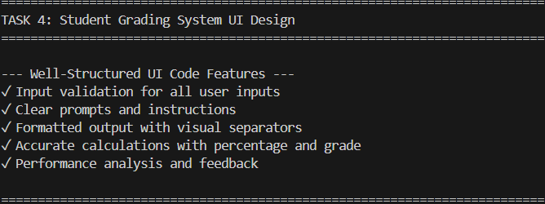

Task Description-5: Analyzing Prompt Specificity in Unit Conversion Functions
# Improving Unit Conversion Function (Kilometers to Miles and Miles to Kilometers)
# Using Clear Instructions

print("\n" + "=" * 80)
print("TASK 5: Analyzing Prompt Specificity in Unit Conversion")
print("=" * 80)

Version 1: Vague prompt result
def convert_distance_v1(value):
"""Basic conversion (ambiguous direction)"""
return value * 1.60934

Version 2: Unclear bidirectional attempt
def convert_distance_v2(value, unit):
"""Attempt at bidirectional conversion but unclear"""
if unit == "km":
return value / 1.60934
else:
return value * 1.60934

Version 3: Clear and accurate with specific instructions
def convert_distance_v3(value, from_unit, to_unit):
"""
Convert distance between kilometers and miles with clear specification

Args:
value (float): The distance value to convert
from_unit (str): Source unit ('km' for kilometers, 'mi' for miles)
to_unit (str): Target unit ('km' for kilometers, 'mi' for miles)

Returns:
dict: Conversion result with details

Conversion factors:
- 1 kilometer = 0.621371 miles
- 1 mile = 1.60934 kilometers

Examples:
>>> convert_distance_v3(10, 'km', 'mi')
{'value': 6.21371, 'from': '10.0 km', 'to': '6.21 mi', 'formula': '10.0 × 0.621371'}

>>> convert_distance_v3(5, 'mi', 'km')
{'value': 8.0467, 'from': '5.0 mi', 'to': '8.05 km', 'formula': '5.0 × 1.60934'}
"""
KM_TO_MILES = 0.621371
MILES_TO_KM = 1.60934

# Normalize units
from_unit = from_unit.lower().strip()
to_unit = to_unit.lower().strip()

# Validate input
valid_units = ['km', 'kilometers', 'mi', 'miles']
if from_unit not in valid_units or to_unit not in valid_units:
raise ValueError(f"Invalid unit. Use 'km' or 'mi'")

if value < 0:
raise ValueError("Distance cannot be negative")

# Normalize unit names
if from_unit in ['km', 'kilometers']:
from_unit = 'km'
else:
from_unit = 'mi'

if to_unit in ['km', 'kilometers']:
to_unit = 'km'
else:
to_unit = 'mi'

# Perform conversion
if from_unit == to_unit:
result = value
formula = f"{value} (same unit)"
elif from_unit == 'km' and to_unit == 'mi':
result = value * KM_TO_MILES
formula = f"{value} × {KM_TO_MILES}"
else: # from_unit == 'mi' and to_unit == 'km'
result = value * MILES_TO_KM
formula = f"{value} × {MILES_TO_KM}"

return {
'value': round(result, 5),
'from': f"{value} {from_unit}",
'to': f"{round(result, 2)} {to_unit}",
'formula': formula
}

# Interactive conversion function
def unit_converter_interface():
"""Interactive interface for unit conversion"""
print("\n" + "╔" + "═" * 58 + "╗")
print("║" + " " * 15 + "DISTANCE UNIT CONVERTER" + " " * 19 + "║")
print("╚" + "═" * 58 + "╝")

print("\nSupported conversions:")
print("1. Kilometers to Miles")
print("2. Miles to Kilometers")
print("3. Exit")

while True:
print("\n" + "-" * 60)
choice = input("Select conversion (1-3): ").strip()

if choice == '3':
print("Thank you for using the converter!")
break

if choice not in ['1', '2']:
print("❌ Invalid choice. Please select 1-3.")
continue

try:
value = float(input("Enter distance value: "))

if value < 0:
print("❌ Distance cannot be negative!")
continue

if choice == '1':
result = convert_distance_v3(value, 'km', 'mi')
else:
result = convert_distance_v3(value, 'mi', 'km')

print("\n📏 Conversion Result:")
print(f" From: {result['from']}")
print(f" To: {result['to']}")
print(f" Formula: {result['formula']}")
print(f" Precise value: {result['value']}")

except ValueError as e:
print(f"❌ Error: {e}")
except Exception as e:
print(f"❌ Unexpected error: {e}")

# Demonstration
print("\n--- Testing Unit Conversion Functions ---")
test_cases = [
(10, 'km', 'mi', "10 km to miles"),
(5, 'mi', 'km', "5 miles to km"),
(100, 'km', 'mi', "100 km to miles"),
(26.2, 'mi', 'km', "Marathon distance to km"),
]

print("\nComparison across different prompt versions:")
print(f"{'Test Case':<30} {'V1 (vague)':<15} {'V2 (unclear)':<15} {'V3 (clear)':<20}")
print("-" * 80)

for value, from_u, to_u, desc in test_cases:
v1_result = f"{convert_distance_v1(value):.2f}"

if from_u == 'km':
v2_result = f"{convert_distance_v2(value, 'km'):.2f}"
else:
v2_result = f"{convert_distance_v2(value, 'mi'):.2f}"

v3_result = convert_distance_v3(value, from_u, to_u)
v3_display = v3_result['to']

print(f"{desc:<30} {v1_result:<15} {v2_result:<15} {v3_display:<20}")

print("\n--- Analysis of Code Quality Differences ---")
print("\nVersion 1 (Vague Prompt):")
print(" ❌ Unclear conversion direction")
print(" ❌ No input validation")
print(" ❌ No documentation")

print("\nVersion 2 (Somewhat Clear):")
print(" ⚠ Bidirectional but confusing parameter")
print(" ⚠ Limited error handling")
print(" ⚠ Minimal documentation")

print("\nVersion 3 (Clear & Specific Prompt):")
print(" ✓ Explicit from/to parameters")
print(" ✓ Comprehensive input validation")
print(" ✓ Detailed documentation with examples")
print(" ✓ Clear return format with formula")
print(" ✓ Supports multiple unit formats")
print(" ✓ Proper error messages")
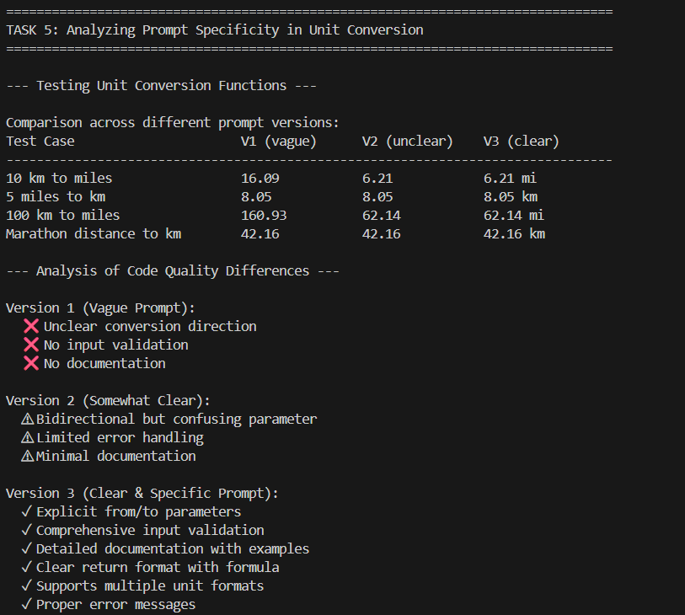

============================================================================
SUMMARY AND CONCLUSIONS
============================================================================
Key Takeaways:

1. PROGRESSIVE PROMPTING (Task 1 - Calculator):
• Starting with minimal context yields basic implementations
• Adding detailed comments, function names, and examples improves code structure
• Well-prompted code is more modular, maintainable, and error-resistant

2. PROMPT REFINEMENT (Task 2 - Sorting):
• Vague prompts lead to ambiguous implementations
• Specific constraints (order, validation) produce accurate results
• Clear requirements prevent misinterpretation

3. FEW-SHOT LEARNING (Task 3 - Prime Numbers):
• Providing input-output examples improves edge case handling
• AI learns patterns from examples to generate robust code
• Examples guide the AI toward comprehensive solutions

4. UI DESIGN PROMPTING (Task 4 - Grading System):
• Detailed requirements yield well-structured interfaces
• Specifying features (validation, formatting, feedback) improves UX
• Clear prompts result in professional, user-friendly code

5. PROMPT SPECIFICITY (Task 5 - Unit Conversion):
• Ambiguous prompts create confusion about functionality
• Explicit parameters and conversions ensure accuracy
• Documentation and examples in prompts translate to better code comments

BEST PRACTICES FOR AI-ASSISTED CODING:
✓ Be specific about requirements and constraints
✓ Provide examples of expected behavior
✓ Include edge cases in prompts
✓ Request error handling and validation
✓ Ask for documentation and comments
✓ Iteratively refine prompts based on output
✓ Compare multiple versions to evaluate improvement

