1. Application Architecture
HealthPulse adopts a Microservices Architecture combined with an Event-Driven backbone. This approach decomposes the system into independently deployable services, each responsible for a specific capability such as data ingestion, ML forecasting, risk classification, and generative AI summarization. Services can scale and evolve independently, making the architecture well-suited for a real-time health monitoring platform.

1.1 Microservices Architecture

Overview
The system is composed of the following independent microservices, each with its own responsibility:
- Data Ingestion Service – Collects weekly Google Trends data (8 symptoms, 6 US regions), weather data, and health news via APIs. Stores raw data in MongoDB Atlas collections.
- Preprocessing Service – Cleans raw data, handles null values, formats time-series, and prepares datasets for ML model training.
- Forecasting Service (SARIMAX) – Performs time-series forecasting on symptom search trends with weekly seasonality. Predicts outbreak trends 3–7 days in advance.
- Risk Classification Service (XGBoost) – Converts trend forecasts into risk levels (Low / Medium / High / Critical) with confidence scores.
- NLP Service (spaCy + BERT) – Extracts symptoms from health news articles and Reddit posts for cross-validation.
- Validation Service – Multi-layer validation using Z-score, Isolation Forest, seasonal decomposition, and epidemiological pattern checks (SIR model).
- Generative AI Summarization Service – Produces human-readable outbreak risk summaries for public health decision-makers.
- Analytics & Reporting Service – Aggregates model outputs, tracks performance metrics (RMSE, MAE, accuracy), and generates dashboards.

Why Microservices?
- Independent Scalability: The Forecasting and Classification services can scale during peak ingestion periods without affecting the NLP or Reporting services.
- Fault Isolation: A failure in the Summarization Service does not impact core prediction functionality.
- Technology Flexibility: Python (ML/DS), Node.js (API gateway), and MongoDB (storage) can each be optimized per service.
- Team Parallelism: Data & ML (Aditya) and Backend & Integration (Kshitij) can develop services concurrently.

API Gateway
All client requests are routed through a centralized API Gateway, which handles authentication, rate limiting, and routing to the appropriate microservice. The dashboard/front-end communicates exclusively with the API Gateway via REST APIs over HTTPS.

Inter-Service Communication
- Synchronous: REST API calls for real-time data requests (e.g., risk score queries, trend lookups).
- Asynchronous: Message queues (RabbitMQ/Kafka) for non-critical operations such as triggering the NLP pipeline when new news data arrives, or logging analytics events.

1.2 Event-Driven Architecture (Supporting Layer)
In addition to synchronous REST communication, HealthPulse employs an event-driven approach for asynchronous processing. Key events include:
- TrendDataIngested Event – Triggers the Preprocessing and Forecasting pipeline when new Google Trends data is collected.
- OutbreakRiskDetected Event – Triggers the Summarization Service and alert dispatch when XGBoost classifies a region as High or Critical risk.
- NewsArticleReceived Event – Triggers the NLP Service to extract symptoms and update cross-validation scores.
- ModelRetrained Event – Logged to the Analytics Service when SARIMAX or XGBoost models are updated.
These events are published to a message broker and consumed by the relevant services, ensuring loose coupling and improved system resilience.

1.3 Serverless Components
Certain non-core, trigger-based functions are deployed as serverless functions (e.g., AWS Lambda or Google Cloud Functions) to reduce infrastructure overhead:
- Scheduled weekly Google Trends data pull (every Sunday).
- Automated model retraining when dataset size crosses a threshold.
- Generating daily regional risk summary reports for the admin dashboard.
- Sending alerts when any region is classified as High or Critical risk.

1.4 Architecture Diagram
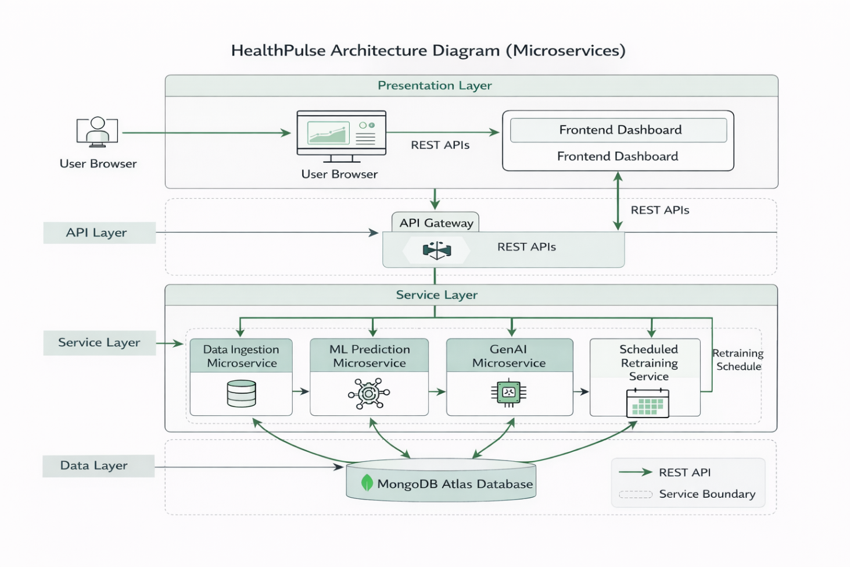

2. Database

2.1 ER Diagram
The Entity-Relationship model for HealthPulse defines the following core entities and their relationships:
- SYMPTOM_TREND – Linked to many FORECAST_RESULTS
- REGION – Has many SYMPTOM_TRENDs and RISK_SCORES
- FORECAST_RESULT – Belongs to one SYMPTOM_TREND for a given REGION
- RISK_SCORE – Links one REGION to one FORECAST_RESULT; stores XGBoost output
- NEWS_ARTICLE – Associated with NLP extraction results
- WEATHER_DATA – Linked to REGION for cross-validation

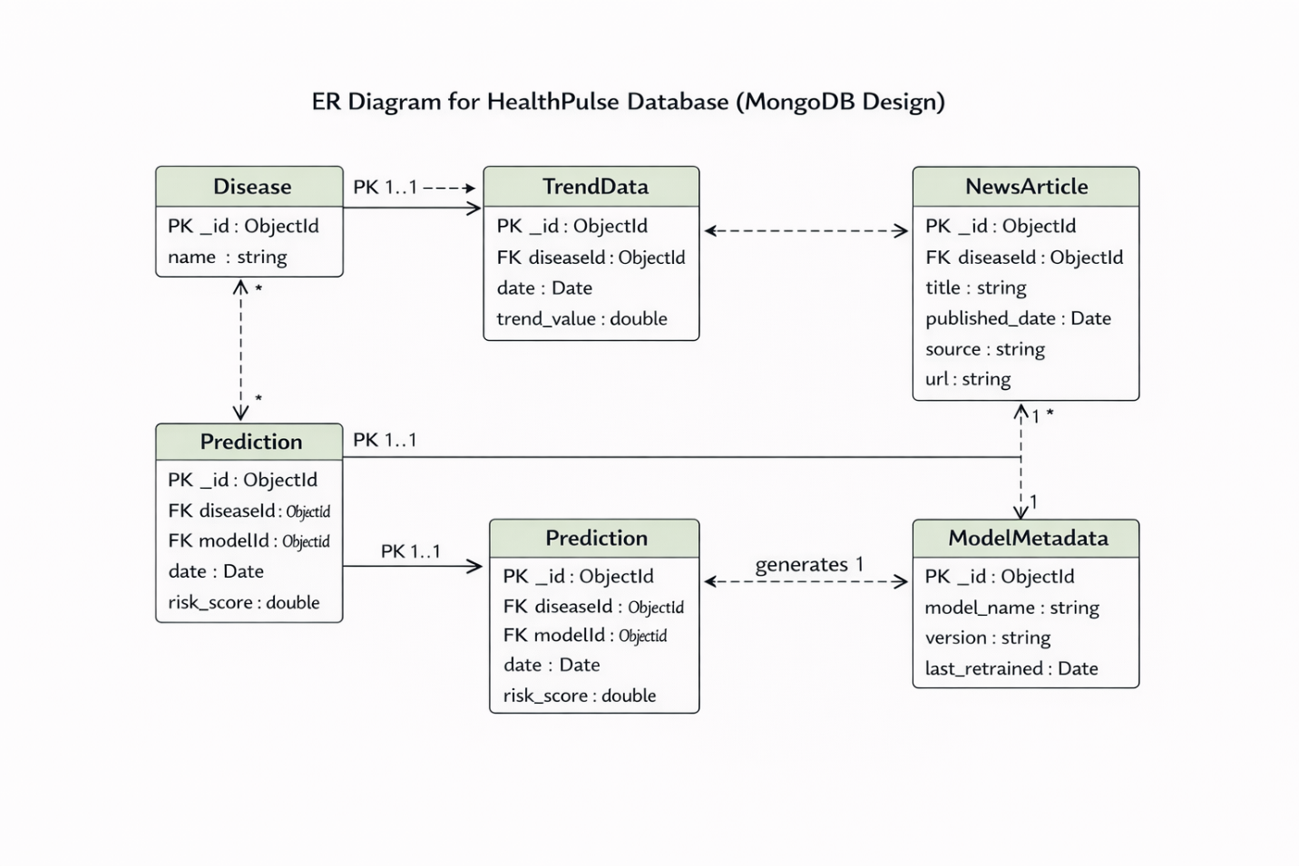

2.2 Schema Design

The following schema is used for HealthPulse (MongoDB Atlas with structured collections):

Collection: SYMPTOM_TRENDS
Field Name | Data Type | Description
trend_id | ObjectId (PK) | Unique identifier for each trend record
region | String | Region code (e.g., US, US-CA, US-NY)
keyword | String | Symptom keyword (e.g., fever, cough, flu)
week_start | Date | Start date of the weekly trend period
trend_value | Float | Google Trends interest score (0–100)
collected_at | Timestamp | Timestamp of data ingestion

Collection: FORECAST_RESULTS

Field Name | Data Type | Description
forecast_id | ObjectId (PK) | Unique identifier for forecast record
trend_id | ObjectId (FK) | Reference to SYMPTOM_TRENDS
model_used | String | SARIMAX or Gradient Boosting Regressor
predicted_value | Float | Forecasted trend score for next period
rmse | Float | Root Mean Square Error of the forecast
mae | Float | Mean Absolute Error of the forecast
forecast_date | Timestamp | When forecast was generated

Collection: RISK_SCORES

Field Name | Data Type | Description
risk_id | ObjectId (PK) | Unique identifier for risk record
region | String | Region code
risk_score | Float | Composite risk score (0–100)
risk_level | Enum | Low / Medium / High / Critical
confidence | Float | XGBoost prediction confidence (0–1)
prob_low | Float | Probability of Low risk class
prob_medium | Float | Probability of Medium risk class
prob_high | Float | Probability of High risk class
prob_critical | Float | Probability of Critical risk class
scored_at | Timestamp | When risk was scored

3. Data Exchange Contract

3.1 Frequency of Data Exchanges
- Scheduled / Weekly: Google Trends data collection every Sunday for all 6 regions and 8 symptom keywords.
- Real-Time (< 1 second latency): Risk score queries, dashboard data retrieval, regional trend lookups.
- On-Demand: Model inference (SARIMAX + XGBoost), NLP extraction from news articles.
- Periodic: Model retraining triggers, daily risk summary generation, validation report updates.

3.2 Data Sets
The primary data sets exchanged between system components are:
- Trend Data: region, keyword, week_start, trend_value (Google Trends API output).
- Weather Data: region, temperature, humidity, date (for cross-validation with trend spikes).
- News Data: article_url, headline, source, credibility_score, extracted_symptoms (NLP output).
- Forecast Data: forecast_id, trend_id, predicted_value, rmse, mae, model_used.
- Risk Data: region, risk_score, risk_level, confidence, prob_low/medium/high/critical.
- Validation Data: confidence_score, anomaly_flags, epidemiological_pattern_match.

3.3 Mode of Exchanges
Data Exchange | Frequency | Data Sets | Mode
App/Dashboard → API Gateway | On demand | Risk scores, trend charts, region data | REST API (HTTPS)
Ingestion → MongoDB | Weekly / scheduled | Trends, weather, news collections | MongoDB Driver / ODM
Preprocessing → Forecasting | Event-triggered | Cleaned time-series datasets | Message Queue (Kafka)
Forecasting → Classification | Per model run | Predicted trend values | Internal REST call
NLP → Validation | On article ingest | Extracted symptoms, credibility score | Message Queue (Kafka)
Validation → Risk Scoring | Post-validation | Confidence score, anomaly flags | Internal REST call
Backend → Google Trends API | Weekly | Keyword + region parameters | REST API (pytrends)

4. Diagrams

4.1 Use Case Diagram

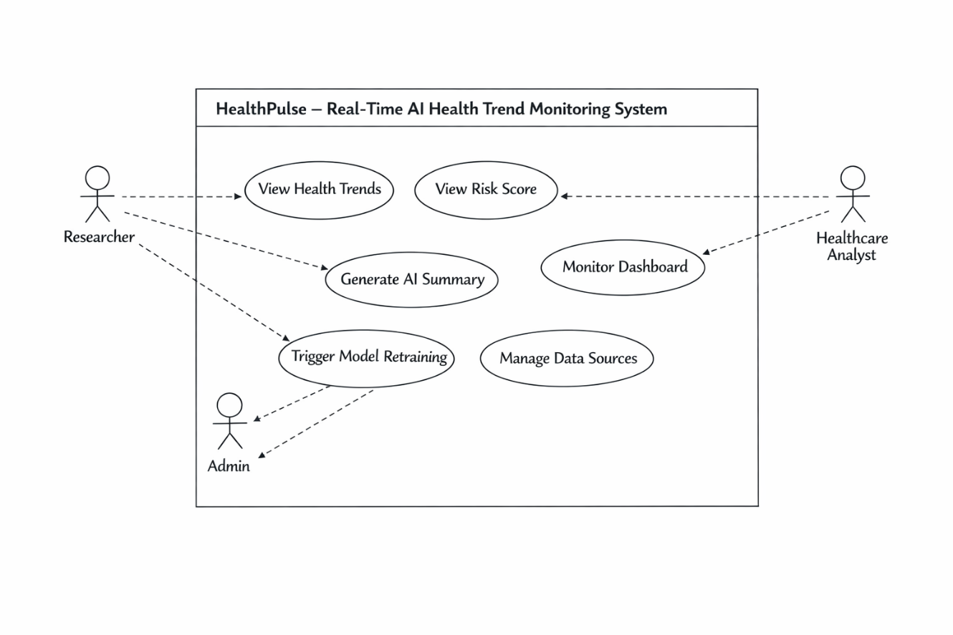

4.2 Class Diagram
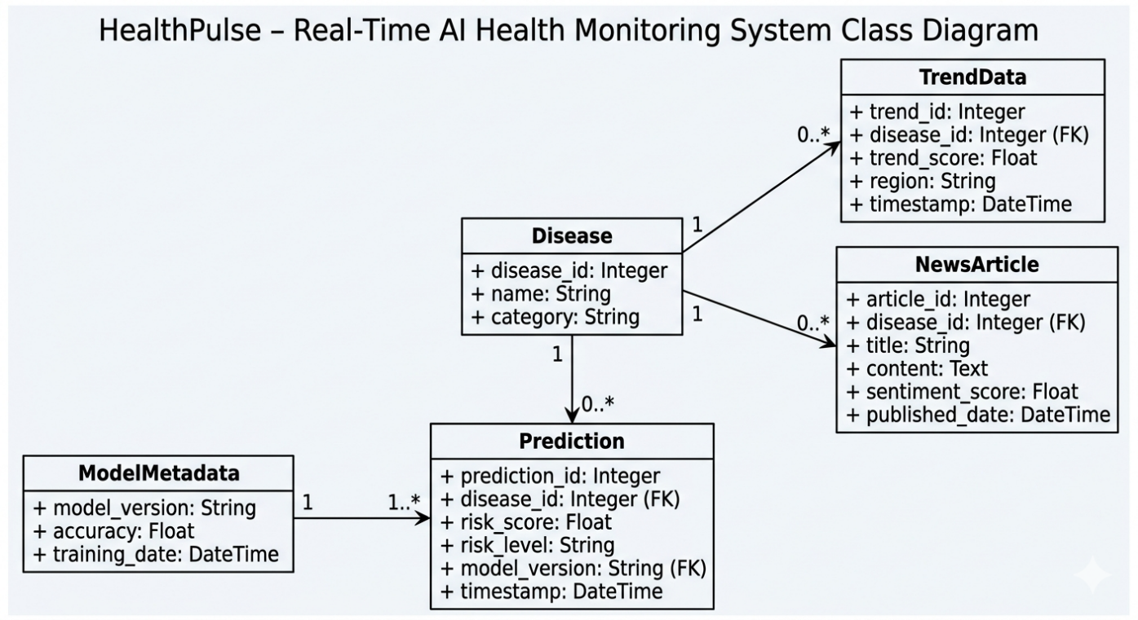

4.3 Data Flow Diagram Level 0
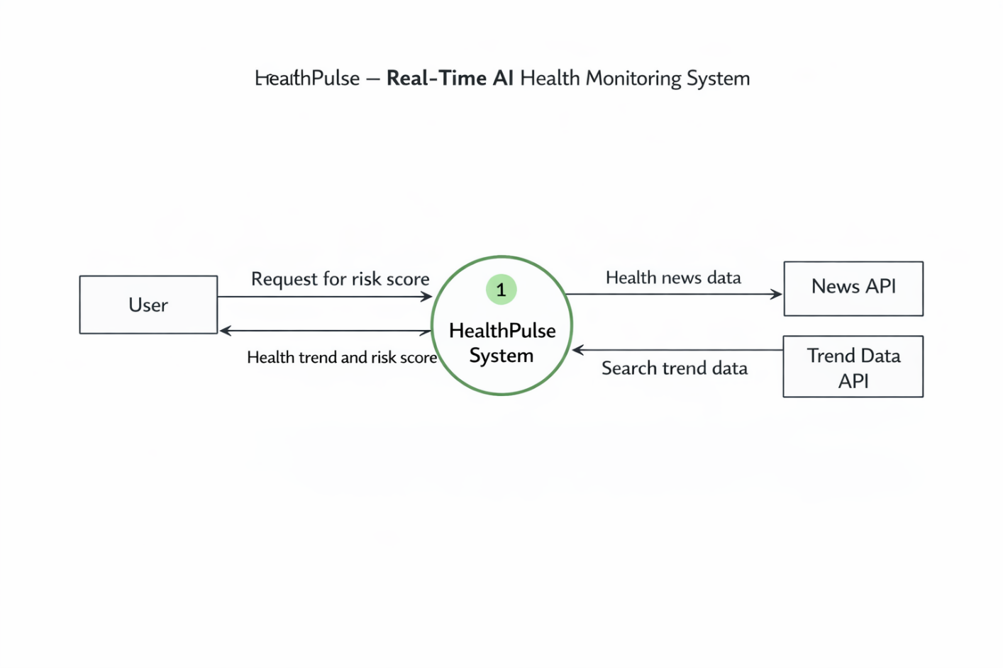

4.4 Data Flow Diagram Level 1
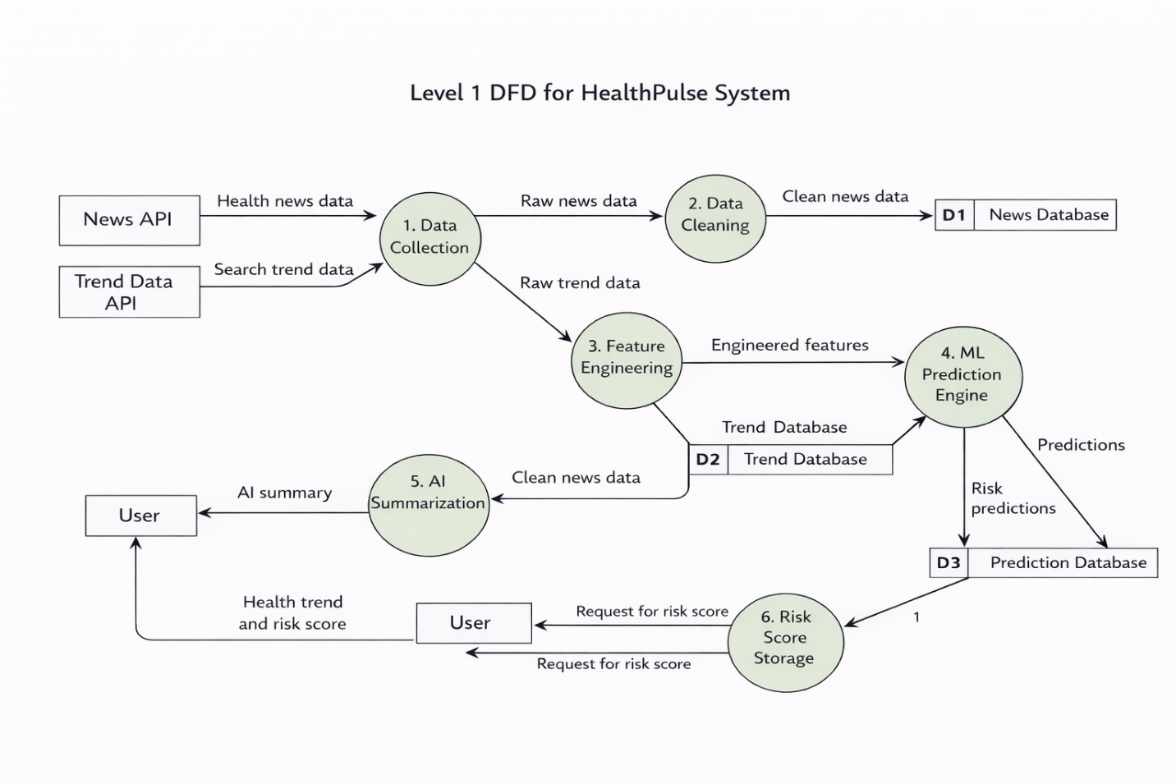

4.5 Component Diagram
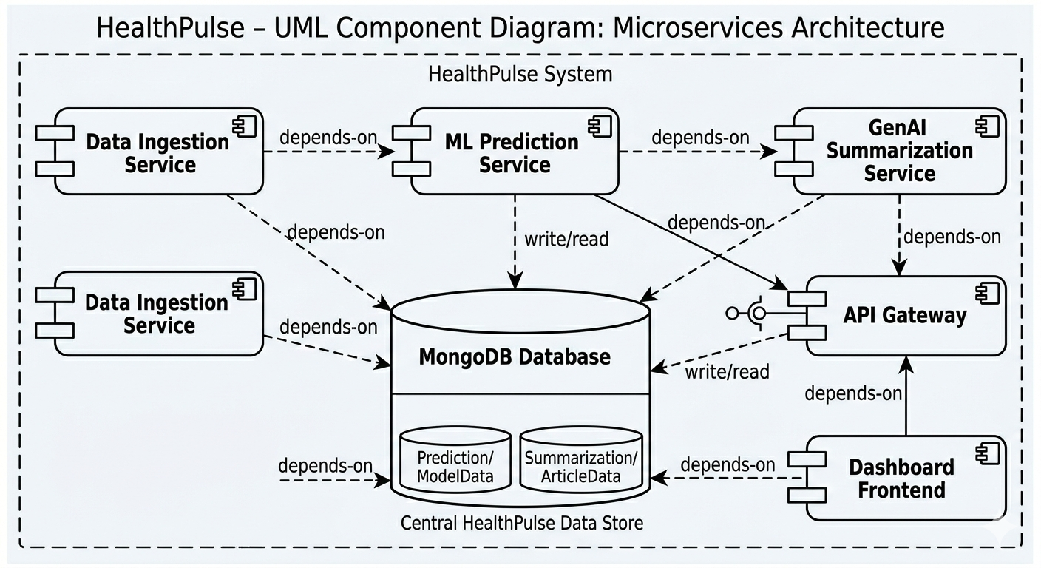

4.6 Sequence Diagram
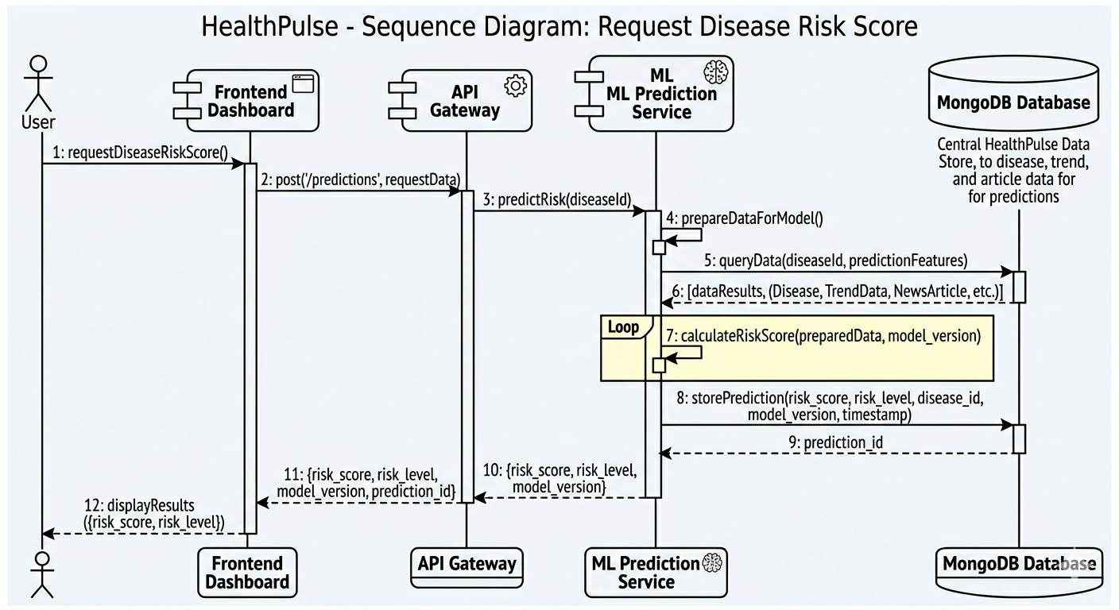

4.7 Deployment Diagram
