**Assignment No.: 4**

**Aim**: To provide an insight about the software development lifecycle.

**Objective**: To understand each phase of the SDLC theoretically so that they can apply this knowledge in the process of developing a product.

**Theory**:

A systems development life cycle is composed of a number of clearly defined and distinct work phases which are used by systems engineers and systems developers to plan for, design, build, test, and deliver information systems. Like anything that is manufactured on an assembly line, an SDLC aims to produce high quality systems that meet or exceed customer expectations, based on customer requirements, by delivering systems which move through each clearly defined phase, within scheduled time-frames and cost estimates. Computer systems are complex and often (especially with the recent rise of service-oriented architecture) link multiple traditional systems potentially supplied by different software vendors. To manage this level of complexity, a number of SDLC models or methodologies have been created, such as "waterfall"; "spiral"; "Agile software development"; "rapid prototyping"; "incremental"; and "synchronize and stabilize". The SDLC adheres to important phases that are essential for developers, such as planning, analysis, design, and implementation, and are explained in the section below. It includes evaluation of present system, information gathering, and feasibility study and request approval. A number of SDLC models have been created: waterfall, fountain, and spiral build and fix, rapid prototyping, incremental, and synchronize and stabilize. The oldest of these, and the best known, is the waterfall model: a sequence of stages in which the output of each stage becomes the input for the next. These stages can be characterized and divided up in different ways, including the following:

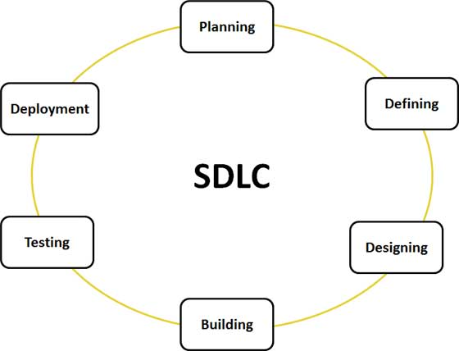

Figure 1

**Stage 1: Planning and Requirement Analysis**

Requirement analysis is the most important and fundamental stage in SDLC. It is performed by the senior members of the team with inputs from the customer, the sales department, market surveys and domain experts in the industry. This information is then used to plan the basic project approach and to conduct product feasibility study in the economical, operational, and technical areas. Planning for the quality assurance requirements and identification of the risks associated with the project is also done in the planning stage. The outcome of the technical feasibility study is to define the various technical approaches that can be followed to implement the project successfully with minimum risks.

## Stage 2: Defining Requirements

## Once the requirement analysis is done the next step is to clearly define and document the product requirements and get them approved from the customer or the market analysts. This is done through .SRS. . Software Requirement Specification document which consists of all the product requirements to be designed and developed during the project life cycle.

## Stage 3: Designing the product architecture

SRS is the reference for product architects to come out with the best architecture for the product to be developed. Based on the requirements specified in SRS, usually more than one design approach for the product architecture is proposed and documented in a DDS - Design Document Specification. This DDS is reviewed by all the important stakeholders and based on various parameters as risk assessment, product robustness, design modularity , budget and time constraints , the best design approach is selected for the product. A design approach clearly defines all the architectural modules of the product along with its communication and data flow representation with the external and third party modules (if any). The internal design of all the modules of the proposed architecture should be clearly defined with the minutest of the details in DDS.

## Stage 4: Building or Developing the Product

In this stage of SDLC the actual development starts and the product is built. The programming code is generated as per DDS during this stage. If the design is performed in a detailed and organized manner, code generation can be accomplished without much hassle. Developers have to follow the coding guidelines defined by their organization and programming tools like compilers, interpreters, debuggers etc are used to generate the code. Different high level programming languages such as C, C++, Pascal, Java, and PHP are used for coding. The programming language is chosen with respect to the type of software being developed.

## Stage 5: Testing the Product

This stage is usually a subset of all the stages as in the modern SDLC models, the testing activities are mostly involved in all the stages of SDLC. However this stage refers to the testing only stage of the product where products defects are reported, tracked, fixed and retested, until the product reaches the quality standards defined in the SRS.

## Stage 6: Deployment in the Market and Maintenance

Once the product is tested and ready to be deployed it is released formally in the appropriate market. Sometime product deployment happens in stages as per the organization’s Business strategy. The product may first be released in a limited segment and tested in the real business environment (UAT- User acceptance testing). Then based on the feedback, the product may be released as it is or with suggested enhancements in the targeting market segment. After the product is released in the market, its maintenance is done for the existing customer base.

**Conclusion:** Thus, the study of SDLC cycle is complete.

**Case Study of SDLC for UID Project**

Synopsis for UID Project with all phases of SDLC

**Aim**: To understand the practical usage of SDLC using the UID project

**Objective**: To study each phase of SDLC under the UID project.

**The UID Project:**

A unique identification is a number assigned to a person so as to identify him uniquely. The unique identification authority of india (UIAD) has been created with the mandate of providing a unique identity to all Indian residents. The UIDA plans to use these biometrics to eliminate duplicates and ensure uniqueness at enrollment. The AADHAR system is being designed to eventually service the entire population of india and will involve biometric identification of 1.2 billion residents.

**Different Phases of SDLC for development of UID Project:**

1. **Requirement Analysis:**

The need for AADHAR project arose after the discovery of fake and duplicate records and non-existent beneficiaries in government’s welfare schemes for the under privileged. This was mainly due to poor attempts at verification of demo graph and biometric information. The AADHAR project was taken up to address these issues.

Following are the requirements for taking up this project:

* To ensure that a significant percentage of the country’s population is brought under the UID system.
* Furnishing each Indian citizen with unique 16 digit identification number
* To store the necessary identity parameters corresponding to the demographic information.
* To collect and store all the data in a central database.
* To provide enough security and threat monitoring services to the database.

**2. Analysis**

The analysis phase of the UID project consists of 3 main factures:

**Enrollment and Awareness:**

Since this project is aimed at covering the entire population, it is extremely important to make sure that even the people in the remotest areas are aware of this plan and enroll their names for the same.

1. **Tools:**

Undertaking this project on a national level implies taking into consideration the following:

1. Authentication and fraud detection applications
2. Administrative tools
3. Information Portal
4. Logistics Interfere application
5. Proper and Optimum database management

**Feasibility:**

While working on the UID project, its financial feasibility for the developers and the government must be minimized. Also in order to physically reach out to people living in remote places adequate manpower and machinery must be established.

**4. Design:**

In the design phase of the UID project we mainly consider-

* **Website- GUI:**

The website of the UID project is the major link connecting people to the required

and stored information. The design of this website should include the following

links:

* Register
* Check your card status
* Updates
* Downloads
* Workshops
* Job opportunities
* Resource Center
* Latest News
* Privacy Policy
* **Database**

The role of the back-end database in this project is extremely crucial for security purposes. The centralized database should be secure from all types of attacks and should also provide facilities for storing new records, deleting (expired) records updating various fields reissuing if the card is misplaced etc.

1. **Coding:**

For actually structuring the database and developing the front end, we need to consider the following points:

* Fingerprint Scanner
* Access Control System
* Mobile Solutions
* IRIS Scanner
* Digital Cameras

While writing the software programs the following modules should be integrated:

* Desktop Security
* Compatibility
* Web based time attendance software
* Multi-biometric authentication system
* Testing

The UID project needs intensive testing on all fronts In order to ensure integrity and consistency of the system.

**Conclusion:** Thus, studied the SDLC under UID project.