**Assignment No: 3**

**Problem based learning and Problem solving Approaches and methodology**

**Aim: To study the problem solving approaches used to find the workplace solution**

**Objective:** To understand the stages involved in Problem based learning and Problem solving Approaches and methodology

**Theory:**

**Problem-based learning** (PBL) is a student-centered [pedagogy](https://en.wikipedia.org/wiki/Pedagogy) in which students learn about a subject through the experience of solving an open-ended problem. Students learn both thinking strategies and domain knowledge. The goals of PBL are to help students develop flexible knowledge, effective problem solving skills, self-directed learning, effective collaboration skills and intrinsic motivation. Problem-based learning is a style of [active learning](https://en.wikipedia.org/wiki/Active_learning).

Working in groups, students identify what they already know, what they need to know, and how and where to access new information that may lead to the solution of the problem.

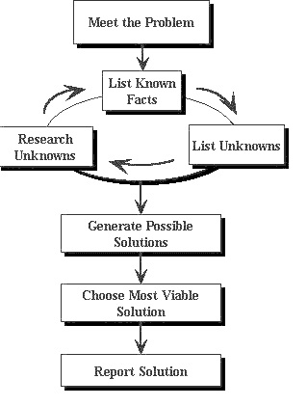

Figure 1: Problem based learning stages

**Problem-based learning (PBL) is an exciting alternative** to traditional classroom learning. With PBL, your teacher presents you with a problem, not lectures or assignments or exercises. Since you are not handed "content", your learning becomes active in the sense that you discover and work with content that you determine to be necessary to solve the problem.

**Problem based learning will provide you with opportunities to**

* Examine and try out what you know
* Discover what you need to learn
* Develop your people skills for achieving higher performance in teams
* Improve your communications skills
* State and defend positions with evidence and sound argument
* Become more flexible in processing information and meeting obligations
* Practice skills that you will need after your education

**A Summary of Problem-Based Learning:**

**1.** **Explore the issues:**  
Your teacher introduces an "ill-structured" problem to you. Discuss the problem statement and list its significant parts. You may feel that you don't know enough to solve the problem but that is the challenge! You will have to gather information and learn new concepts, principles, or skills as you engage in the problem-solving process.

**2. List "What do we know?"**What do you know to solve the problem?  
This includes both what you actually know and what strengths and capabilities each team member has. Consider or note everyone's input, no matter how strange it may appear: it could hold a possibility!

**3**. **Develop, and write out, the problem statement in your own words:**A problem statement should come from your/the group's analysis of what you know, and what you will need to know to solve it. You will need:

* A written statement
* The agreement of your group on the statement
* Feedback on this statement from your instructor.  
  (This may be optional, but is a good idea)

**Note:** The problem statement is often revisited and edited as new information is discovered, or "old" information is discarded.

**4. List out possible solutions**List them all, then order them from strongest to weakest Choose the best one, or most likely to succeed

**5. List actions to be taken with a timeline**

* What do we have to know and do to solve the problem?
* How do we rank these possibilities?
* How do these relate to our list of solutions?  
  Do we agree?

**6. List "What do we need to know?"**Research the knowledge and data that will support your solution You will need information to fill in missing gaps.

* Discuss possible resources Experts, books, web sites, etc.
* Assign and schedule research tasks, especially deadlines

If your research supports your solution, and if there is general agreement, go to (7). If not, go to (4)

**7. Write up your solution with its supporting documentation, and submit it.**You may need to present your findings and/or recommendations to a group or your classmates.

This should include the problem statement, questions, data gathered, analysis of data, and support for solutions or recommendations based on the data analysis: in short, the process and outcome.

**Presenting and defending your conclusions:**  
The goal is to present not only your conclusions,  
but the foundation upon which they rest. Prepare to

* State clearly both the problem and your conclusion
* Summarize the process you used, options considered, and difficulties encountered
* Convince, not overpower  
  Bring others to your side, or to consider without prejudice your supporting documentation and reason
* Help others learn, as you have learned
* If challenged  
  and you have an answer, present it clearly  
  and you don't have an answer, acknowledge it and refer it for more consideration

Sharing your findings with teachers and students is an opportunity in demonstrating that you have learned. If you know your subject well, this will be evident. If a challenge arises that you cannot respond to, accept it as an opportunity to be explored. However, take pride in your attention to quality when you present.

**8. Review your performance**

This debriefing exercise applies both to individuals and the group. Take pride in what you have done well; learn from what you have not done well. Thomas Edison took pride in unsuccessful experiments as part of his journey to successful outcomes!

**9. Celebrate your work!**

**Problem solving:**

The term **problem-solving** is used in many disciplines, sometimes with different perspectives, and often with different terminologies. For instance, it is a mental process in [psychology](https://en.wikipedia.org/wiki/Psychology) and a computerized process in [computer science](https://en.wikipedia.org/wiki/Computer_science). Problems can also be classified into two different types (ill-defined and well-defined) from which appropriate solutions are to be made. Ill-defined problems are those that do not have clear goals, solution paths, or expected solution. Well-defined problems have specific goals, clearly defined solution paths, and clear expected solutions. These problems also allow for more initial planning than ill-defined problems. Being able to solve problems sometimes involves dealing with pragmatics (logic) and semantics (interpretation of the problem). The ability to understand what the goal of the problem is and what rules could be applied represents the key to solving the problem. Sometimes the problem requires some abstract thinking and coming up with a creative solution.

In [computer science](https://en.wikipedia.org/wiki/Computer_science) and in the part of [artificial intelligence](https://en.wikipedia.org/wiki/Artificial_intelligence) that deals with algorithms ("algorithmic"), problem solving encompasses a number of techniques known as [algorithms](https://en.wikipedia.org/wiki/Algorithm), [heuristics](https://en.wikipedia.org/wiki/Heuristic), [root cause analysis](https://en.wikipedia.org/wiki/Root_cause_analysis), etc. In these disciplines, problem solving is part of a larger process that encompasses problem determination, [de-duplication](https://en.wikipedia.org/wiki/Data_deduplication), analysis, diagnosis, repair, etc.

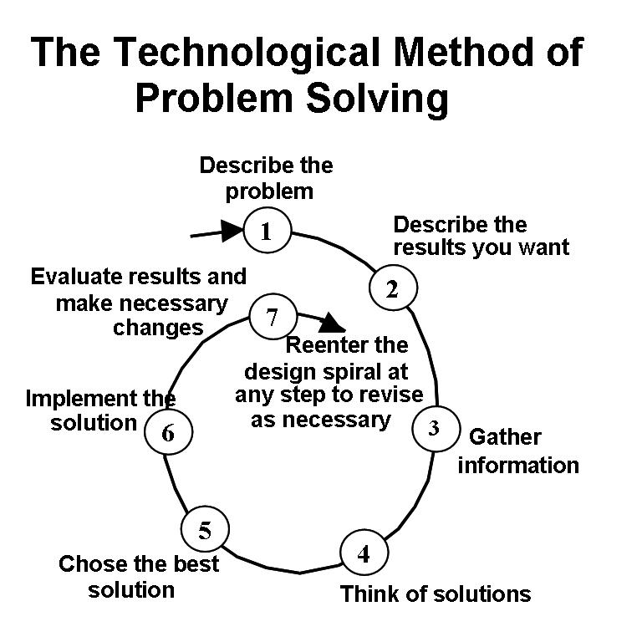

Figure 2: Steps for an effective problem-solving process

**1. Identify the issues.**

* Be clear about what the problem is.
* Remember that different people might have different views of what the issues are.
* *Separate the listing of issues from the identification of interests (that's the next step!).*

**2. Understand everyone's interests.**

* This is a critical step that is usually missing.
* Interests are the needs that you want satisfied by any given solution. We often ignore our true interests as we become attached to one particular solution.
* The best solution is the one that satisfies everyone's interests.
* This is the time for active listening. Put down your differences for awhile and listen to each other with the intention to understand.
* *Separate the naming of interests from the listing of solutions.*

**3. List the possible solutions (options)**

* This is the time to do some brainstorming. There may be lots of room for creativity.
* *Separate the listing of options from the evaluation of the options.*

**4. Evaluate the options.**

* What are the pluses and minuses? Honestly!
* *Separate the evaluation of options from the selection of options.*

**5. Select an option or options.**

* What's the best option, in the balance?
* Is there a way to "bundle" a number of options together for a more satisfactory solution?

**6. Document the agreement(s).**

* Don't rely on memory.
* Writing it down will help you think through all the details and implications.

**7. Agree on contingencies, monitoring, and evaluation.**

* Conditions may change. Make contingency agreements about foreseeable future circumstances (If-then!).
* How will you monitor compliance and follow-through?
* Create opportunities to evaluate the agreements and their implementation. ("Let's try it this way for three months and then look at it.")

### There are several stages to solving a problem:

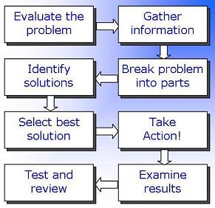

Figure 3: Problem-solving Stages

#### 1) Evaluating the problem

* **Clarifying** the nature of a problem
* **Formulating** questions
* **Gathering** information systematically
* **Collating** and organizing data
* **Condensing** and summarizing information
* **Defining** the desired objective

#### 2) Managing the problem

* **Using the information gathered** effectively
* **Breaking down a problem** into smaller, more manageable, parts
* Using techniques such as **brainstorming** and lateral thinking to consider options
* **Analysing these options** in greater depth
* **Identifying steps that can be taken** to achieve the objective

#### 3) Decision-making

* **deciding between the possible options** for what action to take
* **deciding on further information** to be gathered before taking action
* **deciding on resources** (time, funding, staff etc) to be allocated to this problem

#### 4) Resolving the problem

* **Implementing action**
* **Providing information** to other stakeholders; delegating tasks
* **Reviewing progress**

#### 5) Examining the results

* **Monitoring the outcome** of the action taken
* **Reviewing the problem and problem-solving process** to avoid similar situations in future

 At any stage of this process, **it may be necessary to return to an earlier stage** – for example, if further problems arise or if a solution does not appear to be working as desired.

**Conclusion**: We have discussed about the problem based learning and problem solving approaches used to find the workplace solutions.