**TASK**

This is a simple nodejs app, you just need to do the following:

1- Push it on github so that you can share with us later

2- Dockerize it

3- Setup a minikube in your laptop and run the application .(minikube is just a tool that you can use to host kubernets locally)

4- once you finish it, let us know

==========================================================================================================================================================================

**Setting the things:**

Nodejs folder and required file were shared in drive , I just unzip the folder and save it in my local machine.

**Pushing Node.js App to github:**

**Steps**

1. Created a repository in github
2. In my local directory where I saved the nodejs folder , I opened it using VS code
3. Following github operations were performed

|  |  |
| --- | --- |
| **Command** | **Description** |
| git init | initialized a git repository |
| git remote add origin https://github.com/Adityakafle/nodejs-containerization.git | Linked my local repository to remote github repository. |
| git branch -m master main | renamed the default branch from "master" to "main" because it was bringing conflict |
| git add . | Added all the files to repository |
| git commit -m “Initial Commit” | Committed the changes made |
| git push -u origin main | Pushed the code to github |

**GITHUB LINK: *https://github.com/Adityakafle/nodejs-containerization.git***

**Running Node.js app locally in my machine**

Following operations were performed.

|  |  |
| --- | --- |
| **Command** | **Description** |
| npm init | Since it is node.js project so I ran this command for creating new package.json file and required information to create it was given. |
| npm install express | express.js was missing and error was showing so I installed it |
| npm install ejs | This was also a missing package which was showing error so it is also installed |
| node app.js | app.js script works fine and I was able to get desired output on port 7777 on localhost |
| npm start | wrote start script on package.json |

Now the app is running on port 7777 on localhost in my machine.

**Dockerization of Nodejs Project**

**Docker Installation:**

1. **Downloaded Docker Desktop for windows:**

In official Docker website we can easily download docker at one-click, so I downloaded and installed **Docker Desktop Installer.exe** file and followed prompts to complete the installation.

1. **Verify Docker Installation**



1. **Created Dockerfile:**

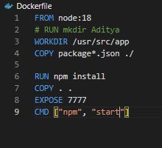

1. **Login to Docker hub and created repository**

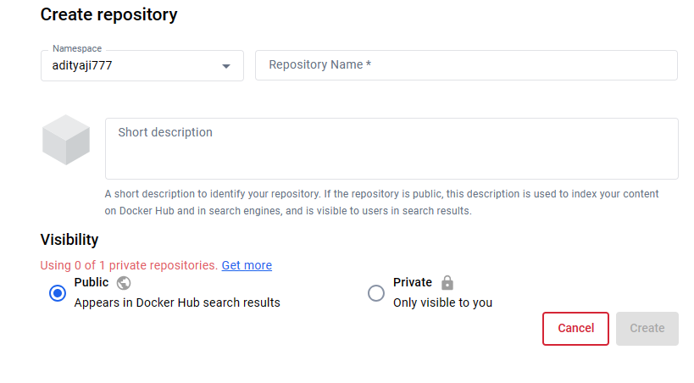

1. **Docker login :**

* Docker login command is executed .
* username and password for docker hub is provided.
* login is succeeded.

1. **Docker tag**

**Command**: docker tag image_id username/repository:tagname

*docker tag my-nodejs-app adityaji7777/my-nodejs-app:latest*

1. **Docker push**

**Command**: docker push username/my-nodejs-app:tagname

*docker push adityaji777/my-nodejs-app:latest*

***(Instead of minikube I tried kind as minikube was consuming so much resources)***

**kind Installation:**

kind is a tool for running local Kubernetes clusters using Docker container “nodes”.

kind was primarily designed for testing Kubernetes itself, but may be used for local development or CI

**Steps :**

* downloaded go 1.16+
* command:
  + *go install* [sigs.k8s.io/kind@v0.22.0](mailto:sigs.k8s.io/kind@v0.22.0)
  + *kind create cluster –name my-nodejs-app-cluster*

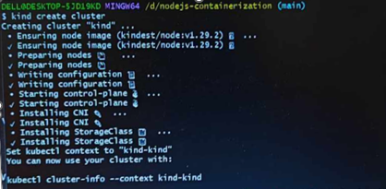

* Created deployment.yaml file

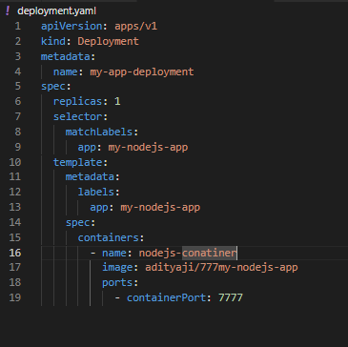

* Created service.yaml

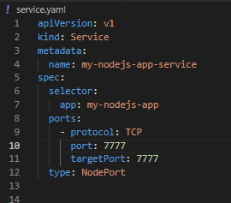

* After Creating deployment and service I tried to access using external ip but didn’t get it so I forwarded the port to 7777 and accessed it from localhost.

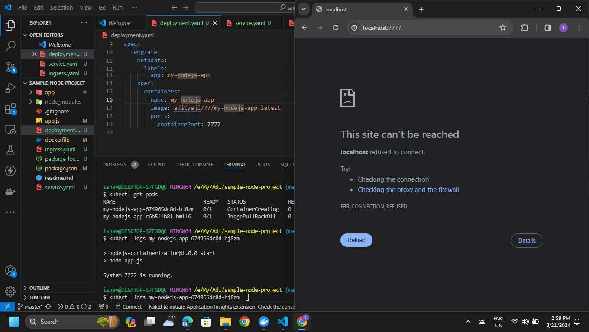

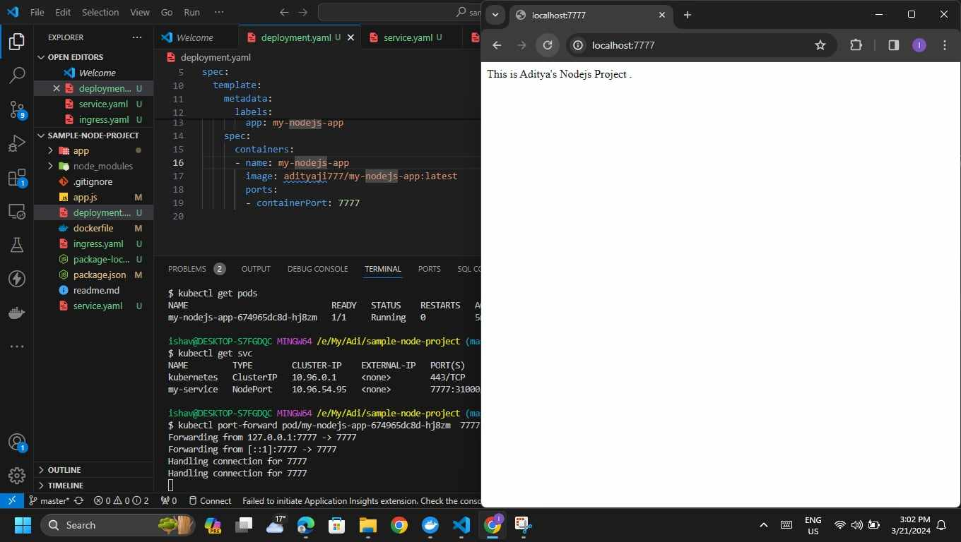

Now the app is running on pod and can be accessible from localhost.