Auto Sales Data Analysis Project Report
Cover Page
Project Title: Exploratory and Analytical Data Analysis on Auto Sales Dataset
Submitted By: [Aditya Karmakar]
Course/Department: [B.Tech CSE]
Institution Name: [Lovely Professional University]
Date: [12-04-2025]

Declaration
I hereby declare that the project titled "Exploratory and Analytical Data Analysis on Auto Sales Dataset" is the result of my independent research and analysis conducted over the course of this academic term. I confirm that the dataset used for this project is available in the public domain and has not been altered beyond necessary preprocessing for analysis. Any references to existing work, theories, tools, or third-party libraries have been cited appropriately in the references section.
Signature: 
Name: [Aditya Karmakar]

Certificate
This is to certify that the project entitled "Exploratory and Analytical Data Analysis on Auto Sales Dataset" submitted by [Your Name], a student of [Your Course/Institution], has been thoroughly reviewed and found to meet the academic requirements of the institution. The student has demonstrated strong analytical and visualization skills and has effectively communicated insights through this project.
Supervisor's Name: [Supervisor Name]
Designation: [Designation]
Date: [Date]

Acknowledgement
I am deeply grateful to my guide and mentor, [Supervisor Name], for their unwavering support, encouragement, and expert guidance throughout the duration of this project. I extend my appreciation to my faculty, peers, and well-wishers who provided feedback and shared their experiences with data analysis. Lastly, I would like to acknowledge the creators and maintainers of the dataset, which served as the foundation of this analytical exploration.

Table of Contents
- Introduction
- Source of Dataset
- EDA Process
- Analysis on Dataset
  - Sales Trend Analysis
  - Product and Category Performance
  - Customer Segmentation and Behavior
  - Pricing Strategy and Discount Impact
  - Order Fulfillment and Status Impact
- Conclusion
- Future Scope
- References

1. Introduction
In today’s competitive global market, businesses in the automotive sector must constantly adapt to changes in customer preferences and economic conditions. Data analytics plays a pivotal role in enabling informed decision-making by uncovering hidden patterns, trends, and relationships within business data. The objective of this project is to utilize a structured exploratory and analytical approach to extract insights from an auto sales dataset. This report highlights the methodology followed, analytical techniques applied, and business interpretations derived from the data.

2. Source of Dataset
The dataset used for this project, titled "Auto Sales data.csv", is publicly accessible and contains comprehensive transactional data, including customer orders, product information, sales values, geographical distribution, deal sizes, and order statuses. The dataset spans multiple years and encompasses both high-level and granular sales attributes, making it suitable for thorough exploratory data analysis and business intelligence reporting.

3. EDA Process
The Exploratory Data Analysis (EDA) was performed using Python and Jupyter Notebook as the development environment. The main steps in the EDA process were:
- Importing core libraries such as Pandas for data manipulation, NumPy for numerical operations, Matplotlib and Seaborn for visualization, and others like Squarify for advanced charting.
- Reading and loading the dataset into a DataFrame using pd.read_csv() and performing structural inspection using df.head(), df.info(), and df.describe().
- Converting relevant date columns to datetime format and creating derived attributes like Year, Month, and Quarter.
- Identifying and handling missing data, data type mismatches, and duplicate entries.
- Performing grouping and aggregations to understand the dataset's shape and structure.
- Creating visual representations of sales trends, category breakdowns, and customer behavior using bar plots, line plots, scatter plots, and heatmaps.

4. Analysis on Dataset
4.1 Sales Trend Analysis
i. Introduction: This section focuses on identifying patterns in total sales over time by examining trends across months and years.
ii. General Description: By extracting year and month components from order dates, the dataset is grouped and aggregated to calculate monthly and yearly sales totals. This allows the identification of high and low-performing time periods.
iii. Specific Requirements, Functions, and Formulas:
- Pandas functions such as groupby, dt.year, dt.month, and sum()
- Seaborn’s lineplot() to visualize sales trends over time iv. Analysis Results: The analysis revealed seasonal patterns in sales, with notable peaks during November and December, likely due to end-of-year promotions and buying behavior. Sales typically dip mid-year, providing opportunities for targeted marketing.
v. Visualization: Line plots comparing sales trends across different years, grouped by month.
4.2 Product and Category Performance
i. Introduction: This section investigates which product lines and individual products contribute most significantly to revenue generation.
ii. General Description: Aggregating sales by PRODUCTLINE and PRODUCTCODE identifies top-performing categories and items. Comparing average sales across these groups sheds light on the product mix's effectiveness.
iii. Specific Requirements, Functions, and Formulas:
- groupby, sum(), and mean() to compute total and average sales per product line
- Visualization using barplot() and optional treemap() for hierarchical display iv. Analysis Results: The results indicated that a few product lines, such as Classic Cars and Vintage Cars, were responsible for the bulk of revenue. A small set of SKUs consistently generated the highest sales.
v. Visualization: Vertical bar charts of revenue by category and top products by total sales.
4.3 Customer Segmentation and Behavior
i. Introduction: To optimize marketing efforts and customer retention strategies, this section explores customer contributions by geography and order size.
ii. General Description: By segmenting the data based on COUNTRY, CUSTOMERNAME, and DEALSIZE, we identify high-value customers and regions. Frequency and volume metrics are also used to categorize customers.
iii. Specific Requirements, Functions, and Formulas:
- Pandas value_counts(), groupby, and agg()
- Seaborn’s barplot() and countplot() for frequency distribution iv. Analysis Results: The findings showed that a small group of customers contributed disproportionately to revenue, supporting the Pareto principle. Countries such as the USA and France led in total sales.
v. Visualization: Bar plots of customer revenue contribution and regional performance.
4.4 Pricing Strategy and Discount Impact
i. Introduction: This section evaluates how unit price and discounting affect order quantity and total revenue.
ii. General Description: Analyzing correlations between PRICEEACH, QUANTITYORDERED, and SALES provides insights into pricing elasticity and customer responsiveness.
iii. Specific Requirements, Functions, and Formulas:
- Use of corr() for correlation matrix
- Binning prices using cut() and plotting relationships with scatterplot() and heatmap() iv. Analysis Results: The analysis demonstrated that while lower prices correlated with higher quantities ordered, total revenue was optimized by balancing pricing and volume.
v. Visualization: Correlation heatmaps, scatter plots, and binned price-revenue charts.
4.5 Order Fulfillment and Status Impact
i. Introduction: Evaluates the influence of order statuses on revenue and identifies bottlenecks in the fulfillment process.
ii. General Description: Categorizing data by STATUS allows understanding of the proportion of successful versus cancelled orders. It also helps assess logistics efficiency.
iii. Specific Requirements, Functions, and Formulas:
- Grouping using groupby('STATUS'), calculating count() and sum()
- Visualizing using Seaborn’s barplot() and countplot() iv. Analysis Results: Orders marked as "Shipped" contributed overwhelmingly to revenue, while "Cancelled" and "On Hold" orders represented opportunity costs.
v. Visualization: Bar charts displaying order status distribution and corresponding revenue impacts.

Images:
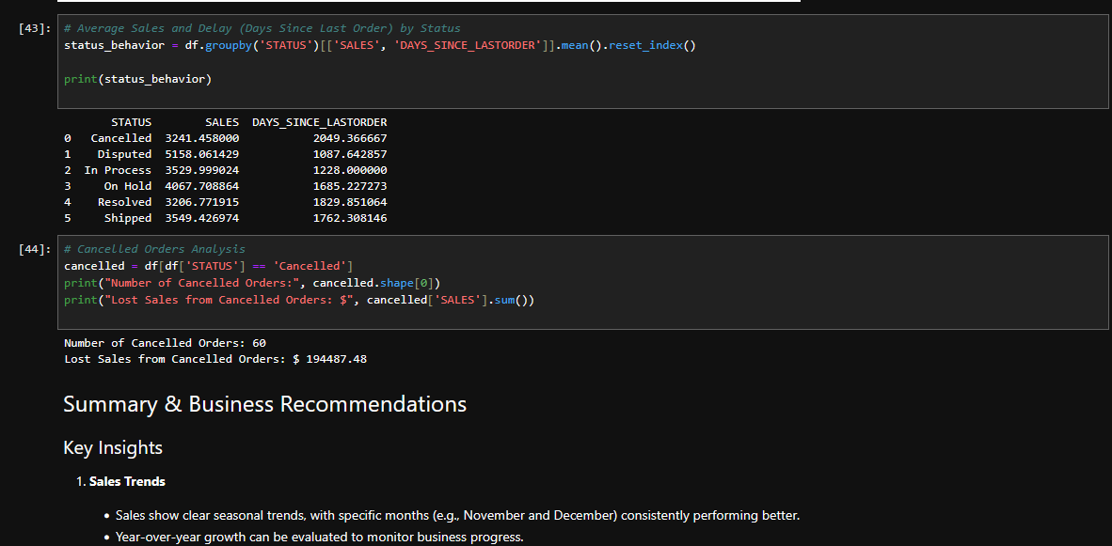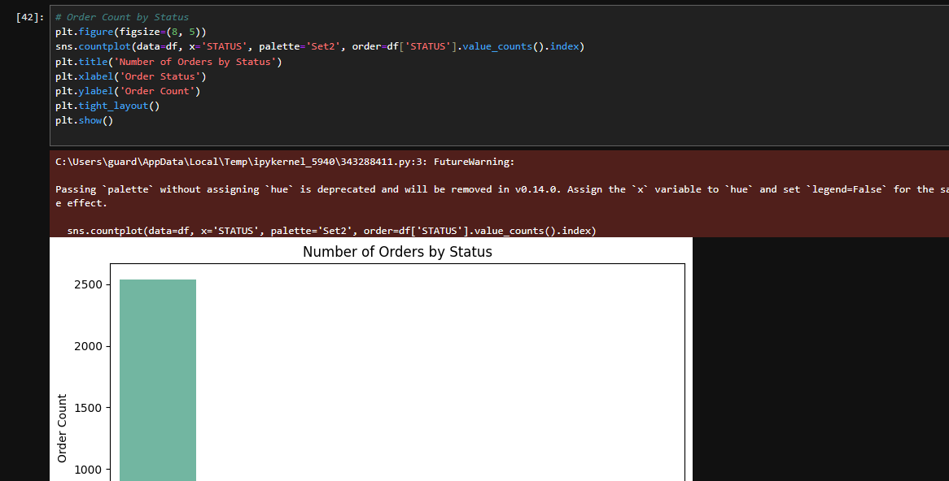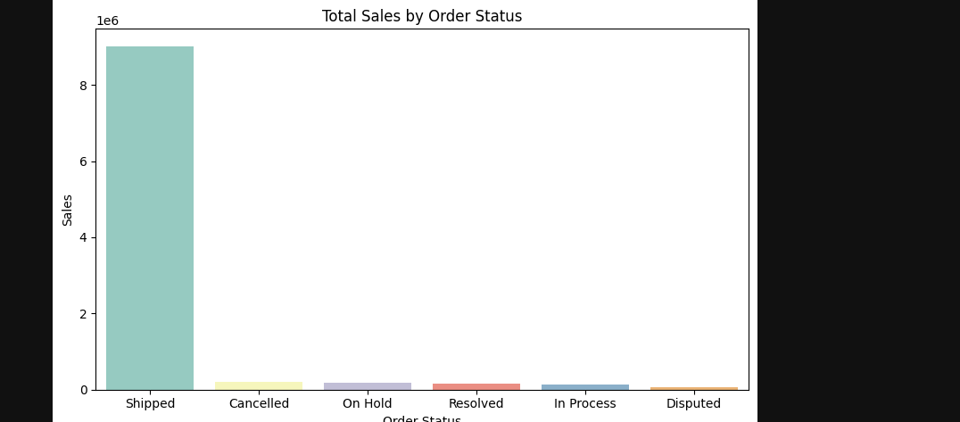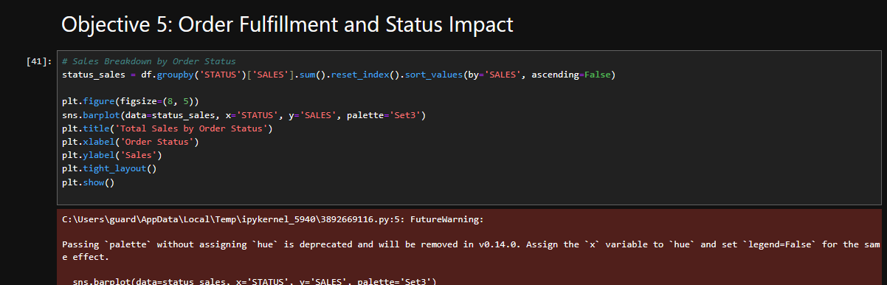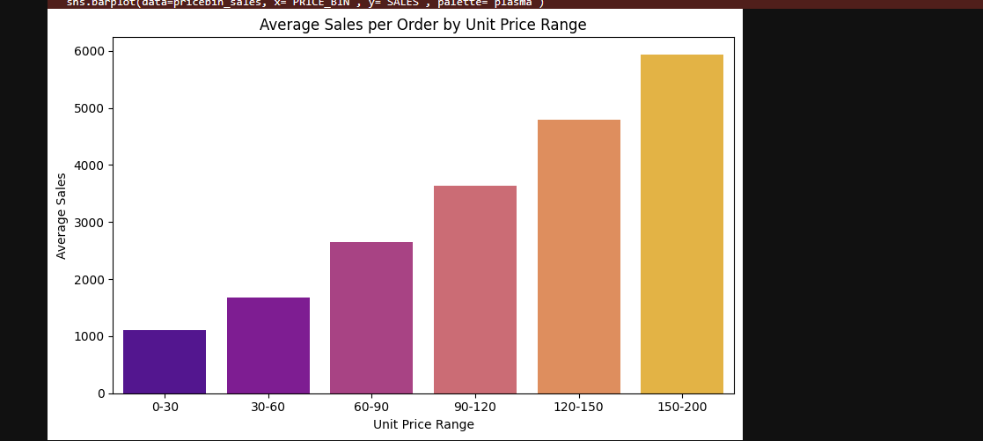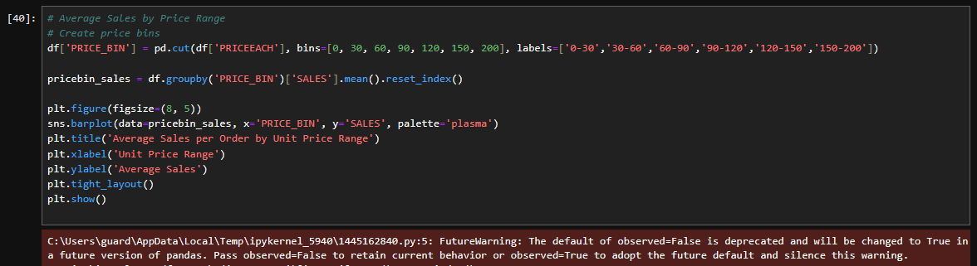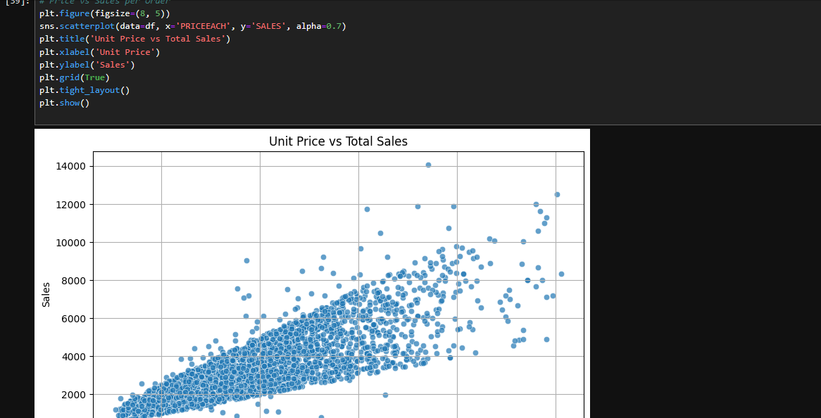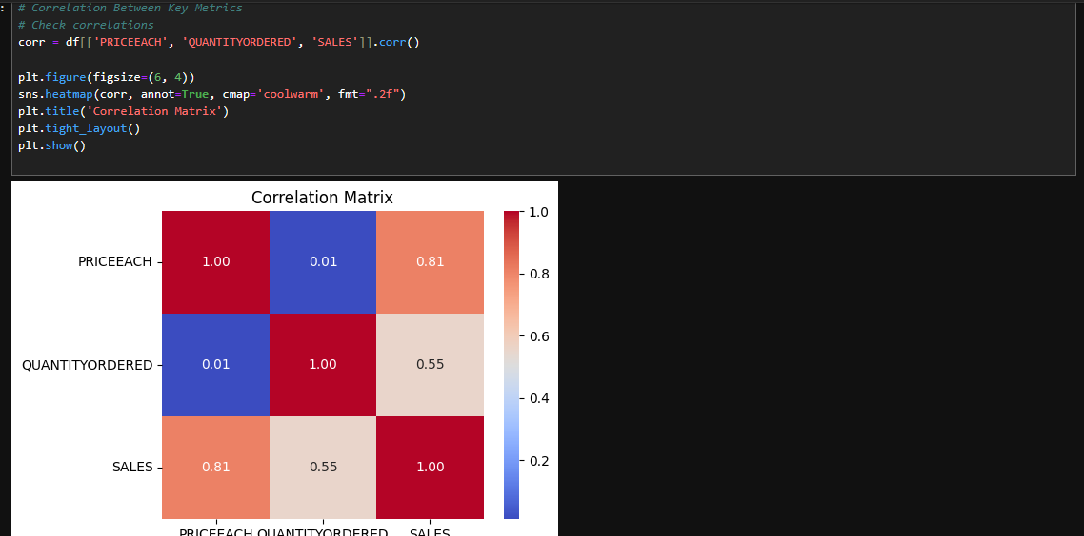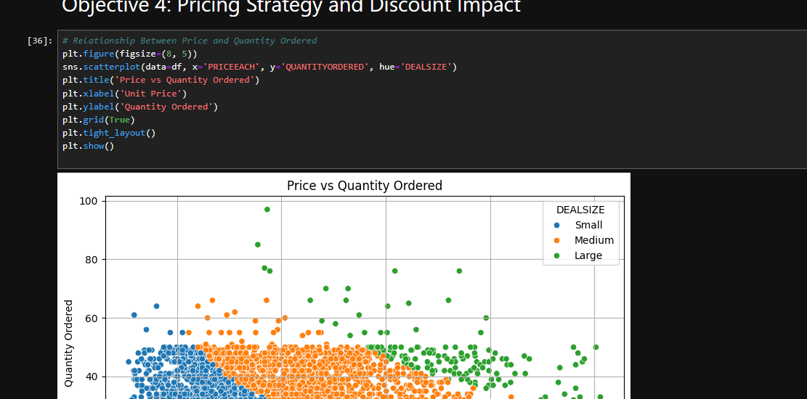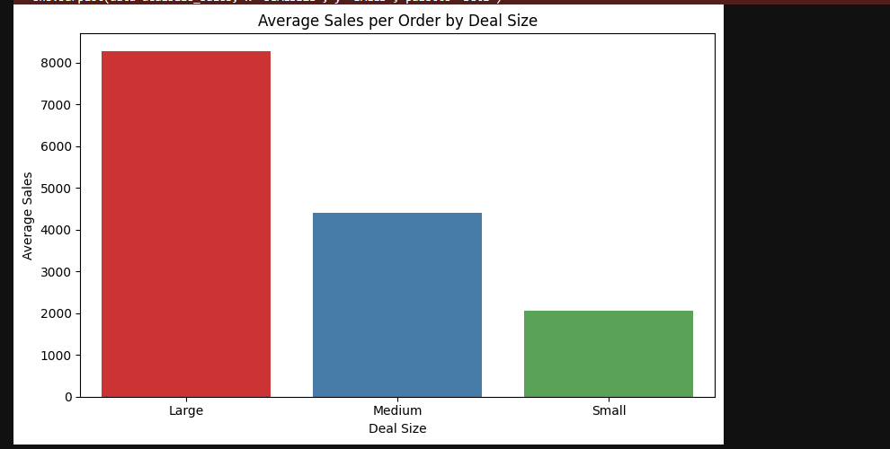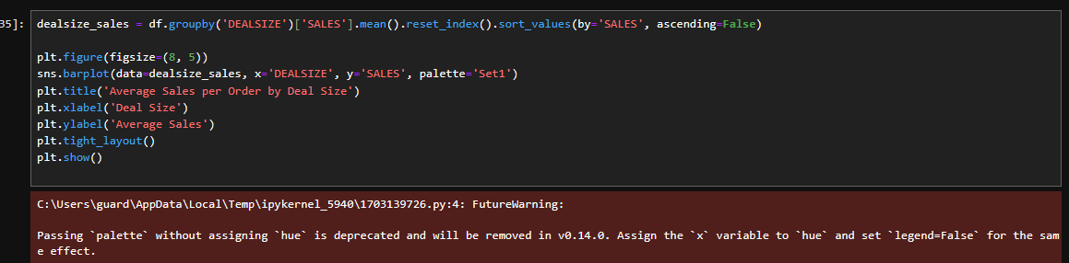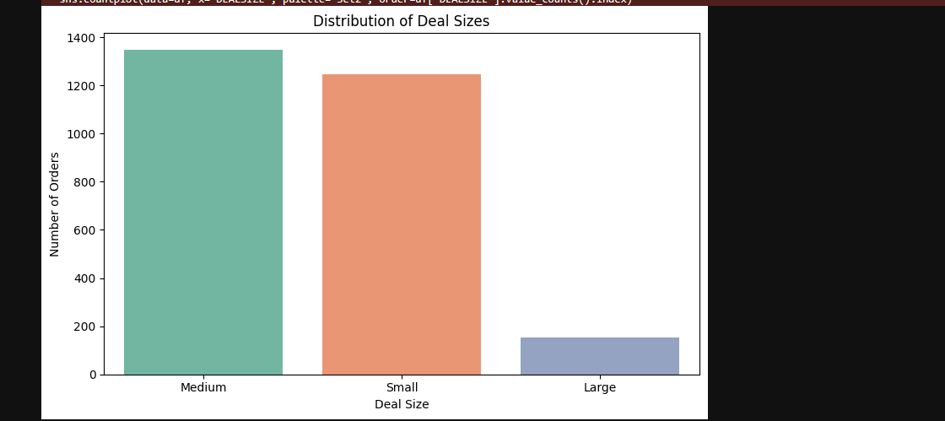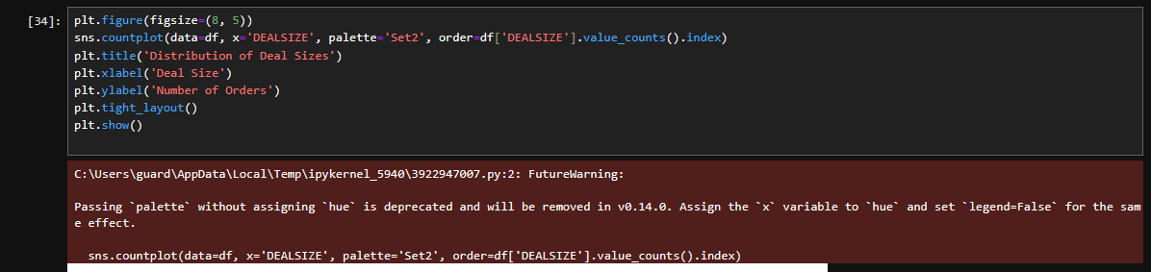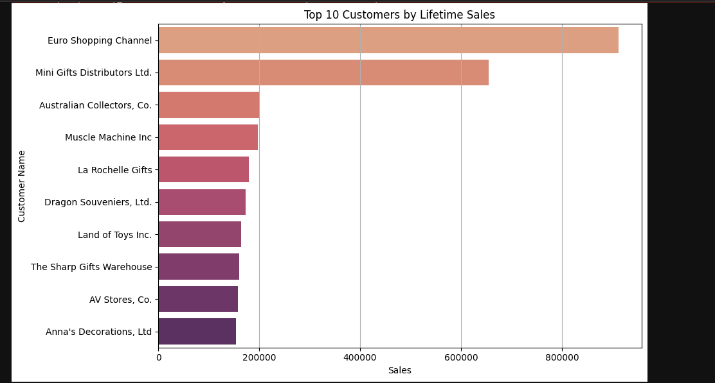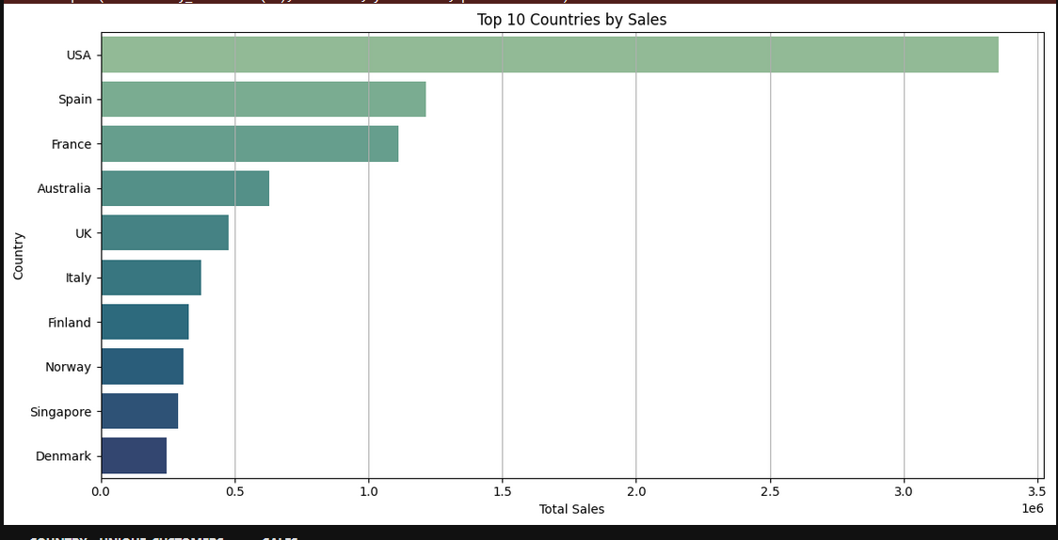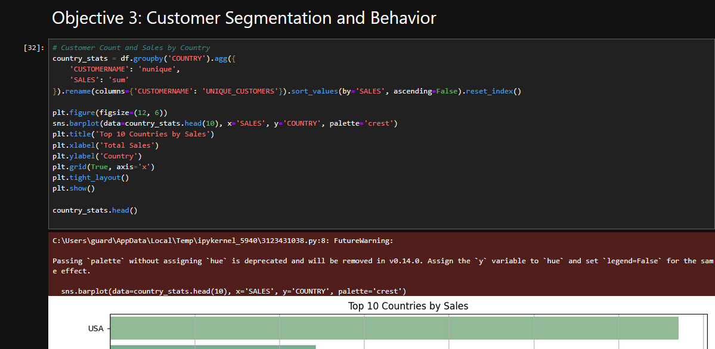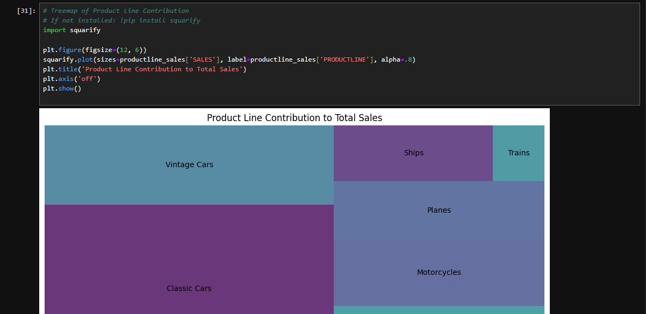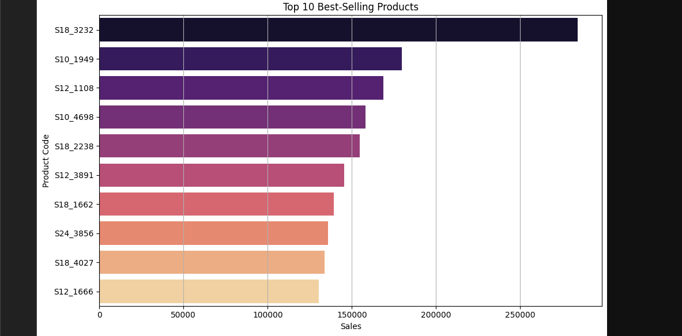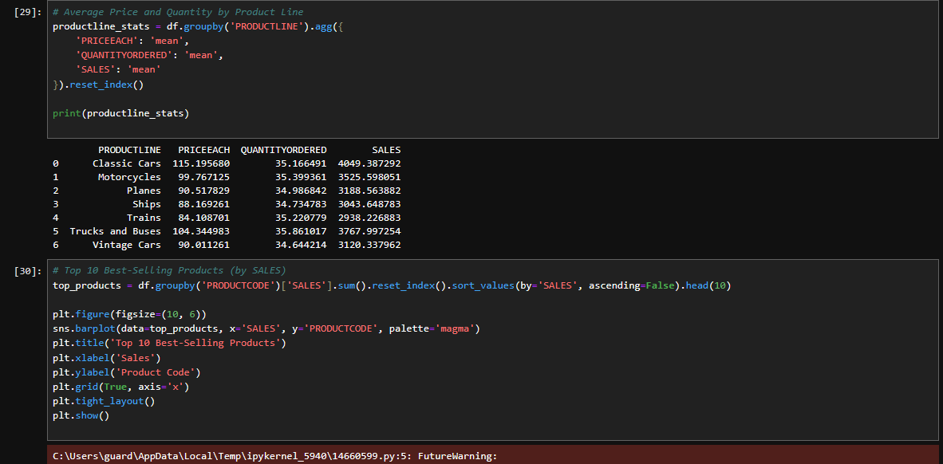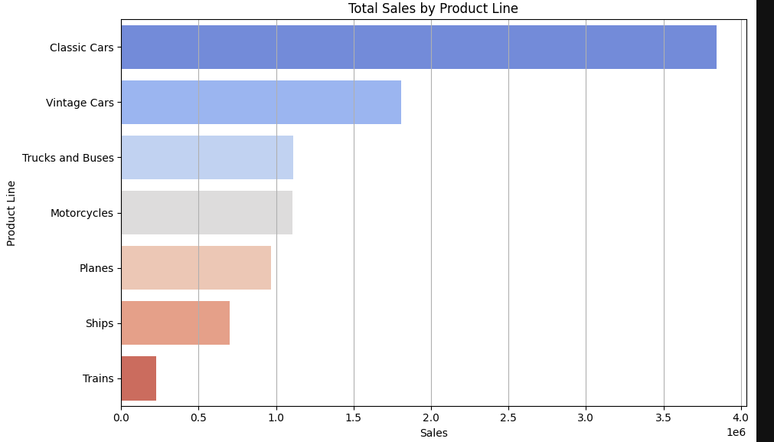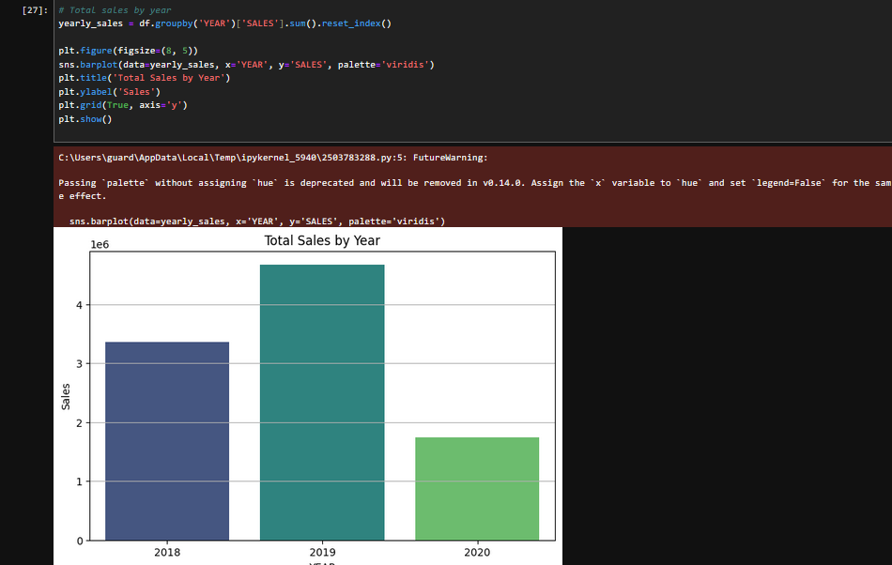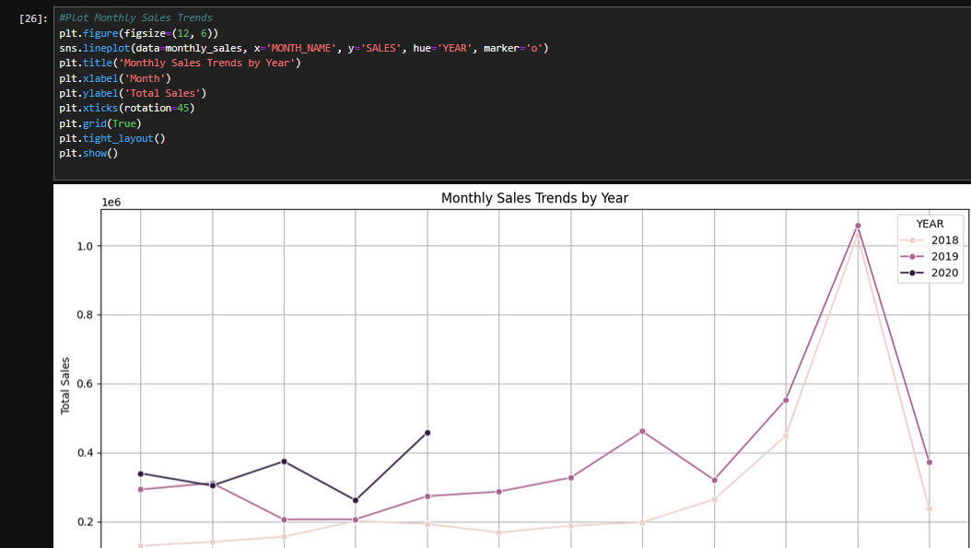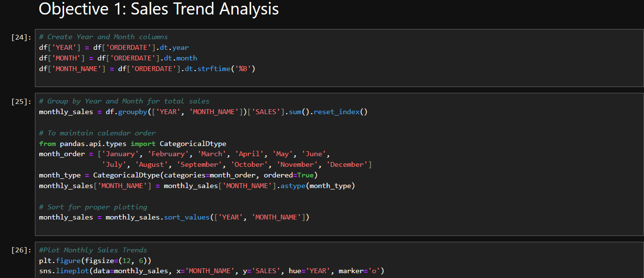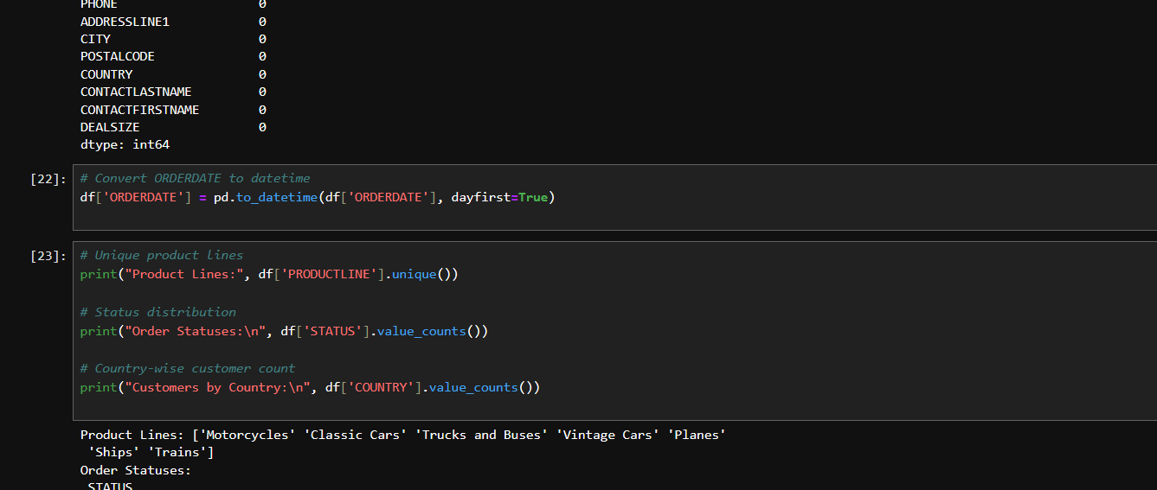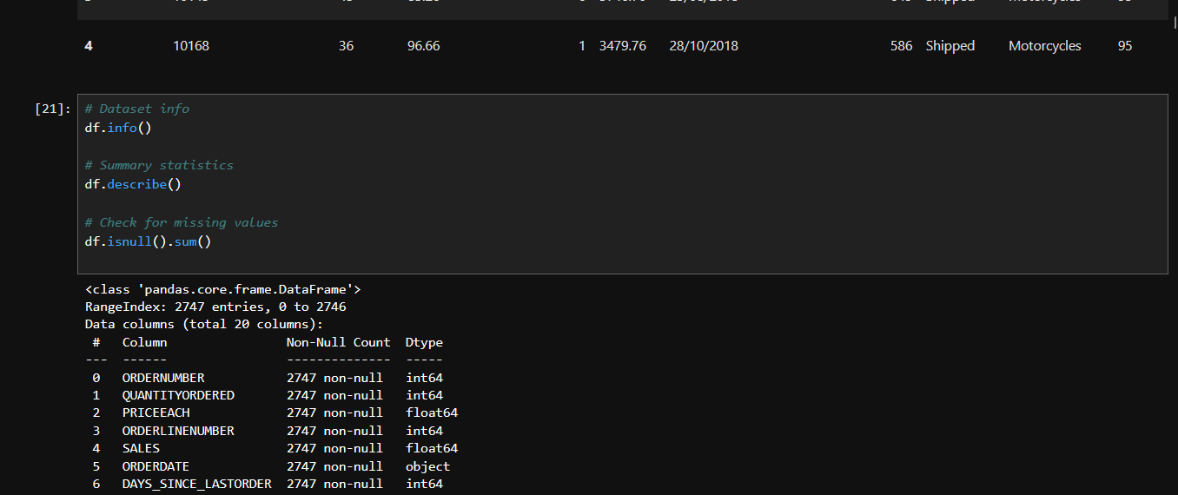

5. Conclusion
This project demonstrates how structured data analysis can provide critical business insights into auto sales operations. From understanding seasonal sales trends to identifying top-performing products and customers, the findings support more data-driven decisions. The analyses reveal not only what has happened but provide guidance for strategy moving forward in terms of marketing, inventory planning, and customer management.

6. Future Scope
There is substantial potential to build upon this analysis using advanced analytics and predictive modeling. Future developments may include:
- Implementing machine learning models to forecast monthly or quarterly sales.
- Building customer segmentation models to tailor marketing strategies.
- Analyzing customer churn and satisfaction using order history and status data.
- Integrating external datasets like economic indicators to enrich insights.
- Creating real-time dashboards using BI tools like Power BI or Tableau for continuous monitoring.

7. References
- Dataset Source: Auto Sales data.csv (public dataset)
- Python Libraries Used: pandas, numpy, matplotlib, seaborn, squarify
- Development Environment: Jupyter Notebook
- Seaborn Documentation: https://seaborn.pydata.org/
- Matplotlib Documentation: https://matplotlib.org/
- Pandas Documentation: https://pandas.pydata.org/
- Additional Online Resources and Tutorials for Data Analysis with Python

