LINUX SYSTEM AND SHELL SCRIPTING LAB
Complete Lab – Questions 1 to 4
Question 1
Create a LabFiles directory and perform create/copy/move/rename/delete operations using touch, cp, mv, rm, unlink, ls, stat.

Step 1 – Create the LabFiles directory
We created the Labfiles directory inside Project1. ls confirmed it was created, and pwd showed the current location.
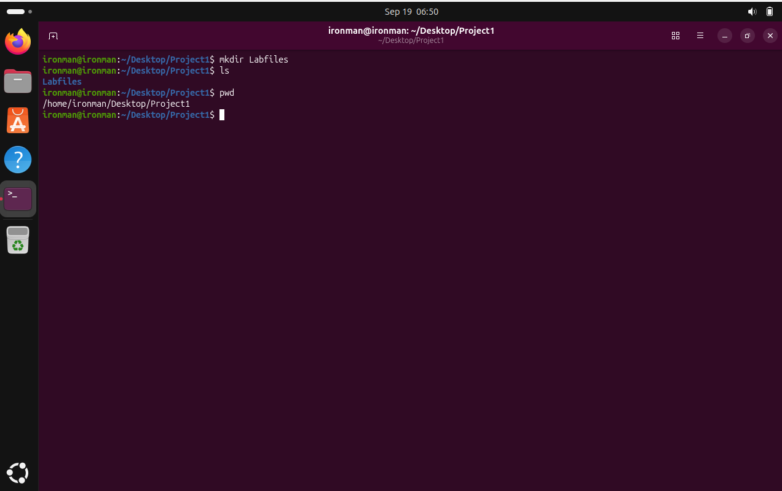

Step 2 – Create the first file
We entered Labfiles and used touch to create files1.txt. ls confirmed the file was present.
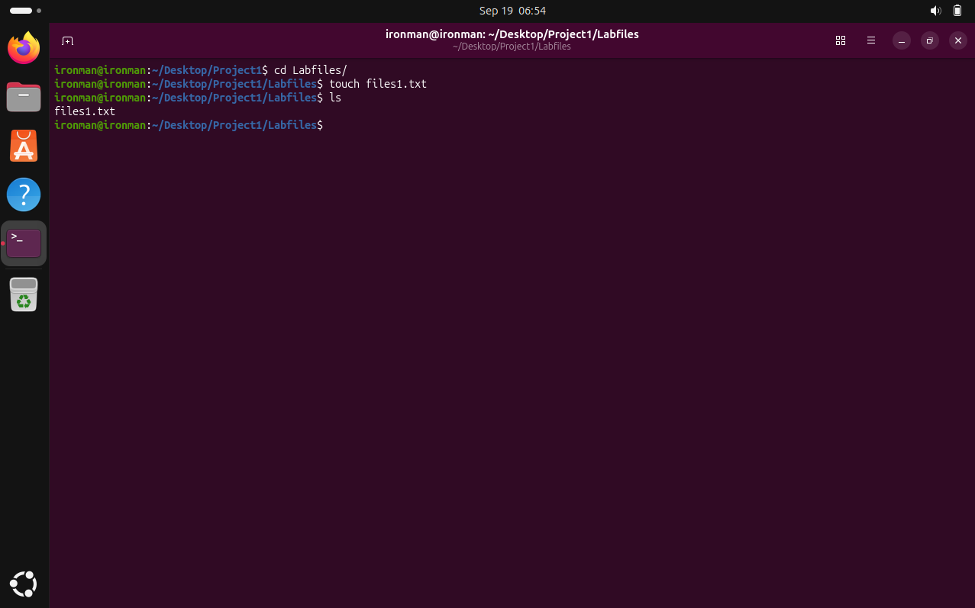

Step 3 – Copy the file
We copied files1.txt to create files2.txt. ls confirmed both files were present.
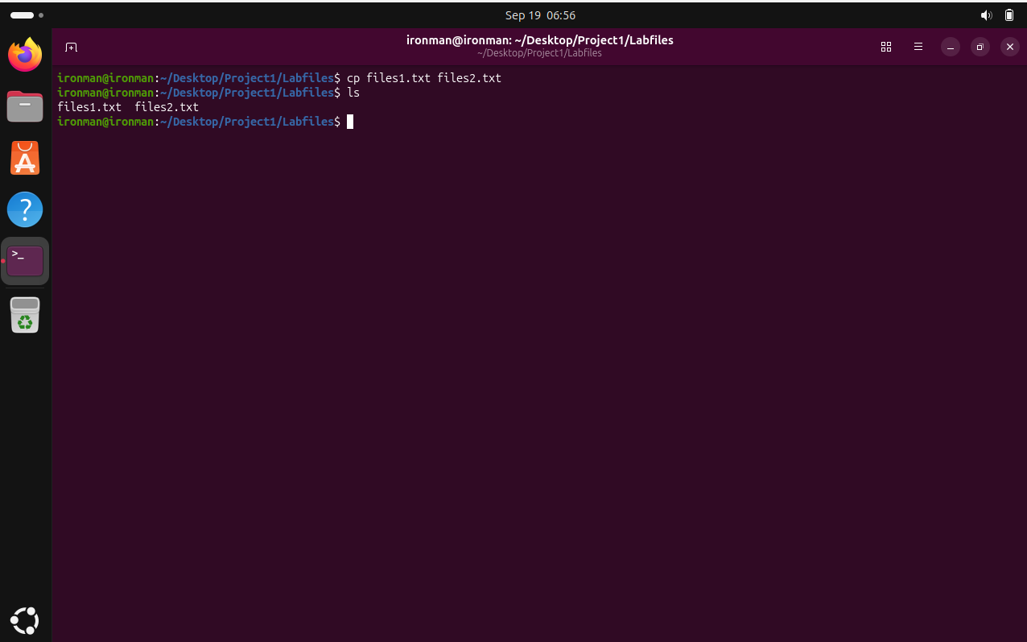

Step 4 – Create another file and check Backup
We created file3.txt, listed the Labfiles contents, and checked the Backup directory.
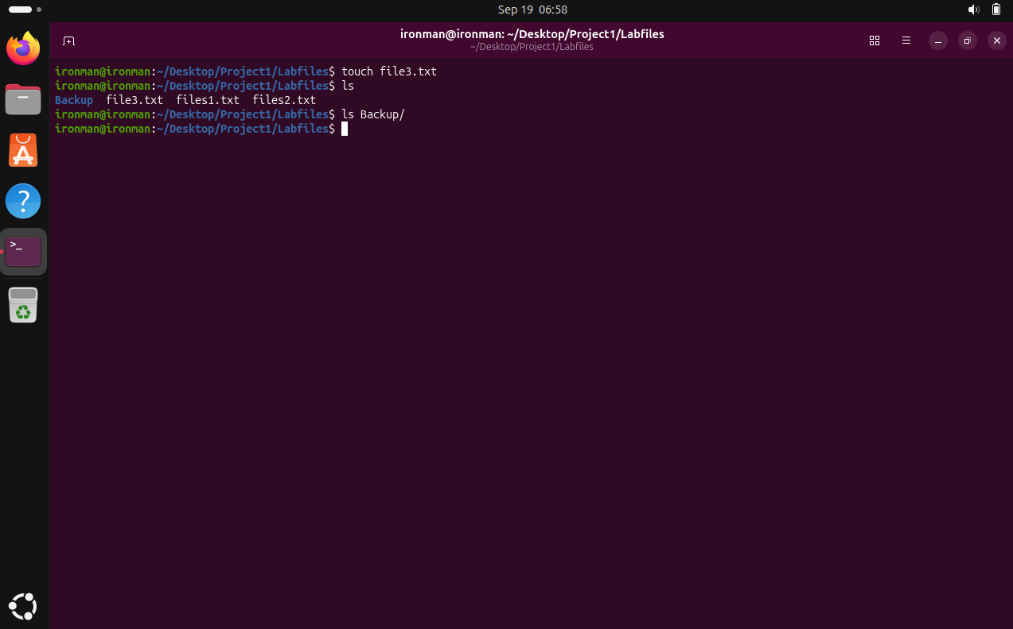

Step 5 – Rename the copied file
We renamed files2.txt to file2.txt using mv and confirmed the renamed file with ls.
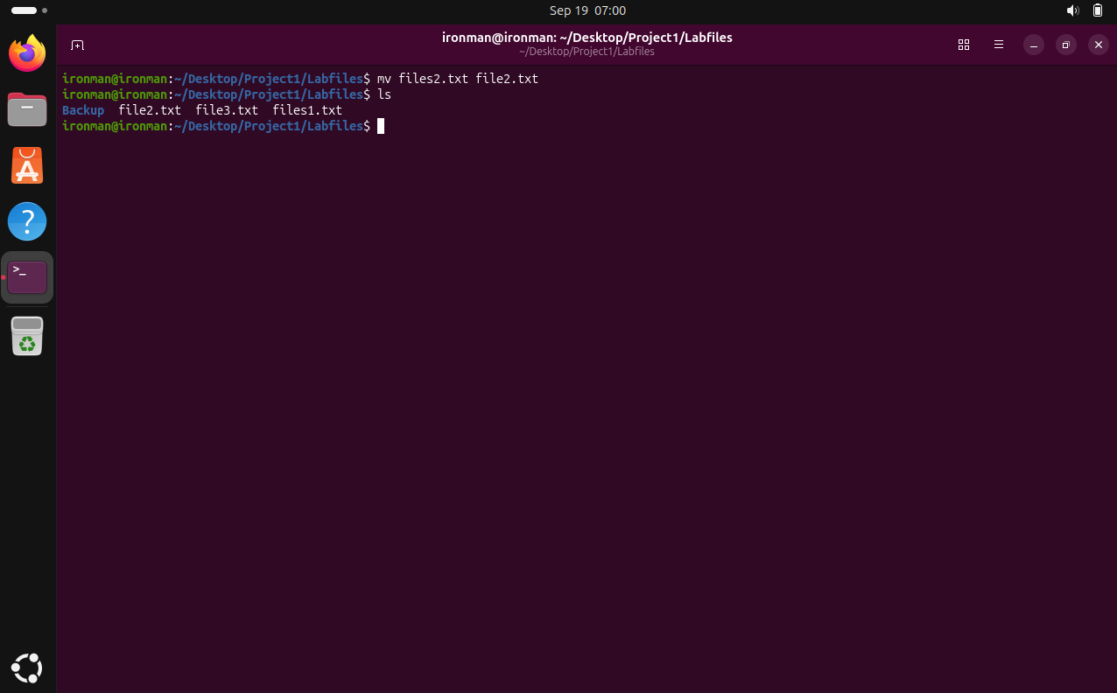

Step 6 – Display file information
We used stat to display detailed information about files1.txt, including permissions, owner, inode, size, and timestamps.
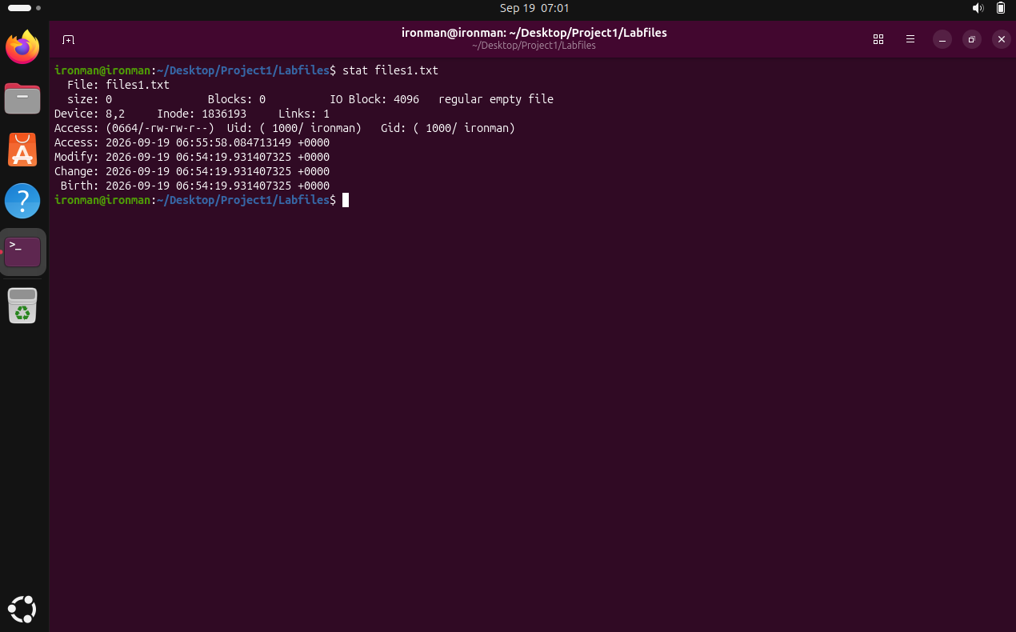

Step 7 – Delete the file
We deleted files1.txt using rm and used ls to confirm it was removed.
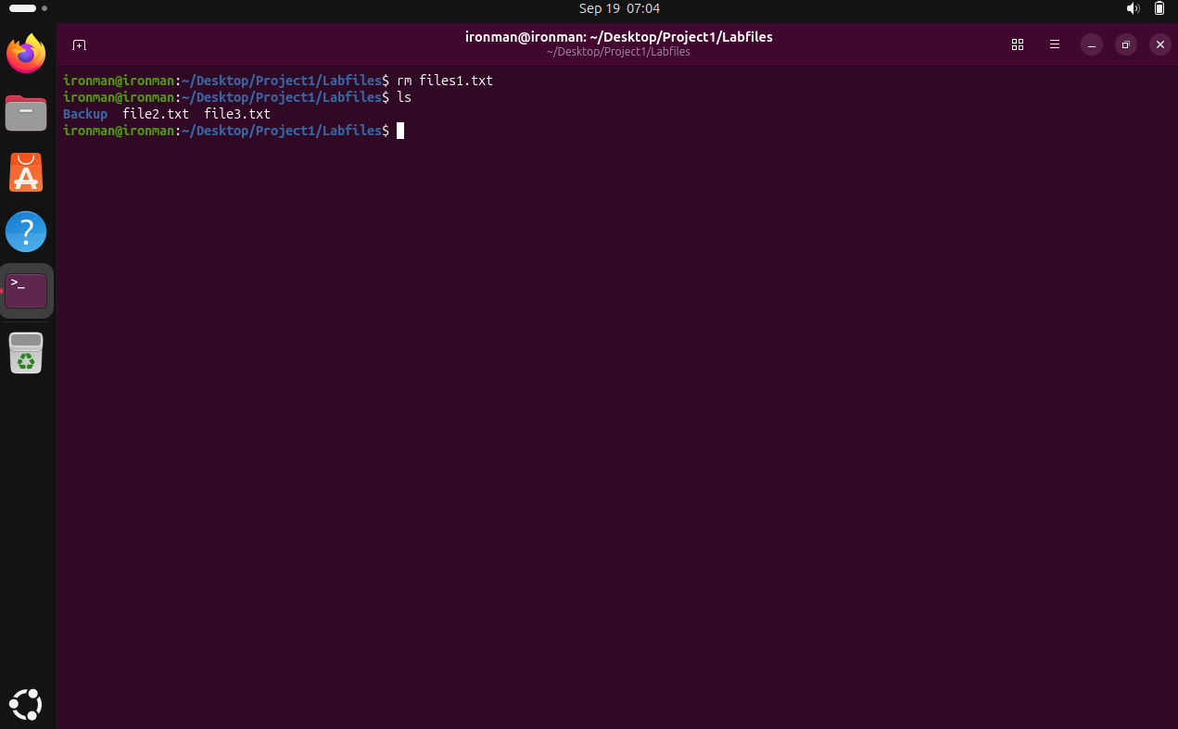

Question 1 note
Note: The supplied screenshots do not show an unlink command being executed, so it is not claimed as evidence.

Question 2
Demonstrate pipes & redirection (>, >>, <, 2>, 2>>, 2>&1, |) with cat, grep, sort, uniq, wc, tee to generate filtered reports.

Step 1 – Create and display the student data
We created students.txt using cat and entered the student records. The file contents were then displayed to verify the data.
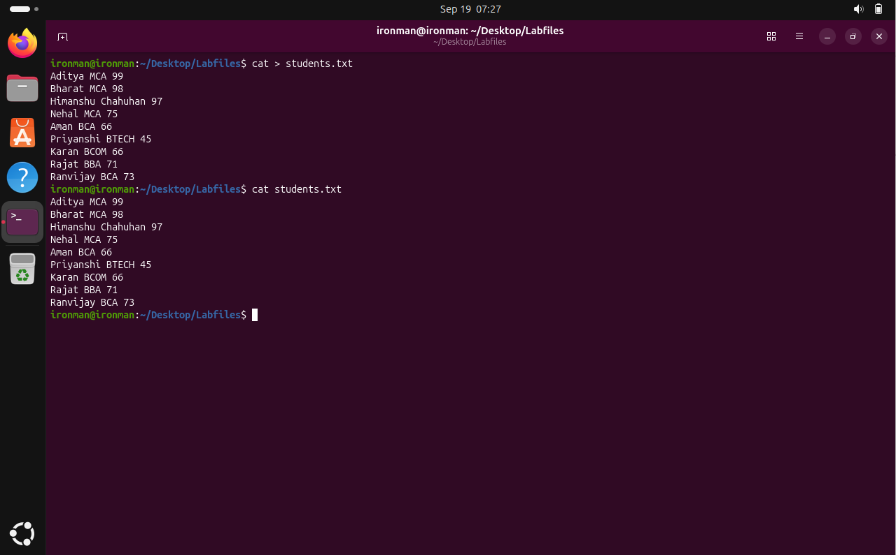

Step 2 – Redirect standard output using >
The > operator redirected the output of cat into report.txt. The report file was then displayed to verify that the contents were written successfully.
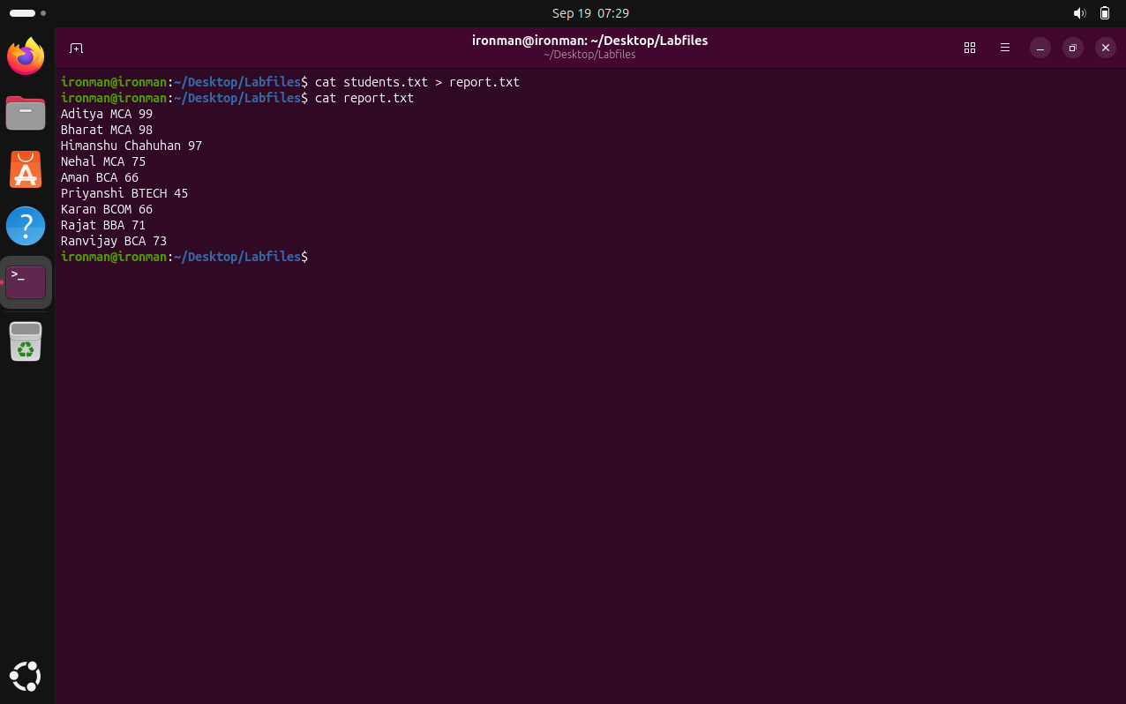

Step 3 – Append output using >>
The >> operator appended new text to the existing report.txt file without overwriting its previous contents. The file was displayed again to verify the append operation.
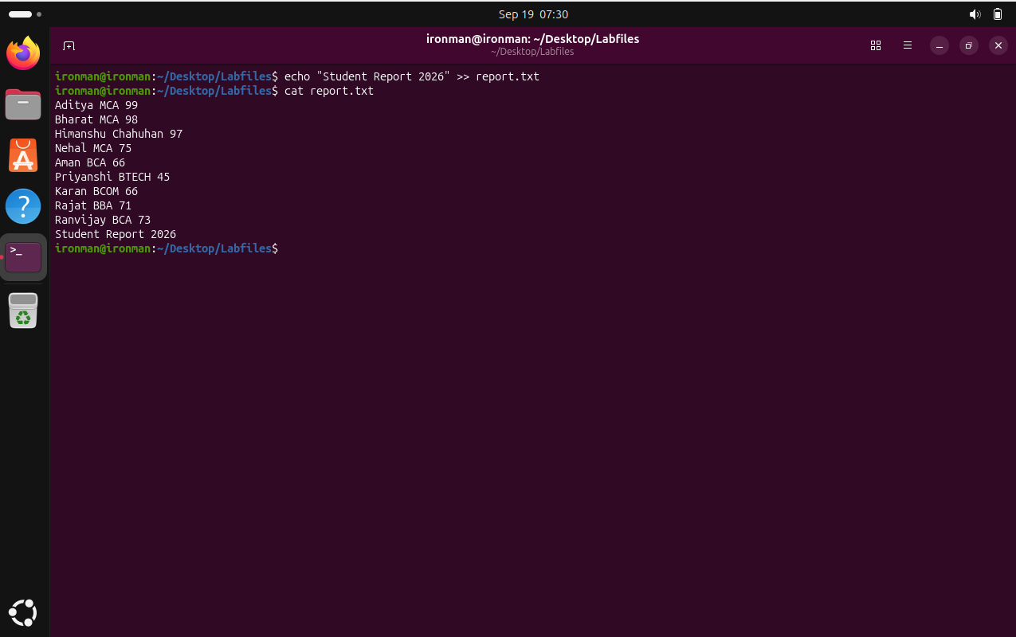

Step 4 – Redirect standard input using <
The < operator supplied students.txt as standard input to wc. This demonstrated input redirection and counted the lines in the file.
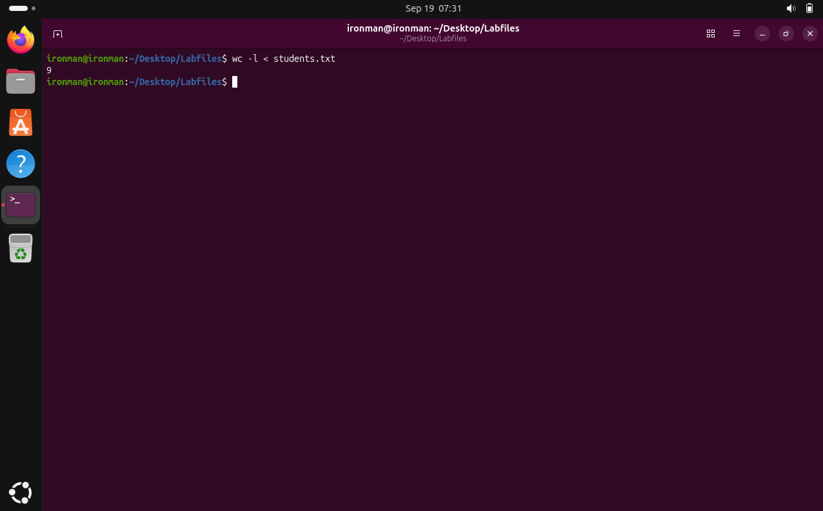

Step 5 – Redirect errors using 2> and 2>>
The 2> operator redirected an error message into a file. The 2>> operator is the append form of error redirection and is included with this step as required.
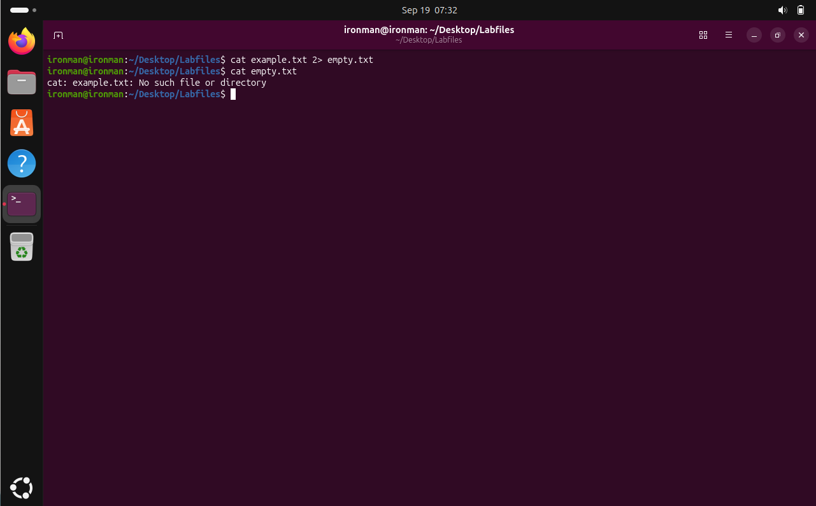

Step 6 – Combine standard output and standard error using 2>&1
The command demonstrated how standard output and standard error can be redirected to the same destination using 2>&1. The resulting file was then displayed.
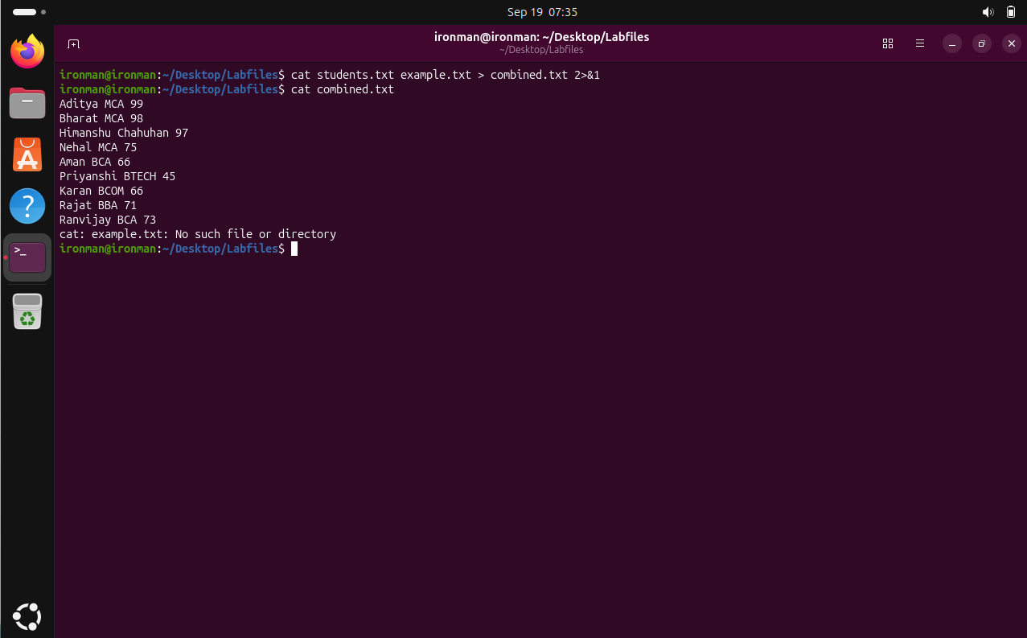

Step 7 – Filter records using a pipe and grep
The pipe operator | passed the output of one command directly to grep. grep filtered the student records and displayed only the entries containing MCA.
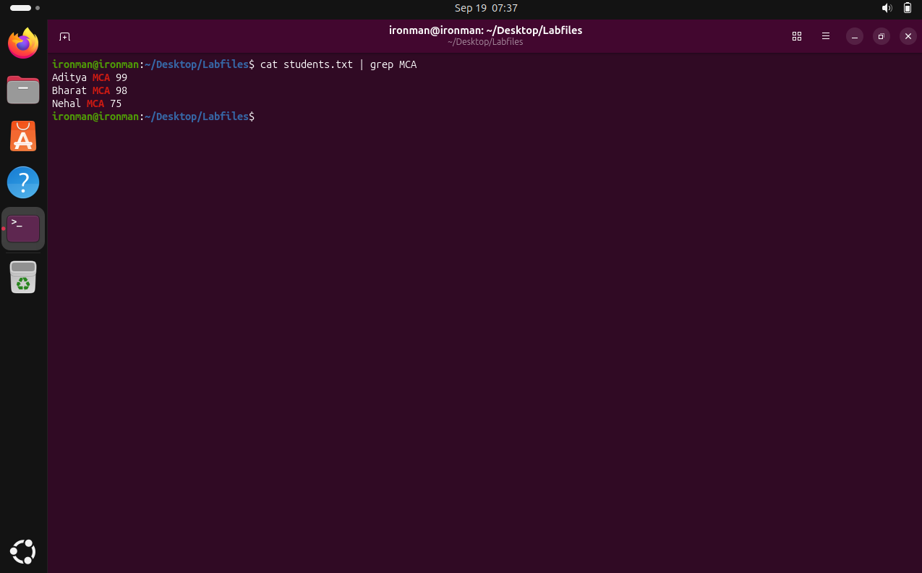

Step 8 – Sort and remove duplicate lines using sort and uniq
The output was passed through a pipeline. sort arranged the records, while uniq removed duplicate lines from the sorted result.
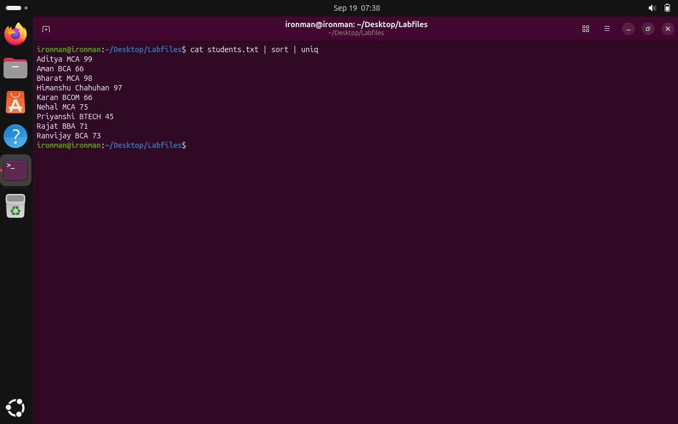

Step 9 – Count filtered records using wc
grep first selected the MCA records, and the pipe passed those results to wc -l. This demonstrated counting filtered output.
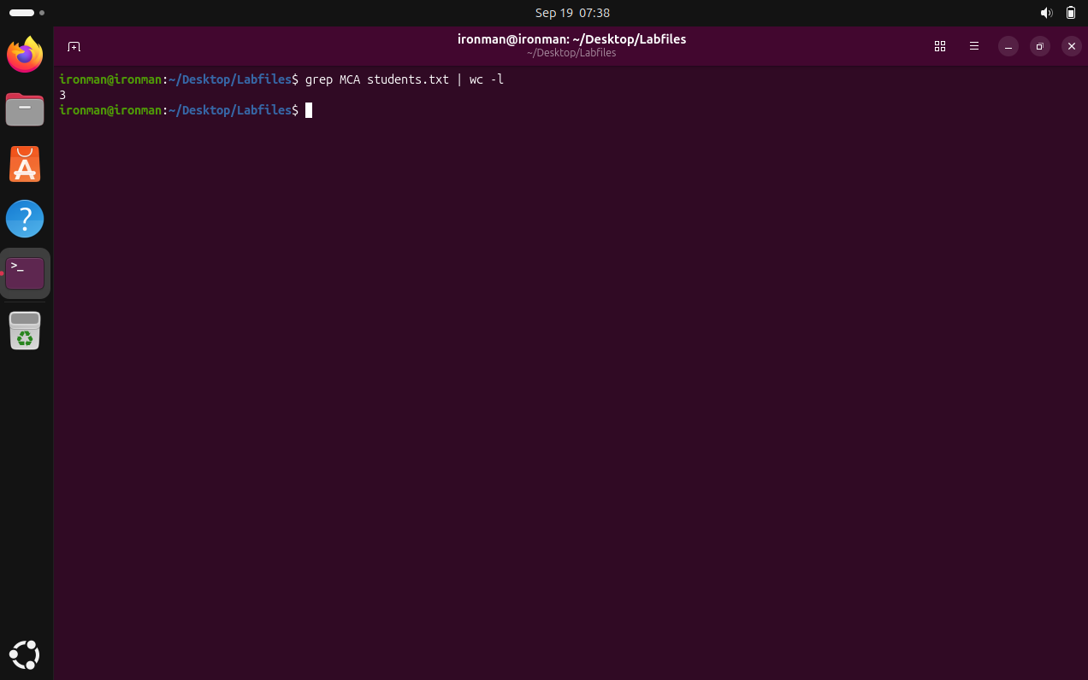

Step 10 – Save filtered output using tee
The tee command displayed the filtered MCA records on the terminal while simultaneously saving the same output into a report file.
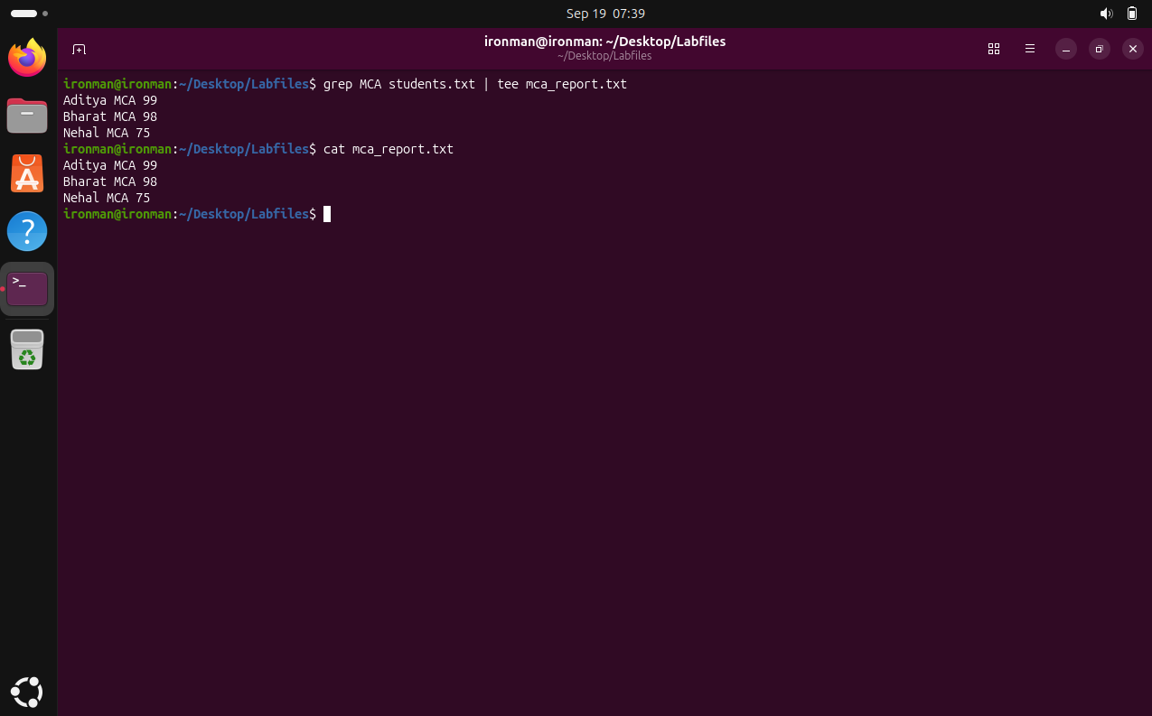

Step 11 – Generate the final filtered report
The final pipeline combined cat, grep, sort, uniq, the pipe operator and tee to generate a filtered MCA report. The saved report was then displayed to verify the result.
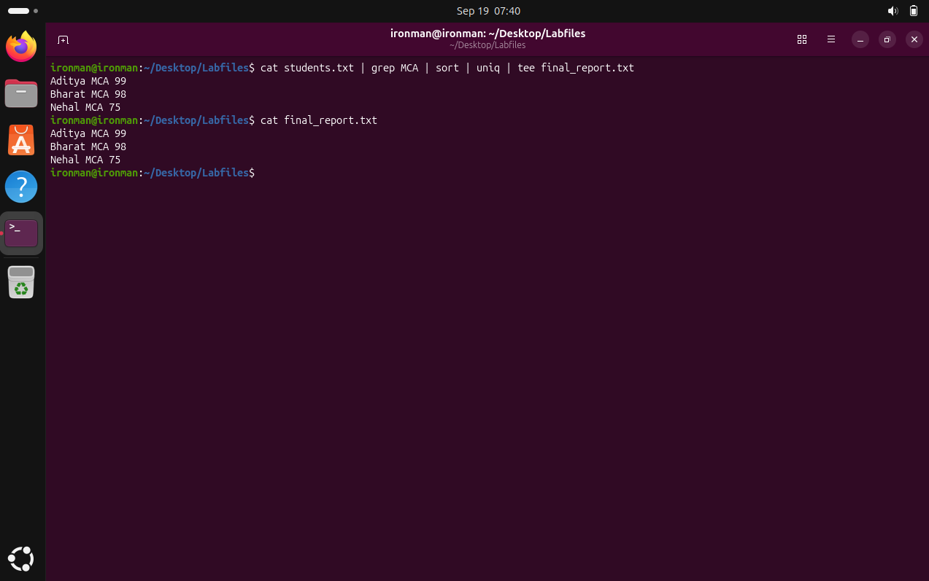

Question 3
Create a College directory hierarchy with subdirectories (CSE, ECE, ME, Civil), nested semester/subject folders, and display it using tree, pwd, cd, mkdir, rmdir, ls.

Step 1 – Return to the home directory and verify the location
We returned to the home directory using cd ~ and used pwd to verify the current location.
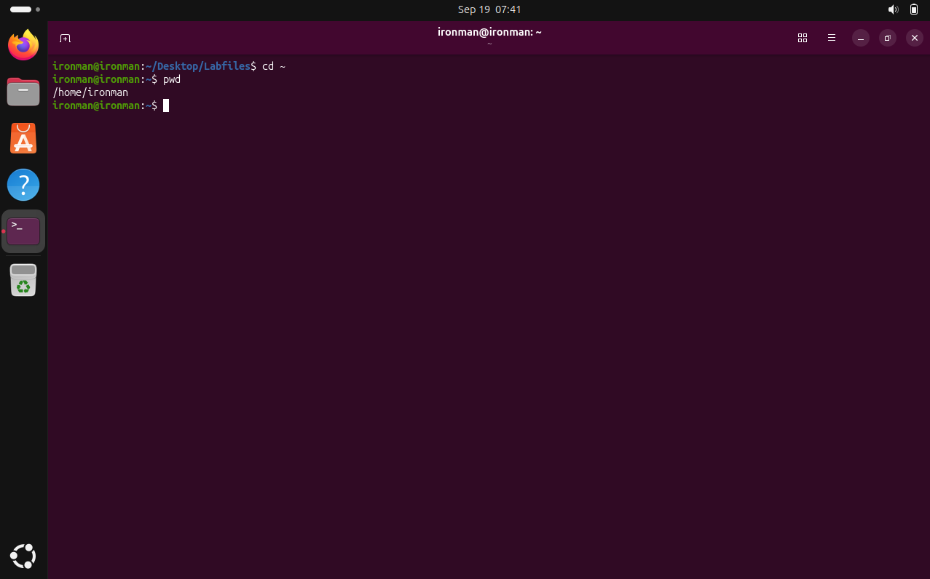

Step 2 – Create the College directory
We created the College directory inside Desktop to begin the required directory hierarchy.
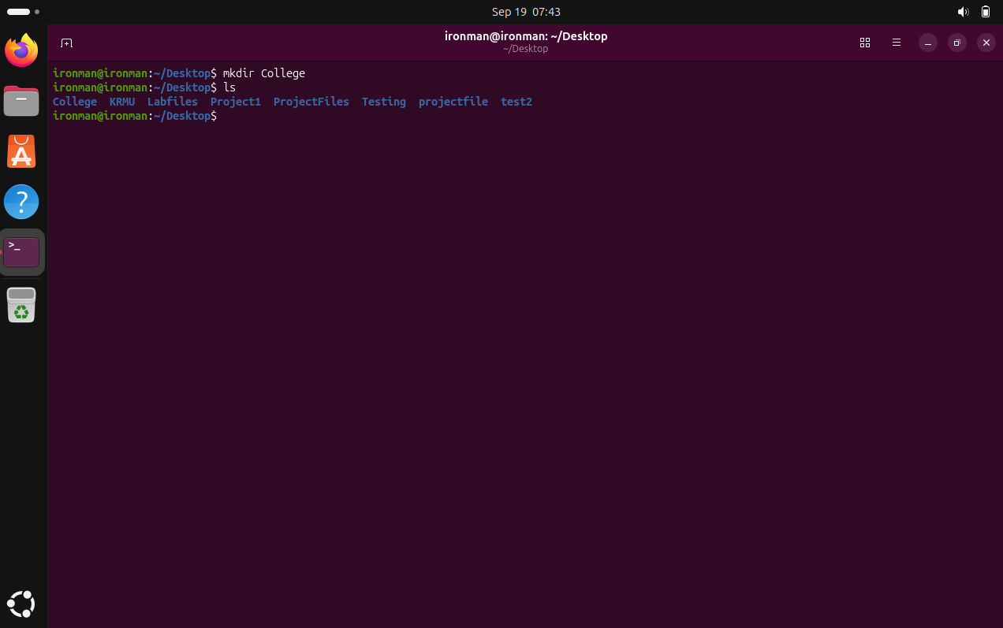

Step 3 – Verify the Desktop contents
We used ls to confirm that the College directory was created along with the existing LabFiles directory.
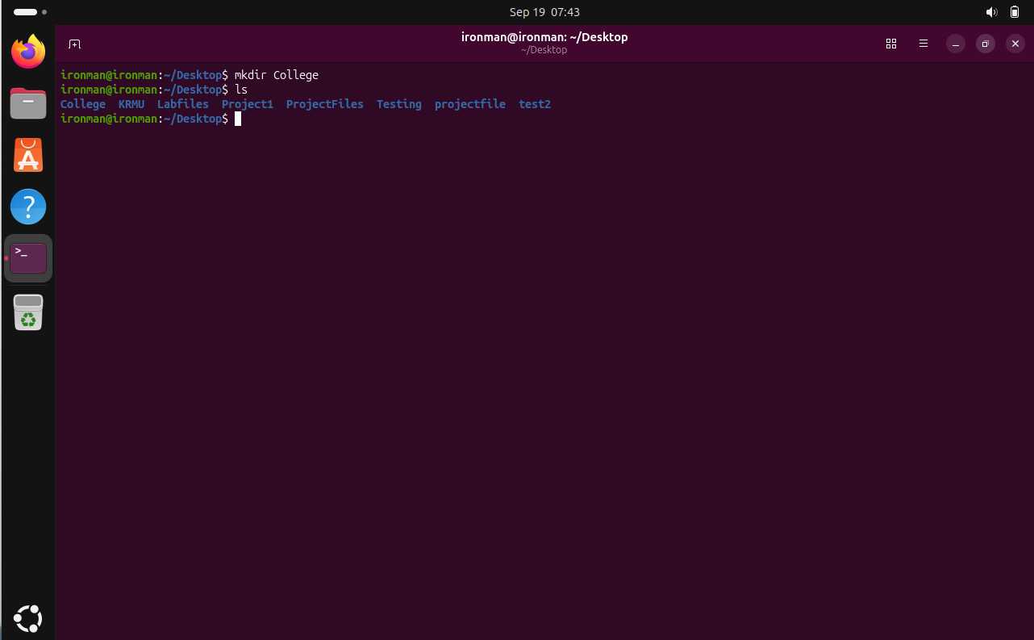

Step 4 – Enter the College directory
We used cd College/ to enter the College directory and continue creating its structure.
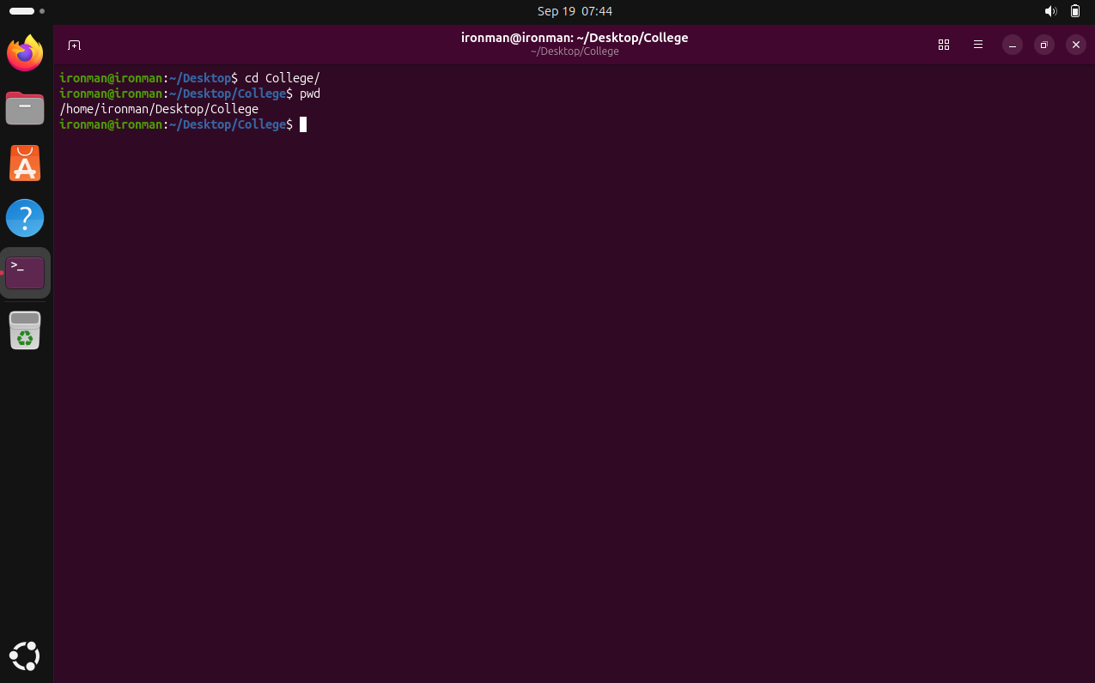

Step 5 – Create the department directories
We created the four department directories: CSE, ECE, ME and Civil. The directory listing confirmed that all four departments were created.
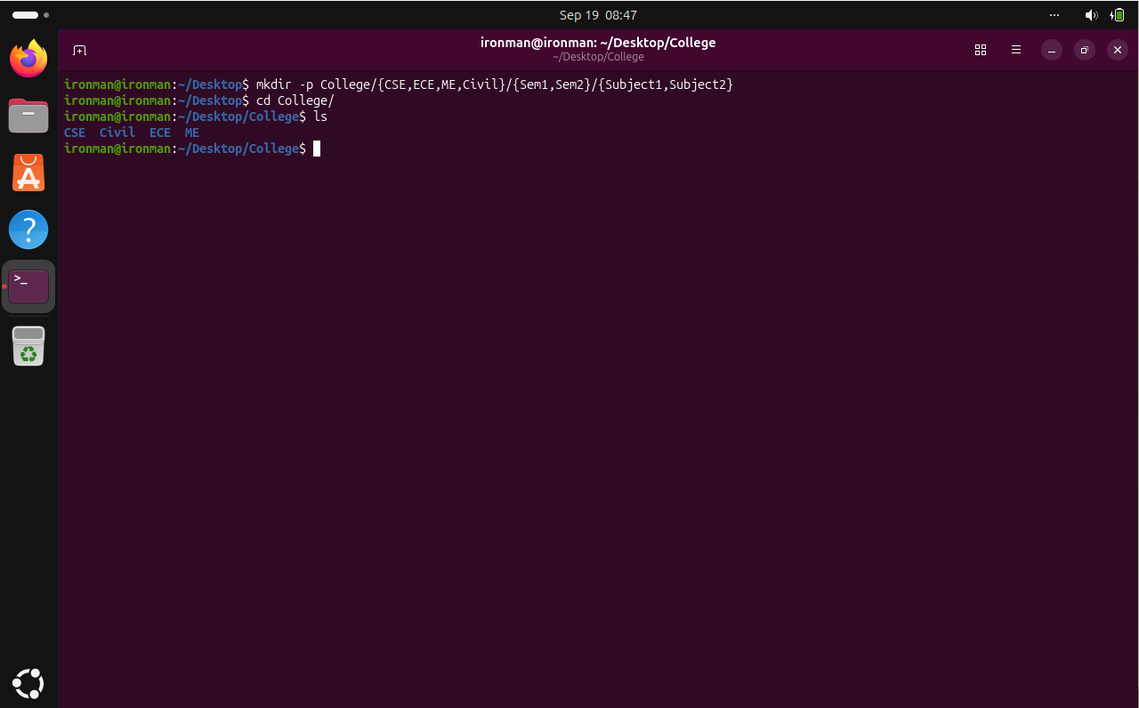

Step 6 – Display the complete department, semester and subject structure using tree
We used tree to display the complete College hierarchy, including all departments, semesters and subject folders.
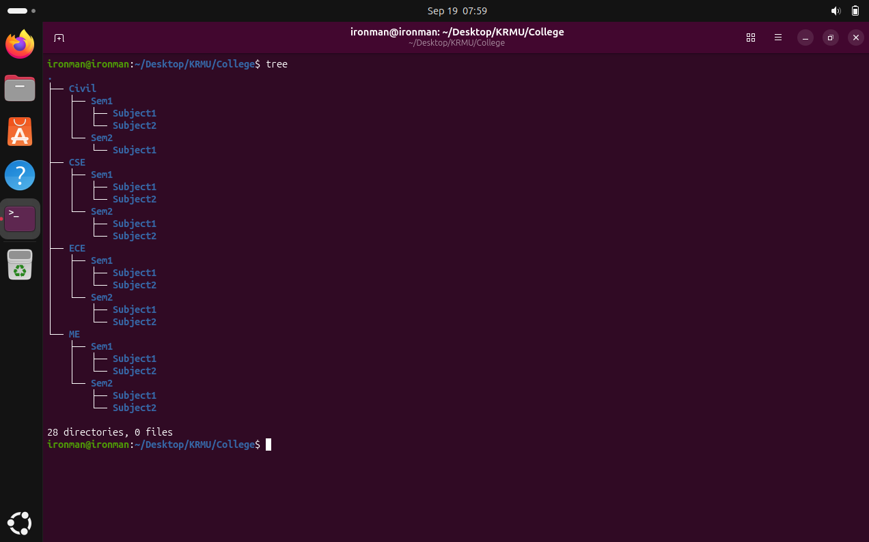

Step 7 – Enter CSE/Sem1 and verify the subjects
We entered the CSE/Sem1 directory using cd and used ls to verify that Subject1 and Subject2 were present.
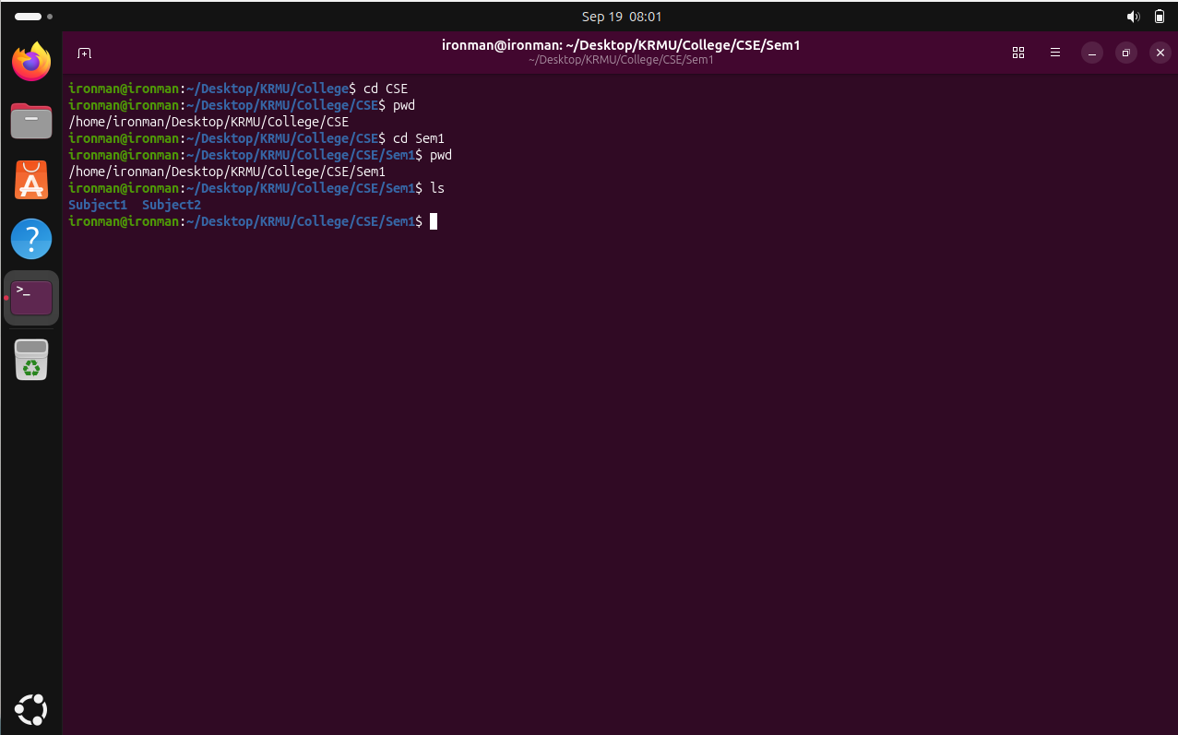

Step 8 – Remove an empty subject directory using rmdir
We used rmdir to remove the empty College/Civil/Sem2/Subject2 directory and then used ls to confirm that only Subject1 remained in Sem2.
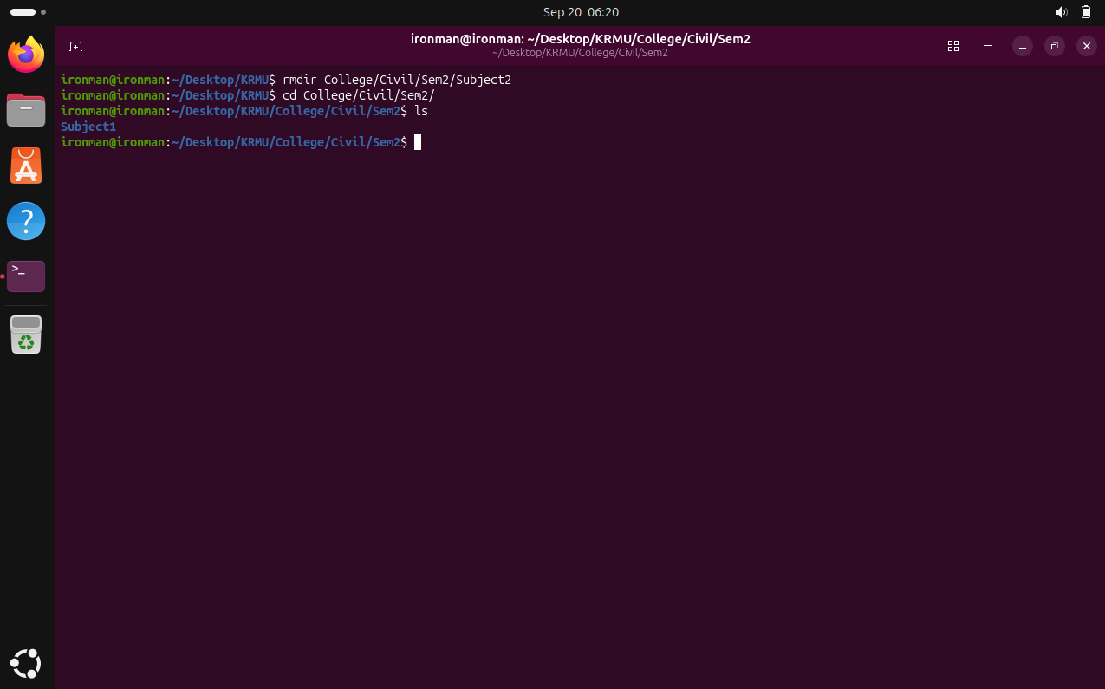

Step 9 – Display the recursive directory listing
We used ls -R College | head -20 to display the first 20 lines of the recursive College directory listing.
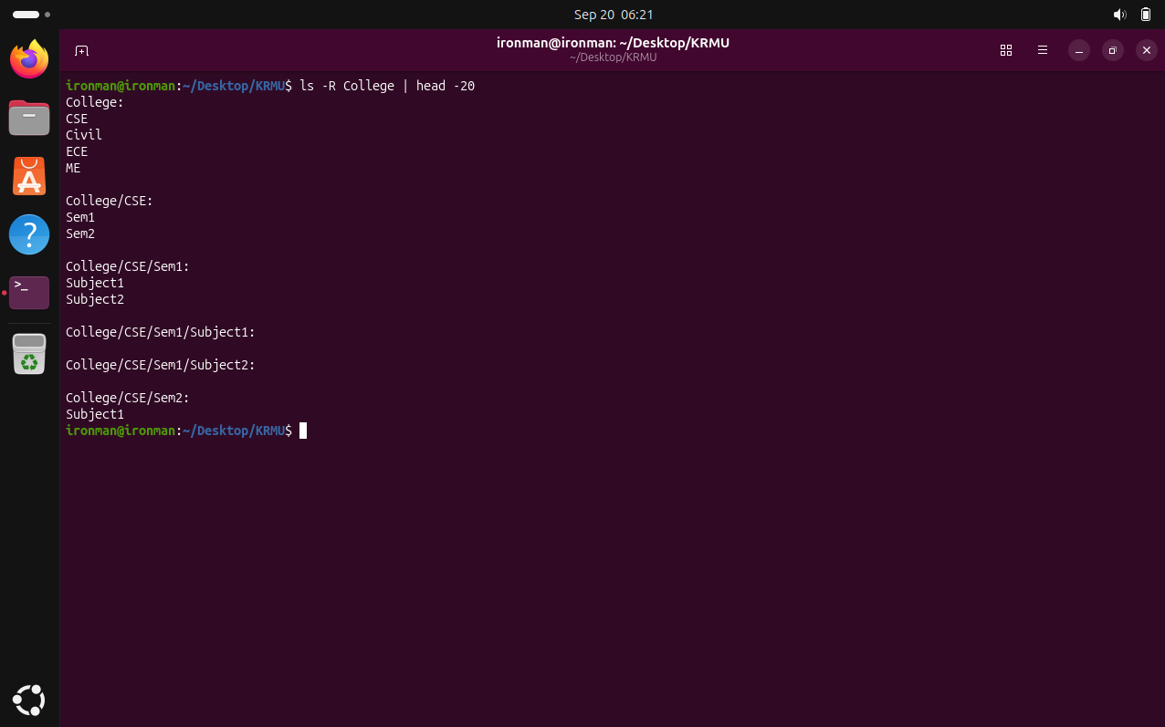

Question 4
Configure file permissions and ownership.

Step 1 – Create permission.txt and verify the file
We created permission.txt using touch and used ls to verify that the file was created successfully.
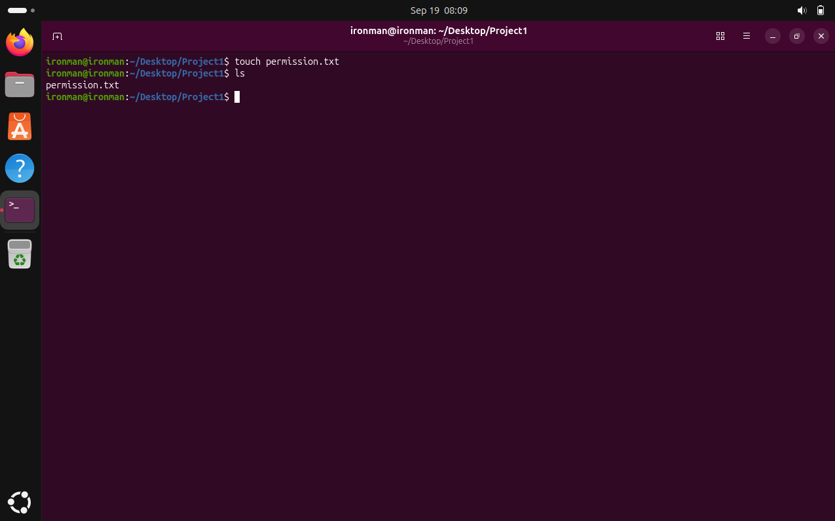

Step 2 – View the initial file permissions
We used ls -l to display the initial permissions, owner, group, size and other file details for permission.txt.
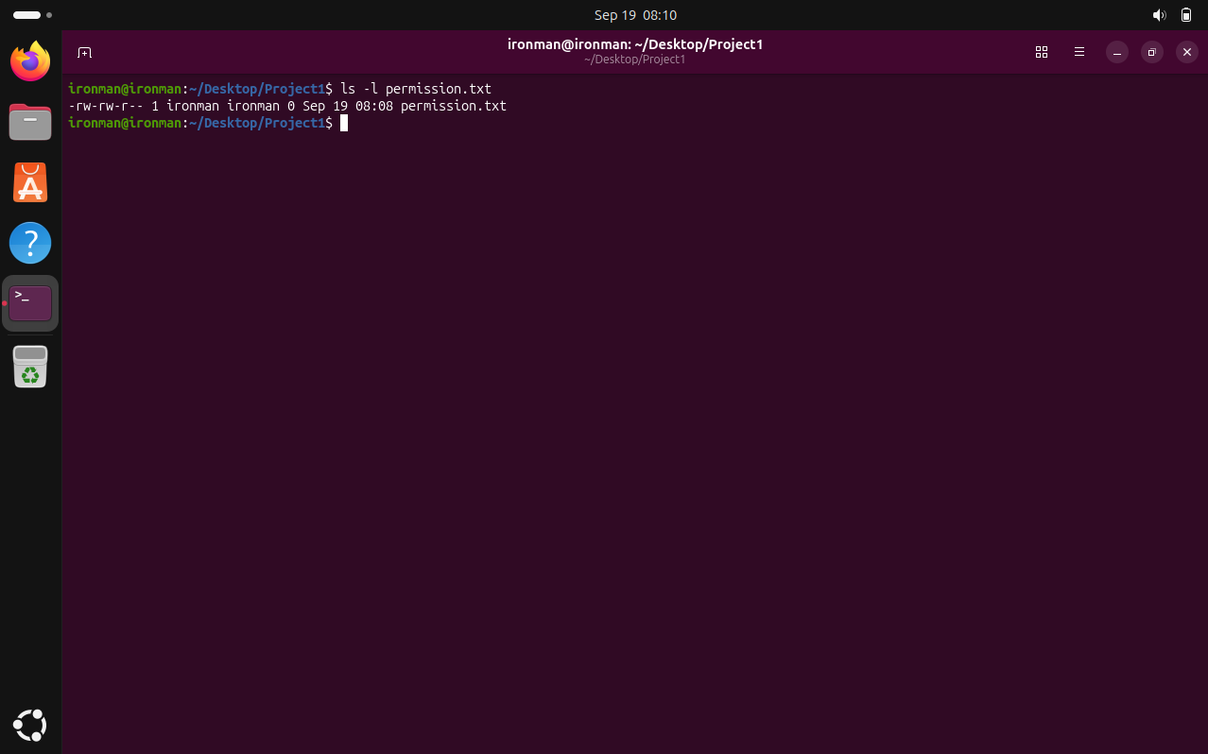

Step 3 – Change permissions to 755
We changed the permissions of permission.txt to 755 using chmod and then verified the new permissions with ls -l.
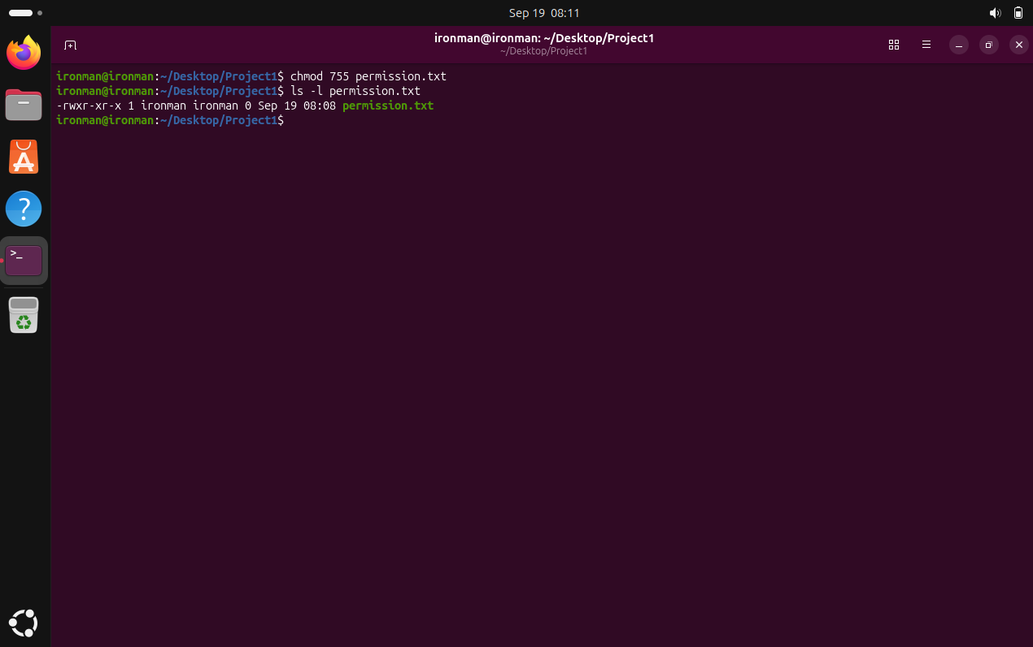

Step 4 – Change permissions to 644
We changed the permissions back to 644 using chmod and verified the result with ls -l.
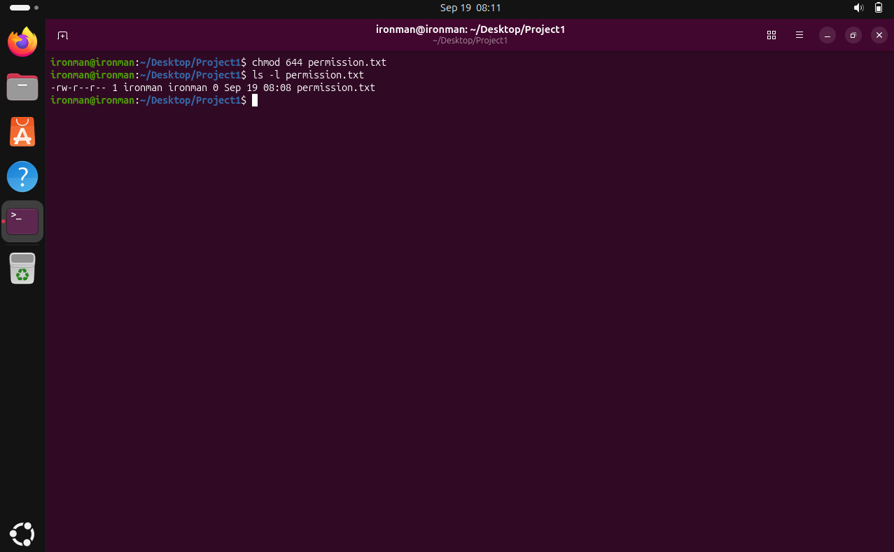

Step 5 – View detailed file information
We used stat to view detailed information about permission.txt, including its permissions, owner, group, size and timestamps.
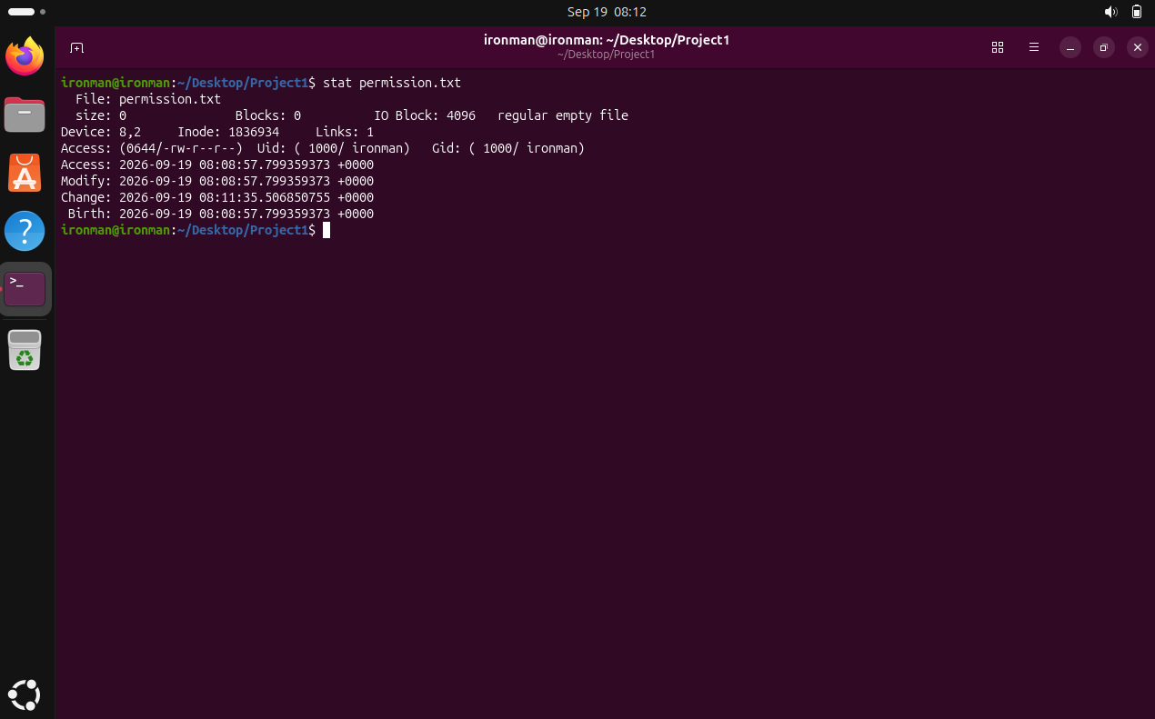

Step 6 – Change file ownership
We used chown to set the owner and group of permission.txt to ironman and then used ls -l to verify the ownership.
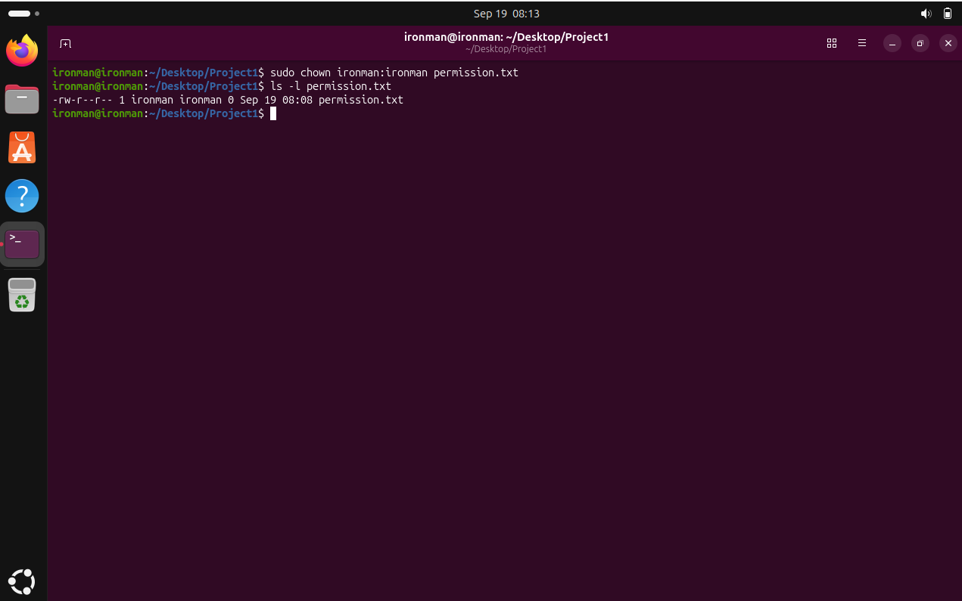

Step 7 – Verify the file information again
We ran stat again to verify the detailed metadata of permission.txt after the ownership operation.
