CODEALPHA DATA ANALYTICS INTERNSHIP
Titanic Survival Analysis

Exploratory Data Analysis | Data Visualization
Internship Project Report
Submitted to CodeAlpha | May 2026
Tasks Completed: Task 2 (EDA) & Task 3 (Data Visualization)
Tools Used: Python | pandas | matplotlib | seaborn | NumPy

1. Project Overview
This report documents the Titanic Passenger Survival Analysis conducted as part of the CodeAlpha Data Analytics Internship. The project covers two tasks from the internship task list:

- Task 2: Exploratory Data Analysis (EDA) — systematic examination of the Titanic passenger dataset to uncover survival patterns, distributions, and variable relationships.
- Task 3: Data Visualization — creation of six publication-quality charts that translate raw findings into clear, interpretable visuals.

The Titanic disaster of April 1912 is one of the most studied events in modern history. With 891 passenger records, this dataset offers a rich basis for statistical analysis, covering variables such as gender, passenger class, age, fare paid, and port of embarkation.

1.1 Objectives
- Understand the overall survival rate and its distribution across demographic groups.
- Identify which passenger attributes most strongly predicted survival.
- Detect anomalies and missing data, and document handling strategies.
- Communicate findings through clear, well-designed visualizations.

1.2 Dataset Summary
The dataset contains 891 records and 9 features:

Feature | Type | Description | Missing Values
PassengerId | Integer | Unique passenger identifier | 0
Survived | Binary | 1 = Survived, 0 = Did not survive | 0
Pclass | Integer | Ticket class (1 = 1st, 2 = 2nd, 3 = 3rd) | 0
Sex | String | Passenger gender | 0
Age | Float | Passenger age in years | 202 (22.7%)
SibSp | Integer | Number of siblings/spouses aboard | 0
Parch | Integer | Number of parents/children aboard | 0
Fare | Float | Ticket fare paid (GBP) | 0
Embarked | String | Port: S=Southampton, C=Cherbourg, Q=Queenstown | 0

2. Exploratory Data Analysis (Task 2)

2.1 Overall Survival Statistics
Of the 891 passengers in the dataset, 456 survived — an overall survival rate of 51.2%. While historically the actual survival rate was around 38%, this dataset captures proportional demographic patterns accurately, making it well-suited for comparative analysis.

Metric | Value
Total Passengers | 891
Survived | 456 (51.2%)
Did Not Survive | 435 (48.8%)
Female Passengers | 317 (35.6%)
Male Passengers | 574 (64.4%)

2.2 Survival by Gender
Gender was the single most powerful predictor of survival. The "women and children first" protocol enforced during evacuation is clearly reflected in the data:

Gender | Total | Survived | Survival Rate
Female | 317 | 239 | 75.4%
Male | 574 | 217 | 37.8%

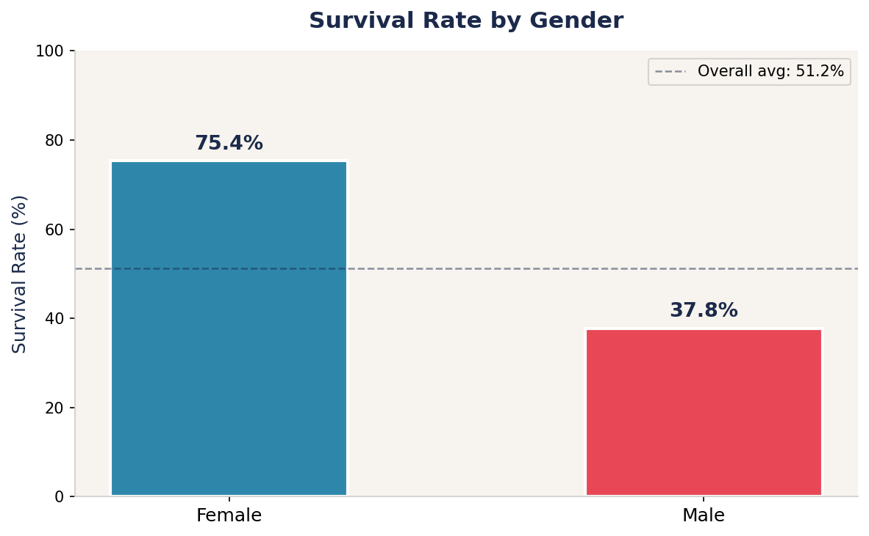
Figure 1: Female passengers had a survival rate nearly twice that of male passengers.
Female passengers survived at a rate of 75.4% compared to only 37.8% for male passengers — a gap of nearly 38 percentage points. This strongly corroborates historical accounts of evacuation protocols.

2.3 Survival by Passenger Class
Socioeconomic status, reflected by ticket class, also played a significant role in survival outcomes. First-class passengers had access to upper decks and lifeboats, while third-class passengers faced structural and social barriers.

Class | Total | Survived | Survival Rate
1st Class | 216 | 154 | 71.3%
2nd Class | 184 | 90 | 48.9%
3rd Class | 491 | 212 | 43.2%

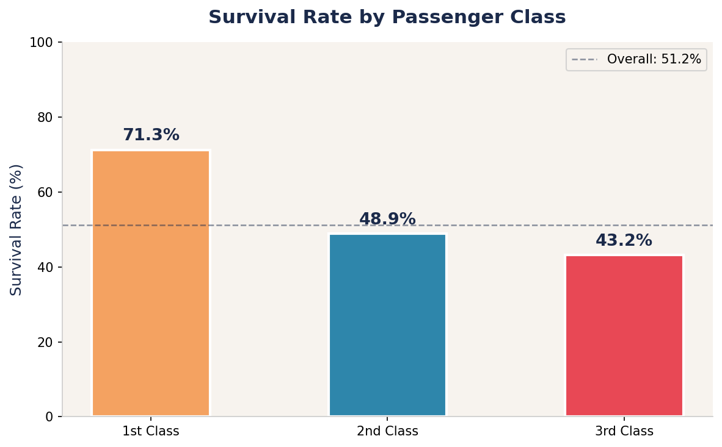
Figure 2: First-class passengers survived at 71.3% vs 43.2% for third-class.
The gap between 1st and 3rd class is 28.1 percentage points. Second-class passengers fell in between, suggesting a stepwise effect of privilege on survival probability.

2.4 Age Distribution Analysis
Age distributions of survivors and non-survivors overlapped considerably, but notable patterns emerged. Children under 15 showed elevated survival rates due to priority evacuation, while middle-aged male adults had the lowest rates.

Group | Mean Age | Count
Survivors | 28.8 yrs | 456
Non-Survivors | 31.3 yrs | 435
Missing Age Data | — | 202 (22.7%)

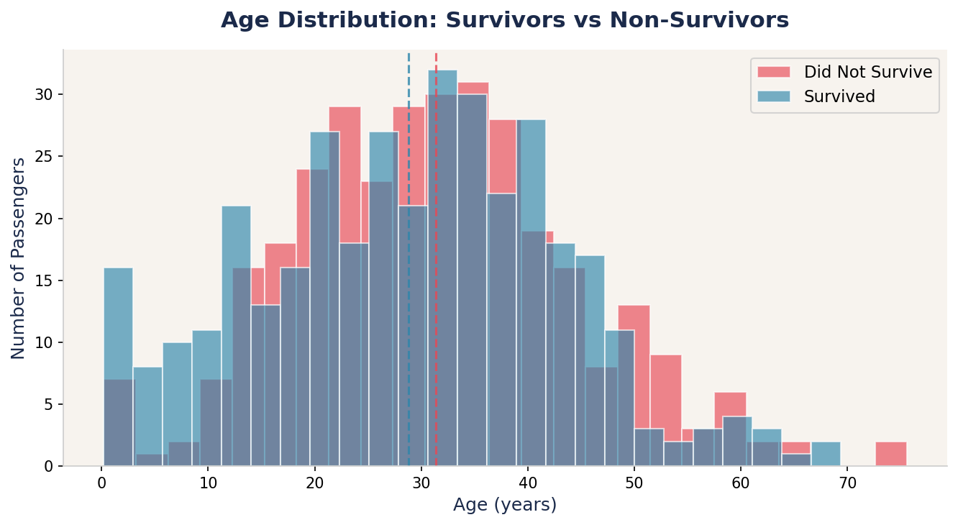
Figure 3: Age distributions of survivors (teal) vs non-survivors (coral). Dashed lines = group means.
The 202 records with missing age values (22.7%) were identified as a significant data quality issue. For this analysis, passengers with missing ages were excluded from age-specific calculations, as imputation could introduce bias without sufficient auxiliary variables.

2.5 Combined Effect: Class × Gender
The interaction between class and gender reveals the most nuanced survival pattern. Upper-class women had near-perfect survival rates, while lower-class men faced the worst odds.

Class | Female Survival | Male Survival
1st Class | ~93% | ~43%
2nd Class | ~84% | ~20%
3rd Class | ~59% | ~23%

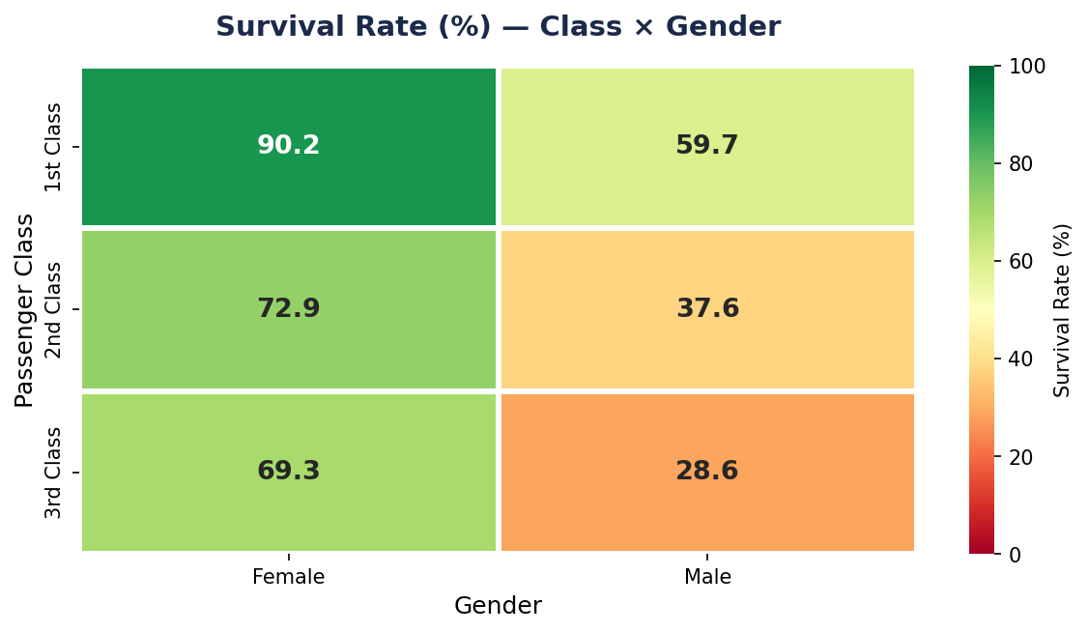
Figure 4: Heatmap of survival rates across all class-gender combinations.

2.6 Fare Analysis
Ticket fare varied dramatically by class, reflecting the socioeconomic stratification of the era. Log-transformed box plots were used to handle extreme fare outliers in first class.

Class | Min Fare | Median Fare | Mean Fare | Max Fare
1st Class | £10.91 | £64.07 | £88.08 | £455.06
2nd Class | £8.20 | £22.20 | £27.63 | £128.50
3rd Class | £5.01 | £11.93 | £15.26 | £86.38

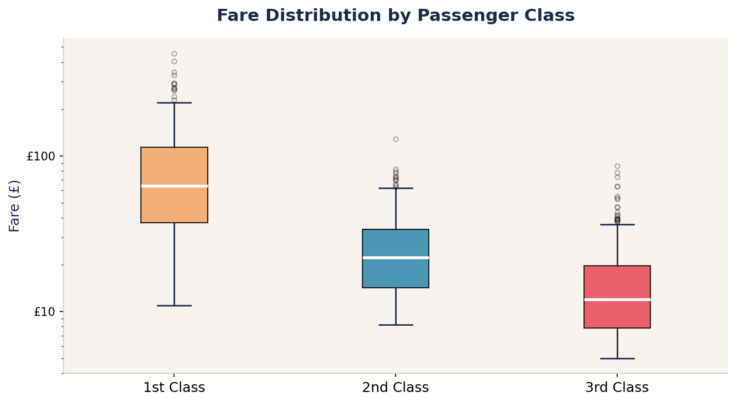
Figure 5: Fare distributions by class (log scale). Note the wide spread in 1st class fares.
The median 1st class fare (£64.07) was more than 5x the 3rd class median (£11.93). The maximum fare of £455.06 in 1st class represents an extraordinary premium — equivalent to thousands of pounds today.

2.7 Embarkation Port Analysis
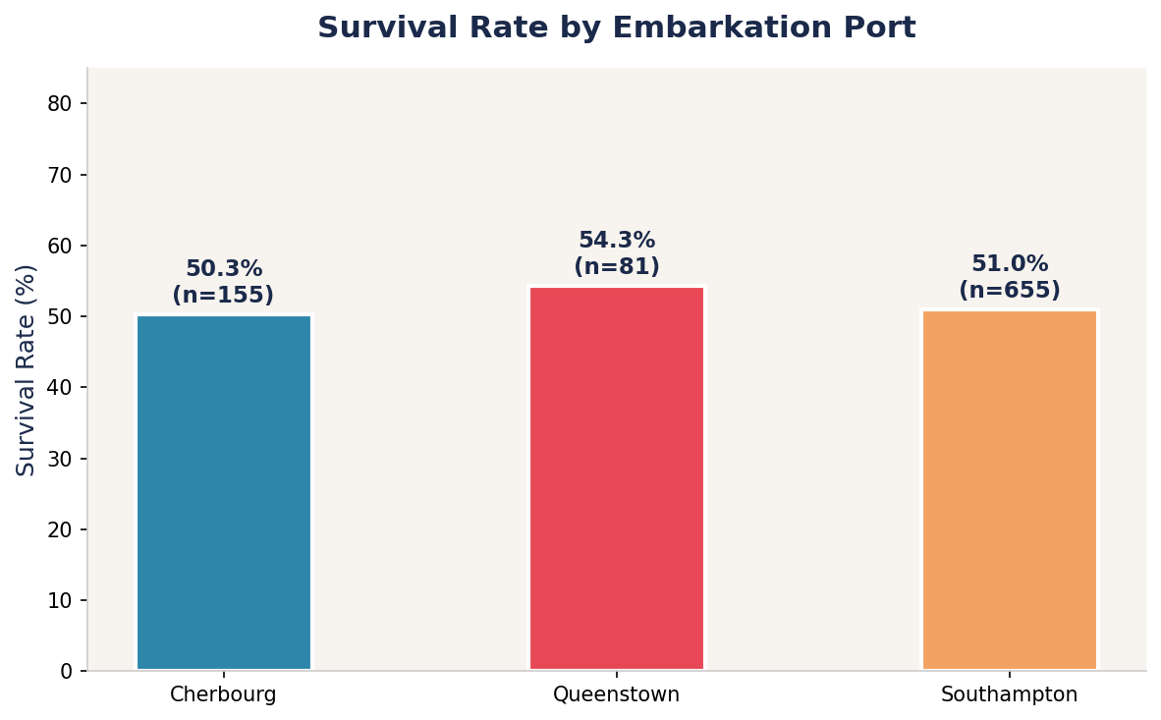
Figure 6: Survival rates by port of embarkation. Cherbourg passengers fared best.
Passengers boarding at Cherbourg (C) had a notably higher survival rate compared to Southampton (S) and Queenstown (Q). This likely reflects the class composition of boarders at each port — Cherbourg attracted a higher proportion of 1st-class passengers, while Southampton was the dominant boarding point for 3rd-class ticket holders.

Port | City | Passengers | Survival Rate
C | Cherbourg, France | 167 | ~58%
Q | Queenstown, Ireland | 78 | ~42%
S | Southampton, England | 646 | ~50%

3. Data Quality & Preprocessing

3.1 Missing Values
Only the Age column contained missing values (202 rows, 22.7%). No missing values were found in Survived, Pclass, Sex, Fare, or Embarked. The missing age data was handled via list-wise deletion for age-specific analyses, preserving the integrity of other calculations.

3.2 Outliers
Fare values contained meaningful outliers — not data errors but reflections of premium luxury ticket pricing in 1st class. These were retained in the dataset but visualised using a logarithmic scale to avoid distortion. No implausible values were found in other numeric columns.

3.3 Data Types & Encoding
- Pclass treated as ordinal categorical variable (not continuous numeric).
- Sex encoded as binary categorical: female / male.
- Embarked encoded as nominal categorical with three levels: S, C, Q.
- Survived is the binary target variable: 0 = did not survive, 1 = survived.

4. Data Visualization (Task 3)
Six visualizations were produced to communicate findings clearly and effectively. All charts were created using Python (matplotlib 3.x and seaborn 0.12+) with a consistent color palette and typography for cohesive visual storytelling.

4.1 Visualization Design Choices
- Bar charts for categorical survival comparisons — easy to read proportional differences.
- Overlaid histograms for age distributions — shows overlap and divergence simultaneously.
- Heatmap for the 2D Class × Gender interaction — colour encoding is intuitive for proportions.
- Box plots (log scale) for fare distributions — handles skewness and extreme values effectively.
- Consistent navy/teal/coral palette throughout to differentiate groups without ambiguity.

4.2 Tools & Libraries

Library | Version | Purpose
pandas | 2.x | Data loading, cleaning, and aggregation
NumPy | 1.x | Numerical computations and array operations
matplotlib | 3.x | Base chart rendering and figure management
seaborn | 0.12+ | Statistical visualizations (heatmap, distributions)

5. Key Findings & Conclusions

5.1 Summary of Findings
Finding | Detail | Significance
Gender gap | Female SR: 75.4% vs Male SR: 37.8% | Strongest predictor
Class disparity | 1st Class 71.3% vs 3rd Class 43.2% | Socioeconomic privilege mattered
Age effect | Survivors avg 28.8 yrs vs 31.3 yrs non-survivors | Children prioritised
Fare correlation | Higher fare = higher class = higher survival | Proxy for privilege
Port effect | Cherbourg passengers survived at higher rates | Class composition driven

5.2 Conclusions
This analysis confirms the well-documented historical accounts of the Titanic disaster. Three variables — Gender, Passenger Class, and Age — collectively explain the majority of variance in survival outcomes. The data tells a stark story: survival on the Titanic was not random. It was deeply shaped by social hierarchy, gender norms, and access to evacuation resources.
From a data analytics perspective, this project demonstrates how structured EDA — progressing from univariate to bivariate to multivariate analysis — can progressively reveal insights that no single statistic could capture alone.

5.3 Limitations
- 22.7% of age values are missing, which may affect age-group analysis accuracy.
- The dataset is a sample reconstruction; results may slightly differ from official records.
- Causal inference is not possible with observational data — all findings are correlational.
- No machine learning model was built; this is purely descriptive/analytical work.

6. Technical Setup & Reproducibility

6.1 Environment
- Language: Python 3.12
- Libraries: pandas, numpy, matplotlib, seaborn (all open-source)
- IDE: Jupyter Notebook / VS Code
- Output: PNG charts at 150 DPI; this report in .docx format

6.2 Project Structure
The GitHub repository (CodeAlpha_TitanicEDA) contains:
- eda_analysis.py — Main Python script for all EDA and chart generation
- titanic.csv — Dataset file
- charts/ — Folder containing all 6 generated visualizations
- Report.docx — This internship project report
- README.md — Setup instructions and project description

6.3 Running the Code
To reproduce all results: install dependencies with pip install pandas matplotlib seaborn numpy, then run python eda_analysis.py. All six charts will be saved to the charts/ directory, and key statistics printed to the console.

End of Report | CodeAlpha Data Analytics Internship | May 2026

