**CONTENT:**

* **ARQ**
* **Aim**
* **Software Requirement**
* **Goback N**
* **Theory(3)**
* **Operations(4)**
* **Algorithm for GoBackN(4-5)**
* **Code (5-6)**
* **Output(7)**
* **Selective Repeat ARQ**
* **Theory(8-9)**
* **Advantage and Disadvantage(9)**
* **Algorithm(10)**
* **Code(11-12)**
* **Output(12)**
* **Result(12)**

**AIM:**

To Simulate and to study of Go Back N protocol

**Automatic Repeat reQuest (ARQ):**

Automatic Repeat reQuest (ARQ) is a communication protocol that uses feedback from the receiver to detect and request the retransmission of lost or corrupted data. The primary purpose of ARQ is to ensure reliable communication in the presence of errors or losses in the transmission medium. ARQ protocols are commonly used in network communication, including both wired and wireless networks.

There are several types of ARQ protocols, and they can be broadly classified into three categories:

**Go-Back-N ARQ:**

Go-Back-N ARQ is a sliding window protocol that allows the sender to transmit multiple frames before receiving acknowledgments from the receiver.

The sender maintains a window of frames, and the receiver sends cumulative acknowledgments, indicating the highest correctly received frame. If a frame is lost or corrupted, the receiver requests the sender to retransmit all frames starting from the one that was not received correctly.

**Selective Repeat ARQ:**

Selective Repeat ARQ is another sliding window protocol where the sender can transmit multiple frames, and the receiver sends individual acknowledgments for each correctly received frame.

In case of a lost or corrupted frame, the receiver requests retransmission of only that specific frame rather than all frames starting from a particular point.

Each type of ARQ protocol has its advantages and disadvantages, and the choice of which to use depends on factors such as the characteristics of the communication channel, error rates, and the desired trade-off between complexity and efficiency. ARQ protocols play a crucial role in achieving reliable data transmission in various network environments.

**SOFTWARE REQUIREMENTS:**

1. NS-2 Simulator
2. Nam
3. Xgraph(optional)

**THEORY:**

Go Back N is a connection oriented transmission. The sender transmits the frames continuously. Each frame in the buffer has a sequence number starting from 1 and increasing up to the window size. The sender has a window i.e. a buffer to store the frames. This buffer size is the number of frames to be transmitted continuously. The size of the window depends on the protocol designer.

**OPERATIONS:**

1. A station may send multiple frames as allowed by the window size.

2. Receiver sends an ACK i if frame i has an error. After that, the receiver discards all incoming frames until the frame with error is correctly retransmitted.

3. If sender receives an ACK i it will retransmit frame i and all packets i+1, i+2,... which have been sent, but not been acknowledged

**ALGORITHM FOR GO BACK N**

1. The source node transmits the frames continuously.

2. Each frame in the buffer has a sequence number starting from 1 and increasing up to the window size.

3. The source node has a window i.e. a buffer to store the frames. This buffer size is the number of frames to be transmitted continuously.

4. The size of the window depends on the protocol designer.

5. For the first frame, the receiving node forms a positive acknowledgement if the frame is received without error.

6. If subsequent frames are received without error (up to window size) cumulative positive acknowledgement is formed.

7. If the subsequent frame is received with error, the cumulative acknowledgment error-free frames are transmitted. If in the same window two frames or more frames are received with error, the second and the subsequent error frames are neglected. Similarly even the frames received without error after the receipt of a frame with error are neglected.

8. The source node retransmits all frames of window from the first error frame.

9. If the frames are errorless in the next transmission and if the acknowledgment is error free, the window slides by the number of error-free frames being transmitted.

10.If the acknowledgment is transmitted with error, all the frames of window at source are retransmitted, and window doesn’t slide.

11.This concept of repeating the transmission from the first error frame in the window is called as GOBACKN transmission flow control protocol.

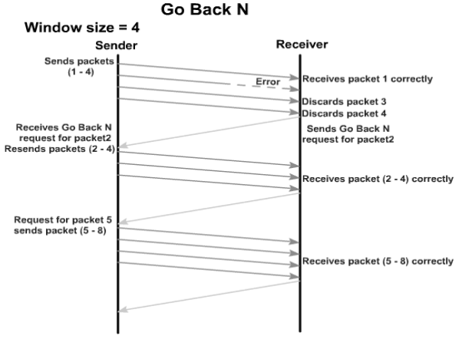

**Code:**

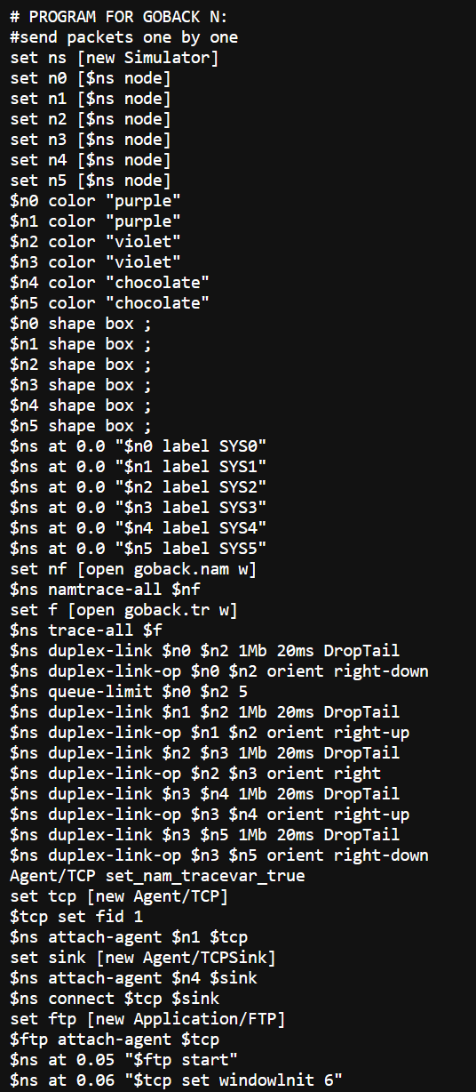

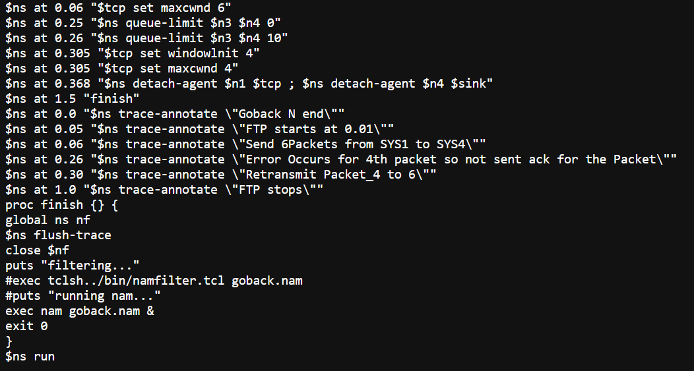

**OUTPUT**

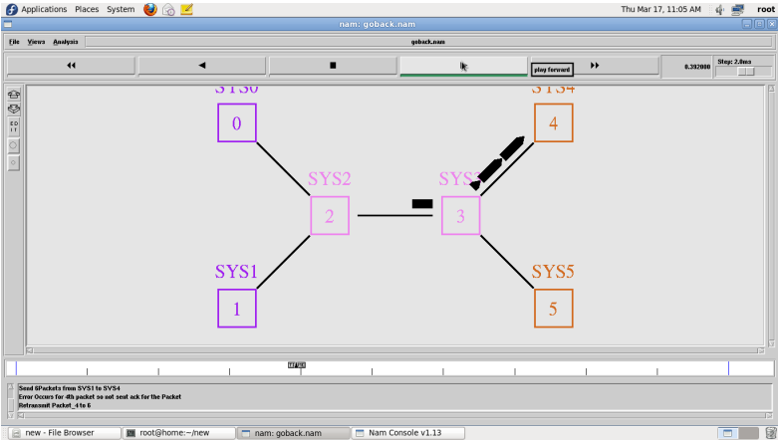

**Selective Repeat ARQ**

is a specific instance of the Automatic Repeat-reQuest (ARQ) Protocol. It may be used as a protocol for the delivery and acknowledgement of message units, or it may be used as a protocol for the delivery of subdivided message sub-units. When used as the protocol for the delivery of messages, the sending process continues to send a number of frames specified by a window size even after a frame loss. Unlike GoBack-N ARQ, the receiving process will continue to accept and acknowledge frames sent after an initial error. The receiver process keeps track of the sequence number of the earliest frame it has not received, and sends that number with every ACK it sends. If a frame from the sender does not reach the receiver, the sender continues to send subsequent frames until it has emptied its window. The receiver continues to fill its receiving window with the subsequent frames, replying each time with an ACK containing the sequence number of the earliest missing frame. Once the sender has sent all the frames in its window, it re-sends the frame number given by the ACKs, and then continues where it left off. The size of the sending and receiving windows must be equal, and half the maximum sequence number (assuming that sequence numbers are numbered from 0 to n-1) to avoid miscommunication in all cases of packets being dropped. To understand this, consider the case when all ACKs are destroyed. If the receiving window is larger than half the maximum sequence number, some, possibly even all, of the packages that are resent after timeouts are duplicates that are not recognized as such. The sender moves its window for every packet that is acknowledged.

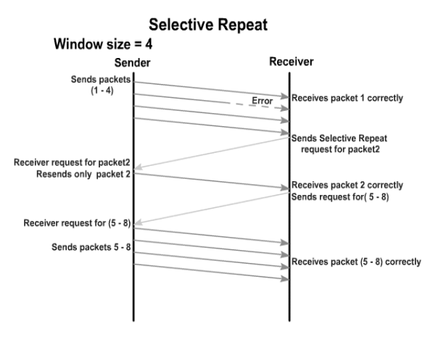

**Advantage over Go Back N:**

1. Fewer retransmissions.

**Disadvantages:**

1. More complexity at sender and receiver

2. Receiver may receive frames out of sequence

**ALGORITHM: SELECTIVE REPEAT**

1. The source node transmits the frames continuously.

2. Each frame in the buffer has a sequence number starting from 1 and increasing up to the window size.

3. The source node has a window i.e. a buffer to store the frames. This buffer size is the number of frames to be transmitted continuously.

4. The receiver has a buffer to store the received frames. The size of the buffer depends upon the window size defined by the protocol designer.

5. The size of the window depends according to the protocol designer.

6. The source node transmits frames continuously till the window size is exhausted. If any of the frames are received with error only those frames are requested for retransmission (with a negative acknowledgement)

7. If all the frames are received without error, a cumulative positive acknowledgement is sent.

8. If there is an error in frame 3, an acknowledgement for the frame 2 is sent and then only Frame 3 is retransmitted. Now the window slides to get the next frames to the window.

9. If acknowledgment is transmitted with error, all the frames of window are retransmitted. Else ordinary window sliding takes place. (* In implementation part, Acknowledgment error is not considered)

10. If all the frames transmitted are errorless the next transmission is carried out for the new window. 11.This concept of repeating the transmission for the error frames only is called Selective Repeat transmission flow control protocol.

**CODE**

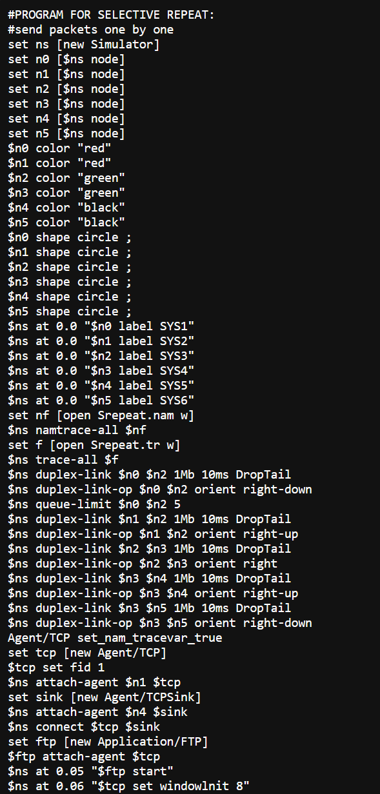

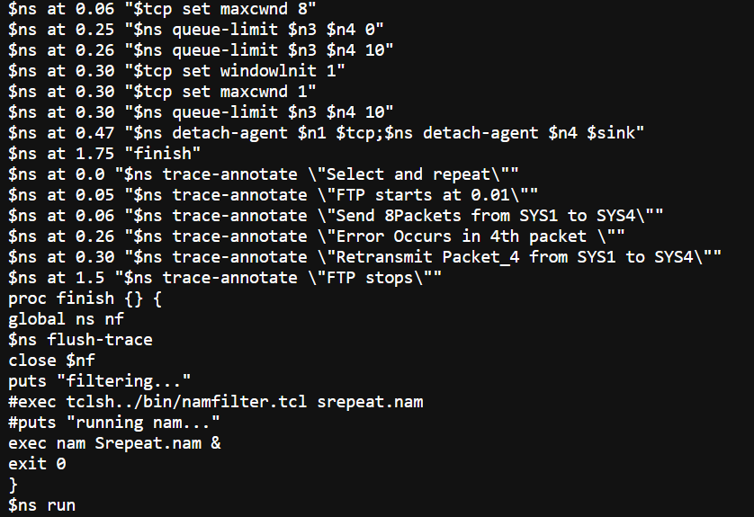

**OUTPUT**

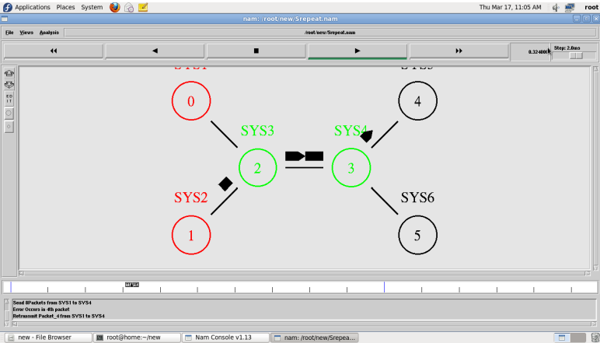

**RESULT:**

Thus the Go back N and Selective Repeat protocols were Simulated and studied.