CONTENTS

1. Introduction

1.1 The importance of encryption (2)

1.2 Symmetric and Asymmetric cryptography (2,4)

1.3 Historical context (4,5)

1.3.1 Hill Cipher

1.3.2 One time Padding

1.4 Objectives (6)

2.Hill Cipher Technique

2.1 Encryption (6,8)

2.2 Decryption (8,9)

2.3 Advantages and Disadvantages (9,10)

2.4 Implementation in Python and Output (11,13)

2.One Time Padding Technique

3.1 Encryption (14,15)

3.2 Decryption (15)

3.3 Advantages and Disadvantages (15,16)

3.4 Implementation in Python (17,18)

Tools used (18)

References (18)

1. **Introduction**

In an era characterized by digital communication and the rapid exchange of information, the need for secure communication has never been more critical. Cryptography, the art and science of secure communication, plays a pivotal role in safeguarding sensitive data from prying eyes. This project delves into the realm of classical encryption techniques, specifically focusing on two well-established methods: the Autokey Cipher and the Affine Cipher. These ciphers, though devised in a different technological era, remain significant in understanding the fundamentals of encryption and decryption.

* 1. **The Importance of Encryption**

Encryption serves as the foundation of secure data transmission and confidentiality in the digital age. It involves the process of converting plaintext messages into ciphertext, rendering them unreadable to anyone without the appropriate decryption key. The significance of encryption lies in its ability to ensure the privacy and integrity of information, guarding against eavesdroppers, hackers, and unauthorized access. This importance extends to various domains, including secure communications, data protection, and digital privacy.

* 1. **Symmetric and Asymmetric Cryptography**

In the realm of cryptography, there are two primary categories of encryption techniques: symmetric and asymmetric cryptography.

* **Symmetric Cryptography**: Symmetric encryption, also known as private key encryption, relies on a single shared key for both encryption and decryption. It is known for its efficiency in terms of speed and simplicity, making it suitable for a wide range of applications, including securing data at rest and in transit.

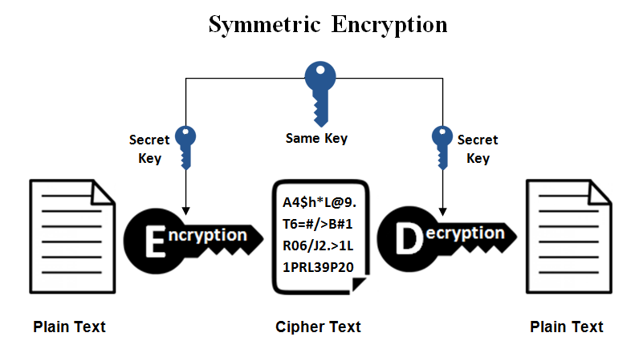

* **Asymmetric Cryptography**: Asymmetric encryption, also known as public key encryption, uses a pair of keys: a public key for encryption and a private key for decryption. Asymmetric cryptography is particularly valuable for securely exchanging keys and verifying the authenticity of communication partners. While the ‘Autokey Cipher’ and the ‘Affine Cipher’ are examples of symmetric encryption techniques, they offer insights into the core principles of cryptography that extend to both symmetric and asymmetric cryptography.

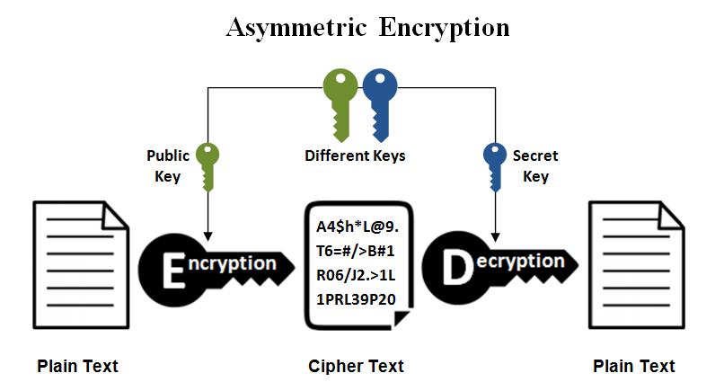

* 1. **Historical Context**

The Hill Cipher and the One-Time Pad Encryption are two important cryptographic techniques that have played significant roles in the history of secure communication. To fully appreciate their significance and understand their development, it is essential to examine the historical context in which these encryption methods emerged.

* + 1. **Hill Cipher:**

The Hill Cipher, developed by American mathematician Lester S. Hill in 1929, was one of the earliest practical implementations of linear algebra in cryptography. Hill was a professor of electrical engineering at the City College of New York, and his invention marked a significant advancement in the field of cryptography during the early 20th century.

The historical backdrop of the Hill Cipher was marked by the need for more secure methods of encryption, driven in part by the increasing use of telegraphy and telecommunication systems. Traditional methods, such as simple substitution ciphers, were vulnerable to frequency analysis and could be easily decrypted. The Hill Cipher represented a pioneering effort to create a more robust and mathematically rigorous encryption technique.

* + 1. **One-Time Pad Encryption:**

The One-Time Pad, also known as the Vernam Cipher or the Perfect Cipher, has a more intriguing historical background. The concept of a one-time pad encryption system can be traced back to the work of Gilbert S. Vernam and Joseph O. Mauborgne, who were engineers at the American company AT&T in the early 20th century. Their goal was to create an unbreakable encryption method.

The one-time pad was first patented in 1919, but it gained widespread recognition during World War II when it was used for highly secure military communications, most notably by the United States and the Soviet Union. The security of the one-time pad is based on the use of a completely random key, which makes it theoretically unbreakable if implemented correctly.

The historical context of the one-time pad is intrinsically tied to the demand for a secure means of communication during wartime, as conventional cryptographic methods were becoming increasingly vulnerable to cryptanalysis.

* 1. **Objectives**
* Provide a comprehensive understanding of the Autokey Cipher and Affine Cipher encryption and decryption processes.
* Simulate these encryption techniques using software tools.
* Compare and contrast the security, complexity, and practicality of the Autokey Cipher and the Affine Cipher
* Present the results of the simulations to illustrate the functioning of these ciphers in a practical context.

1. **Hill Cipher Technique**

The Hill Cipher is a polygraphic substitution cipher, which means it operates on groups of letters (usually pairs or triplets) rather than individual letters. It uses matrix algebra to perform the encryption and decryption processes. In this technique, a plaintext message is divided into blocks of letters, which are then transformed using a matrix multiplication. The result is a ciphertext that can be sent securely. The recipient can reverse the process using the inverse of the encryption matrix to obtain the original plaintext.

* 1. **Encryption Process**

1. Key Selection:

* Choose a square matrix, often referred to as the encryption key matrix. The size of this matrix depends on the Hill Cipher variant being used, but typically it's a 2x2 or 3x3 matrix.
* Ensure that the key matrix is invertible (its determinant must be relatively prime to the alphabet size, e.g., 26 for the English alphabet).

1. Message Preparation:

* Break the plaintext message into blocks of letters, with each block containing as many letters as the size of the key matrix.
* If the last block has fewer letters than the key matrix size, pad it with additional letters to match the required size.

1. Letter to Number Conversion:

* Assign numerical values to each letter in the alphabet. For example, in English, 'A' might be 0, 'B' 1, and so on, up to 'Z' being 25.

1. Matrix Multiplication:

* Convert each block of plaintext letters into a column vector by mapping each letter to its numerical equivalent.
* Multiply the key matrix by the column vector using matrix multiplication. This results in a new column vector, which represents the ciphertext for that block.
* Mathematically, this can be represented as: Ciphertext block (C) = Key matrix (K) × Plaintext block (P)

1. Modulo Operation:

* To prevent the values from growing too large and to keep them within the range of the alphabet, perform a modulo operation. Typically, the result is taken modulo the alphabet size (e.g., modulo 26 in English).

1. Number to Letter Conversion:

* Convert the numerical values in the resulting column vector back to letters using the inverse mapping from step 3.

1. Ciphertext Composition:

* Repeat the encryption process for each block of the plaintext message, resulting in a series of ciphertext blocks.

1. Concatenation:

* Concatenate the individual ciphertext blocks to form the final ciphertext message.
  1. **Decryption Process**

1. Matrix Multiplication (Inverse):

* Multiply the key matrix (K^(-1)) by the ciphertext block, which is the inverse of the encryption key matrix (K). This step is necessary to retrieve the original plaintext block.
* Mathematically, this can be represented as: Plaintext block (P) = Inverse Key matrix (K^(-1)) × Ciphertext block (C)

1. Modulo Operation:

* Apply a modulo operation to the resulting values in the plaintext block to obtain the original numerical values within the range of the alphabet.

3)Number to Letter Conversion:

* Convert the numerical values in the plaintext block back to letters using the inverse mapping.

1. Concatenation:

* Repeat the decryption process for all ciphertext blocks and concatenate the resulting plaintext blocks to recover the original plaintext message.
  1. **Advantages and Disadvantages**

The Hill Cipher is a historical cryptographic technique that has both advantages and disadvantages. Here are five of each:

* Advantages of Hill Cipher:

1. **Stronger Security**: The Hill Cipher offers a higher level of security compared to traditional substitution ciphers, as it operates on multiple letters at a time, making it less susceptible to frequency analysis.
2. **Mathematical Rigor**: It introduces mathematical concepts, such as matrix algebra, into cryptography, making it suitable for educational purposes and providing a foundation for more advanced cryptographic methods.
3. **Variable Block Size**: The Hill Cipher can accommodate different block sizes depending on the key matrix, allowing for flexibility in message encryption.
4. **Difficult to Crack**: When a sufficiently large key matrix is used, the Hill Cipher becomes resistant to many common cryptanalysis techniques, enhancing its security.
5. **Suitable for Multiple Languages**: The Hill Cipher can be adapted for various languages by adjusting the key matrix and alphabet size, making it versatile for different linguistic applications.

* Disadvantages of Hill Cipher:

1. **Key Management**: Generating and securely sharing the key matrix can be challenging. If the key is compromised, the entire encryption system becomes vulnerable.
2. **Limited Key Space**: The number of possible key matrices is limited, which can make the Hill Cipher vulnerable to brute-force attacks when used with small key sizes.
3. **Known-Plaintext Attacks**: In situations where an attacker knows part of the plaintext and corresponding ciphertext, they may exploit this knowledge to deduce the key matrix.
4. **Blocks Must Be a Multiple of Key Size**: The plaintext message needs to be divided into blocks that are a multiple of the key matrix size, which can result in padding for messages that don't perfectly fit.
5. **Vulnerability to Cryptanalysis**: The Hill Cipher is susceptible to specific attacks, such as those involving known-plaintext, chosen-plaintext, or matrix algebra techniques if a weak key matrix is used, highlighting the importance of careful key selection.
   1. **Implementation**

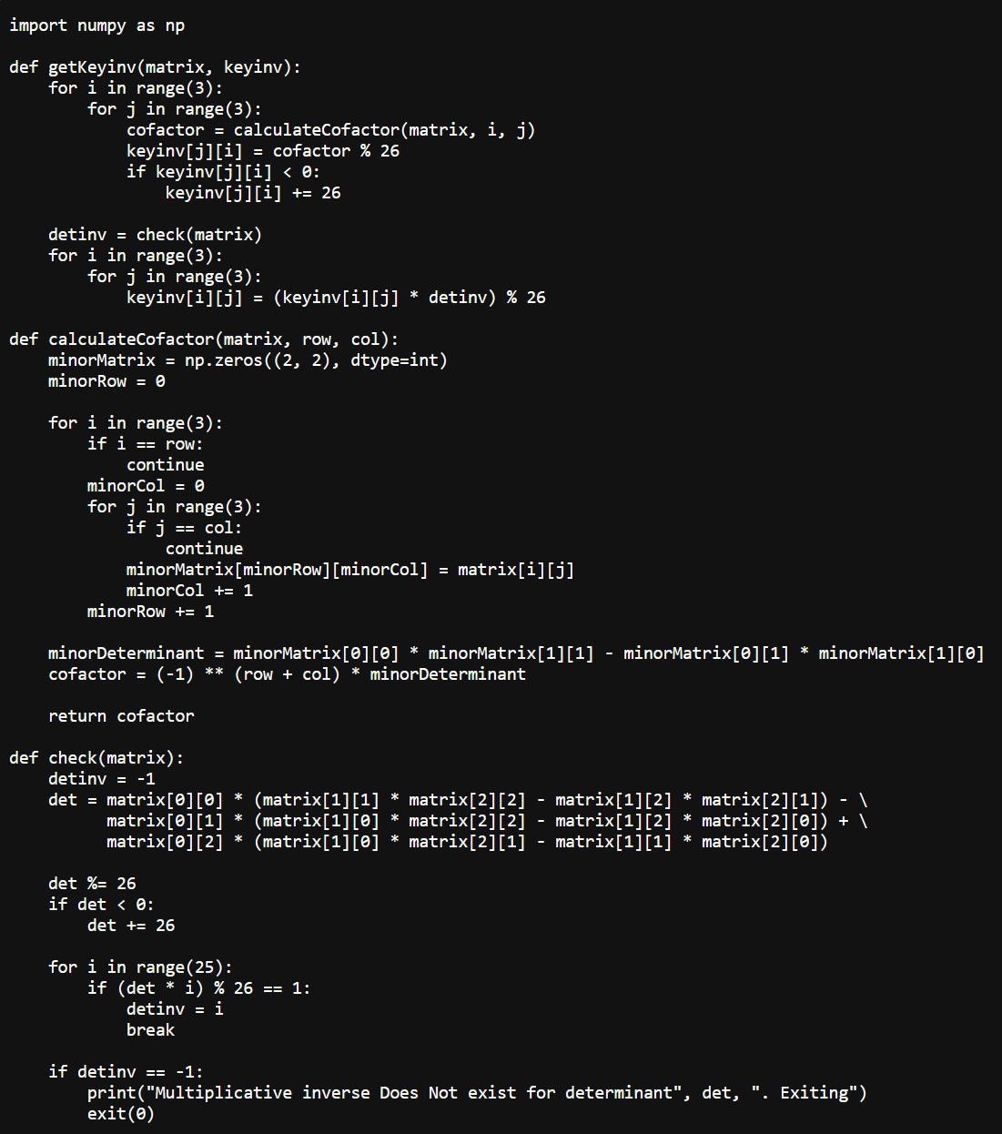

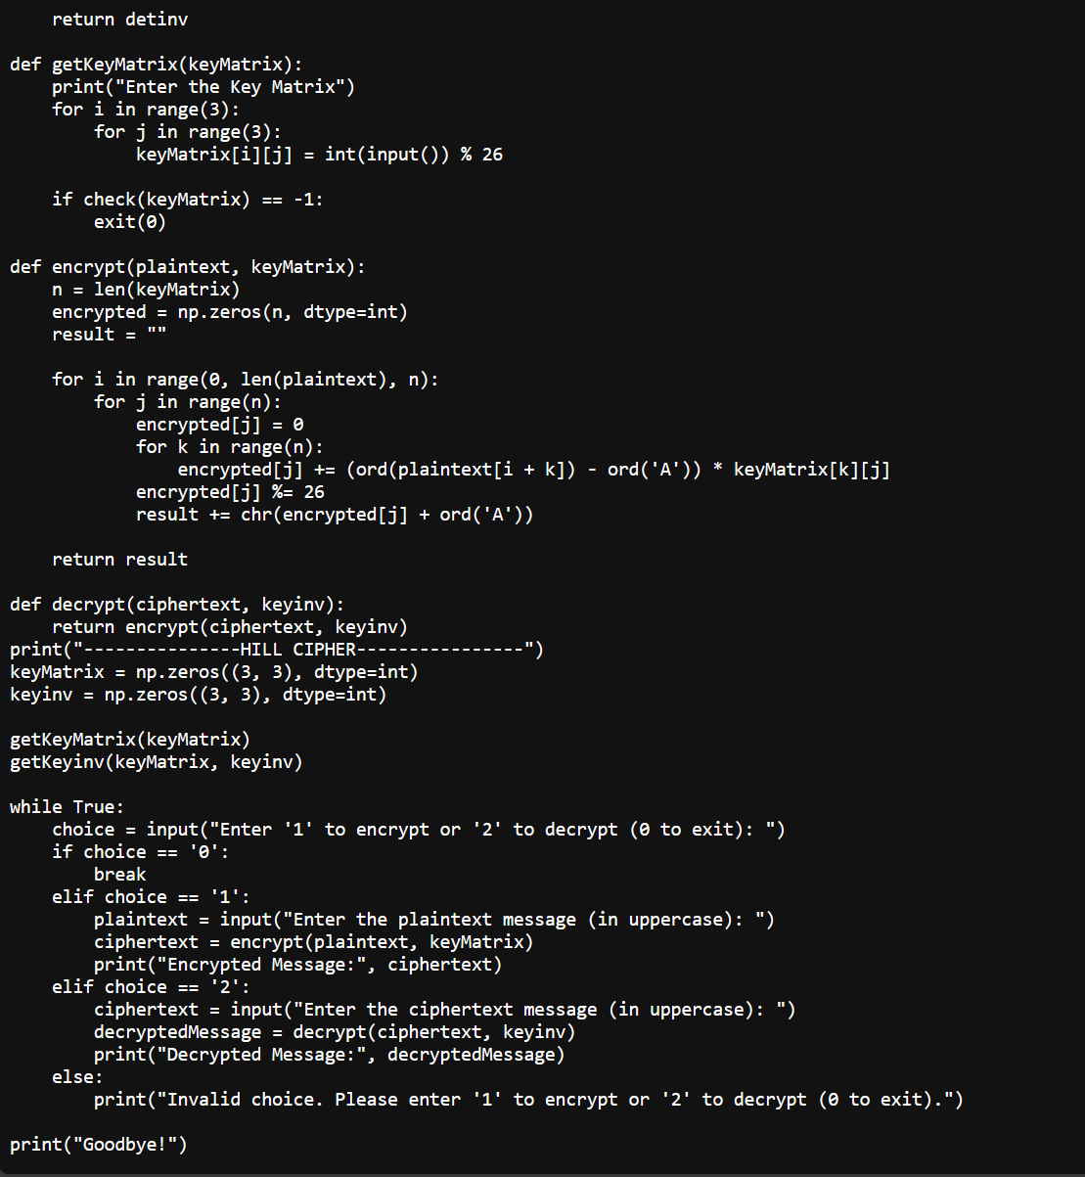

**Output:**

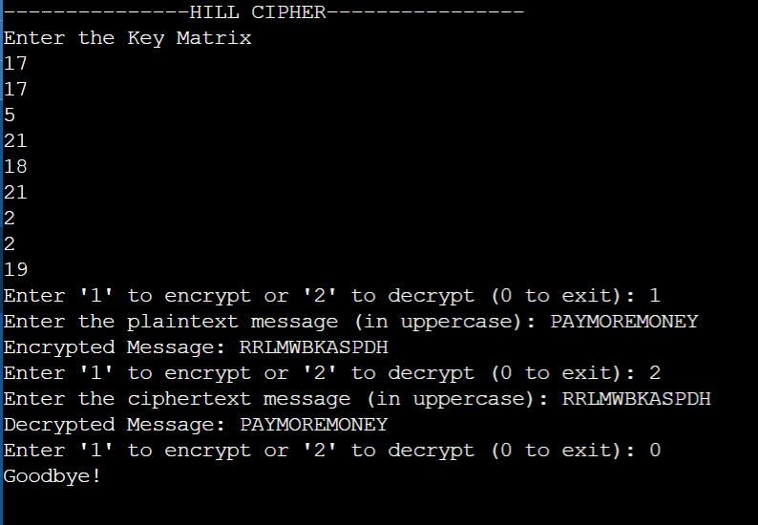

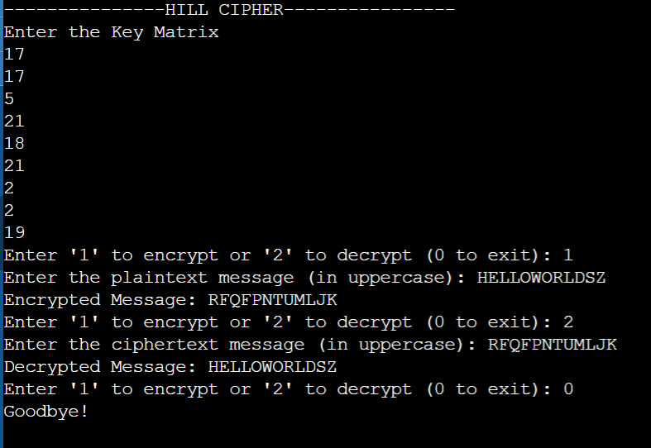

1. **One Time Padding**

The One-Time Pad (OTP) is a cryptographic technique that provides perfect secrecy when implemented correctly. It is a symmetric key encryption method in which each bit or character in the plaintext is XORed (exclusive OR) with a corresponding random bit or character from a secret key. The key is called a "one-time pad" because it should only be used once for a single encryption and decryption process

* 1. **Encryption Process**

1. Key Generation: Create a one-time pad key that is as long as the plaintext message. The key should consist of truly random and unpredictable values, such as random binary digits or characters.
2. Plaintext and Key Alignment: Ensure that the plaintext message and the one-time pad key are aligned, so that each character or bit in the plaintext corresponds to the one in the key.
3. XOR Operation: Perform an XOR operation between each character or bit in the plaintext and the corresponding character or bit in the one-time pad key. This means that if the plaintext bit is 0 and the key bit is 1, the ciphertext bit will be 1, and vice versa.
4. Ciphertext Generation: The result of the XOR operation is the ciphertext. Repeat the XOR operation for the entire message, bit by bit or character by character, until the entire message is encrypted.
5. Transmission: Transmit the ciphertext to the recipient. It is essential to ensure secure transmission of the ciphertext to prevent interception by unauthorized parties.
   1. **Decryption**:
6. Key Generation: The recipient must possess the same one-time pad key that was used for encryption, as the same key is used for decryption.
7. Ciphertext and Key Alignment: Align the ciphertext with the corresponding one-time pad key, ensuring that each character or bit in the ciphertext corresponds to the one in the key.
8. XOR Operation: Perform an XOR operation between each character or bit in the ciphertext and the corresponding character or bit in the one-time pad key, using the same key that was used for encryption.
9. Plaintext Recovery: The result of the XOR operation is the original plaintext. The recipient will obtain the original message, as long as the key was truly random, never reused, and kept secret.
   1. **Advantages and Disadvantages**

The One-Time Pad (OTP) is a theoretically secure encryption technique, but it has both advantages and disadvantages. Here are five of each:

* Advantages of One-Time Pad (OTP):

1. **Perfect Secrecy**: When used with truly random, one-time keys, the OTP offers perfect secrecy and is theoretically unbreakable. It provides the highest level of security possible in cryptography.
2. **Unconditional Security**: The security of the OTP is not reliant on computational complexity, mathematical algorithms, or the power of computers. It remains secure regardless of advances in cryptanalysis.
3. **No Pattern Recognition**: Since the encryption is done using XOR with a random key, it does not produce any patterns that attackers could exploit, making it highly resistant to known-plaintext attacks.
4. **No Key Recovery**: Unless the one-time pad key is compromised, it is impossible for an attacker to deduce any information about the plaintext, as there are as many possible keys as there are plaintexts.
5. **Versatility**: The OTP can be used for both text and binary data encryption, and it can work with any type of data, as it treats data as a stream of bits.

* Disadvantages of One-Time Pad (OTP):

1. **Key Management**: Generating, securely distributing, and maintaining the secrecy of the one-time pad keys is a significant logistical challenge. If keys are lost or compromised, the security of the entire system is jeopardized.
2. **Key Length**: The key must be at least as long as the plaintext, making it impractical for long messages and requiring the distribution of large key material.
3. **One-Time Use**: As the name suggests, each key can be used only once. This makes it impractical for continuous or real-time communication, as a vast amount of key material is needed.
4. **Bulk Encryption**: Encrypting large volumes of data with the OTP can be cumbersome and resource-intensive due to the key length requirement and key distribution challenges.
5. **Infeasible for Most Practical Use Cases**: The OTP is rarely used in modern cryptographic applications due to the difficulties in maintaining and managing truly random, long keys and the impracticality of one-time use in many communication scenarios.
   1. **Implementation**

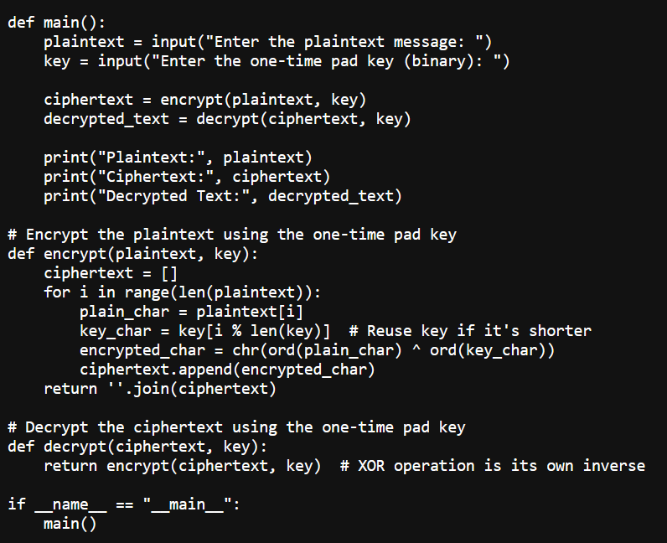

**Output:**

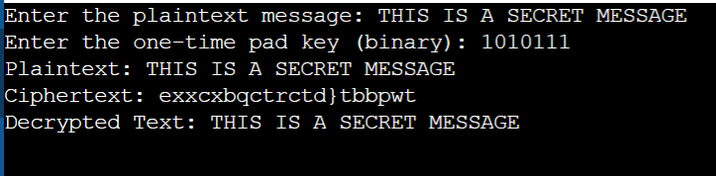

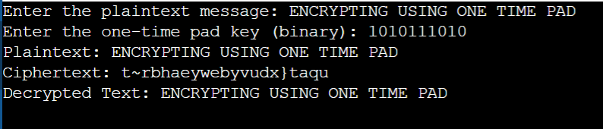

**Tools used:**

1. VS Code for writing python code

2. Microsoft Word Doc for preparing report

3. ChatGPT

**References:**

1. <https://docs.python.org/3/>

2. Cryptography and Network Security Mc-Graw Hill, 3rd Edition, 2015