TutorialsNinja Hybrid Automation Framework

Automation Framework – Quick Start Guide

Created by: Aditya Krishna Prasad

# Framework Flowchart

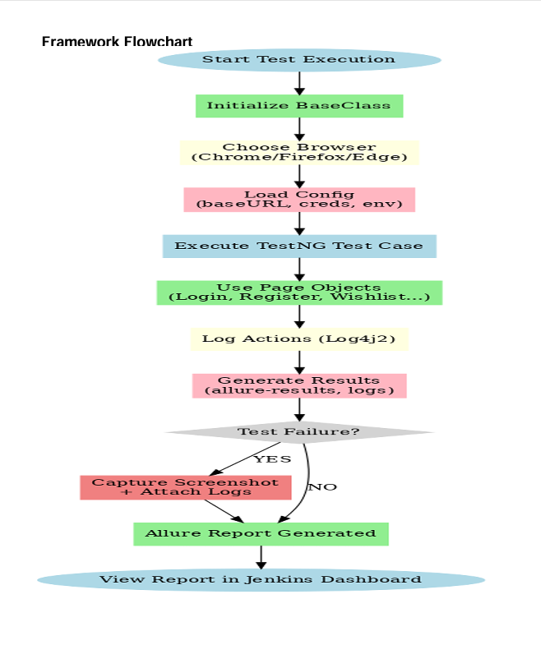

This flowchart shows the end-to-end execution flow of the TutorialsNinja Hybrid Framework, starting from test initialization, browser setup, and configuration loading, through Page Object actions, logging, and result generation, until reports are published in Jenkins.

# 1. Framework Summary

* Language / Test Runner → Java + TestNG
* Design Pattern → Page Object Model (POM)
* Logging → Log4j2 (logs/framework.log)
* - Test classes log high-level test flow
* - Page Objects log UI actions
* Reports → Allure Reports integrated with TestNG
* CI/CD → Jenkins with Allure plugin (history & trend auto-managed)
* Environment Tracking → environment.properties auto-written
* Attachments → Logs attached to each test inside Allure

# 2. Running Tests Locally

* Pre-requisites:
* - JDK 11+ installed (java -version)
* - Maven installed (mvn -v)
* - Allure installed (allure --version)
* - Browsers + WebDrivers available (Chrome, Firefox, Edge)
* Run Tests with Maven: mvn clean test -DsuiteXmlFile=testng.xml -Dbrowser=chrome
* Generate & View Allure Report: allure serve allure-results

# 3. Running Tests in Jenkins

* 1. Job Setup:
* - Link Jenkins job to this Git repository
* - Build Step: mvn clean test -DsuiteXmlFile=testng.xml -Dbrowser=chrome
* 2. Allure Plugin Configuration:
* - Install Allure Jenkins Plugin
* - Post-build action → Allure Report → Results path = allure-results
* 3. After Job Runs:
* - Open job → Allure Report
* - Tabs available: Overview, Categories, History/Trend, Attachments

# 4. Notes for Teammates

* Logs → check under Attachments tab in Allure
* Environment details → see Environment tab in Allure
* If a test fails, check logs first, then Jenkins console
* Passwords in logs are masked as [PROTECTED]

# 5. Framework Folder Structure

TutorialsNinjaHybridFramework/  
├── src/  
│ ├── main/java/ # Application code (if needed)  
│ └── test/java/ # Test classes  
│ ├── pageObjects/ # Page Object Model classes  
│ ├── testBase/ # Base setup & teardown  
│ ├── testCases/ # TestNG test cases  
│ └── utilities/ # Helpers (config reader, logger, data gen, etc.)  
└── src/test/resources/ #(log4j2.xml)