Independent Validation of Pancreatic Cancer Biomarker Candidates
Project: AI-Based Pancreatic Cancer Biomarker Identification Using Relational Graph Convolutional Networks and Deep Q-Networks

1. Objective
To examine whether selected computationally prioritized biomarker candidates show expression differences between pancreatic tumor and adjacent non-tumor samples in an independent public dataset.

2. Dataset
Dataset: GSE183795. The comparison included 139 tumor samples and 102 adjacent non-tumor samples. Three normal-pancreas donor samples were excluded from this two-group comparison.

3. Methodology
Normalized microarray expression values were compared between tumor and adjacent non-tumor groups. Welch's two-sample t-test was used for each candidate, followed by Benjamini-Hochberg false discovery rate (FDR) correction across the successfully tested candidates. An FDR below 0.05 was considered statistically significant for this exploratory analysis.

4. Results
Gene | Tumor mean | Adjacent mean | Mean difference | P-value | FDR
MROH6 | 6.1808 | 5.7788 | 0.4020 | 5.47e-13 | 4.38e-12
SPINK4 | 4.4454 | 4.3762 | 0.0692 | 0.401 | 0.534
IL10RA | 7.3775 | 7.2414 | 0.1362 | 0.202 | 0.323
FCGR1BP | NA | NA | NA | NA | NA
HOXA5 | 5.5641 | 5.4939 | 0.0702 | 0.144 | 0.323
MS4A14 | 6.2443 | 6.1133 | 0.1311 | 0.19 | 0.323
NME8 | 3.7006 | 3.7099 | -0.0093 | 0.751 | 0.858
OSCAR | 5.0726 | 5.2035 | -0.1310 | 3.87e-05 | 0.000155
CLIC2 | 5.5801 | 5.5616 | 0.0185 | 0.861 | 0.861

5. Expression Plot
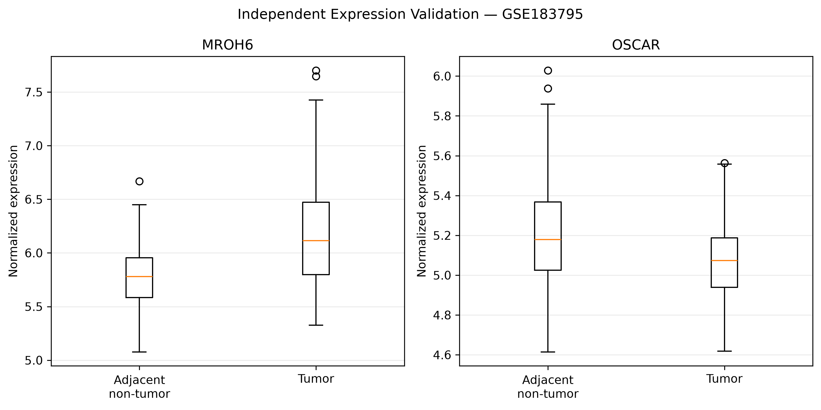
Figure 1. Normalized expression distributions for MROH6 and OSCAR in tumor and adjacent non-tumor samples.

6. Interpretation
MROH6 showed higher average expression in tumor samples, with an FDR of approximately 4.38 × 10⁻¹². OSCAR showed lower average expression in tumor samples, with an FDR of approximately 1.55 × 10⁻⁴. Both met the exploratory FDR threshold of 0.05. The other successfully tested candidates did not meet that threshold in this comparison.

7. Limitations
This analysis evaluates expression differences, not diagnostic performance or clinical utility. The microarray may not represent every transcript or candidate. FCGR1BP was not matched by its official symbol in the matrix. The statistical analysis does not account for all possible confounders, such as patient pairing, batch effects, or clinical characteristics. Independent replication and further biological and clinical assessment are needed before any candidate can be considered clinically validated.

8. Conclusion
In this exploratory independent dataset analysis, MROH6 and OSCAR showed statistically significant tumor-versus-adjacent-tissue expression differences after FDR correction. These results support further study but do not establish that either gene is a clinically validated pancreatic cancer biomarker.

