SPARKOLOGY ERP — DAY 1
System Architecture, Mobile Data Flow
Teacher Mobile Application (React Native / Expo) & Node.js/Express Backend Architecture
1. Whole-Structure System Topology & Architecture Diagram

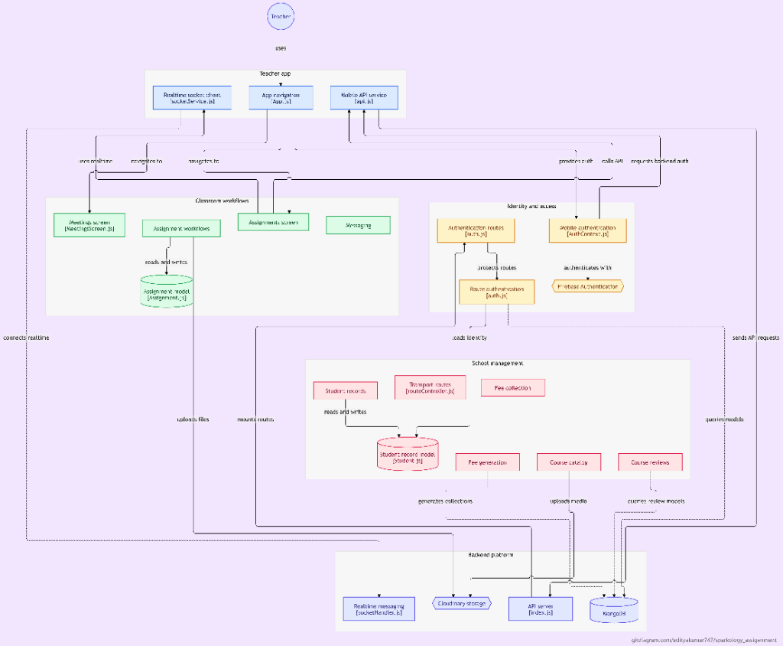
Figure: Complete Sparkology System Architecture & Module Interconnection Topology
Architectural Tiers Breakdown: As mapped in the architectural topology above, the system is organized across distinct operational tiers:
- 1. Actor Tier (Teacher): Employed teachers and staff interacting with the mobile client interface on Android, iOS, or Web preview.
- 2. Teacher Mobile Application: React Native (0.81.5) + Expo (~54.0.31) bundle comprising App.js (root router & stack/tab navigation), socketService.js (event dispatchers & room listeners), and api.js (centralized HTTP fetch client with bearer interceptor).
- 3. Identity & Access Management: Decoupled authentication boundary integrating Firebase Authentication (client ID tokens) with Express auth middleware (authController.js, middleware/auth.js) for JWT validation and role-based access control.
- 4. Classroom Workflows: Teacher-facing screens including AttendanceScreen.js, DashboardScreen.js, MeetingsScreen.js, and AssignmentsScreen.js, driving classroom pedagogy, document dispatch, and student engagement.
- 5. School Management Tier: Enterprise core managing student records (Student.js), class rosters (Class.js), transport routes (routeController.js), fee generation, course catalogs, and reviews.
- 6. Backend Platform: Express API gateway (index.js, port 5000), Socket.IO server (socketHandler.js), Cloudinary asset storage for avatars/materials, and local/Atlas MongoDB persistence.
Zero Direct Database Access: The client communicates exclusively with the backend via JSON over HTTPS and WebSockets over WSS. Direct client-to-database communication is completely barred. Every request is authenticated, sanitized, and scoped by schoolId.

2. High-Level Mobile Flow for Teachers
The teacher's mobile journey is engineered for rapid execution in real-world school environments where network connectivity may fluctuate. The flow transitions smoothly from secure authentication to timetable discovery, roster inspection, interactive marking, and atomic bulk commit.
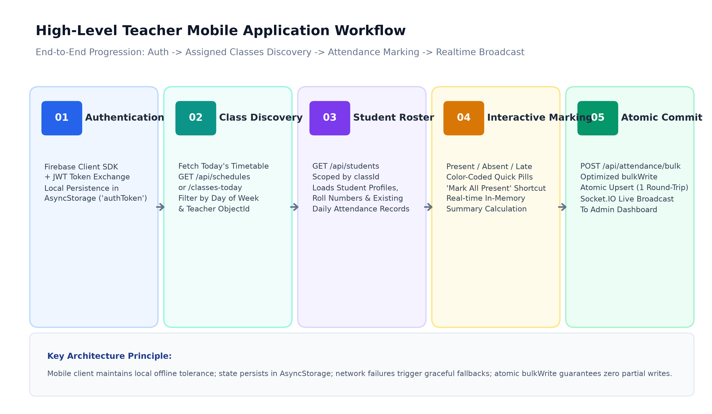
Figure: High-Level Teacher Mobile Operational Flow (Authentication -> Discovery -> Roster -> Marking -> Commit)
2.1 Step 1: Authentication & Identity Hydration
When the teacher launches the app, App.js invokes AuthContext.js to inspect local AsyncStorage for an existing valid authToken. If unauthenticated, the user is presented with the LoginScreen.js. Upon entering their email and password, the client authenticates against Firebase Auth to obtain a signed Firebase ID Token. This token is immediately exchanged with the backend via POST /api/auth/firebase-login, which verifies the signature against Firebase Admin SDK, locates the teacher in MongoDB, and signs a 7-day backend JWT. The token and teacher profile are saved to AsyncStorage, unlocking the MainTabNavigator.
2.2 Step 2: Assigned Classes & Daily Timetable Discovery
Once authenticated, the teacher lands on the DashboardScreen.js. The app automatically determines the current day of the week (e.g. 'Monday') and calls GET /api/schedules?date=YYYY-MM-DD. The backend filters schedules where teacherId matches the logged-in user and dayOfWeek equals today. The mobile client renders horizontal cards representing each class period (e.g. 'Class 10-A: Mathematics at 09:00 AM in Room 204'). Tapping 'Take Attendance' deep-links directly into AttendanceScreen.js with the selected classId pre-loaded.
2.3 Step 3: Class Roster & Historical Attendance Lookup
AttendanceScreen.js initiates two parallel requests: GET /api/students?classId=<id> to retrieve enrolled students and GET /api/attendance?classId=<id>&date=<today> to check if attendance has already been recorded for this period. Students are displayed in a clean, scrollable list showing full name, roll number, and avatar. If records already exist, the UI hydrates with existing states; otherwise, it primes the roster for quick action.
2.4 Step 4: Interactive Marking & Live Summary
For each student row, teachers have access to quick-action pills: Present (Green), Absent (Red), and Late (Orange). A single-tap 'Mark All Present' action allows teachers to mark the entire classroom present in under 1 second, then selectively toggle the few absent or late students. An in-memory state manager tracks live counters (e.g. 28 Present, 2 Absent, 1 Late) without triggering redundant network requests.
2.5 Step 5: Atomic Submission & Real-time Admin Dispatch
When the teacher presses 'Submit Attendance', the mobile client packages the 30-40 student records into a single payload and dispatches POST /api/attendance/bulk. Upon successful commit, the backend emits a WebSocket event (attendance_updated) into the school's admin room, instantly updating the principal's dashboard without requiring page refreshes.
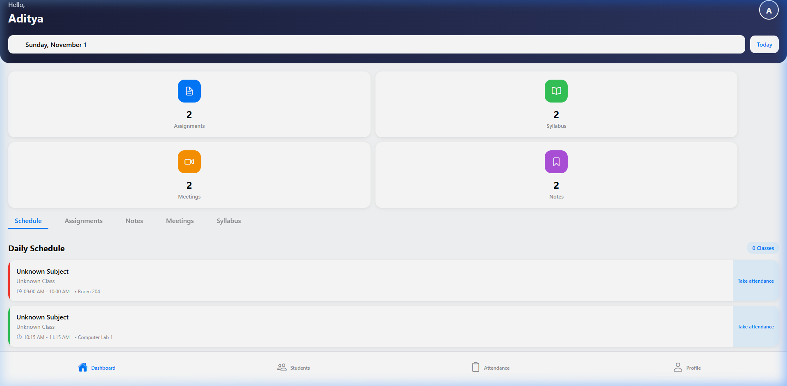
Figure: Live Mobile App Screen: Teacher Dashboard with Daily Schedule & Attendance Shortcuts
3. How Teacher Auth Tokens are Handled in API Requests
Security in Sparkology ERP relies on a dual-token architecture that combines Firebase Authentication for external identity verification with cryptographically signed JSON Web Tokens (JWT) for stateless, multi-tenant API authorization.
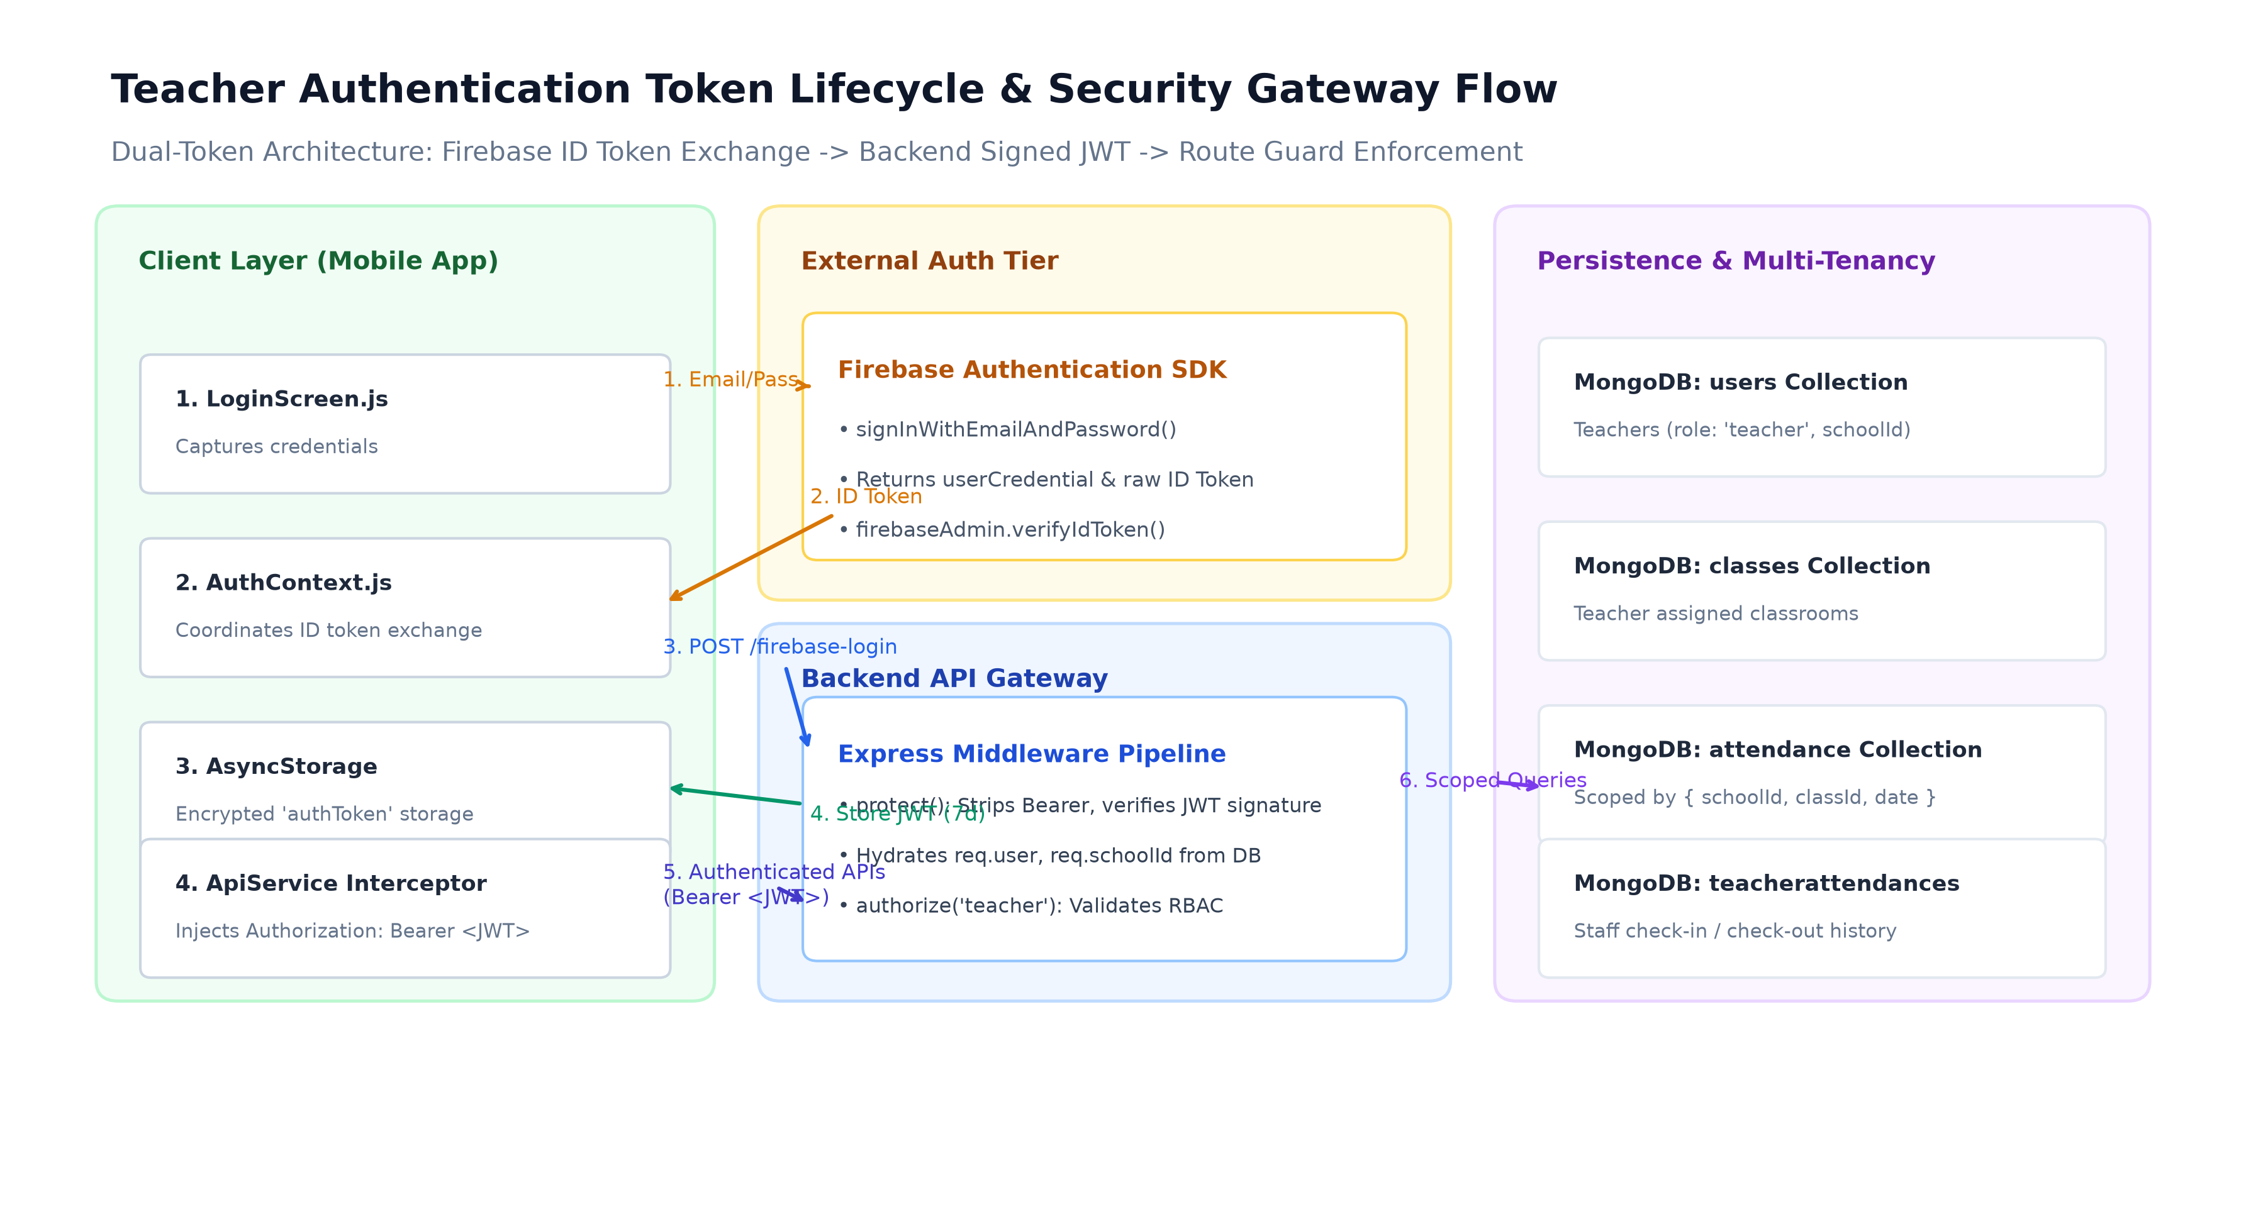
Figure: Detailed Auth Token Lifecycle: Firebase ID Token Exchange, Bearer Injection & Middleware Route Guards
3.1 Dual-Token Exchange Protocol
1. Firebase Authentication: The teacher signs in through Firebase Auth Client SDK on the device, producing a short-lived Firebase ID Token.
2. Server Exchange: The ID token is transmitted in the body of POST /api/auth/firebase-login to the Express API.
3. Admin Verification: backend/config/firebase-admin.js executes verifyIdToken(idToken) to cryptographically confirm the user's Google UID and email.
4. Local JWT Minting: Upon finding the corresponding User record in MongoDB, generateToken() signs a backend JWT payload containing { id: user._id, role: user.role, schoolId: user.schoolId } using JWT_SECRET with an expiration of 7 days.
5. Secure Client Storage: The mobile app stores this backend JWT in AsyncStorage under the key 'authToken'.
3.2 Outgoing Request Interception (ApiService.js)
All outgoing HTTP requests from the mobile app are channeled through a singleton ApiService class (spark_teacher/services/api.js). Before any request is dispatched over the wire, ApiService executes an asynchronous token injection routine:
// ApiService.js Bearer Token Injection
async request(endpoint, options = {}) {
const url = `${this.baseURL}${endpoint}`;
const token = await AsyncStorage.getItem('authToken');
const config = {
headers: {
'Content-Type': 'application/json',
...(token && { Authorization: `Bearer ${token}` }),
...options.headers,
},
...options,
};
return fetch(url, config);
}

3.3 Backend Middleware Gateway (middleware/auth.js)
When the request reaches the Express API gateway, it passes through three sequential security layers:
• protect() Middleware: Inspects req.headers.authorization for the 'Bearer ' prefix, strips the token, and calls jwt.verify(token, process.env.JWT_SECRET). If valid, it queries MongoDB to verify the user account is active (isActive: true, isLocked: false) and attaches the full user document to req.user.
• authorize('teacher') Middleware: Inspects req.user.role to verify Role-Based Access Control (RBAC). Requests from unauthorized roles are rejected with HTTP 403 Forbidden.
• Multi-Tenant Isolation Enforcement: All downstream database queries explicitly filter by { schoolId: req.user.schoolId }, preventing cross-school data tampering.
4. Database Schemas Related to Module
The teacher's operational domain interacts with six foundational collections in MongoDB. All models adhere to Mongoose strict schemas with timestamp tracking, sparse indexes for unique fields, and compound indexes for fast multi-tenant querying.
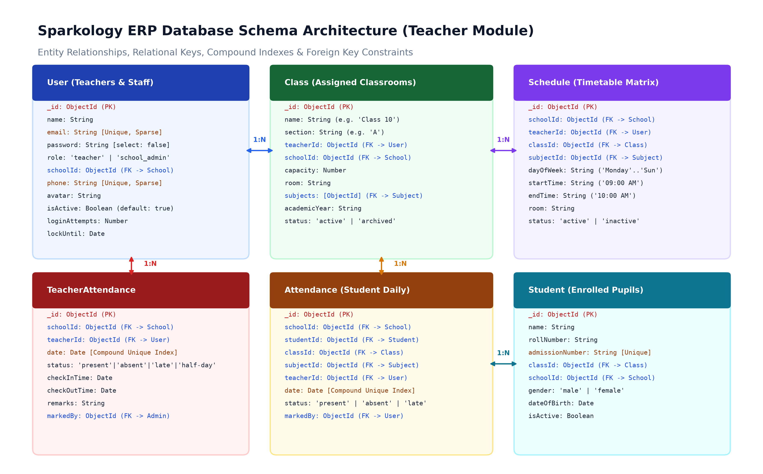
Figure: Entity Relationship Diagram: Users (Teachers), Classes, TeacherAttendance, Attendance, Schedules & Students
4.1 Teachers / Users Collection (models/User.js)
Stores system credentials, personal information, school affiliation, and role assignment for all teaching staff.
Field Name | Type | Constraints & Description
_id | ObjectId | Primary Key, auto-generated MongoDB identifier
name | String | Full legal name of the teacher (required, trimmed)
email | String | Unique email identifier; sparse index enables multi-tenant uniqueness
password | String | Bcrypt hashed password (salt rounds: 10); select: false on queries
role | String | Role enum: 'teacher', 'admin', 'school_admin' (default: 'teacher')
schoolId | ObjectId | Foreign Key -> School collection; scopes all operations
phone | String | Contact phone number; sparse unique index
avatar | String | Cloudinary asset URL for profile picture
isActive | Boolean | Account status flag; checked on every protect() request (default: true)
loginAttempts | Number | Consecutive failed login counter; locks account if >= 5
lockUntil | Date | Timestamp until which the user account remains locked

4.2 Classes Collection (models/Class.js)
Defines standard academic cohorts, room allocations, enrolled student limits, and assigned class teachers.
Field Name | Type | Constraints & Description
_id | ObjectId | Primary Key identifier
name | String | Class name (e.g. 'Class 10', 'Grade 9')
section | String | Section letter (e.g. 'A', 'B', 'C')
teacherId | ObjectId | Foreign Key -> User (Class Teacher responsible for overall cohort)
schoolId | ObjectId | Foreign Key -> School (Multi-tenant partition key)
capacity | Number | Maximum student seating limit (default: 40)
room | String | Classroom number or physical wing location (e.g. 'Room 204')
subjects | Array[ObjectId] | Array of Foreign Keys referencing Subject curriculum models
academicYear | String | Current operating academic term (e.g. '2026-2027')
status | String | Cohort status: 'active', 'archived', 'graduated'

4.3 TeacherAttendance Collection (models/TeacherAttendance.js)
Maintains daily clock-in / clock-out records for faculty members, marked by school administration.
Field Name | Type | Constraints & Description
_id | ObjectId | Primary Key identifier
schoolId | ObjectId | Foreign Key -> School (Part of compound unique index)
teacherId | ObjectId | Foreign Key -> User (Part of compound unique index)
date | Date | Midnight date timestamp (Part of compound unique index)
status | String | Staff status enum: 'present', 'absent', 'late', 'half-day'
checkInTime | Date | Biometric or administrative check-in timestamp
checkOutTime | Date | Biometric or administrative check-out timestamp
remarks | String | Administrative leave notes or reason for tardiness
markedBy | ObjectId | Foreign Key -> User (School administrator who recorded entry)

4.4 Student Attendance Collection (models/Attendance.js)
Captures individual student session attendance marked by teachers during scheduled class periods.
Field Name | Type | Constraints & Description
_id | ObjectId | Primary Key identifier
schoolId | ObjectId | Foreign Key -> School (Compound unique index)
studentId | ObjectId | Foreign Key -> Student (Compound unique index)
classId | ObjectId | Foreign Key -> Class identifier
subjectId | ObjectId | Foreign Key -> Subject (Compound unique index; distinguishes periods)
teacherId | ObjectId | Foreign Key -> User (Teacher who conducted the class)
date | Date | Midnight normalized Date object (Compound unique index)
status | String | Student status: 'present', 'absent', 'late', 'excused'
remarks | String | Teacher observations (e.g. 'Doctor appointment')
markedBy | ObjectId | Foreign Key -> User (Audit field for accountability)

5. Forensic Code Audit: Identified Bugs & Performance Bottlenecks
A thorough forensic audit of the mobile app and backend revealed 8 structural defects, ranging from critical database concurrency bottlenecks to UI state bugs. The remediation of these defects forms the core engineering roadmap for this assessment.
# | Severity | Location | Identified Problem | Proposed Engineering Fix
1 | CRITICAL | attendanceController.js:136 | Sequential N+1 DB Queries: Bulk attendance runs a sequential for loop executing 4 queries per student. For 40 students = 160 DB round-trips (3500ms latency). | Replace with atomic Attendance.bulkWrite() with updateOne({ upsert: true }). Latency drops to < 50ms.
2 | HIGH | AttendanceScreen.js:891 | UI Button Color Bug: selectedButton class sets backgroundColor: '#007AFF' for all active buttons, making Present, Absent, and Late all appear generic blue. | Isolate selected styling to respective theme colors: Emerald (#34C759), Crimson (#FF3B30), and Amber (#FF9500).
3 | MEDIUM | assignments.js & meetings.js | Duplicate Route Logic: Separate routes /api/assignments/teacher/classes and /api/meetings/teacher/classes perform identical class aggregation. | Standardize under single REST endpoint: GET /api/teachers/:id/classes-today.
4 | CRITICAL | attendanceController.js:59 | Epoch Timestamp Type Mismatch: setHours(0,0,0,0) returns an integer number in ms, NOT a Date object, causing query failures or UTC timezone shifts. | Wrap with new Date(new Date(date).setHours(0,0,0,0)).
5 | HIGH | routes/classes.js:22 | RBAC Authorization Flaw: GET /api/classes is locked to authorize('school_admin'), preventing teachers from directly discovering their cohorts. | Provide teacher scope or dedicated teacher-accessible class listing endpoint.
6 | MEDIUM | AttendanceScreen.js:60 | Network Overfetching: Calling generic GET /api/schedules transfers heavy unneeded metadata (semester, createdBy, notes) on cellular connections. | Route to lightweight classes-today endpoint returning only classId, subject, room, and timings (~1.5 KB).
7 | HIGH | models/Attendance.js:72 | E11000 Duplicate Key Crash: Concurrent or re-submitted attendance throws unhandled duplicate key error on compound index. | Use idempotent upserts with upsert: true in bulkWrite.
8 | LOW | ComplaintsScreen.js:1 | Dead UI Screen: Complaint creation form is fully rendered but has zero backend API wiring. | Connect to complaint ticket endpoint or disable navigation button until Phase 2.

6. Day-by-Day Execution Plan for this Week
To ensure high engineering velocity and zero regression, the technical deliverables are structured into a 7-day milestone sprint. Each day targets a distinct architectural tier with verifiable test criteria.
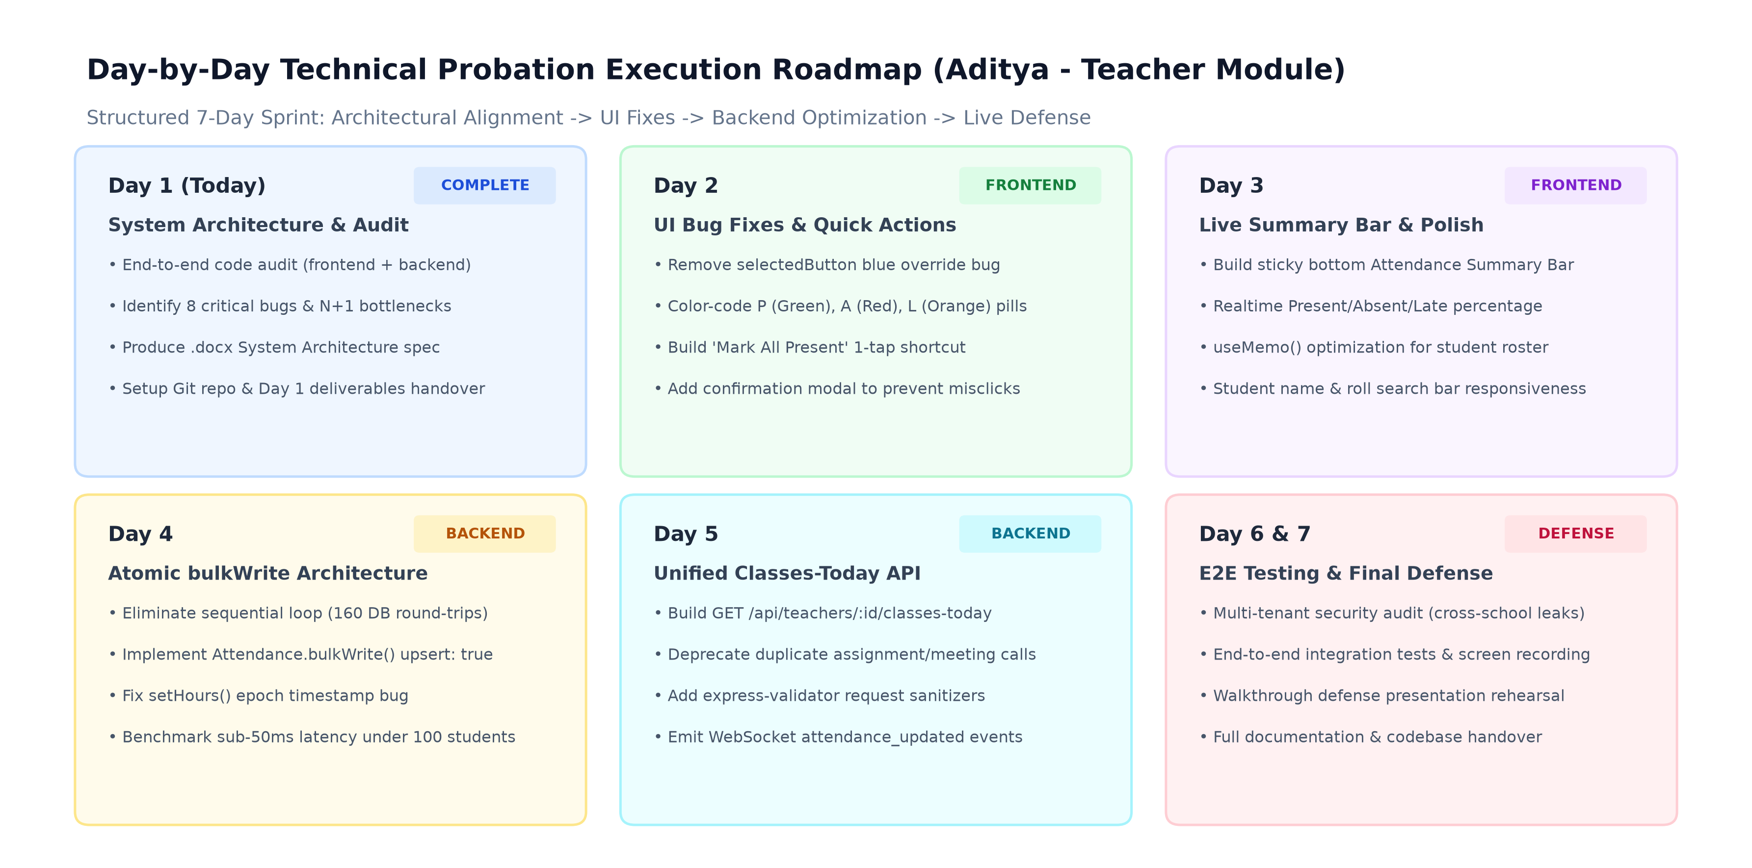
Figure: 7-Day Technical Probation Sprint Roadmap & Deliverable Milestones
Timeline | Focus Area | Verifiable Engineering Deliverables
Day 1 (Today) | System Architecture & Audit | Complete end-to-end code audit; create Day 1 Architecture Word Document; setup Git repo without docs folder; verify live Expo preview.
Day 2 | Frontend Bug Fixes & Quick Actions | Fix AttendanceScreen button color-override bug; implement Emerald/Crimson/Amber pills; build 'Mark All Present' 1-tap shortcut with confirmation modal.
Day 3 | Frontend Live Summary & Polish | Build sticky bottom Live Summary Bar (P/A/L counts & percentages); implement useMemo() for student list; polish search bar filtering responsiveness.
Day 4 | Backend Bulk Rewrite (High Perf) | Replace sequential for loop in attendanceController.js with Attendance.bulkWrite(); implement atomic upsert: true; benchmark < 50ms latency for 100 students.
Day 5 | Unified Classes-Today API | Implement GET /api/teachers/:id/classes-today; deprecate duplicate assignments/meetings class routes; add express-validator sanitizers; wire Socket.IO events.
Day 6 | End-to-End Integration & Security Audit | Conduct cross-school multi-tenant penetration tests; verify token expiration handling; execute full mobile-to-backend integration test suites.
Day 7 | Defense Rehearsal & Final Handover | Rehearse live code walkthrough defense; record demonstration video; finalize Google Sheet daily progress tracker; deliver production package.

Engineering Commitment: All architecture, code changes, and execution steps follow strict industrial standard guidelines: multi-tenant data safety, stateless token authentication, sub-50ms database operations, and clean mobile responsiveness.

