# Bansilal Ramnath Agarwal Charitable Trust’s

Vishwakarma Institute of Technology, Pune-37

*(Anautonomous Institute of Savitribai Phule Pune University)*



**Department of Multidisciplinary Engineering**

|  |  |
| --- | --- |
| **Division** | **CS-A** |
| **Batch** | **B1** |
| **Roll no.** | **90** |
| **Name** | **Aditya Shrinivas Kurapati** |
| **Subject** | **OS** |

1. Producer Consumer PROBLEM USING C PROGRAM

#include <pthread.h>

#include <stdio.h>

#include <stdlib.h>

#include <unistd.h>

#define BUFFER_SIZE 5

typedef struct {

int buf[BUFFER_SIZE];

size_t len;

pthread_mutex_t mutex;

pthread_cond_t can_produce;

pthread_cond_t can_consume;

} buffer_t;

void *producer(void *arg) {

buffer_t *buffer = (buffer_t *)arg;

while (1) {

#ifdef UNDERFLOW

sleep(5);

#endif

pthread_mutex_lock(&buffer->mutex);

if (buffer->len == BUFFER_SIZE) {

pthread_cond_wait(&buffer->can_produce, &buffer->mutex);

}

int t = rand();

printf("Produced %d\n ", t);

buffer->buf[buffer->len] = t;

++buffer->len;

pthread_cond_signal(&buffer->can_consume);

pthread_mutex_unlock(&buffer->mutex);

printf("\nFULL: %ld\n", buffer->len);

printf("\nEmpty: %ld\n", (BUFFER_SIZE - buffer->len));

}

return NULL;

}

void *consumer(void *arg) {

buffer_t *buffer = (buffer_t *)arg;

while (1) {

#ifdef OVERFLOW

sleep(5);

#endif

pthread_mutex_lock(&buffer->mutex);

if (buffer->len == 0) {

pthread_cond_wait(&buffer->can_consume, &buffer->mutex);

}

--buffer->len;

printf("Consumed %d\n", buffer->buf[buffer->len]);

pthread_cond_signal(&buffer->can_produce);

pthread_mutex_unlock(&buffer->mutex);

printf("\nFULL: %ld\n", buffer->len);

printf("\nEmpty: %ld\n", (BUFFER_SIZE - buffer->len));

}

return NULL;

}

int main(int argc, char *argv[]) {

buffer_t buffer = {.len = 0,

.mutex = PTHREAD_MUTEX_INITIALIZER,

.can_produce = PTHREAD_COND_INITIALIZER,

.can_consume = PTHREAD_COND_INITIALIZER};

pthread_t prod, cons;

pthread_create(&prod, NULL, producer, (void *)&buffer);

pthread_create(&cons, NULL, consumer, (void *)&buffer);

pthread_join(prod, NULL);

pthread_join(cons, NULL);

return 0;

}  
  
OUTPUT:-  
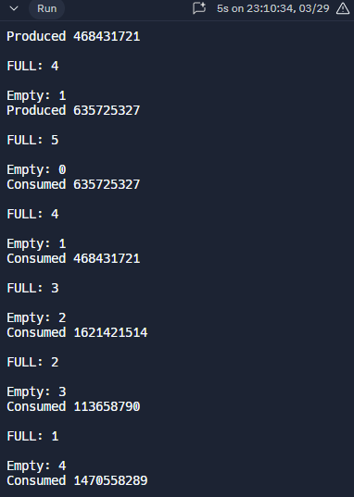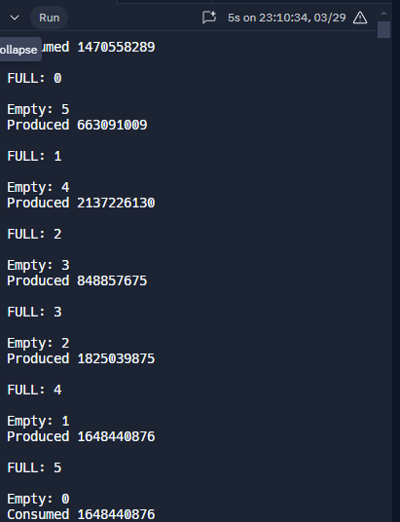  
  
  
  
2. READER_WRITER PROBLEM USING C PROGRAM

#include <pthread.h>

#include <semaphore.h>

#include <stdio.h>

#include <stdlib.h>

#include <unistd.h>

sem_t mutex, writeblock;

int data = 0, rcount = 0;

void *reader(void *arg) {

int f;

f = *((int *)arg);

sem_wait(&mutex);

rcount++;

if (rcount == 1) {

sem_wait(&writeblock);

}

sem_post(&mutex);

printf("Reader %d is reading data %d\n", f, data);

sleep(2);

sem_wait(&mutex);

rcount--;

if (rcount == 0) {

sem_post(&writeblock);

}

sem_post(&mutex);

return NULL;

}

void *writer(void *arg) {

int f;

f = *((int *)arg);

sem_wait(&writeblock);

data++;

printf("Data Written By The Writer Is %d\n", data);

sleep(1);

sem_post(&writeblock);

return NULL;

}

int main() {

int i;

pthread_t rtid[3], wtid[3];

sem_init(&mutex, 0, 1);

sem_init(&writeblock, 0, 1);

while (1) {

for (i = 0; i < 3; i++) {

pthread_create(&wtid[i], NULL, writer, &i);

pthread_create(&rtid[i], NULL, reader, &i);

}

for (i = 0; i < 3; i++) {

pthread_join(wtid[i], NULL);

pthread_join(rtid[i], NULL);

}

sleep(5); // Delay for 5 seconds before running the loop again

printf("/n/n");

}

return 0;

}

OUTPUT:-

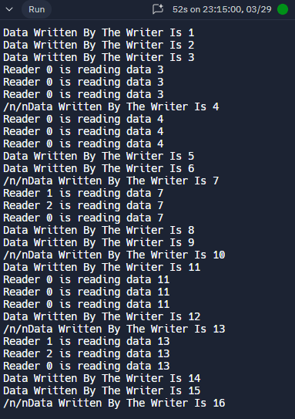

**3.Dinning Philosophers Problem**

#include <pthread.h>

#include <semaphore.h>

#include <stdio.h>

#include <stdlib.h>

#include <unistd.h>

#define MIN(a, b) (a < b ? a : b)

#define MAX(a, b) (a > b ? a : b)

sem_t chopsticks[5];

void *eat(void *arg) {

int i = (int)arg;

int count = 2;

while (count > 0) {

sem_wait(&chopsticks[MIN(i, (i + 1) % 5)]);

sem_wait(&chopsticks[MAX(i, (i + 1) % 5)]);

printf("Philosopher %d is eating\n", i);

sem_post(&chopsticks[MIN(i, (i + 1) % 5)]);

sem_post(&chopsticks[MAX(i, (i + 1) % 5)]);

count--;

}

return NULL;

}

int main() {

pthread_t philosophers[5];

int i;

for (i = 0; i < 5; i++) {

sem_init(&chopsticks[i], 0, 1);

}

for (i = 0; i < 5; i++) {

pthread_create(&philosophers[i], NULL, eat, (void *)i);

}

for (i = 0; i < 5; i++) {

pthread_join(philosophers[i], NULL);

}

return 0;

}

