


KLE Society’s
C.B. KORE POLYTECHNIC CHIKODI-591201
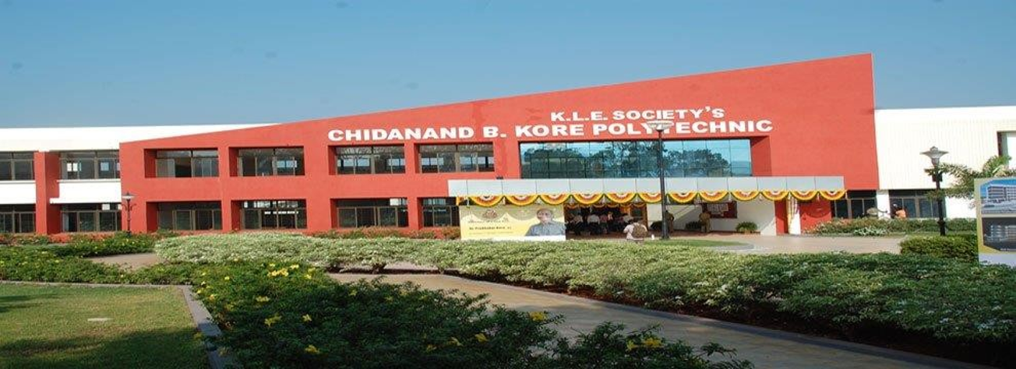

DEPARTMENT OF COMPUTER SCIENCE AND ENGNEERING
INTERNSHIP REPORT ON
ON JOB TRAINING-2

SUBMITTED BY
Soham More 339CS23705

CHORT OWNER H.O.D PRINCIPAL




K. L. E Society's
C. B. KORE POLYTECHNIC, CHIKODI
DEPARTMENT OF COMPUTER SCIENCE AND ENGINEERING
6THSEM 2025-26

INTERNSHIP - 20CS61S
CIE-II
RUBRICS

On Job  Training-2 | Use case  (Task-1) | CIE Marks (30) | Report Submission (50) | Total CIE (80)


UNDER THE GUIDENCE OF UNDER THE GUIDENCE OF
Prof. SARITA KHOT Prof. Anoop J.Desai

Signature of Signature of Signature of
Cohort Owner Head of Department Principal

INDEX
Sl No | Contents | Page No
1 | Introduction | 1-1
2 | Existing System and Literature Survey  - Existing System  - Literature Survey | 2-6
3 | Problem Statement and Objectives  - Problem Definition  - Challenges  - Limitations  - Applications | 7-8
4 | Requirements  - Hardware Requirements  - Software Requirements  - Functional Requirements  - Non-Functional Requirements | 9-11
5 | System Design and Methodology  - Methodology  - Software Architecture  - Database Design  - UI Design  - Module Design  - ERD Diagram | 12-18
6 | Pseudocode | 19-21
7 | Experiments and Results | 22-28
8 | Test Cases | 29-31
9 | Future Scope | 32-32
10 | Conclusion | 33-33
11 | Reference | 34-34

K.L.E SOCIETY’S C.B KORE POLYTECHNIC, CHIKODI
DEPARTMENTOFCOMPUTERSCIENCEANDENGINEERING.
RUBRICSFORASSESSMENTOFINTERNSHIP

NAME: Soham More
REG NO: 339CS23705
SUBJECT/CODE: INTERNSHIP/20CS61S
DIMENSION | SCALE |  |  |  |  | STUDENT SCORE
 | 10 | 20 | 30 | 40 | 50
 | Beginner | Intermediate | Good | Advanced | Expert
Organization | Has not included relevant information | Has included few relevant information | Has included some relevant  information | Has included many relevant  information | Has included all relevant information
Full fill Team roles & duties | Does not performance e duties  assigned | performance very little duties | performance particular duties | performance e early all duties | performance all duties of assigned  team roles
Conclusion | Poor | Lesse Effective | Partially Effective | Summarizes but not exact | Most Effective
Conventions | Frequent Error | More Error | Some Error | Occasional Error | No Error
Average Marks

