
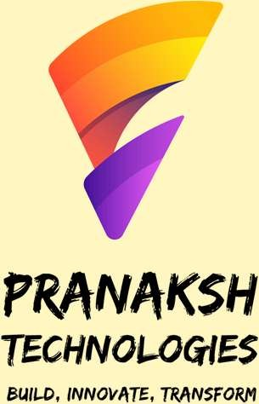
A student of K.L. E’s C.B.Kore Polytechnic, Chikodi has successfully completed
internship of 400 hour’s During the period of 02-07-2024 to 29-09-2024 at
“Pranaksh Technologies LLP”, under the guidance of Mr. Anoop Desai and
team.
Mr. Prathamesh Devarkar was able to successfully participate in accomplish all of the
task required or the project entitled “Web Application Development"
through which he was able to showcase his great work and team player skills.
Internship
Certificate

For Pranaksh Technologies LLP

Director Certificate ID: MAR2025JFSS166033

www. pranakshtechnologies. com

