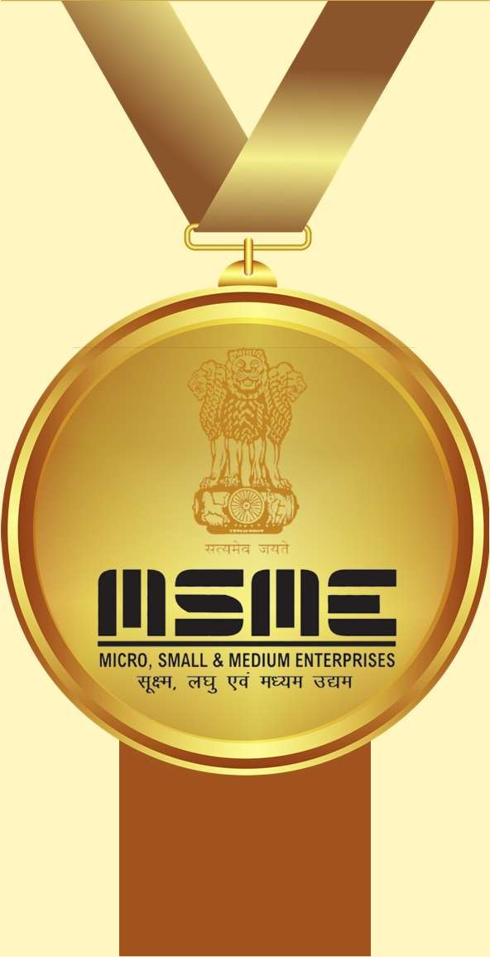
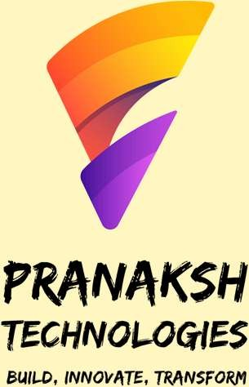
Internship
Certificate

A student of K.L.E’s C.B.Kore Polytechnic, Chikodi

has successfully completed
internship of
400
hour’s
During the period of
02-07-2024
to
29-09-2024
at
“Pranaksh Technologies LLP”, under the guidance of Mr. Anoop Desai and
team.
Mr.
Soham More
was able to successfully participate in accomplish all of the
task required or the project entitled “
Web Application Development"

through which he was able to showcase his great work and team player skills.

For Pranaksh Technologies LLP

Director Certificate ID: MAR2025JFSS166033

www. pranakshtechnologies. com

